**APPLIED PYTHON PROGRAMMING LABORATORY**

LIST OF EXPERIMENTS:

Cycle – 1

1. Downloading and Installing Python and Modules
2. Python 3 on Linux

Follow the instructions given in the URL <https://docs.pythonguide.org/starting/install3/linux/>

* + Steps to install Python on linux
  + Click the above url now you can start the installation of python3 with the command

sudo apt install python 3.11.1

* + Allow the process to complete and verify the python was installed successfully
  + Open The Ubuntu Terminal
  + Check whether the python3 is available or not

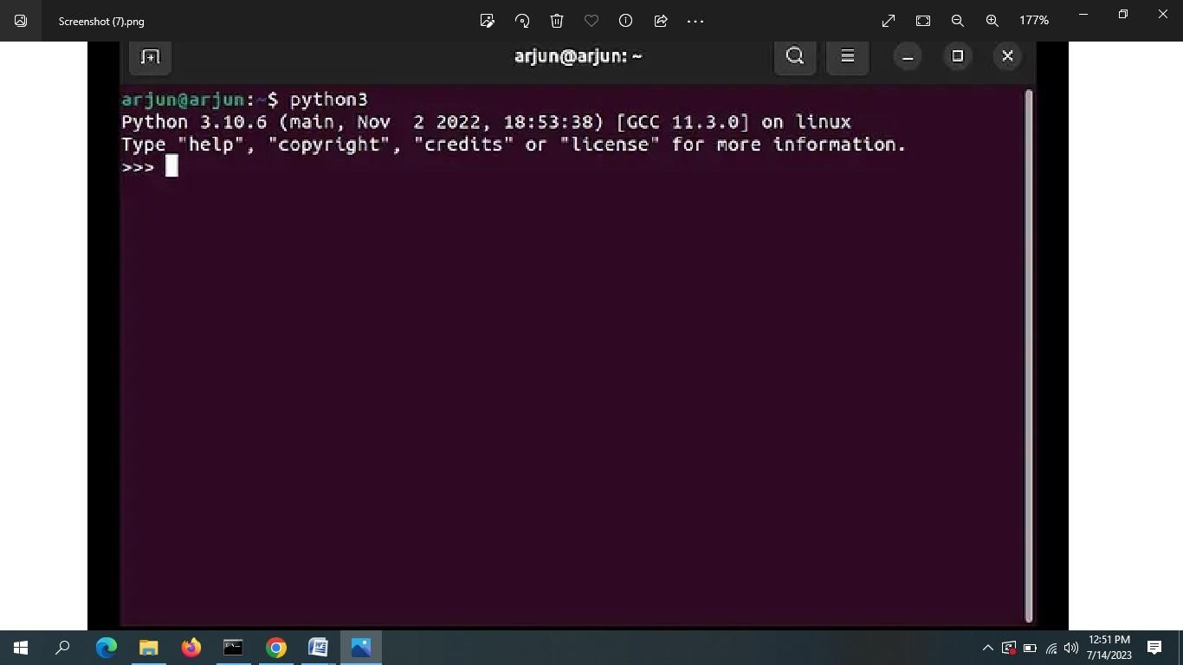

1. You can also run the below command to **check the Python version** on your Ubuntu installation.

python3 –version

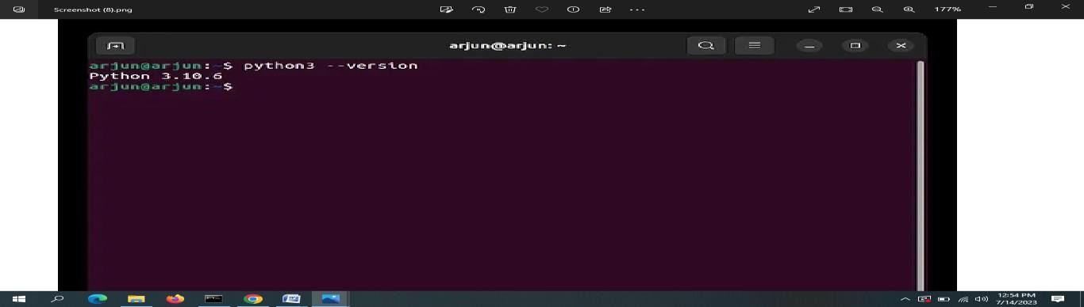

1. If an older version of Python is installed, run the below command to **update Python** to the latest version on your Linux distro.

sudo apt --only-upgrade install python3

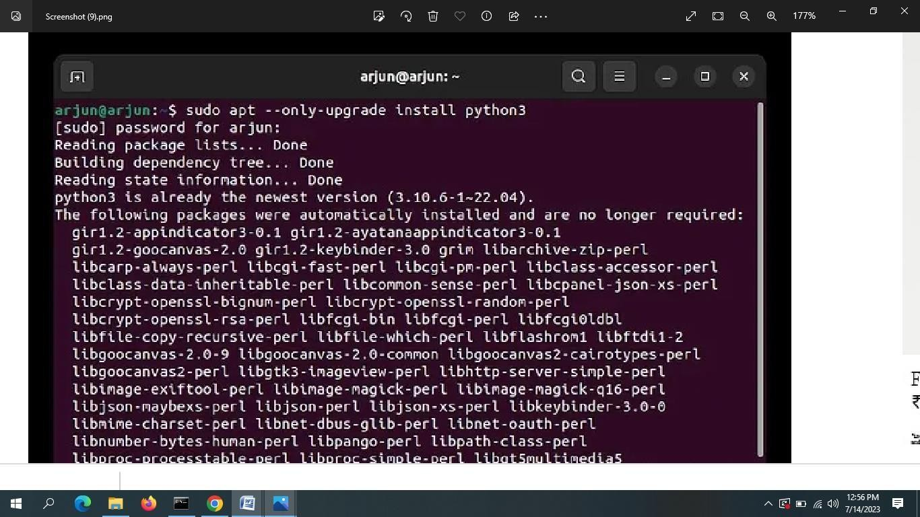

1. Python 3 on Windows

Follow the instructions given in the URL https://docs.python.org/3/using/windows.html (Please remember that Windows installation of Python is harder!

Steps to install python.

1. Visit [http://python.org](http://python.org/)
2. Click on downloads menu

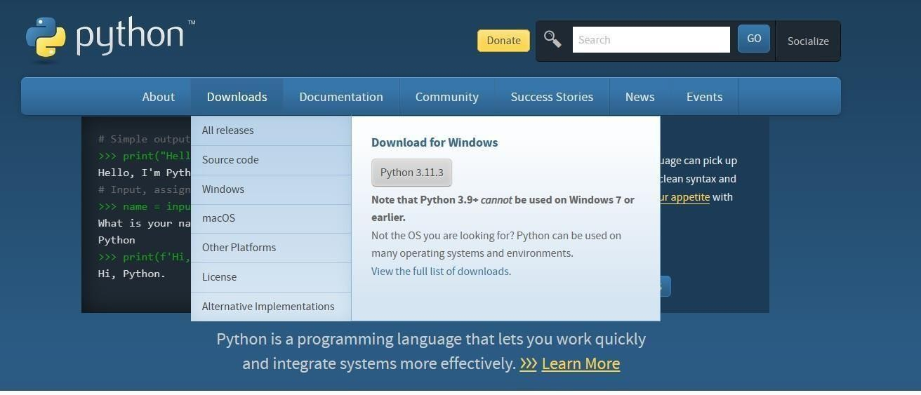

1. Click on Python 3.11.3 to download python software
2. Install the python by following these steps

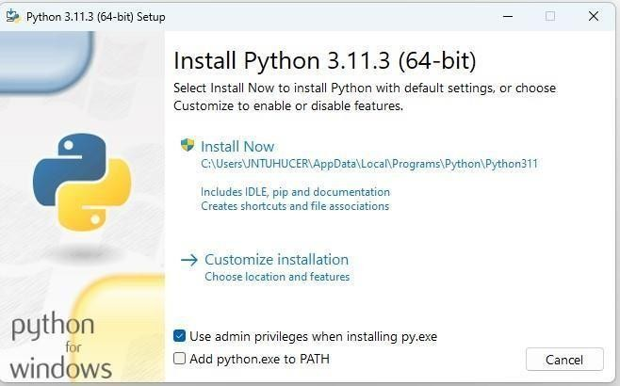

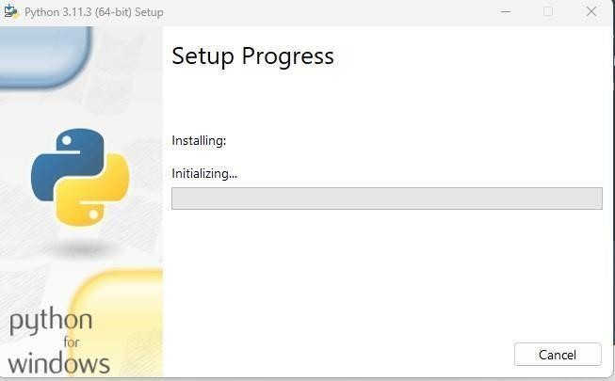

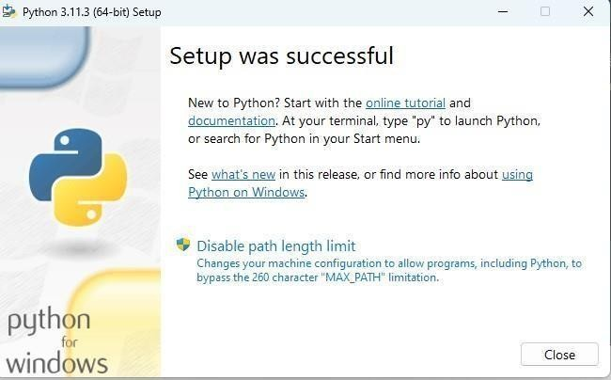

1. pip3 on Windows and Linux

Install the Python package installer by following the instructions given in the URL <https://www.activestate.com/resources/quick-reads/how-to-install-and-use-pip3/>

* + The latest python3 installers for windows install pip3 automatically but make sure that you have clicked the check box “Add Python 3.x to Path ”as shown in these screen shorts

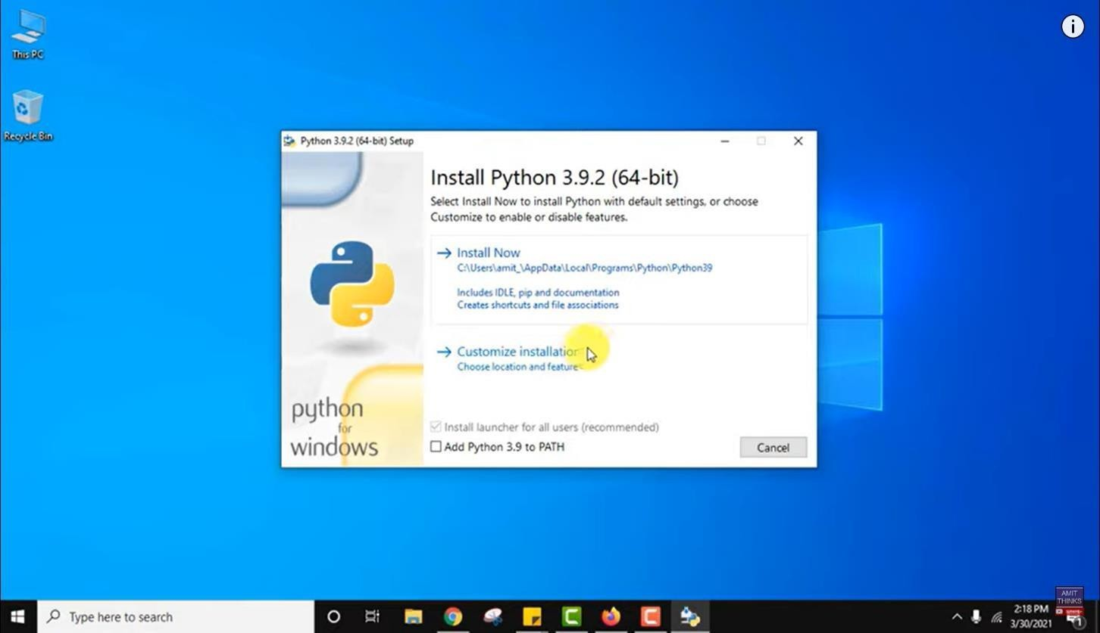

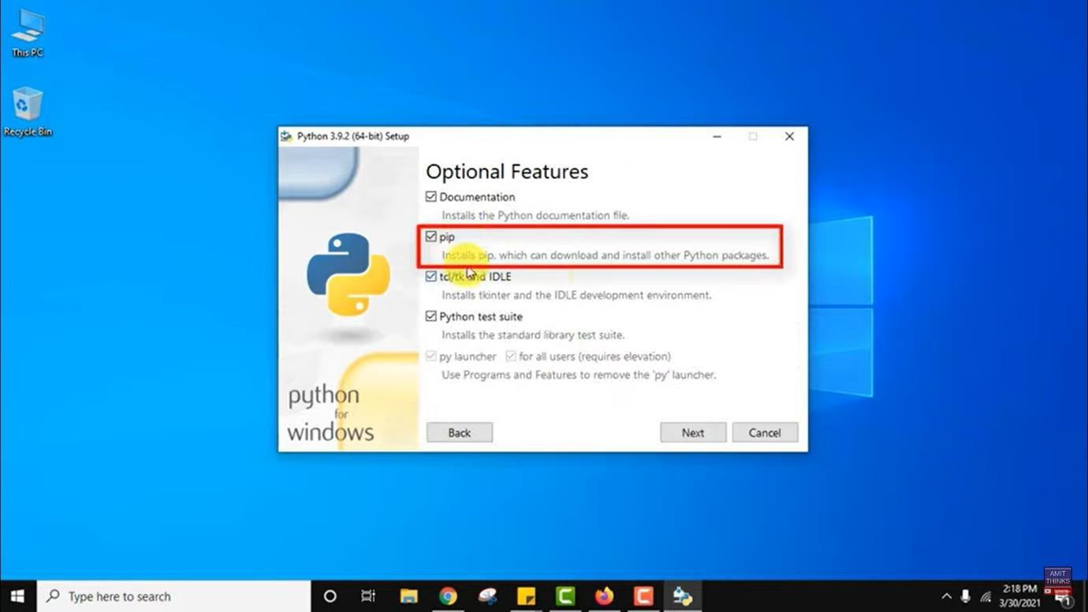

# Verifying pip3 installation

* + **Go to the command prompt**

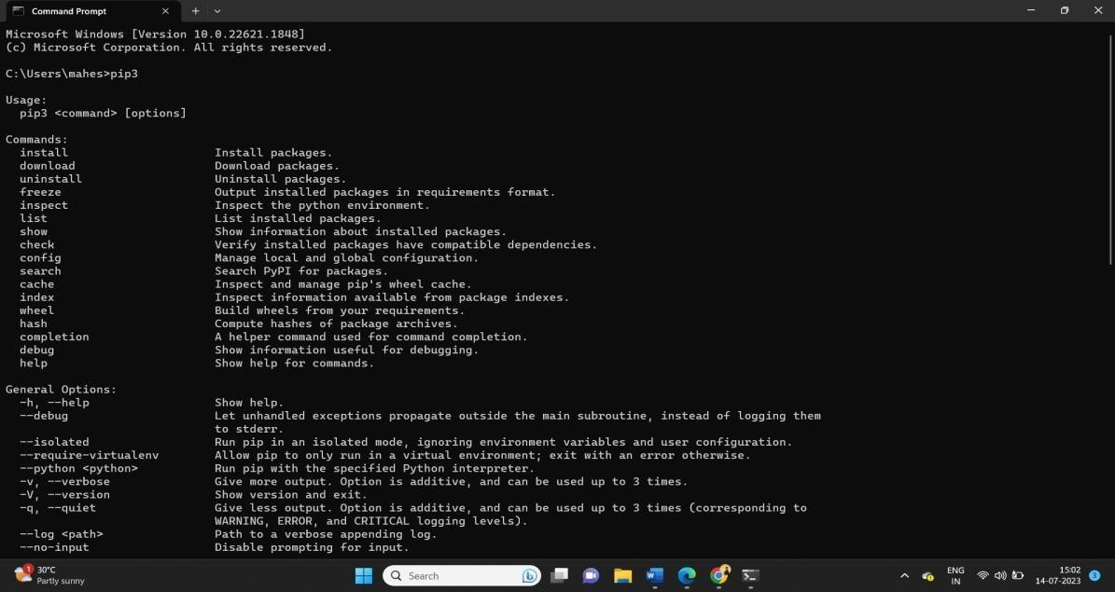

# Pip3 installation on linux:

**pip3** is the official package installer for Python 3. It can be used to install packages from the [Python Package Index.](https://pypi.org/)

# Installation

**Step 1 - Update system**

It is always a good idea to update before trying to install a new package. Run the command below:

sudo apt-get update

STEP 2 - INSTALL PIP3

If Python 3 has already been installed on the system, execute the command below to install pip3:

sudo apt-get -y install python3-pip

STEP 3 - VERIFICATION

To verify the installation, run the following command to cross check the version number:

pip3 --version

1. Installing numpy and scipy

You can install any python3 package using the command pip3 install

* + Go to command prompt type the command pip3 install numpy

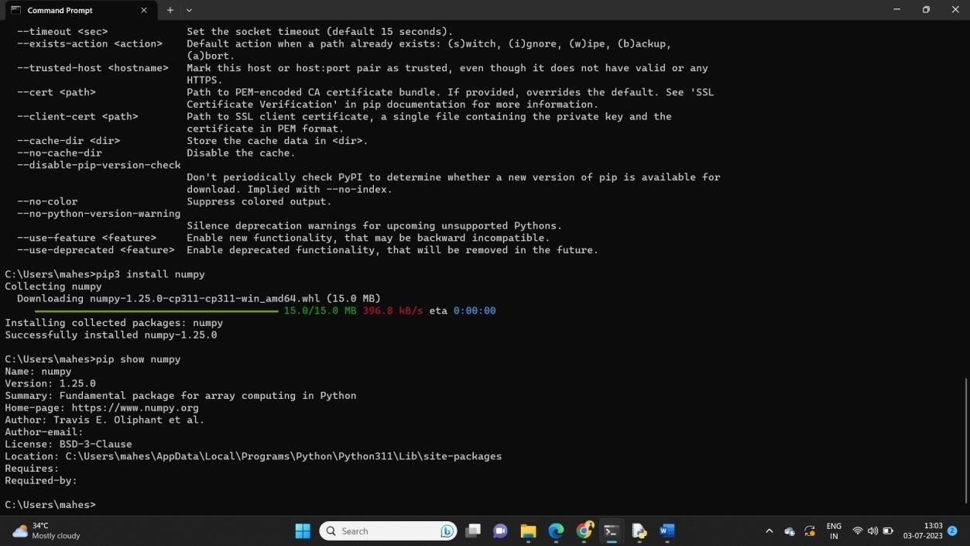

* + Installaling and collecting all the packages from numpy module

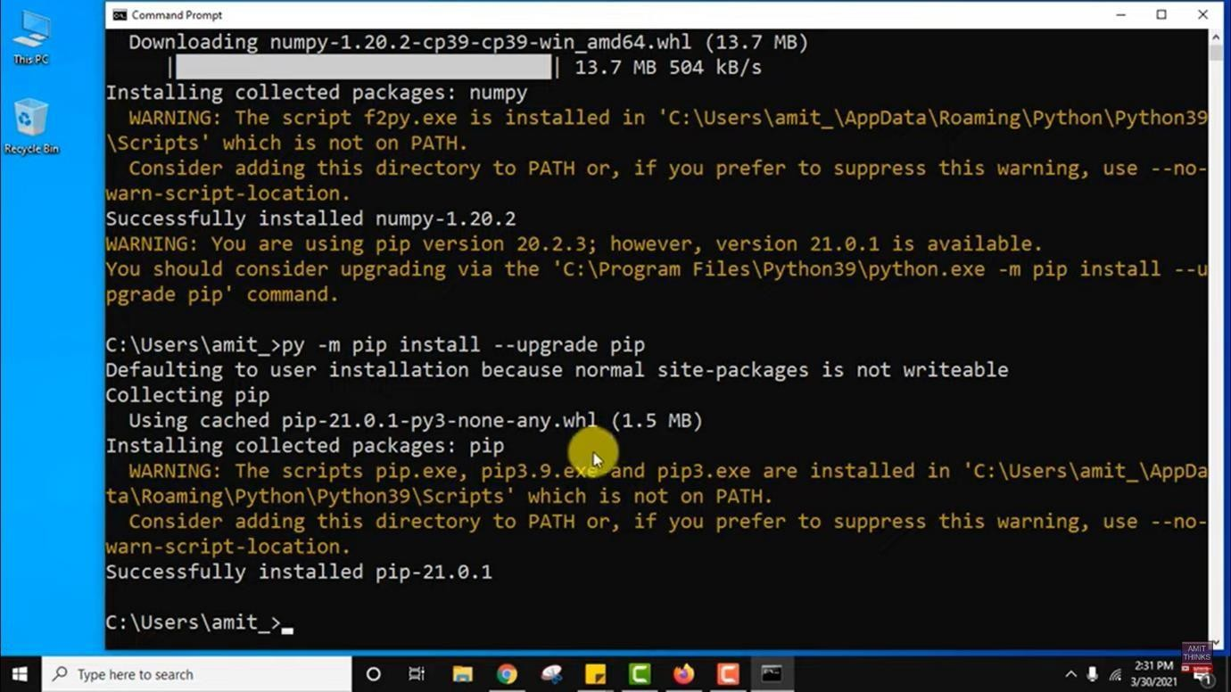

* + Verifying the numpy module

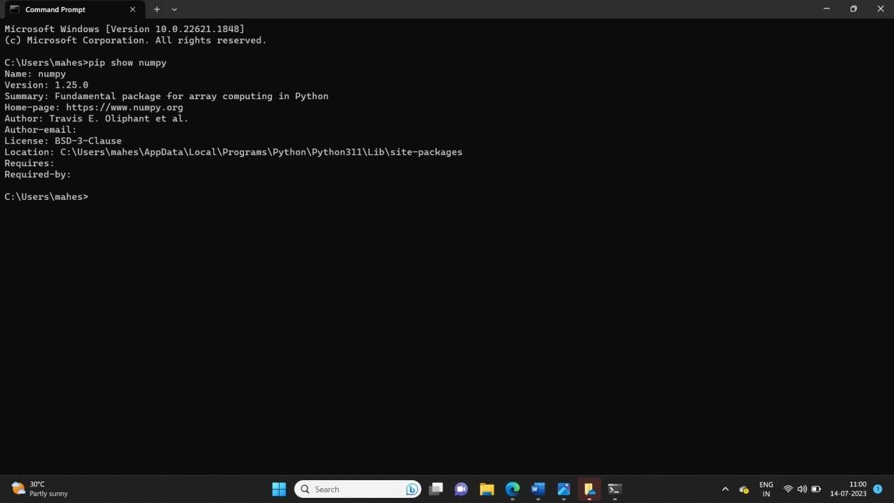

* + Go to command prompt type the command pip3 install Scipy

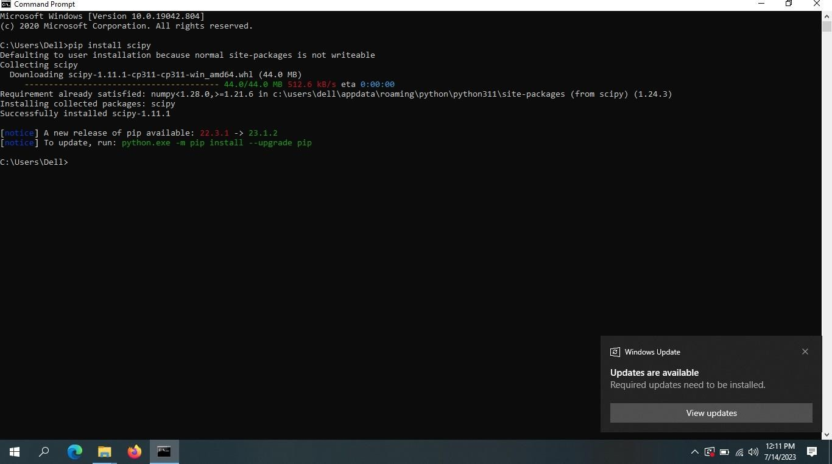

* + Installaling and collecting all the packages from Scipy module

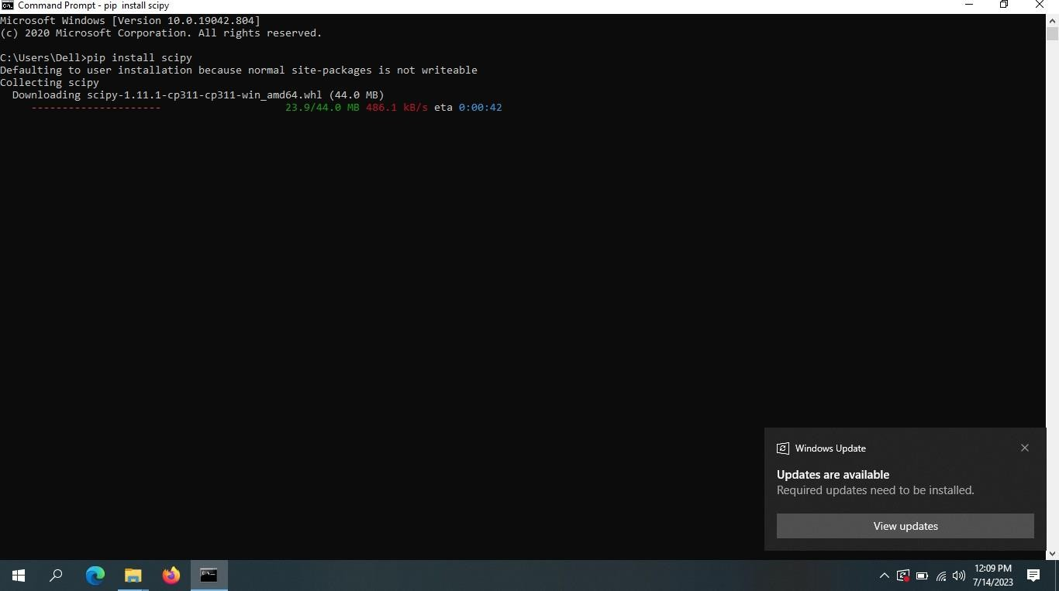

* + Verifying the Scipy module

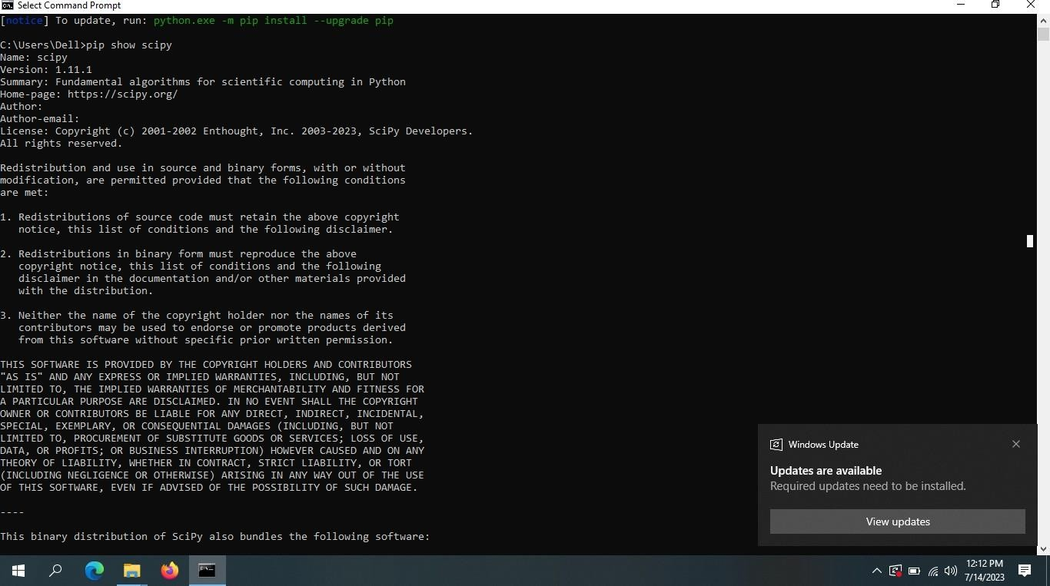

1. Installing jupyterlab

Install from pip using the command pip install jupyterlab

* + Go to command prompt type the command pip3 install jupyter

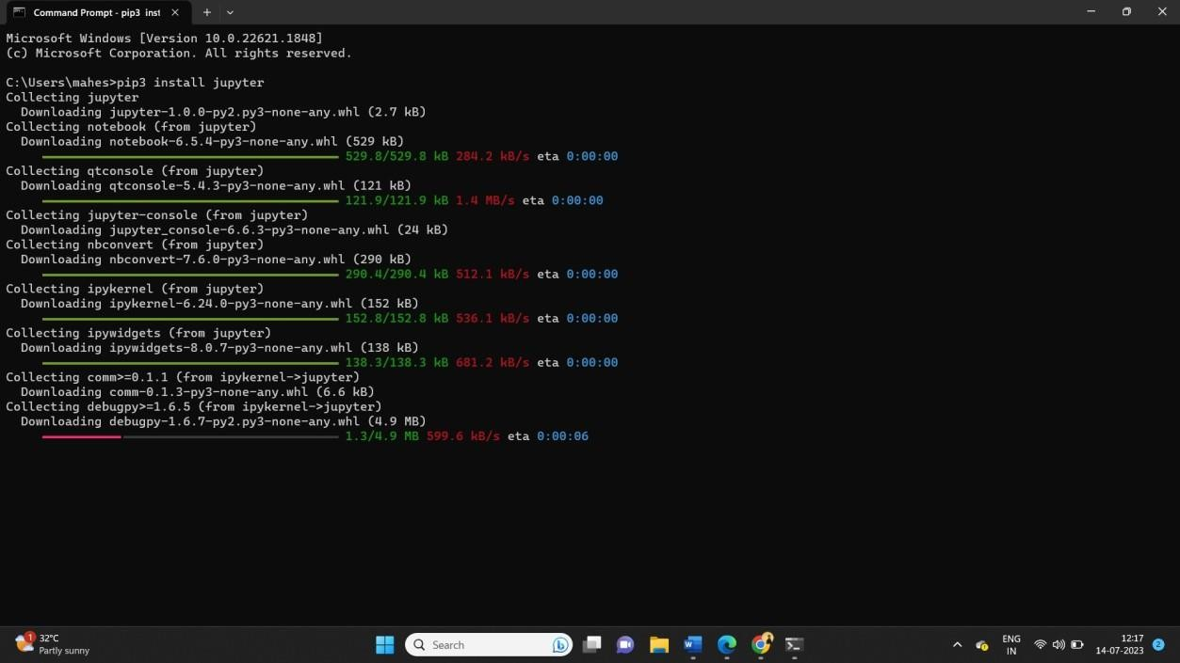

* + Installaling and collecting all the packages from jupyter module

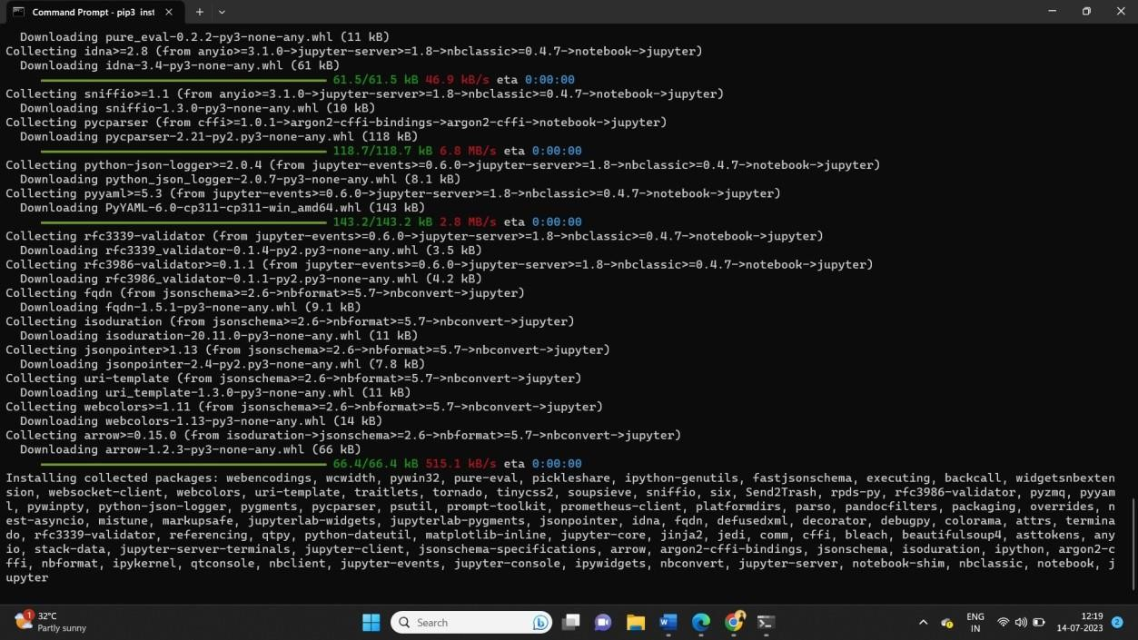

* + Verifying the jupyter module

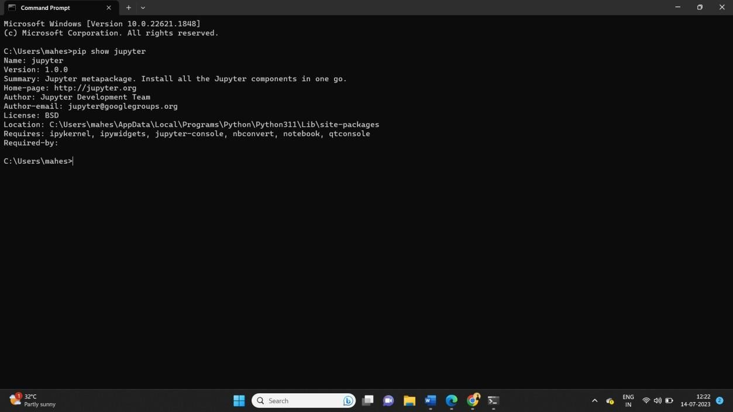

1. Introduction to python3
2. Printing your biodata on the screen Source Code:

#Read name, address, email ,and phoneno from keyboard name=input("enter a name:")

address=int("enter address:") email=int(input("enter email id:")) phoneno=int(input("enter phone no:")) #Print the details Print("Name:",name) Print("Addess:",Address) Print("emailid:",emailid) Print("phoneno:",phoneno)

Output:

enter a name:xxx enter address:5-8/a

enter email [id:xxx@gmail.com](mailto:xxx@gmail.com) enter phone no:123456978

Name:xxx Adrees:5-8/a

[Emailid:xxx@gmail.com](mailto:xxx@gmail.com) Phoneno: 123456978

1. Printing all the primes less than a given number

Source Code:

#printing all primes less than a given number def primenumber(MyNum):

n = 0

i = 2

for i in range(2,MyNum//2+1): if MyNum % i == 0:

n = n + 1 break

if n == 0:

print(MyNum, end=" ")

x = 50

print("Prime numbers less than", x, "are:") for i in range(2, x+1):

primenumber(i) output:

Prime numbers less than 50 are:

2 3 5 7 11 13 17 19 23 29 31 37 41 43 47

1. Finding all the factors of a number and show whether It is a perfect number,i.e., the sum of all its factors(excluding the number itself) is equal to the number itself

Source Code:

#finding all the factors of a number and show whether it is a perfect no i.e n=int(input("enter number"))

sum=0

for i in range(1,n): if n%i==0:

print(i) sum=sum+i

if sum==n:

print(n,"is a perfect number") else:

print(n,"is not a perfect number") output:

enter number6 1

2

3

6 is a perfect number

1. Defining and using Functions
2. Write a fuction to read data form a file and display it on the screen

Source Code: file=open("read.txt","w") file.write(“welcome to the students\n") file.write("python programing class\n") print("data written successfully") file.close()

file=open("read.txt","r") data= file.read() print(data)

file.close()

**OUTPUT:**

Welcome to students python programing class

1. Define a Boolean function is palindrome(<input>)

Source Code:

#define a boolean function is palindrome(<input>) s=input("enter string:")

def is_palindrome(s): return s==s[::-1] ans=is_palindrome(s)

if ans:

print("true") else:

print("false") output:

enter string:madam true

1. Write a function collatz(x) which does the following:if x is odd,x=3x+1;if x is even,then x=x/2.return the number of steps it takes for x=1

Source Code:

# Python 3 program to print # Collatz sequence

x=int(input("enter a number")) def printCollatz(x):

# We simply follow steps # while we do not reach 1 while x != 1:

print(x, end = ' ')

# If n is odd if x & 1:

x = 3 * x + 1

# If even else:

x = x // 2

# Print 1 at the end print(x)

# Driver code printCollatz(x) output:

enter a number6

6 3 10 5 16 8 4 2 1

1. write a fuctionN N(m.s)=exp(-(x-m)2/(2s2))/sqrt(2*3.14)s that computes the normal distribution

Source Code:

from math import * def nd(x , mean , sd):

nd=exp(-(x-mean)**2/(2*sd)**2)/sqrt(2*3.14)*sd print(nd)

nd(4,5,8)

output: 3.179901754297352

1. The package numpy
2. Creating a matrix of given order m*n containg random numbers in the range 1 to 99999

Source Code:

import numpy as np random_numbers=np.random.randint(1,99999,(3,3)) print(random_numbers)

output:

[[59976 20638 111]

[61438 38280 48902]

[75371 29374 88365]]

1. Write a program that adds,subtracts and multiplies two matrices.provide an interface such that,based on the prompt,the function(addition,subtraction,multiplication) should be performed

Source Code:

import numpy as np a=np.array([[2,3],[3,4]])

b=np.array([[4,5],[5,6]])

print("print elements of the first matrix") print(a)

print("print elements of the second matrix") print(b)

print("addition of two matrix") print(np.add(a,b)) print("subtraction of two matrix") print(np.subtract(a,b))

print("multiplication of two matrix") print(np.multiply(a,b))

output:

print elements of the first matrix [[2 3]

[3 4]]

print elements of the second matrix [[4 5]

[5 6]]

addition of two matrix [[ 6 8]

[ 8 10]]

subtraction of two matrix [[-2 -2]

[-2 -2]]

multiplication of two matrix [[ 8 15]

[15 24]]

1. Write a program to slove a system of n linear equations in n variables using matrix inverse

Source Code:

import numpy as np A=np.array([[4,3],[-5,9]])

B = np.array([20, 26])

X = np.linalg.inv(A).dot(B)

print(X)

output:

**[2. 4.]**

1. The package scipy and pyplot
2. Finding if two sets of data have the same mean value

Source Code:

import scipy arr1=scipy.mean([1,3,27]) arr2=scipy.mean([9,9,13]) print("Arithmethi mean is:",arr1) print("Arithmetic mean is:",arr2) output:

Arithmethi mean is: 10.333333333333334 Arithmetic mean is: 10.333333333333334

1. Plotting data read from a file

Source Code:

Output:

1. Fitting a function through a set a data points using polyfit function

Source Code:

import matplotlib.pyplot as mp import numpy as np

x = np.linspace( -10 , 10 , 5 ) y = 2*x + 5

coeff = np.polyfit(x,y,2)

xn = np.linspace(-20,20,100) yn = np.poly1d(coeff) mp.plot( xn,yn(xn),x,y,'o') output:

[<matplotlib.lines.Line2D at 0x1f859323ac0>,

<matplotlib.lines.Line2D at 0x1f859323b20>]

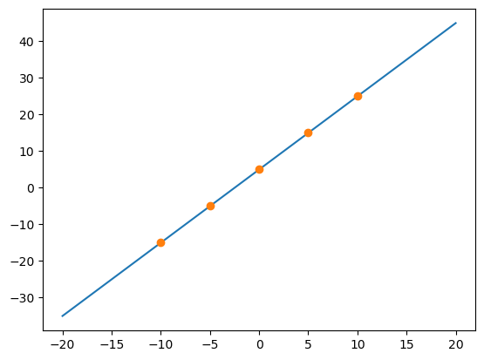

1. Plotting a histogram of a given data set

Source Code:

from matplotlib import pyplot as plt import numpy as np

# Creating dataset

a = np.array([22, 87, 5, 43, 56,

73, 55, 54, 11,

20, 51, 5, 79, 31,

27])

# Creating histogramfig,

ax = plt.subplots(figsize =(10, 7))

ax.hist(a, bins = [0, 25, 50, 75, 100]) # Show plot

plt.show()

output:

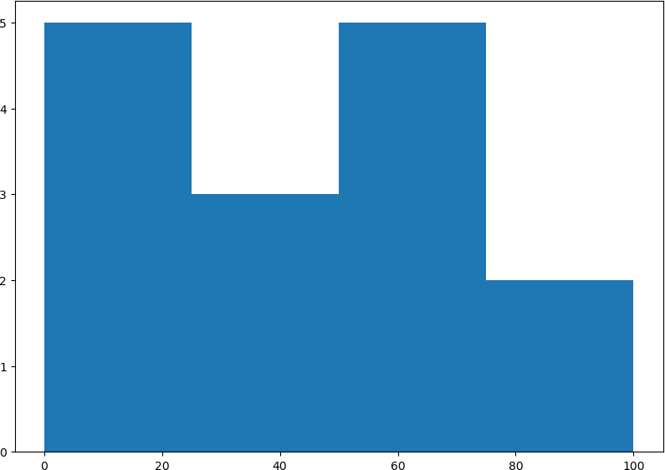

1. The strings package

a) Read text from a file and print the number of lines, words and characters source code:

file=open("read.txt","r") number_of_lines=0 number_of_words=0 number_of_characters=0 for line in file:

line=line.strip("\n") words=line.split() number_of_lines+=1 number_of_words+=len(words) number_of_characters+=len(line)

file.close() print("lines:",number_of_lines,"words:",number_of_words,"characters:",number_of_characters)

**output:**

lines: 2 words: 7 characters: 46