# **KPMG Virtual Internship**

## **Module-3**

**Findings:**

* From the analysis, it is evident that, while the maximum number of lost customers are from NSW, at the same time, most potential customer is also from NSW (Dashboard- Customer by state).
* Maximum profit was from lost customer. So, it is important for the business to find a strategy to get the lost customer back. Furthermore, recent and potential customers are bringing most profit (apart from lost customer). Business must focus on these customer group to increase profitability (Dashboard- Profit by customer and month).
* Platinum and recent customers are bringing most profit for the business (Dashboard- Profit and Wealth Distribution).

**Recommendation:**

* Business should focus more on the customer from NSW.
* Same time business needs to find strategy (increase marketing, introduce loyalty program etc) to increase market share in VIC and QLD.
* Find the reasons behind losing customer and strategy to get them back.

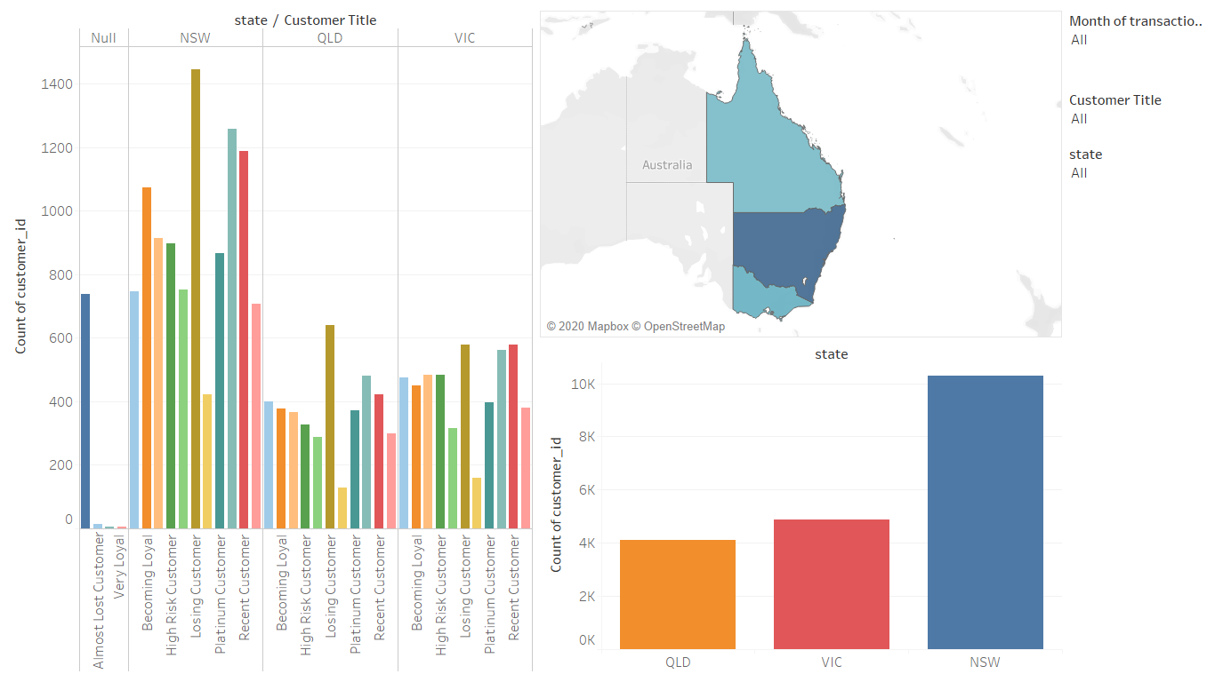**Dashboard:**

Figure 1: Dashboard-1: Customer by state

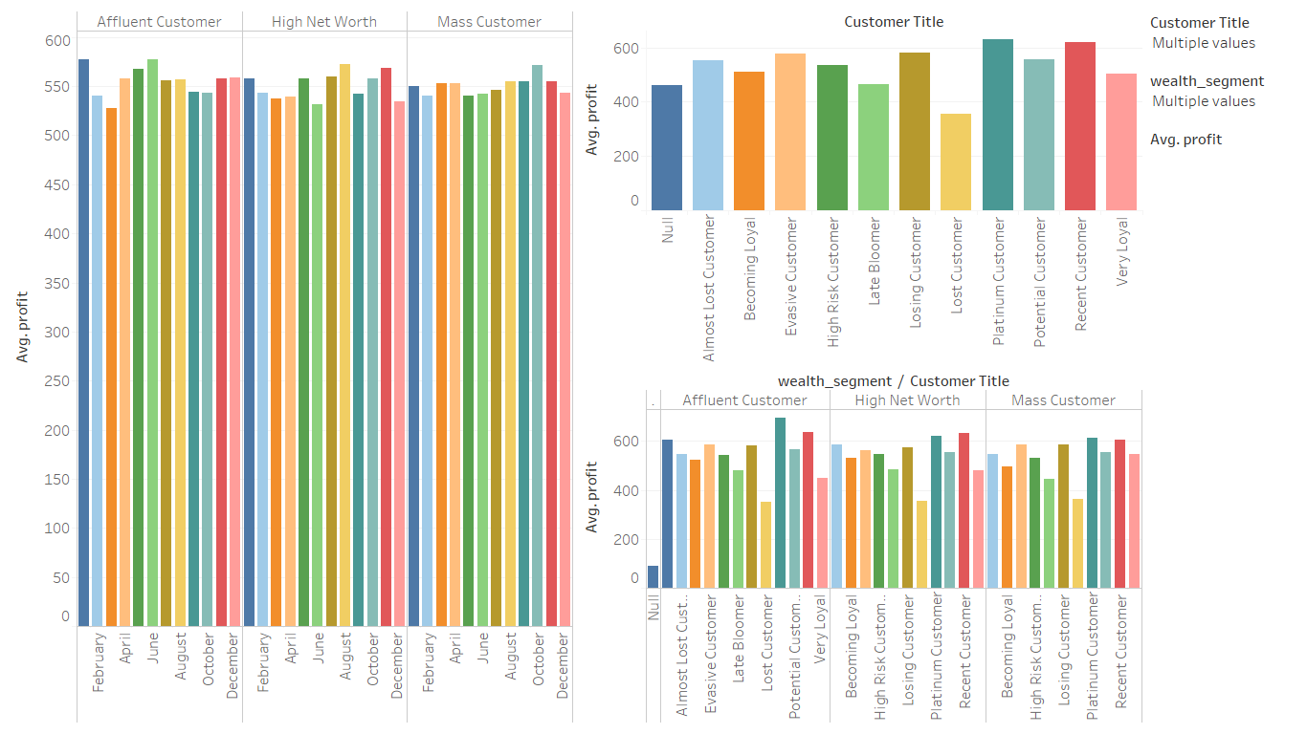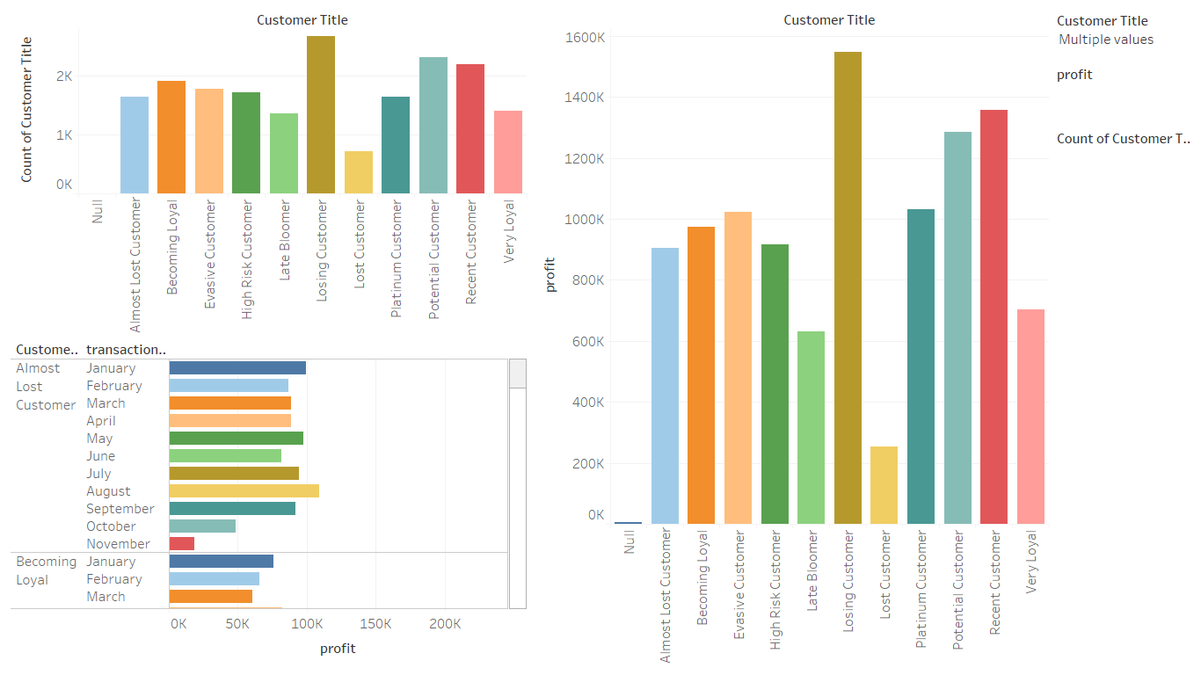Figure 2: Dashboard-2: Profit by customer and month

Figure 3:Dashboard-3: Profit and Wealth Distribution

Attachment: Tableu file 