LAB CYCLE 5

EXPERIMENT 1

AIM:Write a program to determine whether a given year is a leap year [ Use Calendar
Module]

SOURCE CODE

import calendar
def check_leap_year(year):
if calendar.isleap(year):
return f"{year} is a leap year."
else:
return f"{year} is not a leap year."
year = int(input("Enter a year: "))
result = check_leap_year(year)
print(result)

OUTPUT

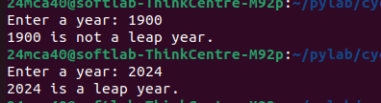

EXPERIMENT 2

AIM:Write a python script to display
a) Current date and time
b) Current Year
c) Month of the year
d) Week number of the year
e) Weekday of the week
f) Day of year
g) Day of the month
h) Day of week [ Use time and datetime Module]

SOURCE CODE
import time
import datetime

current_datetime = datetime.datetime.now()
print(f"Current date and time: {current_datetime}")

current_year = current_datetime.year
print(f"Current Year: {current_year}")

current_month = current_datetime.month
print(f"Month of the Year: {current_month}")

week_number = current_datetime.isocalendar()[1]
print(f"Week number of the Year: {week_number}")

weekday = current_datetime.weekday()
weekdays = ['Monday', 'Tuesday', 'Wednesday', 'Thursday', 'Friday', 'Saturday', 'Sunday']
print(f"Weekday of the Week: {weekdays[weekday]}")

day_of_year = current_datetime.timetuple().tm_yday
print(f"Day of the Year: {day_of_year}")

day_of_month = current_datetime.day
print(f"Day of the Month: {day_of_month}")

day_of_week = current_datetime.strftime('%A')
print(f"Day of the Week: {day_of_week}")

OUTPUT

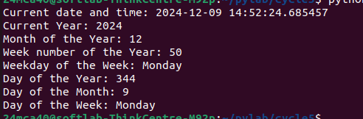

EXPERIMENT 3

AIM:Write a python program to print yesterday, today and tomorrow

SOURCE CODE
from datetime import date,timedelta
today=date.today()
yesterday=today - timedelta(days=1)
tomorrow=today + timedelta(days=1)
print(f"today={today}")
print(f"tomorrow={tomorrow}")
print(f"yesterday={yesterday}")

OUTPUT

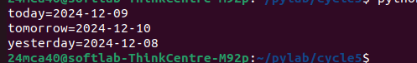

EXPERIMENT 4

AIM:Write a function in file palindrome.py to check whether a string is Palindrome or not.
Import the module to find the longest palindromic substring in a given string by
checking every possible substring and verifying if it is a palindrome

SOURCE CODE
palindrome.py
def ispalindrome(a):
b=a[::-1]
c=True
d=False
if b==a:
return c
else:
return d

def lp_sub(s):
longest = ""
for i in range(len(s)):
for j in range(i + 1, len(s) + 1):
substring = s[i:j]
if ispalindrome(substring) and len(substring) > len(longest):
longest = substring
return longest

p4.py
import palindrome

str=input("Enter a string : ")
con=palindrome.ispalindrome(str)
if(con==True):
print(f"{str} is Palindrome")
else:
print(f"{str} is not palindrome")
longest_sub=palindrome.lp_sub(str)
if longest_sub=="":
print("There is no paindromic substring")
else:
print(f"Longest palindromic substring is {longest_sub}")

OUTPUT
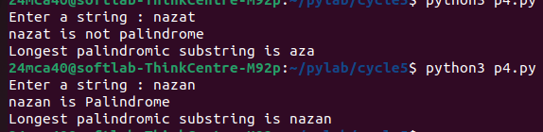

EXPERIMENT 5

AIM:Create a package graphics with modules rectangle, circle and sub-package 3D-graphics
with modules cuboid and sphere. Include methods to find area and perimeter of
respective figures in each module. Write programs that find the area and perimeter of
figures by different importing statements. (Include selective import of modules and
import * statements)

SOURCE CODE

graphics

circle.py
def circle(r):
area=3.14*r*r
print(f"Area of circle = {area}")
perimeter=2*3.14*r
print(f"Perimeter of circle = {perimeter}")
rectangle.py

def rectangle(a,b):
area=a*b
print(f"Area of rectangle = {area}")
perimeter=2*a+b
print(f"Perimeter of rectangle = {perimeter}")

three_d_graphics

cuboid.py

def cuboid(l,b,h):
volume = l*b*h
print(f"Volume of cuboid = {volume}")

sphere.py

def sphere(r):
volume = (4/3) * 3.14 * r * r * r
print(f"Volume of sphere = {volume}")

pg5.py

from graphics import rectangle
from graphics import circle

from graphics.three_d_graphics import cuboid
from graphics.three_d_graphics import sphere

l=int(input("Enter length of rectangle : "))
b=int(input("Enter breadth of rectangle : "))

rectangle.rectangle(l,b)
print()

r=int(input("Enter radius of circle : "))

circle.circle(r)
print()

l=int(input("Enter length of cuboid : "))
b=int(input("Enter breadth of cuboid : "))
h=int(input("Enter height of rectangle : "))

cuboid.cuboid(l,b,h)
print()

l=int(input("Enter radius of sphere : "))
sphere.sphere(r)

OUTPUT
