AI-Assisted Clinical Evaluation System
for Maritime Nursing
Artificial Intelligence Application Elective
Mohammad Abd Al Rahem and Ahmed Asfour
GitHub repository: <insert repository link after upload>
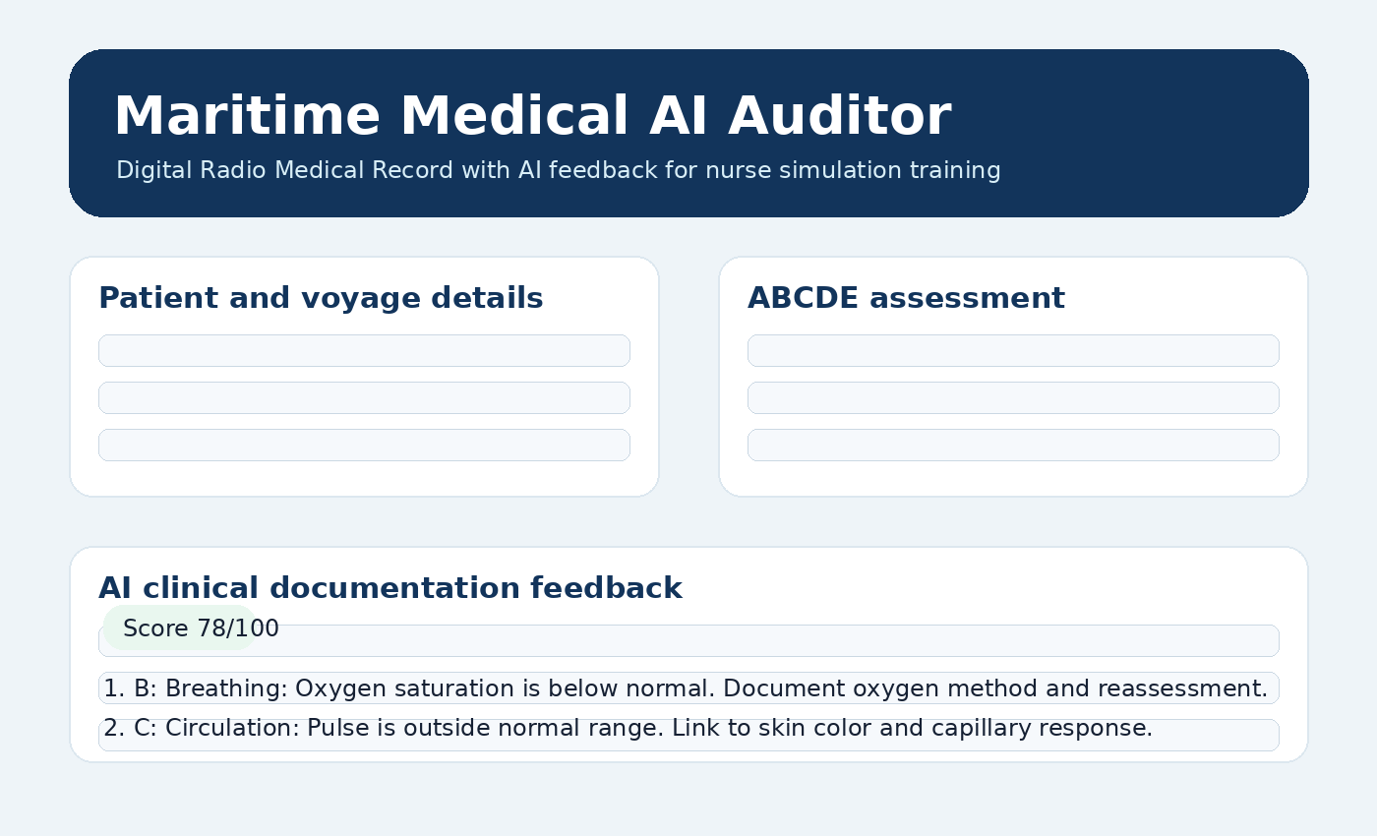

Table of contents
- 1. Introduction and problem statement
- 2. System design and requirements
- 3. Model choice and prompting
- 4. LangChain, RAG, MCP and memory
- 5. API documentation
- 6. Testing with Promptfoo and unit tests
- 7. Guardrails, HITL and limitations
- 8. Conclusion

1. Introduction and problem statement
This project is an offline-first training application for maritime nursing simulation. It digitizes the Danish Maritime Authority Radio Medical Record and adds an AI-assisted review layer that checks whether clinical documentation is complete, internally consistent, and ready to communicate to Radio Medical. The aim is not to replace a nurse or a physician. The aim is to give students a realistic tool that makes documentation gaps visible during training.
The problem is that paper-based or template-based feedback can be too generic. A nurse may enter a low oxygen saturation, delayed capillary response, or an abnormal pupil reaction, but the training response may not explain exactly what is missing in the report. Our project therefore turns the RMR into a React application and uses a FastAPI backend with a local Ollama LLM, LangChain orchestration, RAG context, and deterministic clinical validation rules.

2. System design and requirements
The system follows the exam requirements closely. React is used for the frontend. Python and FastAPI provide the REST API. Ollama hosts the LLM locally so the system can be used in offline maritime training environments. LangChain is used as the orchestration layer for prompt construction, model calls, tool use, and RAG. The backend exposes /api/review for AI review and /api/history for training history.
Requirement | Implementation | Reason
React frontend | Multi-section Radio Medical Record form | Gives nurses a clean digital version of the paper workflow
FastAPI backend | REST endpoints for review and history | Separates UI from AI orchestration
Ollama LLM | llama3.1:8b by default | Runs locally and supports offline use
LangChain | Prompt and model orchestration plan | Keeps prompt, tools and retrieval structured
MCP | Context service with vital range and oxygen guidance tools | Lets the agent request domain context
Promptfoo | Automated prompt assertions | Checks consistency and avoids unsafe outputs
Unit tests | Pytest tests for rules and API | Protects core logic from regression

3. Model choice and prompting
We chose a standard Ollama model instead of a custom model for the first version. The reason is that the task is mainly structured review and feedback generation, not domain model training. A standard local model can perform well when it is controlled by system prompting, deterministic rules, and retrieved reference material. A custom model would add complexity and would need careful validation before it could be trusted in a health-related training scenario.
The system prompt defines the model as a clinical documentation auditor for maritime nursing simulation. It explicitly says that the model must not diagnose. It asks the model to use ABCDE structure, point out missing documentation, and keep feedback professional. The backend also calculates rule findings before the model response, so the LLM is guided by concrete issues instead of being asked to invent issues freely.

4. LangChain, RAG, MCP and memory
The LangChain layer is designed around three inputs: the submitted RMR data, rule-based findings, and retrieved context from the clinical knowledge base. The RAG source contains the normal ranges and documentation expectations used in the Radio Medical Record, such as breathing frequency 12-16/min, oxygen saturation 95-100%, pulse 60-80/min, blood pressure 120-140/60-90, and capillary response below 2 seconds.
The MCP server exposes two tools: one for normal vital ranges and one for oxygen delivery guidance. For example, if oxygen is recorded above 10 l/min, the MCP tool can return guidance that Hudson mask should be used unless another method is clinically justified. Memory is implemented as a review history store. In a full deployment this can be connected to MongoDB so instructors can track simulation attempts over time.

5. API documentation
Method | Path | Purpose | Main data
GET | /health | Backend health check | status
POST | /api/review | Review one Radio Medical Record | patient, assessment, observations
GET | /api/history | List recent simulation reviews | created_at, patient_name, score, finding_count
The review response returns a numeric score, a short summary, structured findings, generated feedback, and retrieved RAG context. The frontend displays this as a training feedback panel.

6. Testing with Promptfoo and unit tests
Promptfoo is used to test prompt behaviour. The included tests check whether the model flags low oxygen saturation, recognizes the mismatch between 12 l/min oxygen and nasal cannula, and avoids diagnostic language. These tests are useful because they test the quality of the generated feedback, not only whether the code runs.
Unit tests are written for the clinical rules and FastAPI endpoints. The most important tests cover low oxygen saturation, oxygen delivery method mismatch, backend health, and the review endpoint. These tests are intentionally focused on the core components because the exam assessment should see that the safety-critical logic is covered.

7. Guardrails, HITL and limitations
The main guardrail is separation between deterministic clinical checks and LLM wording. Rules detect the high-risk documentation issues first, while the LLM turns those findings into readable feedback. The system prompt prevents diagnosis and frames the application as a training tool. Promptfoo adds another guardrail by checking that generated advice stays within the expected behaviour.
A human-in-the-loop is still required. The application should be used by nurses and instructors during simulation training, and not as a real clinical decision-maker. The instructor can decide whether the feedback is correct, whether a missing field was acceptable in the scenario, and how the student should improve the next attempt.

8. Conclusion
The project delivers a realistic AI application that meets the course requirements and is grounded in a concrete maritime nursing workflow. It includes a React RMR interface, a FastAPI backend, Ollama-based LLM design, LangChain orchestration, RAG, MCP, memory, Promptfoo tests, and unit tests. The most important value of the system is that it gives specific, structured feedback on clinical documentation instead of generic template responses.

Appendix A: Setup commands
Backend: cd backend; python -m venv .venv; source .venv/bin/activate; pip install -r requirements.txt; uvicorn app.main:app --reload --port 8000
Frontend: cd frontend; npm install; npm run dev
Promptfoo: cd promptfoo; promptfoo eval
Tests: cd backend; pytest

