RITOS — Horizontal Architecture: How a Refund Flows
Oct 14, 2026 · @KMI

What RITOS does
RITOS decides what should happen to every refund request an online store receives, in seconds, and never lets one person both decide and pay. It sits between the store (ShopFlow) and the store's support and finance teams.
- The problem: refund desks are flooded with claims. Each one needs checks across payments, delivery, photos, return rules and fraud history. Done by hand this is slow, inconsistent, and easy to abuse with duplicate or false claims.
- What RITOS does instead: nine automatic checks run on every claim. RITOS then settles the clear cases itself (pays the genuine ones, rejects the ineligible ones) and sends only the unclear ones to a person, with the evidence and reasons already gathered.
- The promise: no claim is paid without a verified payment behind it, uncertainty always goes to a person rather than an automatic "no", and money only moves after the right people have approved it.

The journey of a refund
A claim reaches a desk within seconds of being raised; a person is involved only when something is unclear or the amount is large.
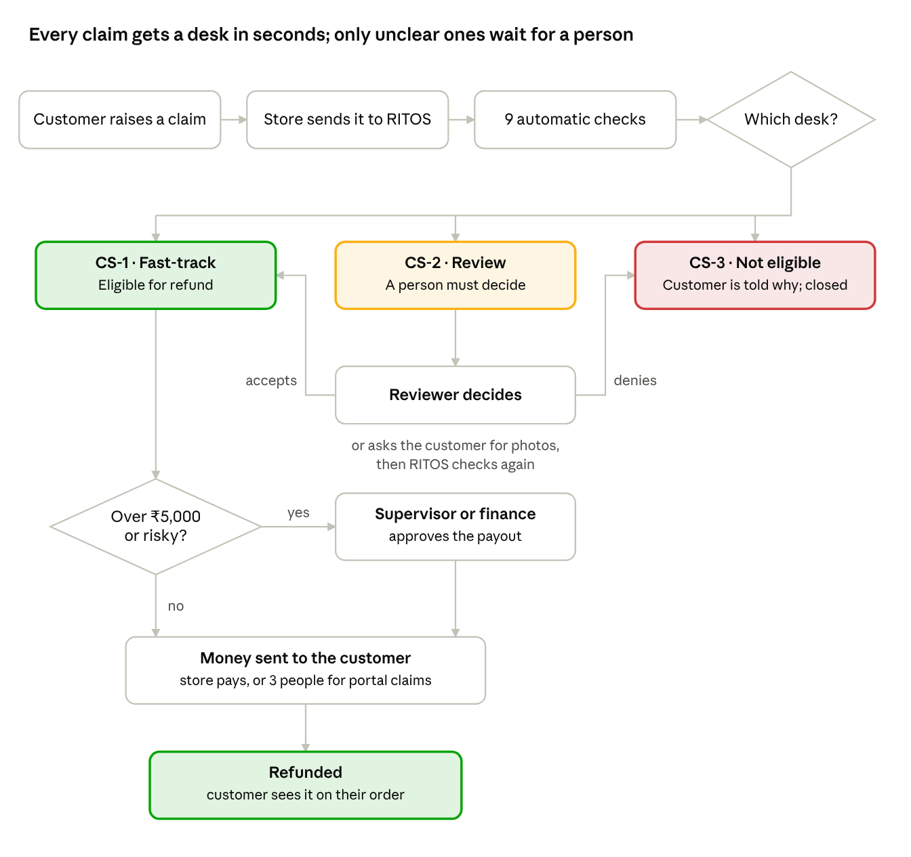
refund journey · claim to refunded
Follow the arrows top to bottom: genuine small claims go straight from CS-1 to payment, unclear ones pass through a reviewer first, and big or risky ones need a supervisor or finance to say yes.

The nine automatic checks
Every claim passes through nine specialist checks, always in this order, each adding what it found. Only check 6 decides where the claim goes; the others gather facts.
- Payment check (Agent 1) — Did this customer really pay, how much, and is there money left to refund? Is this a repeat of an earlier claim?
- Delivery check (Agent 5) — Was the parcel delivered, and is there proof?
- Claim reading (Agent 3) — What is the customer actually saying (damaged, never arrived, changed mind)? Does it contradict the delivery record? AI helps read messy wording here.
- Photo check (Agent 7) — If photos are needed, do they show the right product and the claimed damage?
- Return-rule check (Agent 2) — Is the claim within the return window for this kind of product? Is it a final-sale item?
- Risk check (Agent 4) — Is the amount large, or does the customer claim unusually often?
- Decision (Agent 6) — Uses fixed rules, in a fixed order, to pick the desk: CS-1, CS-2 or CS-3.
- Reviewer assignment (Agent 9) — If a person is needed, picks who, sets a deadline, and (with AI) writes them a short briefing.
- Customer message (Agent 8) — Writes the update the customer sees. AI may polish the wording but cannot add amounts, dates or promises.

The three desks
Every claim lands on exactly one desk, and the desk tells you what happens next.
Desk | Shown as | What lands here | What happens next
CS-1 · Fast-track | Eligible for refund | Payment verified, within the return window, photos fine if needed, low risk | Under ₹5,000: paid automatically (store) or with one click. Above the limit or risky: waits for a supervisor or finance to approve the payout
CS-2 · Review | Needs review | Anything a person must look at: missing or unclear photos, claim contradicts delivery, payment disputes, payment mismatches, non-delivery not yet confirmed | A reviewer decides: accept (moves to CS-1), ask the customer for evidence, or deny (moves to CS-3)
CS-3 · Not eligible | Not eligible | A fixed rule fails: duplicate claim, already refunded, return window expired, final-sale item | The customer is told why. Nothing is paid
RITOS never rejects a claim just because something looks suspicious. Suspicion sends the claim to CS-2, where a person decides.

Who does what
Think of a shop's refund counter: front-desk staff sort the claims, a team lead says yes to the big ones, an accountant checks the payout, a cashier pays. No single person can both decide and pay.
Role | Everyday equivalent | What they do in RITOS | Demo account
Customer | The shopper | Raises the claim, uploads photos if asked, follows the status | aarav@example.com (store), customer@ritos.local (portal)
CS-1 agent | Front desk, easy cases | Pays small, low-risk eligible claims with one click | cs1@ritos.local
CS-2 agent | Front desk, hard cases | Reviews unclear claims: accepts, asks for evidence, or denies | cs2@ritos.local
CS-3 agent | Front desk, rejections | Sends the customer the reason a claim is not eligible | cs3@ritos.local
Supervisor | Team lead | Approves payouts RITOS flagged as big or risky | lead@ritos.local
Finance | Accountant | Authorizes payouts, approves colleagues' payouts, can send money and check unclear payments | finance@ritos.local
Refund operations | Cashier | Sends the money once a payout is approved | refunds@ritos.local
Administrator | Store manager | Can step into any role and manages the system, still never two steps on the same refund | admin@ritos.local
Auditor | Inspector | Reads every record and can confirm unclear payments | audit@ritos.local
When RITOS changes a ticket on its own, the history shows RITOS (automatic), not a person. When a ticket moves from a CS-2 agent to a supervisor, that is RITOS assigning the next step to the right role, not someone taking it over.

How the money actually moves
Who sends the money depends on where the claim came from: the store pays its own refunds after one approval, while refunds RITOS pays itself need three different people.
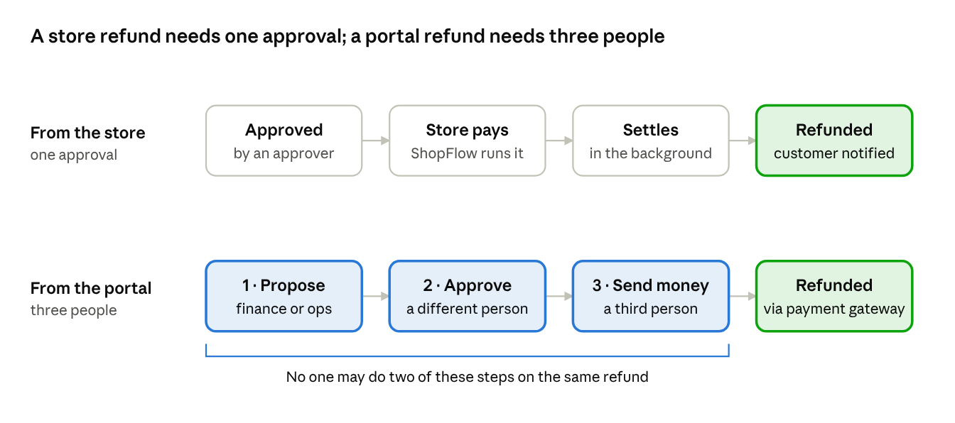
how the money moves · store vs portal
- Store claims (ShopFlow): once a claim is approved (automatically for small genuine claims, or by a supervisor or finance for big or risky ones), RITOS tells the store, the store pays, and the refund settles within seconds. The customer sees "Refunded" on their order.
- Portal claims (RITOS customer portal): finance or refund operations proposes the payout, a different finance approver or administrator approves it, and a third person sends the money through the payment gateway. Each step appears in the Finance Approvals queue, and the screen tells everyone else who must act next.
- A ticket "in review" (CS-2) follows the same road once the reviewer accepts it: it moves to CS-1 and waits for payout approval.

Safety rules and where AI helps
The AI advises; fixed rules decide routing and money.
- AI reads, rules decide. AI (Groq, with Google Gemini as backup) helps read messy claim text, writes a briefing for reviewers, and polishes customer messages. It can make a claim's checks stricter, never looser, and it never approves or pays.
- If the AI is down, nothing breaks. RITOS falls back to its rules automatically.
- Personal details stay private. Names, emails, phone and card numbers are removed before any text goes to an AI provider.
- Uncertain means a person, not a "no". A blurry photo or an unconfirmed delivery goes to CS-2.
- Three people for portal payouts. The person who proposes a payout cannot approve it, and neither can send the money.
- No double refunds. RITOS tracks what is left to refund on each payment and blocks claims that exceed it.
- Everything is recorded. Every check, decision and person is kept in the ticket history and audit log.

Words you will see on screen
On screen | Means
Eligible for refund | RITOS found the claim genuine (CS-1)
Needs review | A person must look at it (CS-2)
Not eligible | A fixed rule rejected it (CS-3)
Waiting for customer evidence | The customer has been asked for photos
With a reviewer | A CS-2 agent must decide
Waiting for payout approval | A supervisor or finance must say yes
Waiting for a second approver | A payout was proposed; a different person must approve it
Approved, ready to pay | Approved; refund operations can send the money
Payment outcome unclear | The payment provider did not confirm; finance must check
Refunded | The money has gone back to the customer
RITOS (automatic) | A step RITOS did on its own, not a person

