Proposed Architecture

Use Cases Diagram (Actors/ Use Cases)
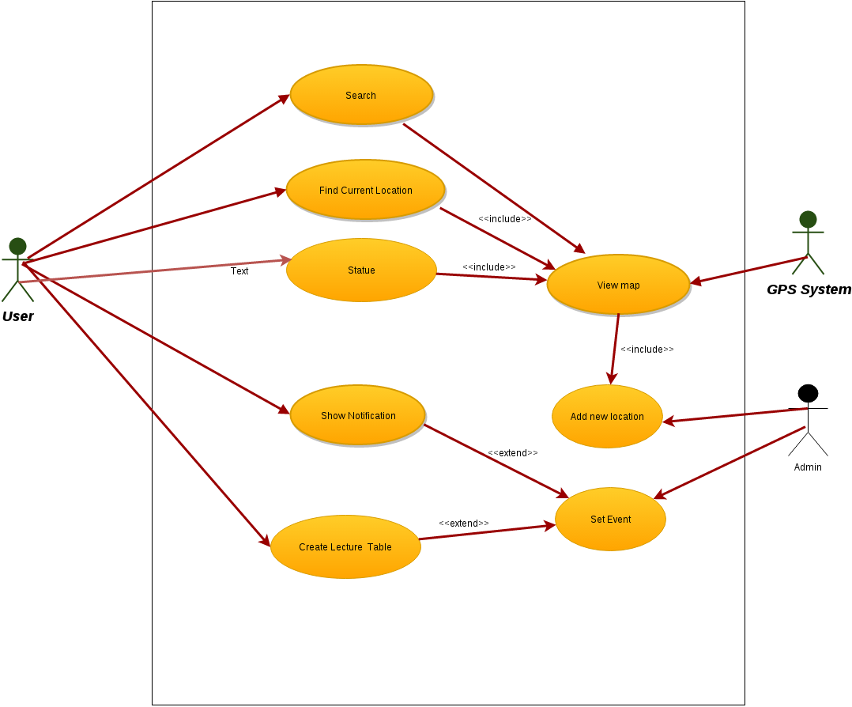
User can search for any place inside the university campus.
User can find his current location.
User can ask for the remaining distance till his destination.
Admin can set Events
Admin can add new location to the database.

My system will consist of one service providers. Which is Google APIs. Next Figs shows how the services interact with the clients. Below is a description of each entity in the system:
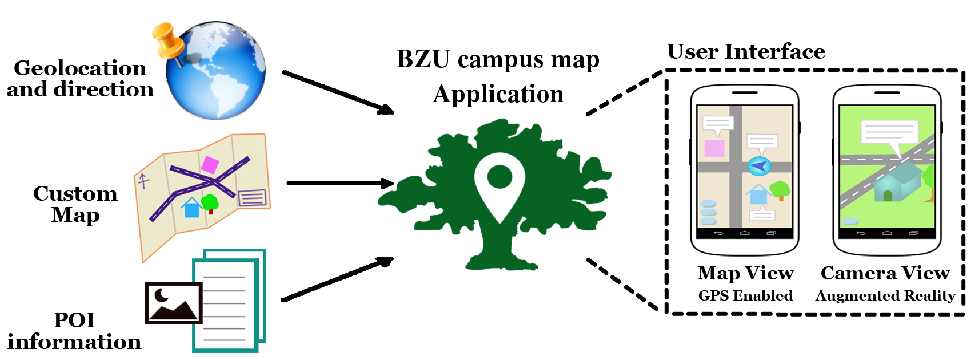

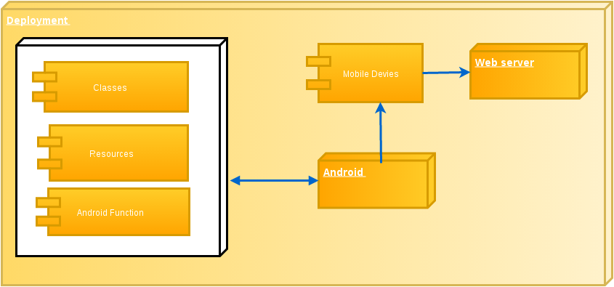

Client
My client will be a Mobile application (which runs Android OS) that invokes service operations.

Enabling Technologies

Client
we are going to create the App using Android studio v2.0, event handlers will be created using Java.

Service provider
implementation style will be RESTful.
data layer SQLite™ DBMS.

