
Faculty of Engineering & Technology
Electrical & Computer Engineering Department
COMPUTER VISION– ENCS5343
Assignment2 Report
Prepared by:
Name: Mohammad Abu Shams ID: 1200549
Name: Joud Hijaz ID: 1200342

Instructor: Dr. Aziz Qaroush
Teaching Assistant: Eng. Ahmad Abbas

Section: 2

Date: 23-12-2024

BIRZEIT

Introduction and Objective
Handwritten text was found to be hard to recognize in computer vision, especially for Arabic. Arabic handwriting was seen to change a lot because it is cursive, and letters were shown to look different in different places. Machines were thought to help by making digital files easier to use and saving old papers.
This assignment was made to study how good SIFT and ORB methods were for Arabic handwriting. These methods were used because they were strong and could handle changes in size, angle, and light. This was very important for Arabic writing, which was found to look very different in many cases. These methods were added to a Visual Bag of Words (VBoW) system.
The assignment goals were:
- SIFT and ORB were used to find important features in Arabic handwriting images.
- A visual dictionary was made with k-means clustering to turn the features into a simple format for machines.
- These methods were tested using a machine learning model like XGBoost. Accuracy, speed, and how well they handled handwriting changes were checked.
The assignment wanted to find which method was better for Arabic text. It was hoped this would help machine learning get better for reading documents and improve pattern recognition.

Background
Reading handwritten text was found to be very hard in computer vision, especially for scripts like Arabic. Arabic writing was seen to change a lot because of its context, making it more difficult. Strong methods like SIFT and ORB were used to help solve this problem.
Scale-Invariant Feature Transform (SIFT) was found to be very good at finding key parts in images that stayed the same even if the size or angle changed. This was very helpful for Arabic handwriting, where letters were written in very different ways by each person.
Oriented FAST and Rotated BRIEF (ORB) was used as a faster option. It was found to be great for real-time work because the FAST and BRIEF methods were improved. ORB was also shown to handle noise better, which was helpful for unclear images.
The Visual Bag of Words (VBoW) model was used with these methods to make the image data easier to study. Features were grouped into "visual words," and a histogram was made to show how many times each word appeared. This process helped machines understand and classify the images.
By using SIFT and ORB together with VBoW, the system was tested to see how good these methods were for reading Arabic handwritten text. First tests showed different levels of success, with some problems when size or rotation changed a lot. This assignment was hoped to make handwriting recognition better by combining strong feature extraction with machine learning to handle the many differences in how people wrote.
Methodology
- Dataset Preparation and Preprocessing
- Dataset Overview: The dataset used in this assignment, isolated_words_per_user, had 8,144 images of Arabic handwritten text. These images were taken from 82 different user, so each image shows a word written in a different style. Because of this, there were many changes in how the letters looked and how people wrote, which made the dataset good for testing feature extraction methods like SIFT and ORB. The structure of the dataset helped to test how well these methods work with real-world handwriting.
- Preprocessing Steps: To make the analysis easier, all images were changed to grayscale. This made the data simpler while keeping the important features needed to recognize the text. Then, every image was resized to 256x256 pixels to make it fit well with the feature extraction methods and to reduce the work needed by the computer. These steps were important for keeping the quality of the images and making sure the features could be extracted in the right way.
- Feature Extraction
- Scale-Invariant Feature Transform (SIFT): SIFT was used to find and describe important points in the images. These points stayed the same even if the image size or rotation changed. This method was chosen because Arabic handwriting has many different styles.
- Oriented FAST and Rotated BRIEF (ORB): ORB was used by us as another way instead of SIFT. It worked well with noisy images and was good for real-time tasks. But in my result, SIFT was faster than ORB, making it a better choice for this scenario. ORB was still used to find and describe more features, but these features were not as exact as the ones found by SIFT.
- Descriptor Matching
- Matching Process: After features were extracted with SIFT and ORB, the descriptors were matched to find similar points between different images. This step was very important to find relationships between features.
- Technique Used: SIFT descriptors were matched by us using the BFMatcher with L2 norm, and ORB descriptors were matched using the BFMatcher with Hamming distance. These methods were chosen to make matching accurate and fast by using the strength of SIFT’s floating-point descriptors and ORB’s binary descriptors.
- Visual Bag of Words (VBoW) Representation
- Clustering Descriptors: K-means clustering was used to group the descriptors into clusters, called "visual words." Cluster sizes from 50 to 500 were tested to find the best size for good detail and fast processing.
- Generating Histograms: For each image, a histogram was made to show how many times each visual word appeared. These histograms were used as features for the next step, classification.
- Classification Using XGBoost
The histograms were used to train the XGBoost classifier. XGBoost is a machine learning model that works with gradient boosting. Parameters like learning rate, max depth, and estimators were tuned using RandomizedSearchCV to make the model work better.
- Robustness Evaluation
- Transformations Tested: The system was tested by changing the images, like scaling, rotation, brightness changes, and adding noise, to check how strong the system was.
- Parameter Tuning Efforts:
  - K-means Clustering: The best number of clusters was chosen to make sure the features were detailed but not too slow to process.
  - XGBoost Tuning: Parameters were tuned a lot to make the classifier work well with the many differences in Arabic handwriting.
Results, Analysis, Visualization, and Comparison
The comparison below between SIFT and ORB showed important differences in performance, strength, and speed. SIFT took 510.8 seconds to process, which was a little faster than ORB, which took 580.68 seconds. SIFT found fewer key points, but they were better quality (83.32 per image), while ORB found more key points (313.84). SIFT was better in accuracy for all changes, with an average accuracy of 41.81%, while ORB had 31.19%. SIFT worked better under scaling (50.56% accuracy) and rotation (63.15% accuracy), but ORB had problems, especially with scaling (18.84% accuracy) and noise (24.60% accuracy). Even though ORB found more matches in all cases, its key points were less reliable, so the precision was lower. These results showed that SIFT is better for tasks that need more accuracy, like recognizing Arabic handwritten text. ORB's faster speed and more key points could be used for real-time applications with more improvements.
Table 1: Performance Metrics Comparison of SIFT and ORB
Metrics | SIFT | ORB
Time Efficiency | 510.8 Seconds | 580.68 Seconds
Average Key points | 83.32 | 313.84
Robustness and Accuracy | Scaling:  Matches: 41.25  Accuracy: 50.56%  Rotation:  Matches: 54.34  Accuracy: 63.15%  Illumination:  Matches: 21.31  Accuracy: 23.18%  Noise:  Matches: 26.62  Accuracy: 30.36% | Scaling:  Matches: 58.68  Accuracy: 18.84%  Rotation:  Matches: 198.58  Accuracy: 58.31%  Illumination:  Matches: 74.97  Accuracy: 23.03%  Noise:  Matches: 155.75  Accuracy: 24.60%
Average Accuracy for Variations | 41.81% | 31.19%

The two histograms below show the BoVW (Bag of Visual Words) feature distributions for ORB and SIFT applied to the same image. The x-axis shows the visual word indices, and the y-axis shows how many times each visual word appears in the image. The histogram for ORB (on the left) shows a denser and more varied distribution of visual words, which is because ORB detected more key points. The SIFT histogram (on the right) shows a more balanced and selective distribution, which means SIFT detected fewer but better-quality key points. Even though ORB found more features, many of them were not useful or repeated, which made the representation less precise. SIFT, with its focused and clear feature extraction, created a more stable and understandable histogram, which helped it have better classification accuracy in this assignment. This comparison showed the trade-off between the quantity and quality of key points detected by the two methods.
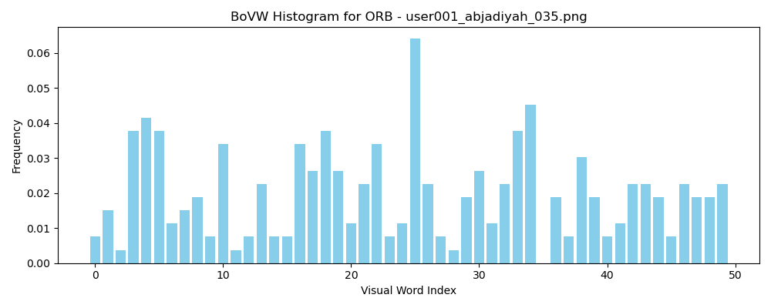
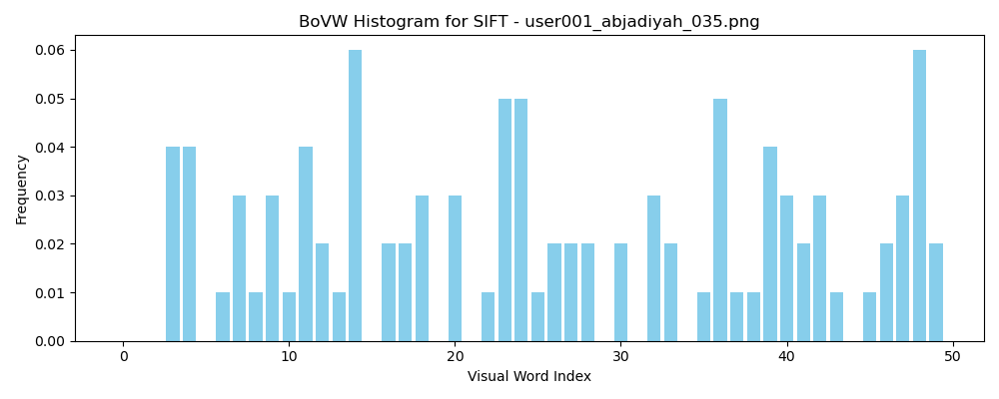

Figure 1: BoVW Histograms Comparison for ORB and SIFT

The two histograms below show the average BoVW (Bag of Visual Words) histograms per class for ORB and SIFT. The ORB histogram shows a very dense and scattered distribution of visual words across all indices. This means ORB found a lot of key points and descriptors. It shows that ORB can take out a lot of different features, but also means there is some repetition and less ability to separate the classes, as the visual words are spread out less clearly among them. On the other hand, the SIFT histogram shows a more organized and focused distribution, with clear peaks and less overall change. This means SIFT found fewer but better-quality features that represent the classes better, making them easier to tell apart. Even though ORB found more features, SIFT’s clearer representation helped it to have better classification accuracy by better showing the important differences between classes. This comparison shows the trade-off between the number of features in ORB and the quality of features in SIFT.
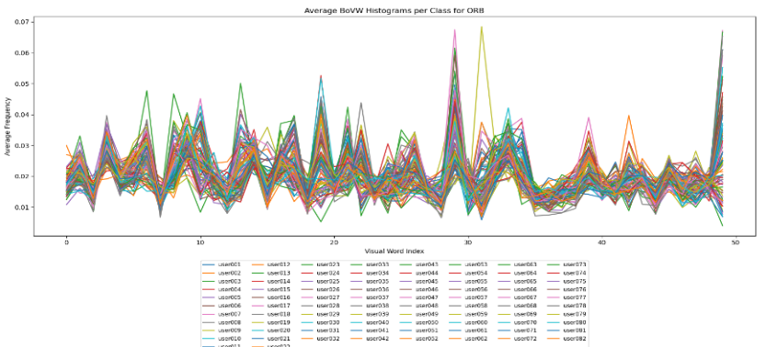
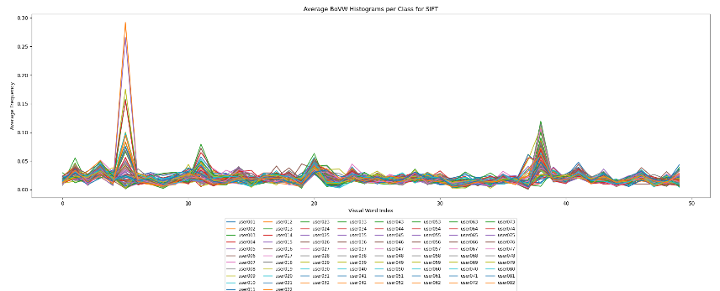

Figure 2: Average BOVW Histograms per Class for ORB and SIFT
The table below was compared the performance of SIFT and ORB in different cluster sizes (k=50, 100, 150, 300, 500) after tuning the clusters in terms of accuracy and processing time. It was showed that both methods got higher accuracy when the number of clusters increased until k=300, after which the performance was either the same or dropped a little. SIFT got the best accuracy of 23.73% at k=300, with 93.89 seconds for processing time, showing a good balance between accuracy and speed. ORB got the best accuracy of 15.30% at k=300, but it took much more time with 173.95 seconds. When the cluster size was smaller, both methods were faster but got lower accuracy because of fewer features. At bigger cluster sizes (k=500), the time to process was higher, but the accuracy didn’t improve, showing that there were not much better results with more clusters. In general, SIFT was better than ORB in accuracy in all sizes, but ORB took more time, especially with bigger clusters. These results showed that k=300 was the best choice for both methods, giving the best balance between time and performance after tuning the clusters.
Table 2: Performance of SIFT and ORB Across Different Cluster Sizes (k)
Number of Cluster | SIFT | ORB
k=50 | Accuracy=16.04%  Time=19.22 seconds | Accuracy=13.79%  Time=23.05 seconds
k=100 | Accuracy=20.09%  Time=32.54 seconds | Accuracy=13.63%  Time=45.88 seconds
k=150 | Accuracy=21.97%  Time=48.94 seconds | Accuracy=15.14%  Time=65.02 seconds
k=300 | Accuracy=23.73%  Time=93.89 seconds | Accuracy=15.30%  Time=173.95 seconds
k=500 | Accuracy=21.69%  Time=147.44 seconds | Accuracy=14.65%  Time=301.53 seconds

The parameter tuning for the XGBoost classifier was done for both SIFT and ORB to make their performance better using the best cluster size of k=300 from the BoVW representation. For both methods, the best parameters were found to be a subsample ratio of 0.8, 100 estimators, a maximum depth of 5, a learning rate of 0.1, and a colsample_bytree of 1.0. These parameters were chosen to balance the model's complexity and its ability to work well. With these tuned parameters, the final XGBoost models were re-trained and evaluated for both SIFT and ORB. This tuning process showed that it is important to change the classifier’s hyperparameters to make the features better and improve classification accuracy.
The evaluation of the final classifiers using tuned XGBoost parameters showed that SIFT got a classification accuracy of 25.12%, which was better than ORB, which had an accuracy of 17.43%. The average accuracy for both methods was 21.28%. SIFT’s higher accuracy showed that it could extract high-quality, unique features, making it better for Arabic handwritten text recognition. On the other hand, ORB find more key points and it had problems with precision, which made its overall performance lower. This comparison showed that SIFT was better for tasks needing precision, while ORB might need more work to improve its classification abilities.
Table 3: Classifier Accuracy Comparison Between SIFT and ORB
 | SIFT | ORB
Classifier Accuracy | 25.12% | 17.43%
Average Accuracy |  | 21.28%

The final predictions for both SIFT and ORB were saved to a CSV file named testing_images.csv. We have submitted it with the report. This file contained the classification results, helping for further analysis and easy access for evaluation. Saving predictions made sure that the outputs of the trained models were documented and could be used for reporting accuracy, checking errors, and comparing the performance of SIFT and ORB in a clear way. This step was important for transparent and reproducible machine learning workflows.
A simple user interface was made. An image was uploaded, and the original image was shown with the predicted user for SIFT and ORB. The key points for both SIFT and ORB were also printed.
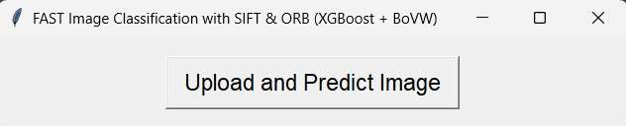
Figure 3: User Interface for Image Classification Using SIFT and ORB
The visualizations below for user022, user080, user082, and user070 were showed how good SIFT and ORB were at finding handwritten text, as both methods predicted the same users correct. SIFT key points were fewer but placed on important parts of the text. This gave higher precision, faster processing, and better classification accuracy. ORB, on the other side, found much more key points, but many of them overlapped or were in not useful areas, showing it focused more on quantity than quality. While both methods classified the users successful, SIFT’s focused way made it more reliable and better for hard handwriting cases, while ORB’s many key points could help for cases needing more detected features.
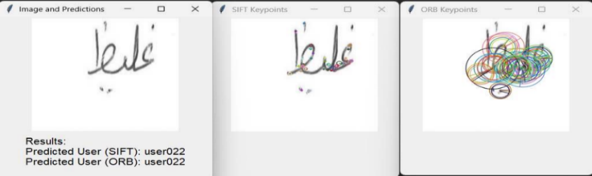
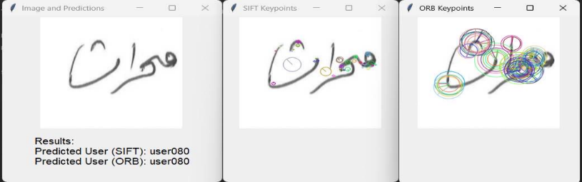

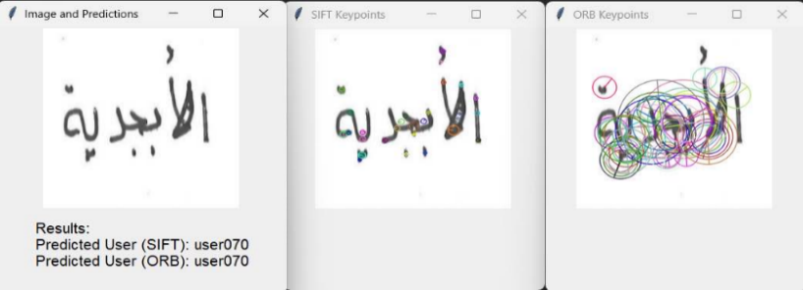
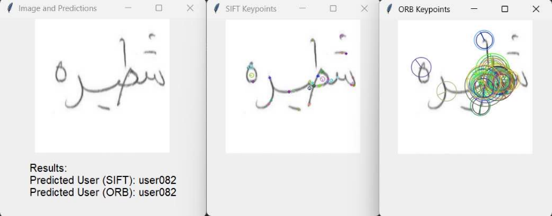

Figure 4: Predictions and Key point Visualizations for SIFT and ORB

The predictions below for user077 were showed the difference in performance between SIFT and ORB. In the first example, the user was incorrectly predicted as "user027" by SIFT, but ORB correctly identified "user077," showing that ORB had higher accuracy in this case. In the second example, the user was correctly identified as "user077" by SIFT, while ORB predicted "user069" wrong. This showed that SIFT had better precision for hard cases because it focused on good-quality key points. ORB’s larger key points sometimes caused overfitting or mistakes, especially with complex handwriting styles. These examples were showed that SIFT worked better for exact feature matching, while ORB had problems with detailed classification.
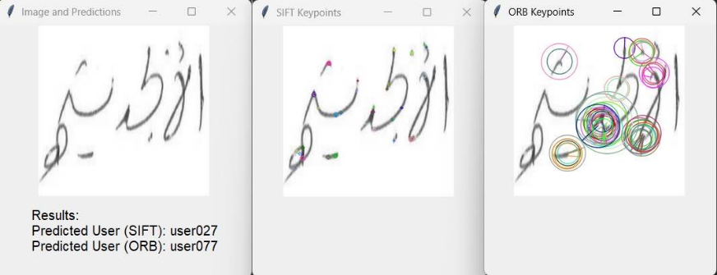
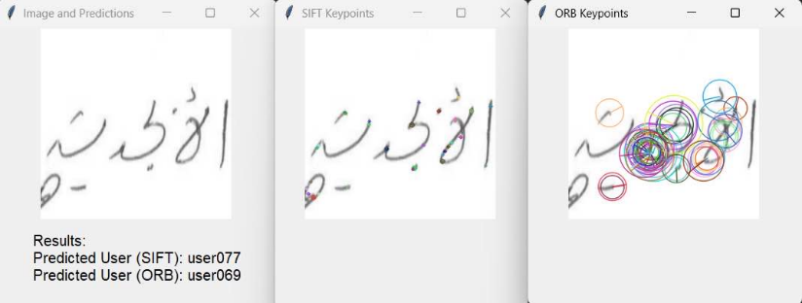

Figure 5: Misclassifications and key point Visualizations for SIFT and ORB

Conclusion and Future Work
This assignment was showed how SIFT and ORB worked for recognizing Arabic handwritten text, showing their good points and limits. SIFT was better in accuracy and precision, especially when dealing with changes like scaling and rotation, with a classification accuracy of 25.12%. Even with fewer key points, SIFT gave higher-quality descriptors, making it good for tasks that needed precision. ORB, while finding more key points, had problems with precision and got a lower accuracy of 17.43%. It performed well in noisy environments and is better suited for real-time applications due to its ability to find a larger quantity of features. The XGBoost classifier was tuned by us, and it classified the features well, with an average accuracy of 21.28%. SIFT was more strong in handling Arabic handwriting differences, but ORB’s faster feature finding could be improved more. Future work could mix these methods with deep learning to solve the problems of Arabic script changes, making recognition better and stronger.
Future work should focus on improving feature detection by adding deep learning methods like Convolutional Neural Networks (CNNs) or models that mix old methods with new neural networks. These methods could give better features and work well with different handwriting styles. Also, adding more samples with different handwriting styles would help the model work better and be more reliable. Making the system work in real time is another good goal, especially by making ORB faster and using it for things like turning old papers into digital files or in tools for learning different languages. These improvements could help increase the accuracy of Arabic text recognition and make the system more useful in real-life situations.

