Final Project Report – Executive KPI Dashboard (2018)

1. Dashboard Link
Book1 | Tableau Public
https://public.tableau.com/app/profile/mohammad.abushams/viz/Book1_17563312212020/ExecutiveKPIDashboard?publish=yes

2. Sketches
Below are the initial hand-drawn sketches that show possible visualization options for each question.
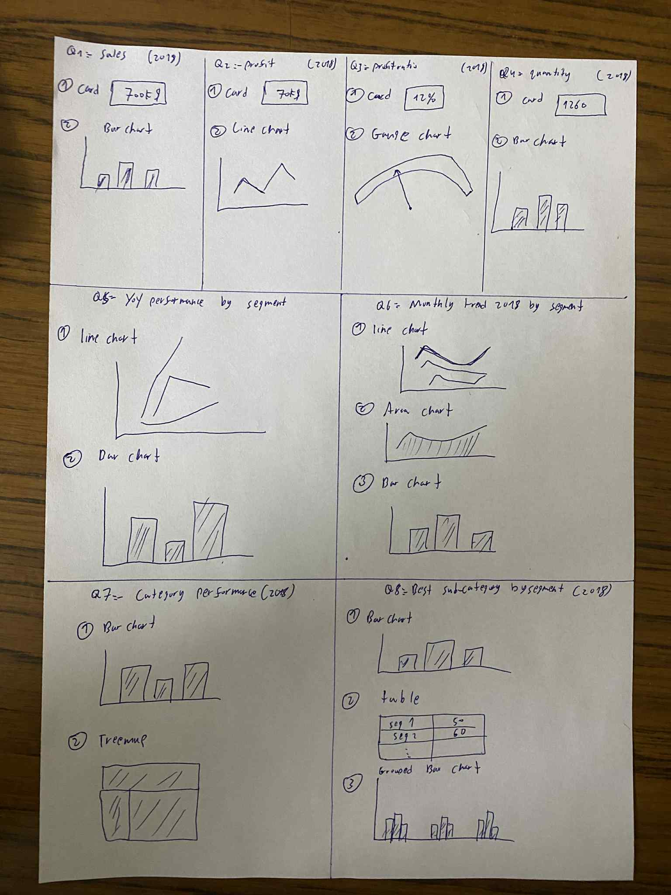

3. Wireframe
The wireframe represents the overall layout of the final dashboard, showing how KPIs and visualizations are organized before building the actual dashboard.
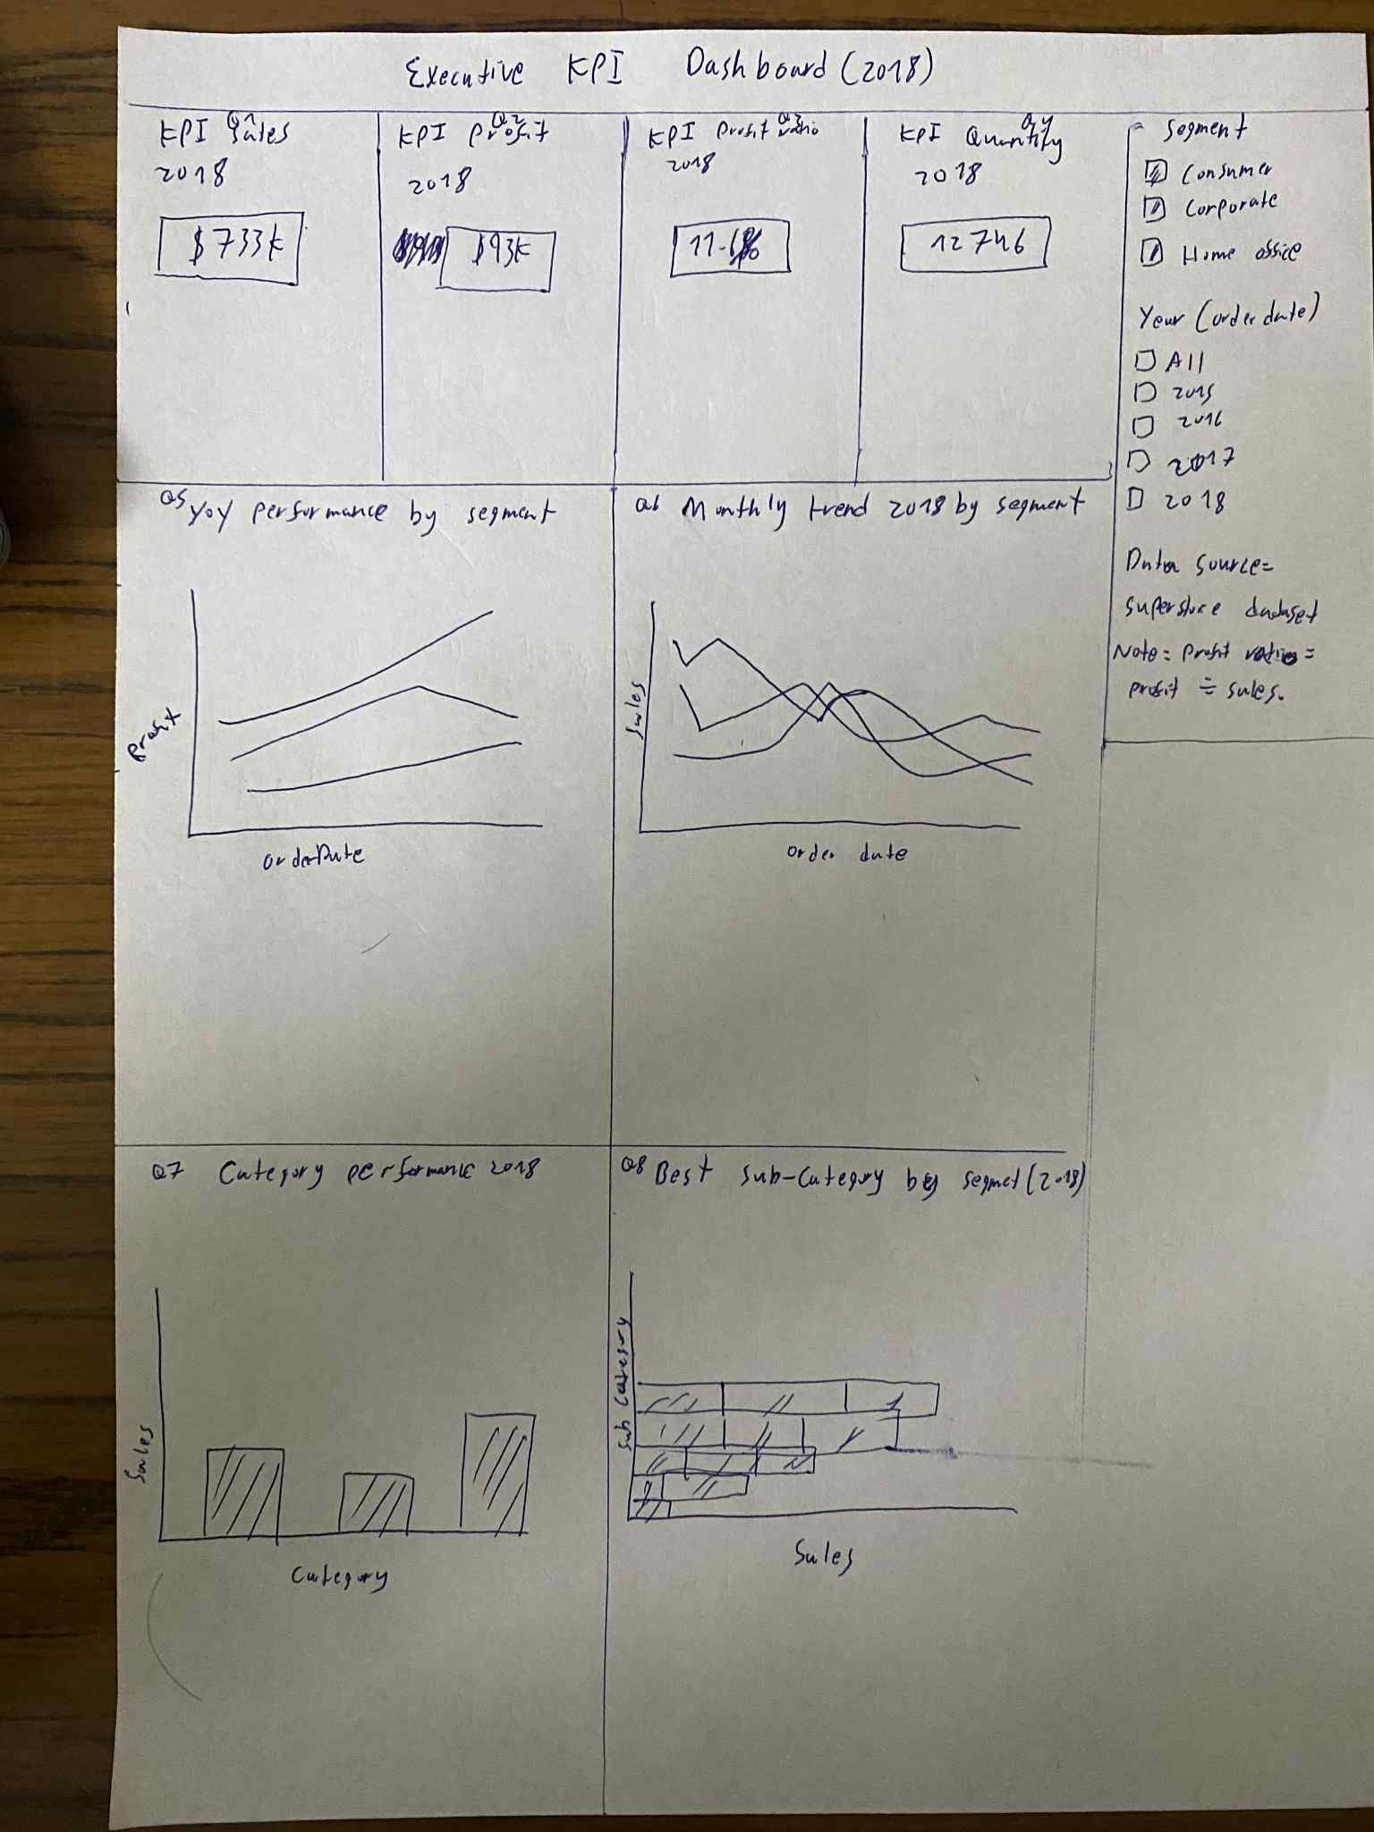

4. Final Dashboard Screenshot
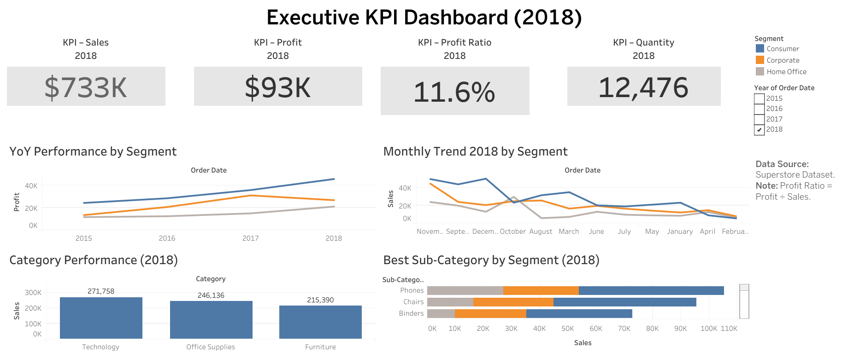

5. Text Hierarchy
To make the dashboard clear and easy to read, I applied a simple text hierarchy:
- Dashboard Title: Largest font, bold, and centered. Example: Executive KPI Dashboard (2018).
- KPI Cards (Sales, Profit, Profit Ratio, Quantity): Big numbers in large bold font (~36–48 pt) so they stand out immediately. Each KPI has a smaller label above it (e.g., KPI – Sales 2018) in lighter text.
- Chart Titles: Medium font size (~16–18 pt), bold, to clearly separate each section. Example: YoY Performance by Segment.
- Axis Labels / Legends: Standard body text (~12 pt), kept consistent across all charts for readability.
- Context / Helper Text: Smallest font (~10 pt), lighter or italic, used for notes like Data Source: Superstore Dataset. Note: Profit Ratio = Profit ÷ Sales.

6. Notes & Context
- Dataset Used: Superstore Dataset (provided in the course resources).
- Filter Controls: Segment (Consumer, Corporate, Home Office) and Year of Order Date (2015–2018).
- Design Principles Applied:
  - Used containers to keep everything aligned and clean.
  - Chose a consistent color palette (blue, orange, gray) that is accessible for color vision deficiencies.
  - Separated the KPI section from the detailed charts to make the flow clear.

7. Conclusion
This dashboard gives executives a clear high-level view:
- The KPI cards summarize 2018 results for Sales, Profit, Profit Ratio, and Quantity.
- YoY performance shows how each customer segment performed over time.
- The monthly trend highlights 2018 patterns and seasonality.
- Category and sub-category charts drill down into detailed performance and highlight top-performing areas.
The main focus of the design was clarity, alignment, and storytelling, so decision-makers can quickly spot key insights and use them for strategic discussions.

