
MBA PROGRAM
BUSA693: OPERATIONS MANAGEMENT
PROJECT1
Comparative Analysis of Time Series Forecasting Methods for Monthly Retail Sales

Prepared by:
Mohammad Abu Shams 1255049
Issa M. Dahu 1255228
Nancy Morrar 1255087
Ahmad Aburahma 1255082
Khader Fawadleh 1245174

Instructor: Dr. Samir Baidoun
Section: 1
Date: 21-9-2026

Table of Contents
List of Figures ii
List of Tables iii
Introduction 1
Data Description 1
Forecasting Methods 4
1. Naive Method 4
2. Moving Average 5
3. Weighted Moving Average 7
4. Simple Exponential Smoothing 9
5. Trend-Adjusted Exponential Smoothing (FIT) 11
6. Trend Projection 14
Seasonality Analysis 15
Combined Trend and Seasonal Forecast 17
Final Comparison of Forecasting Methods 19
Conclusion and Recommendation 22
References 23

List of Figures
Figure 1: Monthly Retail Sales from 2022 to 2025 3
Figure 2: Actual Sales and Naive Forecast 4
Figure 3: Actual Sales vs 3-Month Moving Average 5
Figure 4: Actual Sales vs 6-Month Moving Average 6
Figure 5: Actual Sales vs 12-Month Moving Average 6
Figure 6: Actual Sales vs Weighted Moving Average (0.50, 0.30, 0.20) 7
Figure 7: Actual Sales vs Weighted Moving Average (0.60, 0.30, 0.10) 8
Figure 8: Actual Sales vs Weighted Moving Average (0.70, 0.20, 0.10) 8
Figure 9: Actual Sales vs Exponential Smoothing (α = 0.10) 9
Figure 10: Actual Sales vs Exponential Smoothing (α = 0.30) 10
Figure 11: Actual Sales vs Exponential Smoothing (α = 0.50) 10
Figure 12: Actual Sales vs FIT (α = 0.10, β = 0.10) 11
Figure 13: Actual Sales vs FIT (α = 0.30, β = 0.20) 12
Figure 14: Actual Sales vs FIT (α = 0.50, β = 0.30) 12
Figure 15: Actual Sales vs FIT (α = 0.70, β = 0.50) 13
Figure 16: Actual Sales vs Trend Projection 14
Figure 17: Monthly Seasonal Indices 15
Figure 18: Combined Trend and Seasonal Forecast vs Actual Sales 18
Figure 19: MAD Comparison Across Forecasting Methods 20
Figure 20: MSE Comparison Across Forecasting Methods 20
Figure 21: MAPE Comparison Across Forecasting Methods 21

List of Tables
Table 1: Monthly Retail Sales Data (2022–2025) 1
Table 2: Naive Method Forecast Accuracy 4
Table 3: Moving Average Results 5
Table 4: Weighted Moving Average Results 7
Table 5: Simple Exponential Smoothing Results 9
Table 6: Trend-Adjusted Exponential Smoothing Results 11
Table 7: Trend Projection Results 14
Table 8: Monthly Seasonal Indices 15
Table 9: Seasonal Ratios and Monthly Seasonal Indices 16
Table 10: Combined Trend and Seasonal Forecast – 2025 17
Table 11: Combined Trend and Seasonal Forecast Accuracy 17
Table 12: Final Comparison of All Tested Forecasting Methods 19
Table 13: Best Setting from Each Forecasting Method 19

Introduction
Forecasting is important in operations management because it helps organizations plan for future demand and make better decisions. Good forecasting can support inventory planning, purchasing, capacity planning, and the use of resources. Time series forecasting is useful when historical data are available over regular periods of time.
This project uses monthly retail sales data from January 2022 to December 2025. Several forecasting methods are used, such as the Naive Method, Moving Average, Weighted Moving Average, Simple Exponential Smoothing, Trend-Adjusted Exponential Smoothing, and Trend Projection. Different parameter values are tested for the main forecasting methods. The final comparison includes Moving Average, Weighted Moving Average, Simple Exponential Smoothing, and Trend-Adjusted Exponential Smoothing (FIT).
The accuracy of the forecasting methods is measured using Mean Absolute Deviation (MAD), Mean Squared Error (MSE), and Mean Absolute Percentage Error (MAPE). The main measure used to choose the best method is MAD, where the method with the lowest MAD is considered the best. Seasonality is also analyzed to understand the monthly patterns in the sales data, and a combined trend and seasonal forecast is developed.
The main goal of this project is to compare the forecasting methods, identify the most accurate method for the data, and provide a recommendation based on the results.

Data Description
The data used in this project are monthly retail sales data from January 2022 to December 2025. The dataset has 48 monthly observations. The data were taken from the Federal Reserve Economic Data (FRED) database, and the original source is the U.S. Census Bureau. The sales are measured in millions of dollars and are not seasonally adjusted.

Table 1: Monthly Retail Sales Data (2022–2025)
T | Month | Sales (Millions of Dollars)
1 | 2022-01-01 | 505782
2 | 2022-02-01 | 496221
3 | 2022-03-01 | 584512
4 | 2022-04-01 | 582200
5 | 2022-05-01 | 601192
6 | 2022-06-01 | 594419
7 | 2022-07-01 | 584625
8 | 2022-08-01 | 597265
9 | 2022-09-01 | 562463
10 | 2022-10-01 | 581106
11 | 2022-11-01 | 588876
12 | 2022-12-01 | 637438
13 | 2023-01-01 | 535580
14 | 2023-02-01 | 516582
15 | 2023-03-01 | 589560
16 | 2023-04-01 | 574331
17 | 2023-05-01 | 615939
18 | 2023-06-01 | 597476
19 | 2023-07-01 | 591150
20 | 2023-08-01 | 613511
21 | 2023-09-01 | 579306
22 | 2023-10-01 | 594266
23 | 2023-11-01 | 608426
24 | 2023-12-01 | 657243
25 | 2024-01-01 | 539834
26 | 2024-02-01 | 544169
27 | 2024-03-01 | 597695
28 | 2024-04-01 | 593774
29 | 2024-05-01 | 631832
30 | 2024-06-01 | 592999
31 | 2024-07-01 | 618432
32 | 2024-08-01 | 622421
33 | 2024-09-01 | 579083
34 | 2024-10-01 | 622738
35 | 2024-11-01 | 630399
36 | 2024-12-01 | 691312
37 | 2025-01-01 | 566662
38 | 2025-02-01 | 543970
39 | 2025-03-01 | 624954
40 | 2025-04-01 | 623756
41 | 2025-05-01 | 647306
42 | 2025-06-01 | 616031
43 | 2025-07-01 | 644493
44 | 2025-08-01 | 640803
45 | 2025-09-01 | 611277
46 | 2025-10-01 | 642315
47 | 2025-11-01 | 640201
48 | 2025-12-01 | 716924

​
Table 1 shows the monthly retail sales values used in the analysis. The data cover four full years, giving enough observations to study changes over time and seasonal patterns.

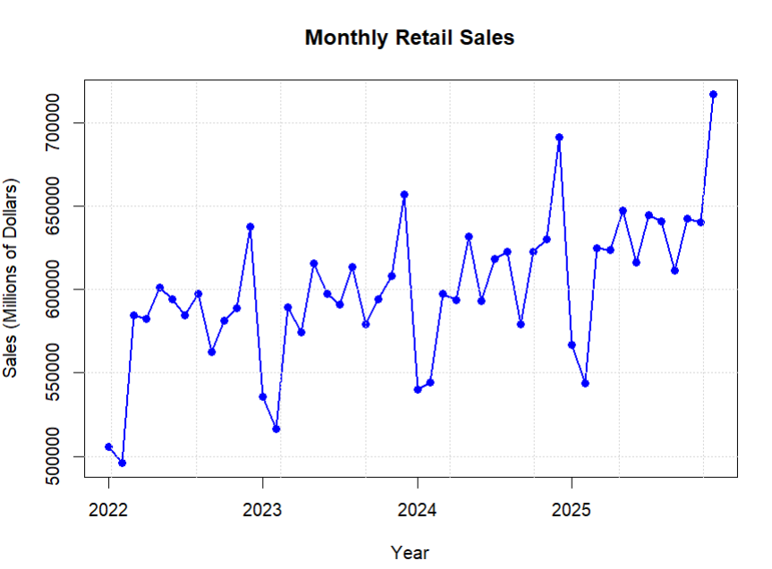
Figure 1: Monthly Retail Sales from 2022 to 2025

Figure 1 shows how monthly retail sales changed during the study period. Overall, sales increase over time, showing an upward trend. The figure also shows similar changes in the same months each year. For example, sales usually increase toward the end of the year and decrease at the beginning of the year. This may show that there is a seasonal pattern in the data, which will be studied later in the project.

Forecasting Methods

1. Naive Method
The Naive Method is one of the simplest forecasting methods. It uses the actual value from the previous period as the forecast for the next period. In simple terms, the most recent value is used to predict the next value.
$$F_{t} =A_{t-1}$$
where $F_{t}$ is the forecast for period t, and $A_{t-1}$is the actual value from the previous period.
Table 2: Naive Method Forecast Accuracy
Method | MAD | MSE | MAPE
Naive | 36303.78 | 2317620273 | 6.061%

The Naive Method gave a MAD of 36,303.78, an MSE of 2,317,620,272.78, and a MAPE of 6.06%. These results will be used as a reference to compare the performance of other forecasting methods.
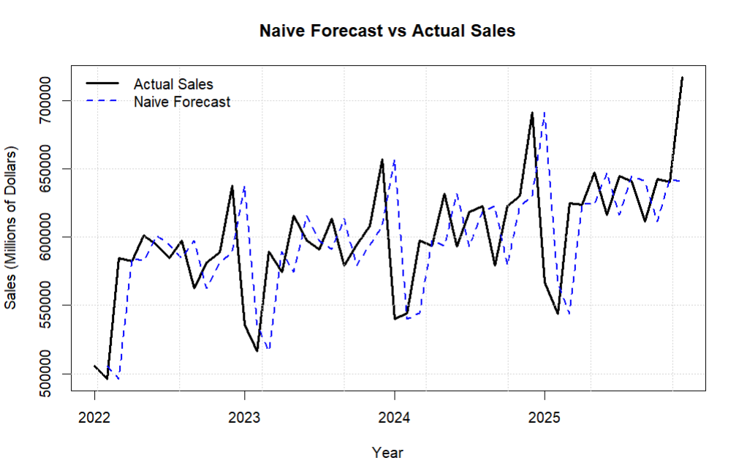
Figure 2: Actual Sales and Naive Forecast
Figure 2 compares the actual monthly sales with the Naive forecast. The Naive Method uses the actual sales from the previous month to predict the next month. Therefore, the forecast generally follows the changes in the actual sales, but with a one-month delay.
The Naive Method was used as a simple reference method to show the basic forecasting performance. It was not included in the final comparison of the forecasting methods.

2. Moving Average
The Moving Average method uses the average of a fixed number of previous values to forecast the next period. In this project, three values of (n) were tested: 3 months, 6 months, and 12 months. This was done to see how the number of months used in the average affects the accuracy of the forecast.
$$MA_{n}=\frac{A_{t-1}+ A_{t-2}+ ... + A_{t-n}}{n}$$
where n is the number of previous periods used in the average.

Table 3: Moving Average Results
Method | n | MAD | MSE | MAPE
Moving Average | 3 | 34525.03 | 1920181912 | 5.779%
Moving Average | 6 | 31103.29 | 1552143601 | 5.174%
Moving Average | 12 | 28566.06 | 1346533628 | 4.693%

The results show that the 12-month Moving Average had the lowest MAD value of 28,566.06. It also had the lowest MSE and MAPE compared with the other two values. Therefore, (n=12) gave the most accurate results among the three Moving Average settings.
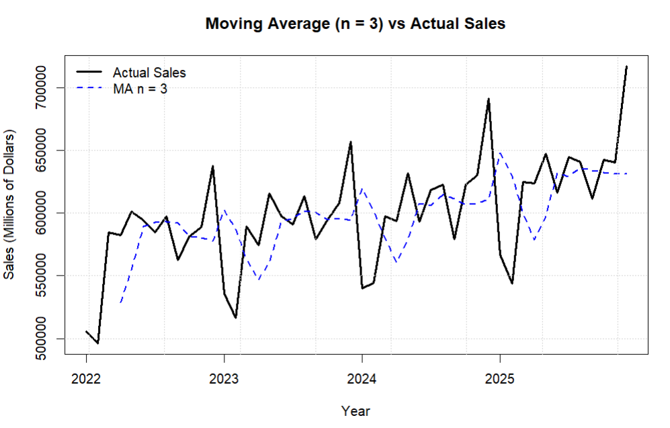
Figure 3: Actual Sales vs 3-Month Moving Average

The 3-month Moving Average reacts quickly to changes in sales because it uses the latest three months. However, there are still some clear differences between the forecast and the actual monthly sales.
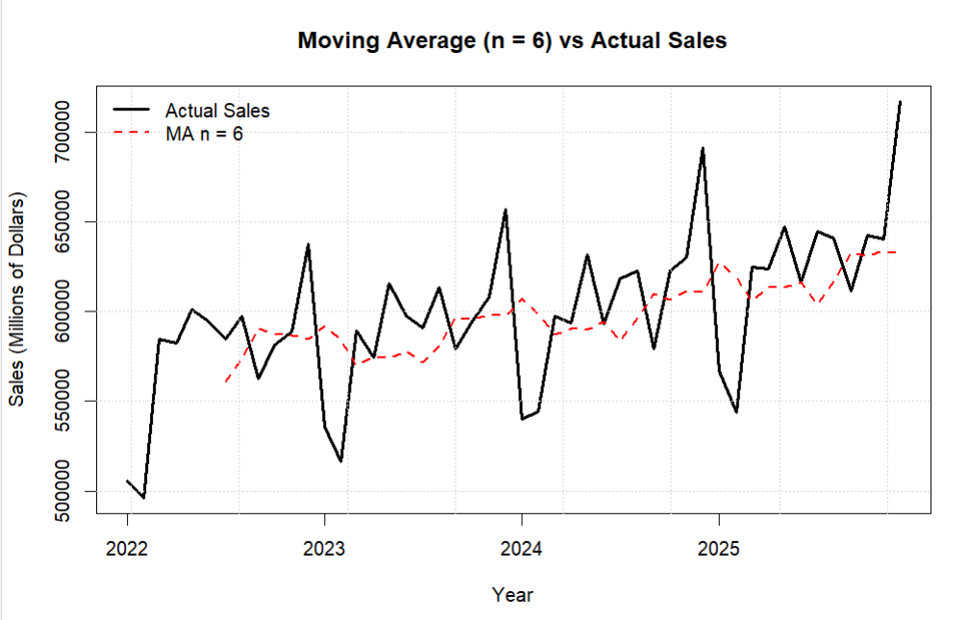
Figure 4: Actual Sales vs 6-Month Moving Average

The 6-month Moving Average gives a smoother forecast than the 3-month Moving Average. It follows the general changes in sales but responds more slowly to short-term changes.
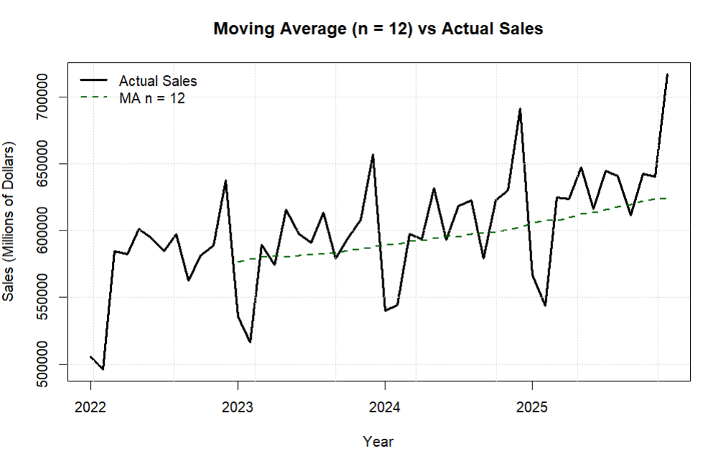
Figure 5: Actual Sales vs 12-Month Moving Average
The 12-month Moving Average gives the smoothest forecast among the three settings. It shows the overall pattern of the data and has the lowest MAD, MSE, and MAPE values.
Based on the accuracy measures and the graph, the 12-month Moving Average performed best among the three tested values.

3. Weighted Moving Average
The Weighted Moving Average method is similar to the Moving Average method, but it gives different weights to past values. Recent values usually get higher weights because they are more important for predicting the next period. In this project, three different sets of weights were tested to compare their forecasting accuracy.
$$WMA = w_{1}A_{t-1} + + w_{2}A_{t-2}+ w_{3}A_{t-3}$$
where $w_{1}$ ${,w}_{2}$and $w_{3 }$are the weights assigned to the previous observations, and the total of the weights equals 1.
The following weight combinations were tested:
(0.50, 0.30, 0.20), (0.60, 0.30, 0.10), and (0.70, 0.20, 0.10).
Table 4: Weighted Moving Average Results
Method | Weights | MAD | MSE | MAPE
Weighted Moving Average | 0.50, 0.30, 0.20 | 34983.15 | 1882678999 | 5.859%
Weighted Moving Average | 0.60, 0.30, 0.10 | 35662.23 | 1946890592 | 5.977%
Weighted Moving Average | 0.70, 0.20, 0.10 | 35085.14 | 1954987450 | 5.869%

The results show that the weight combination (0.50, 0.30, 0.20) had the lowest MAD value of 34,983.15. It also had the lowest MSE of 1,882,678,999 and the lowest MAPE of 5.859%. Therefore, the weight combination (0.50, 0.30, 0.20) gave the most accurate forecast among the three Weighted Moving Average settings.
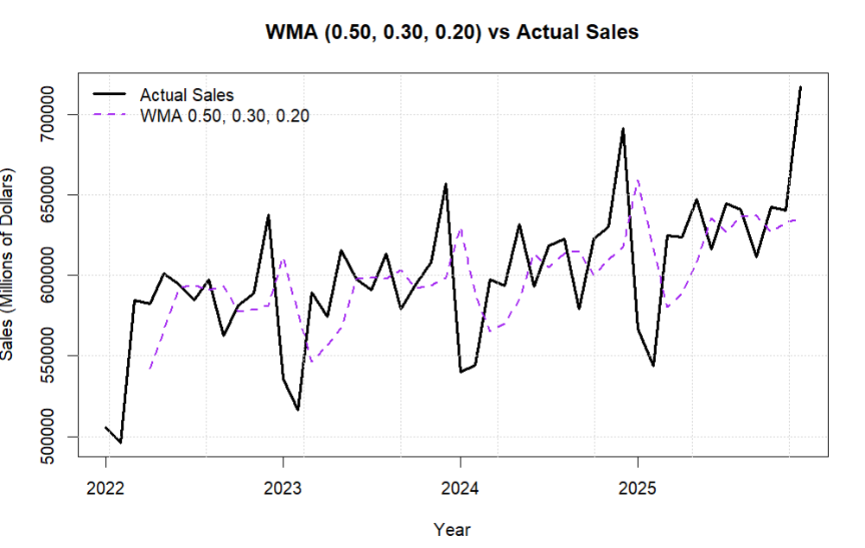
Figure 6: Actual Sales vs Weighted Moving Average (0.50, 0.30, 0.20)
Figure 6 shows the forecast using weights of 0.50, 0.30, and 0.20. This combination gave the lowest MAD, MSE, and MAPE values among the three tested combinations.
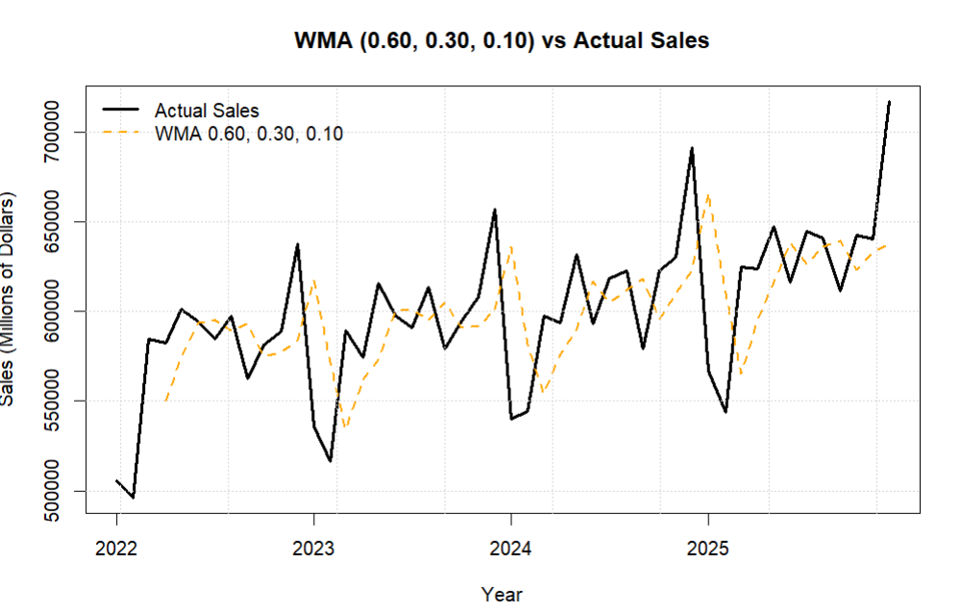
Figure 7: Actual Sales vs Weighted Moving Average (0.60, 0.30, 0.10)
Figure 7 shows the forecast using weights of 0.60, 0.30, and 0.10. Giving more weight to the most recent value did not improve the forecast accuracy compared with the first case.
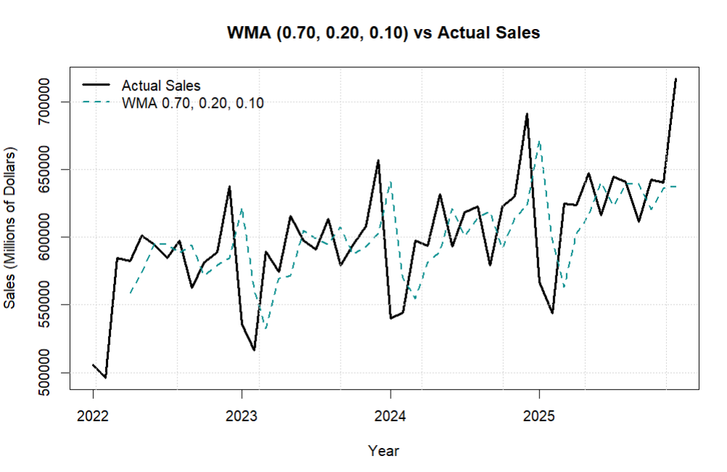
Figure 8: Actual Sales vs Weighted Moving Average (0.70, 0.20, 0.10)
Figure 8 shows the forecast using weights of 0.70, 0.20, and 0.10. Although this case gives the highest weight to the most recent value, its error measures were higher than those of the first case.
Overall, the results show that giving more weight to the most recent value did not improve the forecasting accuracy for this dataset.

4. Simple Exponential Smoothing
The Simple Exponential Smoothing method gives more importance to recent values when forecasting the next period. It uses a smoothing constant called alpha ($α$), which controls the weight given to the most recent actual value. In this project, three different alpha values were tested: 0.10, 0.30, and 0.50.
$$F_{t}= α A_{t-1}+ \left(1-α\right)F_{t-1}$$
where $α$ is the smoothing constant, $A_{t-1}$ is the previous actual value, and $F_{t-1}$ is the previous forecast.

Table 5: Simple Exponential Smoothing Results
Method | Alpha | MAD | MSE | MAPE
Exponential Smoothing | 0.1 | 34068.47 | 1625184232 | 5.555%
Exponential Smoothing | 0.3 | 31778.15 | 1569162121 | 5.293%
Exponential Smoothing | 0.5 | 33634.80 | 1750687402 | 5.626%

The results show that alpha = 0.30 had the lowest MAD value of 31,778.15. It also had the lowest MSE of 1,569,162,121 and the lowest MAPE of 5.293%. Therefore, alpha = 0.30 gave the most accurate forecast among the three Exponential Smoothing settings.
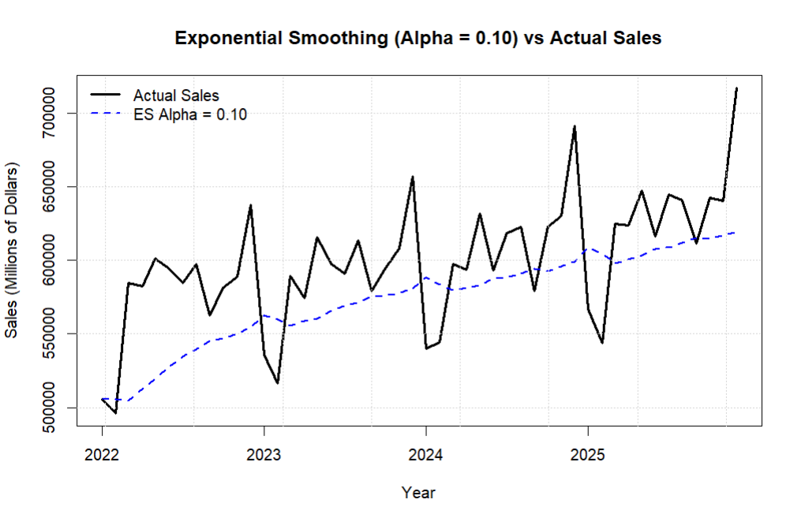
Figure 9: Actual Sales vs Exponential Smoothing (α = 0.10)
Figure 9 shows the forecast using alpha = 0.10. This low alpha value gives a smoother forecast and reacts more slowly to changes in the actual sales values.
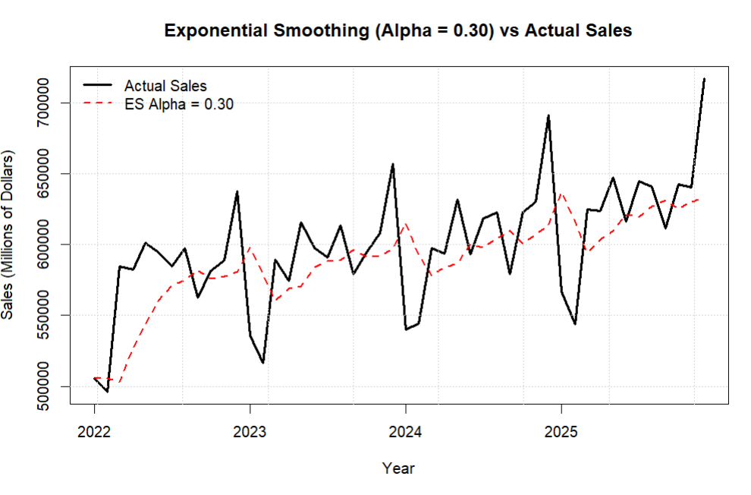
Figure 10: Actual Sales vs Exponential Smoothing (α = 0.30)
Figure 10 shows the forecast using alpha = 0.30. This setting gives a good balance between smoothing the data and responding to changes in sales. It also produced the lowest forecast errors among the three tested values.
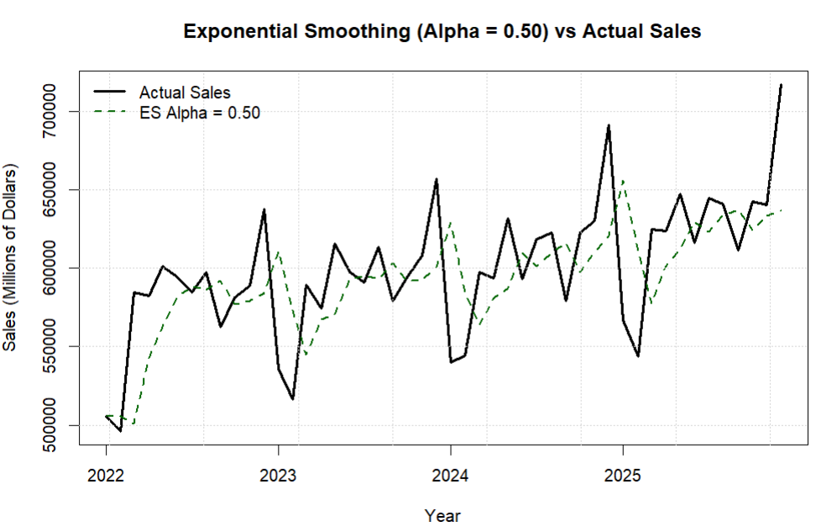
Figure 11: Actual Sales vs Exponential Smoothing (α = 0.50)
Figure 11 shows the forecast using alpha = 0.50. This higher alpha value makes the forecast respond more quickly to recent changes, but the error measures were higher than those for alpha = 0.30.
Overall, increasing alpha did not always improve the forecasting accuracy. The best result was obtained with alpha = 0.30.

5. Trend-Adjusted Exponential Smoothing (FIT)
Trend-Adjusted Exponential Smoothing is used when the data have a trend over time. This method is an extension of Simple Exponential Smoothing because it also includes a trend component. It uses two smoothing constants: alpha ($α$) for the level of the data and beta ($β$) for the trend. In this project, four different combinations of alpha and beta were tested to compare their forecasting accuracy.
$$F_{t}= α A_{t-1} + \left(1-α\right)\left(F_{t-1}+ T_{t-1}\right)$$
$$T_{t}= β(F_{t}-F_{t-1}) + \left(1-β\right)T_{t-1}$$
$${FIT}_{t}=F_{t}+T_{t}$$
where $F_{t}$represents the smoothed forecast, $T_{t}$ represents the trend, α is the smoothing constant for the level, and β is the smoothing constant for the trend.
Four combinations were tested: (α = 0.10, β = 0.10), (α = 0.30, β = 0.20), (α = 0.50, β = 0.30), and (α = 0.70, β = 0.50).
Table 6: Trend-Adjusted Exponential Smoothing Results
Method | Alpha | Beta | MAD | MSE | MAPE
FIT | 0.1 | 0.1 | 27005.41 | 1413062158 | 4.574%
FIT | 0.3 | 0.2 | 31923.15 | 1772419746 | 5.383%
FIT | 0.5 | 0.3 | 36486.31 | 2116401922 | 6.141%
FIT | 0.7 | 0.5 | 41260.78 | 2866273366 | 6.926%

The results show that Case 1, with α = 0.10 and β = 0.10, had the lowest MAD value of 27,005.41. It also had the lowest MSE of 1,413,062,158 and the lowest MAPE of 4.574%. Therefore, Case 1 gave the most accurate forecast among the four Trend-Adjusted Exponential Smoothing settings.
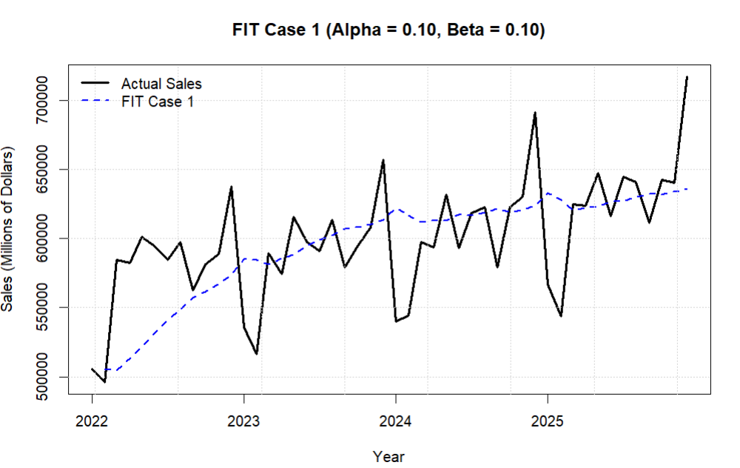
Figure 12: Actual Sales vs FIT (α = 0.10, β = 0.10)
Figure 12 shows the forecast using α = 0.10 and β = 0.10. This case had the lowest forecasting errors among the four tested combinations.
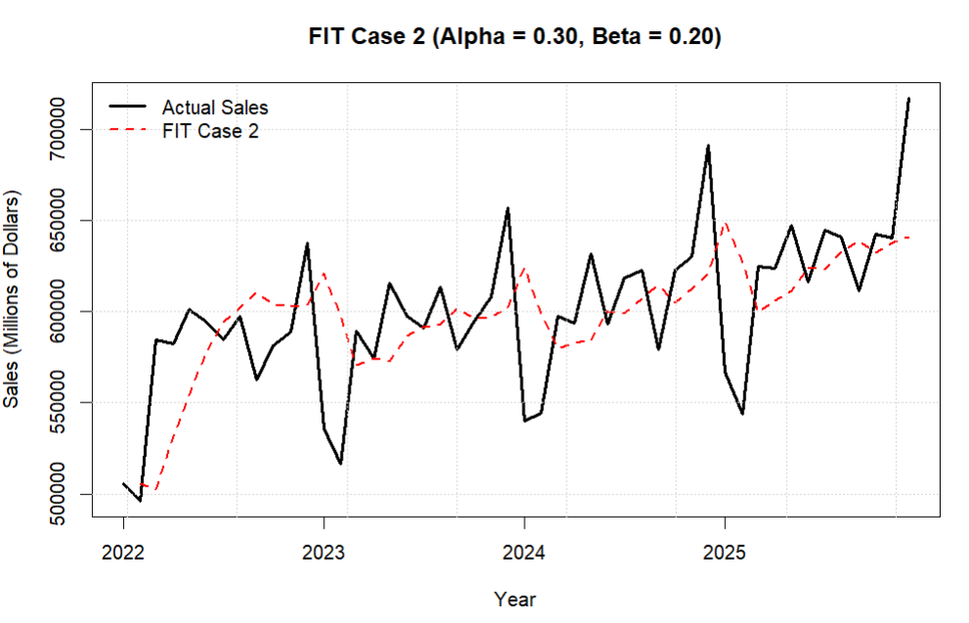
Figure 13: Actual Sales vs FIT (α = 0.30, β = 0.20)
Figure 13 shows the forecast using α = 0.30 and β = 0.20. The forecast responds more strongly to changes in the data, but its error measures were higher than those of Case 1.
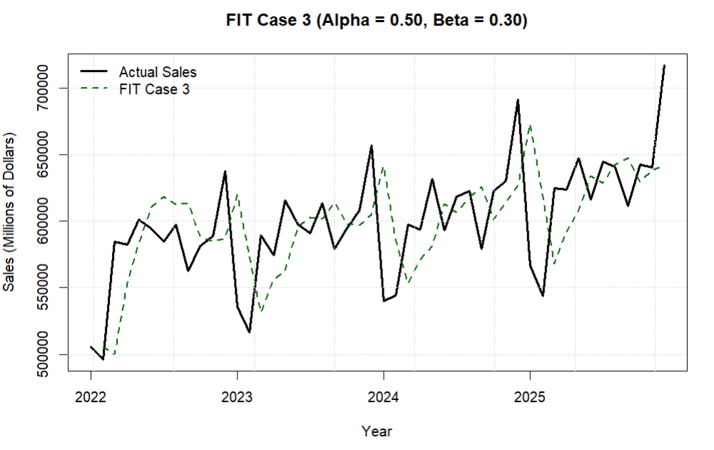
Figure 14: Actual Sales vs FIT (α = 0.50, β = 0.30)
Figure 14 shows the forecast using α = 0.50 and β = 0.30. Increasing both smoothing constants resulted in higher forecasting errors compared with the first two cases.
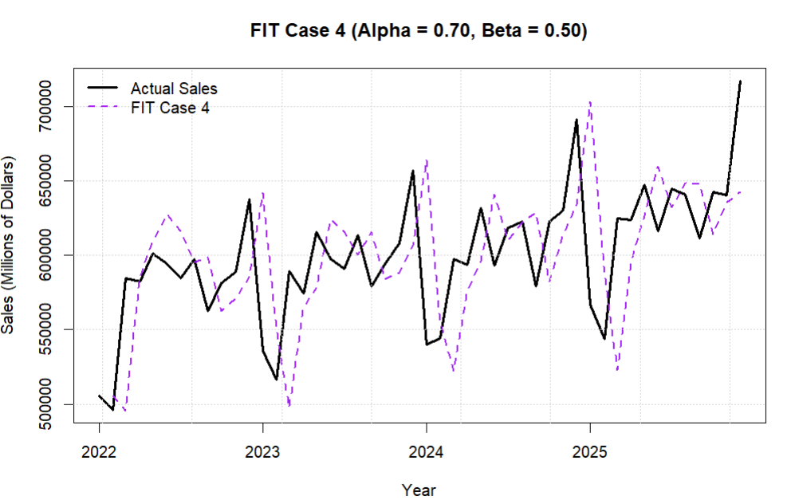
Figure 15: Actual Sales vs FIT (α = 0.70, β = 0.50)

Figure 15 shows the forecast using α = 0.70 and β = 0.50. This combination had the highest MAD, MSE, and MAPE values among the four tested cases.
Overall, increasing the values of α and β did not improve the forecasting accuracy for this dataset. The lowest values of α and β, both equal to 0.10, gave the best FIT results.

6. Trend Projection
Trend Projection is used when the data show an overall upward or downward movement over time. This method fits a straight trend line to the historical data and uses time as the independent variable to estimate sales. In this project, a linear trend model was used to study the overall direction of monthly retail sales.
$$Y_{t}= a + bt$$
where $a$ is the intercept, $b$ is the slope, and $t$represents the time period.

Sales=554933.44+1816.36*$t$
The positive slope of 1,816.36 means that monthly retail sales increased on average during the study period.
Table 7: Trend Projection Results
Method | Intercept | Slope | MAD | MSE | MAPE
Trend Projection | 554933.4 | 1816.36 | 24611.49 | 1180715391 | 4.139%

The Trend Projection method produced a MAD of 24,611.49, an MSE of 1,180,715,391, and a MAPE of 4.139%. The results show that the linear trend represents the general upward movement of the sales data.
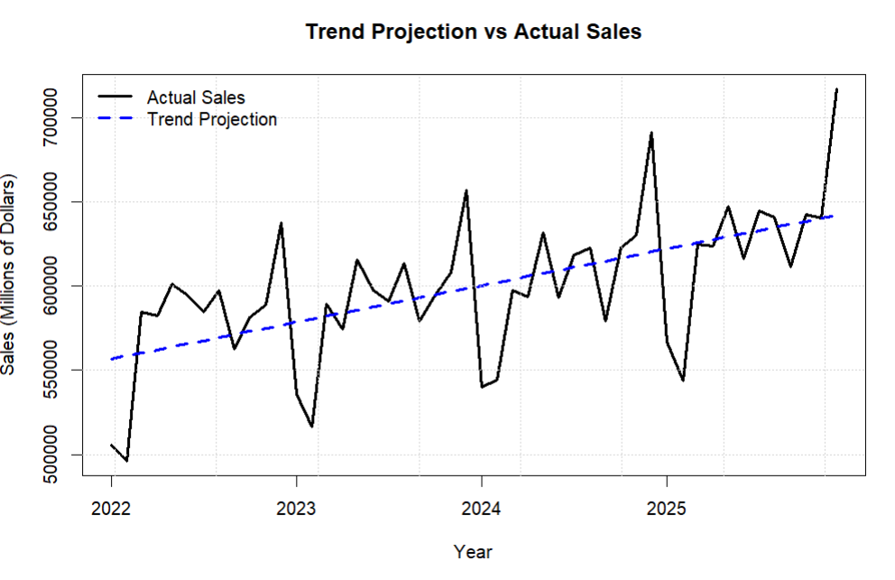
Figure 16: Actual Sales vs Trend Projection
Figure 16 compares the actual monthly sales with the estimated trend line. The trend line increases gradually over time, while the actual sales move above and below the line because of monthly changes and seasonal effects.
Trend Projection was used to identify the general trend in the data and to support the seasonality analysis. It was not included in the final comparison of forecasting methods.

Seasonality Analysis
Seasonality refers to repeated patterns that happen during the same periods over time. Since the data are monthly, the seasonal pattern was analyzed across the 12 months of the year. First, the trend effect was removed from the actual sales values, and then seasonal indices were calculated for each month.
A seasonal index greater than 1 means that sales are higher than the normal trend level for that month, while an index below 1 means that sales are lower than the normal trend level.
Table 8: Monthly Seasonal Indices
Month | Seasonal Index | Seasonal Effect
January | 0.911 | -8.89%
February | 0.888 | -11.15%
March | 1.011 | 1.1%
April | 0.998 | -0.17%
May | 1.046 | 4.64%
June | 1.004 | 0.41%
July | 1.016 | 1.57%
August | 1.028 | 2.78%
September | 0.966 | -3.42%
October | 1.007 | 0.72%
November | 1.016 | 1.57%
December | 1.109 | 10.86%

The seasonal indices show clear differences between the months. Months with an index above 1 have sales above the general trend, while months with an index below 1 have sales below the trend. The results show that sales are generally lower at the beginning of the year and higher toward the end of the year.
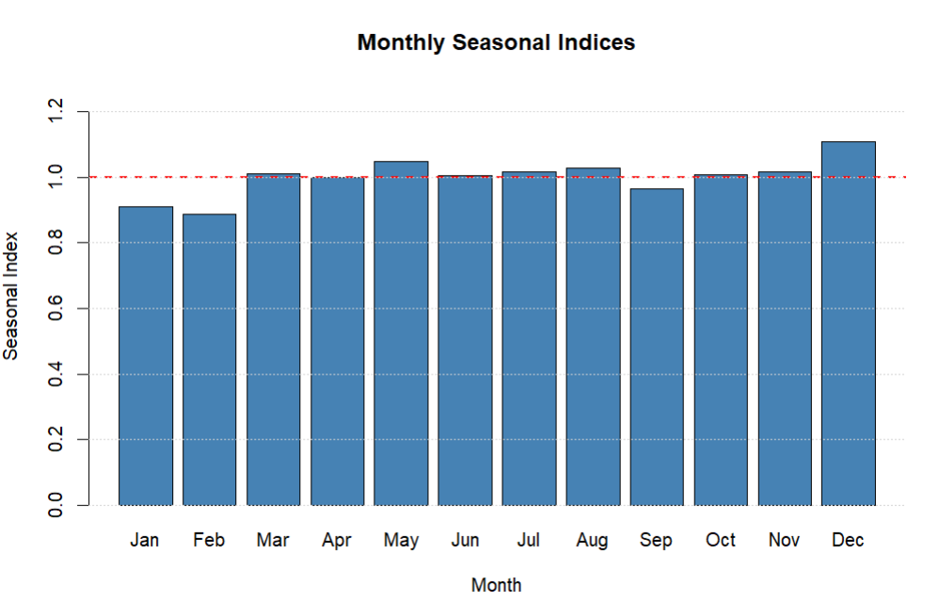
Figure 17: Monthly Seasonal Indices
Figure 17 shows the seasonal pattern across the 12 months. December has the highest seasonal index, while January and February have the lowest values. This shows that the monthly sales data have a clear seasonal pattern.

Table 9: Seasonal Ratios and Monthly Seasonal Indices
Month | Ratio_2022 | Ratio_2023 | Ratio_2024 | Ratio_2025 | Seasonal Index
January | 0.908 | 0.926 | 0.899 | 0.911 | 0.911
February | 0.888 | 0.89 | 0.904 | 0.872 | 0.888
March | 1.043 | 1.013 | 0.99 | 0.999 | 1.011
April | 1.036 | 0.983 | 0.98 | 0.994 | 0.998
May | 1.066 | 1.051 | 1.04 | 1.028 | 1.046
June | 1.051 | 1.017 | 0.973 | 0.976 | 1.004
July | 1.03 | 1.003 | 1.012 | 1.018 | 1.016
August | 1.049 | 1.038 | 1.015 | 1.009 | 1.028
September | 0.985 | 0.977 | 0.942 | 0.96 | 0.966
October | 1.014 | 0.999 | 1.01 | 1.006 | 1.007
November | 1.024 | 1.02 | 1.019 | 1 | 1.016
December | 1.105 | 1.098 | 1.114 | 1.116 | 1.109

Table 9 shows the seasonal ratios for each month across the four years. These ratios compare the actual sales values with the estimated trend values. Ratios above 1 mean that sales were higher than the trend level, while ratios below 1 mean that sales were lower than the trend level. The average pattern across the four years was then used to calculate the monthly seasonal index.
The results show a consistent seasonal pattern across the years. January and February have ratios below 1 in all four years, while December has ratios above 1 in every year. This supports the presence of seasonality in the monthly sales data.
Since the data show both trend and seasonality, the seasonal indices were combined with the trend values to develop the Combined Trend and Seasonal Forecast.

Combined Trend and Seasonal Forecast
The Combined Trend and Seasonal Forecast combines the estimated trend with the monthly seasonal index. This allows the forecast to show both the general movement of sales over time and the seasonal pattern of each month.
Combined Forecast=Trend Forecast × Seasonal Index
The trend value shows the general direction of sales over time, while the seasonal index adjusts the forecast based on the expected seasonal effect for each month.

Table 10: Combined Trend and Seasonal Forecast – 2025
Month | Sales | Trend Forecast | Seasonal Index | Seasonal Trend Forecast
Jan-25 | 566662 | 622138.9 | 0.911 | 566800.6
Feb-25 | 543970 | 623955.27 | 0.888 | 554379.7
Mar-25 | 624954 | 625771.6 | 1.011 | 632656.5
Apr-25 | 623756 | 627588.0 | 0.998 | 626499.2
May-25 | 647306 | 629404.4 | 1.046 | 658613.1
Jun-25 | 616031 | 631220.7 | 1.004 | 633783.7
Jul-25 | 644493 | 633037.1 | 1.016 | 642950.3
Aug-25 | 640803 | 634853.5 | 1.028 | 652482.1
Sep-25 | 611277 | 636669.8 | 0.966 | 614900.6
Oct-25 | 642315 | 638486.2 | 1.007 | 643067.4
Nov-25 | 640201 | 640302.5 | 1.016 | 650382.0
Dec-25 | 716924 | 642118.9 | 1.109 | 711833.1

Table 10 shows how the trend forecast was adjusted using the monthly seasonal index for 2025. Months with seasonal indices above 1 had higher combined forecasts, while months with indices below 1 had lower combined forecasts. For example, December has a high seasonal index of 1.109, which increased the trend forecast from 642,118.9 to 711,833.1.

Table 11: Combined Trend and Seasonal Forecast Accuracy
Method | MAD | MSE | MAPE
Combined Trend and Seasonal Forecast | 6694.12 | 67018280 | 1.114%

The Combined Trend and Seasonal Forecast produced a MAD of 6,694.12, an MSE of 67,018,280, and a MAPE of 1.114%. These results show that the combined model followed the actual sales values closely during the study period.

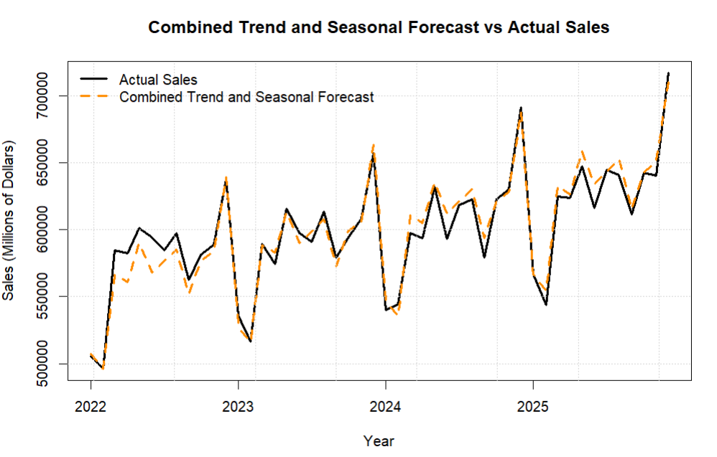
Figure 18: Combined Trend and Seasonal Forecast vs Actual Sales

Figure 18 shows that the Combined Trend and Seasonal Forecast follows the actual sales values closely throughout the study period. The forecast captures both the upward trend and the repeated seasonal changes in monthly sales. The small differences between the two lines are consistent with the low MAD, MSE, and MAPE values.
Although this method produced low forecasting errors, it was used as part of the trend and seasonality analysis and was not included in the final comparison of the main forecasting methods.

Final Comparison of Forecasting Methods
The final comparison was conducted among the four main forecasting methods: Moving Average, Weighted Moving Average, Simple Exponential Smoothing, and Trend-Adjusted Exponential Smoothing (FIT). All tested parameter settings were compared using MAD, MSE, and MAPE. The main criterion for selecting the most accurate forecasting method was the lowest MAD value.

Table 12: Final Comparison of All Tested Forecasting Methods
Method | Setting | MAD | MSE | MAPE
Moving Average | n = 3 | 34525.03 | 1920181912 | 5.779%
Moving Average | n = 6 | 31103.29 | 1552143601 | 5.174%
Moving Average | n = 12 | 28566.06 | 1346533628 | 4.693%
Weighted Moving Average | 0.50, 0.30, 0.20 | 34983.15 | 1882678999 | 5.859%
Weighted Moving Average | 0.60, 0.30, 0.10 | 35662.23 | 1946890592 | 5.977%
Weighted Moving Average | 0.70, 0.20, 0.10 | 35085.14 | 1954987450 | 5.869%
Exponential Smoothing | Alpha = 0.10 | 34068.47 | 1625184232 | 5.555%
Exponential Smoothing | Alpha = 0.30 | 31778.15 | 1569162121 | 5.293%
Exponential Smoothing | Alpha = 0.50 | 33634.80 | 1750687402 | 5.626%
FIT | Alpha = 0.10, Beta = 0.10 | 27005.41 | 1413062158 | 4.574%
FIT | Alpha = 0.30, Beta = 0.20 | 31923.15 | 1772419746 | 5.383%
FIT | Alpha = 0.50, Beta = 0.30 | 36486.31 | 2116401922 | 6.141%
FIT | Alpha = 0.70, Beta = 0.50 | 41260.78 | 2866273366 | 6.926%

Table 12 compares all 13 tested forecasting settings. The results show that the forecasting accuracy changes depending on the method and the parameter values used. The lowest MAD among all tested cases was obtained by the Trend-Adjusted Exponential Smoothing method with α = 0.10 and β = 0.10.
Table 13: Best Setting from Each Forecasting Method
Method | Setting | MAD | MSE | MAPE
Moving Average | n = 12 | 28566.06 | 1346533628 | 4.693%
Weighted Moving Average | 0.50, 0.30, 0.20 | 34983.15 | 1882678999 | 5.859%
Exponential Smoothing | Alpha = 0.30 | 31778.15 | 1569162121 | 5.293%
FIT | Alpha = 0.10, Beta = 0.10 | 27005.41 | 1413062158 | 4.574%

Table 13 summarizes the best setting for each forecasting method. Based on MAD, the FIT method with α = 0.10 and β = 0.10 had the lowest error value of 27,005.41. It also had the lowest MAPE of 4.574%. The 12-month Moving Average had the lowest MSE of 1,346,533,628. However, since MAD was used as the main evaluation criterion, FIT with α = 0.10 and β = 0.10 was selected as the most accurate forecasting method.
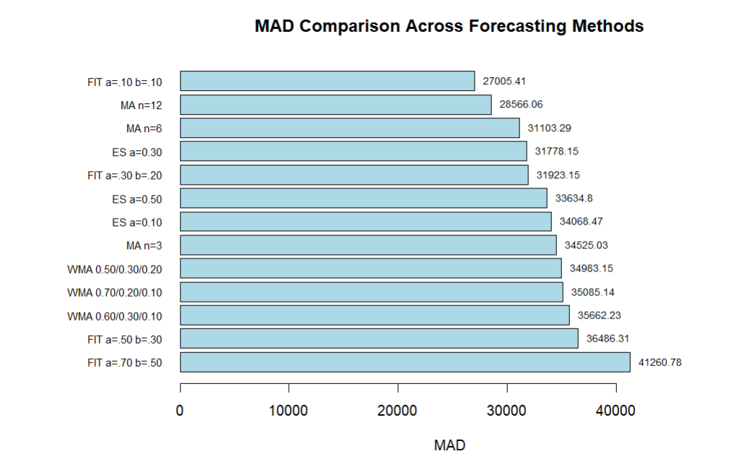
Figure 19: MAD Comparison Across Forecasting Methods
Figure 19 compares the MAD values for all tested forecasting settings. Lower MAD values mean better forecasting accuracy. The Trend-Adjusted Exponential Smoothing method with α = 0.10 and β = 0.10 had the lowest MAD value of 27,005.41, followed by the 12-month Moving Average with a MAD of 28,566.06. The highest MAD was obtained by FIT with α = 0.70 and β = 0.50. Based on MAD, FIT with α = 0.10 and β = 0.10 gave the most accurate forecast among the tested cases.
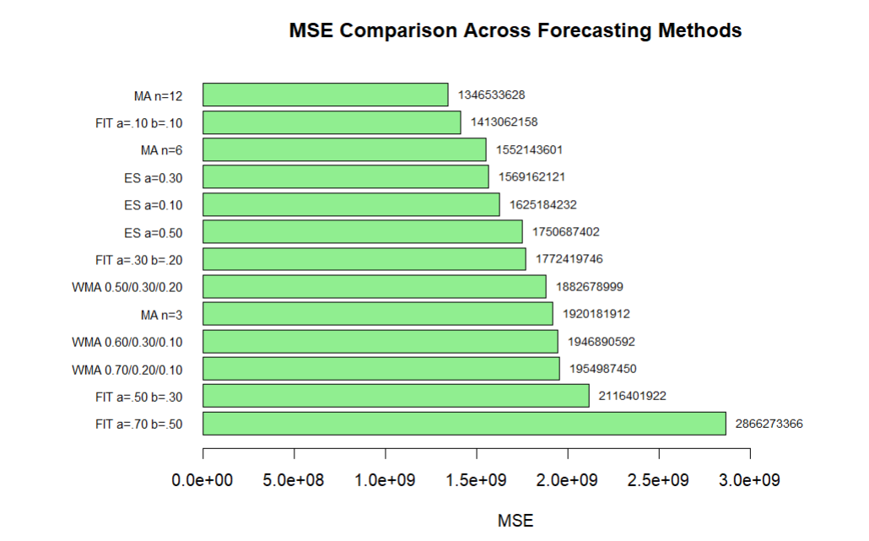
Figure 20: MSE Comparison Across Forecasting Methods
Figure 20 compares the MSE values for all tested forecasting settings. Lower MSE values mean better forecasting performance. The 12-month Moving Average had the lowest MSE value of 1,346,533,628, followed by FIT with α = 0.10 and β = 0.10. The highest MSE was obtained by FIT with α = 0.70 and β = 0.50. Although the 12-month Moving Average had the lowest MSE, MAD was used as the main criterion for selecting the best forecasting method.
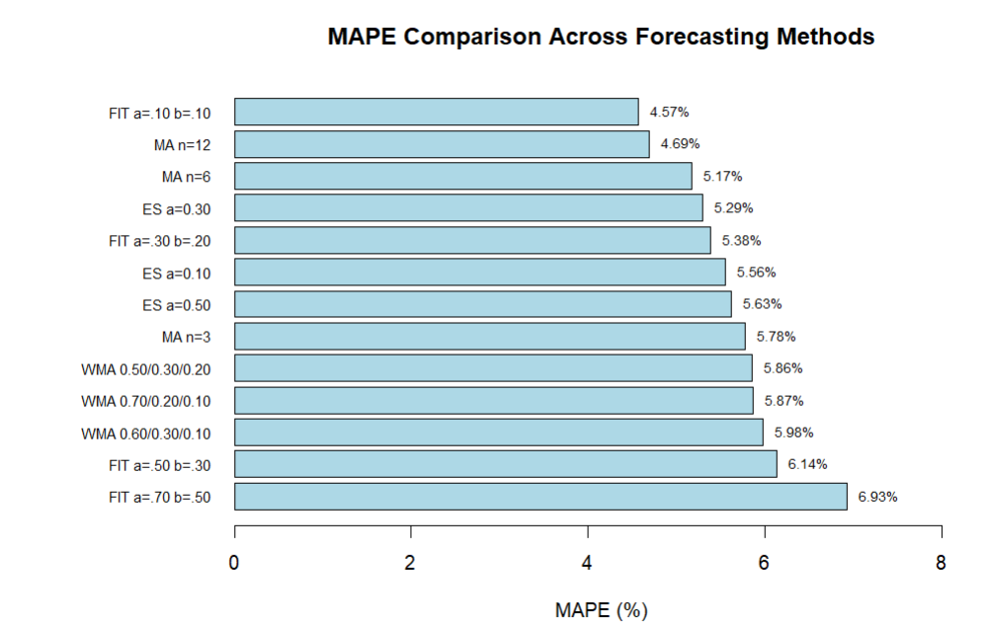
Figure 21: MAPE Comparison Across Forecasting Methods

Figure 21 compares the MAPE values for all tested forecasting settings. Lower MAPE values mean better forecasting accuracy. FIT with α = 0.10 and β = 0.10 had the lowest MAPE value of 4.57%, followed by the 12-month Moving Average with 4.69%. The highest MAPE was obtained by FIT with α = 0.70 and β = 0.50. These results support the good performance of FIT with α = 0.10 and β = 0.10.
Overall, the final comparison shows that FIT with α = 0.10 and β = 0.10 had the lowest MAD and MAPE among the tested forecasting methods. The 12-month Moving Average had the lowest MSE, but MAD was used as the main criterion for selecting the best method. Therefore, FIT with α = 0.10 and β = 0.10 was selected as the preferred forecasting method for this dataset.

Conclusion and Recommendation
This project used different time series forecasting methods on monthly retail sales data from January 2022 to December 2025. The analysis was done using R to organize the data, apply the forecasting methods, calculate the accuracy measures, and create the charts. The methods used were the Naive Method, Moving Average, Weighted Moving Average, Simple Exponential Smoothing, Trend-Adjusted Exponential Smoothing (FIT), and Trend Projection. The final comparison focused on Moving Average, Weighted Moving Average, Simple Exponential Smoothing, and FIT. Different parameter values were tested, and the results were compared using MAD, MSE, and MAPE.
The results showed that FIT with α = 0.10 and β = 0.10 had the lowest MAD value of 27,005.41 and the lowest MAPE value of 4.574% among the methods in the final comparison. The 12-month Moving Average had the lowest MSE value of 1,346,533,628. Since MAD was used as the main criterion, FIT with α = 0.10 and β = 0.10 was selected as the preferred method.
The seasonality analysis also showed a clear pattern in the monthly sales. Sales were usually lower at the beginning of the year, especially in January and February, and higher toward the end of the year. December had the highest seasonal index. The Combined Trend and Seasonal Forecast also showed that including seasonality helped the forecast follow the actual monthly sales more closely.
Based on the final comparison, FIT with α = 0.10 and β = 0.10 is recommended as the preferred forecasting method among the methods compared. However, seasonal patterns should also be considered when forecasting monthly sales because they have an effect on the data.

References
U.S. Census Bureau. (2026). Retail Sales: Retail Trade (MRTSSM44000USN). St. Louis: Federal Reserve Bank of St. Louis. Retrieved from https://fred.stlouisfed.org/series/MRTSSM44000USN

