Sales_Rocket Dashboard Project

**Link : https://public.tableau.com/app/profile/mohammad.abushams/viz/Bookk1_17576026440190/Sales_RocketDashboard?publish=yes**

# SKETCHES

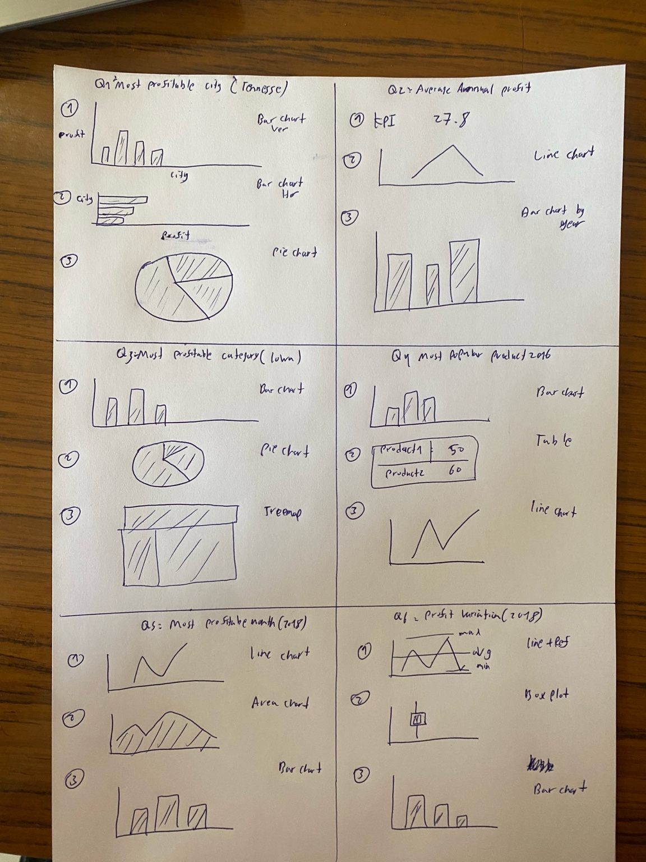

Q1. What is the most profitable City in the State of Tennessee?

**I picked a bar chart to compare profits in each city. It clearly shows which city makes the most money.**

Q2. What’s the average annual profit for that city across all years in that city?

**I used a KPI text box to show the average yearly profit as one easy-to-read number.**

Q3. What’s the most profitable product category in Iowa?

**I chose a bar chart to compare product categories. It helps spot the most profitable category quickly.**

Q4. What is the most popular product in that category in 2016?

**I made a bar chart with product names and quantities to show which product was most popular in 2016.**

Q5. What was the most profitable month in 2018 overall?

**I used a line chart to track profits by month in 2018. The highest point shows the best month.**

Q6. How widely did monthly profits vary in 2018?

**I made a line chart with reference lines (min, max, and average) to show how profits went up and down across the months in 2018.**

# WIREFRAMES

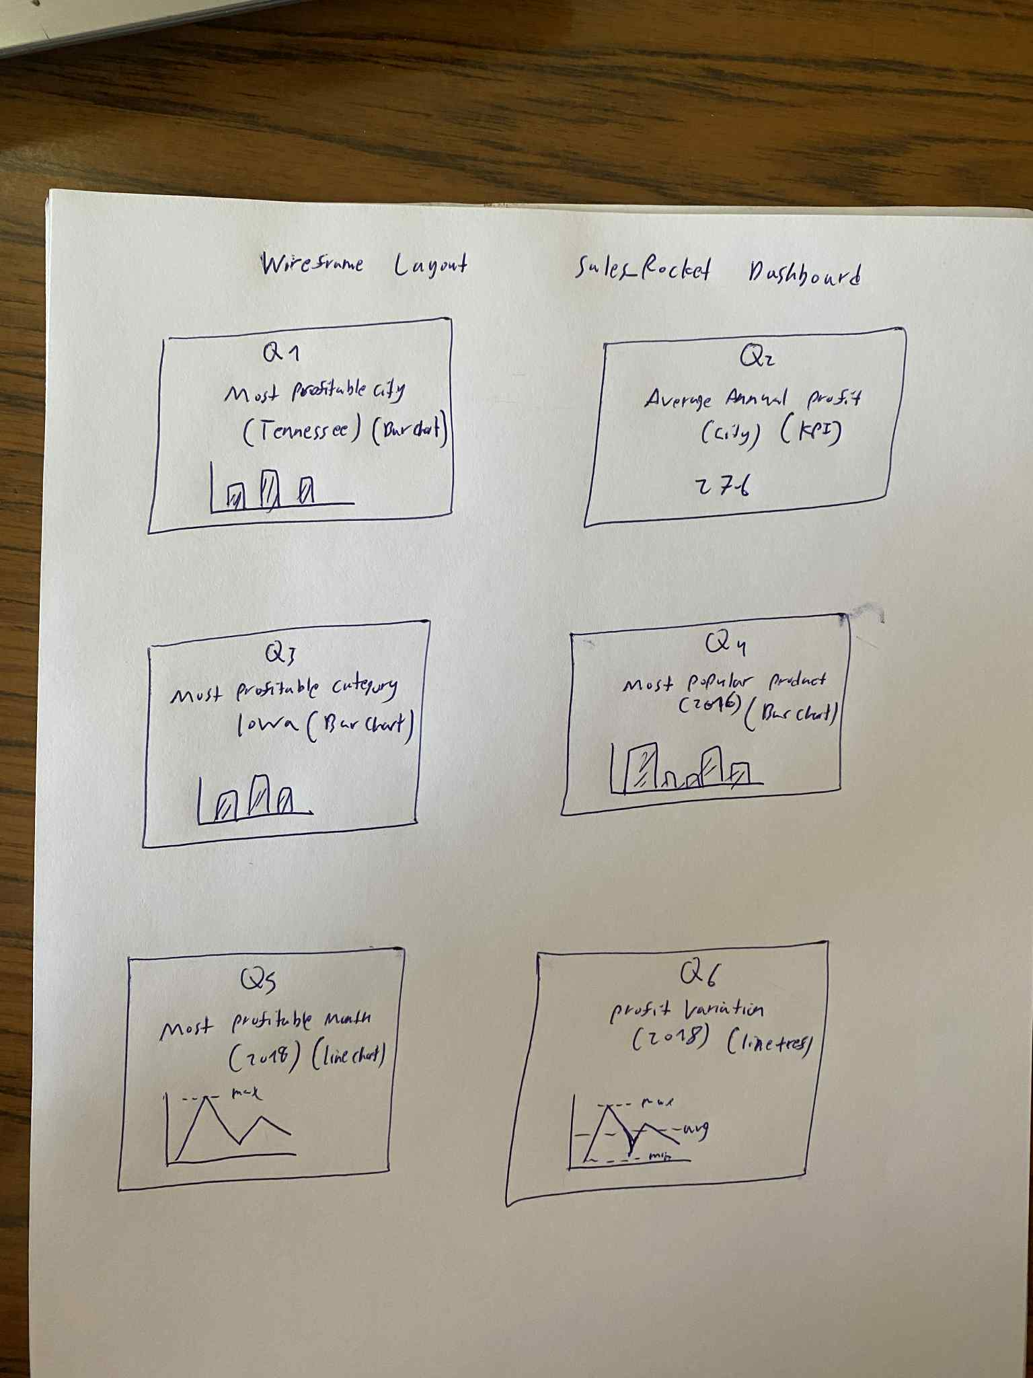

Q1.What is the most profitable City in the State of Tennessee?

**Bar chart to show the most profitable city**

Q2. What’s the average annual profit for that city across all years in that city?

**KPI card to display average annual profit**

Q3.What’s the most profitable product category in Iowa?

**Bar chart to compare product categories in Iowa**

Q4.What is the most popular product in that category in 2016?

**Bar chart to show the most popular product in 2016**

Q5.What was the most profitable month in 2018 overall?

**Line chart to highlight the top month in 2018**

Q6.How widely did monthly profits vary in 2018?

**Line chart with reference lines to show profit changes in 2018**