# Name: Mohammad Abushams

**Email: 1200549@student.birzeit.edu**

**Program: Data Visualization**

**Project 1: US Flight Delays (2015) – Analysis Report**

**Question 1: Which airlines have the worst delays?**

**Links:**  
[Average Arrival Delay by Airline (2015).](https://public.tableau.com/app/profile/mohammad.abushams/viz/Book1_17563312212020/AverageArrivalDelaybyAirline2015?publish=yes)

**Summary:**  
This bar chart shows the average arrival delay for each airline in 2015. Hawaiian Airlines (HA) had the longest delays (about 23 minutes), while Virgin America (VX) and Frontier Airlines (F9) had the shortest (about 13–14 minutes).

**Finding:**  
Some airlines usually had longer delays (HA, EV, DL, UA), while others (VX, F9, AS) did better with shorter delays.

**Design:**  
A bar chart was used to make it easy to compare airlines. All bars are the same color so the only thing that changes is their length, which clearly shows the difference in delays.

**Resources:**  
Udacity project instructions, Tableau official documentation, Kaggle dataset.

**Figure:**

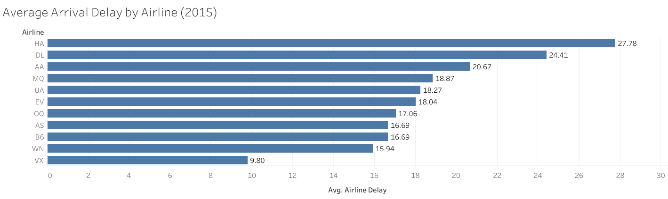

### ****Question 2: What causes delays?****

**Link:**  
[Causes of Flight Delays by Month (2015).](https://public.tableau.com/app/profile/mohammad.abushams/viz/Book1_17563312212020/CausesofFlightDelaysbyMonth2015?publish=yes)

**Summary:**  
The stacked area chart shows the reasons for flight delays in 2015. The biggest reason was Late Aircraft, especially in June (161k minutes). Weather delays stayed low all year, while Airline and Air System delays went up and down.

**Finding:**  
Delays were highest in summer (June–July), mostly because of Late Aircraft.

**Design:**  
A stacked area chart was used to show how each reason adds to the total delays each month. Different colors were used for each reason, making it easy to see patterns and seasonal peaks.

**Resources:**  
Udacity project instructions, Tableau official documentation, Kaggle dataset.

**Figure:**

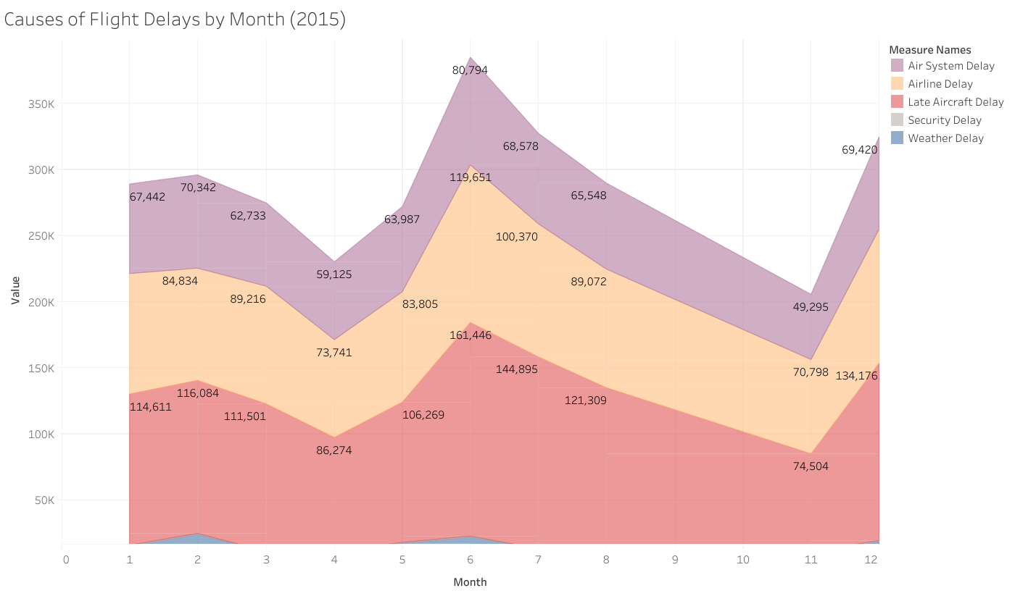

### ****Question 3:**** How do delays vary by time and location?

**Link:**  
[US Airline Delays: Time & Location Insights (Dashboard).](https://public.tableau.com/app/profile/mohammad.abushams/viz/Book1_17563312212020/USAirlineDelaysTimeLocationInsights?publish=yes)

**Summary:**  
This dashboard shows a line chart of average delays by month and a map of average delays by airport in 2015. Users can filter by airline to see changes over time and across locations.

**Finding:**  
The line chart shows clear seasonal trends, with delays peaking in June and dropping in September. The map shows that delays are uneven—airports in the Northeast and West often have more delays, while central airports perform better. Together, the charts show both time and location patterns.

**Design:**  
A line chart was used to show monthly trends, and a map was used to show where delays happen. A blue–orange color scale makes the map easy to read, even for colorblind viewers. An airline filter adds interactivity, letting users focus on specific carriers.

**Resources:**  
Udacity project instructions, Tableau official documentation, Kaggle dataset.

**Figure:**

