1. Open cmd and make sure all files in correct directory otherwise wont work. (test.txt and input.txt)

Ex: C:\Users\Ahmar\Desktop\cs370 project\src (for me)

2. type javac main.java to compile

3. type java main input.txt output.txt

Once you hit enter you will see this screen type in

Username: admin

Password: admin (see pic below)

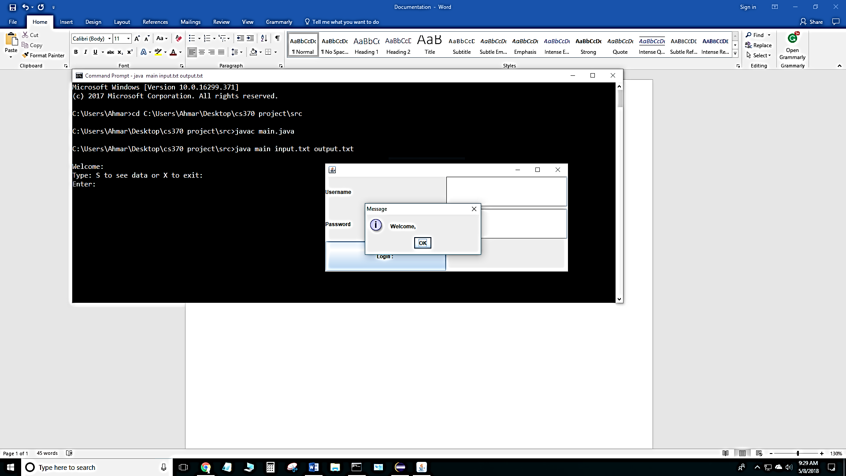

4. data will be read in input.txt and output will be stored in output.txt

Follow program through and image files/html will be found in src file as well as the log transaction if anything is added/deleted or modified in hashtable.

Final pics below:

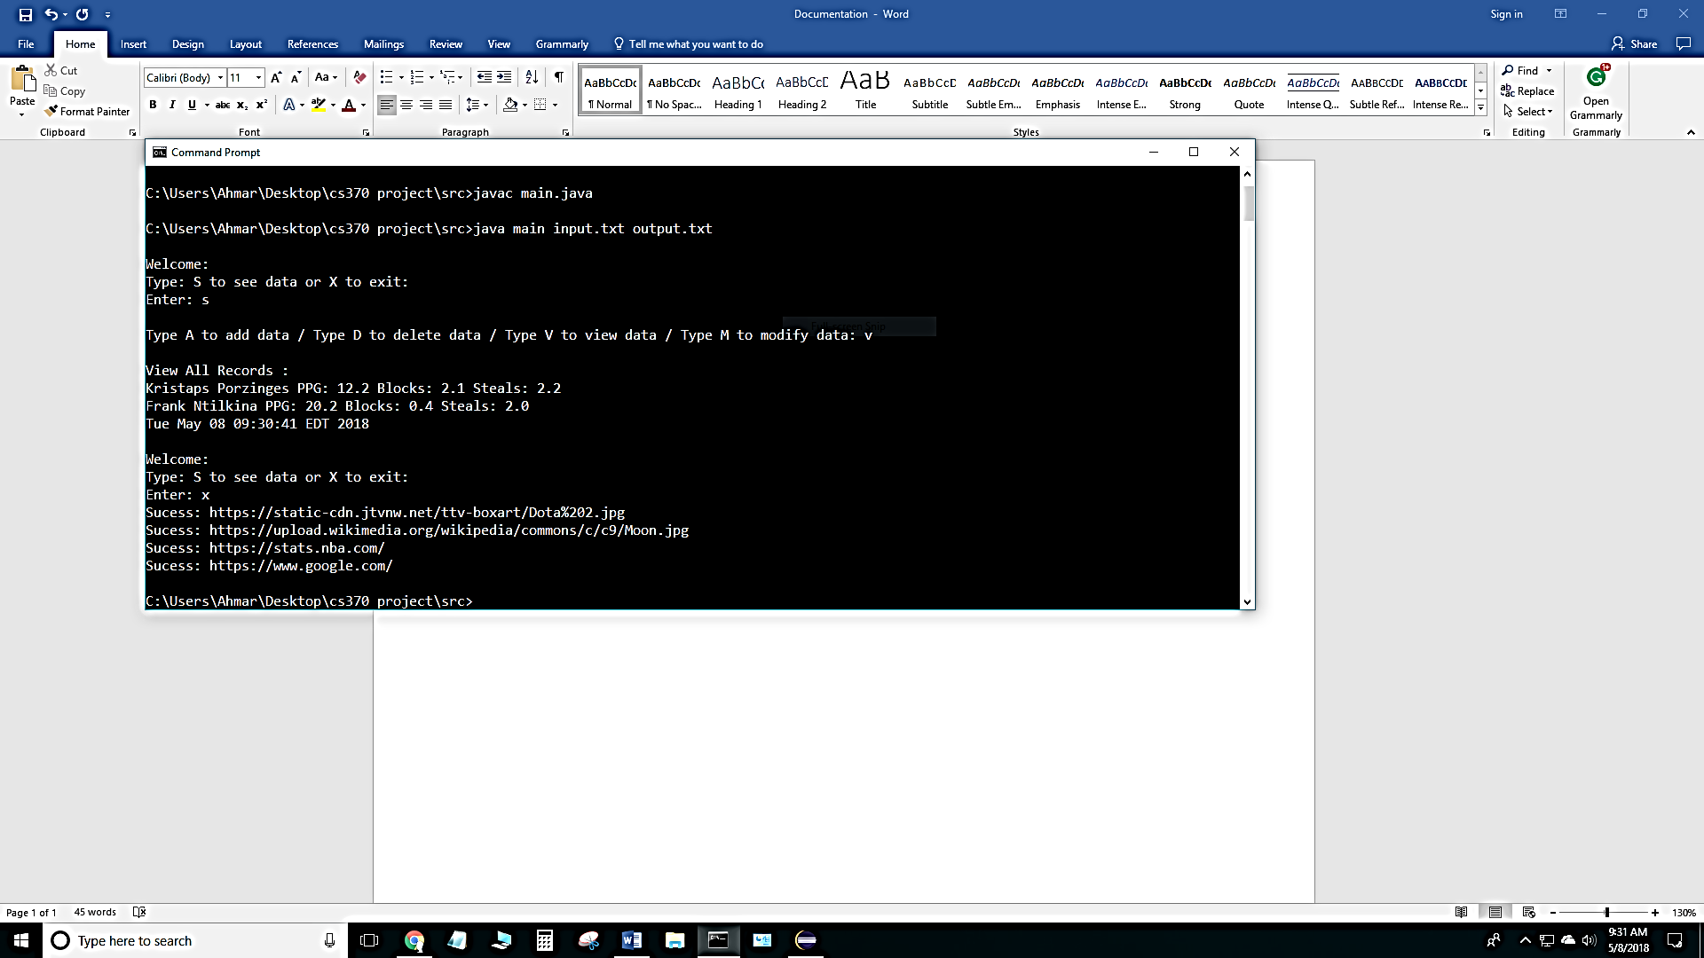

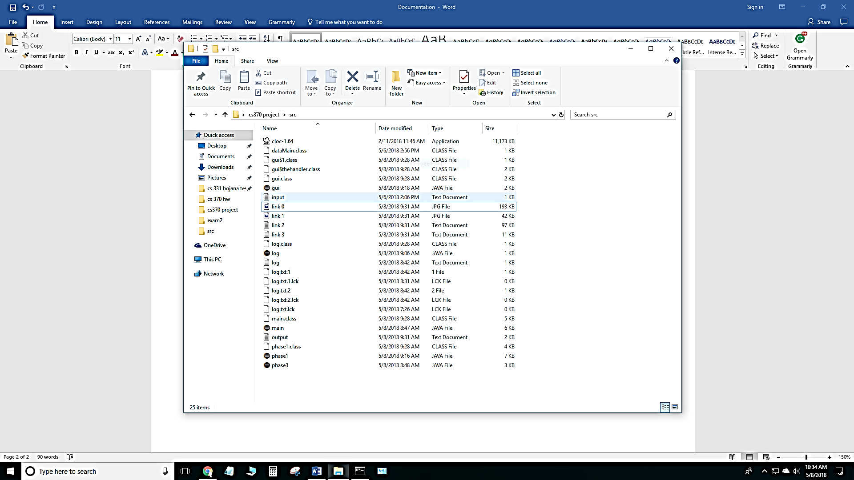

Note: test.txt is the info stored into hashtable from file (phase1)