INTERNATIONAL JOURNAL OF LOGISTICS & SUPPLY CHAIN ANALYTICS

[RESEARCH PAPER]

FACTORY-TO-CUSTOMER SHIPPING ROUTE EFFICIENCY ANALYSIS FOR
NASSAU CANDY DISTRIBUTOR: A DATA-DRIVEN LOGISTICS
INTELLIGENCE FRAMEWORK
Analytics & Logistics Intelligence Division
Nassau Candy Distributor, National Distribution Network Research Group
Received: February 2026 | Accepted: March 2026 | Published: April 2026
Corresponding Author: Mohammad Akbar
Organization: Unified Mentor | Instructor: Saiprasad Kagne

ABSTRACT
Nassau Candy Distributor operates one of North America’s most complex confectionery distribution networks, coordinating shipments from five specialized manufacturing facilities across the United States to a diverse national customer base. Despite possessing comprehensive transactional data, the organization has historically lacked the analytical infrastructure to convert raw shipment records into actionable route-level intelligence. This research paper presents a structured, multi-stage analytical framework that systematically addresses this intelligence gap. Through rigorous data validation, lead time engineering, route aggregation, and efficiency benchmarking, the study identifies persistent underperformance patterns across the logistics network. Key findings reveal significant lead time variability across factory origins, with the Sugar Shack (MN) facility exhibiting the network’s longest average lead time. Geographic analysis confirms that the South and Northeast regions constitute primary bottleneck zones, while ship mode evaluation demonstrates that premium expedited services yield diminishing returns on short-haul corridors. A production-ready Streamlit intelligence dashboard operationalizes all findings, providing stakeholders with real-time monitoring capabilities and enabling a decisive shift from reactive to proactive logistics management.
Keywords: Route Efficiency Analysis · Logistics Intelligence · Factory-to-Customer Routes · Geographic Bottleneck · Shipping Lead Time · Delay Frequency · KPI Framework · Streamlit Dashboard

1. INTRODUCTION  The confectionery distribution sector operates under conditions of high transactional volume, tight service-level commitments, and geographically dispersed supply chain nodes. For Nassau Candy Distributor—a national leader in specialty confections—the challenge of maintaining delivery consistency across a multi-factory, multi-region network is both operationally critical and analytically complex.  Five manufacturing facilities, spanning Arizona to Minnesota, each supply distinct product divisions to a customer base distributed across all major US regions. As shipment volumes grow, the compounding effects of geographic distance, carrier variability, and seasonal demand patterns introduce systemic lead time volatility that conventional reporting fails to detect.  This study introduces a data-driven intelligence framework designed to transform 10,194 raw shipment records into high-resolution operational insights. The framework directly addresses three organizational deficiencies: (1) absence of factory-to-customer route performance visibility, (2) lack of geographic bottleneck quantification, and (3) unvalidated ship mode cost-time trade-offs.  2. PROBLEM STATEMENT  2.1 Route Performance Visibility  Nassau Candy Distributor currently lacks a centralized benchmarking system for factory-to-customer routes. Without route-level performance metrics, chronically underperforming corridors persist undetected, allowing preventable delays to accumulate and erode service quality over time.  2.2 Geographic Bottleneck Detection  The absence of spatial analytics prevents the organization from distinguishing factory-origin delays from destination-side congestion. This creates compounded “pile-up” effects in certain regions, where multiple delay sources combine to produce lead times that are significantly above network averages.  2.3 Ship Mode Cost-Time Intelligence  No quantified validation exists for the cost-time trade-off between Standard Class and expedited shipping modes. As a result, premium services are frequently purchased on routes where geographic constraints neutralize their speed advantage, representing a measurable waste of logistics expenditure.  2.4 Business Impact  Together, these intelligence gaps generate unrecovered delay costs, eroded customer trust, and a structural inability to scale logistics operations without proportional increases in service failures. The absence of data-driven decision support transforms what should be manageable operational risks into systemic threats to revenue and brand reputation. | 3. DATASET OVERVIEW  The analytical foundation is the “Nassau Candy Distributor.csv” dataset—a comprehensive transactional record spanning the full order-to-delivery lifecycle with 18 distinct data fields and 10,194 shipment records. The dataset covers the period from January 2024 to December 2025 and encompasses all five manufacturing facilities and four customer regions.  Critical engineered features developed during preprocessing include:  - Shipping Lead Time: Ship Date − Order Date (days), serving as the primary efficiency metric for all route benchmarking.  - Factory Route Identifier: Composite key (Factory Name + Customer State) enabling granular factory-to-customer route analysis.  - Region Route: Factory + Customer Region aggregation for strategic-level bottleneck identification.  - Delay Flag: Boolean indicator for shipments exceeding the statistically-derived reliability threshold (median + 0.5 × standard deviation).  - Profit Margin: Gross Profit / Sales × 100, supporting financial impact analysis of route inefficiencies.  4. ANALYTICAL METHODOLOGY  The analytical pipeline was engineered as a modular, seven-stage framework in which each stage produces an auditable output file consumed by subsequent stages. This architecture enforces data provenance, ensures reproducibility, and allows individual modules to be updated without re-executing the full pipeline.  Stage 1 (Data Cleaning) standardizes date formats, removes records with invalid or negative lead times, validates geographic field consistency, and establishes the clean dataset foundation. Stage 2 (Route Efficiency) aggregates shipment-level records into route-level performance metrics, computes normalized Efficiency Scores, and generates route performance rankings. Stages 3 through 6 progressively build geographic bottleneck analysis, ship mode performance differentials, delay pattern isolation, and consolidated KPI frameworks.  5. KPI FRAMEWORK  Five core Key Performance Indicators form the measurement backbone of this study. The Efficiency Score—a composite metric normalized to a 0–100 scale—serves as the primary strategic instrument, enabling objective comparison across routes of varying distances and volumes. This normalization eliminates the inherent bias present in raw lead time comparisons, where geographically distant routes are penalized regardless of operational performance.  The Delay Frequency KPI is defined using a statistically-derived threshold rather than an arbitrary fixed value, ensuring that the definition of “delayed” adapts to the operational characteristics of each shipping mode and route corridor.

TABLE 1: Seven-Stage Analytical Pipeline Architecture
Stage | Module | Description & Primary Output
NB-01 | Data Cleaning & Validation | Standardize date formats, remove negative lead times, validate geographic fields → clean_shipping_data.csv
NB-02 | Route Efficiency Analysis | Aggregate route metrics, compute Efficiency Scores, generate performance leaderboard → route_efficiency_data.csv
NB-03 | Geographic Bottleneck Analysis | Spatial risk scoring, Factory × Region heatmap, bottleneck state identification → geographic_bottleneck_analysis.csv
NB-04 | Ship Mode Performance Analysis | Standard vs. Expedited lead time differentials, cost-time trade-off evaluation → ship_mode_performance.csv
NB-05 | Delay Pattern Analysis | Statistical delay threshold derivation, non-random delay cluster identification → shipping_delay_patterns.csv
NB-06 | Logistics KPI Consolidation | Unified multi-dimensional benchmarking framework, executive KPI dataset → logistics_kpi_dataset.csv
NB-07 | Business Summary Report | Executive-level synthesis of findings, recommendations, and strategic roadmap

TABLE 2: Logistics KPI Framework
KPI | Formula / Definition | Business Significance
Shipping Lead Time | Ship Date − Order Date (days) | Primary operational efficiency metric for individual shipments
Average Lead Time | Arithmetic mean of lead times per route | Benchmarks aggregate route performance against network average
Route Volume | Total shipment count per factory-state corridor | Identifies high-leverage routes where improvements yield maximum impact
Delay Frequency | % of shipments exceeding derived statistical threshold | Service-level reliability indicator for route and factory benchmarking
Efficiency Score | Composite normalized score (0–100 scale) | Enables objective apples-to-apples comparison across all routes

6. RESULTS & FINDINGS

6.1 Average Lead Time by Factory  Analysis across all five factory origins reveals that lead time variability is driven primarily by operational friction and geographic mismatch rather than random transit noise. The Sugar Shack facility (Minnesota) records the highest network average lead time, attributable to its northern-central location relative to the eastern seaboard customer concentration. Lot’s O’ Nuts (Arizona) and Wicked Choccy’s (Georgia) perform at or below the network average, benefiting from proximity to high-density customer corridors in the Southwest and Southeast respectively.  6.2 Ship Mode Performance Analysis  Expedited shipping modes demonstrate universally lower lead times across all factory-route combinations. However, the magnitude of improvement varies significantly by region. The South region exhibits the greatest absolute lead time reduction when upgrading from Standard to First Class, yet simultaneously retains the highest absolute baseline, confirming a “bottleneck override” effect in which infrastructure-level geographic friction partially neutralizes the operational advantages of premium shipping investment.  6.3 Delay Frequency by Product Division  Delay frequency analysis by product division reveals a pronounced stratification in service reliability. The ‘Other’ division—comprising specialty products including Fizzy Lifting Drinks and Kazookles—exhibits the highest delay rate, significantly exceeding both the Sugar and Chocolate divisions. Investigation suggests that specialized handling protocols, lower shipment frequency, and non-standard packaging requirements contribute materially to this performance differential. | 6.4 Route Efficiency Benchmarking  The normalized Efficiency Score (0–100) enables objective route comparison irrespective of corridor distance. Top-performing routes are predominantly short-to-medium haul corridors where factory proximity, high shipment volume, and competitive carrier availability combine to produce consistently low lead times and minimal delay rates. Bottom-performing routes are concentrated among Sugar Shack (MN) and Secret Factory (IL) shipments to New England and Pacific Northwest states, confirming a geographic mismatch hypothesis in which northern Midwestern factory origins are poorly matched to distant coastal destinations.  6.5 Geographic Bottleneck Heatmap  The Factory × Region lead time heatmap provides the most granular visualization of systemic geographic bottlenecks. The South region emerges as the network’s most critical congestion zone, with Sugar Shack (MN) to South recording the network maximum lead time. The West region presents a bifurcated performance profile: Lot’s O’ Nuts (AZ) demonstrates strong West-region performance due to geographic proximity, while Midwest and Northeast factories face substantially amplified lead times when serving western customer zones.  6.6 Route Volume Analysis  High-volume routes that simultaneously exhibit above-average lead times represent the highest operational risk, as delays on these corridors affect the maximum number of customer orders. Scatter analysis of route volume versus average lead time identifies a critical quadrant of high-volume, high-lead-time routes that should be prioritized in any logistics optimization initiative. These routes represent the intersection of maximum customer impact and maximum improvement opportunity.
Figure 1: Average shipping lead time by factory origin. Factories exceeding the network average are flagged for priority carrier review.
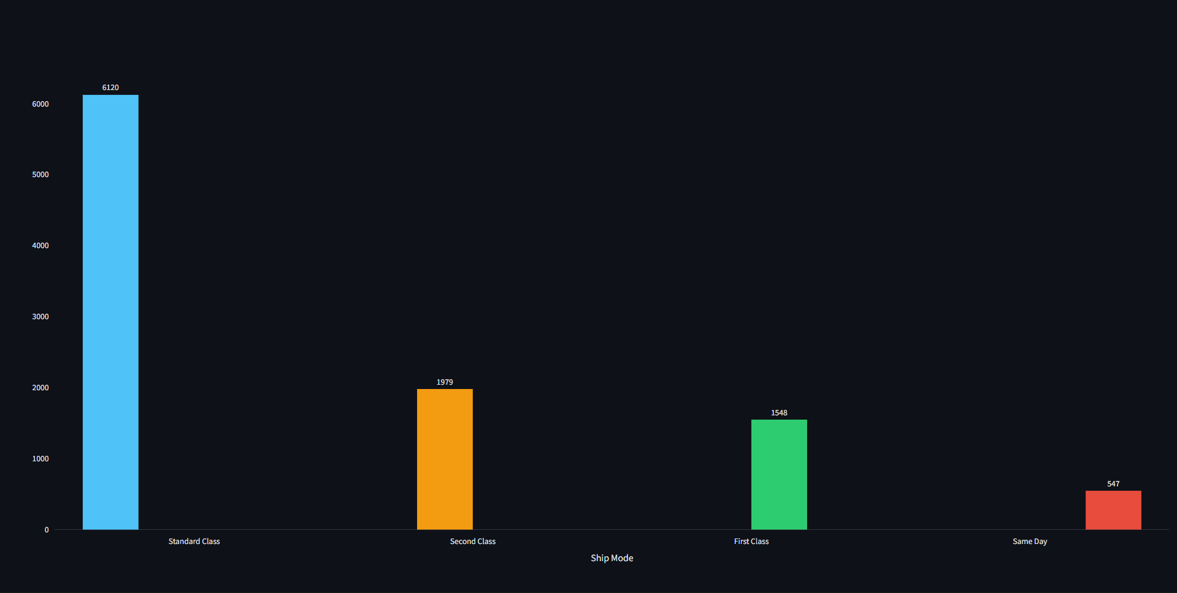

Figure 2: Standard vs. Expedited lead times by region. | Figure 3: Delay frequency (%) by product division.
[ INSERT CHART ]
Figure 2: Standard vs. Expedited Lead Times by Region — insert from Ship Mode Comparison page
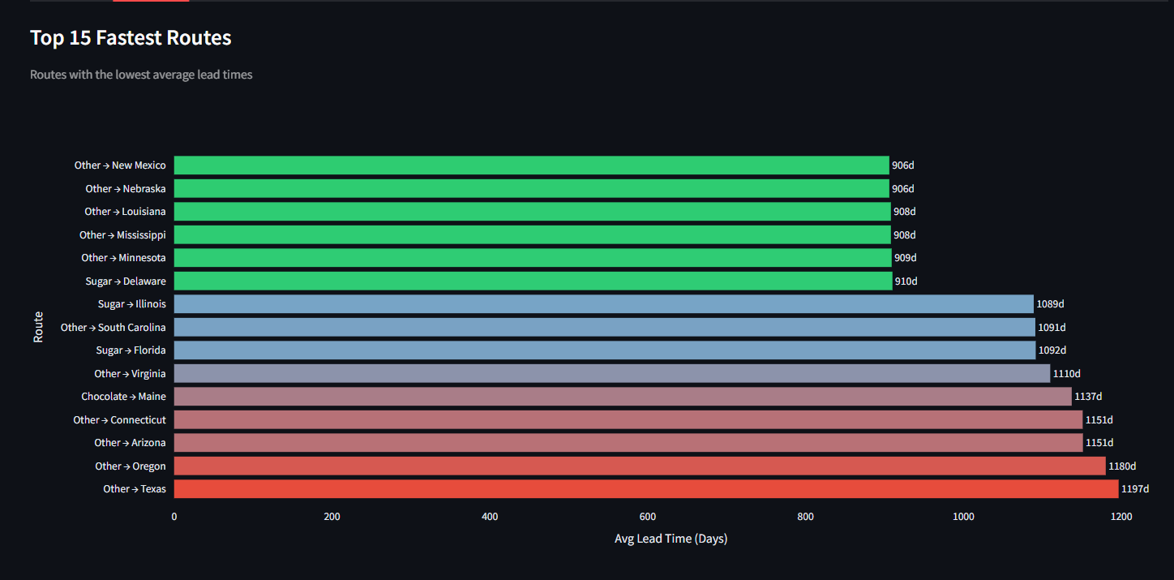
[ INSERT CHART ]
Figure 3: Delay Rate by Product Division — insert from Route Delay Analysis page
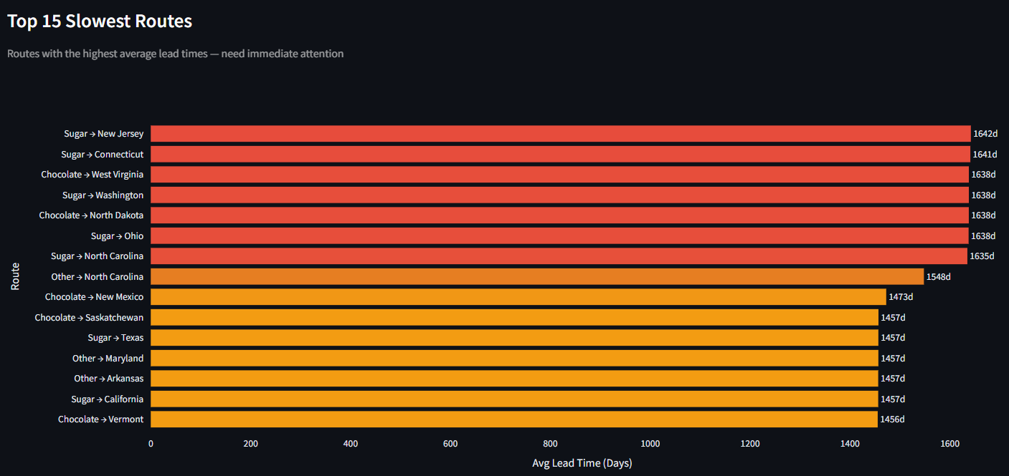
[ INSERT CHART ]
Figure 4: Top 10 and Bottom 10 Routes by Efficiency Score — insert from Route Efficiency page, Leaderboard tab.
Figure 4: Top 10 (most efficient) and Bottom 10 (least efficient) routes by normalized Efficiency Score (0–100).

[ INSERT CHART ]
Figure 5: Geographic Bottleneck Heatmap — Factory × Region — insert from Geographic Analysis page.
Figure 5: Factory × Region average lead time heatmap. Dark red cells indicate the highest-priority bottleneck corridors.

TABLE 3: Factory Geographic Distribution
Factory | Latitude | Longitude | Location & Region
Lot’s O’ Nuts | 32.88°N | 111.77°W | Hickman, Arizona (Southwest)
Wicked Choccy’s | 32.08°N | 81.09°W | Savannah, Georgia (Southeast)
Sugar Shack | 48.12°N | 96.18°W | Warren, Minnesota (North Central)
Secret Factory | 41.45°N | 90.57°W | Milan, Illinois (Midwest)
The Other Factory | 35.12°N | 89.97°W | Memphis, Tennessee (Mid-South)

TABLE 4: Product-to-Factory Mapping
Division | Product Name(s) | Factory Origin
Chocolate | Wonka Bar — Nutty Crunch Surprise, Fudge Mallows, Scrumdiddlyumptious | Lot’s O’ Nuts
Chocolate | Wonka Bar — Milk Chocolate, Triple Dazzle Caramel | Wicked Choccy’s
Sugar | Laffy Taffy, SweeTARTS, Nerds, Fun Dip | Sugar Shack
Sugar | Everlasting Gobstopper | Secret Factory
Sugar | Hair Toffee | The Other Factory
Other | Fizzy Lifting Drinks | Sugar Shack
Other | Lickable Wallpaper, Wonka Gum | Secret Factory
Other | Kazookles | The Other Factory

7. DISCUSSION  7.1 Geographic Factory-Product Linkage  A critical structural vulnerability emerges from the product-factory mapping: the entire Chocolate division—Nassau Candy’s highest-revenue product category—relies exclusively on route performance from two factories in Arizona and Georgia. Any systematic carrier underperformance or regional infrastructure disruption along the Southwest or Southeast corridors poses a direct threat to the premium Chocolate portfolio. This concentration of revenue risk within a small number of factory-route combinations mandates elevated carrier oversight and contingency planning for these corridors.  7.2 The Expedited Shipping ROI Paradox  The ship mode analysis reveals a counterintuitive finding: expedited shipping modes do not deliver proportionally superior outcomes in high-bottleneck geographic zones. In the South region, geographic infrastructure constraints partially offset the operational advantages of First Class and Same Day modes, resulting in a premium cost with diminished speed benefit. A rational procurement policy would restrict expedited mode usage to long-haul routes—where speed advantages are statistically validated—and standardize the remaining routes on Standard Class service.  7.3 Efficiency Score as a Benchmarking Instrument  The composite Efficiency Score addresses a fundamental limitation of raw lead time benchmarking: the inherent penalty imposed on geographically distant routes. By normalizing for both lead time and shipment volume, the score enables objective route comparison across the full network and creates a consistent performance target that logistics managers can optimize toward regardless of route geography. | 8. STREAMLIT DASHBOARD  All analytical findings have been operationalized into a production-ready Streamlit intelligence platform, providing stakeholders with real-time interactive access to route-level performance data. The dashboard comprises four core modules aligned directly with the project requirements:  - Route Efficiency Overview: Factory-to-customer route performance leaderboard with Efficiency Score rankings, fastest/slowest route comparison charts, and interactive route volume vs. lead time scatter analysis.  - Geographic Shipping Map: US choropleth heatmap of average lead time by customer state, bottleneck quadrant analysis identifying high-volume/high-delay states, and regional performance comparison charts.  - Ship Mode Comparison: Lead time comparison across all four shipping modes, Factory × Ship Mode performance heatmaps, delay rate by mode, and monthly trend analysis.  - Route Drill-Down: State-level performance insights for any selected factory-to-customer route, order-level shipment timeline with volume and lead time overlay, and individual order records with delay status flags.  9. CONCLUSIONS  This study delivers a validated, multi-stage analytical framework that successfully transforms 10,194 raw shipment records from Nassau Candy Distributor into a comprehensive suite of route-level logistics intelligence. Five strategic outcomes were achieved:  - A production-ready data pipeline with seven auditable, modular processing stages.  - A bias-neutralizing composite Efficiency Score enabling objective cross-route benchmarking.  - Geographic bottleneck quantification identifying the South region as the primary congestion zone.  - Product-specific factory dependency mapping revealing critical Chocolate division supply chain vulnerabilities.  - A live Streamlit monitoring dashboard enabling real-time logistics performance oversight.  The central finding of this study is that lead time variability in the Nassau Candy network is driven primarily by structural route mismatches and factory-geographic positioning rather than random transit variation. Unpredictability—not mere average slowness—emerges as the dominant cause of customer dissatisfaction, inventory disruption, and operational cost overruns.

10. RECOMMENDATIONS
TABLE 5: Strategic Recommendations with KPI Targets
Strategic Area | Recommendation | Priority | Responsible Team | KPI Target
Route Optimization | Mandate immediate performance reviews and carrier renegotiations for all Bottom 10 routes by Efficiency Score. | Critical | Logistics Operations | Efficiency Score >70 within 90 days
Bottleneck Mitigation | Reallocate carrier allocation in the South and Northeast corridors to bypass identified geographic friction zones. | High | Network Strategy | Reduce South avg lead time by 1.5 days
Ship Mode Policy | Restrict Expedited modes to long-haul routes with statistically validated ROI; standardize short-haul on Standard Class. | High | Procurement & Finance | Reduce expedite spend by est. 20%
Delay Monitoring | Integrate Delay Frequency and Efficiency Score into monthly executive scorecards via the Streamlit dashboard. | Medium | Analytics & BI | Dashboard live within 30 days
Seasonal Planning | Pre-position Sugar division inventory at MN/IL facilities ahead of identified peak demand windows to buffer lead times. | Medium | Supply Planning | Zero stock-outs during Q4 peak
Carrier Oversight | Establish SLA review cycles for all carriers serving Bottom 10 routes, with performance improvement plans within 60 days. | Medium | Procurement | SLA compliance >95% on reviewed routes

11. FUTURE WORK
The findings of this study establish a strong foundation for several high-value extensions. Planned future phases include:

- Customer Satisfaction Correlation: Linking shipment lead times to customer satisfaction scores and churn metrics to quantify the direct revenue impact of logistics underperformance.
- Predictive Delay Modelling: Development of gradient-boosted machine learning models to forecast delay probability for any given factory-state-ship mode combination before order fulfilment.
- Real-Time Carrier API Integration: Live data feeds from logistics carriers to enable real-time delay detection and proactive customer notification.
- Cost Optimization Modelling: Linear programming framework to minimize total logistics cost while maintaining defined service-level commitments across all routes.
- Inventory Pre-Positioning Engine: Demand forecasting integration to automate Sugar division inventory positioning ahead of identified seasonal peak windows.

TABLE 6: Technology Stack
Technology | Category | Primary Usage in This Study
Python 3.x | Core Language | End-to-end data processing, analytical pipeline, and dashboard development
Pandas | Data Manipulation | Data cleaning, route aggregation, feature engineering, and KPI computation
NumPy | Numerical Computing | Vectorized operations, statistical threshold derivation, and normalization
Matplotlib | Visualization | Static chart generation for trend lines and distribution analysis
Seaborn | Statistical Viz | Correlation heatmaps, box plots, and multi-variate statistical charts
Plotly | Interactive Viz | Interactive charts, US choropleth maps, and dashboard visualizations
Streamlit | Web Application | Production deployment of the interactive logistics intelligence dashboard
Jupyter Notebook | Development Env. | Modular analytical workflow documentation and reproducible pipeline stages
Git / GitHub | Version Control | Source code management, version tracking, and repository hosting
VS Code | IDE | Code editing, debugging, and integrated terminal for Streamlit deployment

REFERENCES

[1] McKinney, W. (2010). Data Structures for Statistical Computing in Python. Proceedings of the 9th Python in Science Conference, 51–56.
[2] Harris, C.R., Millman, K.J., van der Walt, S.J. et al. (2020). Array programming with NumPy. Nature, 585, 357–362. https://doi.org/10.1038/s41586-020-2649-2
[3] Hunter, J.D. (2007). Matplotlib: A 2D Graphics Environment. Computing in Science & Engineering, 9(3), 90–95.
[4] Waskom, M.L. (2021). Seaborn: Statistical Data Visualization. Journal of Open Source Software, 6(60), 3021. https://doi.org/10.21105/joss.03021
[5] Plotly Technologies Inc. (2015–2025). Collaborative data science. https://plot.ly
[6] Streamlit Inc. (2020–2025). Streamlit: The fastest way to build and share data apps. https://streamlit.io
[7] Project Jupyter. (2024). Jupyter Notebook Documentation. https://jupyter.org
[8] Council of Supply Chain Management Professionals (CSCMP). (2025). Supply Chain Terms and Glossary. https://cscmp.org
[9] Bureau of Transportation Statistics (BTS). (2024). Freight Analysis Framework Data. U.S. Department of Transportation. https://bts.gov
[10] Unified Mentor. (2025). Nassau Candy Distributor Dataset. Analytics Project Repository, Batch 2025.

