Medi App Project Report

Table of Contents

1. Introduction

2. Features of the Weather App

3. API Integration

4. Firebase Integration

5. Widgets and UI Components

6. Navigation and Routing

7. App Architecture

8. App Pages

9. Challenges Faced

10. Conclusion

11. Future Enhancements

References

1. Introduction

1.1 Project Overview
The Medi App is a comprehensive medical application developed using Flutter, designed to provide users with a seamless experience for booking doctor appointments, managing messages, and accessing various health services. The app integrates with Firebase for backend services and utilizes various Flutter widgets for a rich user experience.

1.2 Objectives
- To offer a platform where users can book appointments with doctors.
- To facilitate communication between users and healthcare professionals through chat functionality.
- To allow users to explore symptoms and find suitable doctors.
- To integrate Firebase for authentication, data storage, and real-time updates.

2. Features

2.1 User Authentication
- Login Page: Allows users to log into the application.
- Sign Up Page: Provides a registration option for new users.
- Firebase Authentication: Handles user sign-in and sign-up processes securely.

2.2 Doctor Appointment Booking
- Home Screen: Displays options for clinic visits and home visits. Users can choose their preferred option and make appointments.
- Appointment Screen: Provides a detailed view of available doctors and allows users to book appointments.

2.3 Messaging System
- Message Screen: Lists recent chats and active users. Users can view and initiate conversations with doctors.
- Chat Screen: Allows users to communicate with doctors in real-time.

2.4 Symptom Checker
- Home Screen: Features a symptom checker where users can select their symptoms to find relevant doctors.

2.5 User Profile
- Profile Management: Allows users to manage their personal information and settings.

3. Technical Stack

3.1 Flutter
- Framework: Flutter is used for building the cross-platform user interface, providing a smooth and responsive experience across different devices.
- Widgets: Utilizes various Flutter widgets like Scaffold, AppBar, ListView, GridView, InkWell, Material, TextFormField, etc., to construct the UI.

3.2 Firebase
- Authentication: Manages user sign-up and sign-in through Firebase Authentication.
- Firestore: Stores and retrieves user data, messages, and appointment details in real-time.
- Firebase Storage: Used to store and retrieve profile images and other assets.

3.3 APIs
- Backend Services: RESTful APIs may be used to interact with external services for functionalities such as payment processing or accessing additional health information.
- Integration: APIs are integrated into the app for functionalities like real-time updates and data synchronization.

4. Flutter Widgets

4.1 AppBar
- Purpose: Provides a consistent header for screens with navigation options and titles.
- Customization: Includes actions like call, video call, and more options in the ChatScreen.

4.2 ListView
- Purpose: Displays a scrollable list of items, such as messages or symptoms.
- Customization: Used in MessageScreen for recent chats and HomeScreen for symptoms.

4.3 GridView
- Purpose: Shows items in a grid layout, useful for displaying doctors in HomeScreen.
- Customization: Configured to show doctor profiles with images and ratings.

4.4 TextFormField
- Purpose: Provides input fields for user data entry.
- Customization: Used in search functionality and chat input areas.

5. Navigation

5.1 Route Management
- Navigator: Handles navigation between screens, such as moving from the WelcomeScreen to LoginPage or SignupPage.
- MaterialPageRoute: Used for defining routes and managing transitions.

5.2 Screens
- WelcomeScreen: The initial screen with options to log in or sign up.
- LoginPage: Allows users to log into their accounts.
- SignupPage: Provides a registration form for new users.
- HomeScreen: Displays options for booking appointments and checking symptoms.
- MessageScreen: Shows recent chats and active users.
- ChatScreen: Allows real-time messaging between users and doctors.
- AppointmentScreen: Enables users to book appointments with doctors.

6. User Interface Design

6.1 Design Principles
- Consistency: Ensures a consistent look and feel across all screens.
- Responsiveness: Adapts to different screen sizes and orientations.
- Accessibility: Provides features like readable fonts, accessible colors, and clear navigation.

6.2 Layouts
- Screen Layouts: Describes the layout structure for different screens including padding, margins, and alignment.

6.3 Color Scheme and Typography
- Colors: Uses a primary color (#7165D6) and secondary colors to maintain brand consistency.
- Typography: Defines font sizes, weights, and styles for various text elements.

7. Firebase Integration

7.1 Firebase Authentication
- Sign-In/Sign-Up: Handles user authentication and account management.
- Security: Ensures secure access to the application.

7.2 Firestore
- Data Storage: Stores user profiles, appointment details, and chat messages.
- Real-Time Updates: Provides real-time data synchronization.

7.3 Firebase Storage
- Image Storage: Stores user profile images and other media files.
- Access: Retrieves images and assets for display in the app.

8. Challenges and Solutions

8.1 Challenges
- Real-Time Messaging: Implementing efficient real-time chat functionality.
- Data Synchronization: Ensuring data consistency across different screens and users.

8.2 Solutions
- Firebase Integration: Utilized Firebase for real-time updates and data storage.
- Widget Optimization: Implemented efficient Flutter widgets to handle large datasets and improve performance.

9. Testing

9.1 Unit Testing
- Purpose: Tests individual functions and methods to ensure they work as expected.

9.2 Integration Testing
- Purpose: Tests interactions between different components and screens.

9.3 User Testing
- Purpose: Gathers feedback from real users to identify usability issues and improve the app.

10. Future Enhancements

10.1 Additional Features
- Telemedicine: Integration of video consultations.
- Advanced Symptom Checker: Enhanced symptom analysis and recommendations.

10.2 Performance Improvements
- Optimization: Fine-tuning the app for better performance and responsiveness.
- Bug Fixes: Addressing any issues identified during testing.

11. Conclusion

11.1 Summary
The Medi App provides a comprehensive solution for managing doctor appointments, messaging, and health symptom checking. Built using Flutter and Firebase, it offers a robust and scalable platform for users and healthcare professionals.

11.2 Acknowledgments
Thank you to all contributors and testers who helped make the Medi App a success.

12. References
- Flutter Documentation: https://flutter.dev/docs
- Firebase Documentation: https://firebase.google.com/docs

Interface:
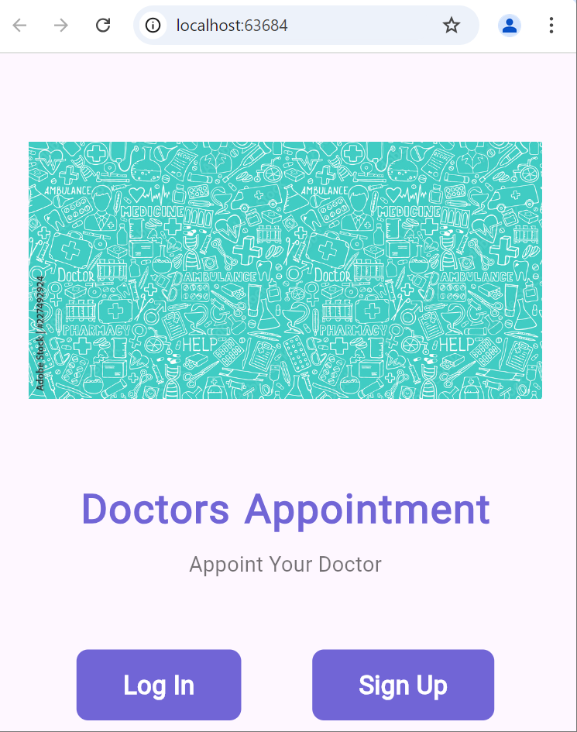 | 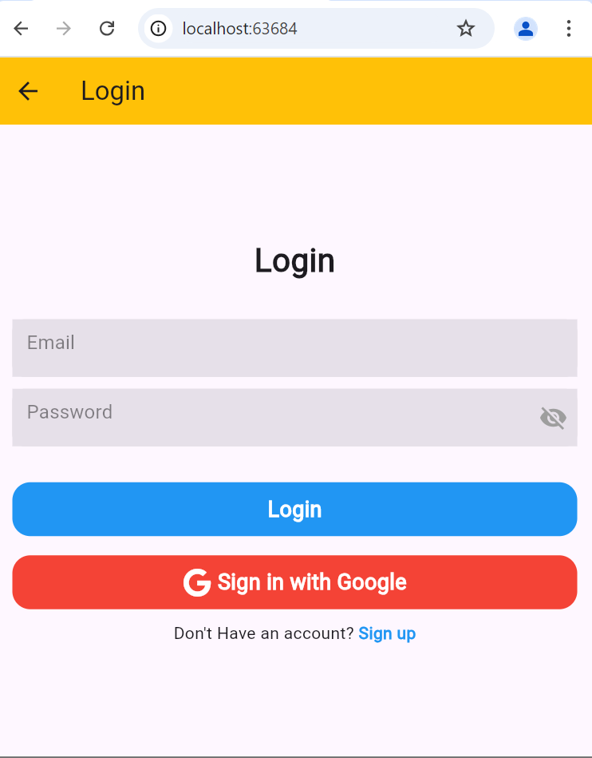
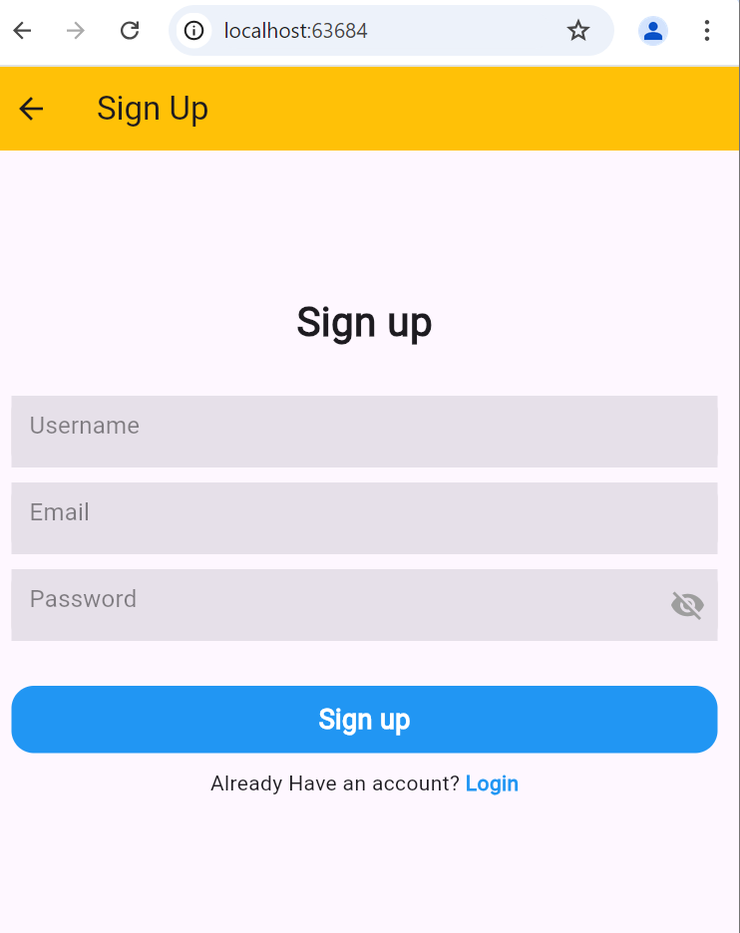 | 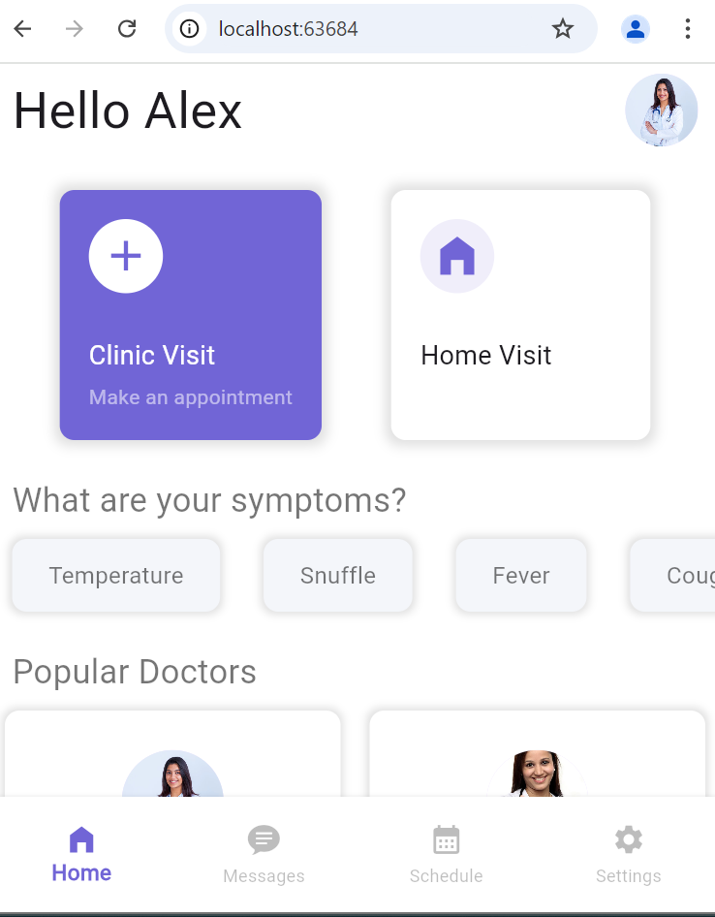

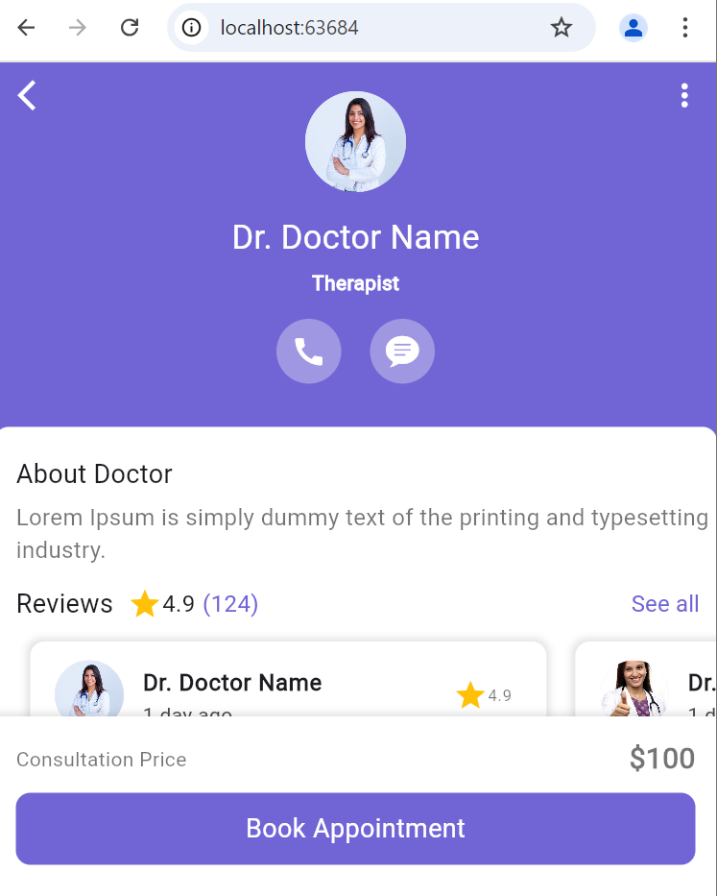 | 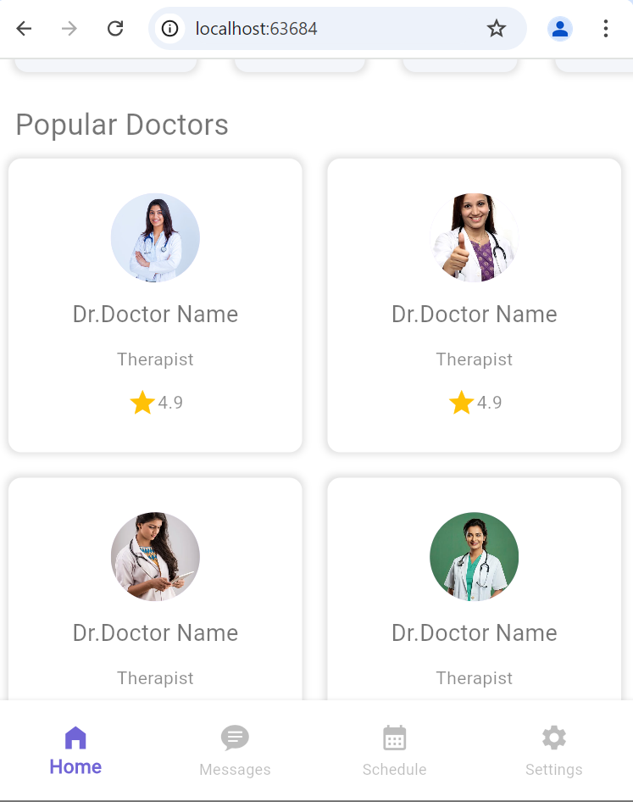
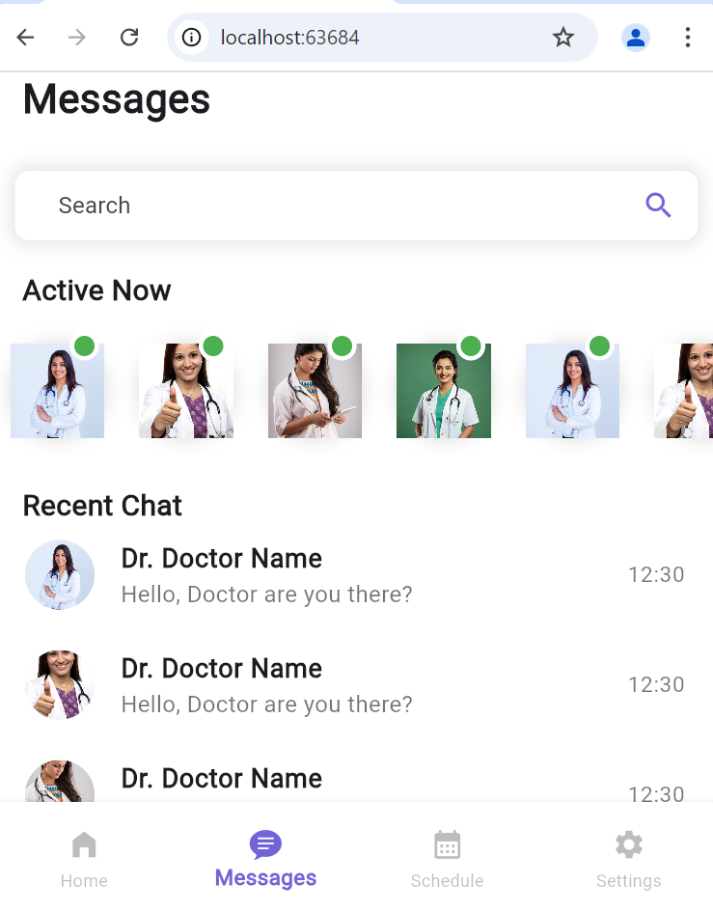 | 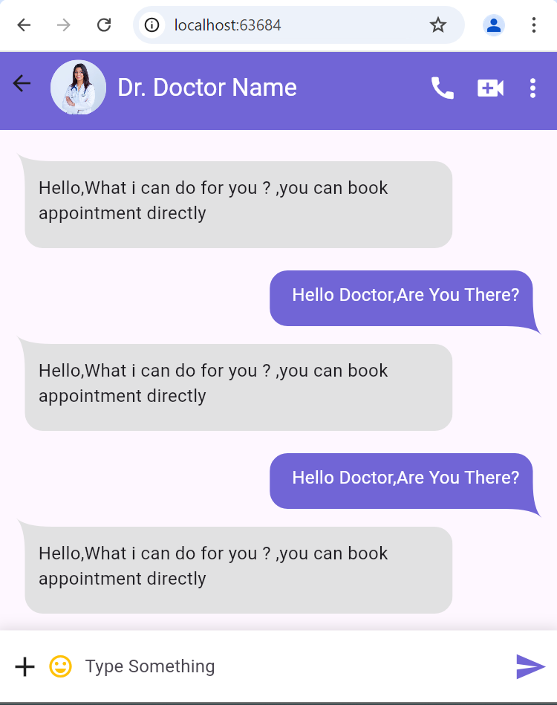
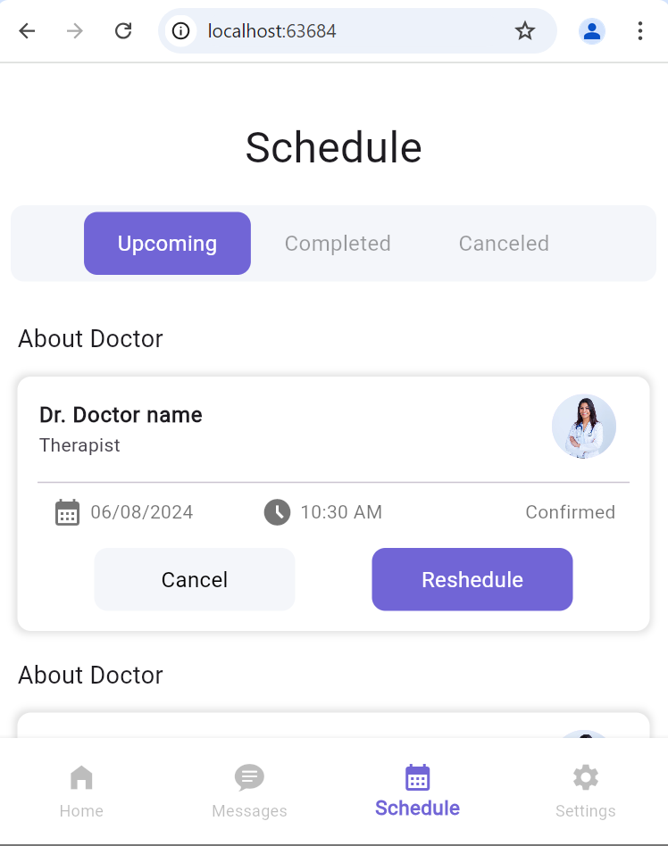
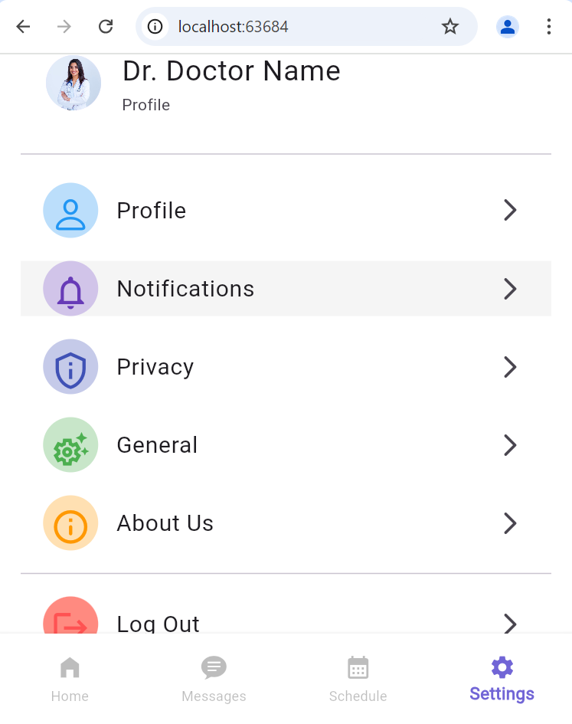

Code:
MainPage:
import 'package:flutter/material.dart';
import 'package:firebase_core/firebase_core.dart';
import 'authentication/login_page.dart';
import 'authentication/signup_page.dart';
import 'firebase_options.dart';
import 'screens/welcome_screen.dart';
import 'widgets/navbar_roots.dart';

// ...

void main()async{
WidgetsFlutterBinding.ensureInitialized();
await Firebase.initializeApp(
options: DefaultFirebaseOptions.currentPlatform,
);
runApp(MyApp());
}

class MyApp extends StatelessWidget {
const MyApp({super.key});

@override
Widget build(BuildContext context) {
return MaterialApp(
routes: {
"/home": (context) => NavBarRoots(),
"/login": (context) => LoginPage(),
"/signup": (context) => SignupPage()

},
debugShowCheckedModeBanner: false,
home: WelcomeScreen(),
);
}
}

LoginPage:

import 'package:firebase_auth/firebase_auth.dart';
import 'package:flutter/material.dart';
import 'package:flutter/widgets.dart';
import 'package:font_awesome_flutter/font_awesome_flutter.dart';
import 'package:google_sign_in/google_sign_in.dart';

import 'firebaseauthservice.dart';
import 'formcontainer.dart';
import 'toast.dart';

class LoginPage extends StatefulWidget {
const LoginPage({Key? key});

@override
State<LoginPage> createState() => _LoginPageState();
}

class _LoginPageState extends State<LoginPage> {

bool _isSigning=false;

final FirebaseAuthService _auth = FirebaseAuthService();
final FirebaseAuth _firebaseAuth = FirebaseAuth.instance;

TextEditingController _emailcontroller = TextEditingController();
TextEditingController _passwordcontroller = TextEditingController();

@override
void dispose() {
_emailcontroller.dispose();
_passwordcontroller.dispose();
// TODO: implement dispose
super.dispose();
}

@override
Widget build(BuildContext context) {
return Scaffold(
appBar: AppBar(
backgroundColor: Colors.amber,
title: Text("Login"),
),
body: Center(
child: Padding(
padding: const EdgeInsets.symmetric(horizontal: 15),
child: Column(
mainAxisAlignment: MainAxisAlignment.center,
children: [
Text(
"Login",
style: TextStyle(fontSize: 27, fontWeight: FontWeight.bold),
),
SizedBox(
height: 30,
),
FormContainerWidget(
controller: _emailcontroller,
hintText: "Email",
ispasswordfield: false,
),
SizedBox(
height: 10,
),
FormContainerWidget(
controller: _passwordcontroller,
hintText: "Password",
ispasswordfield: true,
),
SizedBox(
height: 30,
),
GestureDetector(
onTap: _signin,
child: Container(
width: double.infinity,
height: 45,
decoration: BoxDecoration(
borderRadius: BorderRadius.circular(15),
color: Colors.blue),
child: Center(
child: _isSigning ? CircularProgressIndicator(color: Colors.white,) : Text(
"Login",
style: TextStyle(
color: Colors.white,
fontSize: 18,
fontWeight: FontWeight.bold),
)),
),
),
SizedBox(height: 16,),

GestureDetector(
onTap:(){
// _signInWithGoogle();
} ,
child: Container(
width: double.infinity,
height: 45,
decoration: BoxDecoration(
borderRadius: BorderRadius.circular(15),
color: Colors.red),
child: Center(
child: Row(
mainAxisAlignment: MainAxisAlignment.center,
children: [
Icon(FontAwesomeIcons.google, color: Colors.white,),
SizedBox(width: 5,),
Text("Sign in with Google",
style: TextStyle(
color: Colors.white,
fontSize: 18,
fontWeight: FontWeight.bold),
),
],
)),
),
),

SizedBox(
height: 10,
),
Row(
mainAxisAlignment: MainAxisAlignment.center,
children: [
Text("Don't Have an account? "),
GestureDetector(
onTap: () {
Navigator.pushNamed(context, "/signup");
},
child: Text(
"Sign up",
style: TextStyle(
color: Colors.blue, fontWeight: FontWeight.bold),
),
)
],
)
],
),
),
),
);
}

void _signin() async {

setState(() {
_isSigning =true;
});

String email = _emailcontroller.text;
String password = _passwordcontroller.text;

User? user = await _auth.signinWithEmailAndPassword(email, password);

setState(() {
_isSigning = false;
});

if (user != null) {
showToast(message: "User is Successfully sign in");
Navigator.pushNamed(context, "/home");
} else {
showToast(message: "Some Error happened!");
}
}
}

HomePage:

import 'package:flutter/material.dart';

import 'appointment_screen.dart';

class HomeScreen extends StatelessWidget {
// const HomeScreen({super.key});
List symptoms=[
"Temperature",
"Snuffle",
"Fever",
"Cough",
"Cold",
];
List imgs=[
"doctor1.jpg",
"doctor2.jpg",
"doctor3.jpg",
"doctor4.jpg",
];
@override
Widget build(BuildContext context) {
return SingleChildScrollView(
padding: EdgeInsets.only(top: 40),
child: Column(
crossAxisAlignment: CrossAxisAlignment.start,
children: [
Padding(padding: EdgeInsets.symmetric(
horizontal: 15
),
child: Row(
mainAxisAlignment: MainAxisAlignment.spaceBetween,
children: [
Text("Hello Alex",
style: TextStyle(
fontSize: 35,
fontWeight: FontWeight.w500,
),
),
CircleAvatar(
radius: 25,
backgroundImage: AssetImage("images/doctor1.jpg"),
)
],
),
),
SizedBox(height:30 ),
Row(
mainAxisAlignment: MainAxisAlignment.spaceEvenly,
children: [
InkWell(
onTap: () {

},
child:Container(
padding: EdgeInsets.all(20),
decoration: BoxDecoration(
color: Color(0xFF7165D6),
borderRadius: BorderRadius.circular(10),
boxShadow: [
BoxShadow(
color: Colors.black12,
blurRadius: 6,
spreadRadius: 4,
),
],
),
child: Column(
crossAxisAlignment: CrossAxisAlignment.start,
children: [
Container(
padding: EdgeInsets.all(8),
decoration: BoxDecoration(
color: Colors.white,
shape: BoxShape.circle,
),
child: Icon(
Icons.add,
color: Color(0xFF7165D6),
size: 35,
),
),
SizedBox(height: 30),
Text("Clinic Visit",
style:TextStyle(
fontSize: 18,
color: Colors.white,
fontWeight: FontWeight.w500,
)
,),
SizedBox(height: 5,),
Text("Make an appointment",
style: TextStyle(
color: Colors.white54,
),),
],
),
) ,
),
InkWell(
onTap: () {

},
child:Container(
padding: EdgeInsets.all(20),
decoration: BoxDecoration(
color: Colors.white,
borderRadius: BorderRadius.circular(10),
boxShadow: [
BoxShadow(
color: Colors.black12,
blurRadius: 6,
spreadRadius: 4,
),
],
),
child: Column(
crossAxisAlignment: CrossAxisAlignment.start,
children: [
Container(
padding: EdgeInsets.all(8),
decoration: BoxDecoration(
color:Color(0xFFF0EEFA),
shape: BoxShape.circle,
),
child: Icon(
Icons.home_filled,
color: Color(0xFF7165D6),
size: 35,
),
),
SizedBox(height: 30),
Text("Home Visit",
style:TextStyle(
fontSize: 18,
// color: Colors.white,
fontWeight: FontWeight.w500,
)
,),
SizedBox(height: 5,),
Text("Call a doctor to home",
style: TextStyle(
color: Colors.white54,
),),
],
),
) ,
),
],
),
SizedBox(height: 25,),
Padding(padding: EdgeInsets.only(left: 15),
child: Text(
"What are your symptoms?",
style: TextStyle(
fontSize: 23,
fontWeight: FontWeight.w500,
color: Colors.black54,
),
),
),
SizedBox(height: 70,
child: ListView.builder(
shrinkWrap: true,
scrollDirection: Axis.horizontal,
itemCount: symptoms.length,
itemBuilder:
(context,index)
{
return Container(
margin: EdgeInsets.symmetric(
vertical: 10,horizontal: 15
),
padding: EdgeInsets.symmetric(horizontal: 25),
decoration: BoxDecoration(
color: Color(0xFFF4F6FA),
borderRadius: BorderRadius.circular(10),
boxShadow: [
BoxShadow(
color: Colors.black12,
blurRadius: 4,
spreadRadius: 2,
),
]
),
child: Center(
child: Text(symptoms[index],
style: TextStyle(
fontSize: 16,
fontWeight: FontWeight.w500,
color: Colors.black54,
),),
),
);
}),
),
SizedBox(height: 15),
Padding(padding: EdgeInsets.only(left: 15),
child: Text("Popular Doctors",
style: TextStyle(
fontSize: 23,
fontWeight: FontWeight.w500,
color: Colors.black54,
),
),
),
GridView.builder(
gridDelegate: SliverGridDelegateWithFixedCrossAxisCount(
crossAxisCount: 2),
itemCount: 4,
shrinkWrap: true,
physics: NeverScrollableScrollPhysics(),
itemBuilder: (context, index) {
return InkWell(
onTap: () {
Navigator.push(context, MaterialPageRoute(builder:
(context)=>AppointmentScreen()
));
},
child:Container(
margin: EdgeInsets.all(10),
padding: EdgeInsets.symmetric(vertical: 15),
decoration: BoxDecoration(
color: Colors.white,
borderRadius: BorderRadius.circular(10),
boxShadow: [
BoxShadow(
color: Colors.black12,
blurRadius: 4,
spreadRadius: 2,
),
]
),
child: Column(
mainAxisAlignment: MainAxisAlignment.spaceEvenly,
children: [
CircleAvatar(
radius: 35,
backgroundImage: AssetImage("images/${imgs[index]}"),
),
Text("Dr.Doctor Name",
style: TextStyle(
fontSize: 18,
fontWeight: FontWeight.w500,
color: Colors.black54,
),
),
Text("Therapist",
style: TextStyle(
color: Colors.black45,
),
),
Row(
mainAxisSize: MainAxisSize.min,
mainAxisAlignment: MainAxisAlignment.center,
children: [
Icon(Icons.star,
color: Colors.amber,
),
Text("4.9",
style: TextStyle(
color: Colors.black45,
),
),
],
),
],
),
) ,
);
},
),
],
),
);
}
}

Setting Page:
import 'package:firebase_auth/firebase_auth.dart';
import 'package:flutter/cupertino.dart';
import 'package:flutter/material.dart';

class SettingScreen extends StatelessWidget {
const SettingScreen({super.key});

@override
Widget build(BuildContext context) {
return SingleChildScrollView(
child: Padding(
padding: EdgeInsets.only(top: 50, left: 20, right: 20),
child: Column(
crossAxisAlignment: CrossAxisAlignment.start,
children: [
Text(
"Settings",
style: TextStyle(
fontSize: 30,
fontWeight: FontWeight.w500,
),
),
SizedBox(height: 30),
ListTile(
leading: CircleAvatar(
radius: 30,
backgroundImage: AssetImage("images/doctor1.jpg"),
),
title: Text(
"Dr. Doctor Name",
style: TextStyle(
fontWeight: FontWeight.w500,
fontSize: 25,
),
),
subtitle: Text("Profile"),
),
Divider(
height: 50,
),
ListTile(
onTap: () {},
leading: Container(
padding: EdgeInsets.all(10),
decoration: BoxDecoration(
color: Colors.blue.shade100,
shape: BoxShape.circle,
),
child: Icon(
CupertinoIcons.person,
color: Colors.blue,
size: 35,
),
),
title: Text(
"Profile",
style: TextStyle(
fontWeight: FontWeight.w500,
fontSize: 20,
),
),
trailing: Icon(Icons.arrow_forward_ios_rounded),
),
SizedBox(height: 20),
ListTile(
onTap: () {},
leading: Container(
padding: EdgeInsets.all(10),
decoration: BoxDecoration(
color: Colors.deepPurple.shade100,
shape: BoxShape.circle,
),
child: Icon(
Icons.notifications_none_outlined,
color: Colors.deepPurple,
size: 35,
),
),
title: Text(
"Notifications",
style: TextStyle(
fontWeight: FontWeight.w500,
fontSize: 20,
),
),
trailing: Icon(Icons.arrow_forward_ios_rounded),
),
SizedBox(height: 20),
ListTile(
onTap: () {},
leading: Container(
padding: EdgeInsets.all(10),
decoration: BoxDecoration(
color: Colors.indigo.shade100,
shape: BoxShape.circle,
),
child: Icon(
Icons.privacy_tip_outlined,
color: Colors.indigo,
size: 35,
),
),
title: Text(
"Privacy",
style: TextStyle(
fontWeight: FontWeight.w500,
fontSize: 20,
),
),
trailing: Icon(Icons.arrow_forward_ios_rounded),
),
SizedBox(height: 20),
ListTile(
onTap: () {},
leading: Container(
padding: EdgeInsets.all(10),
decoration: BoxDecoration(
color: Colors.green.shade100,
shape: BoxShape.circle,
),
child: Icon(
Icons.settings_suggest_outlined,
color: Colors.green,
size: 35,
),
),
title: Text(
"General",
style: TextStyle(
fontWeight: FontWeight.w500,
fontSize: 20,
),
),
trailing: Icon(Icons.arrow_forward_ios_rounded),
),
SizedBox(height: 20),
ListTile(
onTap: () {},
leading: Container(
padding: EdgeInsets.all(10),
decoration: BoxDecoration(
color: Colors.orange.shade100,
shape: BoxShape.circle,
),
child: Icon(
Icons.info_outline_rounded,
color: Colors.orange,
size: 35,
),
),
title: Text(
"About Us",
style: TextStyle(
fontWeight: FontWeight.w500,
fontSize: 20,
),
),
trailing: Icon(Icons.arrow_forward_ios_rounded),
),
Divider(height: 40),
ListTile(
onTap: () async {
await FirebaseAuth.instance.signOut();

Navigator.pushReplacementNamed(context, '/login');
},
leading: Container(
padding: EdgeInsets.all(10),
decoration: BoxDecoration(
color: Colors.redAccent.shade100,
shape: BoxShape.circle,
),
child: Icon(
Icons.logout,
color: Colors.redAccent,
size: 35,
),
),
title: Text(
"Log Out",
style: TextStyle(
fontWeight: FontWeight.w500,
fontSize: 20,
),
),
trailing: Icon(Icons.arrow_forward_ios_rounded),
),
],
),
),
);
}
}

