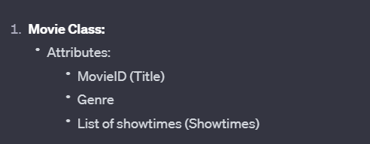  
  
**import java.util.List;**

**public class Movie {**

**private String movieID;**

**private String genre;**

**private List<String> showtimes;**

**// Constructor, getters, and setters**

**}  
  
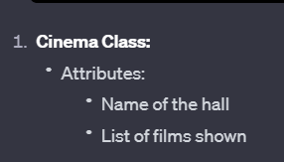  
  
import java.util.List;**

**public class Cinema {**

**private String hallName;**

**private List<Movie> filmsShown**

**// Constructor, getters, and setters**

**}  
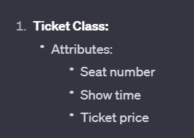  
  
public class Ticket {**

**private int seatNumber;**

**private String showTime;**

**private double ticketPrice;**

**// Constructor, getters, and setters**

**}  
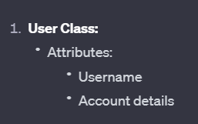  
  
public class User {**

**private String username;**

**private String accountDetails;**

**// Constructor, getters, and setters}**

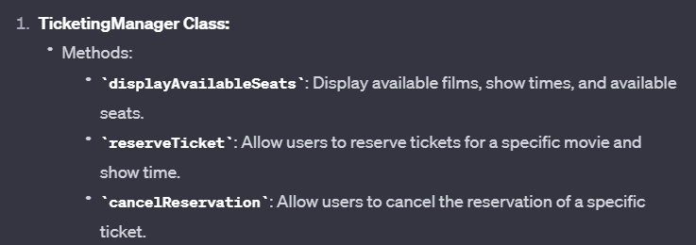

**import java.util.List;**

**public class TicketingManager {**

**// Constructor**

**public void displayAvailableSeats(List<Cinema> cinemas) {**

**// Implement**

**}**

**public void reserveTicket(User user, Movie movie, String showTime, int numberOfTickets) {**

**// Implement**

**}**

**public void cancelReservation(User user, Movie movie, String showTime, int seatNumber) {**

**// Implement**

**}**

**}**