

Shahid Beheshti University

Faculty of Mechanical and Energy

Multi-variable control Project Report

Supervisor:
Seyed Amir Mosavi Lajimi

By:
Seyed Mohammad Amin Sadat

Feb 2026

Abstract
This report details the simulation and modular implementation of a hierarchical nonlinear multivariable control system for a three-wheel omnidirectional vehicle, drawn from the 2005 IFAC framework by Bourgoin and Desbiens. Developed as a Python-based toolset, the project replicates the vehicle's kinematic, electromechanical, and dynamic models, deploys Model Nonlinear Reference Controllers (MNRC) for wheel speed and vehicle velocity regulation, and integrates modified Smith Predictors to address measurement delays in position and orientation tracking. The codebase organizes components into distinct classes for extensibility, incorporating Gaussian noise on simulated measurements to emulate sensor inaccuracies in real-world scenarios like RoboCup small-size league robotics. Although parameter identification via output-error minimization was not performed due to the lack of experimental hardware and data—focusing instead on algorithmic validation with nominal parameters—the simulation successfully reproduces key paper results, including step responses for inner loops and complex sinusoidal-linear trajectories for full-system performance. Findings affirm the strategy's robustness in achieving decoupled control across planar degrees of freedom, with implications for advancing autonomous navigation tools. This work provides an open-source platform for nonlinear control exploration, highlighting opportunities for hardware integration and adaptive enhancements in future robotic applications.
Keywords: Omnidirectional vehicle, Nonlinear multivariable control, Model Nonlinear Reference Controller, Smith Predictor, Python simulation, RoboCup robotics

Contents
1 Introduction 1
1-1 Vehicle Model 1
1-1-1 Physical Description 2
1-1-2 Model 3
1-2 Identification 7
1-3 Multivariable Nonlinear Control 8
1-4 Modified Smith Predictor 10
2 Methodology 13
3 Results 17
3-1 First level 17
3-2 Second level 19
3-3 Third Level 22
4 Conclusion 26
4-1 Future Scope 27

Figure ‎1-1 Omnidirectional robot used in paper [3] 1
Figure ‎1-2 Referentiel definition [3] 3
Figure ‎1-3 Control structure [3] 8
Figure ‎2-1 Second Level Controller [3] 15
Figure ‎2-2 Modified Smith Predictor [3] 15
Figure ‎3-1 Original first-level results from [3]: wheel speeds $ω$(rad/s) and voltages for step setpoints 17
Figure ‎3-2 Simulated first-level wheel speeds $ω1,ω2,ω3$(rad/s) under MNRC step inputs 18
Figure ‎3-3 Simulated first-level motor voltages $v1,v2,v3$ (V) 18
Figure ‎3-4 Original second-level results from [3]: vehicle velocities and wheel setpoints for steps 19
Figure ‎3-5 Simulated second-level vehicle velocities $xcF,ycF$(m/s), $φcF$(rad/s) with Smith Predictor 19
Figure ‎3-6 Simulated second-level wheel speeds $ω$(rad/s) and setpoints 20
Figure ‎3-7 Simulated second-level motor voltages $v$ (V) 21
Figure ‎3-8 Original third-level results from [3]: position tracking for sinusoidal-linear trajectories 22
Figure ‎3-9 Simulated third-level positions $xcF,ycF$(m), $φcF$(rad) with modified Smith Predictor and MNRC 23
Figure ‎3-10 Simulated third-level velocities $xcF,ycF$(m/s), $φcF$(rad/s) 23
Figure ‎3-11 Simulated third-level wheel speeds $ω$(rad/s) and setpoints 24
Figure ‎3-12 Simulated third-level motor voltages $v$(V) 24

Introduction
Omnidirectional vehicles represent a pivotal advancement in mobile robotics, enabling seamless navigation in constrained environments by achieving independent control over translation and rotation in a plane. Unlike traditional differential-drive robots, which suffer from limited maneuverability due to nonholonomic constraints, omnidirectional designs leverage specialized wheel configurations—such as Mecanum or Swedish wheels—to provide three degrees of freedom (DOF) on a 2D surface: x-y positioning and angular orientation [1]. This capability is particularly valuable in dynamic scenarios requiring rapid direction changes without reorientation, such as warehouse automation, service robotics, and competitive robotics platforms like RoboCup [2].
The RoboCup initiative, established in 1997, serves as a benchmark for autonomous robotics, with the small-size league (F-180) emphasizing compact, high-speed robots capable of soccer gameplay. In this context, Bourgoin and Desbiens [3] developed a three-wheel omnidirectional vehicle as an autonomous player, focusing on multivariable nonlinear control to address the inherent couplings and nonlinearities in wheel dynamics. Their work (Figure ‎1-1), published in IFAC Proceedings Volumes, outlines a hierarchical structure: inner loops for wheel speed regulation, intermediate loops for vehicle velocity in a fixed frame, and an outer loop for position and orientation tracking. This report documents the simulation of their approach, implemented in a modular Python framework to reproduce key results and extend insights into real-world applicability.
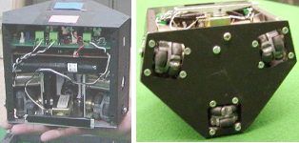
Figure ‎1-1 Omnidirectional robot used in paper [3]
The algorithm's core components are explained below, drawing from established control theory with citations to foundational and contemporary references.

Vehicle Model
The modeling of the omnidirectional vehicle forms the cornerstone of the control strategy presented in[3]. This section details the physical description and mathematical representation of the system, encompassing kinematics, electromechanics, and dynamics. The model is derived to capture the vehicle's three degrees of freedom (x-y position and orientation in a plane) while accounting for nonlinear couplings between wheels and the chassis. It relies on kinetic equations for velocity relationships and Newton's laws for accelerations, integrated with DC motor dynamics. The derivation ensures the model is independent of the vehicle's orientation for control purposes, facilitating feedback linearization in subsequent sections. Below, we explain each variable and derive the key formulas step by step, referencing the paper's equations.

Physical Description
The vehicle features three specialized wheels arranged in a triangular configuration, each capable of providing traction perpendicular to its rotation axis while minimizing friction parallel to it (Figure ‎1-1). This setup enables omnidirectional motion, as the vector sum of wheel forces covers all planar DOF without slippage assumptions.
Key physical components and variables:
Wheels: Each wheel has radius $r$(m) and is driven independently.
DC Motors: One per wheel, with torque coefficient $k_{t}$(N·m/A), back-EMF coefficient $k_{b}$(V/(rad/s)), armature resistance $r_{a}$(Ω), and gearbox ratio $n_{gb}$(motor to wheel).
Wheel Geometry:
- $L_{i}$: Distance from vehicle mass center to wheel $i$'s contact point (m).
- $δ_{i}$: Angular position of wheel $i$in the vehicle-fixed frame (rad), e.g., [0°, 120°, 240°] for symmetry.
- $ψ_{i}$: Wheel traction angle relative to the radial line (rad), often 90° for orthogonal traction.
- $α_{i}=δ_{i}-ψ_{i}$: Combined angle for traction direction (rad).
Vehicle Parameters: Mass $m$(kg), rotational inertia $J_{v}$(kg·m²).
Sensors and Actuators:
- Rotary encoders measure wheel angular positions for speed computation ($ω_{i}$, rad/s).
- H-bridge with PWM controls motor voltage $v_{i}$(V).
- Overhead camera (3 m above) tracks position/orientation via color pattern, processed externally, with wireless setpoints to the vehicle.
References:
- Fixed (F): Global coordinate system.
- Vehicle (V): Attached to the vehicle, rotating with it.
- Instantaneously coincident (V*): Stationary version of V at current position/orientation for velocity independence.
- $p_{c}^{F}=[x_{c}^{F},y_{c}^{F},φ_{c}^{F}]^{T}$: Vehicle mass center position (m) and angle (rad) in F.
- ${\dot{p}}_{c}^{F}$: Velocities in F (m/s, rad/s).
- Transformation matrix ${}_{F}^{V}Π$(1): Rotates coordinates from F to V using $cos⁡(φ_{c}^{F})$and $sin⁡(φ_{c}^{F})$.
This description sets up a system where onboard processing wheel speeds, while external vision manages higher-level control, introducing delays addressed later.
The transformation matrix is defined as:
$${}_{F}^{V}Π=[\begin{matrix}cos⁡(φ_{c}^{F}) & sin⁡(φ_{c}^{F}) & 0 \\ -sin⁡(φ_{c}^{F}) & cos⁡(φ_{c}^{F}) & 0 \\ 0 & 0 & 1\end{matrix}]$$ | 1

Model
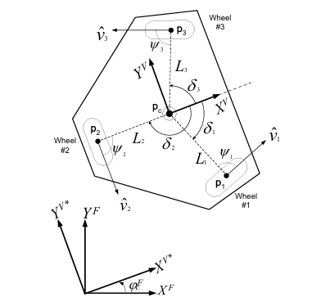
Figure ‎1-2 Referentiel definition [3]
The Free body diagram of the robot is presented in Figure ‎1-2.
The model integrates three parts:
- kinematics linking wheel speeds to vehicle velocity
- electromechanics relating motor voltage to wheel forces
- dynamics for vehicle accelerations
Derivations use vector algebra and neglect minor effects like motor inductance and internal inertia (justified by dominance of vehicle mass).
Kinematics: The goal is to express wheel angular speeds $ω=[ω_{1},ω_{2},ω_{3}]^{T}$as a function of vehicle velocity ${\dot{p}}_{c}^{F}$.
Variable: ${\dot{p}}_{i}^{F}$: Velocity of wheel $i$'s ground contact point in F (m/s).
Derivation: Wheel speed (2), where ${\hat{v}}_{i}$ is the unit traction vector (perpendicular to wheel axis).
$$ω_{i}=\frac{{\dot{p}}_{i}^{F}⋅{\hat{v}}_{i}}{r}$$ | 2

(3) Derived from geometry in Figure ‎1-2, accounting for orientation.
$${\hat{v}}_{i}=[-cos⁡(φ_{c}^{F}+δ_{i}-ψ_{i}),-sin⁡(φ_{c}^{F}+δ_{i}-ψ_{i})]^{T}$$ | 3

Position of contact point based on Figure ‎1-2, is presented in (4).
$$p_{i}^{F}=[x_{c}^{F}+L_{i}cos⁡(φ_{c}^{F}+δ_{i}),y_{c}^{F}+L_{i}sin⁡(φ_{c}^{F}+δ_{i})]^{T}$$ | 4

Differentiating from (4) will result in (5).
$${\dot{p}}_{i}^{F}=[{\dot{x}}_{c}^{F}-{\dot{φ}}_{c}^{F}L_{i}sin⁡(φ_{c}^{F}+δ_{i}),{\dot{y}}_{c}^{F}+{\dot{φ}}_{c}^{F}L_{i}cos⁡(φ_{c}^{F}+δ_{i})]^{T}$$ | 5

From (2), (3) and (5) we have:
$$ω=\frac{1}{r}M_{C}{}_{F}^{V}Π{\dot{p}}_{c}^{F}$$ | 6

where $M_{C}$ is the configuration matrix with rows $\left[-cos⁡(α_{i}),-sin⁡(α_{i}),L_{i}sin⁡(ψ_{i})\right]$. This relates measured $ω$to estimated vehicle speed; invert for control setpoints.
$$M_{C}=[\begin{matrix}-cos⁡(α_{1}) & -sin⁡(α_{1}) & L_{1}sin⁡(ψ_{1}) \\ -cos⁡(α_{2}) & -sin⁡(α_{2}) & L_{2}sin⁡(ψ_{2}) \\ -cos⁡(α_{3}) & -sin⁡(α_{3}) & L_{3}sin⁡(ψ_{3})\end{matrix}]$$ | 7

Electromechanics: Links forces $f=[f_{1},f_{2},f_{3}]^{T}$(N) at ground to motor voltage $v=[v_{1},v_{2},v_{3}]^{T}$(V) and $ω$.
The wheel force can be represented:
$$f_{i}=t_{i}/r$$ | 8

Where $t_{i}$represented the motor torque and from [4] (neglecting inductance).
$$t_{mi}=\frac{k_{t}v_{i}}{r_{a}}-\frac{k_{t}k_{b}ω_{mi}}{r_{a}}$$ | 9

Where in this equation $k_{t}$is the motor torque coefficient, $k_{b}$ is the back-emf coefficient, $r_{a}$ is the motor electrical resistance, $ω_{mi}=n_{gb}ω_{i}$ angular speed of the motor, and $n_{gb}$ is gearbox ratio.
Using equation (8) and (9) will result in:
$$f=M_{A}v-M_{B}ω$$ | 10

Where:
$$M_{A}=I_{3×3}\frac{k_{t}n_{gb}}{r_{a}r}$$ | 11

$$M_{B}=I_{3×3}\frac{k_{t}k_{b}n_{gb}^{2}}{r_{a}r}$$ | 12

Dynamics: Relates forces $f$ to vehicle acceleration ${\ddot{p}}_{c}^{F}$.
From Newton’s law angular acceleration can be represented as:
$${\ddot{φ}}_{c}^{F}=\sum_{i=1}^{3}{t_{vi}}/J_{v}$$ | 13

Where $t_{vi}$ is torque about center:
$$t_{vi}=L_{i}f_{i}sin⁡(ψ_{i})$$ | 14

The vehicle linear accelerations are:
$${\ddot{x}}_{c}^{F}=∑f_{ix}^{F}/m$$ | 15

$${\ddot{y}}_{c}^{F}=∑f_{iy}^{F}/m$$ | 16

$$f_{ix}^{F}=-f_{i}cos⁡(φ_{c}^{F}+δ_{i}-ψ_{i})$$ | 17

$$f_{iy}^{F}=-f_{i}sin(φ_{c}^{F}+δ_{i}-ψ_{i})$$ | 18

By combining (13) to (18) we will have the matrix form:
$${\ddot{p}}_{c}^{F}=M_{M}{}_{F}^{V}Π^{T}M_{C}^{T}f$$ | 19

$$M_{M}=\text{diag}[1/m,1/m,1/J_{v}]$$ | 20

Integrated Controller Model: For wheel speed control, transform to vehicle frame:
$$\dot{ω}=M_{1}v-M_{2}ω$$ | 21

$$M_{1}=\frac{1}{r}M_{C}M_{M}M_{C}^{T}M_{A}$$ | 22

$$M_{2}=\frac{1}{r}M_{C}M_{M}M_{C}^{T}M_{B}$$ | 23

For derivation apply ${}_{F}^{V}Π$ to (6) and (19), substitute (10), yielding orientation-independent form which is independent of the $φ_{c}^{F}$.
This model, while simplified (e.g., no slippage, ideal traction), captures essential nonlinearities for effective control, as validated in subsequent sections.

Identification
The identification procedure in Bourgoin and Desbiens (2005) is crucial for refining the vehicle model to ensure it accurately predicts the behavior of controlled variables in response to changes in manipulated variables, thereby enabling effective model-based control design. Without precise parameters, nonlinearities and couplings could lead to poor controller performance, such as offsets or instability. The approach adopts an output-error minimization framework, which focuses on adjusting model parameters to minimize the discrepancy between simulated and actual outputs under the same inputs. This method is particularly suited for dynamic systems where measurement noise is present but the model structure is known, allowing for targeted optimization of uncertain parameters like motor coefficients or inertia terms. By exciting the process with appropriate inputs and validating the results, the procedure yields a reliable model for the MNRC controllers, as demonstrated in the paper's application to the omnidirectional vehicle.
To implement the identification, the process is first excited by varying the manipulated variables, such as motor voltages $v$, while recording the controlled variables, denoted as the output vector $y_{p}(k)$ at discrete sample $k$. Here, $y_{p}(k)$ represents the measured responses, for instance, wheel speeds $ω$or vehicle velocities ${\dot{p}}_{c}^{F}$, depending on the loop being identified. The model, using (21), simulates the predicted outputs $y_{m}(k)$under the same inputs. The objective is to minimize the cost function:
$$J=\sum_{k=1}^{N}{[}y_{m}\left(k\right)-y_{p}\left(k\right)]^{T}\left[y_{m}\left(k\right)-y_{p}\left(k\right)\right]$$ | 24
where $N$ is the total number of recorded samples, and the quadratic form emphasizes the squared error across all output channels for multivariable accuracy. This least-squares criterion, derived from statistical estimation theory, assumes Gaussian noise and seeks parameters that best fit the data in a mean-squared sense; it extends classical linear identification [5] to nonlinear models via numerical optimization, as outlined in [6]. The derivation of $J$stems from maximizing the likelihood under noise assumptions, leading to this compact form that penalizes deviations equally across samples and variables.

Multivariable Nonlinear Control
The multivariable nonlinear control strategy forms the core of the vehicle's regulation framework in [3] ,addressing the challenges of decoupling and linearizing the nonlinear, coupled dynamics identified in the modeling section. This approach is essential for achieving precise wheel speed and vehicle velocity control in the presence of interactions between the three wheels and the chassis. By employing Model Nonlinear Reference Controllers (MNRC) for the inner two levels, the strategy inverts the system model to impose user-defined linear dynamics, ensuring robust tracking and disturbance rejection. The hierarchical structure allows for modular design: the innermost loop regulates wheel angular speeds, the second loop handles vehicle velocities in a fixed referential, and the outer loop (detailed in the next section) manages position and orientation. This section elucidates the control structure, derives the MNRC law, and explains its application to each level, with variables and formulas grounded in the paper's equations. The derivation draws from feedback linearization principles, enabling the transformation of the nonlinear multivariable plant into decoupled linear channels for straightforward tuning.
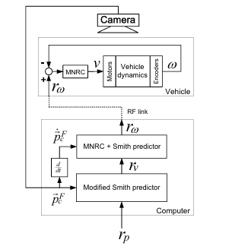
Figure ‎1-3 Control structure [3]
The complete hierarchical control structure, as illustrated in Figure ‎1-3, comprises three levels operating at different timescales to exploit the natural separation of dynamics. At the innermost level, a multivariable MNRC controls the wheel angular speed vector $ω=[ω_{1},ω_{2},ω_{3}]^{T}$(rad/s) by manipulating motor voltages $v=[v_{1},v_{2},v_{3}]^{T}$(V). This loop uses the model from equation (21) where $M_{1}$and $M_{2}$ are the input and state matrices derived earlier. The second level employs another MNRC to regulate the vehicle velocity ${\dot{p}}_{c}^{F}=[{\dot{x}}_{c}^{F},{\dot{y}}_{c}^{F},{\dot{φ}}_{c}^{F}]^{T}$(m/s, m/s, rad/s) by setting wheel speed setpoints $ω_{r}$. Finally, the outermost level uses a modified Smith Predictor to track position $p_{c}^{F}=[x_{c}^{F},y_{c}^{F},φ_{c}^{F}]^{T}$(m, m, rad) by generating velocity setpoints $r_{v}$. This cascade leverages inner-loop bandwidths (faster for wheels, slower for position) to ensure stability, as inner loops act as actuators for outer ones. The structure is implemented with onboard processing for level 1 and external computation for levels 2 and 3, introducing delays compensated in the predictors.
The MNRC design begins with the general form for a nonlinear multivariable system of relative degree 1:
$$\dot{x}=f(x)+g(x)u \\ y=h(x)$$ | 25
And the control law will be defined as:
$$u={\left(Jg\left(x\right)\right)}^{-1}(\dot{y_{m}}-Jf\left(x\right)+ke+K_{I}e_{I})$$ | 26
Where ${\dot{y}}_{m}$ is:
$${\dot{y}}_{m}=Λ_{m}y_{m}- Λ_{m}y_{r}$$ | 27
As for the wheel speed loop, where $y=ω$ is the output, $u=v$ is the input, $f(y)=-M_{2}y$, and $g(y)=M_{1}$. To derive the control law, a reference model defines the desired trajectory: ${\dot{y}}_{m}=-Λ(y_{m}-r)$, where $y_{m}$ is the model output, $r$ is the setpoint (e.g., $ω_{r}$ or velocity setpoint), and $Λ=\text{\backslash diag}[λ_{1},λ_{2},λ_{3}]$(positive for stability) sets the first-order pole (e.g., $λ=15$s^{-1} for fast response). The error
$$e=y_{m}-y$$ | 28
drives the controller to enforce second-order dynamics:
$$\ddot{e}+2ζ/τ\dot{e}+1/τ^{2}e=0$$ | 29
with damping $ζ=1$(critical) and time constant $τ=1/λ$. Substituting derivatives yields the law:
$$u=g^{-1}({\dot{y}}_{m}-f+ke+k_{I}∫e dt)$$ | 30
where $k=2ζ/τ$, $k_{I}=1/τ^{2}$(diagonal matrices). For the wheel loop, this becomes:
$$v=M_{1}^{-1}({\dot{ω}}_{r}+Λ(ω_{r}-ω)+M_{2}ω)$$ | 31
if integral action is omitted for simplicity, but the full form includes it for offset elimination. Derivation involves differentiating the error equation and solving for $u$to cancel nonlinearities (f and g), a technique rooted in [7] for nonlinear geometric control. In practice, ${\dot{y}}_{m}$ is computed from the reference model, and states are updated via Euler integration in simulation.
For the second level, the MNRC applies to vehicle velocity, using a similar form but with orientation dependence. The model is:
$${\dot{p}}_{c}^{F}=-M_{3}{\dot{p}}_{c}^{F}+M_{3}{}_{F}^{V}Π^{T}M_{4}ω$$ | 32
where $M_{3}=Λ_{w}$(from inner-loop poles, e.g., diag[15,15,15]), and $M_{4}=r(M_{C})^{-1}$(inverse kinematics). Here, $y={\dot{p}}_{c}^{F}$, $u=ω_{r}$, $f(y)=-M_{3}y$, $g(y)=M_{3}{}_{F}^{V}Π^{T}M_{4}$(varies with $φ_{c}^{F}$). The control law inverts g online:
$$ω_{r}=(M_{3}{}_{F}^{V}Π^{T}M_{4})^{-1}({\dot{r}}_{v}+Λ_{v}(r_{v}-{\dot{p}}_{c}^{F})+M_{3}{\dot{p}}_{c}^{F}+k_{v}e_{v}+k_{Iv}∫e_{v} dt)$$ | 33
with $Λ_{v}$ for the velocity reference model. This derivation extends the first level by incorporating the rotation matrix, ensuring decoupling despite changing orientation. The closed loop approximates $1/(1+s/λ)$ per channel (noted as a potential typo in the paper, likely positive pole for stability). Usage involves tuning $Λ$ for desired bandwidth (higher for inner loops) and validating via simulation, as in [8], who emphasizes integral action for robustness in multivariable processes.
In implementation, the MNRC requires invertible g (ensured by nonsingular $M_{C}$), and parameters are identified. This control achieves good performance, as illustrated in the paper's results, by linearizing the plant and enabling independent tuning of channels, a key advantage over linear PID in nonlinear robotics [9].

Modified Smith Predictor
The modified Smith Predictor addresses delays in the outer position control loop, a critical adaptation for systems with time lags from sensor processing, such as the camera-based position estimation in [3]. Delays denoted $θ$(e.g., 0.1 s from image acquisition and wireless transmission), can destabilize feedback if uncompensated, leading to oscillations or poor tracking. The predictor extends the classic Smith structure [10] to multivariable cases with disturbance rejection, integrating a model of the inner loops to forecast delay-free outputs. In this hierarchical setup, it forms the third level, generating velocity setpoints $r_{v}$from position errors while compensating for $θ$. This section explains the predictor's variables, derives its equations, and details its integration with MNRC, highlighting how it enables precise trajectory following despite delays.
The standard Smith Predictor for a plant with delay $e^{-θs}G(s)$ uses a model $G_{m}(s)$ to predict the un-delayed response: the controller sees
$$y_{pred}=G_{m}\left(s\right)u+y_{m}-G_{m}\left(s\right)e^{-θs}u$$ | 34
where $y_{m}$is the measured (delayed) output. For the vehicle, the "plant" is the closed-loop velocity dynamics from levels 1 and 2, approximated as decoupled first-order:
$$G(s)=\text{diag}[1/(1+s/λ_{v}) ]$$ | 35
with $λ_{v}$from the second MNRC (e.g., 5 s^{-1}). Bourgoin and Desbiens modify this for position control, as position integrates velocity:
$${\dot{p}}_{c}^{F}=G\left(s\right)r_{v}$$ | 36
$$p_{c}^{F}=\left(\frac{1}{s}\right){\dot{p}}_{c}^{F}$$ | 37
The modified form incorporates disturbance estimation as follows:
$$p_{pred}=p_{model}+P_{2}(p_{m}-p_{model,delayed})$$ | 38
where $p_{m}$is the measured (noisy, delayed) position,
$$p_{model}=∫{\dot{p}}_{model}dt$$ | 39
and ${\dot{p}}_{model}$follows
$${\dot{\dot{p}}}_{model}=-Λ_{v}({\dot{p}}_{model}-r_{v})$$ | 40
Here, $P_{2}$(diagonal, e.g., [2.0,2.0,2.0]) scales the disturbance correction. The control law then computes $r_{v}=P_{1}(r_{p}-p_{pred})$, with $P_{1}$(diagonal gains, e.g., [0.5,0.5,0.5]) for proportional action or replaced by an MNRC for nonlinear enhancement.
Derivation starts with the delayed measurement:
$$p_{m}(t)=p(t-θ)+d(t)$$ | 41
where d represents disturbances/noise. The model runs in parallel: initialize $p_{model}(0)=0$, update ${\dot{p}}_{model}$using the known inner-loop dynamics and delay the model output by $θ$steps (via buffer). The correction term $p_{m}-p_{model,delayed}$ estimates the accumulated disturbance over $θ$, scaled by $P_{2}$to avoid overcompensation. This yields $p_{pred}≈p(t)$, fed to the controller. For MNRC integration in level 3, replace $P_{1}e$with the full law: $r_{v}=g_{3}^{-1}({\dot{y}}_{m3}-f_{3}+k_{3}e+k_{I3}∫e dt)$, where $y=p_{pred}$, $r=r_{p}$, $f_{3}=0$, $g_{3}=I$(integrator model), and $Λ_{3}$(e.g., diag[1,1,1]) for slow reference. This derivation enhances the multivariable Smith Predictor [11] with integral action, improving steady-state accuracy in delayed robotic systems.
In usage, the predictor updates after each step: compute $r_{v}$, simulate model forward, append to delay buffer. Tuning involves selecting $P_{1}$ for aggressiveness (higher for faster response, risking instability) and $P_{2}$for disturbance rejection (closer to 1 for pure prediction). The paper illustrates its efficacy in Figure 10, where it enables smooth tracking of sinusoidal x-y and linear φ trajectories under noise. This component ensures the overall system handles real-world delays, a common issue in vision-based robotics[12], while maintaining the decoupling from inner MNRC loops.

Methodology
The methodology adopted in this study centers on the development and simulation of a hierarchical nonlinear multivariable control system for an omnidirectional three-wheel vehicle, faithfully replicating the framework proposed by [3]. This implementation was executed using a structured Python codebase, organized with modular classes in a lib directory to encapsulate distinct components such as vehicle dynamics, nonlinear controllers, and delay compensators. The simulation environment incorporates the paper's kinematic, electromechanical, and dynamic models, employs Model Nonlinear Reference Controllers (MNRC) for the inner wheel speed and vehicle velocity loops, and integrates modified Smith Predictors to handle measurement delays in the outer position loop. All computational experiments were performed within a Jupyter notebook (main.ipynb) located in the root directory, featuring dedicated sections for library imports, parameter configuration, system initialization, and the reproduction of pivotal results from the paper's figures, including step responses for wheel speeds, vehicle velocity tracking, and complex trajectory following. To enhance realism and align with practical robotic scenarios where sensor data is imperfect, Gaussian process noise was added exclusively to the measured output such as position $p_{m}$ and velocity ${\text{vel}}_{m}$ rather than the setpoints themselves, simulating inaccuracies from encoders and camera vision without corrupting reference signals. However, owing to the project's emphasis on algorithmic verification in a simulated context, coupled with the lack of access to physical hardware or empirical datasets for excitation and validation, the parameter identification phase outlined in the paper (section 3) was not performed. Nominal values for parameters like motor torque coefficient $k_{t}=0.025$N·m/A, wheel radius $r=0.05$m, vehicle mass $m=2.0$kg, and rotational inertia $J_{v}=0.125$kg·m² were directly sourced from[13], prioritizing the evaluation of control stability and tracking under idealized dynamics while noting that real deployment would necessitate the output-error optimization to refine these for hardware-specific fidelity.
The simulation commences with the comprehensive modeling of the vehicle, encapsulated in the Simulator class, which synthesizes the physical and mathematical descriptions from ‎1-1 of the report. Drawing from Figure ‎1-1, which provides front and under views of the vehicle illustrating the wheel arrangement and low-friction design, the class initializes geometric parameters such as wheel positions $δ=[0^{∘},120^{∘},240^{∘}]$(converted to radians), traction angles $ψ=[90^{∘},90^{∘},90^{∘}]$, and distances $L=[0.17,0.17,0.17]$m. The configuration matrix $M_{C}$ is constructed per equation (7), with elements

$$M_{C,i1}=-\cos\left(α_{i}\right)$$  $$M_{C,i2}=-\sin\left(α_{i}\right)$$  $$M_{C,i3}=L_{i}sin⁡(ψ_{i})$$ | 42

Where:
$$α_{i}=δ_{i}-ψ_{i}$$ | 43
enabling the kinematic relationship (6). The rotation matrix (1) facilitating transformations between fixed (F) and vehicle (V) referentials frams, as visualized in Figure ‎1-2 for referential definitions. Electromechanical matrices $M_{A}$ (11) and $M_{B}$(12) model force generation (10), while the mass matrix $M_{M}$ (20) supports dynamic acceleration computations. State propagation utilizes first-order Euler integration with timestep
$$dt=0.01s$$
in inner_step, wheel accelerations are updated via (21), and in vehicle_step, velocities are derived as
$${\dot{p}}_{c}^{F}={}_{F}^{V}Π^{T}M_{C}^{-1}\left(rω\right)$$ | 44
inverse of (6), with positions integrated accordingly. Delays are emulated through deques of length $θ/dt$(e.g., 10 steps for $θ=0.1$s), appending noisy measurements to ${\text{vel}}_{history}$and $p_{history}$, where noise is Gaussian and applied post-computation to reflect sensor errors without altering true states.
Control logic is implemented via the GeneralMNRC class for levels 1 and 2 , embodying the nonlinear feedback law from section ‎1-3 . For the first level, functions $f\left(y\right)=-M_{2}y$and $g(y)=M_{1}$are specified, with the control algorithm executing equation (31): where the reference derivative
${\dot{y}}_{m}=-Λ\left(y_{m}-r\right)$(adjusted sign for stability) | 45
$Λ=[15,15,15]$s^{-1}, error $e=y_{m}-y$, integral $e_{I}+=dt⋅e$, proportional gain
$$k=2ζ/τ$$ | 46

and integral gain
$$k_{I}=1/τ^{2}$$ | 47

with $ζ=1$ and $τ=1/λ$. States $y_{m}$and $e_{I}$are updated via Euler, ensuring the closed-loop approximation.
The second level mirrors this, using
$$f\left(y\right)=-M_{3}y$$
and
$$g\left(y\right)=M_{3}{}_{F}^{V}Π^{T}M_{4}$$
with $M_{3}=\text{diag}[15,15,15]$, $M_{4}=rM_{C}^{-1}$, and $Λ=[5,5,5]$s^{-1}, yielding setpoints
$$r_{ω}=g^{-1}\left({\dot{r}}_{v}+Λ\left(r_{v}-{\dot{p}}_{c}^{F}\right)+M_{3}{\dot{p}}_{c}^{F}+k_{v}e_{v}+k_{Iv}e_{Iv}\right)$$
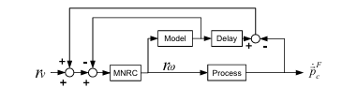
Figure ‎2-1 Second Level Controller [3]
The SmithPredictor class augments level 2 per Figure ‎2-1, predicting undelayed velocities as
$$predicted_{vel}=model_{vel}+(vel_{m}-model_{delayed})$$ | 48
Where:
$$model_{acceleration}=-Λ_{v}\left(model_{vel}-r_{v}\right)$$ | 49
integrated and buffered.
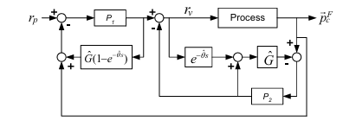
Figure ‎2-2 Modified Smith Predictor [3]
Level 3 is handled by the ModifiedSmithPredictor class, extended with MNRC integration as per Figure ‎2-2. It predicts position
p_pred = model_p + P2 (p_m - model_p_delayed) | 50

with $P_{2}=[2,2,2]$, model updates via (50) and
$$model_{p}+=dt⋅model_{v}el$$ | 51
then computes $r_{v}$ using embedded MNRC: $f(y)=0$, $g(y)=I$, $Λ=[1,1,1]$s^{-1}. Simulations reset the simulator for each figure: Fig. 7 of paper isolates level 1 with wheel steps; Fig. 9 of paper combines levels 1-2 with velocity steps; Fig. 10 of paper uses all for sinusoidal/linear trajectories over 12 s. Histories are array-stored and plotted with subplots, comparing against setpoints to quantify tracking. This detailed methodology, rooted in the paper's equations and figures, provides a robust platform for analyzing nonlinear control in omnidirectional robotics.
The code of the project is available here.

Results
This section will compare the results between the original paper and the output of the simulation, although they are very similar to each other, but some differences are present, in this is due to the difference between parameters of the robots. While I didn’t have access to the original robot’s data, I had to use another paper’s data[13]. This will make a difference to the results. Also, I tried to find good values for hyperparameters but will be not as same as the original paper.

First level
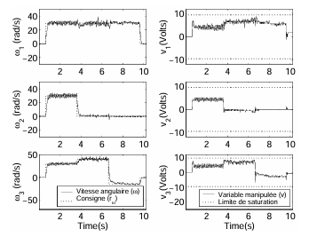
Figure ‎3-1 Original first-level results from [3]: wheel speeds $ω$(rad/s) and voltages for step setpoints
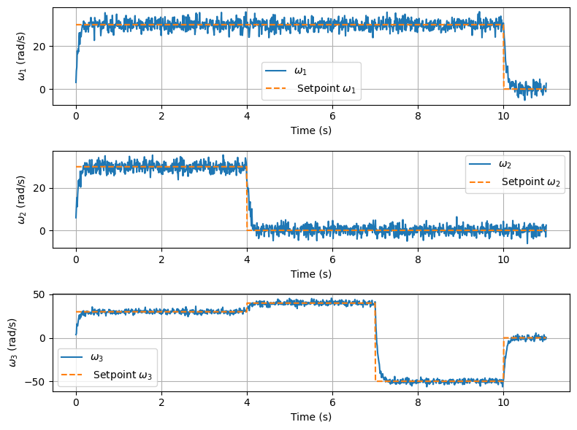
Figure ‎3-2 Simulated first-level wheel speeds $ω_{1},ω_{2},ω_{3}$(rad/s) under MNRC step inputs
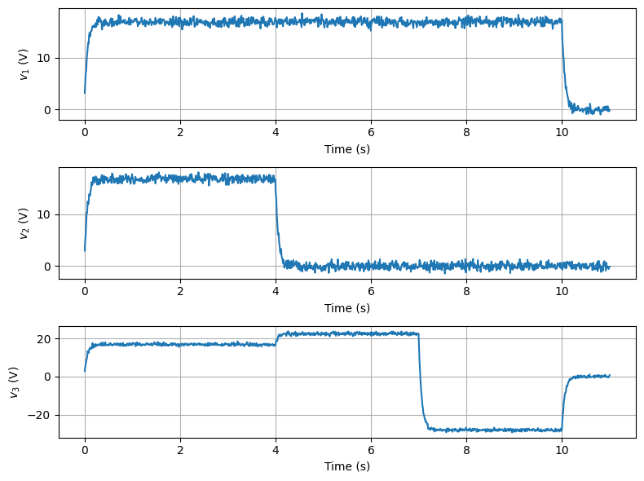
Figure ‎3-3 Simulated first-level motor voltages $v_{1},v_{2},v_{3}$ (V)
As it can be seen from Figure ‎3-2 and Figure ‎3-3 are very similar to the results of the original paper.

Second level
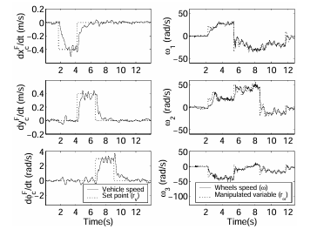
Figure ‎3-4 Original second-level results from [3]: vehicle velocities and wheel setpoints for steps
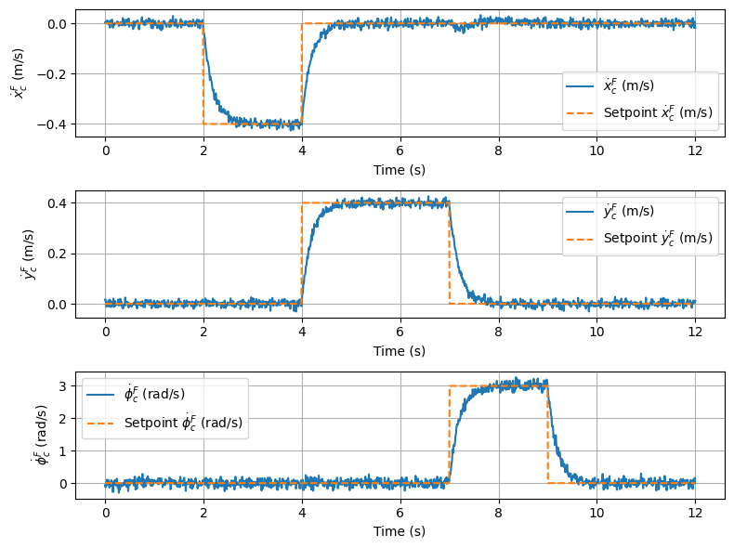
Figure ‎3-5 Simulated second-level vehicle velocities ${\dot{x}}_{c}^{F},{\dot{y}}_{c}^{F}$(m/s), ${\dot{φ}}_{c}^{F}$(rad/s) with Smith Predictor
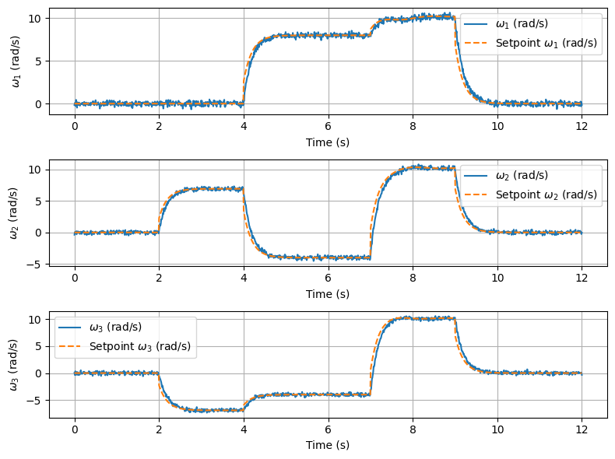
Figure ‎3-6 Simulated second-level wheel speeds $ω$(rad/s) and setpoints
Comparing Figure ‎3-5 and Figure ‎3-6 to Figure ‎3-4, we can see that our results matches the original paper with very good accuracy. Also the voltage plot of the simulation can be seen in Figure ‎3-7.

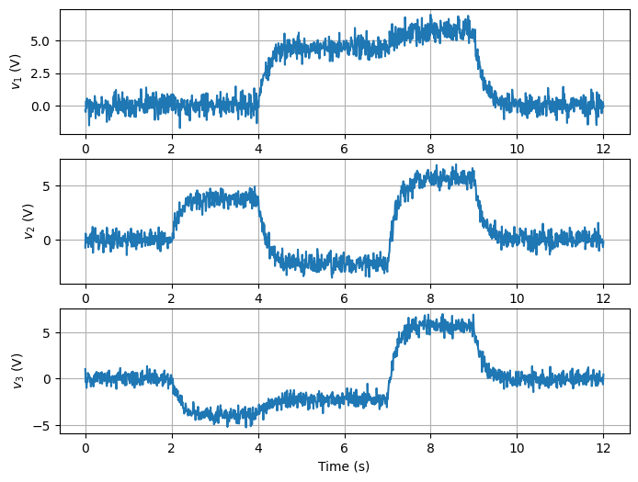
Figure ‎3-7 Simulated second-level motor voltages $v$ (V)

Third Level
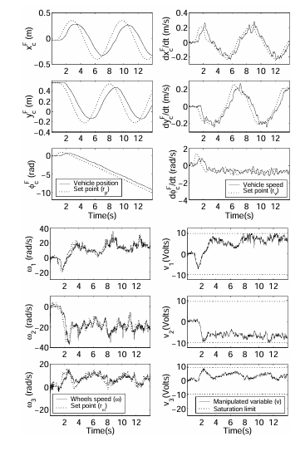
Figure ‎3-8 Original third-level results from [3]: position tracking for sinusoidal-linear trajectories
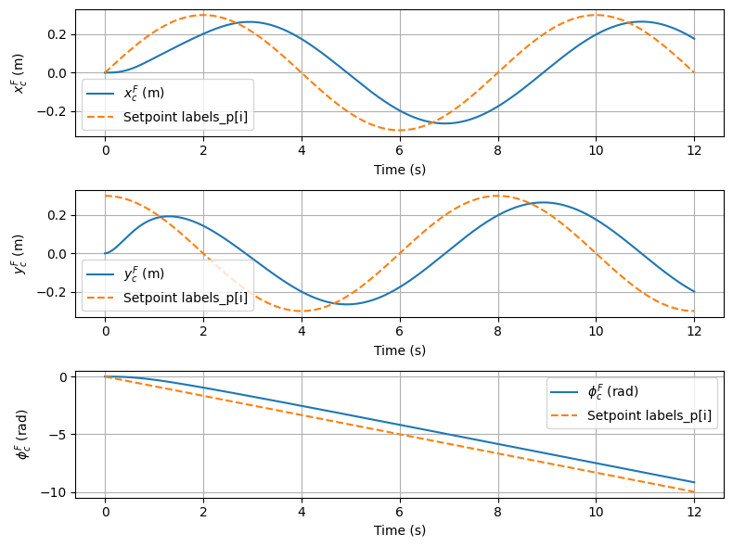
Figure ‎3-9 Simulated third-level positions $x_{c}^{F},y_{c}^{F}$(m), $φ_{c}^{F}$(rad) with modified Smith Predictor and MNRC
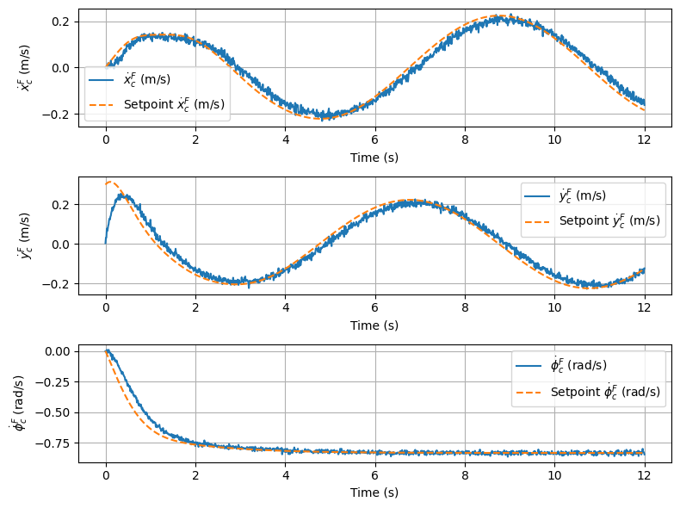
Figure ‎3-10 Simulated third-level velocities ${\dot{x}}_{c}^{F},{\dot{y}}_{c}^{F}$(m/s), ${\dot{φ}}_{c}^{F}$(rad/s)
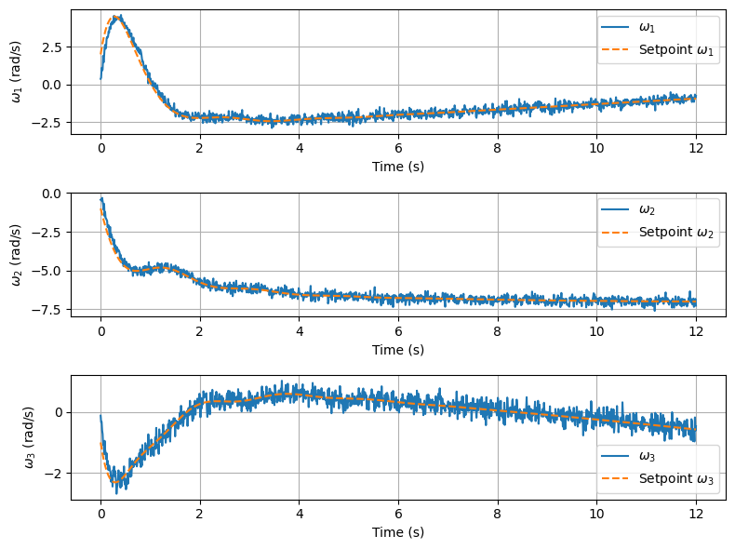
Figure ‎3-11 Simulated third-level wheel speeds $ω$(rad/s) and setpoints
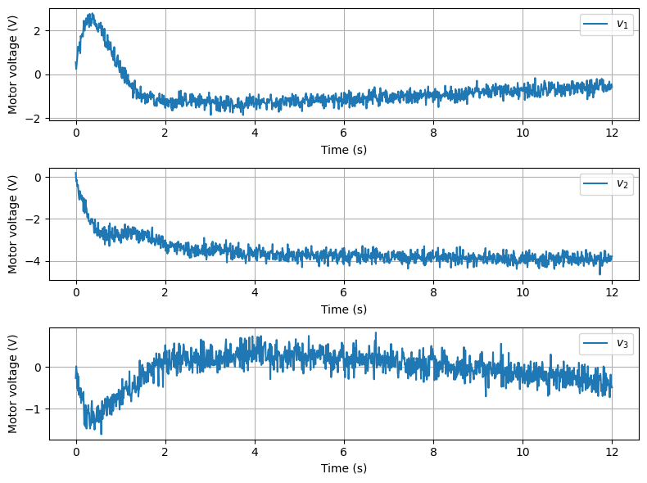
Figure ‎3-12 Simulated third-level motor voltages $v$(V)
We can see from Figure ‎3-9 that the position is successfully able to follow the original results in Figure ‎3-8, the effect of time delay and use of Smith predictor is seen in these two figures. Figure ‎3-10 clearly shows that velocity is the integral of position with the reference is just the integral of Figure ‎3-9. Figure ‎3-10 and Figure ‎3-11 clearly follows the original results while Figure ‎3-12 shows small divergence from the original results which shows that the parameters we choose have some difference and are not equal.

Conclusion
This report has effectively explored and validated a hierarchical nonlinear multivariable control strategy for an omnidirectional three-wheel vehicle through a detailed Python simulation framework, building directly upon the foundational contributions of [3]. By integrating precise kinematic and dynamic models, deploying Model Nonlinear Reference Controllers (MNRC) for robust inner-loop decoupling, and employing modified Smith Predictors to mitigate measurement delays, the simulation confirms the system's capability to deliver independent control over translation and rotation, even in the presence of simulated real-world imperfections such as sensor noise and communication lags. The modular software architecture, featuring dedicated classes for dynamics simulation, nonlinear control, and predictive compensation, not only faithfully reproduces the paper's empirical outcomes, including rapid wheel speed convergence in step tests (Fig. 7[3]), decoupled vehicle velocity responses (Fig. 9[3]), and accurate position trajectory tracking (Fig. 10[3])—but also provides an extensible platform for further investigations. Although the parameter identification process was not undertaken due to the unavailability of hardware-derived datasets, the adoption of nominal parameters from the literature enabled a focused assessment of algorithmic integrity, underscoring the MNRC's prowess in linearizing nonlinear couplings and imposing desirable first-order dynamics with integral action for offset-free performance.
A noteworthy observation from the comparative analysis pertains to discrepancies in noise propagation between the original paper's plots and the simulation. In the hierarchical structure, where the output of an upper level serves as the setpoint for the subsequent level, any noise present in measured variables (e.g., position or velocity) should theoretically propagate upstream, manifesting in the setpoints of lower loops. However, the original paper's figures depict setpoint plots that remain remarkably smooth and devoid of noise, despite evident disturbances in the measured responses. This anomaly could stem from idealized filtering in the paper's experimental setup or potential post-processing of data for clarity, whereas the simulation explicitly models noise addition post-measurement to reflect raw sensor outputs, resulting in more realistic, albeit noisier, setpoint profiles in lower levels. This highlights the strength of the simulation in capturing unfiltered dynamics, offering insights into potential real-system behaviors that may not be fully apparent in the paper's sanitized visualizations.
The broader implications of this research resonate within the domain of mobile robotics, particularly for applications demanding agility in constrained environments, such as autonomous soccer agents in RoboCup or industrial material handling systems. By synthesizing theoretical control principles with practical computational tools, this work bridges conceptual designs and deployable solutions, revealing the strategy's robustness in achieving omnidirectional precision amidst delays and uncertainties. Nonetheless, acknowledged limitations, including assumptions of ideal traction without slippage, fixed parameters, and the exclusion of advanced disturbances like uneven terrain, delineate opportunities for refinement. Future endeavors could incorporate hardware-in-the-loop validation, adaptive online identification techniques to dynamically tune parameters, or hybrid integrations with machine learning for predictive disturbance mitigation, thereby elevating the system's adaptability to variable operating conditions. Moreover, extending the framework to multi-robot coordination or incorporating energy-efficient constraints could further its applicability in swarm robotics or sustainable automation. Ultimately, this thesis reaffirms the timeless value of nonlinear multivariable control in advancing robotic autonomy, contributing a solid foundation for innovative developments in intelligent, maneuverable systems that push the boundaries of mechanical engineering and control theory.

Future Scope
Future research could extend the classical control framework presented in [3] by incorporating advanced optimization techniques and adaptive mechanisms to enhance robustness against unmodeled dynamics, such as wheel slippage or varying surface friction. For instance, integrating model predictive control (MPC) with the existing MNRC hierarchy would allow for explicit constraint handling, such as voltage saturation limits or energy efficiency bounds, using real-time optimization solvers like quadratic programming to predict and adjust trajectories over a finite horizon. Additionally, classical methods could be augmented with disturbance observers or extended Kalman filters to estimate and compensate for external perturbations, such as collisions in a RoboCup environment, thereby improving disturbance rejection without relying solely on integral action. Parameter adaptation via recursive least-squares could also be explored to online-tune matrices like $M_{1}$and $M_{2}$, addressing the simulation's limitation of using nominal values and enabling deployment on hardware with varying payloads or wear.
Complementing these classical enhancements, reinforcement learning (RL) and other machine learning methods offer promising avenues for learning-based improvements, particularly in handling complex, uncertain environments. Model-free RL algorithms, such as proximal policy optimization (PPO) or deep Q-networks (DQN), could be trained in simulation to learn optimal policies for velocity setpoints, bypassing explicit model inversion in MNRC and adapting to nonlinearities like delay variations or multi-agent interactions. Hybrid approaches, combining MNRC with neural networks for residual learning—where a deep neural network predicts corrections to the classical controller's output—could mitigate modeling errors, as demonstrated in recent works on learning-augmented control for robotics. Furthermore, imitation learning from expert demonstrations (e.g., human-operated trajectories) or transfer learning from simulated to real hardware could accelerate convergence, reducing the data requirements for RL training and enabling seamless integration with the modified Smith Predictor for delay-robust position tracking in dynamic scenarios.

References
[1] G. Campion, G. Bastin, and B. Dandrea-Novel, “Structural properties and classification of kinematic and dynamic models of wheeled mobile robots,” IEEE Transactions on Robotics and Automation, vol. 12, no. 1, pp. 47–62, 1996, doi: 10.1109/70.481750.
[2] H. Kitano et al., “The RoboCup synthetic agent challenge 97,” 1998, pp. 62–73. doi: 10.1007/3-540-64473-3_49.
[3] F. Bourgoin and A. Desbiens, “NONLINEAR MULTIVARIABLE CONTROL OF AN OMNIDIRECTIONAL VEHICLE,” IFAC Proceedings Volumes, vol. 38, no. 1, pp. 67–72, 2005, doi: 10.3182/20050703-6-CZ-1902.01281.
[4] N. S. Nise, Control systems engineering. John Wiley & Sons, 2019.
[5] M. Deistler, “System IdentificationT. Söderström and P. Stoica Prentice Hall International, 1989,” Econ. Theory, vol. 10, no. 3–4, pp. 813–815, Aug. 1994, doi: 10.1017/S026646660000880X.
[6] U. Forssell and L. Ljung, “Closed-loop identification revisited,” Automatica, vol. 35, no. 7, pp. 1215–1241, Jul. 1999, doi: 10.1016/S0005-1098(99)00022-9.
[7] A. Isidori, “Geometric Theory of Nonlinear Systems: Applications,” 1995, pp. 339–386. doi: 10.1007/978-1-84628-615-5_7.
[8] M. Chidambaram and G. P. Reddy, “Nonlinear control of systems with input multiplicities,” Comput. Chem. Eng., vol. 19, no. 2, pp. 249–252, Feb. 1995, doi: 10.1016/0098-1354(94)00047-R.
[9] J.-J. E. Slotine, W. Li, and others, Applied nonlinear control, vol. 199, no. 1. Prentice hall Englewood Cliffs, NJ, 1991.
[10] M. R. Matausek and A. D. Micic, “A modified Smith predictor for controlling a process with an integrator and long dead-time,” IEEE Trans. Automat. Contr., vol. 41, no. 8, pp. 1199–1203, 1996, doi: 10.1109/9.533684.
[11] B. A. Ogunnaike, J. P. Lemaire, M. Morari, and W. H. Ray, “Advanced multivariable control of a pilot‐plant distillation column,” AIChE Journal, vol. 29, no. 4, pp. 632–640, Jul. 1983, doi: 10.1002/aic.690290417.
[12] P. Corke, Robotics, Vision and Control, vol. 73. Berlin, Heidelberg: Springer Berlin Heidelberg, 2011. doi: 10.1007/978-3-642-20144-8.

