

COMSATS UNIVERSITY ISLAMABAD
Department of Computer Science

Lab Midterm, FALL - 2025
Artificial Intelligence

Submitted By:
Muhammad Anas Khan
Mohammad Aqa Noori

Reg. N0:
FA24-BSE-047
FA24-BSE-109

Class:
BSE-3A

Submitted To:

Mr. Waqas Ali
Smart Flight Route Optimizer Using A* Search Algorithm

1) Objective
The objective of this project is to design and implement an intelligent flight route optimizer using the A* (A-star) search algorithm. The system determines the most time-efficient flight path between two airports, simulates flight delays, and suggests alternative routes. The project provides hands-on experience in implementing heuristic search algorithms and demonstrates how A* can efficiently navigate realworld pathfinding problems.

2) Problem Statement
In modern aviation networks, passengers often need to travel between multiple airports through connecting flights. Choosing the fastest and most efficient route becomes challenging due to variations in flight durations, distances, and delays. The problem addressed in this project is to find the optimal flight route between two airports based on minimum travel time, while also providing an alternative path in case of flight delays.
The challenge is to design a system that:
- Models airports and flights as a graph.
- Uses an efficient heuristic search algorithm (A*).
- Visualizes the flight network and paths.
- Handles realistic scenarios like delays dynamically.

3) Chosen Approach
This project uses the A* (A-star) search algorithm, which is a heuristic-based pathfinding algorithm. A* combines the advantages of Uniform Cost Search and Greedy Best-First Search by considering both the actual cost to reach a node (g(n)) and the estimated cost (heuristic) from that node to the goal (h(n)). The algorithm chooses the path that minimizes the function: f(n) = g(n) + h(n).
In this project:
- g(n) = total travel time from the source to the current airport.
- h(n) = heuristic estimate of time from the current airport to the destination.

This allows the algorithm to efficiently find the fastest possible route.

4) Design and Implementation
Tools and Libraries Used
- Language: Python 3
- Libraries:
- networkx – for representing and visualizing the graph of airports.
- matplotlib – for graphical visualization of routes. iii. rich – for interactive console interface and formatted output. iv. json and heapq – for data handling and priority queue operations.
System Components
i. Data Input: Flight data is stored in a flights.json file containing airports and flight details (time, cost, distance). ii. Graph Representation: Airports are represented as nodes, and flights as directed edges with associated weights.
- A* Search Algorithm: Finds the path with minimum travel time.
- Delay Simulation: Recomputes paths after a flight delay.
- Visualization: Displays routes using networkx and matplotlib. vi. Menu Interface: Interactive CLI using the rich library.

5) Results and Analysis
The system successfully finds the fastest route between selected airports. The delay simulation feature dynamically recalculates alternate routes when specific flights are unavailable. Visualization clearly highlights selected and alternate paths. The A* algorithm efficiently reduces the search space, making it accurate and effective for time-based pathfinding problems.

6) Challenges Faced and Solutions
Challenge | Solution
Handling missing or incorrect JSON data | Implemented file validation and error handling with colored console feedback.
Ensuring accurate route visualization | Used networkx.spring_layout() for clear, non-overlapping layout.
Recomputing paths after flight delays | Created a delay simulation function that rebuilds the graph dynamically.
User-friendly output | Integrated the rich library for visually appealing tables and menus.

7) Conclusion
This project demonstrates the effectiveness of the A* search algorithm in solving real-world pathfinding problems such as flight route optimization. The system not only finds the most efficient route but also adapts to changes like flight delays, proving its robustness and practical utility. Through this project, a strong understanding of heuristic-based search, graph modeling, and algorithmic problem-solving was achieved.

Code:

smartflight_route_optimizer.py

import json
import heapq
import networkx as nx
import matplotlib.pyplot as plt
from rich.console import Console
from rich.table import Table
from rich.prompt import Prompt

console = Console()

# Load flight data from flights.json
def load_flight_data(filename="flights.json"):
try:
with open(filename, 'r') as file:
data = json.load(file)
graph = {airport: {} for airport in data['airports']}
airports = data['airports']
for flight in data['flights']:
graph[flight['from']][flight['to']] = {
'cost': flight['cost'],
'time': flight['time'],
'distance': flight['distance']
}
return graph, airports
except FileNotFoundError:
console.print(f"[red]Error: {filename} not found.[/red]")
return None, None

# A* Search: Fastest path by time
def a_star(graph, start, goal):
def heuristic(node):
return 1.0 if node != goal else 0.0 # Simple time-based heuristic

open_list = [(heuristic(start), 0, start, [start], 0)] # (f_score, g_score, current, path, total_distance)
visited = set()
g_scores = {start: 0}

while open_list:
_, g_score, current, path, total_distance = heapq.heappop(open_list)
if current == goal:
return path, g_score, total_distance
if current not in visited:
visited.add(current)
for neighbor, attrs in graph[current].items():
if neighbor not in visited:
new_g = g_score + attrs['time']
new_distance = total_distance + attrs['distance']
if neighbor not in g_scores or new_g < g_scores[neighbor]:
g_scores[neighbor] = new_g
f_score = new_g + heuristic(neighbor)
heapq.heappush(open_list, (f_score, new_g, neighbor, path + [neighbor], new_distance))
return None, None, None

# Delay Simulation: Suggest alternative route if a flight is delayed
def delay_simulation(graph, original_path, delayed_flight, delay_hours):
if not original_path:
return None, None, None
new_graph = graph.copy()
for i in range(len(original_path) - 1):
if (original_path[i], original_path[i+1]) == delayed_flight:
new_graph[original_path[i]].pop(original_path[i+1], None)
new_path, new_time, new_distance = a_star(new_graph, original_path[0], original_path[-1])
return new_path, new_time, new_distance

# Visualization
def visualize_route(path, graph, title):
G = nx.DiGraph()
for start in graph:
for end in graph[start]:
G.add_edge(start, end)

pos = nx.spring_layout(G)
plt.figure(figsize=(8, 5))
nx.draw(G, pos, with_labels=True, node_color='lightblue', node_size=500, font_size=10)
if path:
path_edges = list(zip(path, path[1:]))
nx.draw_networkx_edges(G, pos, edgelist=path_edges, edge_color='r', width=2)
plt.title(title)
plt.show()

# Menu-based interface with rich formatting
def menu():
graph, airports = load_flight_data()
if not graph or not airports:
console.print("[red]Exiting due to missing flight data.[/red]")
return

while True:
console.print("\n[bold cyan]=== SmartFlight Route Optimizer (A* Algorithm) ===[/bold cyan]")

# Display airports
table = Table(title="Available Airports")
table.add_column("No.", style="cyan", justify="center")
table.add_column("Code", style="magenta")
table.add_column("City", style="green")
airport_names = {
"ISB": "Islamabad", "KHI": "Karachi", "LHE": "Lahore", "PEW": "Peshawar",
"DXB": "Dubai", "LHR": "London Heathrow", "JFK": "New York JFK", "NRT": "Tokyo Narita"
}
for i, airport in enumerate(airports, 1):
table.add_row(str(i), airport, airport_names.get(airport, airport))
console.print(table)

# Get source airport
src_idx = Prompt.ask(
"\nSelect source airport (1-{})".format(len(airports)),
console=console,
choices=[str(i) for i in range(1, len(airports) + 1)],
show_choices=False
)
try:
src_idx = int(src_idx) - 1
start_airport = airports[src_idx]
except ValueError:
console.print("[red]Invalid input. Try again.[/red]")
continue

# Get destination airport
table = Table(title="Available Destination Airports")
table.add_column("No.", style="cyan", justify="center")
table.add_column("Code", style="magenta")
table.add_column("City", style="green")
for i, airport in enumerate(airports, 1):
table.add_row(str(i), airport, airport_names.get(airport, airport))
console.print(table)

dest_idx = Prompt.ask(
"Select destination airport (1-{})".format(len(airports)),
console=console,
choices=[str(i) for i in range(1, len(airports) + 1)],
show_choices=False
)
try:
dest_idx = int(dest_idx) - 1
goal_airport = airports[dest_idx]
if goal_airport == start_airport:
console.print("[red]Source and destination cannot be the same.[/red]")
continue
except ValueError:
console.print("[red]Invalid input. Try again.[/red]")
continue

# Run A* algorithm
console.print("\n[bold yellow]Results:[/bold yellow]")
path, time, distance = a_star(graph, start_airport, goal_airport)
if path:
console.print(f"[green]A* (min time): {' → '.join(path)}[/green]")
console.print(f"[cyan]Time: {time} hours[/cyan]")
console.print(f"[cyan]Distance: {distance} km[/cyan]")
if len(path) > 1:
delayed_flight = (path[0], path[1])
alt_path, alt_time, alt_distance = delay_simulation(graph, path, delayed_flight, 2.0)
if alt_path:
console.print(f"\n[green]A* Delay Simulation (delayed {delayed_flight}): {' → '.join(alt_path)}[/green]")
console.print(f"[cyan]Alternative time: {alt_time} hours[/cyan]")
console.print(f"[cyan]Alternative distance: {alt_distance} km[/cyan]")
visualize_route(alt_path, graph, f"A* Alternative Path (Delay): {start_airport} to {goal_airport}")
else:
console.print(f"[red]A* Delay Simulation (delayed {delayed_flight}): No alternative path found.[/red]")
visualize_route(path, graph, f"A* Path: {start_airport} to {goal_airport}")
else:
console.print("[red]No path found with A*.[/red]")

# Ask to continue
cont = Prompt.ask(
"\nDo you want to try another route? (y/n)",
console=console,
choices=["y", "n"],
default="n"
)
if cont.lower() != 'y':
console.print("[bold cyan]Thank you for using SmartFlight Route Optimizer![/bold cyan]")
break

if __name__ == "__main__":
menu()

Flights.json:
{
"airports": ["ISB", "KHI", "LHE", "PEW", "DXB", "LHR", "JFK", "NRT"],
"flights": [
{"from": "ISB", "to": "KHI", "cost": 5000, "time": 2.0, "distance": 1100},
{"from": "KHI", "to": "ISB", "cost": 5000, "time": 2.0, "distance": 1100},
{"from": "KHI", "to": "LHE", "cost": 4000, "time": 1.5, "distance": 1000},
{"from": "LHE", "to": "KHI", "cost": 4000, "time": 1.5, "distance": 1000},
{"from": "ISB", "to": "PEW", "cost": 3000, "time": 1.0, "distance": 150},
{"from": "PEW", "to": "ISB", "cost": 3000, "time": 1.0, "distance": 150},
{"from": "PEW", "to": "LHE", "cost": 1500, "time": 1.0, "distance": 400},
{"from": "LHE", "to": "PEW", "cost": 1500, "time": 1.0, "distance": 400},
{"from": "KHI", "to": "PEW", "cost": 3500, "time": 1.5, "distance": 900},
{"from": "ISB", "to": "DXB", "cost": 15000, "time": 3.0, "distance": 1950},
{"from": "KHI", "to": "DXB", "cost": 12000, "time": 2.5, "distance": 1200},
{"from": "DXB", "to": "ISB", "cost": 15000, "time": 3.0, "distance": 1950},
{"from": "DXB", "to": "LHR", "cost": 20000, "time": 7.0, "distance": 5500},
{"from": "LHR", "to": "DXB", "cost": 20000, "time": 7.0, "distance": 5500},
{"from": "DXB", "to": "JFK", "cost": 30000, "time": 14.0, "distance": 11000},
{"from": "JFK", "to": "DXB", "cost": 30000, "time": 14.0, "distance": 11000},
{"from": "LHR", "to": "JFK", "cost": 25000, "time": 7.5, "distance": 5500},
{"from": "JFK", "to": "LHR", "cost": 25000, "time": 7.5, "distance": 5500},
{"from": "DXB", "to": "NRT", "cost": 28000, "time": 9.0, "distance": 8000},
{"from": "NRT", "to": "JFK", "cost": 35000, "time": 13.0, "distance": 10800}
]
}

Outputs :

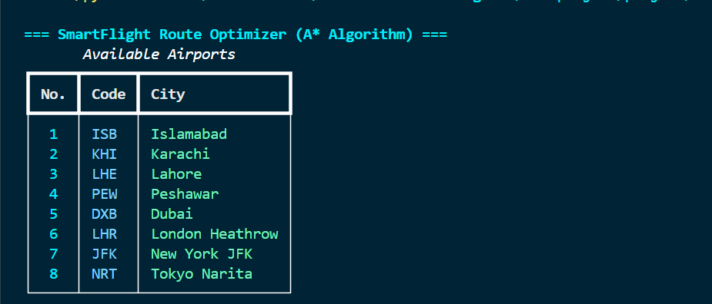

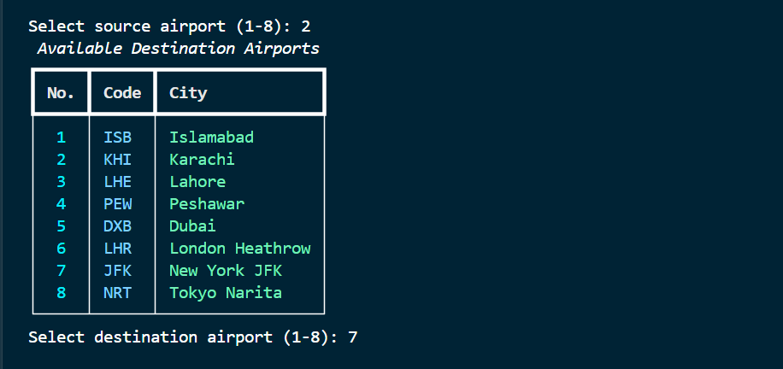

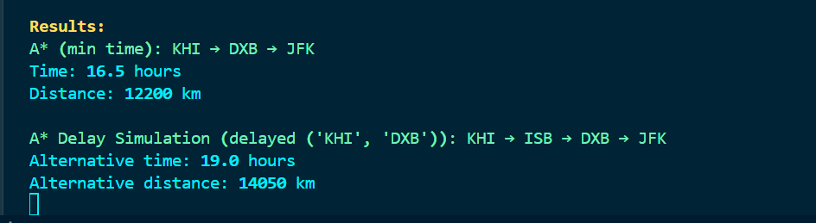

A*
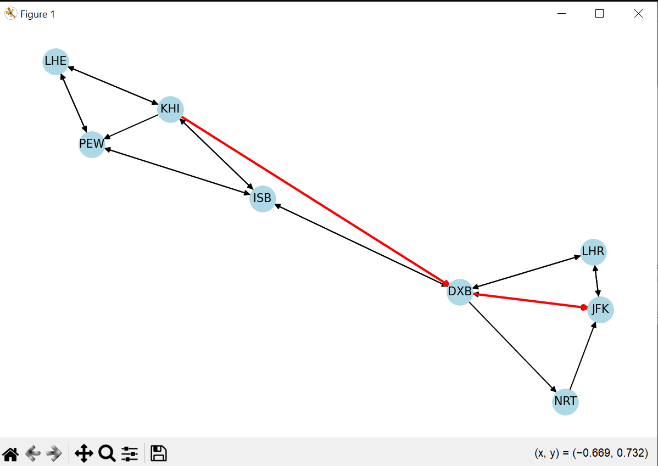

A* Delay Simulation
