

DATA STRUCTURES

FOODIFY

GROUP MEMBERS

Hassan Raza Attari (19k-1360)

Mohammad Asad (19k-1293)

Ali Hamza Usmani (19k-0146)

**ABSTRACT OVERVIEW**

Foodify is a solution to resolve a major problem in the time of COVID. People are bound to stay in their homes but to taste outside food, still people can order food from restaurants, but we are still bound to only one restaurant, we wanted a solution which can not only provide food to the customers but provide the food recommended by others from a variety of thousands of restaurants.

**MOTIVATION AND IDEA**

As previously mentioned, we got this idea from FOODPANDA which are already delivering quality food to different parts of the world but such services are not available in small city of BANGALORE so we wanted to create this app for Bangalore which so we tried to include almost every restaurant of BANGALORE in our app dataset.

**TOOLS AND TECHHNOLOGIES USED**

We created our desktop application using C++ as our programming language because of its performance.

We used various concepts of data structures in various parts of our project e.g.

LinkedList, Stack, queue, adjacency Matrix graphs, Hash tables and most importantly arrays as well as OOP concepts.

We used concepts of deep learning example Collaborative filtering to make our recommendations to customers more accurate.

**Salient features**

1) Sign Up option for User using contact number and password

-can change user information e.g. address and contact number.

-can register complaint.

2) Sign In option for User using existing contact number [MUST BE VALID].

3) Explore restaurants

-Simply select from all restaurants

-Check similar restaurant by pressing ‘R’ key in a restaurant tab

-Place order

4)Get recommended restaurants

-list all the restaurants with a good weighted average score [Highest rating and the greatest number of people voted].

-get recommended restaurants of those restaurants.

5) Contact foodify

6) CART to store the food .

**SOME FUNCTIONALITY OF OUT PROJECT**

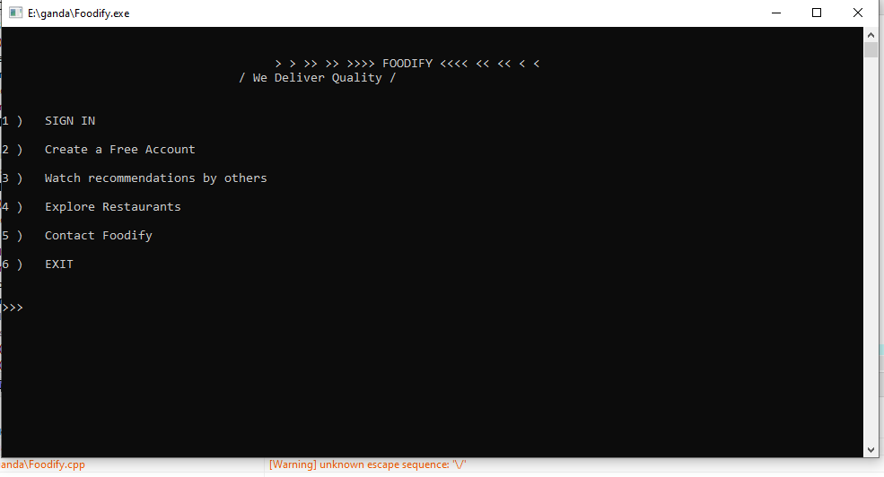

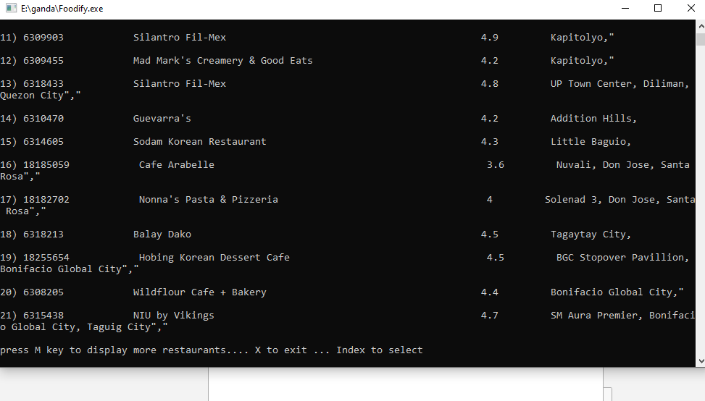

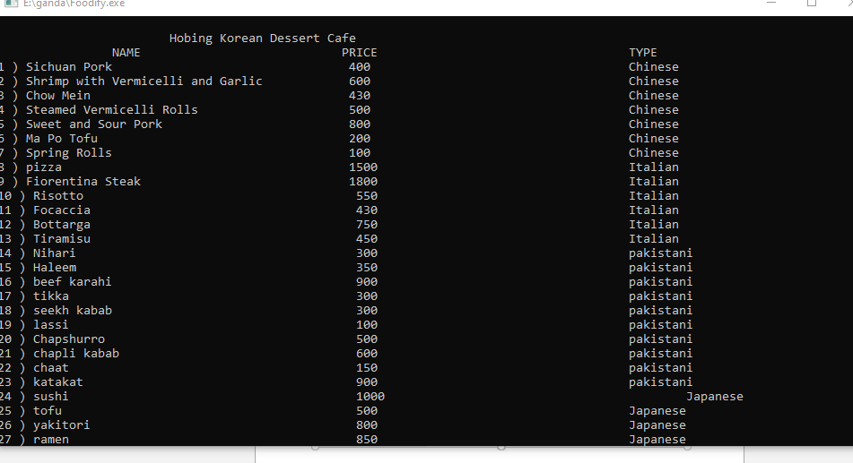

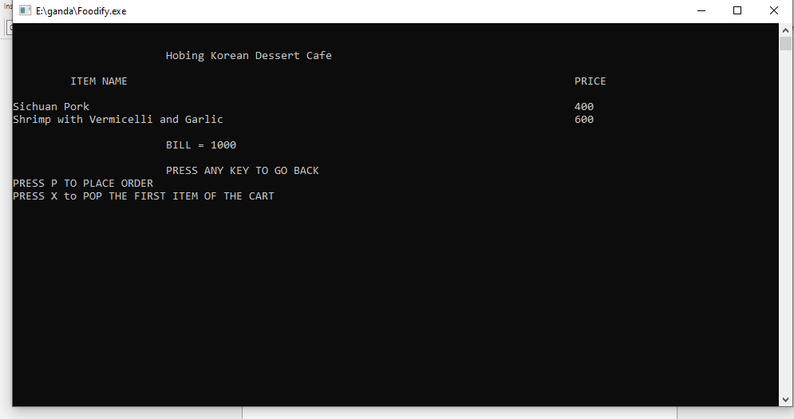

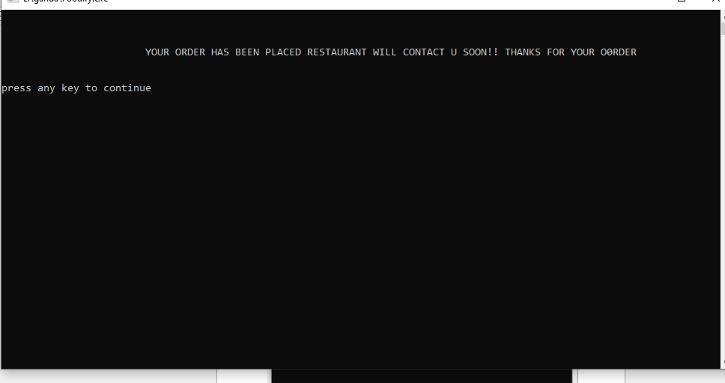

**CLASSES USED IN OUR PROJECT**

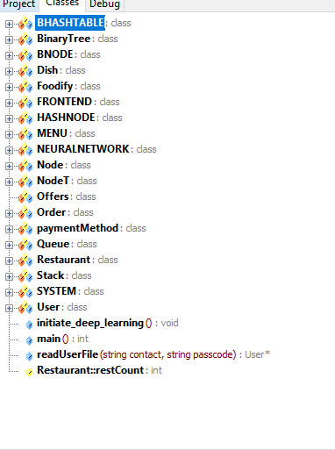

**DATA STRUCTURES CONCEPT USED IN OUR PROJECT**

We have used various concepts of data structures in our project.

We have implemented the CART using QUEUE.

We have implemented the screen management using STACK.

We have used arrays to store linear data

We have used LINKED LIST inside queue as the size of data is not known which could be added into STACK.

We have implemented HASH TABLE and arrays to store data to train in our neural network.

We have used adjacency matrix graph to create relation between each restaurant in our item based collaborative filtering.

**DEEP LEARNING CONCEPT**

Our project is solely based on deep learning so we have tried our based to make recommendation as precise as possible.

We have used two types of recommendation

1)ITEM/USER BASED FILTERING: - Using the data given by Zomato dataset, we calculated weighted average from that data for every restaurant and sorted the final result to get actual list of recommended restaurants.

2) Item-Based Collaborative Filtering: - We created a 2D matrix which and used it to create relation between every restaurant and for that we used our own data set of food ordered by user as well as their rating. We calculated correlation using Pearson correlation formulae and those restaurants with high correlation (> 0.50) are saved in the output file and the data is used for recommendations.

**Conclusion**

We would like to thank Google and YouTube which supported us during the process and in the future, I would like to implement the same concepts in a real-world app and deploy it on Google play store.