VR14_IOTLab_Task7

**EXPERIMENT-7:**

**Aim:**

Smoke Detection using MQ-2 Gas Sensor

**Apparatus (Components):**

1. 1-Arduino UNO Board
2. RED LED
3. GREEN LED
4. Bread Board
5. Connecting wires
6. MQ-2 Smoke Sensor
7. Buzzer

**MQ-2 Smoke Sensor**

The Gas Sensor (MQ2) module is useful for gas leakage detection (in home and industry). It is suitable for detecting H2, LPG, CH4, CO, Alcohol, Smoke or Propane. Due to its high sensitivity and fast response time, measurements can be taken as soon as possible. The sensitivity of the sensor can be adjusted by using the potentiometer. The resistance of the sensor is different depending on the type of the gas. The smoke sensor has a built-in potentiometer that allows you to adjust the sensor sensitivity according to how accurate you want to detect gas. The sensor value only reflects the approximated trend of gas concentration in a permissible error range, it DOES NOT represent the exact gas concentration. The detection of certain components in the air usually requires a more precise and costly instrument, which cannot be done with a single gas sensor.

#### Features

Wide detecting scope

Stable and long life

Fast response and High sensitivity

#### Hardware Specification:

|  |  |  |  |  |  |
| --- | --- | --- | --- | --- | --- |
| **Item** | **Parameter** | **Min** | **Typical** | **Max** | **Unit** |
| VCC | Working Voltage | 4.9 | 5 | 5.1 | V |
| PH | Heating consumption | 0.5 | - | 800 | mW |
| RL | Load resistance |  | adjustable |  |  |
| RH | Heater resistance | - | 33 | - | Ω |
| RS | Sensing Resistance | 3 | - | 30 | kΩ |

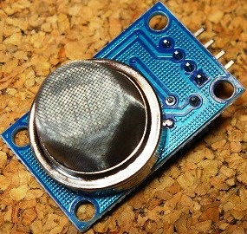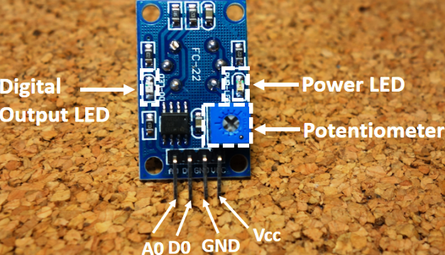

*Work principle of MQ-2 Smoke Sensor:*

The voltage that the sensor outputs changes accordingly to the smoke/gas level that exists in the atmosphere. The sensor outputs a voltage that is proportional to the concentration of smoke/gas.

In other words, the relationship between voltage and gas concentration is 1) The greater the gas concentration, the greater the output voltage and 2) The lower the gas concentration, the lower the output voltage.

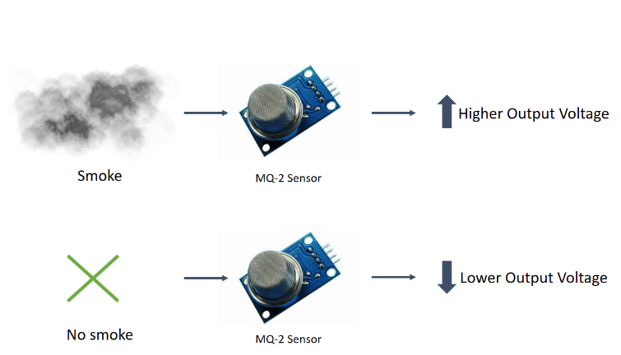

The output can be an analog signal (A0) that can be read with an analog input of the Arduino or a digital output (D0) that can be read with a digital input of the Arduino.

*Pin Wiring*

The MQ-2 sensor has 4 pins.

Pin-------------------------------------Wiring to Arduino Uno

A0-------------------------------------Analog pins

D0-------------------------------------Digital pins

GND-----------------------------------GND

VCC------------------------------------5V

*Connection schematic diagram:*

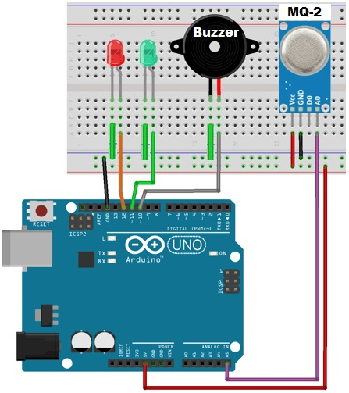

*Arduino code for MQ-2 sensor*

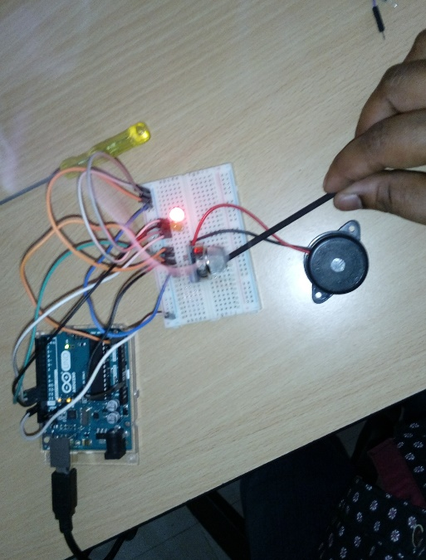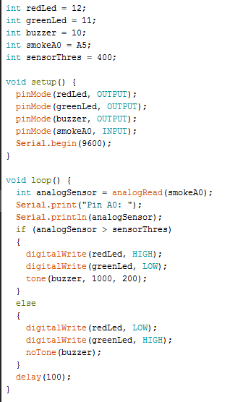

*Expected Output:*

