D-Lab Project

# User Manual

Prepared by Metamorphosis Ltd & SRGB

# About this Manual

This manual is intended to prepare to instruct Field Research Assistants (DRAs) on how to install and prepare the Desktop Monitoring Software into each School Lab PCs.

It has step by step instruction in terms of what to install and how to setup the software.

This manual is the English Language version and for the DRAs there will be a Bangla Language version as well for ease of understanding.

# Installing the Software

Each DRA will be provided with a Pen Drive which will have the necessary software and files.

Some of the files are for Software and others will be Video Data.

The software is compatible with the following Windows versions and Bit editions.

|  |  |  |
| --- | --- | --- |
| **S/N** | **Windows Type** | **Windows Bit** |
| 1 | Windows 7 | 32 bit |
| 2 | Windows 7 | 64 bit |
| 3 | Windows 10 | 32 bit |
| 4 | Windows 10 | 64 bit |

**How to Find Windows Version & Bit**

**Installation Steps**

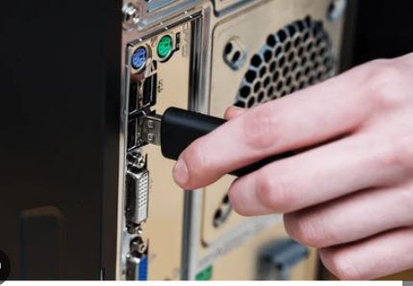

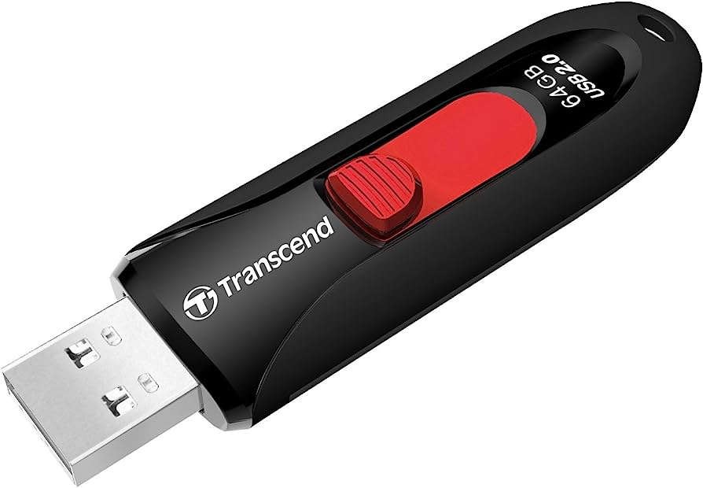

2.1 Insert the Pendrive in the Desktop Computer into a USB port

2.2 Wait (For about 30 seconds) for the Computer to Detect the Pen Drive.

2. 3 Go to My Computer and Open the Pen Drive if its not loaded Automatically.

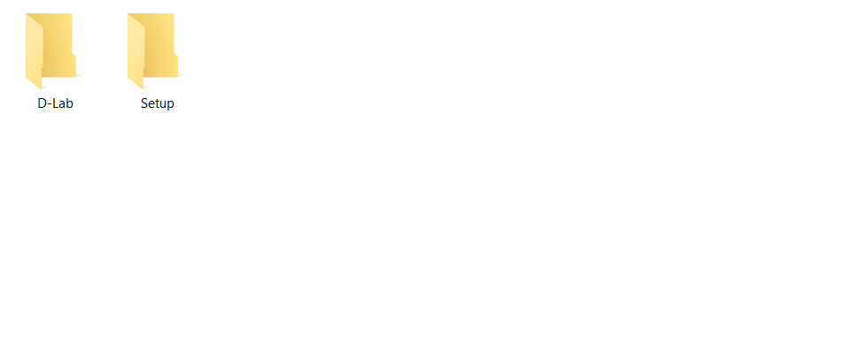2.4 Once open, you will see 2 Folders in the Pen Drive: D-Lab & Setup.

2.5 Copy both Folders in Desktop (Select both Folders > Right Click on them > Copy; then go to Desktop > Right Click > Paste)

2.6 Once both Folders are Copied into Desktop (This may take around 10 to 15 Minutes depending on Computer Speed), double click on the folder called **Setup**.

2.7 You will see a number of Files inside **Setup** folder.

2.8 First double click on the file called: **install_dependencies** (it takes around 15 to 20 minutes for it to finish)

2.9 After previous installation is finished, double click on the file **node-v18.16.0-x64** (it takes around 2 to 3 minutes)

2.10 After that double click on the file **mongodb-windows-x86_64-6.0.8-signed** (takes around 5 to 8 minutes)

2.11 As last step, double click on the file **install** (takes around 10 seconds to 20 seconds)

**Software Running Steps**

2.12 Once all installation is done, a Login Screen will appear where you have to enter Username and Password.

**Username**

**Password**

2.13 Please enter the following username and password

Username: dlabadmin

Password: A@7179lab

2.14 DRAs will first time add School EIIN, Lab and PC Id.

**School EIIN**

**School Name**

**Lab Id**

**Pc Id**

**Username**

If searched by School EIIN, it will show School Name or they can also Search by School Name and EIIN will be automatically filled up.

If it has only 1 Lab, Enter Lab ID as 1.

Enter each PC as 1, 2, 3 etc.

**Interface Items**

**edit**

**Switch video**

**All month information**

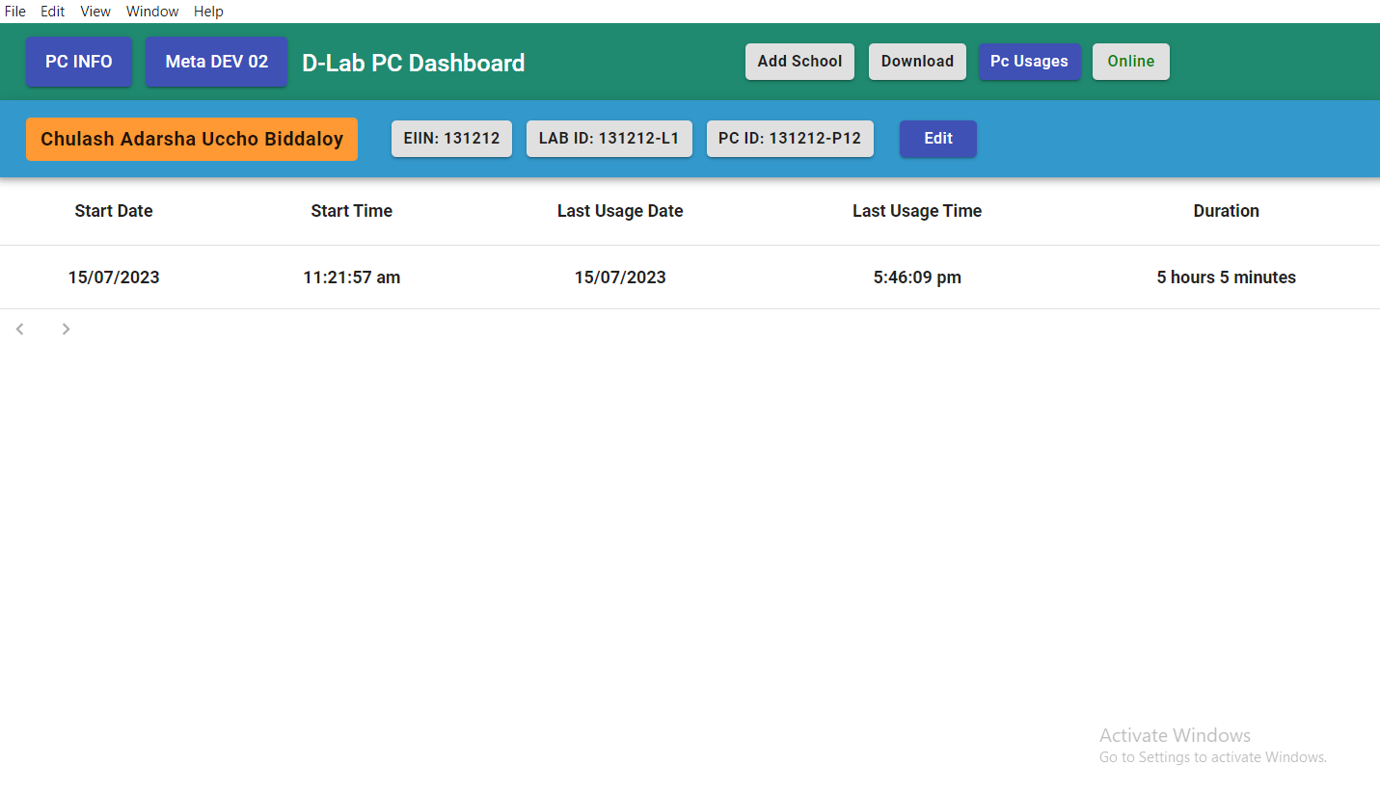

**Download Single Data**

**Pc Usages**

**Add school**

From the interface

1. User can click to know instant time of pc usage (it refreshes every 2 minutes)
2. User can download single month information
3. User can edit the school information
4. User can see the all-month data of pc usages
5. There are two mode. PC Info to show PC Usage and Video Info to show video running time.

**Downloading Data**

**edit**

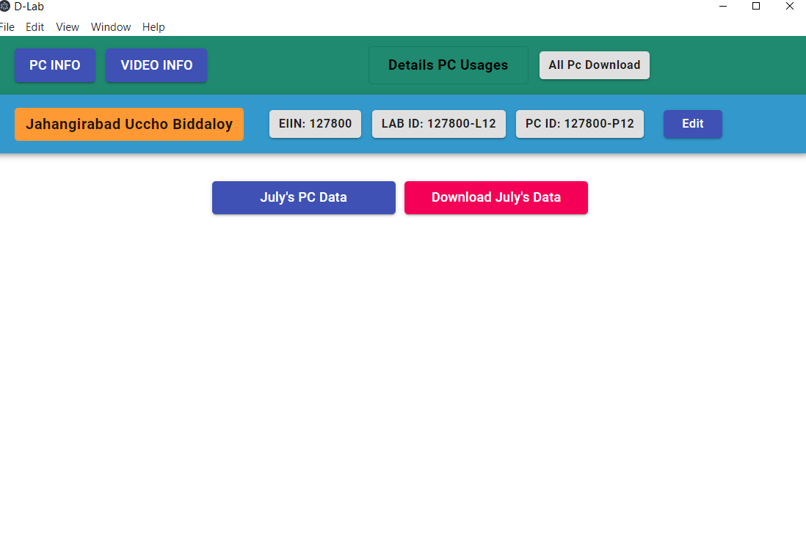

**Download all Data**

**Month wise download**

**Click to show July data**

**Switch video**

**Back to pc info**

When you click on single month it will show all log information.

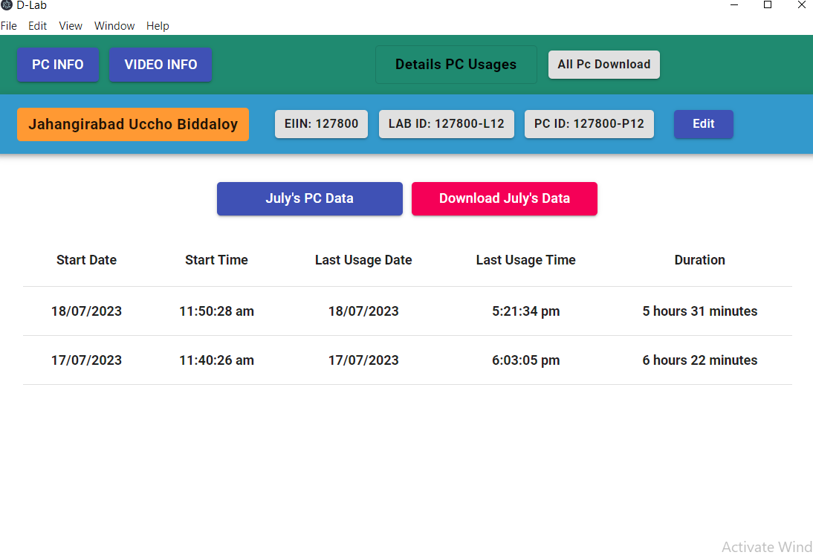

**Single moth information**

* User can click to all information of pc usages / monthly
* User can download month wise school information / all information*
* User can switch Video mode

**Video View Monitoring**

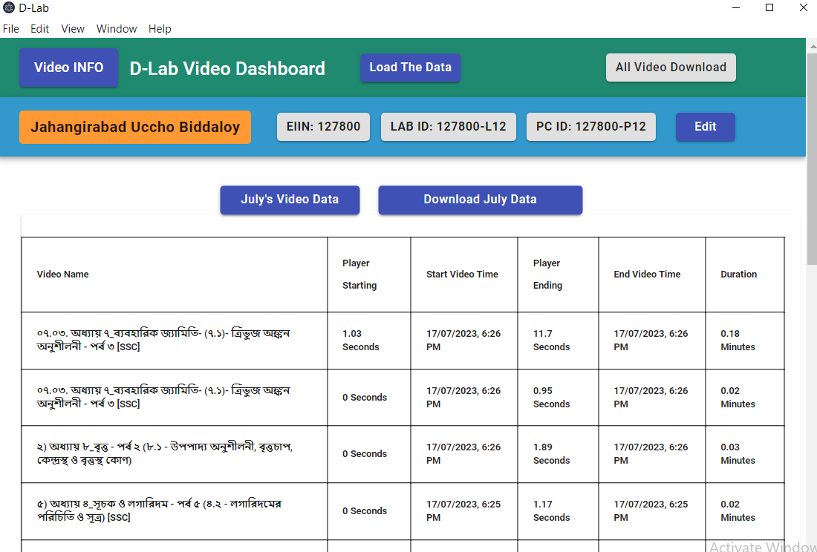

**single month information**

**Switch the pc mode**

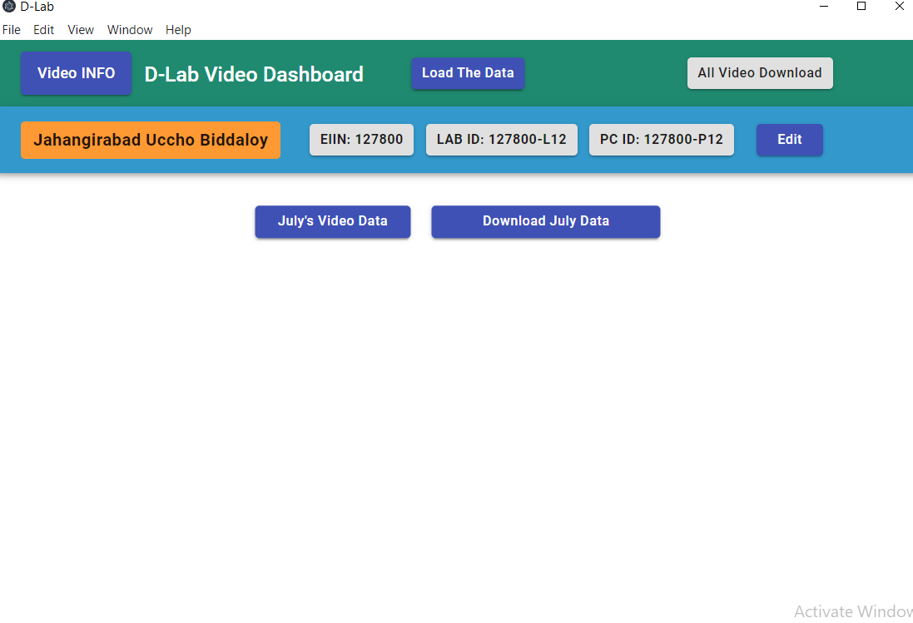

**Download all Data**

**Load the data**

**Download**

**Month wise**

**Switch pc**

**Single month information**

* User can click to know the video details/month wise/all
* User can download all information of video / month wise video information
* Load the data to see video information from playing video of given files
* User can see the all-month data of pc usages
* Use can switch to PC mode

**How to Run the Videos**

In the Desktop there is folder called **D-Lab** which has all the video dividing into Subject and Class.

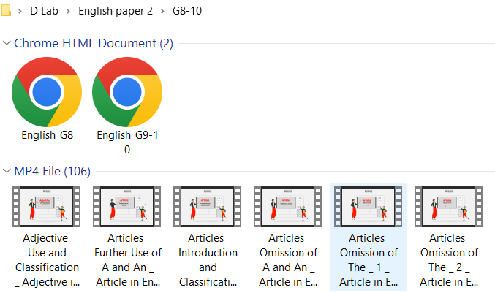Click on the Subject Files which will open in Browser.

Click on video title and list of video.

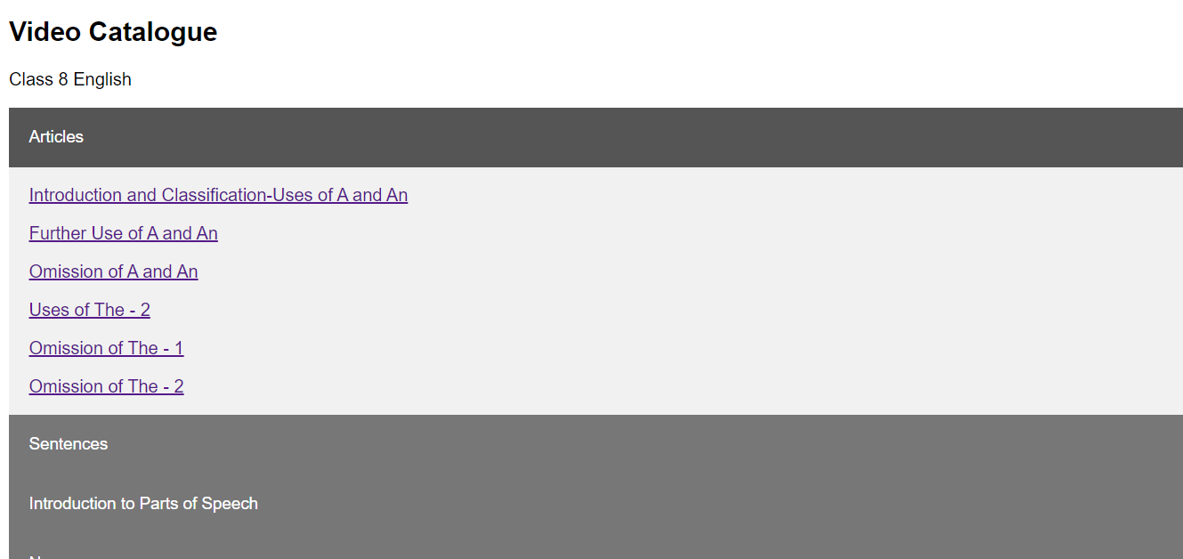Click on any video title to start watching the video.

After playing the video, if its paused or stopped, it will log the data.

**Adding Protection to Video Folder**

**Admin Dashboard for Research Team & Admin**

Researcher and Admin can login into Admin Dashboard to do the following:

1. Get data from school labs which have active internet connection.
2. Upload manually data for school labs which do not have active internet connection.

Go to the following URL in your browser to access the Login page of Admin Dashboard



Put admin username and password to gain access to the data.

Once login, user can search for any School by Name, EIIN etc.

User can download all school data or can download individual school data as well.

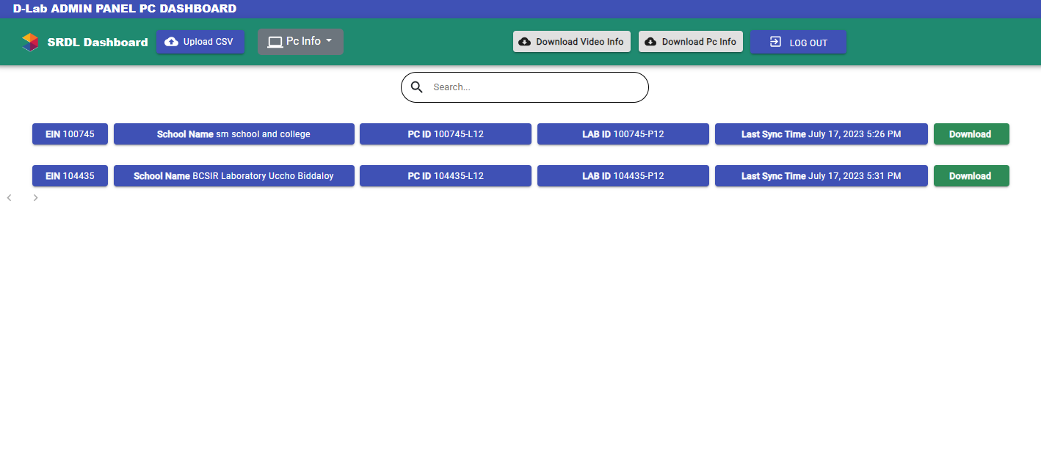Data can be for PC Usage or Video Usage.

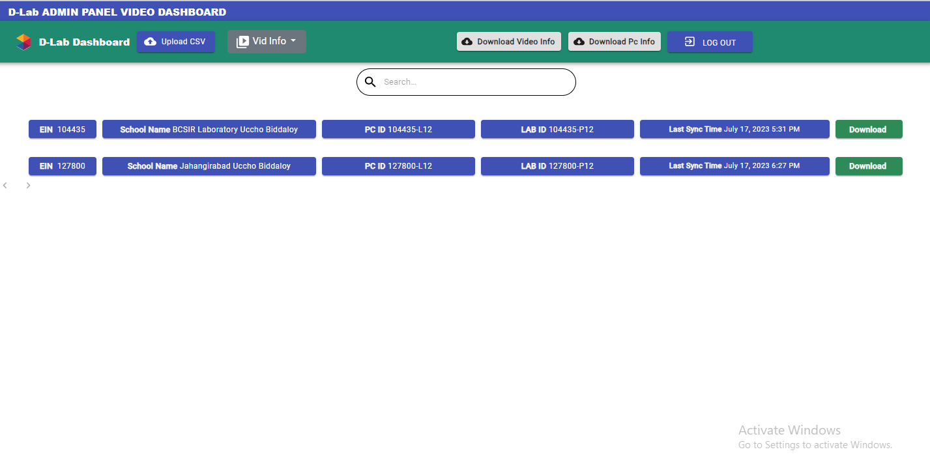

**Uploading Manual Data**

Click on the button called **Upload CSV** and select the file and Upload.

After upload, data will be available in the Dashboard.

You may upload multiple files together.