**Assingment 3**

**(Laptop)**

**Aqib Naqvi, R/N: 5**

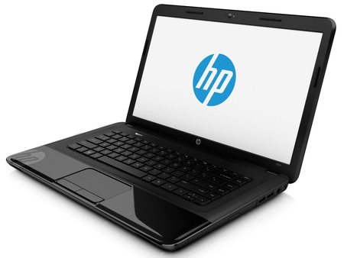

A **laptop** (also **laptop computer**), often called a **notebook**, is a small, portable [personal computer](https://en.wikipedia.org/wiki/Personal_computer) (PC) with a "[clamshell](https://en.wikipedia.org/wiki/Flip_(form))" form factor, typically having a thin [LCD](https://en.wikipedia.org/wiki/Liquid-crystal_display) or [LED](https://en.wikipedia.org/wiki/Light-emitting_diode) [computer screen](https://en.wikipedia.org/wiki/Computer_screen) mounted on the inside of the upper lid of the [clamshell](https://en.wikipedia.org/wiki/Clamshell_design) and an [alphanumeric keyboard](https://en.wikipedia.org/wiki/Alphanumeric_keyboard) on the inside of the lower lid. Today, laptops are commonly used in a variety of settings, such as at work, in education, for playing games, Internet surfing, for personal multimedia, and general home computer use.

**Histroy:** As the [personal computer](https://en.wikipedia.org/wiki/Personal_computer) (PC) became feasible in 1971. A "personal, portable information manipulator" was imagined by [Alan Kay](https://en.wikipedia.org/wiki/Alan_Kay) at [Xerox PARC](https://en.wikipedia.org/wiki/Xerox_PARC) in 1968,  and described in his 1972 paper as the "[Dynabook](https://en.wikipedia.org/wiki/Dynabook" \o "Dynabook)" The IBM Special Computer APL Machine Portable (SCAMP) was demonstrated in 1973. This prototype was based on the [IBM PALM processor](https://en.wikipedia.org/wiki/IBM_PALM_processor). The [IBM 5100](https://en.wikipedia.org/wiki/IBM_5100) in September 1975.

**My Laptop Specifications:**

|  |  |
| --- | --- |
| **Processor** | Intel Core i3-2370M Processor (2.4 GHz, 3MB L3 Cache) |
| **Chipset** | Intel HM75 Express Chipset |
| **Graphics** | Intel HD Graphics 3000 |
| **Display** | 14.0-inch diagonal HD Bright View LED Display (1366 x 768) |
| **Memory** | 2GB DDR3 RAM |
| **Hard Drive** | HP 500GB 5400RPM |
| **Optical Drive** | HP Super Multi DVD Burner |
| **Networking/ Wireless** | Integrated 10/100BASE-T Ethernet LAN 802.11b/g/n WLAN |
| **Operating System** | Microsoft Windows 7 Home Basic |
| **I/O Ports** | 3 USB 2.0, HDMI, RJ-45, Headphone out, Microphone in |
| **Webcam/ MIC** | HP 720p High Definition Webcam with integrated microphone |
| **Audio** | Altec Lansing Internal Speakers |
| **Keyboard/ Touchpad** | Notebook keyboard with Touchpad supporting Multi-Touch gestures |
| **Media Card** | Multi-Format Digital Media Card Reader for Secure Digital and Multimedia Cards |
| **Battery** | 6-Cell Lithium-Ion Battery |
| **Power** | 65W AC Adopter |
| **Carrying Bag** | HP Backpack with customized logo |