**APEEJAY SCHOOL, NOIDA**

Title: XII COMPUTERSCIENCEPROJECT

Subtitle: Online Grocery Application

Name: Panav Gupta Name: Mohd. Ayaan Ahmad

RollNo. - RollNo. -

**INDEX**

|  |  |  |
| --- | --- | --- |
| Sno. | Topic | PageNo. |
| 1 | Acknowledgement | 3 |
| 2 | Certificate | 4 |
| 3 | Problem Definition | 5 |
| 4 | Proposed System | 6 |
| 5 | Hardware and Software Required | 7 |
| 6 | Design (Logical) | 8 |
| 7 | Design (Physical) | 8 |
| 8 | Input/Output Screen Formats | 9 |
| 9 | Scope for Improvements | 13 |
| 10 | Bibliography | 14 |

**Acknowledgement**

I want to express my deep gratitude to my teacher Ms. Sujata Bharadwaj, who gave us the golden opportunity to do this wonderful Computer Science project. Their guidance and encouragement were indispensable in bringing this project to fruition

We also came to know about so many new things, and we are thankful to them. We want to extend our sincere thanks to our family and friends for their unwavering support and motivation throughout this journey.

**CERTIFICATE**

This is to certify that Panav Gupta and Mohd. Ayaan Ahmad, students of class XII have successfully completed their Computer Science project under the guidance of Ms.Sujata Bhardwaj (Subject Teacher) during the year 2024-25.

_________________ _________________

Sign of external Sign of internal

Examiner Examiner

**PROBLEM DEFINATION**

The primary issue that the proposed Grocery Store system aims to solve is the inefficiency and inconvenience associated with manual inventory management, billing, and customer service in traditional grocery stores. This system seeks to streamline the entire process, from stock management to customer checkout, to enhance overall operational efficiency, reduce human errors, and improve customer satisfaction. Additionally, the system will address challenges like tracking stock levels, generating automated bills, inventory management, etcetera.

**PROPOSED SYSTEM**

The proposed system is a computerized Grocery Store management solution designed to automate various tasks involved in running a grocery store. This system will include features like inventory management, billing, customer management, and report generation. It will enable store owners and employees to keep real-time track of inventory, process sales transactions quickly, and generate detailed reports on sales and stock levels. The system will also offer an intuitive user interface for easy interaction and an underlying database and binary files for storing and retrieving all necessary data.

**HARDWARE AND SOFTWARE REQUIRED**

**Hardware:**

* A computer or server with sufficient processing power and storage capacity.
* Receipt printer for printing bills.
* Network router (if the system is to be accessed by multiple users on different machines).
* Backup storage devices for data security.

**Software:**

* **Operating System:** Windows, Linux, or macOS.
* **Database Management System (DBMS):** MySQL, etc.
* **Programming Language:** Python.
* **IDE (Integrated Development Environment):** Visual Studio, PyCharm, etc
* **Additional Modules:** tkinter(ttk, fileidealog), PIL(ImageTK, Image), pickle, os, shutil, mysql.connecter, random

**DESIGN (logical)**

The logical design of the Grocery Store system involves defining the system's architecture and how different modules will interact with each other. Key components include:

* **Database Design:** Tables for product bills and transactions.
* **Binary file Design:** Files for the inventory of the whole store
* **User Interface Design:** Screens for product management, billing, and report generation.

**DESIGN (physical)**

The physical design involves putting together the actual parts of the system. This includes:

* **Database Setup:** Creating simple tables in a database to store information about products, customers, and sales.
* **User Interface:** Designing basic screens that users will see, such as the product list, billing screen, inventory manager (for owner), etc
* **Hardware:** Setting up the necessary equipment like a computer, printer to make the system work.

**INPUT/OUTPUT SCREEN FORMATS**

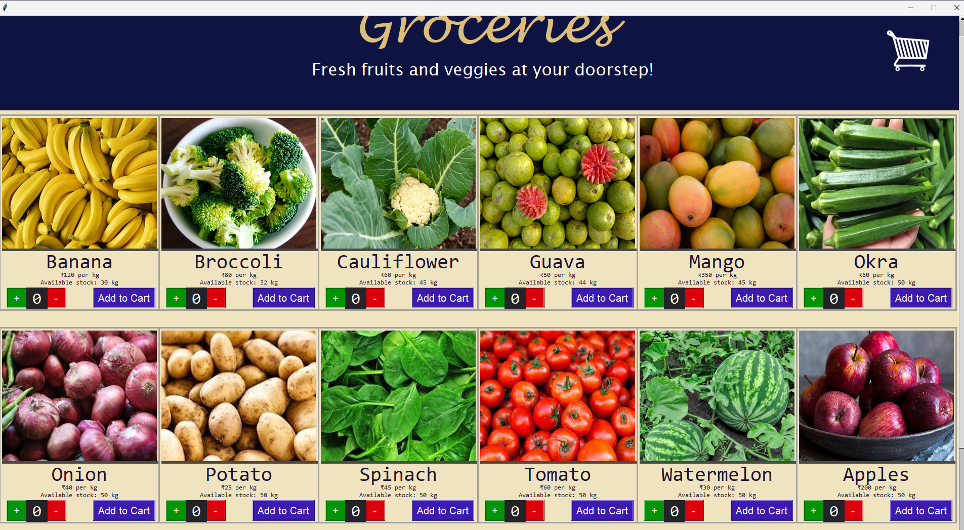

**SCOPE FOR IMPROVEMENT**

While the proposed system aims to cover all essential aspects of grocery store management, there is always room for further enhancements. Future improvements could include:

* **Integration with Online Platforms:** Allowing customers to place orders online and pick them up in-store.
* **Mobile Application:** A mobile app version of the system for on-the-go management.
* **Advanced Analytics:** Incorporating AI to predict customer buying patterns and optimize stock levels.
* **Multi-Store Support:** Expanding the system to manage multiple stores from a single interface.

**BIBLOGPRAHY / REFRENCES**

1. **Websites**:

* <https://stackoverflow.com/>
* <https://www.reddit.com/r/learnpython/>
* <https://www.geeksforgeeks.org/>
* <https://www.tutorialspoint.com/>

1. **Videos**:

* <https://www.youtube.com/watch?v=tJxcKyFMTGo&list=PLaL2yxczKLcARpDfF_5JO5Eydb0qwVOBB>
* <https://www.youtube.com/watch?v=YXPyB4XeYLA>

1. **Books**:

* Class 12 Comp. Science NCERT
* Sumita Arora