

Yousef Michael 201911057 Eyad Daraghmeh 201910961

Mohammad Mohyee 201920057 Baraa S Kamasya

Introduction :

A company that wants to find the population density for each town, and it wants to know the location of each person in the town and who have job.

For record population Density= number of people in town/ the land area.

In this project we show how the execution mechanism.

Description:

The company has several Sections and each one should have unique number, name, location, number of workers.

A section has Workers and a single worker has individual number, name ( Fist name, middle name, Last name) ,salary, commission, phone number, section id ,Each one must be either a data entry employee which will have speed type for inserting the data in the computers, And the second one is researcher who have to go to the towns to collect data and he have communication skills, and town id.

A single town a has number, name, mayor name, mayor id, and number of streets, town area, and persons#. Every street has name, town id, unique street number, And many houses sets in one street. Every house has singular number, street number of the house, number of persons in the house, family name.

Each person has id number, name ( First name, Last name), job id, house id, age, gender,salary.

We have a lot of jobs in tow each job has job id, the quantity of persons in this job.

Populated density in each town contains town id, and density of people.

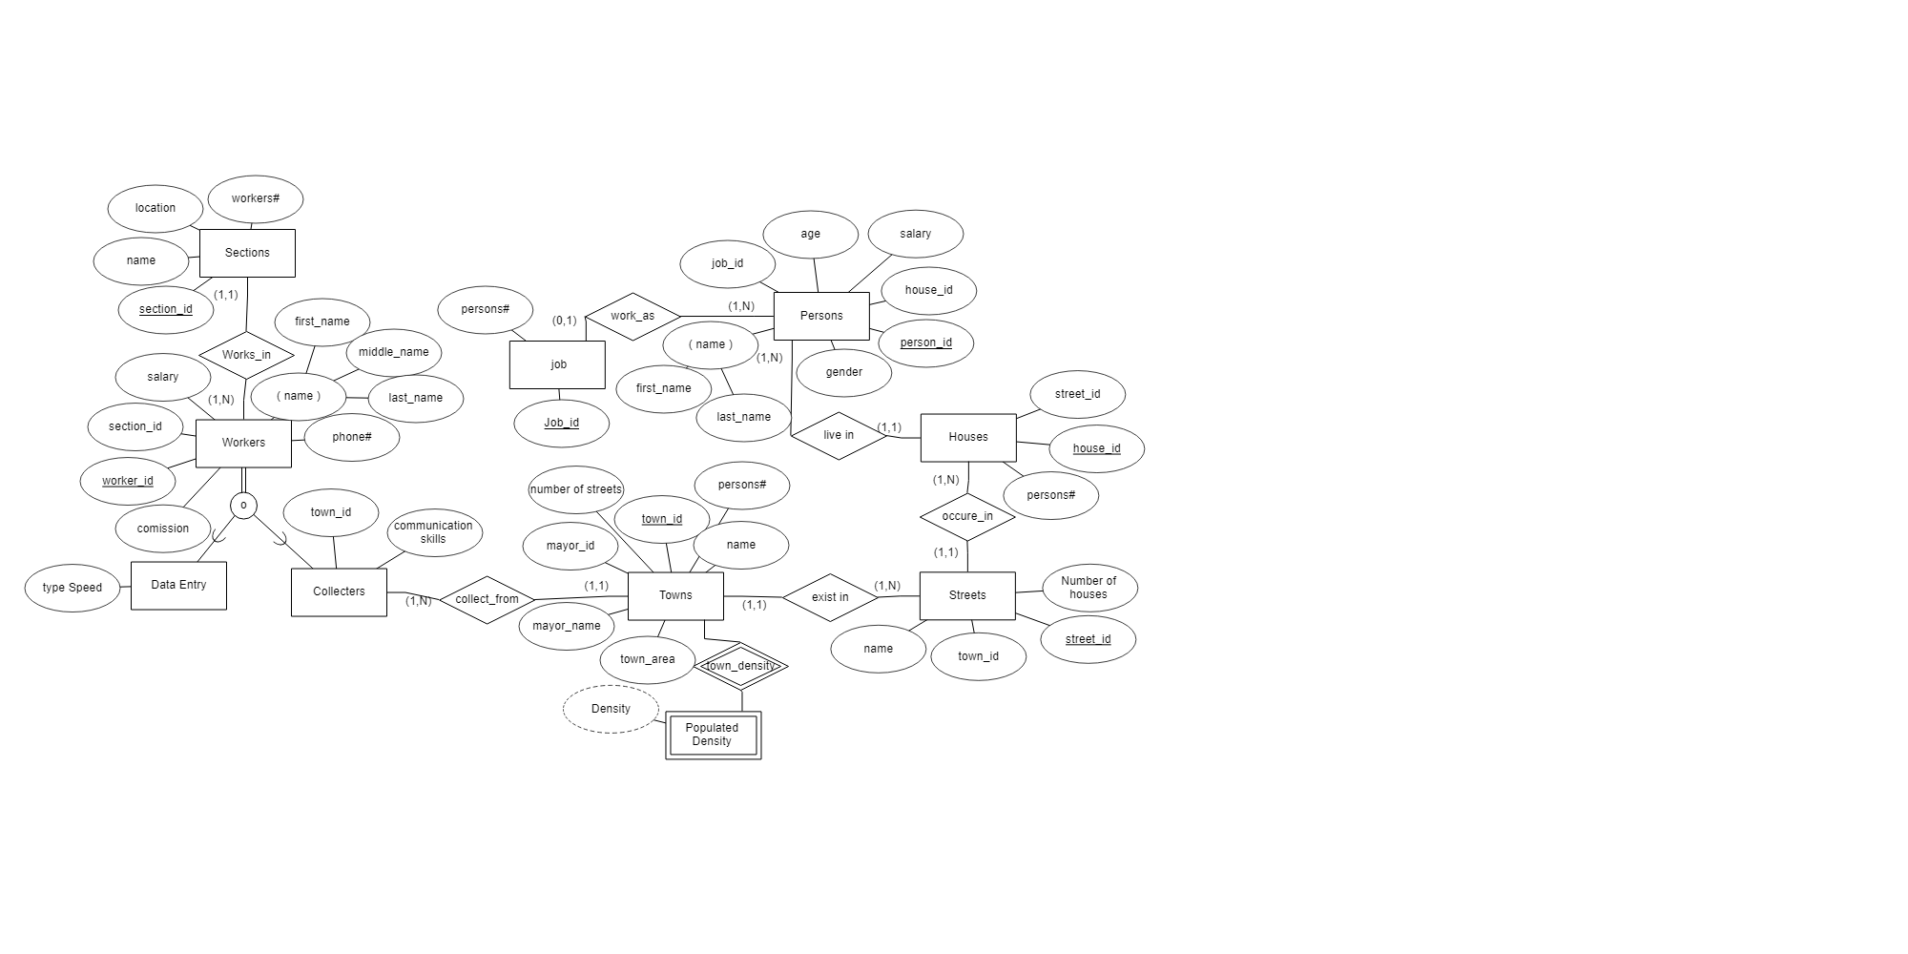

**Schema:**

sections

|  |  |  |  |
| --- | --- | --- | --- |
| Section_id | name | location | Workers# |

workers

|  |  |  |  |  |  |  |  |
| --- | --- | --- | --- | --- | --- | --- | --- |
| Worker_id | Section_id | salary | commission | Phone# | First_name | Middle_name | Last_name |

Data_entry

|  |  |
| --- | --- |
| worker_id | Type_speed |

collecters

|  |  |  |
| --- | --- | --- |
| Worker_id | Town_id | Communication_skills |

towns

|  |  |  |  |  |  |  |
| --- | --- | --- | --- | --- | --- | --- |
| Town_id | name | Mayor_id | Mayor_name | Streets# | Town_area | Persons# |

Populated_density

|  |  |
| --- | --- |
| Town_id | density |

streets

|  |  |  |  |
| --- | --- | --- | --- |
| Street_id | Town_id | name | Houses# |

Complement shema:

streets

|  |  |  |  |
| --- | --- | --- | --- |
| Street_id | Town_id | name | Houses# |

houses

|  |  |  |
| --- | --- | --- |
| House_id | Street_id | Persons# |

persons

|  |  |  |  |  |  |  |  |
| --- | --- | --- | --- | --- | --- | --- | --- |
| Person_id | First_name | Last_name | Job_id | age | gender | salary | House_id |

jobs

|  |  |
| --- | --- |
| Job_id | Persons# |

Tables:

Sections:

|  |  |  |  |
| --- | --- | --- | --- |
| Section_id | name | location | Workers# |
| 1 | Tubas_section | tubas | 20 |
| 2 | Nablus_section | nablus | 25 |
| 3 | Ramallah_section1 | ramallah | 35 |
| 4 | Ramalla_section2 | ramallah | 30 |

Workers:

|  |  |  |  |  |  |  |  |
| --- | --- | --- | --- | --- | --- | --- | --- |
| Worker_id | Section_id | Phone# | First_name | Middle_name | Last_name | salary | commission |
| 100011 | 1 | 059111 | yousef | hamadan | odeh | 12000 | 0.10 |
| 100012 | 3 | 059112 | eyad | abu | salah | 35780 | 0.05 |
| 100013 | 2 | 059113 | baraa | kalil | mahran | 20622 |  |
| 100023 | 4 | 059123 | mohammad | ibrahim | Daragmeh | 15000 |  |
| 100014 | 4 | 059124 | zeynep | tamir | bolot | 16700 | 0.15 |

Data_entry:

|  |  |
| --- | --- |
| Worker_id | type_speed |
| 100012 | good |
| 100013 | Need practice |
| 100023 | excellent |

Collecters:

|  |  |  |
| --- | --- | --- |
| Worker_id | Town_id | Communication_skills |
| 100011 | 1 | good |
| 100014 | 2 | It’okey |

Towns:

|  |  |  |  |  |  |  |
| --- | --- | --- | --- | --- | --- | --- |
| Town_id | name | Mayor_id | Mayor_name | Streets# | Town_area  Km2 | Persons# |
| 1 | tubas | 1234 | Ibraheem | 12 | 25 | 1000 |
| 2 | jenin | 1235 | sameer | 18 | 40 | 1500 |
| 3 | nablus | 1236 | ahmad | 24 | 60 | 2500 |

Populated_density:

|  |  |
| --- | --- |
| Town_id | Density  Per km2 |
| 1 | 40 |
| 2 | 37.5 |
| 3 | 41.7 |

Streets:

|  |  |  |  |
| --- | --- | --- | --- |
| Street_id | Town_id | name | Houses# |
| 11 | 1 | abdallah | 10 |
| 22 | 2 | nerat | 8 |
| 33 | 3 | Al-quds | 12 |

Houses:

|  |  |  |
| --- | --- | --- |
| House_id | Street_id | Persons# |
| 111 | 11 | 5 |
| 222 | 22 | 4 |
| 333 | 33 | 2 |

Persons:

|  |  |  |  |  |  |  |  |
| --- | --- | --- | --- | --- | --- | --- | --- |
| Person_id | First_name | Last_name | Job_id | age | gender | House_id | salary |
| 00001 | Eyad | jeib | doctor | 20 | m | 333 | 60700 |
| 00002 | zyan | samarah | teacher | 22 | f | 222 | 10200 |
| 00003 | samera | hassan | programmar | 20 | f | 111 | 20670 |
| 00004 | baraa | jeib | doctor | 21 | m | 333 | 19700 |

Job:

|  |  |
| --- | --- |
| Job_id | Persons# |
| doctor | 20 |
| programmar | 30 |
| Teacher | 15 |

**Sql:**

Sections:

CREATE TABLE Sections

(

section_id int NOT NULL,

name varchar2(15) NOT NULL,

location varchar2(20),

workers# int,

PRIMARY KEY (section_id)

);

Workers:

CREATE TABLE Workers

(

worker_id int NOT NULL,

first_name varchar2(10) NOT NULL,

middle_name varchar2(10) NOT NULL,

last_name varchar2(10),

phone# int,

section_id int ,

salary int ;

commission decimal(10,4);

PRIMARY KEY (worker_id)

);

Collecters:

CREATE TABLE Collecters

(

town_id INT ,

communication_skills varchar2(15),

worker_id INT NOT NULL,

PRIMARY KEY (worker_id)

);

Data_entry:

CREATE TABLE Data_Entry

(

type_Speed varchar2(18),

worker_id INT NOT NULL,

PRIMARY KEY (worker_id)

);

Towns:

CREATE TABLE Towns

(

town_id INT NOT NULL,

name varchar2(22) NOT NULL,

mayor_name varchar2(15) NOT NULL,

mayor_id INT NOT NULL,

number_of_streets INT ,

town_area INT not null,

persons# INT not null,

PRIMARY KEY (town_id)

);

Streets:

CREATE TABLE Streets

(

name varchar2(15),

street_id INT NOT NULL,

town_id INT NOT NULL,

Number_of_houses INT,

PRIMARY KEY (street_id)

);

Houses:

CREATE TABLE Houses

(

house_id INT NOT NULL,

street_id INT NOT NULL,

persons# INT NOT NULL,

PRIMARY KEY (house_id)

);

Persons:

CREATE TABLE Persons

(

person_id INT NOT NULL,

first_name varchar2(15) NOT NULL,

last_name varchar2(15) NOT NULL,

job_id varchar2(15),

house_id INT NOT NULL,

age INT ,

gender char(1),

salary int ;

PRIMARY KEY (person_id)

);

Job:

CREATE TABLE job

(

Job_id varchar2(15) NOT NULL,

persons# INT NOT NULL,

PRIMARY KEY (Job_id)

);

Populated_density:

CREATE TABLE Populated_Density

(

town_id int not null,

density int not null,

primary key(town_id,density)

);

Foreign keys:

Alter table workers add (constraint s foreign key(section_id) references sections(section_id));

Alter table data_entry add (constraint s2 foreign key(worker_id) references workers(worker_id));

Alter table collecters add (constraint s3 foreign key(worker_id) references workers(worker_id));

Alter table collecters add (constraint s4 foreign key(town_id) references towns(town_id));

Alter table populated_density add (constraint s5 foreign key(town_id) references towns(town_id));

Alter table streets add (constraint s6 foreign key(town_id) references towns(town_id));

Alter table houses add (constraint s7 foreign key(street_id) references streets(street_id));

Alter table persons add (constraint s8 foreign key(house_id) references houses(house_id));

Alter table persons add (constraint s9 foreign key(job_id) references job(job_id));

Questions:

1-Fill in the table workers a new values.

2-Display the first name and worker number of workers who work in section 4.

3-retrieve the last name ,worker number ,section number of the employee whose first name is Eyad.

4-display person first name and last name together and the length of his name.

5.display workers last name ,id, section location and section id to which he/she belongs .

6.display the workers names and salarie’s revision based on the section id of the worker.

7.retrieve the statement in the previous question using decode.

8.display the average , highest, lowest and sum of salary for all persons.

9.display every house and whats town it belongs to.

10.retrieve the density of a town that have been inserted by the user

11.display the workers name and section id and the salary for a worker whose section id is the same as that of worker num 100014