

**The Arab American University**

Faculty of Engineering and Information Technology

**Engineering/IT Project Management**

**Course Project**

**Smart House**

***Prepared By:***

**Mohammed Ma’moun Zyoud 201910443**

**Mohammed Fawzi Daraghmeh 201911182**

**Mohammad Mohyee Majed 201920057**

***Instructor***

**Dr Rami Hadrob**

**May 2023 © Arab American University – Palestine**

**Abstract**

A smart home project involves integrating technology into a home to make daily life simpler, more effective, and more comfortable. It is a creative and intriguing idea. An automated living area that can be fully managed by the owner or occupant via a central hub, a mobile device, or voice commands is the goal of a smart home project. In order to control lighting, temperature, security systems, entertainment systems, and other things in the home, numerous sensors, cameras, and other devices must be installed throughout the house. These devices must be able to communicate with each other and the central hub.

Numerous advantages come with a smart home project, such as increased comfort and convenience, cost savings on energy bills, increased security, and personalization to suit the occupants' particular needs and preferences. Smart home projects are an exciting and creative method to increase a house's utility and liveability because the possibilities for building a fully intelligent and automated living space are practically unlimited as technology develops.

**Table of Contents**

**Chapter one**

**1.1 introduction**

**1.2 the scope, time, and cost constraints for the project**

**1.3 the project sponsor and the project manager**

**1.4 the business case for the project**

**1.5 the project stakeholders**

**1.6 management strategy**

**1.7 the project charter**

**1.8 the project Kick-off meeting**

**Chapter two**

**2.1 Overview**

**2.2 Requirements Matrix for Project**

**2.3 project scope statement**

**2.4 work breakdown structure (WBS) and WBS dictionary**

**2.5 project schedule, in the form of a Gantt chart with all dependencies and resources entered**

**2.6 Project Organizational Chart**

**2.7 Project  Budget**

**2.8 Project Financial Analysis**

**2.9 A list of prioritized risks**

**2.10 Summary**

**Chapter three**

**3.0 Project execution**

**3.1 Introduction**

**3.2 Milestone report**

**Chapter Four**

**4.1 Project Monitoring and Controlling**

**4.2 Status/Progress Report**

**4.3 Summary**

**Chapter five**

**5.  Project closing**

**5.1 introduction**

**5.2 Lessons-learned report**

**5.3 conclusion**

**List of Tables**

**Table 1.1: business case**

**Table 1.2: project stakeholders**

**Table 1.3: management strategy**

**Table 1.4: roles and responsibilities**

**Table 1.5: kick-off meeting**

**Table 2.1: requirement matrix**

**Table 2.2: project scope statement**

**Table 2.3: WBS Dictionary**

**Table 2.4: Project Budget**

**Table 2.5: project financial analysis**

**Table 2.6: list of prioritized risks**

**Table 3.1: milestone report**

**Table 4.1: status/progress report**

**Table 5.1: lessons learned report**

**List of Figures**

**Figure 2.1: project schedule with Gantt chart**

**Figure 2.2: network diagram**

**Figure 2.3: project organizational chart**

**Figure 2.4: payback**

**Chapter One**

**Project Pre-Initiation and Initiation**

# **Introduction**

With the development of technology, smart home becomes a need in different asper of people life

It can be defined as where two physical devices interconnected to each other via remote controllers. A smart home provides comfort, security, convenience, and energy efficiency of their home by using a smart home technology app on a smartphone or other connected device to control smart devices like smart locks, security cameras, automated doors, etc. The internet plays a key role. This research shed light on the advantages of the topic provided.

# **1.2 the scope, time, and cost constraints for the project**

# Scope: create a smart house

Time: 14 months

Cost: 100000$

constraints: Unstable prices of used tool’s

ـــــــــــــــــــــــــــــــــــــــــــــــــــــــــــــــــــــــــــــــــــــــــــــــــــــــــــــــــــــــــــــــــــــــــــــــــــــــــــــــــــــــــــــــــــــــــــــــــــــــــــــ

# **1.3 the project sponsor and the project manager**

Project manager: Mohammed Ma’moun Zyoud

Sponsor: Mohammed Mohyee Majed

# **1.4 The business case for the project**

Implementing a smart house project can have significant benefits for businesses.

**1.4.1 Table of Business Case**

**Table 1.1**

|  |
| --- |
| 1. **Introduction/ Background**   The fact that this concept wasn’t common among people, by the time It has become popular among consumers and industry experts in the shape of an idea.  The idea of smart home can be tracked to **1901 – 1920 –** **where the invention of home appliances**. **1966 – 1967 -** **ECHO IV and the Kitchen Computer**- Westinghouse engineer Jim Sutherland was the first one who embedded smart home via creating ECHO IV which controls. - Geotechnology -this term was used in 1991 to describe notion that integrated Gerontology and Technology aiming to made audit life easier. in 2000s the concept was rapidly spread |
| **2.0 Business Objective**  The project aims to make a smart house controlled by smart phone and voice command |
| **3.0 Current Situation and Problem/Opportunity Statement**  Opportunity: There are opportunities for businesses to change their product management approach by giving a free base and then selling their services, for example, a home monitoring base station may be installed for “free,” but services that send alerts such as burglar alarms, and smoke detection alarms are billed. |
| **4.0 Critical Assumption and Constraints**  1- Unstable prices of used tool’s  2- Internet connection interruption.  3-Area of building. |
| **5.0 Analysis of Option and Recommendation**  Recommendations: Commitment to the schedule and budget |
| **6.0 Preliminary Project Requirements**  1- Establish the budget and schedule.  2- Hiring a highly experienced consultant with extensive technical knowledge.  3- Central Hub: A central hub is the brain of the smart home.  4- Sensors and Devices: Sensors and devices such as motion sensors, temperature sensors, smart thermostats, smart lighting etc.  5- Voice Control: The smart home should have the option of voice control  Mobile Control: The smart home should also have the option of controlling and monitoring the devices  6- Security: The smart home should have robust security measures in place to protect the privacy and security of the homeowner or occupant. |
| **7.0 Budget Estimate and Financial Analysis**  ********************************** |
| **8.0 Schedule Estimate**  Approximately two months for study and 6 months for application |
| **9.0 Potential Risks**  1-Difficulties in importing some tools.  2-Internet connection problem.  3- the prices of tools. |
| **10.0 Exhibits**  Exhibit A: Financial Analysis  Exhibit B: Time Analysis |

# 

# **1.5 The Project Stakeholders**

**Stakeholder Register for Project Name**

**Prepared by:** Mohammed Ma’moun Zyoud **Date: April 2023**

**Table 1.2:**

|  |  |  |  |  |
| --- | --- | --- | --- | --- |
| **Name** | **Position** | **Internal/External** | **Project Role** | **Contact Information** |
| Project manger | Mohammed Zyoud | Internal | Project manager | m.zyoud7@student.aaup.edu |
| Sponsor | Mohammad Majed | Internal | Sponsor | m.baniodeh4@student.aaup,edu |
| Advisor | Mohammad daraghmeh | Internal | Advisor | m.daraghmh1@student.aaup.edu |

# **1.6 management strategy**

|  |
| --- |
| Mohammed Ma’moun Zyoud |
| Mohammad Mohyee Majed |
| Mohammad Fawzi Daraghmeh |

ـــــــــــــــــــــــــــــــــــــــــــــــــــــــــــــــــــــــــــــــــــــــــــــــــــــــــــــــــــــــــــــــــــــــــــــــــــــــــــــــــــــــــــــــــــــــــــــــــــــــــــــ

# **1.7 the Project Charter**

**Project Title**: Smart home

**Project Start Date: 27.4.2023** **Projected Finish Date:** 27.11.2023

**Budget Information: \*\*\*\*\*\*\*\*\*\*\*\*\*\*\*\*\*\*\*\*\*\*\*\*\*\*\*\*\*\*\*\*\*\*\***

**Project Manager:**

Mohammed Ma’moun Zyoud ,0595924590, m.zyoud7@student.aaup.edu

Mohammad Mohee Majed, 0592558417, [m.baniodeh4@student.aaup.edu](mailto:m.baniodeh4@student.aaup.edu)

Mohammad Fawzi Daraghmeh, 0592803400, m.daraghmh1@student.aaup.edu

**Project Objectives:** to create a living space that is fully integrated with technology.

**Main Project Success:** That the work meets the requirements of the stakeholders.

**Approach:** matrix

## **Table of Roles and Responsibilities**

**Table 1.4:**

|  |  |  |  |
| --- | --- | --- | --- |
| **Role** | **Name** | **Organization/**  **Position** | **Contact Information** |
| Project manger | Mohammed Zyoud | PMO Director | m.zyoud7@student.aaup.edu |
| Sponsor | Mohammad Majed | CEO | m.baniodeh4@student.aaup.edu |
| Advisor | Mohammad Daraghmeh | **Team member** | m.daraghmh1@student.aaup.edu |

# **1.8 Kick-off Meeting**

**Meeting Objective:** Get the project off to a great start by introducing key stakeholders, reviewing project goals, and discussing future plans

**Agenda:**

* Introductions of attendees
* Background of project
* Review of project-related documents (i.e., business case, project charter)
* Discussion of project organizational structure
* Discussion of project scope, time, and cost goals
* Discussion of other important topics
* List of action items from meeting

**Table 1.5:**

|  |  |  |
| --- | --- | --- |
| **Action Item** | **Assigned To** | **Due Date** |
| **Specific requirements** | Mohmmed Zyoud | 3/5/2023 |
| **Tools develop** | Mohammed majed | 6/5/2023 |
| **Control & management** | Mohammed daraghmeh | 10/5/2023 |

**Date and time of next meeting: 11/5/2023**

**Chapter Two**

**Project Planning**

# **2.1 Overview**

In this chapter, we will outline our project plans.

# **2.2 Requirements Matrix for Project Name**

**Prepared by:** Mohammed Ma’moun Zyoud **Date:26/5/2023**

**Table 2.1**

|  |  |  |  |  |
| --- | --- | --- | --- | --- |
| **Requirement No.** | **Name** | **Category** | **Source** | **Status** |
| **REQ 1** | Motion sensor Lighting control | Hardware (Lighting System) | Customer | Implemented  (Tested) |
| **REQ 2** | Voice-controlled devices. | Automation  (Voice Assistant System) | Customer | Implemented  (In Progress) |
| **REQ 3** | Energy consumption monitoring | Energy Monitoring System | Business Analyst | Implemented  (Tested) |
| **REQ 4** | Security camera system with mobile access | Security System | Architect | Implemented  (In Progress) |
| **REQ 5** | Remote for temperature control | HVAC System  (Heating, Ventilation, and Air Conditioning) | Product Owner | Implemented  (In Progress) |
| **REQ 6** | The smart house should have automated blinds for natural light control | Blinds System | Architect | Planned  (Not started) |

# **2.3 project scope statement**

In this section we will write the scope statement

**Scope Statement (Version xx)**

**Table 2.2**

|  |
| --- |
| **Project Title: Smart House**  **Date:26/5/2023** **Prepared by:** Mohammed Zyoud, project manager, m.zyoud7@student.aaup.edu |
| **Project Justification**: The objective of the Smart House project is to create and execute a cutting-edge and intelligent home automation system that improves the convenience, comfort, efficiency, and security of homeowners. The smart house project convivence for homeowners with automated control of lighting, temperature and entertainment system. in regards of energy efficiency, the smart house will optimize energy consumption by intelligently controlling cooling lighting and heating that leads to reducing bills and promoting sustainability. The system will also Improve safety with a complete security system, including security cameras, motion sensors with remote access to get Real-time monitoring and mobile notifications. Smart house will add an addition value to property with increasing demand for connected homes and automation features. The Smart House project Compatible with growing trend of home automation and the Internet of Things (IoT). By providing interoperability with cutting-edge technologies and devices by designing a scalable and adaptive system architecture. |
| **Product Characteristics and Requirements:**   1. Security and Privacy: strong security will be implemented to protect the smart house system and homeowner’s data from unauthorized access. 2. Energy Efficiency: The system should increase energy efficiency by keeping an eye on and managing the home's energy use. 3. Maintenance and Support: adequate support and maintenance systems should be in place to address any problems or issues that may occur while the smart home system is in operation. 4. User Experience: The system should increase user experience with user-friendly interfaces and controls that are accessible to users of varying technical proficiency. 5. Reliability and Fault Tolerance: The system should operate consistently and performs its intended functions without frequent failures or downtime. 6. Automation and Control: Homeowners should be able to automate repetitive operations and manage various parts of their home with the system's intelligent automation and control features. 7. Connectivity: The smart home system should be able to connect and communicate with a variety of home appliances and technology. |
| **Summary of Project Deliverables**  **Project management-related deliverables:** business case, charter, team contract, scope statement, WBS, schedule, cost baseline, status reports, final project presentation, final project report, lessons-learned report, and any other documents required to manage the project.  **Product-related deliverables:** research reports, design documents, software code, hardware, etc.   1. Smart House System Architecture: A detailed architecture diagram and documentation outlining the overall structure and components of the smart house system. 2. User Interfaces: the creation of user interfaces for interacting and controlling the smart house system 3. Installation Instructions: Detailed instructions and suggestions, including any hardware devices, wiring, or networking needs, are provided for installing the smart home system's component parts. 4. Configuration and setup instructions: instructions for setting up and customizing the smart home system in detail. This covers system initialization procedures, device pairing, network configuration, and user account creation. 5. User Guides and Manuals: Information geared at end-users that explains how to use and operate the smart home system's capabilities. 6. Testing and Validation Reports: Documentation summarizing the testing done on the smart home system, including performance testing, security testing, integration testing, and functional testing. 7. Maintenance and Support Documentation: documentation explaining the smart home system's maintenance and support processes. This provides instructions for system updates, methods for reporting and resolving bugs, customer support contact details, and suggested maintenance procedures. 8. Training Materials: Training materials such as presentations, videos, or user guides aimed at educating users. 9. Security Documentation: A complete security documentation package that details the security precautions used in the smart home system. |
| **Project Success Criteria:**  The smart house system meets the defined requirements and provides the intended functionalities like User Satisfaction that user satisfied with the usability, convenience, and overall user experience and operating reliability and performance.  The project successfully engages and satisfies the expectations of all relevant stakeholders, including homeowners, project sponsors.  The project meets the defined budget and cost constraints while delivering the expected functionalities and benefits. The return on investment (ROI) can be evaluated by comparing the initial investment with the cost savings and added value provided by the smart house system.  Long-term Support and Maintenance: Adequate support and maintenance mechanisms are in place to address any issues or concerns that arise during the operation of the smart house system |

# **2.4 work breakdown structure (WBS)** **and WBS dictionary**

**Work Breakdown Structure Template for Smart House**

**Prepared by: Mohammed Ma’moun Zyoud** **Date: 26/5/2023**

**1.0 Initiating**

     1.1 Identify key stakeholders

                1.1.1 Identify the sponsor

                1.1.2 Identify project manager

                1.1.3 Identify the users

                1.1.4 Identify the suppliers

                1.1.5 Identify the support team

      1.3 Prepare project charter

      1.4 Identify the project environment

**2.0 Planning**

      2.1 Hold team planning meeting

2.2 Prepare team contract

2.3 prepare scope statement

      2.4 prepare WBS

2.5 Develop Project Schedule.

2.6 Perform Cost Estimation and Budgeting.

      2.7 Define specific functionality

      2.8 Define Quality Assurance Processes.

      2.9 Define the project requirements

2.10 Establish Communication and Reporting Protocols

2.11 Identify Project Risks and Mitigation Strategies

2.12 Develop Procurement Strategy.

2.13 Plan stakeholder Engagements

**3.0 Execution**

   3.1 Procure Hardware and Software Components

3.2 Install and Configure Smart House Devices and Infrastructure

3.3 Develop and Implement Software Applications

3.4 Integrate Smart House Components and Systems

3.5 Conduct User Acceptance Testing

3.6 Train End-Users and Support Staff

3.7 Obtain Stakeholder Approval for System Deployment

**4.0 Monitoring and Controlling**

4.1 Monitor Project Progress and Performance

4.2 Manage Project Scope and Change Requests

4.3 Track and Control Project Schedule

4.4 Monitor Resource Allocation and Usage

4.5 Perform Quality Assurance and Control

4.6 Manage Project Risks and Mitigation

4.7 Review and Report Project Status

4.8 Conduct Stakeholder Communication and Engagement

4.9 Adjust Project Plan as Needed

**5.0 Closing**

5.1 Perform System Acceptance Testing and Final Validation

5.2 Document Lessons Learned and Best Practices

5.3 Complete Project Documentation and Archiving

5.4 Handover Deliverables to Operations or Maintenance

**Table 2.3:**

|  |
| --- |
| WBS Dictionary Entry May 27 |
| Project Title: Smart House. |
| WBS Item Number: 1.0 |
| WBS Item Name: Initiating |
| Description: This item is to know the stockholder by identify ever one role in the project (sponsor, project manager, suppliers, etc… .). After that, we need to build the project charter that will has initial information on the project. Of course, we can’t forget the project environment which will tell us how every component work, how to integrate between the components. |
|  |
| WBS Item Number: 2.1 |
| WBS Item Name: Hold team planning meeting |
| Description: Now the stakeholders need to meet up so that thee see how will the move forward in the project. |
|  |
| WBS Item Number: 2.2 |
| WBS Item Name: Prepare team contract |
| Description: of course the stakeholders have to sign a contract so that they will work by it. |
|  |
| WBS Item Number: 2.3 |
| WBS Item Name: prepare scope statement |
| Description: this one involve the product user acceptance criteria, and detailed information on all project deliverables, etc … . |
|  |
| WBS Item Number: 2.4 |
| WBS Item Name: prepare WBS |
| Description: it describe the process and items that have to be done and how much time each will need. |
|  |
| WBS Item Number: 2.5 |
| WBS Item Name: Develop Project Schedule |
| Description: it is an important item because the schedule will describe the first day of work and execution to the end of the project(last day) which means we have to work by the it. |
|  |
| WBS Item Number: 2.6 |
| WBS Item Name: Perform Cost Estimation and Budgeting. |
| Description: how we can forget the importance of a budget, in this section it must have to perform a good analysis to minimize the cost and budget. |
|  |
| WBS Item Number: 2.7 |
| WBS Item Name: Define specific functionality |
| Description: that describe what possible function that can be added to the project. |
|  |
| WBS Item Number: 2.8 |
| WBS Item Name: Define Quality Assurance Processes. |
| Description: there is no good product without a good quality, then we need to perform a high quality process that will be used on the project on to get a good final product. |
|  |
| WBS Item Number: 2.9 |
| WBS Item Name: Define the project requirements |
| Description: we have to define the functional and non-functional requirements that will be applied on the project . |
|  |
| WBS Item Number: 2.10 |
| WBS Item Name: Establish Communication and Reporting Protocols |
| Description: how the stakeholders will communicate with each other, which one of them have a high influence on the project. What types of reports must be applied to the CEO and so on. |
|  |
| WBS Item Number: 2.11 |
| WBS Item Name: Identify Project Risks and Mitigation Strategies |
| Description: predict any risk that it has a possibility to happen during the execution of the project. And how the team will face those risks. |
|  |
| WBS Item Number: 2.12 |
| WBS Item Name: Develop Procurement Strategy. |
| Description: involve the resources needed for the project and when to buy each resource and when. |
|  |
| WBS Item Number: 2.13 |
| WBS Item Name: Plan stakeholder Engagements |
| Description: when each stakeholder will have to get involved in the project and how each one will affect the it. |
|  |
| WBS Item Number: 3.1 |
| WBS Item Name: Procure Hardware and Software Components |
| Description: start the needed component regardless it is a software or hardware component |
|  |
| WBS Item Number: 3.2 |
| WBS Item Name: Install and Configure Smart House Devices and Infrastructure |
| Description: place the devices and configure them to the user requirements. |
|  |
| WBS Item Number: 3.3 |
| WBS Item Name: Develop and Implement Software Applications |
| Description: build the software app or website and any other applications that the user need. |
|  |
| WBS Item Number: 3.4 |
| WBS Item Name: Integrate Smart House Components and Systems |
| Description: join the components with each other, then install and integrate the systems with the hardware and the house. |
|  |
| WBS Item Number: 3.5 |
| WBS Item Name: Conduct User Acceptance Testing |
| Description: show the deliverables to the user and see if they meet his expectations. |
|  |
| WBS Item Number: 3.6 |
| WBS Item Name: Train End-Users and Support Staff |
| Description: let the end-user know how to deal with the each component and the final product so there will not be any misuse from the end-user. |
|  |
| WBS Item Number: 3.7 |
| WBS Item Name: Obtain Stakeholder Approval for System Deployment |
| Description: show the stakeholder the progress and components when each one of them is done so they see it is how they expected it to be. |
|  |
| WBS Item Number: 4.0 |
| WBS Item Name: Monitoring and Controlling |
| Description: from the day one to the last day of the project there must be monitoring and controlling of the project day by day to see the progress. And if it needs any change how it will be reported, analyzed, approved or not and if ok how to perform the change without affecting Project Schedule. |
|  |
| WBS Item Number: 5.0 |
| WBS Item Name: Closing |
| Description: perform the validation on the final product to see if it is of high quality, see the stakeholder what lesson they learned through this project, end the final document of the project and finally deliver the it to the sponsor. |
|  |

# **2.5 project schedule, in the form of a Gantt chart with all dependencies and resources entered and Network Diagram**

**Figure 2.1: project schedule with Gantt chart**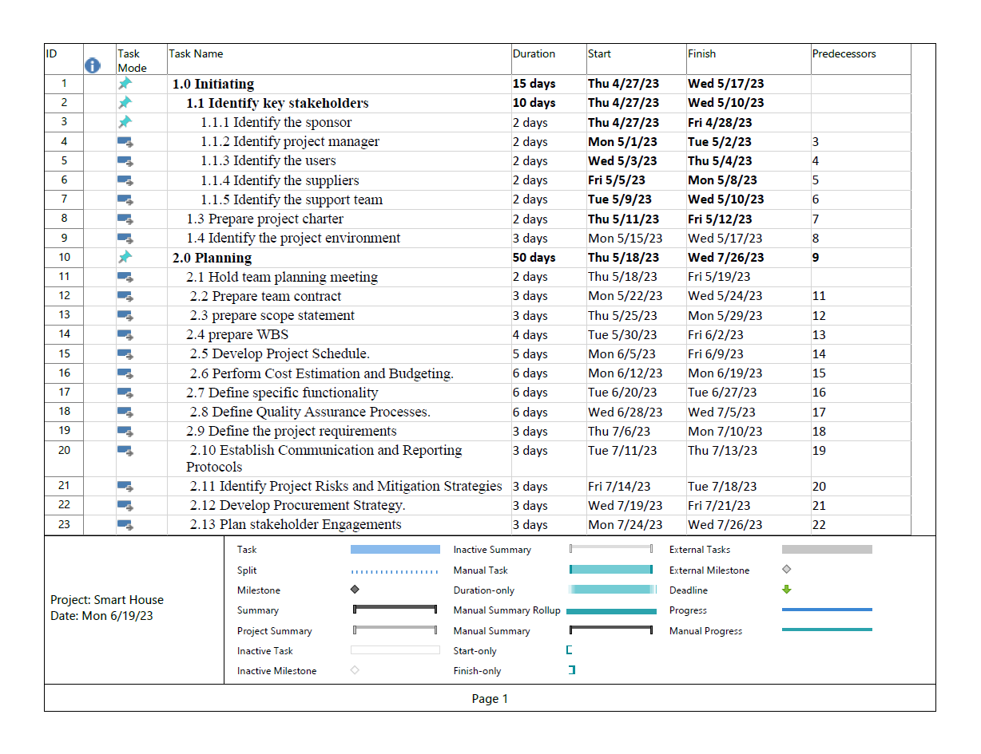

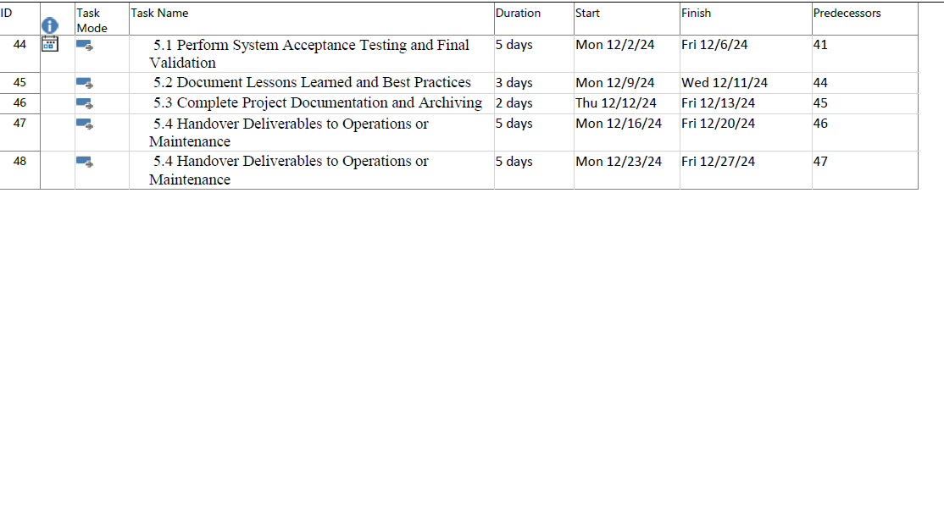

Gantt Chart:

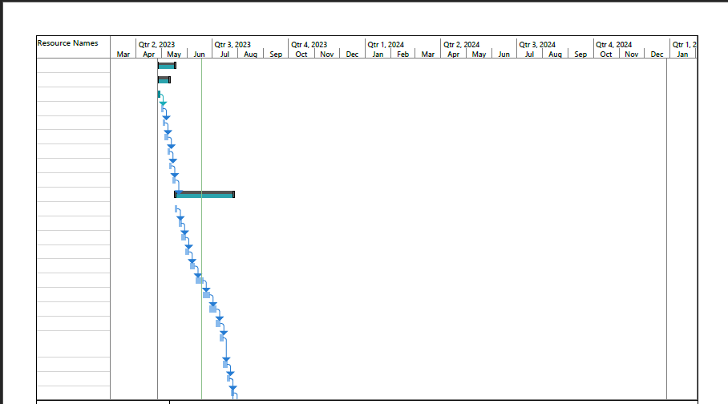

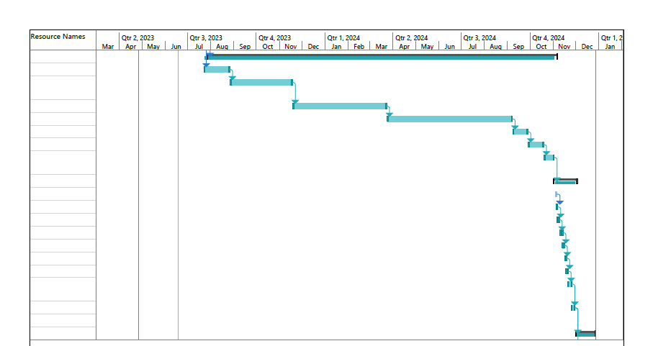

Part of Network diagram:

**Figure 2.2:network diagram**

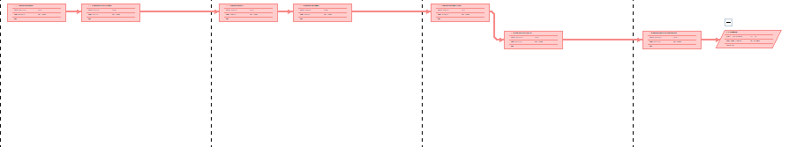

# **2.6 Project Organizational Chart: Figure 2.3**

# 

# **2.7 Project Budget**

An example:

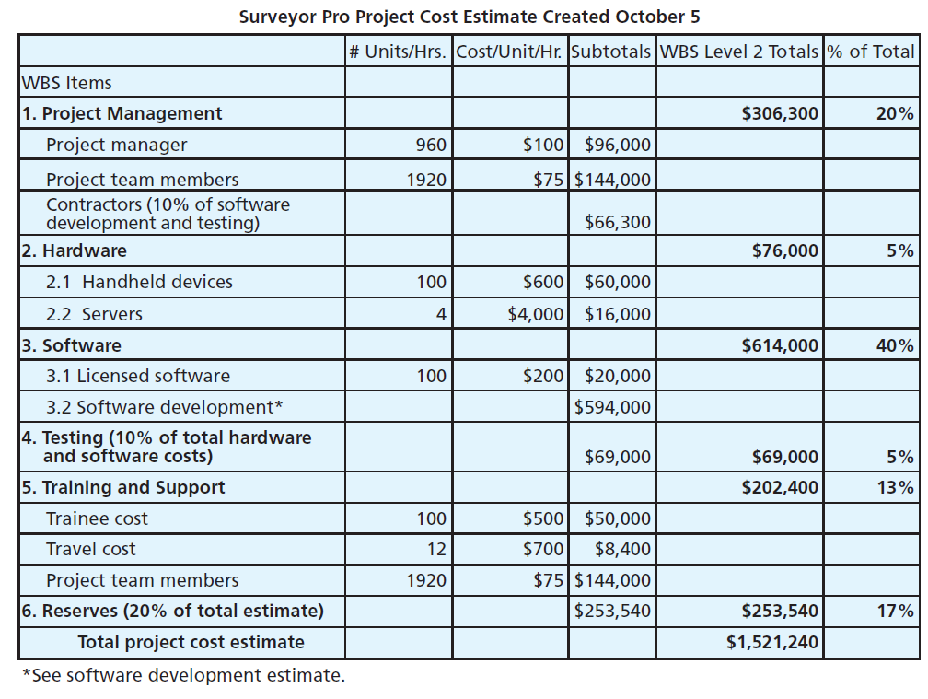

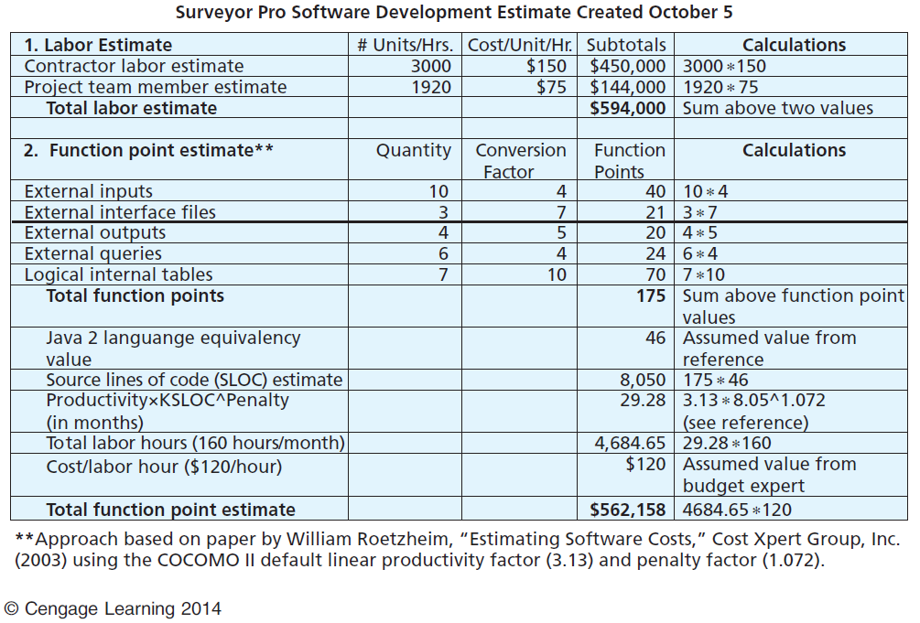

|  |  |  |  |  |  |  |
| --- | --- | --- | --- | --- | --- | --- |
|  | **XXX Project Cost Estimate** |  |  |  |  |  |
| **Prepared by: Mohammed Zyoud** | **Date:19/6/2023** |  |  |  |  |  |
| Note: Change the WBS items and other entries to meet your project needs. This data is from Figure 7-1 of Schwalbe's text | | | | | |  |
| Information Technology Project Management, Fourth Edition. Also make sure the formulas work properly based on the data you enter. | | | | | | |
|  | # Units/Hrs. | Cost/Unit/Hr. | Subtotals | WBS Level 1 Totals | % of Total |  |
| WBS Items |  |  |  |  |  |  |
| **1. Project Management** |  |  |  | **$306,300** | **20%** |  |
| 1.1 Project manager | 960 | $100 | $96,000 |  |  |  |
| 1.2 Project team members | 1920 | $75 | $144,000 |  |  |  |
| Contractors (10% of software development and testing) |  |  | $66,300 |  |  |  |
| **2. Hardware** |  |  |  | **$76,000** | **5%** |  |
| 2.1  Handheld devices | 100 | $600 | $60,000 |  |  |  |
| 2.2  Servers | 4 | $4,000 | $16,000 |  |  |  |
| **3. Software** |  |  |  | **$614,000** | **40%** |  |
| 3.1 Licensed software | 100 | $200 | $20,000 |  |  |  |
| 3.2 Software development* |  |  | $594,000 |  |  |  |
| **4. Testing** (10% of total hardware and software costs) |  |  | $69,000 | **$69,000** | **5%** |  |
| **5. Training and Support** |  |  |  | **$202,400** | **13%** |  |
| 5.1 Trainee cost | 100 | $500 | $50,000 |  |  |  |
| 5.2 Travel cost | 12 | $700 | $8,400 |  |  |  |
| 5.3 Project team members | 1920 | $75 | $144,000 |  |  |  |
| **6. Reserves (20% of total estimate)** |  |  | $253,540 | **$253,540** | **17%** |  |
| **Total project cost estimate** |  |  |  | **$1,521,240** |  |  |

# **2.8 Project Financial Analysis**

**Table 2.5**

|  |  |  |  |  |  |  |
| --- | --- | --- | --- | --- | --- | --- |
| **Financial Analysis for Smart house** | | | | | | |
| **Created by: Mohammad Daraghmeh** |  | **Date:** | **11/5/2023** |  |  |  |
| Note: Change the inputs, shown in green below (i.e. interest rate, number of years, costs, and benefits). Be sure to double-check the formulas based on the inputs. | | | | | | |
|  |  |  |  |  |  |  |
| **Discount rate** | **7.00%** |  |  |  |  |  |
|  |  |  |  |  |  |  |
| Assume the project is completed in Year 0 |  |  | **Year** |  |  |  |
|  | **0** | **1** | **2** | **3** | **Total** |  |
| Costs | **100000₪** | **50000₪** | **30000₪** | **20000₪** |  |  |
| Discount factor | 1.00 | 0.93 | 0..87 | 0.81 |  |  |
| **Discounted costs** | **100000** | **46500** | **26100** | **16200 ₪** | **188800₪** |  |
|  |  |  |  |  |  |  |
| Benefits | **0** | **150000** | **150000** | **150000** |  |  |
| Discount factor | 1.00 | 0.93 | 0.87 | 0.81 |  |  |
| **Discounted benefits** | **0** | **139500** | **130500** | **121500** | **391500** |  |
|  |  |  |  |  |  |  |
| Discounted benefits - costs | (100000) | 93000 | 104400 | 105300 | |  | | --- | | **202700** | | **NPV** |
| Cumulative benefits - costs | (100000) | |  | | --- | | (7000) | | 97400 | 202700 |  |  |
|  |  |  |  |  |  |  |
| |  | | --- | | **ROI** | | **107.3%** |  |  |  |  |  |
|  | **Payback in Year 1** | | |  |  |  |
| **Assumptions** |  |  |  |  |  |  |
| Enter assumptions here |  |  |  |  |  |  |

Example Payback period:

|  |  |  |  |  |
| --- | --- | --- | --- | --- |
| Year | Costs | Benefits | Cum Costs | Cum Benefits |
| 0 | 140,000 | 0 | 140,000 | 0 |
| 1 | 37,200 | 186,000 | 177,200 | 186,000 |
| 2 | 34,400 | 172,000 | 211,600 | 358,000 |
| 3 | 31,600 | 158,000 | 243,200 | 516,000 |

190000

170000

150000

150000

0

**Figure 2.4**

**2.7 A list of prioritized risks (part of a risk register)**

**List of Prioritized Risks for Project Name**

**Table**

**Prepared by:** Mohammed Zyoud **Date: 26/5/2023**

**Table 2.6:**

|  |  |
| --- | --- |
| **Ranking** | **Potential Risk** |
| 1 | Data Privacy and Security Risks |
| 2 | Technical Risks |
| 3 | User Acceptance and Usability Risks |
| 4 | Project Management Risks |
| 5 | Infrastructure and Connectivity Risks |
| 6 | Regulatory and Compliance Risks |
| 7 | External Risks |

**2.9** **summary**

In chapter two we discussed the project’s plan. We started by specifying the needed requirements of the project. We mentioned all the requirements with their category, source and status. Then we established the scope statement which includes project justification, product characteristics, project deliverables and some criteria we take in consideration to determine the success of the project. After that, we built the Work Breakdown Structure using project management process groups and their underlying sub activities, mapped project schedule in the form of a Gantt chart using MS project and represented the project team in a Project Organizational Chart. We also estimated the project budget by finding the costs and doing some financial analyses. We finally put a list of prioritized risks that could face us during our project.

**Chapter Three**

**Project Execution**

# **3.1 Introduction**

Project execution is the stage of the project management process where the project plan is put into action. It is the stage where the project team carries out the activities and tasks outlined in the project plan to deliver the project's products and services. The main goal of project execution is to produce the project deliverables within the defined scope, schedule, and budget

# **3.2 Milestone report**

**Milestone Report for Project Name:** smart home

**Prepared by:** Mohammad Daraghmh **Date: 1/8/2023**

**Table 3.1:**

|  |  |  |  |  |
| --- | --- | --- | --- | --- |
| **Milestone** | **Date** | **Status** | **Responsible** | **Issues/Comments** |
| **Initiating** |  |  |  |  |
| Identifying stakeholders |  | complete |  |  |
| Develop project charter |  | complete |  |  |
| Prepare project charter |  | complete |  |  |
| Sign project charter |  | complete |  |  |
| **planning** |  |  |  |  |
| Determine project team |  | complete |  |  |
| Make team contract |  | complete |  |  |
| Project scope statement |  | complete |  |  |
| Define requirements |  | complete |  | Both requirements |
| Project schedule |  | complete |  |  |
| Create Gantt chart |  | complete |  |  |
| Review Gantt chart |  | complete |  |  |
| Prioritized risk |  | complete |  |  |
| Project plan |  | complete |  |  |
| Develop project plan |  | complete |  |  |
| Review project plan |  | complete |  |  |
| **Executing** |  |  |  |  |
| Implementation |  | complete |  |  |
| Prepare hardware devices |  | complete |  |  |
| Prepare the website for use |  | complete |  |  |
| Learn the training staff on how to use devices |  | complete |  |  |
| Test hardware devices |  | complete |  |  |
| **Monitoring and controlling** |  |  |  |  |
| status report |  | complete |  |  |
| Report performance |  | complete |  |  |
| Daily meeting |  | complete |  |  |
| Control changes |  | complete |  |  |
| **Closing** |  |  |  |  |
| Prepare project report |  | complete |  |  |
| Prepare final project presentation |  | complete |  |  |
| Lessons learned report |  | complete |  |  |

## 

# **3.3 Summary**

Milestones are important markers in a project that indicate the completion of a significant task or deliverable. Milestones are linked to specific dates or deadlines and are used to monitor key activities and outcomes.

**Chapter Four**

**Project Monitoring and Controlling**

# **4.1 Introduction**

Project Monitoring and Controlling is a critical aspect of project management that involves tracking the progress of a project, identifying any deviations from the project plan, and making necessary adjustments to ensure the project stays on track.

# **4.2 Status/Progress Report**

**Status/Progress Report**

**Table 4.1:**

|  |
| --- |
| **Project Name: smart home**  **Team Member Name: Mohammad Daraghmeh**  **Date: 10-10-2023**  **Reporting Period: every week** |
| **Work completed this reporting period:**  In this period, we finish many tasks like initiating the project by identifying the stakeholders, develop project charter and determining kick-off meeting.  Also, we finish part of planning like  Determining project team and make team contract.  Also, we defining the requirement. |
| **Work to complete next reporting period:**  In the next period we seek to create a Gantt chart and  Make a schedule and review |
| **What’s going well and why:**  Until now everything is going well because all the team working well and committing with the schedule and we have an expertise people |
| **What’s not going well and why:**  Everything is going well |
| **Suggestions/Issues:**  Make sure that your team working well and have an enough skills and experiences |
| **Project changes**  No changes**.** |

# **4.3 Summary**

A project status/progress report is a key component of project management, as it helps to track the progress of the project and ensure that it is aligned with the project plan. The progress report is used to identify and address any deviations from the project plan, and to make decisions and adjustments to ensure the project stays on track. The report should be regularly updated and shared with stakeholders to keep everyone informed of the project status.

**Chapter Five**

**Project Closing**

# 

# **5.1 Introduction**

**Close Project or Phase is the process of finalizing all activities for the project, phase, or contract.**

**The key benefits of this process are the project or phase information is archived, the planned work is completed, and organizational team resources are released to pursue new endeavors.**

**This process is performed once or at predefined points in the project.**

# **5.2 Lessons-learned report**

**Lessons Learned Report**

**Table 5.1:**

|  |
| --- |
| **Prepared by:** Mohammad Daraghmeh **Date:**25/11/2023  **Project Name: Smart home**  **Project Sponsor:** **Mohammad Mohyee Majed**  **Project Manager:** Mohammad Zyoud  **Project Dates: Project Start Date:** 27-Apr-2023 **Projected Finish Date:** 27-June-2024  **Final Budget:** 100000$ |
| 1. Did the project meet scope, time, and cost goals?   Yes, the project meet the scope, time and cost **.**   1. What was the success criteria listed in the project scope statement?   Completion of the project with the time and budget as in plan.  Provide high quality equipment to give a nice result.  Provide a well-experience people that attracts graduates.   1. Reflect on whether or not you met the project success criteria.   We made sure that we met the project success criteria.   1. In terms of managing the project, what were the main lessons your team learned?   We learned that the time it is very important factor to success and we must make  attention on them and managing the project help us to reach the goal with the best  condition   1. Describe one example of what went right on this project.   One example of what went right on this project was the effective collaboration and communication among the project team, which contributed to the successful outcome of the project.   1. Describe one example of what went wrong on this project.   We had a problem in looking for a experiences in a real but we solved it by  making a zoom meeting with them   1. What will you do differently on the next project based on your experience working on this project?   For the next project, the team will implement a risk management plan to manage  potential delays and technical difficulties in advance. The team will also establish  clear and consistent communication processes with external partners to ensure  effective collaboration. Additionally, a robust testing and quality assurance  process will be incorporated to identify and resolve technical difficulties early on  in the project. |

# **5.3 In conclusion,**

while the project did meet its scope goals and received positive feedback from the stakeholders, it encountered some challenges in terms of timeline and budget. However, these challenges provided valuable lessons for the team in terms of effective risk management and communication processes, and the importance of a robust testing and quality assurance process. The team will incorporate these lessons into future projects to ensure more successful outcomes. Overall, the lessons learned from this project will help the team to continually improve and enhance their project management processes.

**References**

1. <https://www.fixr.com/costs/home-automation>
2. <https://todayshomeowner.com/smart-home/guides/how-expensive-are-smart-homes/>