

**Selenium Project Report.**

Name: Mohammad Mohyee Bani Odeh

ID: 201920057

Instructor: Sami Awad

* **Part1:** download the selenium and the required tools and configure them:

1. Pycharm environment to use python language and configure it.

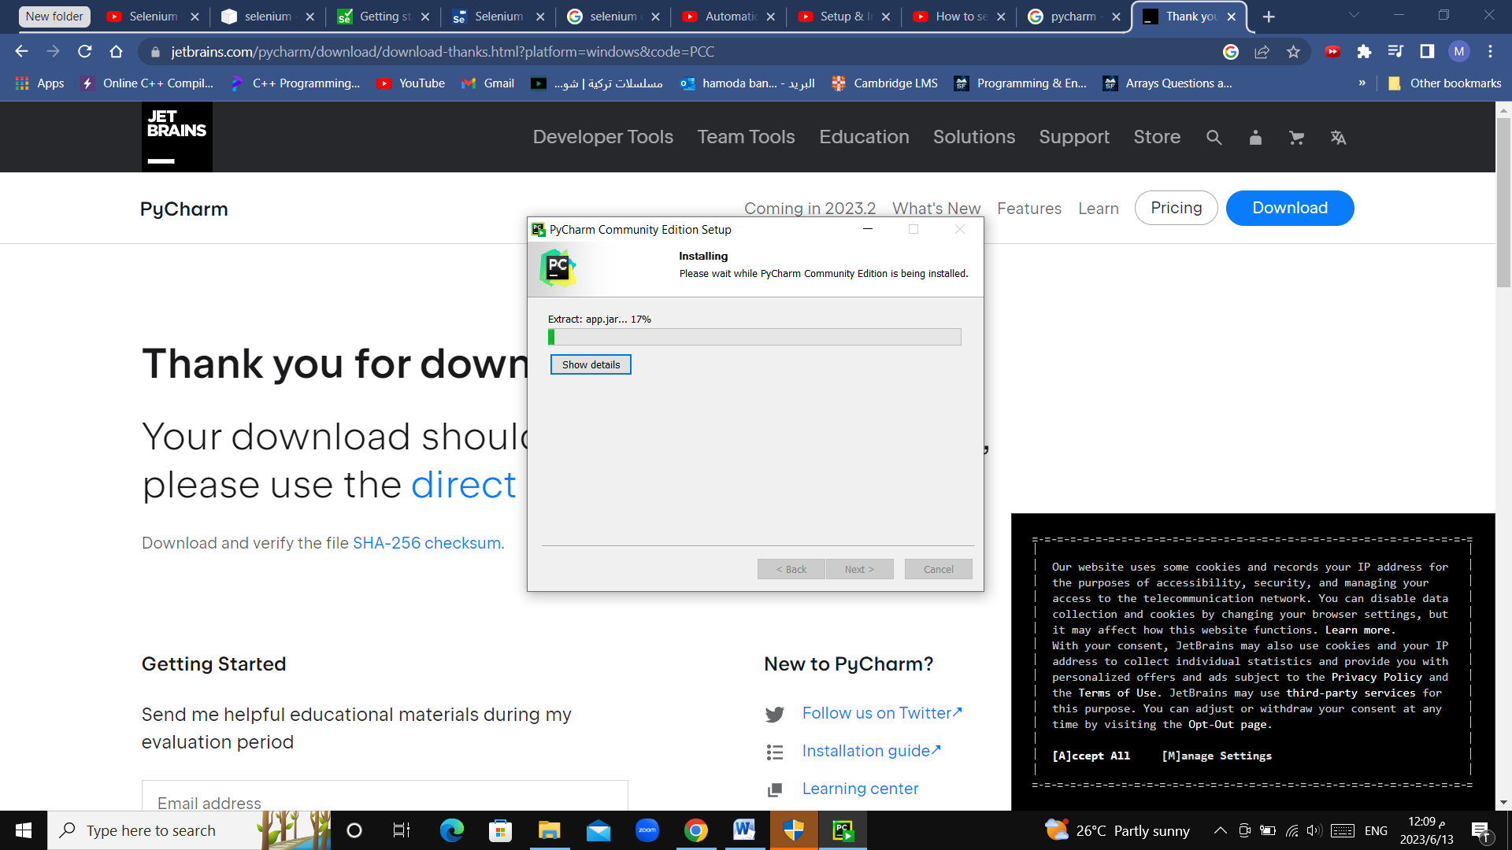

1. Download python language.

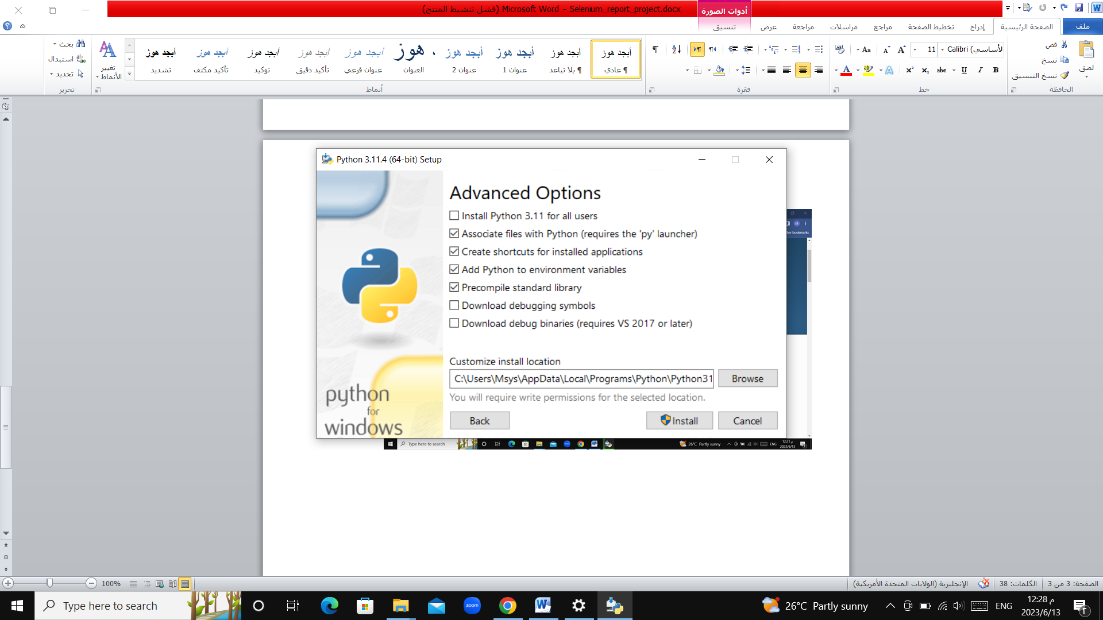

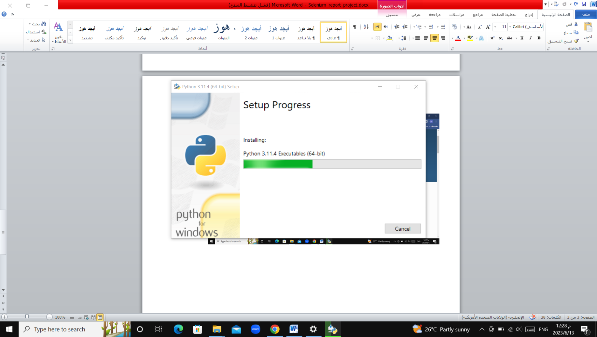

1. Selenium installation

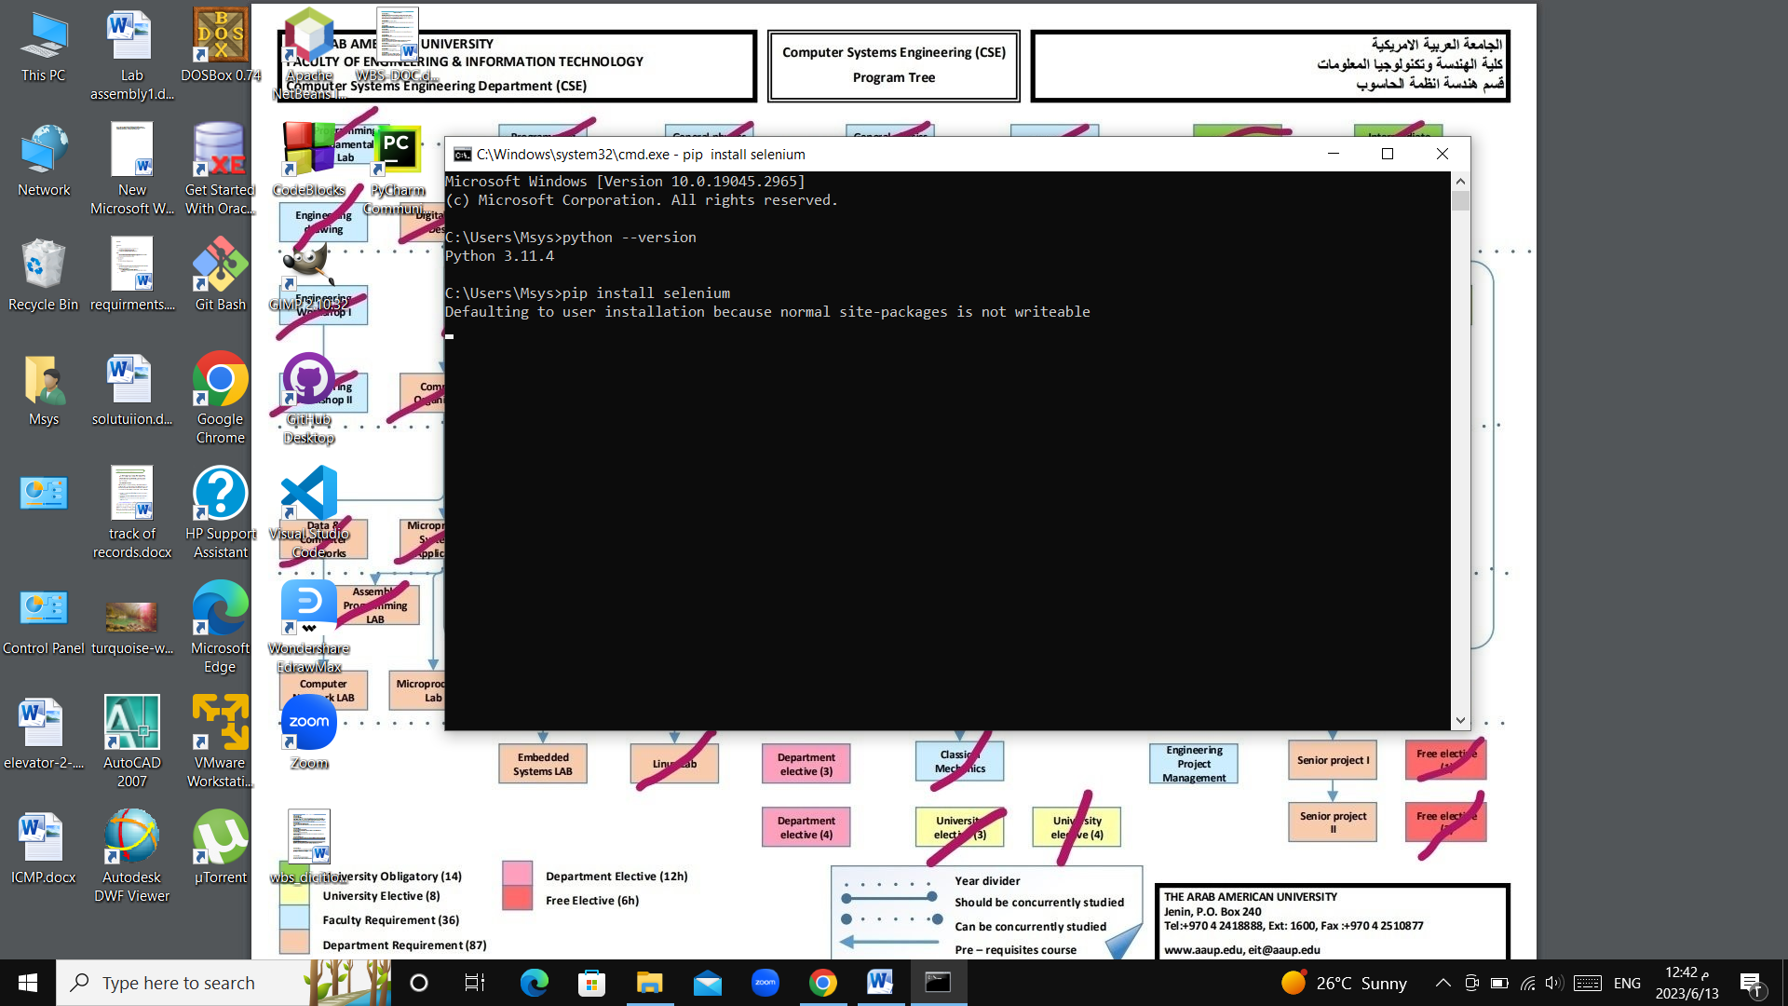

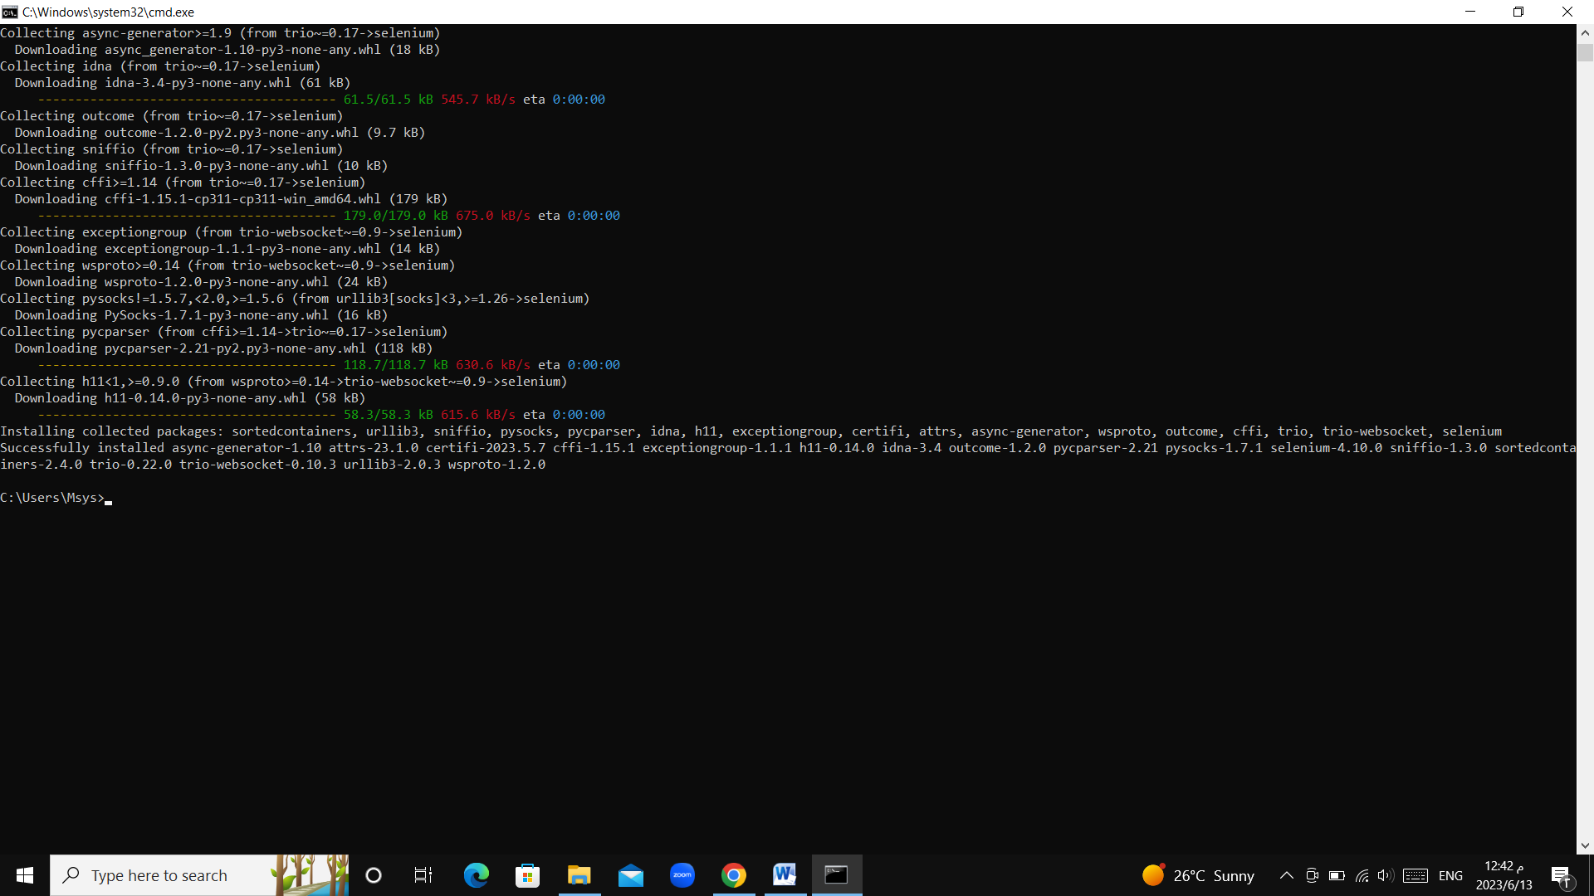

1. Chrome driver installation.

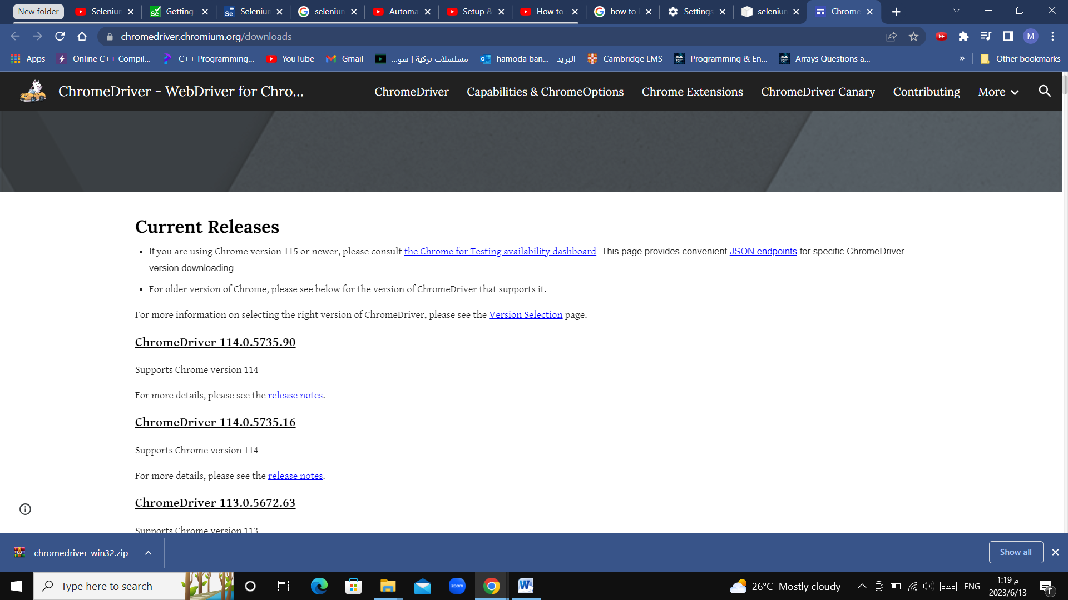

**Part2: build a test case.**

In this project the site (https://www.seleniumeasy.com/) will be used.

this test case is made to test a button in the main page which is Subscribe button.

1-Build the interface and connection to the chrome web_driver that have been installed earlier.

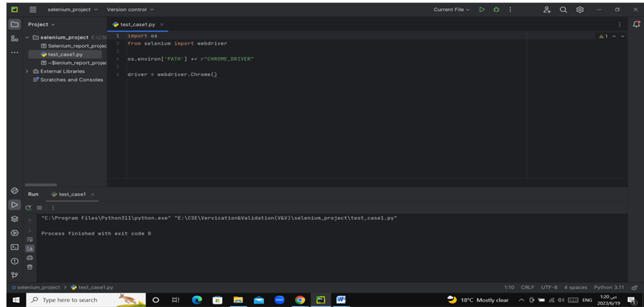

2- then write the test case and run it.

