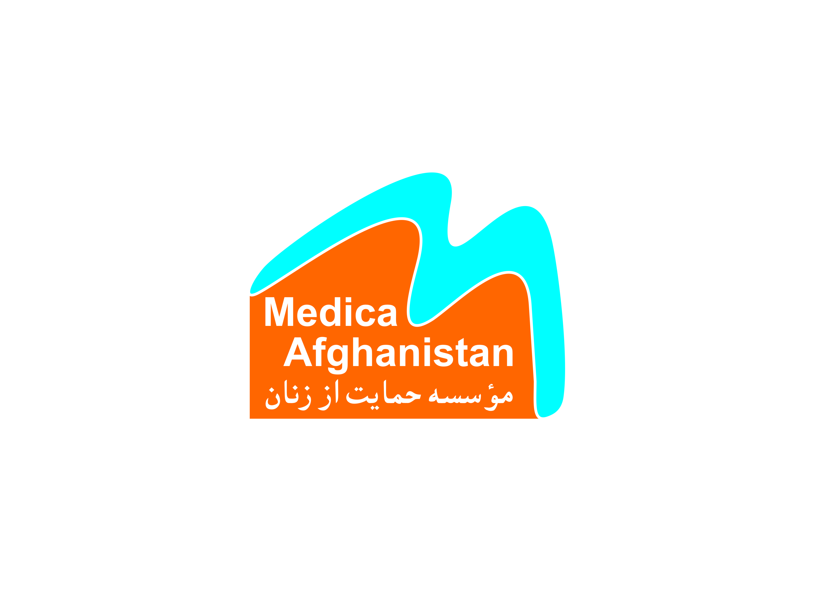

Service Contract and Terms of Reference

Contractual basis:

- Time frame: 1st June – 30th September 2021
- Project/Donor: D & P Project
- Function of the contractor: legal Researcher
- Goal of the assignment: To research on non-material compensation issue and draft the related law to defining and assessing (non-Material compensation)

Responsibility of the Reacher:

- (Preparation related questionnaires, fill them by predetermined groups; collection, analysis of questionnaires and minutes of meetings, preparation of reports.
- Identify types of damages for compensation;
- Determining how to measure the damage according to available international procedure or experience or practice which are acceptable with Afghanistan concept.
- Determining how to pay each of the damages taking into account the principles and laws in force in the country.
- Conduct detailed research of intended subject matter, document, report, and present research findings to MA management team based of requirment of MA;
- Compile and organize findings in graphs, charts, mock-ups, and diagrams through delivering presentations when required.
- Drafting and Submitting the non-material compensation law draft to the Medica Afghanistan (MA).

Task delivery under the contract:
The legal researcher will be developing and producing tool for the assessment non-material compensation for compensation claims to draft law according to international judicial law and practice.

Confidentiality with regard to service extended:

- As a general rule, the contractor is obligated to a duty of confidentiality regarding all events with which she/he is confronted and information which he has access to in the scope of his assignment of tasks, special job-related communication requirements notwithstanding. The service provider acknowledges that by reason of their relationship, both the client and the service provider may have access to certain products, information and materials relating to the other party's organization, which may include organizational plan, the donors, software technology, and strategic plan that are confidential and of substantial value to either party.

- After termination of the contract, all work materials, files, documents, work results, etc., which are property of Medica Afghanistan, must be handed over.

- The provisions of this section shall survive the termination of the agreement for any reason. Upon any breach or threatened breach of this section, either

Responsibility of Medica Afghanistan:

Collaboration: Medica Afghanistan Legal aid programme manager will collaborate actively to the service contract by providing information and answering to the legal consultant’s questions.

Payment:

Payments will be made in two instalments at the middel and end of the Contracting duration which is 30th Sep 2021.

The Service provider bills the client a total of 140000Afg for this project from which 2% withholding TAX will be deducted equal to 2800 Afg. Please know that your company registration license is required to be annexed with this agreement, should it be not there then 7% TAX will be deducted.

Termination:

Either party may terminate this agreement by providing two -week (15 working days) written notice if they are NOT satisfied with one another’s performance and/or they fail to execute their responsibilities. THE CLIENT is not entitled to any payment to THE SERVICE PROVIDER on the termination of CONTRACT.

Agreement Modification:

This agreement is modifiable only by writing, signed by both parties.

Force Majeure:

Notwithstanding any other provision of this agreement to the contrary, the client shall not be liable to the service provider for any failure to fulfill obligations hereunder if such failure is due to insecurity, labor dispute, fire, flood, political issues, act of God and any other cause beyond the reasonable control of the client. In the event of any such occurrence, the duration for this project shall be correspondingly extended based on donor’s approval.

Undertaking:

We agree to subscribe for the service on the above terms and conditions, including any amendments both parties may make from time to time to these terms and conditions. We acknowledge that we have read and understood the above terms and conditions.

Kabul,
Place, date Place, date

Dr. Soraya Sobhrang
Executive Director Ali Jafari
Women Support Organization,
Medica -Afghanistan Legal Consultant

