**Mohammed Bhatia**

**2205034**

**MITU20BTIT0040**

**TY -IT CORE-1**

**Batch: C5**

**Code:**

*/\**

*Program 1. Write a program using the function to perform the following operation*

*Area of Circle*

*Area of   Rectangle*

*Area of Triangle*

*Circumference of Circle*

*\*/*

#include<stdio.h>

#define PI 3.14159

float areaCircle(float r){

    float area = PI * r * r;

    return area;

}

float areaRectangle(float l,float w){

    float area = l * w;

    return area;

}

float areaTriangle(float b,float h){

    float area = (0.5 * b * h);

    return area;

}

float circumferenceCircle(float r){

    float circum = 2*PI*r;

    return circum;

}

int main(){

    float radius, length, width, base, height;

*// Circle*

    printf("Enter the radius of the circle: ");

    scanf("%f", &radius);

    float circle_area = areaCircle(radius);

    printf("Area of the circle: %.2f\n", circle_area);

*// Rectangle*

    printf("Enter the length of the Rectangle: ");

    scanf("%f", &length);

    printf("Enter the Width of the Rectangle: ");

    scanf("%f", &width);

    float rectangle_area = areaRectangle(length,width);

    printf("Area of the Rectangle: %.2f\n", rectangle_area);

*// Triangle*

    printf("Enter the base of the Triangle: ");

    scanf("%f", &base);

    printf("Enter the Height of the Triangle: ");

    scanf("%f", &height);

    float triangle_area = areaTriangle(base,height);

    printf("Area of the Triangle: %.2f\n", triangle_area);

*// Circumference of circle*

    printf("Enter the radius of the circle: ");

    scanf("%f", &radius);

    float circumference_area = circumferenceCircle(radius);

    printf("Circumference of the circle: %.2f\n", circumference_area);

}

**Output:**

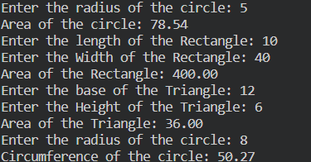

**Code:**

*/\**

*Program2 .Write a program using function to find the root of quadratic Equation*

*\*/*

#include<stdio.h>

#include<math.h>

void findRoots(float a, float b, float c) {

    float discriminant, root1, root2;

*// Calculate discriminant*

    discriminant = b*b - 4*a*c;

    if (discriminant > 0) {

*// Real and distinct roots*

        root1 = (-b + sqrt(discriminant)) / (2*a);

        root2 = (-b - sqrt(discriminant)) / (2*a);

        printf("Roots are real and distinct.\n");

        printf("Root 1 = %.2f\n", root1);

        printf("Root 2 = %.2f\n", root2);

    }

    else if (discriminant == 0) {

*// Real and equal roots*

        root1 = -b / (2*a);

        printf("Roots are real and equal.\n");

        printf("Root 1 = Root 2 = %.2f\n", root1);

    }

    else {

*// Complex roots*

        float realPart = -b / (2*a);

        float imaginaryPart = sqrt(-discriminant) / (2*a);

        printf("Roots are complex and different.\n");

        printf("Root 1 = %.2f + %.2fi\n", realPart, imaginaryPart);

        printf("Root 2 = %.2f - %.2fi\n", realPart, imaginaryPart);

    }

}

int main(){

    float a,b,c;

    printf("\nEnter the values for (a*x^2 + b*x + c):\n");

    printf("\nEnter the values of coefficient of a,b,c\n");

    scanf("%f %f %f",&a,&b,&c);

    findRoots(a,b,c);

}

**Output:**

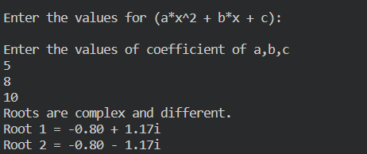

**Code:**

*/\**

*Program3. Write a program to use function to create factorial of a number Fibonacci series*

*Fibonacci () and Factorial() will be two functions used .*

*Ensure that user will be asked in a  menu what to perform using switch case*

*\*/*

#include <stdio.h>

void factorial(int n)

{

    int fact = 1;

    for (int i = 1; i <= n; i++)

    {

        fact = fact * i;

    }

    printf("\nfactorial of %d is %d\n", n, fact);

}

void fibonacci(int number)

{

    int n3 = 0, n1 = 0, n2 = 1;

    printf("\n%d %d", n1, n2);

    for (int i = 2; i < number; ++i) {

        n3 = n1 + n2;

        printf(" %d", n3);

        n1 = n2;

        n2 = n3;

    }

}

int main()

{

    int choice=0, n1, n2;

    while (choice <= 3)

    {

        printf("\nMenu:\n");

        printf("\n1) Factorial of Number\n");

        printf("\n2) Fibonacci series for Number\n");

        printf("\n3) Exit\n");

        printf("\nEnter Your choice: \n");

        scanf("%d", &choice);

        switch (choice)

        {

        case 1:

            printf("Enter the number to find factorial:\n");

            scanf("%d", &n1);

            factorial(n1);

            break;

        case 2:

            printf("Enter the number to find fibonacci series:\n");

            scanf("%d", &n2);

            fibonacci(n2);

            break;

        default:

            printf("Invalid choice\n");

            break;

        }

    }

}

**Output:**

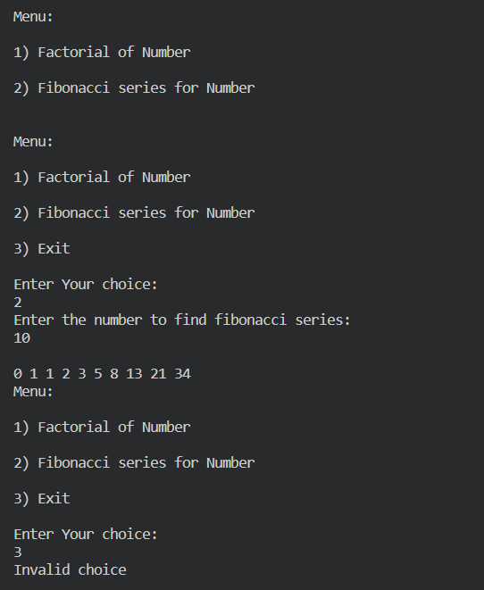

**Code:**

*/\**

*Program 4 . Write a program to sort the numbers in the array using bubble sort and selection sort.*

*Bubble() sort() use display() function to print the array values .User switch case to ask the type of sorting*

*\*/*

#include <stdio.h>

void display(int arr[], int size) {

    printf("Array elements: ");

    for (int i = 0; i < size; i++) {

        printf("%d ", arr[i]);

    }

    printf("\n");

}

void bubbleSort(int arr[], int size) {

    for (int i = 0; i < size - 1; i++) {

        for (int j = 0; j < size - i - 1; j++) {

            if (arr[j] > arr[j + 1]) {

                int temp = arr[j];

                arr[j] = arr[j + 1];

                arr[j + 1] = temp;

            }

        }

    }

}

void selectionSort(int arr[], int size) {

    for (int i = 0; i < size - 1; i++) {

        int minIndex = i;

        for (int j = i + 1; j < size; j++) {

            if (arr[j] < arr[minIndex]) {

                minIndex = j;

            }

        }

        int temp = arr[i];

        arr[i] = arr[minIndex];

        arr[minIndex] = temp;

    }

}

int main() {

    int numbers[] = { 64, 34, 25, 12, 22, 11, 90 };

    int size = sizeof(numbers) / sizeof(numbers[0]);

    int choice;

    printf("Array before sorting:\n");

    display(numbers, size);

    printf("Choose the sorting method:\n");

    printf("1. Bubble Sort\n");

    printf("2. Selection Sort\n");

    printf("Enter your choice (1 or 2): ");

    scanf("%d", &choice);

    switch (choice) {

        case 1:

            bubbleSort(numbers, size);

            printf("Array after Bubble Sort:\n");

            display(numbers, size);

            break;

        case 2:

            selectionSort(numbers, size);

            printf("Array after Selection Sort:\n");

            display(numbers, size);

            break;

        default:

            printf("Invalid choice.\n");

    }

    return 0;

}

**Output:**

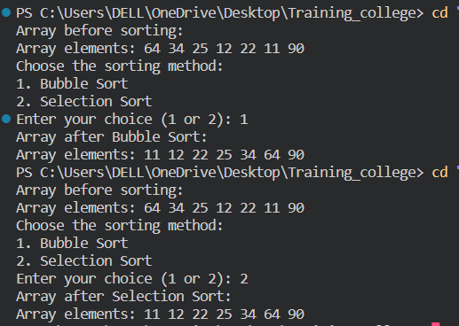

**Code:**

*/\**

*Program 5 . Write  a program to find the maximum  and minimum of 10 different numbers of an array  Function name should be Min_Max()*

*\*/*

#include<stdio.h>

void min_max(int arr[],int size,int *min,int *max){

    *min = arr[0];

    *max = arr[0];

    for(int i=0;i<size;i++){

        if(arr[i]<*min){

            *min = arr[i];

        }

        else if(arr[i]>*max){

            *max = arr[i];

        }

    }

}

int main(){

    int arr[10];

    int min,max;

    printf("Enter 10 different numbers:\n");

    for (int i = 0; i < 10; i++) {

        printf("Enter Number %d: ", i+1);

        scanf("%d", &arr[i]);

    }

    min_max(arr, 10, &min, &max);

    printf("Minimum number: %d\n", min);

    printf("Maximum number: %d\n", max);

}

**Output:**

