

Attendance Management System



I3306 Database II

Prepared by   
Mohammad Dabaja

Lebanese University

Faculty of Sciences I

Department of computer Sciences

2019 - 2020

# Table of Contents

Table of Contents 2

Chapter I - Introduction 3

Chapter II - Architecture 4

Chapter III - Database Modeling 5

III.1. Conceptual Data Model 5

III.2. Database Scheme 5

III.3. Physical Data Model 6

Chapter IV - Services & Interface Modeling 7

IV.1. Services 7

IV.2. Interface Modeling 8

Chapter V - Implementation 12

V.1. . Bat File 12

V.2. Create Database 12

V.3. DDL 13

V.4. Triggers 15

V.5. Create User & grant privilege 17

Chapter VI - Conclusion 18

1. Introduction

Attendance management system is made to manage the process of education in a university. It facilitates the election of the room were a teacher will give the lesson, and help the student and the teacher to track what was given I previous session. but the more important that it allow to take attendance of student in easy way.

1. Architecture

This application uses 3-tier architecture. It has the following layers:

1. Presentation layer runs on a client (PC)
2. Data is stored on a Server.

The application interface which is called ODBC (Open Database Connectivity) an API which allows the client-side program to call the DBMS. The DBMS offers ODBC drivers for their DBMS. 2 tier architecture provides added security to the DBMS as it is not exposed to the end user directly. This architecture provides Direct and faster communication.

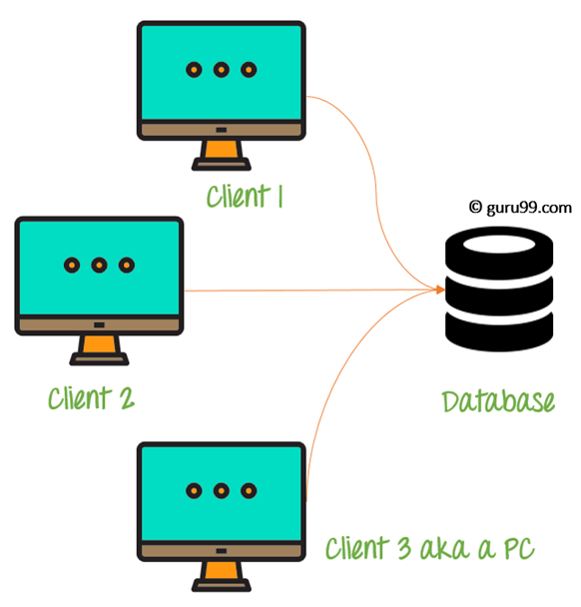

Figure : 2-tier Architecture Diagram

In this project the MySQL database engine was used as a database engine, java as programming language and J connector as ODBC.

1. Database Modeling
   1. Conceptual Data Model

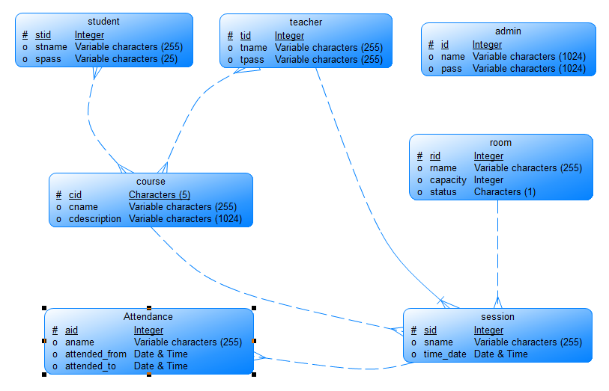

Figure : CDM

* 1. Database Scheme

Course (cid, came, description)

Student (stid, stname, pass)

Teacher (tid, tname, pass)

Admin (id, name, pass)

Room (rid, rname, capacity, status)

Session (sid, sname, time _date)

Attendance (aid, aname, attended _from, attended _to)

Course _Registration (#stid, #cid)

Teaches (#tid, #cid)

* 1. Physical Data Model

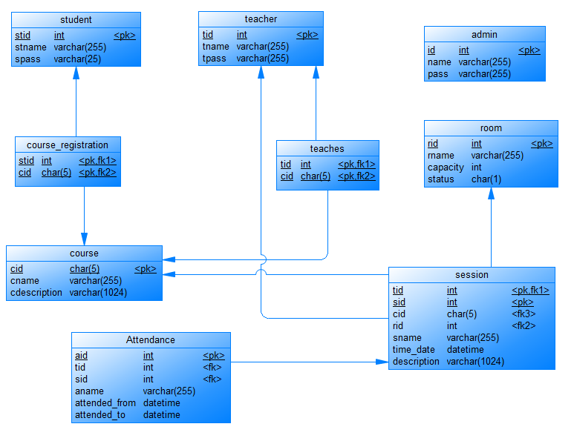

Figure : PDM

Database was modeled using Power Designer tool.

1. Services & Interface Modeling
   1. Services
2. Admin can view, insert, delete, update student, course, rooms and teacher to the system.
3. Admin and teacher can add, update or delete sessions for a specific time in an empty room.
4. Teacher can take attendance for student in a specific session.
   1. Interface Modeling

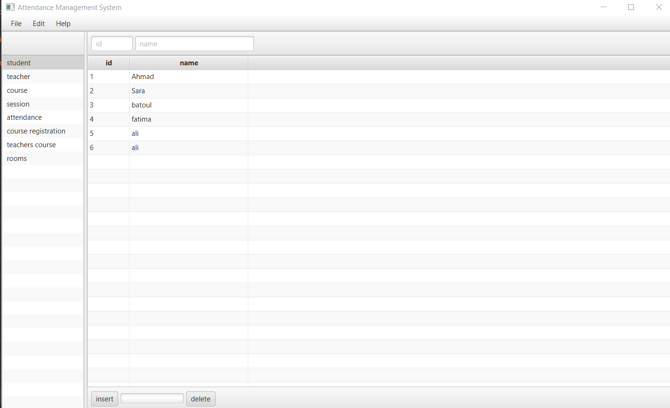

Figure : Student View

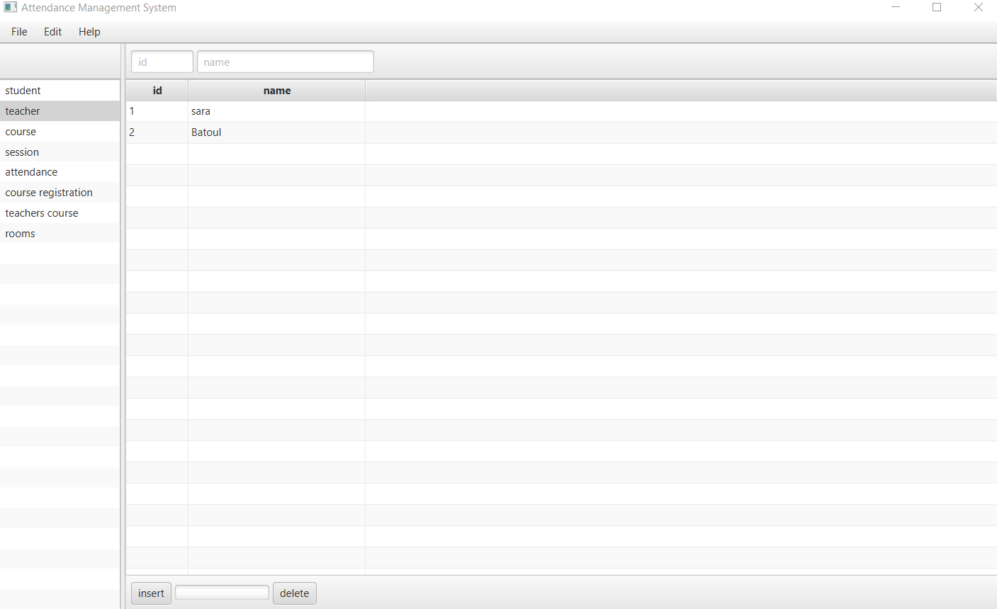

Figure : Teacher View

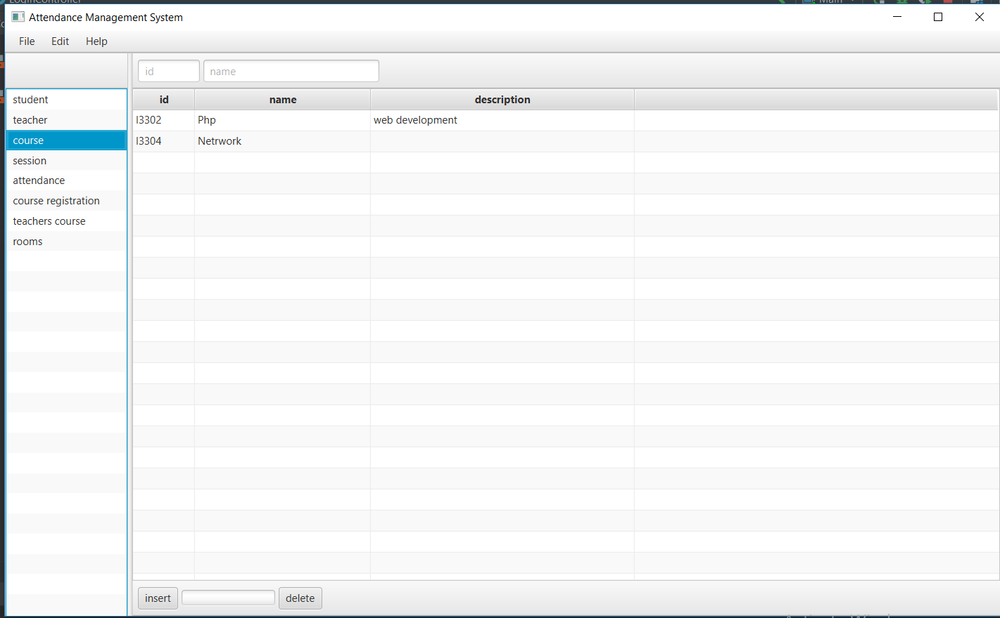

Figure : Course View

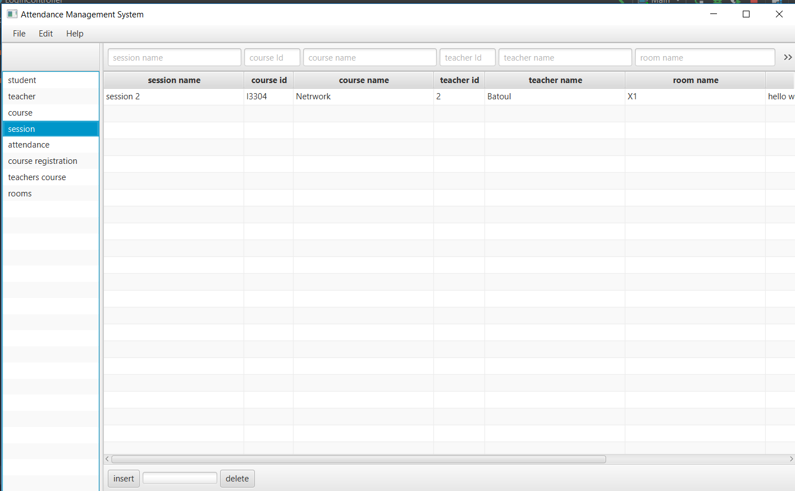

Figure : Session View

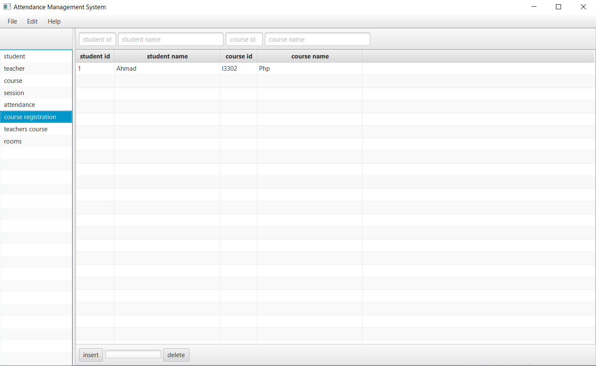

Figure : Course Registration View

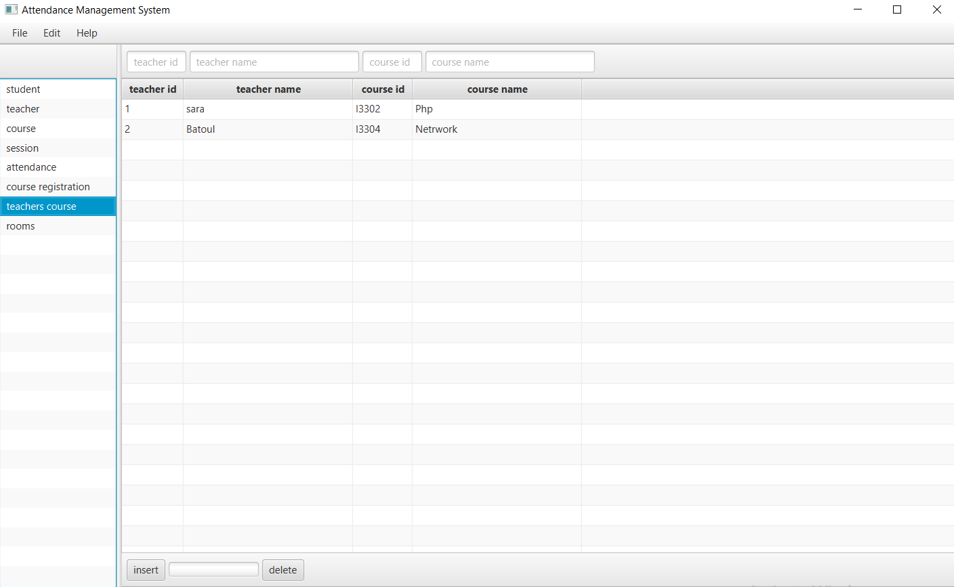

Figure : Teacher Courses View

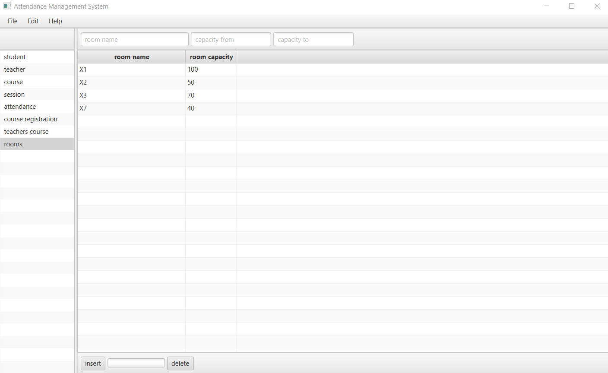

Figure : Room View

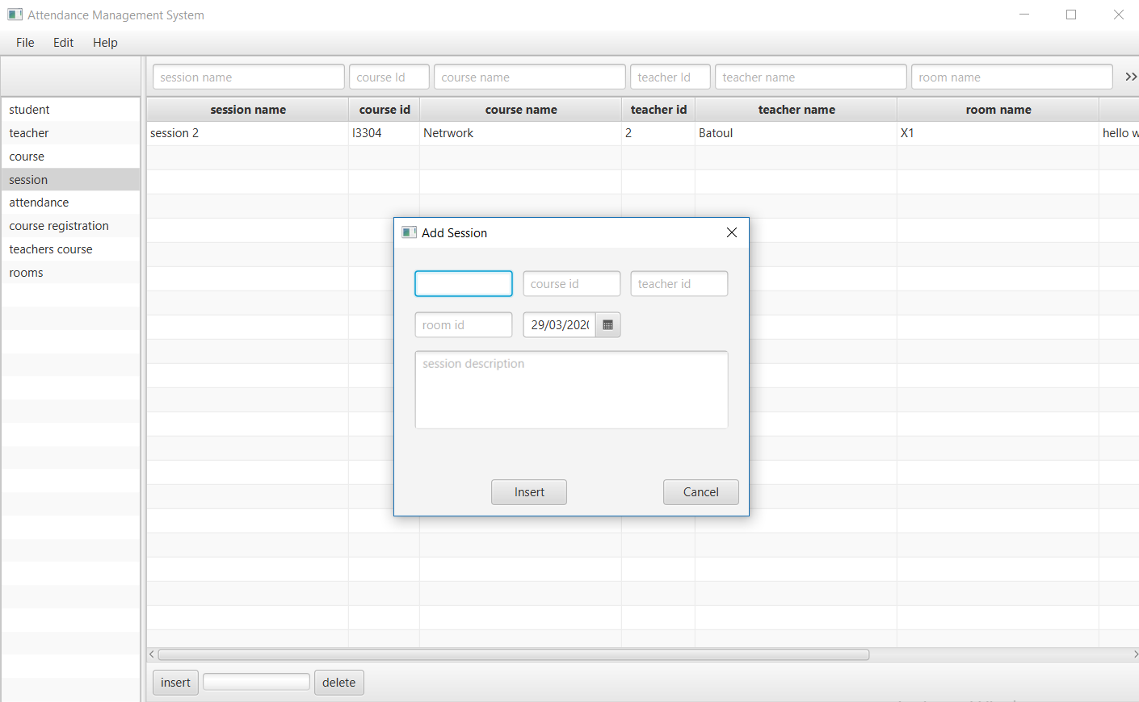

Figure : Insert Session

1. Implementation
   1. . Bat File

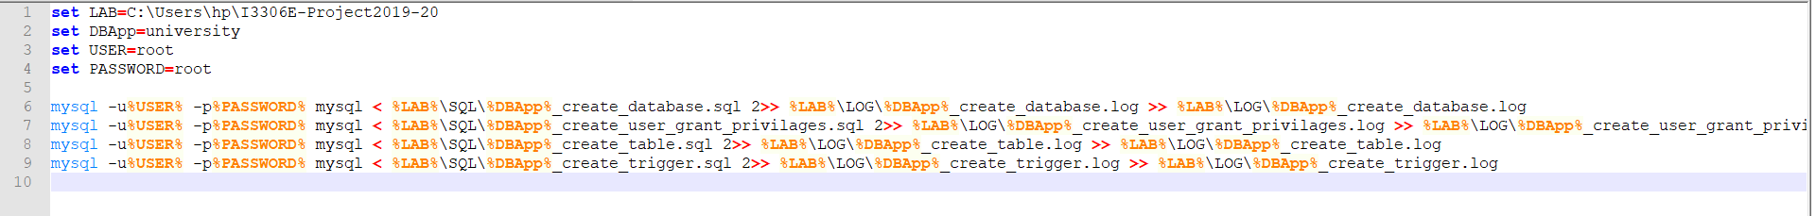

Figure : .Bat file

reasons for creating a MySQL database from a batch file:

* the batch file provides an historical record of what's been done
* a batch file means that databases are reproducible - either at another time or in another place
  1. Create Database

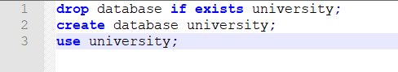

* 1. DDL

Tables of this database are created with the indexes on each primary key in university_create_database script.

All the DDL script is put I transaction.

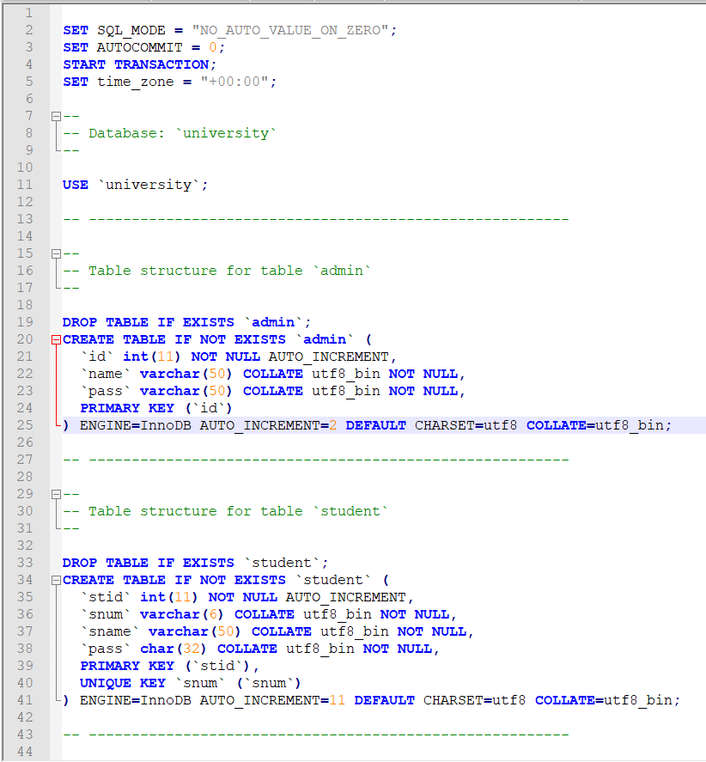

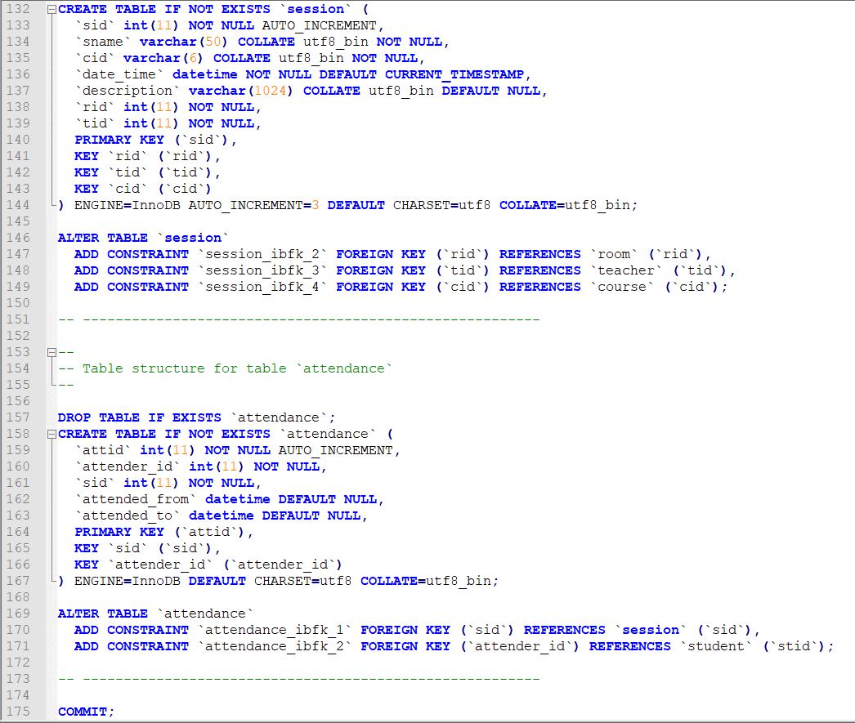

* 1. Triggers

Triggers are added on each tale to materialize the referential-integrity constraints in university_create_trigger script.

All the triggers scripts are put I transaction.

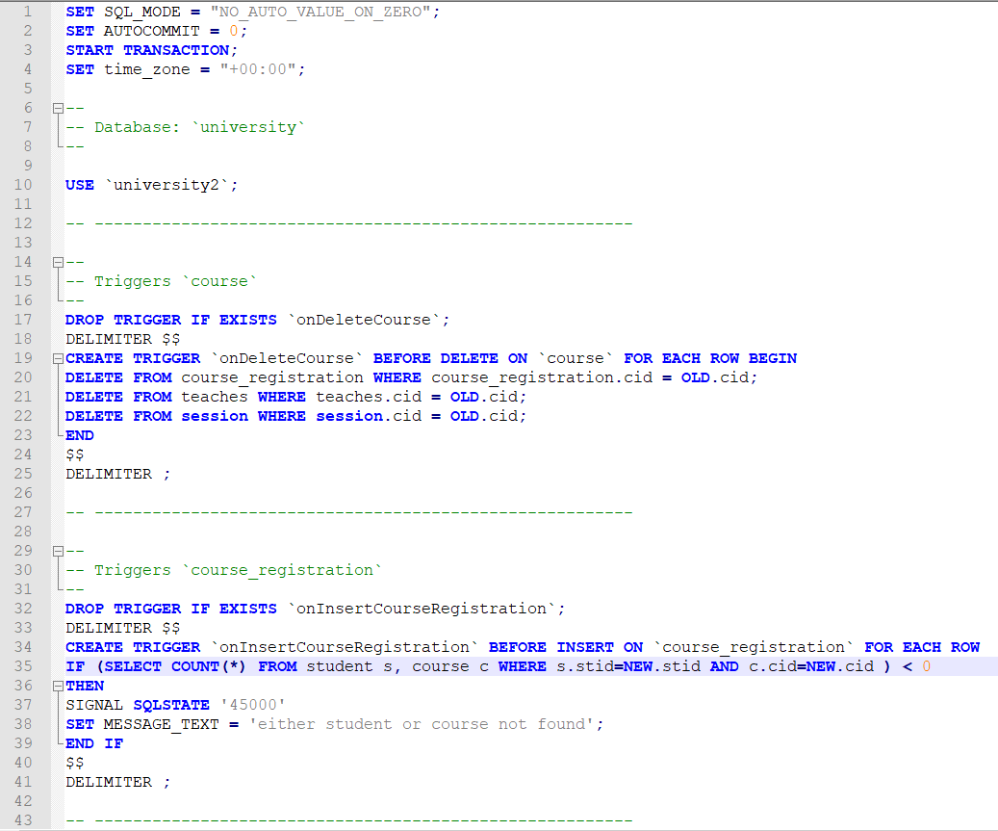

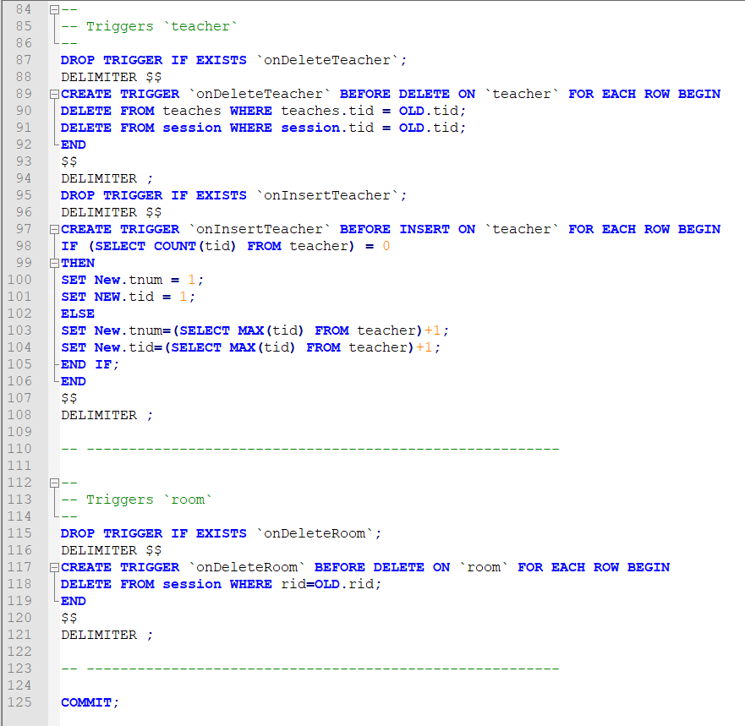

* 1. Create User & grant privilege

In university_create_user_grant_privilages script a specific user for our system is created having all privilege needed.

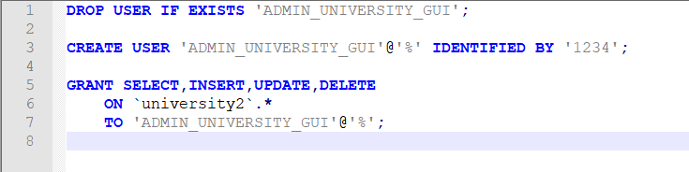

1. Conclusion