***Section 1 - Introduction***

**Design Patterns:**

In programming, we encounter various problems and challenges while writing and developing software. There are standard and reliable solutions to these problems, known as Design Patterns.

These patterns are the result of many years of investigation and research by prominent programmers worldwide. Design Patterns empower you to overcome programming challenges and implement scalable, modern, and clean software.

**Why Use Design Patterns?**

1. Improved software development
2. Modern and maintainable software
3. Clean and structured code
4. Reusable code
5. Enhanced software flexibility
6. Time-saving solutions

**How Are Design Patterns Created?**

Design Patterns are not created by a specific person or company but have evolved through contributions from various programmers.

In 1993, four individuals identified the 24 most effective and widely used design patterns. These pioneers are known as the Gang of Four (GoF).

_______________________________________________________________________________________________

***Section 2 - What is UML and its types?***

UML (Unified Modeling Language) is a simple graphical modeling language used for documenting software systems. It provides various diagrams to help with software documentation.

**UML Diagrams:**

1. Structure Diagrams
2. Behavioral Diagrams
3. Interaction Diagrams

**- Types of Structural Diagrams:**

1. Class Diagram
2. Object Diagram
3. Composite Structure Diagram
4. Component Diagram
5. Deployment Diagram
6. Package Diagram

We use these diagrams to understand design patterns. In this course, we use C# to implement these design patterns, but the diagrams help us apply them in other programming languages as well.

_______________________________________________________________________________________________

***Section 3 - Required Software***

To work with UML diagrams and implement design patterns in C#, you may need the following software:

For UML diagrams we use => Drawio.com (we can use download for app or online in site)

And for coding with C#, we need **Visual Studio**, **VS Code**, or **Rider**.

_______________________________________________________________________________________________

***Section 4 - Class and Interface Diagrams in UML***

In this section, we are going to use **Diagram IO** and describe its features.

1. **Creating a Class:**
   * Drag a new class from the shapes menu.
   * Give it a name, such as **Article**.
   * Add properties to the class.
2. **Access Modifiers:**  
   In UML, the symbol before a property or method represents its access level:
   * **+ (Public)** → Accessible from anywhere
   * **- (Private)** → Accessible only within the class
   * **# (Protected)** → Accessible within the class and its subclasses
   * **~ (Internal / Package Private)** → Accessible within the same package
3. **Declaring Properties:**
   * Example: + Id: int
   * This means: **public int Id;** in C#.
4. **Declaring Methods:**
   * Example: + methodName(paramType): returnType
   * The type inside () represents the **input parameters**, and the type after : represents the **return type**.
   * Example: + GetArticle(id: int): Article
     + This means:  
       public Article GetArticle(int id);

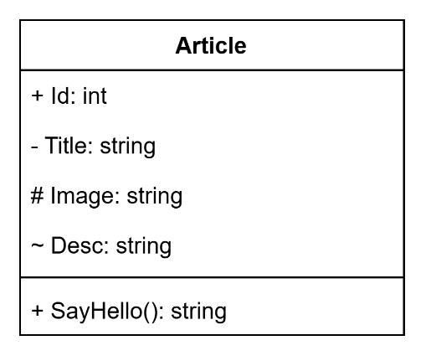

This is a sample of a class with some properties and one method.  
If we want to create a static class, we should write the name of class like this:

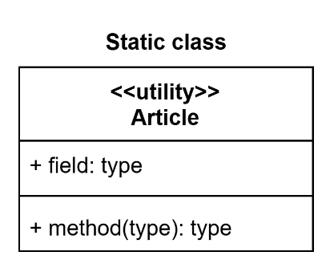

And if we want to create an Abstract Class, we Should Italic the name of Class:

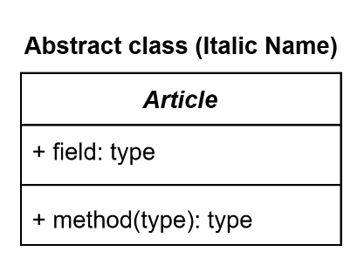

Also, for property or Field if we want that field be abstract, we italic the name of field or property.

For interface we can use interface or class from UML tool shapes. But with one condition we must write up the name of interface, «interface» to specify that class is interface. If you just add 'I' in first of class name doesn't make it interface and must put «interface» at the top of the name. As class or interface shape :

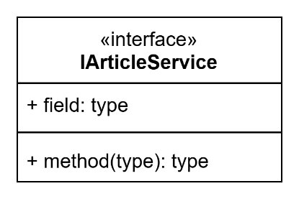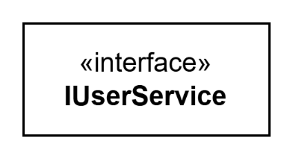

_______________________________________________________________________________________________

***Section 5 Relationships in UML***