**PRACTICAL – 9**

**Write a program to understand the use of Firebase with Raspberry Pie to control sensors.**

**Install DHT Python Library:**

$  git clone https://github.com/adafruit/Adafruit_Python_DHT.git

$  cd Adafruit_Python_DHT

$  sudo apt-get install build-essential python-dev python-openssl

$  sudo python setup.py install

**Install Firebase Python Library:**

$  sudo pip install requests==1.1.0

$  sudo pip install python-firebase

|  |  |
| --- | --- |
|  | import smbus |
|  | import time |
|  | from firebase import firebase |
|  |  |
|  |  |
|  | bus = smbus.SMBus(1) #If I2C library detects the pull up then initialize the register using sensors |
|  |  |
|  |
|  |
|  |
|  | bus.write_i2c_block_data(0x44, 0x2C, [0x06]) |
|  |  |
|  | time.sleep(0.5) |
|  |  |
|  | data = bus.read_i2c_block_data(0x44, 0x00, 6 |
|  | temp = data[0] * 256 + data[1] #shifting data[0] to left side and adding data[1] xisting in right side |
|  | cTemp = -45 + (175 * temp / 65535.0) #formula mentioned in datasheet |
|  | fTemp = -49 + (315 * temp / 65535.0) #formula mentioned in datasheet |
|  | humidity = 100 * (data[3] * 256 + data[4]) / 65535.0 |
|  | print "Temperature in Celsius is : %.2f C" %cTemp |
|  | print "Temperature in Fahrenheit is : %.2f F" %fTemp |
|  | print "Relative Humidity is : %.2f %%RH" %humidity |
|  | time.sleep(5) #5milliseconds |
|  |  |
|  |  |
|  | firebase= firebase.FirebaseApplication('HOST ID') |
|  |  |
|  |  |
|  | result = firebase.post('Project Name', {'cTemp':str(cTemp),'ftemp':str(fTemp), 'humidity':str(humidity)}) |
|  | print(result) |

**Output:-**

**[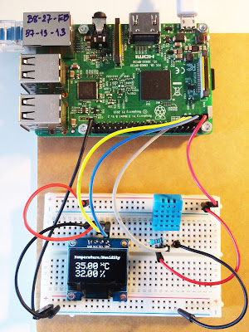](https://2.bp.blogspot.com/-JcPernpaB8U/WLZ8WJgaEGI/AAAAAAAAnrk/ZzTQe71jmJczyaaa0jfUuphaQe8WXxvQQCLcB/s1600/RaspberryPi_DHT_OLED.jpg)**