Quiz 1 ***(CSE331L.7 – Asif Ahmed Neloy_Summer’20)***

Department of Electrical and Computer Engineering

School of Engineering and Physical Sciences

North South University, Bashundhara, Dhaka-1229, Bangladesh

*Time 20 minutes, Marks 20 (You need to answer all questions).*

***Name – Md. Fahad Mojumder***

***ID - 1712145642***

1. **Why it is never a good idea to store any data in the segment registers?[5]**

**Answer: There are four parts in segment registers. Which is CS,DS,ES,SS. It is possible to store any data in segment register. But its not a good idea. Segment register build for very special purpose. Which is pointing at accessible blocks of memory. Segment resister work together with general purpose register to access any data from memory.**

1. **Write a program in Assembly language that will add 4 integer number (1,2,2,1) using only AX register and Store the result in the AX register.**

**org 100h**

**MOV AX, 01**

**MOV AX, 02**

**MOV AX, 02**

**MOV AX, 01**

**ADD AX,AX,AX,AX ;AX = AX+AX+AX+AX**

**; add your code here**

**ret**

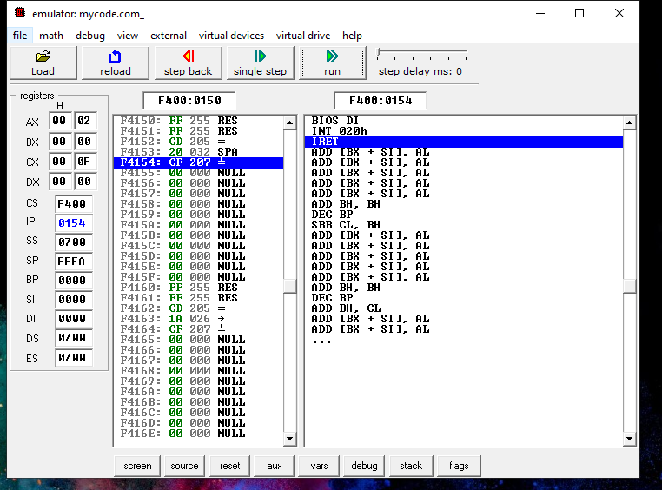

**End**