Dependent(Dname, empId, gender, birthdate)



Emp(SSN, gender, BD, fname, lname, deptId, managerId)



Dept(Dnum, Dname, managerId, hiredate)



Dep_loc(deptId, loc)

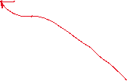

Project(pnum, pname, city, loc, deptId)



Emp_project(empId, projectId, hours)