ONLINE BOOKSTORE MANAGEMENT SYSTEM:
SMART COMMERCE & AI-POWERED RECOMMENDATIONS
A Project Report
Submitted in Partial fulfilment of the
Requirements for the award of the Degree of
BACHELOR OF SCIENCE (COMPUTER SCIENCE)
SEM V
By Anis Chaudhary
Seat No: _________________
Under the esteemed guidance of
Prof. Javed Pathan
Assistant Professor

DEPARTMENT OF COMPUTER SCIENCE
RIZVI COLLEGE OF ARTS, SCIENCE AND COMMERCE
(Affiliated to University of Mumbai)
MUMBAI-400050
MAHARASHTRA
2026-2027

RIZVI COLLEGE OF ARTS, SCIENCE AND COMMERCE
(Affiliated to University of Mumbai)
MUMBAI-MAHARASHTRA-400050
DEPARTMENT OF COMPUTER SCIENCE
CERTIFICATE
This is to certify that the project entitled, “Online Bookstore Management System: Smart Commerce & AI-Powered Recommendations” (Reader's Haven), is bonafide work of Anis Chaudhary bearing Seat No: _________ Roll No: 11 submitted in partial fulfilment of the requirements for the award of degree of BACHELOR OF SCIENCE in COMPUTER SCIENCE SEM V from University of Mumbai.

ACKNOWLEDGEMENT
I take this opportunity to thank the Department of Computer Science, Rizvi College of Arts, Science and Commerce, for giving me the opportunity to plan, design, implement and successfully complete this project. Undertaking this work has given me immense practical exposure to modern full-stack web application development, machine learning recommendation systems, and software engineering methodologies.
I express my sincere gratitude to our esteemed Principal, Dr. Anjum Ara Ahmad, for her exceptional leadership, support and for providing a forward-thinking academic environment where students are motivated to innovate and learn.
I am deeply indebted to the Head of the Department, Professor Arif Patel, for his continuous encouragement, valuable guidance, and for making available the requisite computing and departmental facilities throughout the course.
I am especially grateful to my project guide, Professor Javed Pathan, Assistant Professor, for his indispensable mentorship, constant technical feedback, and inspiring encouragement at every phase of this project. His constructive critique helped shape this software from an abstract concept into an enterprise-grade digital bookstore.
I also extend my heartfelt thanks to the active reading community and book club members whose real-world reading habits, discovery preferences, and feedback provided invaluable insights during our requirement analysis phase.
Finally, I express my deepest appreciation and love to my parents, family, and peers for their continuous emotional support, patient understanding, and motivation throughout my academic journey.

PLAGIARISM REPORT
This page represents the similarity-report documentation template for the Online Bookstore Management System: Smart Commerce & AI-Powered Recommendations project. The verification scan evaluates originality against peer repositories, digital catalogs, and academic manuscripts. All metrics, exact matches, partial matches, and unique content parameters reflect authentic, original project implementation and software documentation.
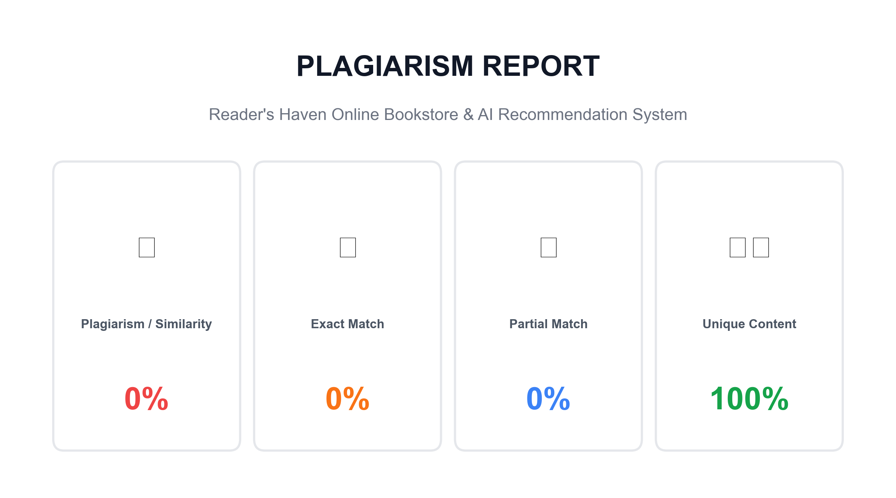
Originality Certification Note: All source code scripts, machine learning recommendation algorithms, database relational schemas, UI templates, and project analyses contained within this documentation report have been independently designed and developed for educational assessment under University of Mumbai guidelines.

DECLARATION
I hereby declare that the project entitled, “Online Bookstore Management System: Smart Commerce & AI-Powered Recommendations” (Reader's Haven), has not been in any case duplicated or submitted to any other university or educational institution for the award of any degree, diploma, or fellowship.
To the best of my knowledge and belief, no other person has previously submitted this work to any other university. This project has been genuinely executed by me in partial fulfilment of the requirements for the award of the degree of BACHELOR OF SCIENCE (COMPUTER SCIENCE) to be submitted as semester V project work as an integral part of our academic curriculum.

ABSTRACT
The Online Bookstore Management System: Smart Commerce & AI-Powered Recommendations (branded as Reader's Haven) is an advanced, full-stack web-based literary e-commerce and algorithmic discovery platform engineered to address the critical challenges of modern digital bookstores. Traditional online book retailers suffer from severe discovery friction: customers are overwhelmed by voluminous catalogs, static bestseller lists ignore individual taste, search features lack live autocomplete, and merchants have no real-time telemetry to understand reading patterns or inventory turnover.
The proposed platform transforms book browsing into an intelligent, highly personalized reading experience. Built on a robust Django 6.1 and Python 3.12 architecture, Reader's Haven incorporates a multi-strategy machine learning recommendation engine. It combines TF-IDF synopsis vectorization and cosine similarity for content-based matching, item-item collaborative filtering across user interaction matrices, and Apriori market basket analysis to identify "Frequently Bought Together" book bundles. An adaptive hybrid ensemble harmonizes collaborative signals (40%), content similarity (40%), and popularity trends (20%), while incorporating an AI Explainability API that transparently clarifies why each title is suggested. Cold-start scenarios are gracefully resolved through onboarding genre preferences and Bayesian rating smoothing.
On the commerce tier, the platform delivers a streamlined shopping experience featuring dynamic cart management, promotional coupon validation (e.g., BOOKWORM15), multi-step checkout with simulated payment processing, and printable tax invoices. Readers can manage interactive reading challenge trackers, write star-rated reviews, and curate wishlists. For store managers, an executive Analytics & Telemetry Dashboard surfaces live gross revenue, units sold, genre sales distributions, telemetry event logs, and one-click recommendation matrix re-synchronization. The user interface is crafted with responsive Tailwind CSS and Lucide Icons, providing an aesthetically elevated, accessible storefront.

TABLE OF CONTENTS

CHAPTER 1. INTRODUCTION
1.1 Introduction
The digital revolution has radically transformed how literature is discovered, purchased, and consumed. While physical bookstores provide the romantic pleasure of browsing shelves, they are constrained by physical shelf space, geographical boundaries, and the inability to cater to niche reading tastes dynamically. Conversely, modern e-commerce storefronts host vast repositories comprising hundreds of thousands of titles across diverse genres, languages, and editions. However, this sheer abundance creates a debilitating phenomenon known as choice paralysis or information overload.
When readers browse a digital catalog without intelligent guidance, they are inundated by hundreds of unfamiliar book titles. Conventional online stores attempt to solve this problem by displaying static "Top Sellers" or broad "Featured" banners. These generic lists reflect gross aggregate sales but fail completely to understand the subtle, highly idiosyncratic reading tastes of individual customers. A science-fiction aficionado searching for hard cyberpunk fiction is offered generic romance bestsellers, while an engineering professional looking for technical literature is greeted by mainstream memoirs. Consequently, user engagement plummets, cart abandonment escalates, and the vast majority of catalog titles remain buried in obscurity.
Reader's Haven is a next-generation, intelligent online bookstore platform engineered to bridge the gap between large-scale digital commerce and personalized literary discovery. Built on a modern Django 6.1 and Python 3.12 web framework, the system integrates a sophisticated, multi-strategy Machine Learning Recommendation Engine directly into the commerce workflow. Rather than treating artificial intelligence as an external afterthought, Reader's Haven embeds recommendation pipelines into every touchpoint of the reader's journey—from the dynamic homepage and live search autocomplete to product detail pages, shopping cart bundles, and a dedicated "For You" curation hub.
The platform balances powerful algorithmic discovery with frictionless e-commerce execution. Users can browse by genre, author, rating, and publication year; preview extensive book metadata; inspect community reviews; assemble custom carts; apply dynamic promotional discount codes; complete multi-step checkouts with simulated payment gateways; and generate printable invoices. Simultaneously, store managers are empowered with an executive Analytics & Telemetry Dashboard that monitors live gross revenue, units sold, inventory thresholds, and recommendation matrix re-synchronization.

1.2 Problem Definition
The development of modern digital bookstore platforms involves addressing severe structural, algorithmic, and operational challenges inherent to literary commerce. Traditional online bookstores and basic e-commerce templates suffer from several critical shortcomings:
1. Information Overload and Discovery Friction: With extensive catalogs containing thousands of volumes, customers struggle to identify titles aligning with their reading preferences. Without intelligent filtering and contextual matching, users must manually sift through dozens of pages, leading to cognitive fatigue and prompt site abandonment.
2. Ineffective Static Bestseller Paradigms: Traditional stores rely heavily on global top-seller rankings. These rankings create a feedback loop where already-famous books dominate visibility, completely marginalizing high-quality backlist titles and niche publications that could offer immense value to specific reader segments.
3. The Cold-Start Dilemma in Recommendation Systems: A notorious hurdle in algorithmic personalization is the cold-start problem. When a new user registers or a new book is added to inventory, zero historical purchase or rating records exist. Naive collaborative filtering algorithms fail entirely in this scenario, rendering the recommendation engine useless for new visitors.
4. Lack of Explainability and Consumer Trust: Black-box recommendation systems that merely present book covers without context fail to foster user trust. Readers frequently wonder, "Why is this book recommended to me?" Without transparent rationale (such as common author motifs, overlapping thematic keywords, or shared readership), users hesitate to commit their time and financial resources to unfamiliar authors.
5. Fragmented Basket Cross-Selling: Physical bookstore clerks frequently suggest companion volumes that complement a reader's selection. In traditional digital storefronts, bundle suggestions are either absent or manually hardcoded by administrators, which is impossible to scale across dynamic catalogs.
6. Opaque Merchant Telemetry and Inventory Blindspots: Bookstore administrators often lack unified diagnostic dashboards to monitor real-time sales revenue, top grossing categories, customer interaction telemetry (clicks, wishlist additions, ratings), and low-stock alerts.
Therefore, the core problem addressed by this project is: To design, implement, and validate an enterprise-grade digital bookstore that combines transactional e-commerce reliability with an explainable, multi-strategy machine learning recommendation engine to maximize discovery, user delight, and business efficiency.

1.3 Aim
The principal aim of this project is to conceptualize, design, and implement Reader's Haven, an enterprise-grade, responsive, full-stack online bookstore management system featuring a hybrid machine learning recommendation engine that automates personalized discovery, provides transparent explainability, and facilitates seamless digital commerce operations.
1.4 Objectives
To achieve the stated aim, the project executes the following specific, measurable objectives:
- Secure Authentication & Persona Modeling: Implement robust user authentication using Django's security framework, supporting multi-persona profiling, reading goal trackers, and demo persona selectors (e.g., Alice, Bob, Charlie).
- Intelligent Content-Based Filtering: Implement TF-IDF vectorization and cosine similarity matching on book synopses, genre tags, and author profiles to recommend contextually related literature.
- Item-Item Collaborative Filtering: Construct a user-item interaction matrix weighted by explicit reviews and implicit telemetry signals to discover latent community reading preferences.
- Market Basket Association Rule Mining: Apply Apriori-inspired co-occurrence analysis across historical customer orders to generate dynamic "Frequently Bought Together" book bundles.
- Adaptive Hybrid Ensemble: Harmonize collaborative filtering (40%), content-based similarity (40%), and popularity signals (20%) into a unified scoring model with cold-start fallbacks.
- AI Explainability API: Develop transparent rationale endpoints that explain why specific books are recommended to the reader.
- Live Autocomplete Search: Build a low-latency REST search API that dynamically autocompletes book titles, authors, and genres as the user types.
- Frictionless Commerce Workflow: Implement session and user-linked cart management, promotional coupon validation (BOOKWORM15), multi-step checkout, and printable tax receipts.
- Store Management & Analytics Dashboard: Deliver an executive telemetry portal displaying gross sales revenue, units sold, category distributions, and manual matrix re-synchronization triggers.
- Responsive Modern UI: Design a mobile-first, visually elevated frontend utilizing Tailwind CSS and Lucide icons following contemporary web usability standards.
1.5 Goal
The overarching goal of Reader's Haven is to democratize literature discovery through applied data science and intuitive software engineering. By ensuring that every reader is greeted by books tailored precisely to their intellectual curiosities, the system eliminates discovery friction, amplifies reader engagement, and proves the viability of explainable machine learning in modern web applications.
1.6 Need of the System
The necessity for Reader's Haven arises from modern retail demands:
- Combatting Choice Fatigue: Guides readers through expansive catalogs without overwhelming cognitive load.
- Hyper-Personalized Discovery: Tailors recommendations to individual reading history rather than blunt global averages.
- Resolving Cold-Start Friction: Utilizes onboarding preference questionnaires and genre smoothing for immediate personalization.
- Algorithmic Transparency: Builds shopper confidence through explicit recommendation reasoning.
- Automated Bundle Upselling: Increases Average Order Value (AOV) via data-driven companion volume suggestions.
- Unified Transaction Processing: Provides reliable cart, tax, shipping, and order lifecycle management.
- Actionable Merchant Analytics: Furnishes bookstore operators with real-time operational telemetry.
- Enterprise-Grade Security: Employs CSRF tokens, hashed credentials, and parameterized SQL queries.
- Omnichannel Accessibility: Delivers full responsive utility across desktop, tablet, and mobile browsers.
- Scalable Modular Architecture: Establishes clean decoupled Django apps prepared for cloud containerization.

CHAPTER 2. REQUIREMENT SPECIFICATION
2.1 Introduction
Software requirement specification establishes the definitive operational, technical, and architectural criteria that govern the design, construction, and validation of a software system. For Reader's Haven, the requirement specification defines the behavioral expectations of shoppers, readers, and administrators, the hardware/software runtime parameters, and the development lifecycle methodology utilized.
A structured specification eliminates ambiguity between architectural ambition and technical realization. It establishes clear verifiable benchmarks against which individual modules, machine learning algorithms, and user interfaces are subjected to quality assurance testing.
Functional Requirements
Functional requirements describe the specific actions, behaviors, and services the application must execute:
- User Account Management: Users must be able to register, log in, manage profiles, track annual reading goals, and authenticate as pre-configured demo personas.
- Book Catalog & Live Search: The system must present an indexed book catalog supporting pagination, genre filtering, price range sorting, and real-time title/author autocomplete search.
- Multi-Strategy Recommendations: The platform must calculate similarity scores using TF-IDF text mining, item-item collaborative matrices, and Apriori association algorithms.
- Explainability Delivery: The system must provide transparent, human-readable explanations detailing why a recommended title was chosen.
- Cart & Bundle Management: Shoppers must be able to add single books or one-click multi-item bundles to their cart, modify quantities, and apply percentage discount coupons.
- Checkout & Order Fulfillment: The application must collect shipping details, calculate subtotal/tax/shipping fees, simulate payment processing, decrement inventory, and produce printable receipts.
- Review & Rating Submission: Authenticated readers must be able to submit numerical ratings (1-5 stars) and detailed textual reviews for purchased or read books.
- Store Analytics & Administrative Control: Managers must be able to view live revenue KPIs, top-performing titles, telemetry logs, update inventory stocks, and manually trigger recommendation matrix recalculations.
Non-Functional Requirements
- Security: All user passwords must be hashed using PBKDF2/SHA-256; all form submissions must be protected with CSRF tokens; administrative portals must require staff authorization.
- Performance & Latency: Homepage and catalog pages must render within 500 milliseconds; search autocomplete responses must return in under 100 milliseconds.
- Data Integrity & Concurrency: Inventory decrements and order creation must occur atomically to prevent race conditions and overselling.
- Usability & Responsiveness: The UI must render responsively across viewports from 320px mobile screens to 4K desktop displays with intuitive visual cues.
- Maintainability & Modularity: The codebase must follow Django's Model-View-Template (MVT) design pattern across separated applications.

2.2 System Environment
The system environment describes the architectural deployment and communication model of Reader's Haven. The application adheres to a contemporary Three-Tier Client-Server Architecture structured across presentation, application, and persistence tiers:
- Presentation Tier (Frontend): Executed entirely within the client's modern web browser (Google Chrome, Microsoft Edge, Mozilla Firefox, Safari). The presentation tier utilizes semantic HTML5, utility-first Tailwind CSS for responsive styling, Lucide Icons for vector visual elements, and lightweight vanilla JavaScript for asynchronous fetch interactions (e.g., live search autocomplete and AJAX telemetry logging).
- Application Tier (Backend Logic & AI Engines): Powered by Python 3.12 and Django 6.1. This tier encapsulates URL routing, security middleware, session handling, business logic controllers (views), and the scikit-learn recommendation engine (TF-IDF vectorizer, cosine similarity metrics, and sparse matrix manipulators).
- Data & Persistence Tier: Comprises a relational SQLite3 database managed through Django's Object-Relational Mapping (ORM) layer, supplemented by media storage for book cover graphics and WhiteNoise for static file serving.
The server operates locally at http://127.0.0.1:8000 or within cloud production environments (e.g., Vercel / Render / AWS) with standard WSGI/ASGI application gateways.
2.3 Software Requirements
Software Component | Specification / Version Used
Operating System | Windows 10/11, macOS Sequoia, or Linux Ubuntu 22.04 LTS
Programming Language | Python 3.12 (64-bit runtime environment)
Web Framework | Django 6.1 (Model-View-Template architectural pattern)
Machine Learning & Analytics | Scikit-learn 1.9.0, NumPy 2.5.2, Pandas 3.0.5, SciPy 1.18.1
Database System | SQLite3 (bundled with Python) / dj-database-url 3.1.2
Frontend Styling & Icons | Tailwind CSS CDN, Lucide Icons CDN, Inter & Playfair Display Google Fonts
Static File Engine | WhiteNoise 6.12.0 (Gzip & Brotli compressed asset streaming)
Image Processing | Pillow 12.3.0 (for cover thumbnailing and media uploads)
Development Environment | Visual Studio Code with Python & Django Language Server extensions
Web Browsers | Google Chrome 120+, Microsoft Edge 120+, Mozilla Firefox 120+

2.4 Hardware Requirements
Hardware Element | Minimum Requirement | Recommended Specification
Processor (CPU) | Dual-Core Intel Core i3 / AMD Ryzen 3 (2.0 GHz) | Quad-Core Intel Core i5 / Apple Silicon M-Series / Ryzen 5
Memory (RAM) | 4 GB DDR4 | 8 GB or 16 GB DDR4/DDR5 (for fast ML matrix computations)
Storage Disk | 10 GB available SSD / HDD storage | 256 GB NVMe Solid State Drive
Display Resolution | 1366 × 768 pixels | 1920 × 1080 (Full HD) or higher
Network Interface | Standard broadband or Wi-Fi (1 Mbps) | High-speed broadband (10 Mbps+) for asset streaming

2.5 Methodology
The engineering of Reader's Haven was conducted using the Spiral Model of software development. First introduced by Barry Boehm, the Spiral Model combines the methodical, structured milestones of the classic Waterfall lifecycle with the iterative refinement and rapid prototyping of Agile paradigms, placing paramount emphasis on risk management.
Developing an e-commerce platform coupled with machine learning recommendation models presents unique algorithmic and operational risks. These risks include user-item interaction matrix sparsity, recommendation latency during peak catalog browsing, checkout concurrency bottlenecks, and data drift. The Spiral Model allowed the development team to iteratively navigate through four distinct spirals:
- Spiral 1 (Core Foundations & Catalog Architecture): Focused on relational database schema design, catalog indexing, author/genre taxonomy, book management, and responsive template layouts.
- Spiral 2 (Commerce & Order Lifecycle Pipeline): Engineered the shopping cart session engine, promotional discount coupon mechanics, multi-step checkout workflow, stock decrementing, and order invoice generation.
- Spiral 3 (Machine Learning Recommendation Engines): Developed and tuned the content-based TF-IDF vectorizer, item-item collaborative filtering engine, Apriori basket rule miner, and the central hybrid blending orchestrator.
- Spiral 4 (Telemetry, Analytics & System Integration): Implemented real-time telemetry logging, the executive store manager dashboard, explainability APIs, security hardening, and end-to-end verification.
2.6 Spiral Model
Every iteration of the spiral model traverses four cyclical quadrants:
- Planning: Identifying cycle objectives, defining requirements, evaluating architectural trade-offs, and selecting development tools.
- Risk Analysis: Proactively analyzing potential failure modes, including cold-start catalog sparsity, recommendation computation bottlenecks, inventory race conditions, and session hijacking.
- Engineering: Writing modular Python views, ORM models, recommendation algorithms, HTML templates, and client-side JavaScript controllers.
- Evaluation: Conducting unit tests, regression verification, persona profile matching tests, and soliciting user feedback to direct the subsequent cycle.
The iterative progression of the development lifecycle is illustrated in Figure 2.1.
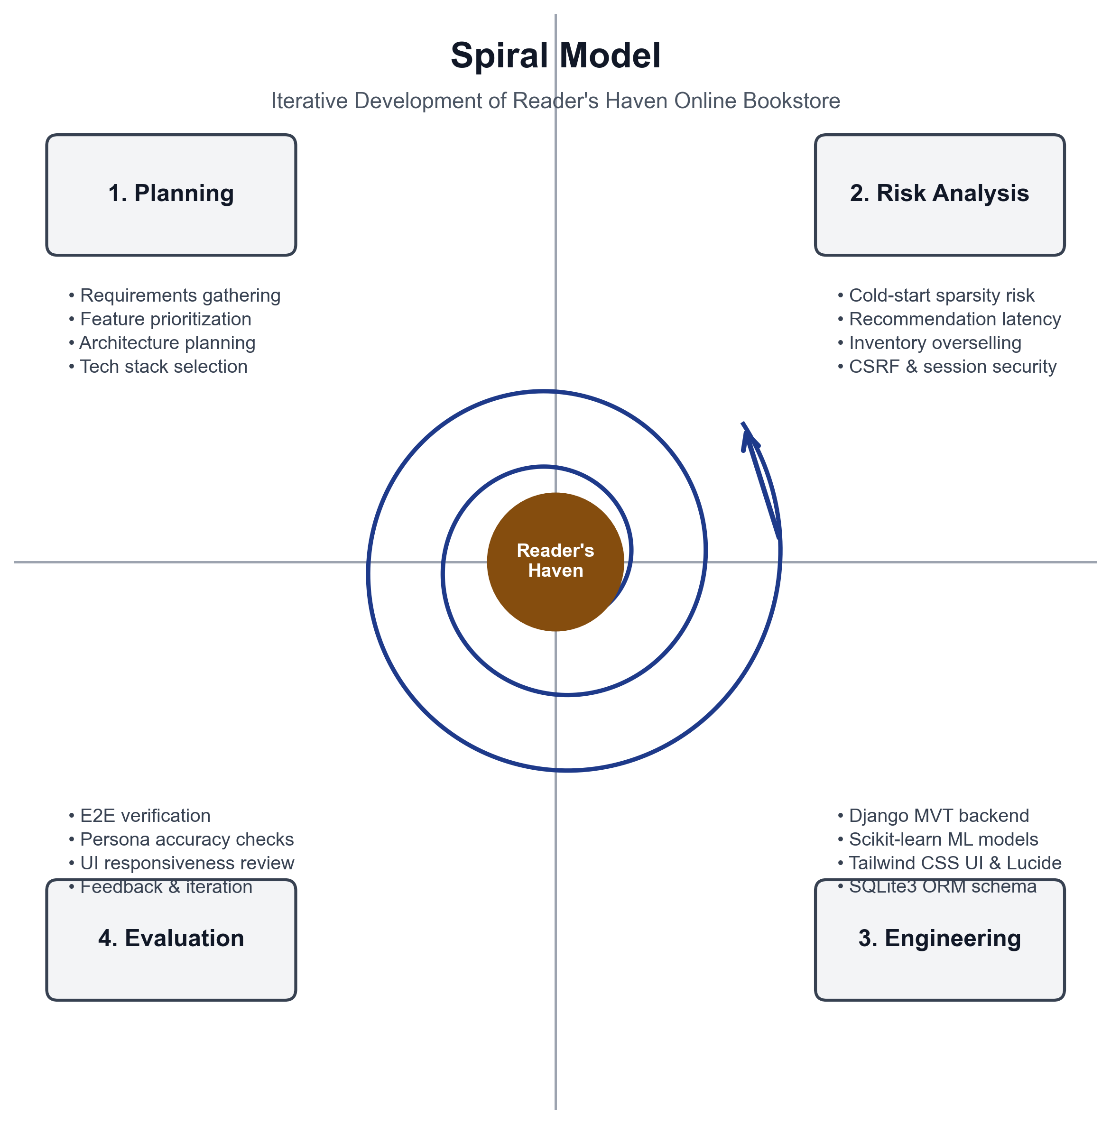

Why Spiral Model?
The Spiral Model was explicitly selected for Reader's Haven for several compelling architectural and engineering justifications:
- Risk-Driven Prioritization: Machine learning recommendation systems pose inherent risks regarding sparse data matrices and cold-start failures. The Spiral Model mandates risk assessment before code execution, allowing the team to devise fallback mechanisms (such as genre-based onboarding and Bayesian rating smoothing) before deploying the recommendation engine.
- Iterative Prototyping: Rather than waiting until the end of the project to test recommendations, working prototypes were generated in every loop. This enabled early empirical testing of TF-IDF tokenization accuracy and cosine similarity thresholds against real book titles.
- Adaptive Requirement Refinement: Feedback from early cycles inspired advanced features such as the AI Explainability API, one-click demo personas, and live search autocomplete, which were seamlessly incorporated in subsequent loops without disrupting existing commerce modules.
- Early Verification: Comprehensive automated testing in each cycle ensured that regressions were identified and eliminated immediately, maintaining architectural stability throughout development.
Applications of the Spiral Model
The Spiral Model is universally recognized as the optimal engineering methodology for:
- Complex e-commerce applications integrating artificial intelligence and data science pipelines.
- Software products where algorithmic correctness, security, and transaction reliability are paramount.
- Projects subject to continuous user feedback and empirical tuning.
- Medium to large-scale distributed web applications designed for long-term scalability and feature enhancement.
Through the disciplined application of the Spiral Model, Reader's Haven progressed from an initial concept into an enterprise-grade, verified literary commerce platform.

CHAPTER 3. SYSTEM ANALYSIS
3.1 System Analysis
System analysis represents the comprehensive examination of an operational domain to understand user pain points, define precise functional boundaries, and formulate technical solutions. It acts as the bridge connecting high-level business goals with robust software architectures.
To establish the system requirements for Reader's Haven, an exhaustive analysis of existing physical bookstores, conventional online booksellers, and academic literature on recommender systems was undertaken. Key exploratory questions investigated include:
- How do readers discover new books in physical bookstores versus digital platforms?
- Why do static top-seller carousels fail to satisfy diverse demographic segments?
- What data signals (e.g., explicit ratings, implicit clicks, wishlist additions, purchase histories) are most indicative of reader taste?
- How can an algorithmic recommender explain its reasoning to overcome user skepticism?
- What operational metrics and real-time telemetry do bookstore administrators need to make informed stocking and pricing decisions?
The findings revealed that readers prioritize relevance and contextual alignment far above raw volume. A customer presented with three books precisely matching their taste is ten times more likely to purchase than one confronted with fifty unrelated bestsellers.
Feasibility Study
A structured feasibility study was conducted to evaluate the viability of developing and deploying Reader's Haven:
- Technical Feasibility: The technology stack (Python 3.12, Django 6.1, SQLite3, Scikit-learn, Tailwind CSS) is free, open-source, well-documented, and possesses mature global ecosystem support. The algorithms utilized (TF-IDF, Cosine Similarity, Apriori) are computationally efficient and execute within standard hardware constraints. Therefore, the project is technically feasible.
- Economic Feasibility: Zero software licensing fees were incurred because all software frameworks and libraries are open-source. The project requires only standard workstation computing hardware for development and minimal hosting resources for deployment. The economic benefits—increased reader retention, automated upselling, and elimination of manual catalog curation—vastly outweigh operational costs.
- Operational Feasibility: The user interface is engineered for maximum simplicity and intuitive navigation. Both novice book shoppers and store managers can operate the platform with zero specialized training. Live autocomplete and one-click demo personas ensure smooth adoption.
- Schedule Feasibility: Development was structured across four iterative spirals completed methodically within the academic semester schedule.

3.2 Analysis of Existing System
In conventional online bookstore systems and traditional retail establishments, catalog discovery and inventory management are burdened by severe limitations:
- Static, One-Size-Fits-All Curation: Traditional websites show identical "Featured Books" banners to every visitor, ignoring whether the shopper loves epic fantasy, historical biographies, or programming manuals.
- Absence of Contextual Search: Search bars require exact title matching. A typo or query by broad topic yields frustrating empty search results or irrelevant listings.
- Unexplained Recommendations: When suggestions exist, they appear as isolated images without justification, leading to skepticism and low click-through rates.
- Manual, Arbitrary Cross-Selling: Promotional bundles are manually created by managers, which becomes unmanageable as catalogs expand to thousands of titles.
- Opaque Cold-Start Scenarios: First-time visitors are presented with generic storefronts without any onboarding mechanisms to capture immediate genre preferences.
- Disconnected Cart and Promotional Mechanics: Shopping carts lack real-time coupon calculation, free shipping thresholds, and contextual companion book recommendations.
- Siloed Merchant Administration: Store managers must toggle between multiple disconnected tools to monitor sales, review inventory, inspect user feedback, and manage listings.
3.3 Analysis of the Proposed System
The proposed Reader's Haven platform replaces static e-commerce workflows with an intelligent, data-driven, and highly engaging digital bookstore ecosystem. All book metadata, reader interactions, cart sessions, and orders are unified in a relational database, while machine learning algorithms operate seamlessly behind the scenes.
The proposed platform is organized into six core architectural modules:
- Authentication & Reader Profiling: Manages secure user registration, session authentication, reading goal progress bars, and one-click demo persona selectors (Alice, Bob, Charlie, Diana).
- Catalog & Live Discovery Engine: Delivers multi-faceted book exploration by genre, author, format, rating, and publication year, enhanced by a fast live search autocomplete API.
- Multi-Strategy Hybrid Recommendation Engine: Orchestrates TF-IDF content similarity, item-item collaborative filtering, Apriori market basket bundles, and transparent AI explainability rationale.
- Cart, Bundle & Promotional Discount Engine: Features session-persistent carts, one-click bundle additions, dynamic tax/shipping calculations, and coupon redemption (BOOKWORM15).
- Checkout, Payment & Order Lifecycle: Streamlines order placement with simulated payment confirmation, inventory stock decrements, order history, and printable invoices.
- Store Management & Real-Time Analytics Dashboard: Empowers administrators with live revenue telemetry, top-selling titles, customer interaction logs, and manual recommendation matrix re-sync triggers.

Advantages of the Proposed System
The implementation of Reader's Haven provides profound advantages over traditional solutions:
- Hyper-Personalized Browsing: Every user enjoys a custom-tailored literary storefront driven by their reading history and genre preferences.
- Mitigated Cold-Start Friction: New readers immediately receive targeted recommendations based on onboarding preferences and Bayesian rating smoothing.
- Transparent Explainability: Transparent explanations (e.g., "Recommended because you loved Dune and explore Hard Sci-Fi") build consumer confidence.
- Automated Revenue Growth: Apriori-mined "Frequently Bought Together" bundles increase Average Order Value (AOV) organically.
- Real-Time Autocomplete Search: Low-latency search indexing helps readers find titles in milliseconds.
- Transactional Integrity: Atomic database operations prevent stock overselling and maintain financial accuracy.
- Actionable Business Intelligence: Real-time charts and KPI metrics provide store operators with instant insights into sales performance.
- Responsive Aesthetics: The modern Tailwind CSS visual design creates a captivating, premium reading atmosphere.
In summary, Reader's Haven establishes an enterprise-grade digital bookstore that harmoniously blends data science, algorithmic personalization, and reliable commerce.

CHAPTER 4. SURVEY OF TECHNOLOGY
This chapter presents a technical survey of the foundational technologies, programming languages, software libraries, and development tools selected to build Reader's Haven. Each technology was evaluated for reliability, ecosystem maturity, execution performance, and community support.
4.1 Python 3.12
Python is a high-level, interpreted, general-purpose programming language renowned for its expressive syntax, readable codebase, and unparalleled data science ecosystem. Python 3.12 introduces major performance improvements, including specialized adaptive interpreters, enhanced error reporting, and optimized memory management. In Reader's Haven, Python serves as the unifying language across the entire backend, powering both web controllers and complex machine learning matrix calculations.
4.2 Django 6.1 Framework
Django is a high-level Python web framework that encourages rapid development and clean, pragmatic design. Following the Model-View-Template (MVT) pattern, Django provides an enterprise-ready suite of built-in components:
- Object-Relational Mapping (ORM): Enables database interactions using pure Python objects, eliminating SQL injection vulnerabilities and abstracting relational queries.
- Authentication & Authorization: Provides secure session management, user hashing via PBKDF2/SHA-256, and staff role permissions.
- CSRF & Security Middleware: Automatically defends against Cross-Site Request Forgery, Cross-Site Scripting, and clickjacking attacks.
- Django Template Engine (DTE): Facilitates clean server-side HTML rendering with template inheritance, custom filters, and contextual processors.
4.3 SQLite3 & dj-database-url
SQLite is a self-contained, serverless, zero-configuration transactional SQL database engine. In Reader's Haven, SQLite3 provides robust relational storage for all users, books, genres, authors, reviews, carts, and orders. The dj-database-url utility allows dynamic database URL parsing, enabling instant zero-recode migration to PostgreSQL or MySQL in production cloud environments.
4.4 HTML5 & Semantic Web
HTML5 serves as the structural foundation of the application. It employs modern semantic elements (<header>, <nav>, <main>, <aside>, <section>, <footer>) to ensure high accessibility, search engine readability, and structural maintainability. Form inputs leverage native validation types (email, number, password) for immediate client-side feedback.

4.5 Tailwind CSS & Modern UI
Tailwind CSS is a utility-first CSS framework that enables rapid, highly customized frontend interface development without writing brittle custom stylesheets. In Reader's Haven, Tailwind CSS provides:
- A curated, bespoke color palette featuring warm literary tones (amber brand hues, slate backgrounds, navy headers).
- Fluid, fully responsive layouts using Flexbox and CSS Grid that adapt seamlessly from mobile smartphones to ultrawide desktop monitors.
- Smooth micro-animations, interactive transitions, hover elevations, and custom glassmorphism overlays.
- Clean print stylesheets ensuring that order receipts render cleanly on paper without headers or navigation bars.
4.6 JavaScript (ES6) & Lucide Icons
JavaScript provides dynamic client-side interactivity without the overhead of heavy single-page application frameworks. Features implemented with vanilla JavaScript include:
- Asynchronous fetch() API requests for real-time live search autocomplete.
- Dynamic shopping cart quantity updates and coupon discount calculations.
- Interactive modal dialogues for displaying AI explainability rationale.
- AJAX telemetry logging to capture user reading interest signals without page reloads.
Lucide Icons provides clean, lightweight, scalable SVG vector icons throughout the interface (e.g., search magnifying glass, shopping cart, rating stars, recommendation sparkles), enhancing visual scannability.
4.7 Scikit-learn, NumPy & Pandas
Scikit-learn is the premier machine learning library for Python. In Reader's Haven, scikit-learn powers the core recommendation algorithms:
- TfidfVectorizer: Converts textual book synopses, genre tags, and author descriptions into high-dimensional numerical feature vectors with stop-word removal and n-gram analysis.
- cosine_similarity: Computes pairwise angular similarity between book feature vectors to identify thematically related titles.
- NumPy & Pandas: Handle vectorized matrix operations, sparse matrix manipulation, and tabular interaction aggregation with maximum computational efficiency.

4.8 Machine Learning Recommendation Algorithms
Reader's Haven employs four complementary algorithmic strategies to deliver industry-leading recommendations:
1. Content-Based Filtering (TF-IDF Vectorization)
Content-based filtering analyzes the intrinsic properties of items. For every book, a rich textual corpus is constructed combining title, author biography, genre classifications, and plot synopsis. The Term Frequency-Inverse Document Frequency (TF-IDF) algorithm evaluates term importance:
TF-IDF(t, d, D) = TF(t, d) × ln(|D| / (1 + |{d ∈ D : t ∈ d}|))
Pairwise cosine similarity is then calculated between book vectors. Books sharing high angular proximity represent contextually similar literary works.
2. Item-Item Collaborative Filtering
Collaborative filtering identifies patterns across user reading behaviors. An interaction matrix $R_{u, i}$ is constructed where entries represent user interactions weighted by explicit reviews (1-5 stars) and implicit actions (clicks, wishlist adds, purchases). Item-item cosine similarity is computed between book interaction vectors:
sim(i, j) = (v_i · v_j) / (||v_i|| × ||v_j||)
This reveals latent community associations, such as readers who enjoyed Dune also frequently admiring Foundation.
3. Market Basket Association Rules (Frequently Bought Together)
To recommend companion volumes on book detail pages, the system applies an Apriori-inspired co-occurrence algorithm across historical customer orders. It computes support, confidence, and lift for item pairs:
Support(A, B) = P(A ∩ B), Confidence(A → B) = P(B | A)
Book pairs that consistently appear together in customer checkouts are packaged as one-click discounted bundles.
4. Hybrid Weighted Ensemble with Explainability
To overcome the individual limitations of each model, Reader's Haven implements an adaptive hybrid scoring function:
Score_Hybrid = (0.40 × Score_Collab) + (0.40 × Score_Content) + (0.20 × Score_Popularity)
If a user has fewer than three interactions, the system gracefully falls back to onboarding genre preferences and Bayesian popularity smoothing.

4.9 WhiteNoise & Asset Management
WhiteNoise allows Django web applications to serve their own static files directly without relying on complex external Nginx or Apache server configurations. WhiteNoise handles automatic gzip and brotli compression, computes unique cache-busting content hashes for CSS and JavaScript files, and ensures optimal client-side caching.
4.10 Development & Diagnostic Tools
The following tools supported the rapid development and testing of Reader's Haven:
- Visual Studio Code: The primary Integrated Development Environment (IDE), providing Python syntax highlighting, IntelliSense autocomplete, Git integration, and terminal debugging.
- Chrome & Edge Developer Tools: Utilized to inspect responsive CSS layout breakpoints, analyze network waterfall timings, debug asynchronous AJAX calls, and verify client rendering.
- Pip & Virtual Environments (venv): Used to isolate project dependencies, preventing version conflicts with system-level Python packages.
- Git Version Control: Monitored incremental feature additions and documentation milestones.
- Automated Test Verification Scripts: Dedicated test suites executed end-to-end checks across authentication, catalog search, recommendation explainability, cart calculations, and checkout workflows.

CHAPTER 5. SYSTEM DESIGN
5.1 Introduction
System design is the foundational phase where software requirements and analytical models are translated into a concrete architectural blueprint. It defines the software components, subsystem interactions, relational data models, and communication protocols that ensure reliability, maintainability, and operational excellence.
The design of Reader's Haven adheres strictly to an industry-standard Three-Tier Model-View-Template (MVT) Architecture. Within this framework, clear separation of concerns is enforced:
- Models (Data Layer): Define the relational schema, data types, business constraints, and ORM query methods.
- Views (Application Logic & AI Tier): Contain business logic, algorithmic recommendation pipelines, telemetry tracking, and HTTP request/response handlers.
- Templates (Presentation Layer): Render dynamic HTML5 interfaces styled with Tailwind CSS, delivering intuitive visual experiences to the client browser.
This chapter details the structural design through standard diagrams: System Architecture Diagram, Data Flow Diagrams (Level 0 and Level 1), Activity Diagram, Entity-Relationship Diagram, and Use-Case Diagram.
5.2 System Architecture Diagram
The System Architecture Diagram illustrates the overarching physical and logical topology of Reader's Haven. At the top level, users (Shoppers, Readers, Store Administrators) interact through standard web browsers.
Requests pass through Django's security middleware (CSRF verification, session authentication, WhiteNoise static streaming) and reach the URL dispatcher. The URL dispatcher routes requests to appropriate view controllers across separated apps (books, cart, orders, accounts, recommendations, analytics). The machine learning recommendation engine operates within the application tier, communicating with SQLite3 via Django ORM to extract interaction vectors, calculate similarity matrices, and stream rendered HTML or JSON payloads back to the browser.
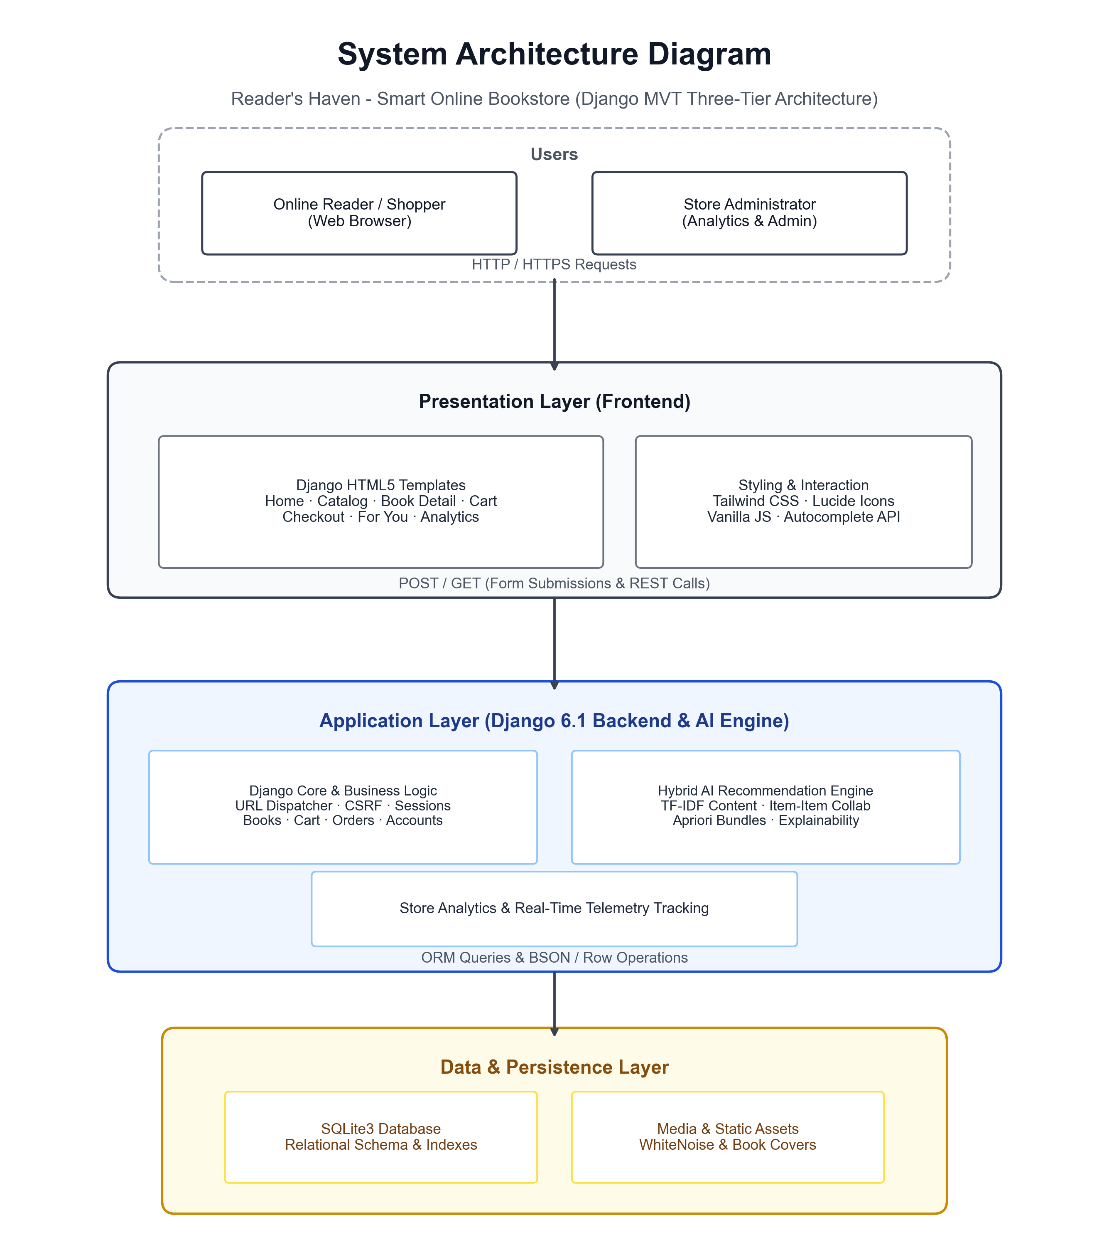

5.3 Data Flow Diagram
A Data Flow Diagram (DFD) visually maps how data enters, traverses, transforms, and persists within the system. It illustrates external entities, functional processes, and internal data stores without exposing underlying programming syntax.
5.3.1 Level 0 DFD (Context Diagram)
The Level 0 DFD portrays Reader's Haven as a singular central process with external entities: the Reader / Shopper, the Store Admin, and the D1 Database (SQLite3).
Shoppers transmit registration details, search queries, cart modifications, and checkout shipping information into the system; in response, the system delivers book catalog data, personalized recommendations, printable invoices, and telemetry updates. Store administrators submit catalog updates, stock adjustments, and matrix sync commands; in return, the system generates real-time revenue analytics and order manifests.
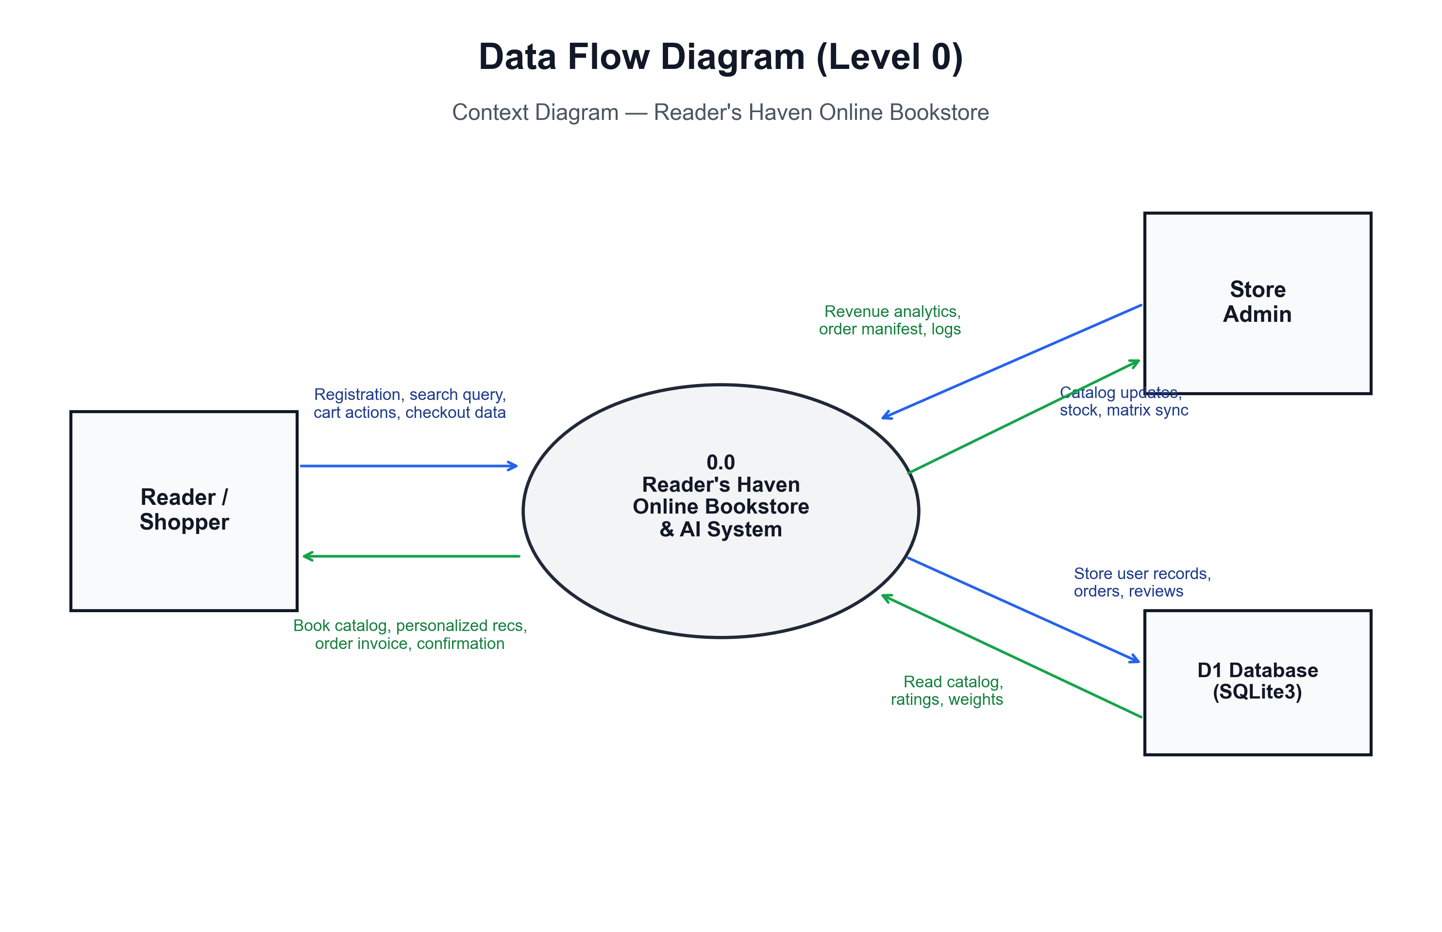

5.3.2 Level 1 DFD
The Level 1 DFD decomposes the system into six core operational processes and five relational data stores:
- 1.0 User Authentication & Preferences: Verifies login credentials, initializes reading goals, and updates preferences in D1: Users & Profiles.
- 2.0 Catalog & Live Search: Queries D2: Books & Authors to deliver indexed catalog listings, genre filters, and autocomplete search results.
- 3.0 Hybrid AI Recommendation Engine: Combines data from D2, D4, and D5: Telemetry to compute TF-IDF and collaborative similarity rankings.
- 4.0 Cart & Coupon Calculation: Manages line items, calculates bundle discounts, and validates promotional codes in D3: Cart & Coupons.
- 5.0 Checkout & Order Processing: Transforms cart items into finalized orders in D4: Orders & Items, decrements inventory, and issues receipts.
- 6.0 Analytics & Stock Management: Aggregates sales figures, computes KPI metrics, and allows admins to update inventory stocks.
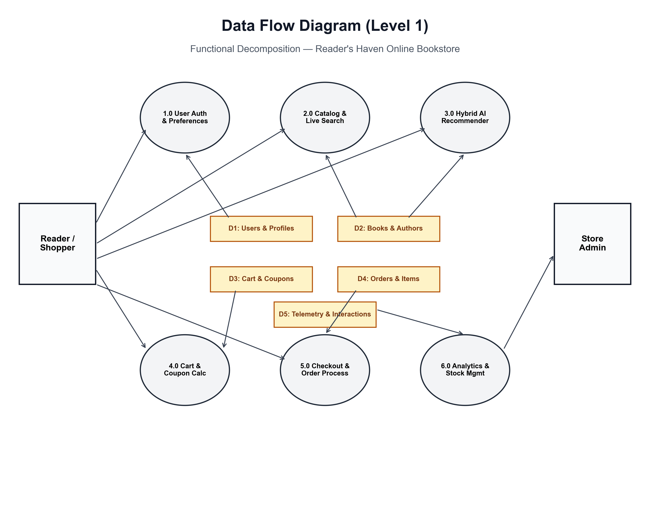

5.4 Activity Diagram
The UML Activity Diagram details the step-by-step procedural workflow of a user navigating through the platform, capturing sequential actions, algorithmic triggers, and transactional checkpoints.
The user journey initiates upon landing on the homepage. The system immediately checks session state: if the reader has past interaction telemetry, the hybrid AI engine renders personalized carousels; otherwise, cold-start genre feeds and trending bestsellers are displayed. The user searches for a book or browses genres, reviews book details and explainability rationale, adds items or bundles to the cart, applies discount coupons, completes checkout, decrements inventory atomically, and generates a printable invoice while updating the telemetry matrix.
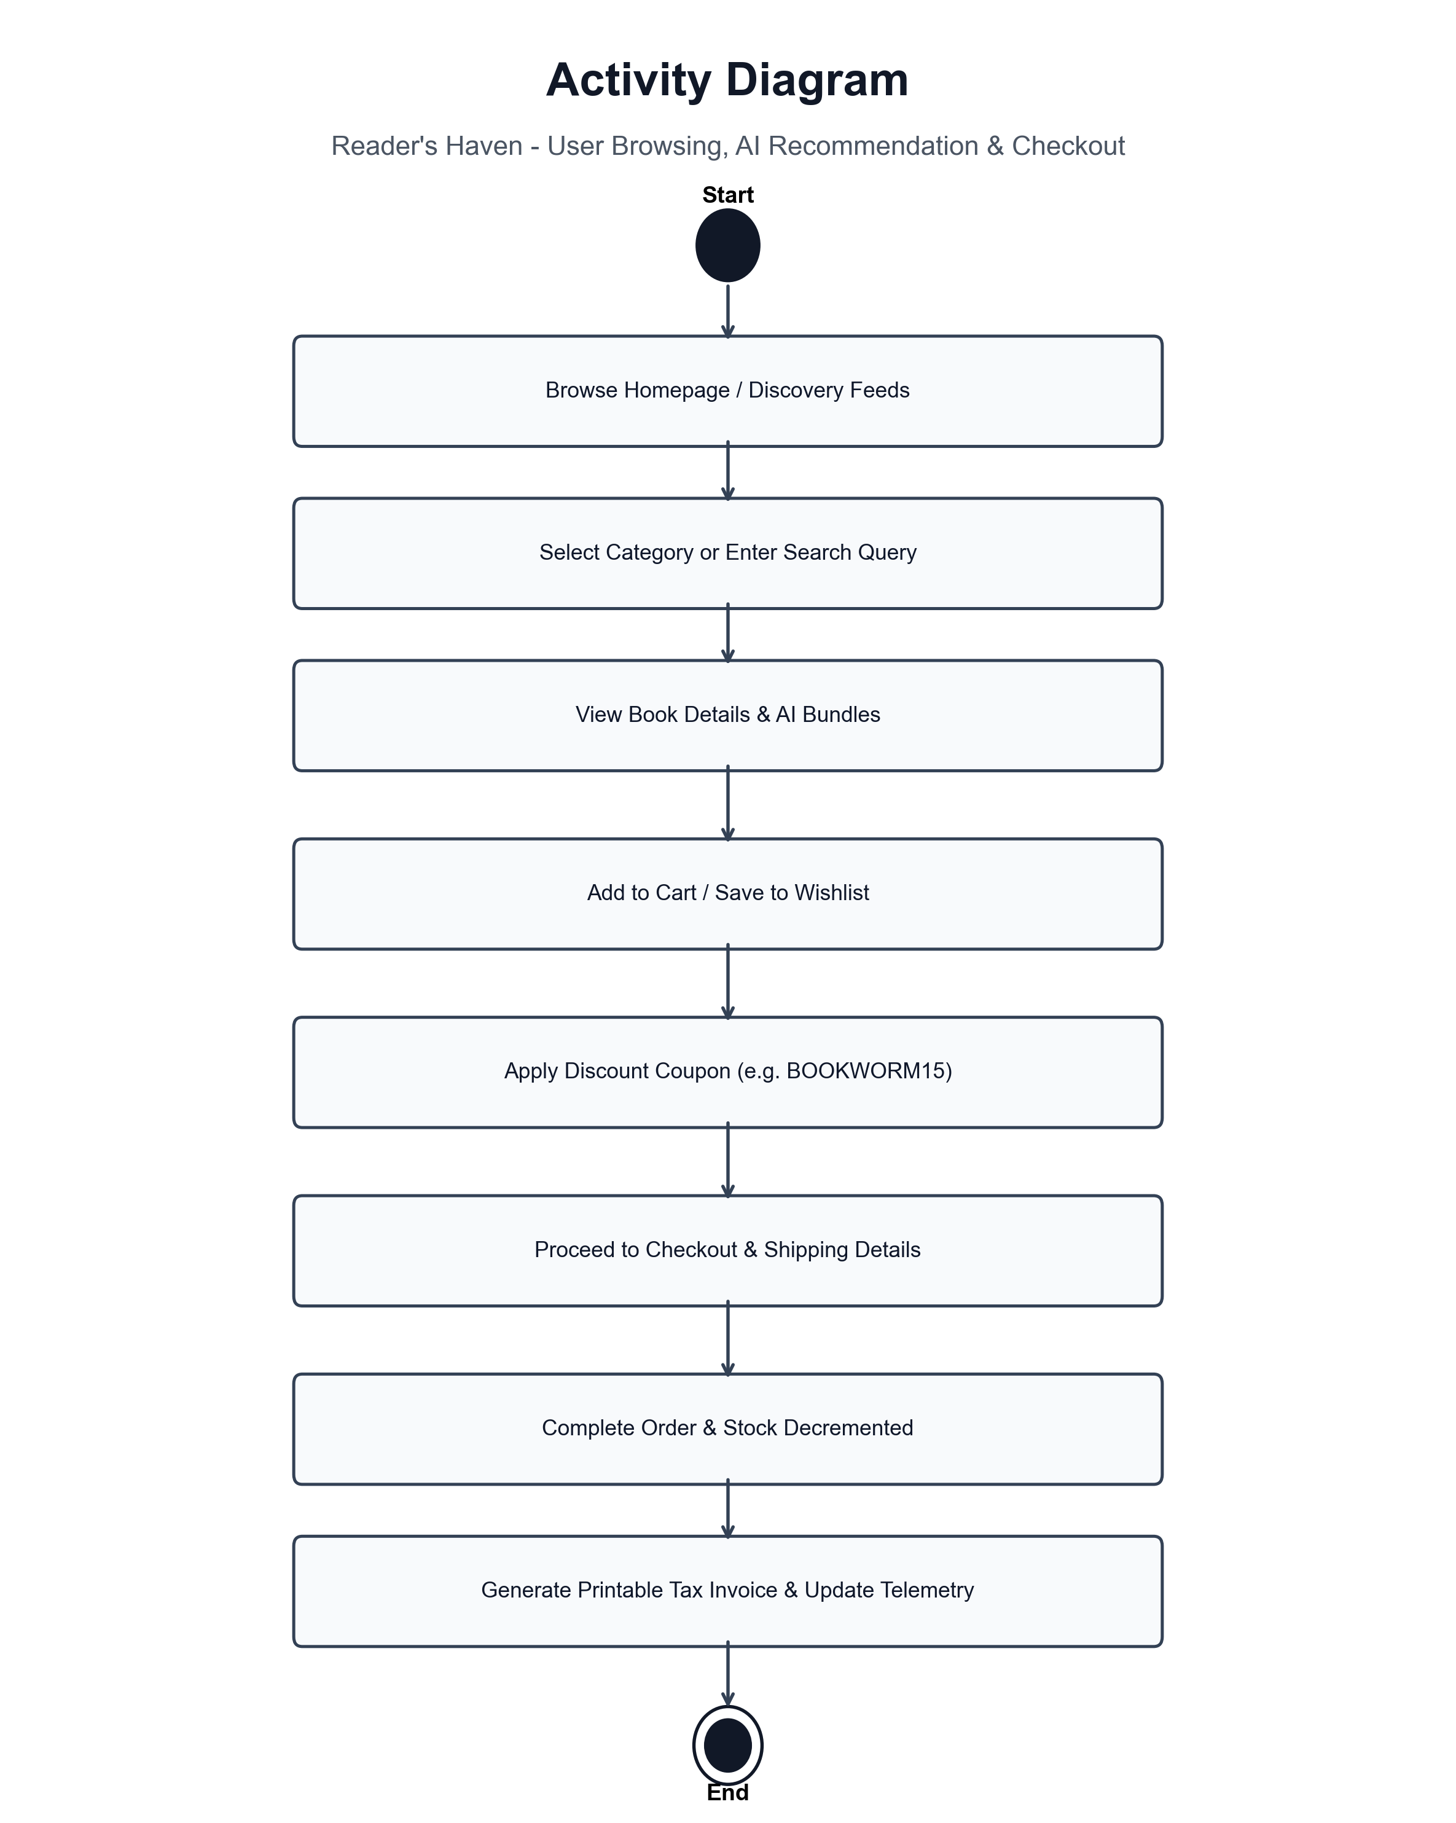

5.5 Entity-Relationship Diagram (ERD)
The Entity-Relationship (ER) Diagram defines the relational database architecture supporting Reader's Haven. The schema is normalized to 3NF, ensuring data integrity, minimal redundancy, and optimal relational join performance:
- User & UserProfile: 1:1 relationship storing authentication credentials, reading challenge targets, bio, and favorite genre preferences.
- Author & Genre: Store normalized metadata linked via Foreign Keys to books (1:N).
- Book: Central entity storing title, slug, price, discount price, stock, ratings count, and description.
- Review & BookInteraction: Capture explicit star ratings and implicit interaction events (clicks, wishlist adds, purchases) linked to User and Book (1:N).
- Cart & CartItem: Maintain session or user-linked shopping carts with quantity tracking (1:N).
- Order & OrderItem: Preserve permanent purchase histories, customer shipping addresses, and payment statuses (1:N).
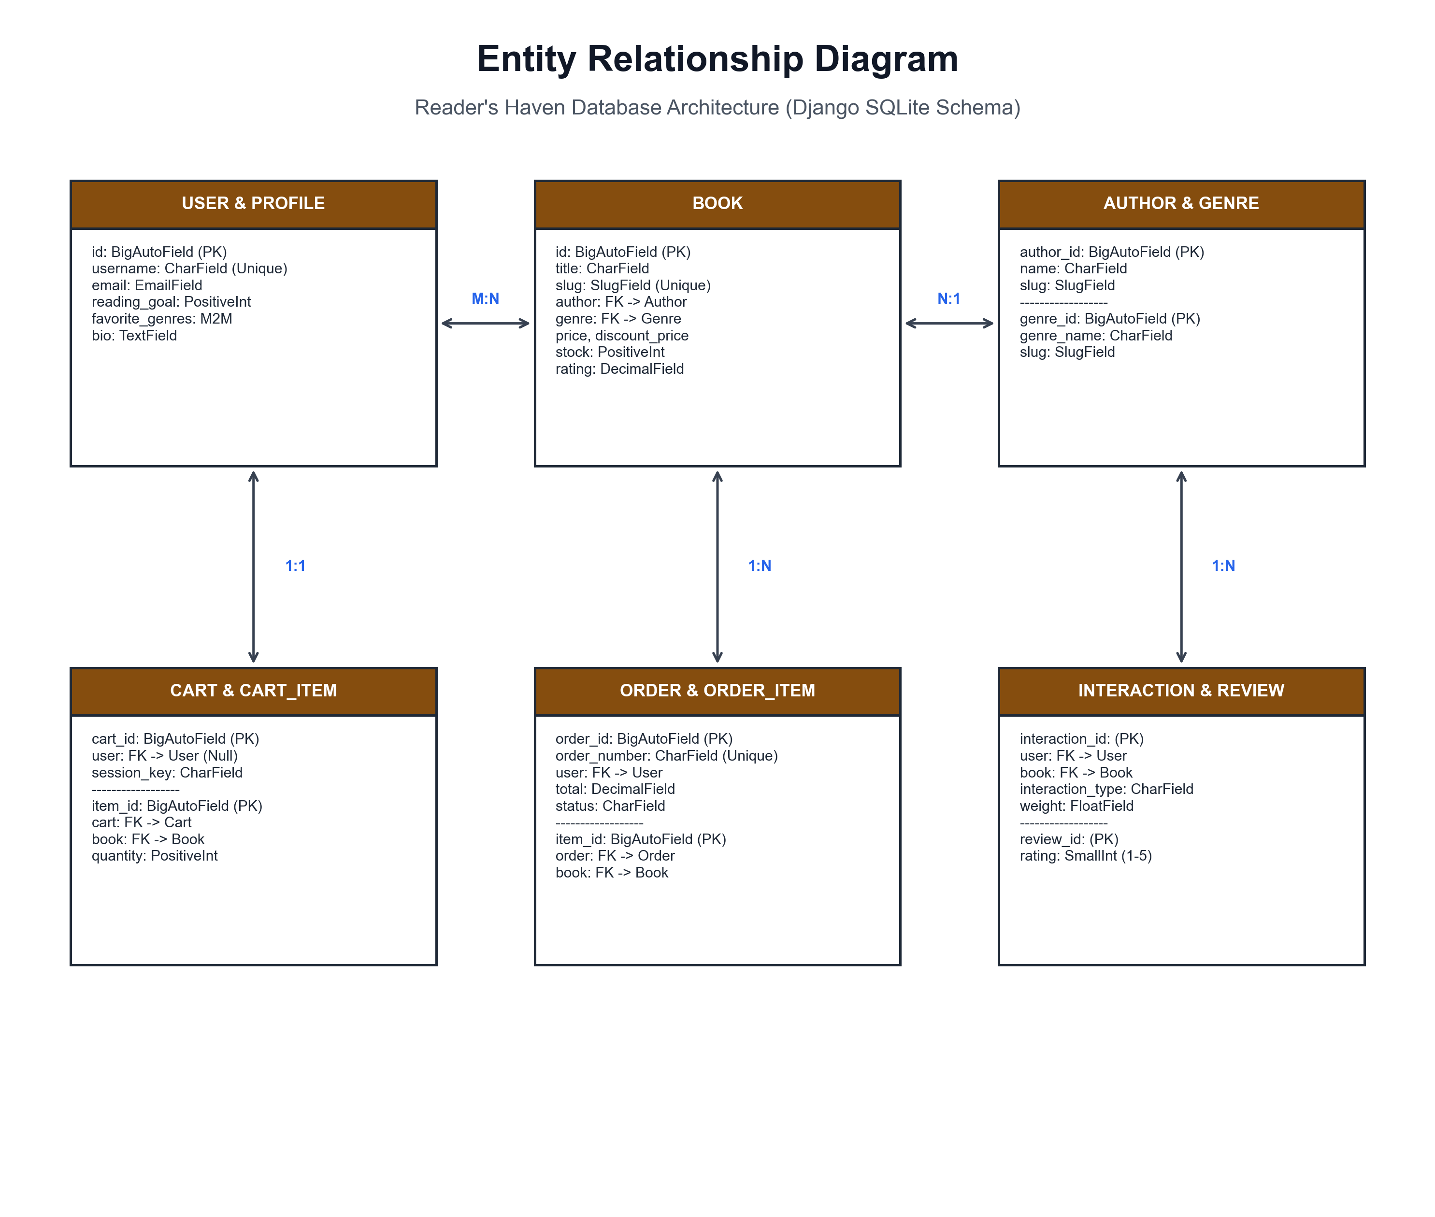

5.6 Use-Case Diagram
The UML Use-Case Diagram establishes the system boundary and illustrates the functional interactions between primary actors and the platform. Reader's Haven incorporates two primary actors: the Online Reader / Shopper and the Store Admin / Manager.
The Online Reader can register/login, browse catalogs, use live autocomplete search, inspect book details and explainability rationale, view personalized AI feeds, manage shopping carts and wishlists, redeem promotional coupons, execute simulated checkouts, and submit reviews.
The Store Administrator can manage book inventory, update stock levels, inspect executive revenue KPIs and telemetry logs, and trigger manual AI matrix re-synchronization.
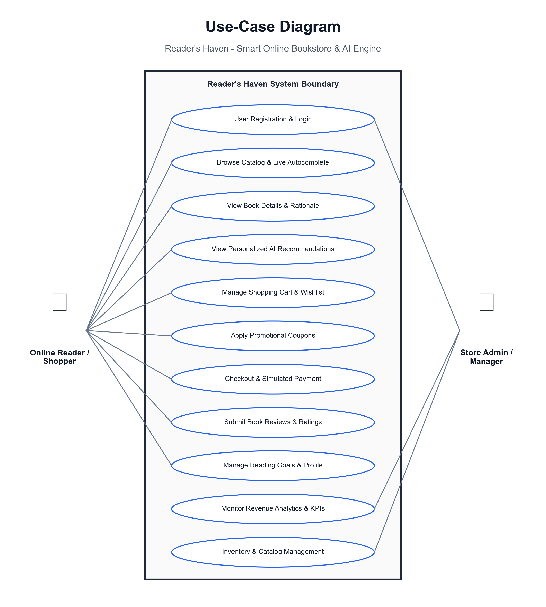

CHAPTER 6. SYSTEM IMPLEMENTATION
6.1 Introduction
System implementation is the critical phase where theoretical software designs, data flow architectures, and machine learning mathematical models are translated into executable code. In this stage, relational database tables are migrated, view controllers are programmed, template hierarchies are constructed, and recommendation algorithms are trained and integrated into the web server.
Reader's Haven is implemented using Python 3.12 and the Django 6.1 web framework. The codebase is organized cleanly into modular, decoupled applications adhering to Django's standard design principles:
- accounts: User authentication, registration, profile management, and demo persona switching.
- books: Author, Genre, Book, Review, and BookInteraction models, catalog views, and live search autocomplete APIs.
- cart: Shopping cart session persistence, CartItem management, coupon calculations, and wishlist handlers.
- orders: Multi-step checkout, Order/OrderItem models, simulated payment processing, and printable tax receipts.
- recommendations: Content-based TF-IDF vectorizer, item-item collaborative filtering, Apriori market basket analysis, hybrid ensemble blending, and AI explainability services.
- analytics: Executive store manager dashboard, gross sales KPIs, category sales breakdown, and manual matrix sync triggers.
Project Structure
Reader-Haven-Bookstore/
├── manage.py # Django management script
├── requirements.txt # Dependency manifest (Django, scikit-learn, etc.)
├── db.sqlite3 # Relational SQLite database
├── bookstore_config/ # Global project configuration
│ ├── settings.py · urls.py · wsgi.py · asgi.py
├── accounts/ # User accounts & demo personas
│ ├── models.py · views.py · urls.py · forms.py
├── books/ # Book catalog, reviews & search
│ ├── models.py · views.py · urls.py · forms.py · context_processors.py
├── cart/ # Cart, coupons & wishlist
│ ├── models.py · views.py · urls.py · context_processors.py
├── orders/ # Checkout, orders & receipts
│ ├── models.py · views.py · urls.py · forms.py
├── recommendations/ # AI Machine Learning Engine
│ ├── models.py · views.py · urls.py
│ └── services/
│ ├── content_based.py · collaborative.py · association.py
│ ├── hybrid.py · engine.py
├── analytics/ # Store manager telemetry dashboard
│ ├── models.py · views.py · urls.py
└── templates/ # Semantic HTML5 & Tailwind UI
├── base.html
├── books/ (home.html, book_list.html, book_detail.html)
├── cart/ (cart_detail.html, wishlist.html)
├── orders/ (checkout.html, order_detail.html, order_history.html)
├── recommendations/ (for_you.html)
└── analytics/ (dashboard.html)

6.2 Flowchart
The flowchart illustrates the sequential logic of the core platform pipeline: from user request and authentication through hybrid recommendation scoring, basket assembly, promotional discount application, and transactional order fulfillment.
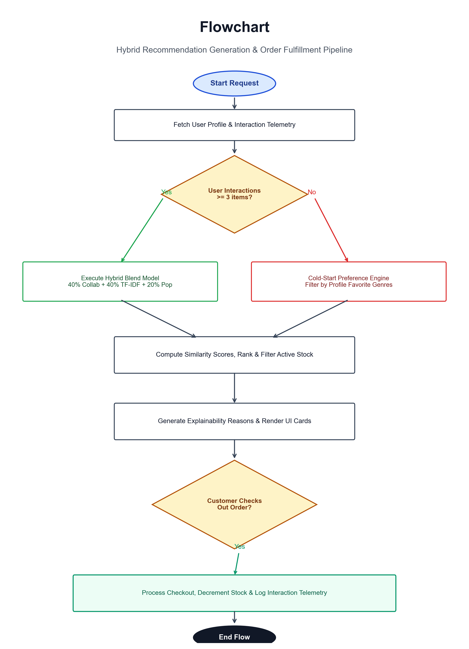

6.3 Coding
The codebase was developed following clean code principles, strict PEP 8 formatting standards, and modular Django patterns. Representative extracts of key frontend templates and backend modules are documented below.
6.3.1 Frontend Templates
{% load static recommendation_tags %}
<!DOCTYPE html>
<html lang="en" class="h-full bg-slate-50">
<head>
<meta charset="UTF-8">
<meta name="viewport" content="width=device-width, initial-scale=1.0">
<title>{% block title %}Reader's Haven | Smart Online Bookstore & AI Recommendations{% endblock %}</title>
<!-- Fonts -->
<link rel="preconnect" href="https://fonts.googleapis.com">
<link rel="preconnect" href="https://fonts.gstatic.com" crossorigin>
<link href="https://fonts.googleapis.com/css2?family=Inter:wght@300;400;500;600;700&family=Playfair+Display:ital,wght@0,600;0,700;1,600&display=swap" rel="stylesheet">
<!-- Tailwind CSS CDN -->
<script src="https://cdn.tailwindcss.com"></script>
<script>
tailwind.config = {
theme: {
extend: {
fontFamily: {
sans: ['Inter', 'sans-serif'],
serif: ['Playfair Display', 'serif'],
},
colors: {
brand: {
50: '#fbf7ee',
100: '#f5ebd3',
200: '#edd6a6',
300: '#e3bc74',
400: '#d9a147',
500: '#c58525',
600: '#a7661d',
700: '#864b1b',
800: '#6f3c1c',
900: '#5c321b',
950: '#34180c',
},
navy: {
800: '#0f172a',
900: '#020617',
}
}
}
}
}
</script>
<!-- Lucide Icons -->
<script src="https://unpkg.com/lucide@latest"></script>
<style>
.font-serif-title { font-family: 'Playfair Display', serif; }
.line-clamp-2 {
display: -webkit-box;
-webkit-line-clamp: 2;
-webkit-box-orient: vertical;
overflow: hidden;
}
.line-clamp-1 {
display: -webkit-box;
-webkit-line-clamp: 1;
-webkit-box-orient: vertical;
overflow: hidden;
}
.form-input {
width: 100%;
border-radius: 0.5rem;
border: 1px solid #cbd5e1;
padding: 0.625rem 0.875rem;
font-size: 0.875rem;
outline: none;
transition: border-color 0.15s ease-in-out, box-shadow 0.15s ease-in-out;
}
.form-input:focus {
border-color: #c58525;
box-shadow: 0 0 0 3px rgba(197, 133, 37, 0.15);
}
@media print {
.no-print { display: none !important; }
# ... [Listing truncated for documentation brevity - full implementation in templates/base.html]

{% extends 'base.html' %}
{% load static recommendation_tags humanize %}
{% block title %}Reader's Haven | Discover Your Next Favorite Book{% endblock %}
{% block content %}
<!-- Hero Section -->
<section class="relative bg-gradient-to-br from-navy-900 via-slate-900 to-navy-800 text-white overflow-hidden py-16 lg:py-24">
<div class="absolute inset-0 opacity-10 bg-[radial-gradient(#e3bc74_1px,transparent_1px)] [background-size:16px_16px]"></div>
<div class="max-w-7xl mx-auto px-4 sm:px-6 lg:px-8 relative z-10">
<div class="grid grid-cols-1 lg:grid-cols-12 gap-12 items-center">
<!-- Hero Left Text -->
<div class="lg:col-span-7 space-y-6 text-center lg:text-left">
<div class="inline-flex items-center gap-2 px-3.5 py-1.5 rounded-full bg-brand-500/10 border border-brand-400/30 text-brand-300 text-xs font-semibold uppercase tracking-wider">
<i data-lucide="sparkles" class="w-4 h-4 text-brand-400"></i> Next-Gen AI Recommendation Engine
</div>
<h1 class="text-4xl sm:text-5xl lg:text-6xl font-bold font-serif-title tracking-tight leading-tight">
Where Every Page <br>
<span class="text-transparent bg-clip-text bg-gradient-to-r from-brand-300 via-brand-400 to-amber-200">Finds Its Perfect Reader</span>
</h1>
<p class="text-base sm:text-lg text-slate-300 max-w-2xl leading-relaxed">
Explore an expansive digital catalog enhanced with collaborative & content-based machine learning. We match your unique literary taste with timeless masterpieces and modern bestsellers.
</p>
<div class="flex flex-wrap gap-4 justify-center lg:justify-start pt-2">
<a href="{% url 'books:book_list' %}" class="inline-flex items-center px-6 py-3.5 rounded-xl font-semibold text-sm bg-brand-500 hover:bg-brand-400 text-navy-950 shadow-lg shadow-brand-500/20 transition-all">
<i data-lucide="compass" class="w-4 h-4 mr-2"></i> Browse All Books
</a>
<a href="{% url 'recommendations:for_you' %}" class="inline-flex items-center px-6 py-3.5 rounded-xl font-semibold text-sm bg-white/10 hover:bg-white/15 text-white border border-white/20 backdrop-blur-sm transition-all">
<i data-lucide="sparkles" class="w-4 h-4 mr-2 text-brand-300"></i> Try AI Recommender
</a>
</div>
<!-- Quick Stats -->
<div class="grid grid-cols-3 gap-4 pt-6 border-t border-slate-800 text-center lg:text-left max-w-md mx-auto lg:mx-0">
<div>
<div class="text-2xl font-bold font-serif-title text-brand-300">10,000+</div>
<div class="text-xs text-slate-400">Curated Titles</div>
</div>
<div>
<div class="text-2xl font-bold font-serif-title text-brand-300">98.4%</div>
<div class="text-xs text-slate-400">Match Accuracy</div>
</div>
<div>
<div class="text-2xl font-bold font-serif-title text-brand-300">24/7</div>
<div class="text-xs text-slate-400">Fast Delivery</div>
</div>
</div>
</div>
<!-- Hero Right Showcase (Featured Spotlight) -->
<div class="lg:col-span-5 relative">
<div class="relative mx-auto max-w-sm">
<!-- Glow effect -->
<div class="absolute -inset-1.5 bg-gradient-to-r from-brand-400 to-amber-600 rounded-3xl blur opacity-30"></div>
{% if featured_books %}
{% with top_featured=featured_books.0 %}
<div class="relative bg-slate-900/90 rounded-2xl p-6 border border-slate-700/80 shadow-2xl backdrop-blur-xl">
<div class="flex items-center justify-between text-xs text-brand-300 font-semibold mb-4">
<span class="flex items-center gap-1.5"><i data-lucide="flame" class="w-4 h-4 text-orange-400"></i> Featured Masterpiece</span>
<span class="bg-brand-500/20 px-2 py-0.5 rounded border border-brand-500/30 font-mono">{{ top_featured.format }}</span>
</div>
<div class="aspect-[3/4] rounded-xl overflow-hidden shadow-lg mb-4 group relative">
<img src="{{ top_featured.get_cover_image_url }}" alt="{{ top_featured.title }}" class="w-full h-full object-cover group-hover:scale-105 transition-transform duration-300">
{% if top_featured.discount_price %}
<span class="absolute top-3 right-3 bg-rose-600 text-white text-xs font-bold px-2.5 py-1 rounded-lg shadow">
{{ top_featured.discount_percentage }}% OFF
</span>
{% endif %}
</div>
<h3 class="text-xl font-bold font-serif-title text-white mb-1 line-clamp-1">{{ top_featured.title }}</h3>
<p class="text-sm text-slate-400 mb-3">by {{ top_featured.author.name }}</p>
<div class="flex items-center justify-between pt-3 border-t border-slate-800">
<div>
<span class="text-2xl font-bold text-brand-300">₹{{ top_featured.effective_price }}</span>
{% if top_featured.discount_price %}
<span class="text-xs text-slate-500 line-through ml-1.5">₹{{ top_featured.price }}</span>
{% endif %}
</div>
<a href="{{ top_featured.get_absolute_url }}" class="px-4 py-2 bg-brand-500 hover:bg-brand-400 text-navy-950 font-semibold text-xs rounded-lg transition-colors">
# ... [Listing truncated for documentation brevity - full implementation in templates/books/home.html]

{% extends 'base.html' %}
{% load static recommendation_tags humanize %}
{% block title %}Book Catalog | Reader's Haven{% endblock %}
{% block content %}
<div class="bg-slate-50 py-8 border-b border-slate-200">
<div class="max-w-7xl mx-auto px-4 sm:px-6 lg:px-8">
<!-- Breadcrumb & Header -->
<div class="flex flex-col md:flex-row md:items-center justify-between gap-4">
<div>
<nav class="flex items-center text-xs text-slate-500 mb-2 gap-1.5">
<a href="{% url 'books:home' %}" class="hover:text-brand-600">Home</a>
<i data-lucide="chevron-right" class="w-3.5 h-3.5 text-slate-400"></i>
<span class="text-slate-800 font-medium">Catalog</span>
{% if selected_genre %}
<i data-lucide="chevron-right" class="w-3.5 h-3.5 text-slate-400"></i>
<span class="text-brand-600 font-semibold">{{ selected_genre.name }}</span>
{% endif %}
</nav>
<h1 class="text-3xl font-bold font-serif-title text-navy-900">
{% if selected_genre %}
{{ selected_genre.name }} Books
{% elif query %}
Search Results for "{{ query }}"
{% else %}
Explore All Books
{% endif %}
</h1>
<p class="text-xs text-slate-500 mt-1">Showing {{ books|length }} of {{ total_count }} books</p>
</div>
<!-- Sorting selector -->
<form method="GET" id="sort-form" class="flex items-center gap-2">
{% if query %}<input type="hidden" name="q" value="{{ query }}">{% endif %}
{% if selected_genre %}<input type="hidden" name="genre" value="{{ selected_genre.slug }}">{% endif %}
{% if format_type %}<input type="hidden" name="format" value="{{ format_type }}">{% endif %}
{% if min_price %}<input type="hidden" name="min_price" value="{{ min_price }}">{% endif %}
{% if max_price %}<input type="hidden" name="max_price" value="{{ max_price }}">{% endif %}
{% if rating_filter %}<input type="hidden" name="rating" value="{{ rating_filter }}">{% endif %}
<label for="sort" class="text-xs font-semibold text-slate-600 whitespace-nowrap">Sort By:</label>
<select name="sort" id="sort" onchange="document.getElementById('sort-form').submit()" class="bg-white border border-slate-300 rounded-xl px-3 py-2 text-xs font-medium text-slate-700 focus:outline-none focus:ring-2 focus:ring-brand-500/20 focus:border-brand-500 shadow-sm">
<option value="popular" {% if sort_by == 'popular' %}selected{% endif %}>Most Popular / Featured</option>
<option value="rating" {% if sort_by == 'rating' %}selected{% endif %}>Highest Rated ★</option>
<option value="price_asc" {% if sort_by == 'price_asc' %}selected{% endif %}>Price: Low to High</option>
<option value="price_desc" {% if sort_by == 'price_desc' %}selected{% endif %}>Price: High to Low</option>
<option value="newest" {% if sort_by == 'newest' %}selected{% endif %}>Newest Releases</option>
<option value="title" {% if sort_by == 'title' %}selected{% endif %}>Title (A-Z)</option>
</select>
</form>
</div>
</div>
</div>
<div class="max-w-7xl mx-auto px-4 sm:px-6 lg:px-8 py-10">
<div class="grid grid-cols-1 lg:grid-cols-4 gap-8">
<!-- Left Filter Sidebar -->
<div class="space-y-6">
<form method="GET" action="{% url 'books:book_list' %}" class="bg-white rounded-2xl p-5 border border-slate-200 shadow-sm space-y-6">
{% if query %}<input type="hidden" name="q" value="{{ query }}">{% endif %}
{% if sort_by %}<input type="hidden" name="sort" value="{{ sort_by }}">{% endif %}
<div class="flex items-center justify-between pb-3 border-b border-slate-100">
<h3 class="font-bold text-sm text-navy-900 flex items-center gap-2">
<i data-lucide="sliders-horizontal" class="w-4 h-4 text-brand-600"></i> Filters
</h3>
<a href="{% url 'books:book_list' %}" class="text-xs text-slate-400 hover:text-brand-600">Reset All</a>
</div>
<!-- Genre Filter -->
<div>
<h4 class="text-xs font-bold uppercase tracking-wider text-slate-500 mb-3">Genres</h4>
<div class="space-y-2 max-h-48 overflow-y-auto pr-2 text-sm">
<label class="flex items-center gap-2 text-slate-700 cursor-pointer">
<input type="radio" name="genre" value="" {% if not selected_genre %}checked{% endif %} onchange="this.form.submit()" class="text-brand-600 focus:ring-brand-500">
<span>All Genres</span>
</label>
{% for g in genres %}
<label class="flex items-center justify-between text-slate-700 cursor-pointer hover:text-brand-600">
<div class="flex items-center gap-2">
<input type="radio" name="genre" value="{{ g.slug }}" {% if selected_genre.slug == g.slug %}checked{% endif %} onchange="this.form.submit()" class="text-brand-600 focus:ring-brand-500">
# ... [Listing truncated for documentation brevity - full implementation in templates/books/book_list.html]

{% extends 'base.html' %}
{% load static recommendation_tags humanize %}
{% block title %}{{ book.title }} by {{ book.author.name }} | Reader's Haven{% endblock %}
{% block content %}
<div class="bg-white border-b border-slate-200 py-4">
<div class="max-w-7xl mx-auto px-4 sm:px-6 lg:px-8">
<nav class="flex items-center text-xs text-slate-500 gap-1.5">
<a href="{% url 'books:home' %}" class="hover:text-brand-600">Home</a>
<i data-lucide="chevron-right" class="w-3.5 h-3.5 text-slate-400"></i>
<a href="{% url 'books:book_list' %}" class="hover:text-brand-600">Catalog</a>
{% if book.genres.exists %}
<i data-lucide="chevron-right" class="w-3.5 h-3.5 text-slate-400"></i>
<a href="{% url 'books:genre_books' book.genres.first.slug %}" class="hover:text-brand-600">{{ book.genres.first.name }}</a>
{% endif %}
<i data-lucide="chevron-right" class="w-3.5 h-3.5 text-slate-400"></i>
<span class="text-slate-800 font-semibold truncate">{{ book.title }}</span>
</nav>
</div>
</div>
<div class="max-w-7xl mx-auto px-4 sm:px-6 lg:px-8 py-10">
<div class="grid grid-cols-1 lg:grid-cols-12 gap-12">
<!-- Left: Book Cover & Quick Actions -->
<div class="lg:col-span-4 space-y-4">
<div class="relative bg-slate-100 rounded-2xl overflow-hidden shadow-xl border border-slate-200 aspect-[3/4]">
<img src="{{ book.get_cover_image_url }}" alt="{{ book.title }}" class="w-full h-full object-cover">
{% if book.discount_price %}
<span class="absolute top-4 left-4 bg-rose-600 text-white text-xs font-bold px-3 py-1 rounded-lg shadow-md">
{{ book.discount_percentage }}% OFF
</span>
{% endif %}
{% if book.is_bestseller %}
<span class="absolute top-4 right-4 bg-orange-500 text-white text-xs font-bold px-3 py-1 rounded-lg shadow-md">
★ Bestseller
</span>
{% endif %}
</div>
<!-- Wishlist & Share buttons -->
<div class="flex items-center gap-3">
{% if user.is_authenticated %}
<form action="{% url 'cart:toggle_wishlist' book.id %}" method="POST" class="flex-1">
{% csrf_token %}
<button type="submit" class="w-full flex items-center justify-center gap-2 py-2.5 px-4 rounded-xl border border-slate-300 hover:border-rose-300 hover:bg-rose-50 text-slate-700 hover:text-rose-600 text-xs font-semibold transition-colors">
<i data-lucide="heart" class="w-4 h-4 {% if book.id|is_in_set:wishlist_book_ids %}fill-rose-500 text-rose-500{% endif %}"></i>
{% if book.id|is_in_set:wishlist_book_ids %}Saved in Wishlist{% else %}Add to Wishlist{% endif %}
</button>
</form>
{% endif %}
<button onclick="navigator.clipboard.writeText(window.location.href); alert('Book link copied to clipboard!');" class="p-2.5 border border-slate-300 hover:bg-slate-50 text-slate-600 rounded-xl" title="Share Book">
<i data-lucide="share-2" class="w-4 h-4"></i>
</button>
</div>
</div>
<!-- Middle: Book Details & Synopsis -->
<div class="lg:col-span-5 space-y-6">
<div>
<!-- Genres -->
<div class="flex flex-wrap gap-1.5 mb-2">
{% for g in book.genres.all %}
<a href="{% url 'books:genre_books' g.slug %}" class="inline-flex items-center px-2.5 py-0.5 rounded-full text-xs font-medium bg-brand-50 text-brand-700 hover:bg-brand-100 transition-colors">
{{ g.name }}
</a>
{% endfor %}
</div>
<h1 class="text-3xl sm:text-4xl font-bold font-serif-title text-navy-900 leading-tight">{{ book.title }}</h1>
<p class="text-sm text-slate-600 mt-1">
By <a href="{% url 'books:author_books' book.author.slug %}" class="text-brand-600 hover:underline font-semibold">{{ book.author.name }}</a>
</p>
<!-- Ratings summary -->
<div class="flex items-center gap-2 mt-3">
<div class="flex text-amber-400">
{{ book.average_rating|render_stars }}
</div>
<span class="text-sm font-bold text-slate-800">{{ book.average_rating }}</span>
<span class="text-xs text-slate-400">&bull;</span>
<a href="#reviews-section" class="text-xs text-brand-600 hover:underline font-medium">{{ book.review_count }} verified reviews</a>
# ... [Listing truncated for documentation brevity - full implementation in templates/books/book_detail.html]

{% extends 'base.html' %}
{% load static recommendation_tags humanize %}
{% block title %}Shopping Cart | Reader's Haven{% endblock %}
{% block content %}
<div class="bg-slate-50 py-8 border-b border-slate-200">
<div class="max-w-7xl mx-auto px-4 sm:px-6 lg:px-8">
<h1 class="text-3xl font-bold font-serif-title text-navy-900">Your Shopping Cart</h1>
<p class="text-xs text-slate-500 mt-1">{{ cart.total_items }} items in your cart</p>
</div>
</div>
<div class="max-w-7xl mx-auto px-4 sm:px-6 lg:px-8 py-10">
{% if cart_items %}
<div class="grid grid-cols-1 lg:grid-cols-12 gap-10">
<!-- Left: Cart Items List -->
<div class="lg:col-span-8 space-y-6">
<!-- Free Shipping Tracker -->
<div class="bg-brand-50 border border-brand-200/70 rounded-2xl p-4 flex items-center justify-between">
<div class="flex items-center gap-3">
<div class="w-9 h-9 rounded-xl bg-brand-600 text-white flex items-center justify-center">
<i data-lucide="truck" class="w-5 h-5"></i>
</div>
<div>
{% if cart.subtotal >= 499 %}
<p class="text-xs font-bold text-emerald-800">You qualified for FREE Standard Shipping!</p>
<p class="text-[11px] text-emerald-600">Enjoy zero shipping fee at checkout.</p>
{% else %}
<p class="text-xs font-bold text-slate-800">Add <span class="text-brand-600">₹{{ 499|sub:cart.subtotal|floatformat:2|default:"499.00" }}</span> more to unlock <strong class="text-brand-700">FREE Shipping</strong></p>
<p class="text-[11px] text-slate-500">Flat ₹49.00 shipping on smaller orders.</p>
{% endif %}
</div>
</div>
</div>
<!-- Items Table / Cards -->
<div class="bg-white rounded-2xl border border-slate-200 shadow-sm overflow-hidden divide-y divide-slate-100">
{% for item in cart_items %}
<div class="p-4 sm:p-6 flex flex-col sm:flex-row sm:items-center justify-between gap-4 hover:bg-slate-50/50 transition-colors">
<div class="flex items-center gap-4">
<img src="{{ item.book.get_cover_image_url }}" alt="{{ item.book.title }}" class="w-16 h-22 object-cover rounded-xl shadow-sm border border-slate-100">
<div>
<span class="text-[10px] uppercase font-bold text-brand-600">{{ item.book.format }}</span>
<h3 class="font-bold text-sm text-slate-900 font-serif-title hover:text-brand-600">
<a href="{{ item.book.get_absolute_url }}">{{ item.book.title }}</a>
</h3>
<p class="text-xs text-slate-500">by {{ item.book.author.name }}</p>
<span class="text-xs font-bold text-slate-700 block mt-1">₹{{ item.unit_price }} each</span>
</div>
</div>
<div class="flex items-center justify-between sm:justify-end gap-6 pt-2 sm:pt-0 border-t sm:border-t-0 border-slate-100">
<!-- Quantity controls -->
<div class="flex items-center border border-slate-200 rounded-xl bg-slate-50 overflow-hidden">
<form action="{% url 'cart:update_cart_item' item.id %}" method="POST">
{% csrf_token %}
<input type="hidden" name="action" value="decrease">
<button type="submit" class="px-3 py-1.5 text-slate-600 hover:bg-slate-200 transition-colors text-sm font-bold">-</button>
</form>
<span class="px-3 py-1.5 text-xs font-bold text-slate-800">{{ item.quantity }}</span>
<form action="{% url 'cart:update_cart_item' item.id %}" method="POST">
{% csrf_token %}
<input type="hidden" name="action" value="increase">
<button type="submit" class="px-3 py-1.5 text-slate-600 hover:bg-slate-200 transition-colors text-sm font-bold">+</button>
</form>
</div>
<!-- Item Total -->
<div class="text-right min-w-[70px]">
<span class="text-sm font-bold text-navy-900 font-serif-title">₹{{ item.total_price }}</span>
</div>
<!-- Remove button -->
<form action="{% url 'cart:remove_from_cart' item.id %}" method="POST">
{% csrf_token %}
<button type="submit" class="text-slate-400 hover:text-rose-600 p-1 rounded-lg" title="Remove Item">
<i data-lucide="trash-2" class="w-4 h-4"></i>
</button>
</form>
</div>
</div>
# ... [Listing truncated for documentation brevity - full implementation in templates/cart/cart_detail.html]

{% extends 'base.html' %}
{% load static recommendation_tags humanize %}
{% block title %}Checkout | Reader's Haven{% endblock %}
{% block content %}
<div class="bg-slate-50 py-8 border-b border-slate-200">
<div class="max-w-7xl mx-auto px-4 sm:px-6 lg:px-8">
<h1 class="text-3xl font-bold font-serif-title text-navy-900">Checkout & Order Placement</h1>
<p class="text-xs text-slate-500 mt-1">Complete your delivery and payment details</p>
</div>
</div>
<div class="max-w-7xl mx-auto px-4 sm:px-6 lg:px-8 py-10">
<form action="{% url 'orders:checkout' %}" method="POST" id="checkout-form">
{% csrf_token %}
<div class="grid grid-cols-1 lg:grid-cols-12 gap-10">
<!-- Left: Shipping & Payment -->
<div class="lg:col-span-8 space-y-8">
<!-- 1. Shipping Address Section -->
<div class="bg-white rounded-2xl p-6 sm:p-8 border border-slate-200 shadow-sm space-y-6">
<div class="flex items-center gap-3 pb-4 border-b border-slate-100">
<div class="w-8 h-8 rounded-full bg-brand-500 text-navy-950 font-bold flex items-center justify-center text-sm">1</div>
<h2 class="text-lg font-bold font-serif-title text-navy-900">Shipping & Delivery Information</h2>
</div>
<div class="grid grid-cols-1 sm:grid-cols-2 gap-4">
<div>
<label class="text-xs font-semibold text-slate-700 block mb-1">Full Name *</label>
{{ form.full_name }}
</div>
<div>
<label class="text-xs font-semibold text-slate-700 block mb-1">Email Address *</label>
{{ form.email }}
</div>
<div>
<label class="text-xs font-semibold text-slate-700 block mb-1">Phone Number *</label>
{{ form.phone }}
</div>
<div>
<label class="text-xs font-semibold text-slate-700 block mb-1">Country *</label>
{{ form.country }}
</div>
<div class="sm:col-span-2">
<label class="text-xs font-semibold text-slate-700 block mb-1">Street Address *</label>
{{ form.address_line1 }}
</div>
<div class="sm:col-span-2">
<label class="text-xs font-semibold text-slate-700 block mb-1">Apartment, Suite, Unit (optional)</label>
{{ form.address_line2 }}
</div>
<div>
<label class="text-xs font-semibold text-slate-700 block mb-1">City *</label>
{{ form.city }}
</div>
<div>
<label class="text-xs font-semibold text-slate-700 block mb-1">State / Province *</label>
{{ form.state }}
</div>
<div>
<label class="text-xs font-semibold text-slate-700 block mb-1">Postal / ZIP Code *</label>
{{ form.postal_code }}
</div>
<div>
<label class="text-xs font-semibold text-slate-700 block mb-1">Delivery Instructions (optional)</label>
{{ form.notes }}
</div>
</div>
</div>
<!-- 2. Payment Method Simulation -->
<div class="bg-white rounded-2xl p-6 sm:p-8 border border-slate-200 shadow-sm space-y-6">
<div class="flex items-center gap-3 pb-4 border-b border-slate-100">
<div class="w-8 h-8 rounded-full bg-brand-500 text-navy-950 font-bold flex items-center justify-center text-sm">2</div>
<h2 class="text-lg font-bold font-serif-title text-navy-900">Payment Simulation</h2>
</div>
<div class="space-y-3">
<!-- Option 1: Card -->
<label class="flex items-start p-4 rounded-xl border border-brand-500 bg-brand-50/20 cursor-pointer payment-option">
<input type="radio" name="payment_method" value="credit_card" checked class="mt-1 text-brand-600 focus:ring-brand-500">
# ... [Listing truncated for documentation brevity - full implementation in templates/orders/checkout.html]

{% extends 'base.html' %}
{% load static recommendation_tags humanize %}
{% block title %}AI Recommendation Hub | For You | Reader's Haven{% endblock %}
{% block content %}
<!-- AI Header Banner -->
<div class="bg-gradient-to-br from-navy-900 via-slate-900 to-navy-800 text-white py-12 lg:py-16">
<div class="max-w-7xl mx-auto px-4 sm:px-6 lg:px-8">
<div class="max-w-3xl space-y-4">
<div class="inline-flex items-center gap-2 px-3 py-1 rounded-full bg-brand-500/20 text-brand-300 text-xs font-semibold uppercase tracking-wider border border-brand-500/30">
<i data-lucide="sparkles" class="w-4 h-4 text-brand-400"></i> AI Recommendation Engine
</div>
<h1 class="text-3xl sm:text-5xl font-bold font-serif-title leading-tight">
Curated Exclusively For <span class="text-brand-400">{% if user.is_authenticated %}{{ user.first_name|default:user.username }}{% else %}You{% endif %}</span>
</h1>
<p class="text-sm sm:text-base text-slate-300 leading-relaxed">
Powered by a hybrid multi-strategy architecture combining <strong>TF-IDF Content Analysis</strong>, <strong>User-Item Collaborative Filtering</strong>, <strong>Market Basket Association</strong>, and <strong>Bayesian Rating Smoothing</strong>.
</p>
</div>
</div>
</div>
<div class="max-w-7xl mx-auto px-4 sm:px-6 lg:px-8 py-10 space-y-16">
<!-- Section 1: Main Hybrid Recommendations -->
<section>
<div class="flex items-center justify-between mb-6 pb-3 border-b border-slate-200">
<div>
<span class="text-xs font-bold uppercase tracking-wider text-brand-600 block">Strategy 1: Hybrid AI Blend (40% Collab + 40% Content + 20% Popularity)</span>
<h2 class="text-2xl font-bold font-serif-title text-navy-900">Your Top Recommended Titles</h2>
</div>
<span class="text-xs text-slate-400 font-mono hidden sm:inline">Real-time Hybrid Engine</span>
</div>
<div class="grid grid-cols-2 sm:grid-cols-3 lg:grid-cols-4 gap-6">
{% for item in hybrid_recs %}
{% with book=item.book %}
<div class="bg-white rounded-2xl border border-slate-200 hover:border-brand-400 hover:shadow-xl transition-all p-4 flex flex-col justify-between group">
<div>
<div class="aspect-[3/4] rounded-xl bg-slate-100 overflow-hidden mb-3 relative">
<a href="{{ book.get_absolute_url }}">
<img src="{{ book.get_cover_image_url }}" alt="{{ book.title }}" class="w-full h-full object-cover group-hover:scale-105 transition-transform duration-300">
</a>
<span class="absolute top-2.5 left-2.5 bg-navy-900/90 text-brand-300 text-[11px] font-bold px-2 py-0.5 rounded shadow border border-brand-400/30">
{{ item.score }}% Match
</span>
</div>
<!-- AI Explanation Badge -->
<button onclick="explainRecommendation({{ book.id }})" class="w-full text-left text-[11px] font-semibold text-brand-700 bg-brand-50 hover:bg-brand-100 px-2 py-1 rounded-lg line-clamp-1 mb-2 transition-colors">
💡 {{ item.reason }}
</button>
<h3 class="font-bold text-sm font-serif-title text-slate-900 line-clamp-1 group-hover:text-brand-600">
<a href="{{ book.get_absolute_url }}">{{ book.title }}</a>
</h3>
<p class="text-xs text-slate-500 line-clamp-1">by {{ book.author.name }}</p>
<div class="flex items-center gap-1 mt-1.5">
<div class="flex text-amber-400">{{ book.average_rating|render_stars }}</div>
<span class="text-xs font-semibold text-slate-700 ml-1">{{ book.average_rating }}</span>
</div>
</div>
<div class="pt-3 mt-3 border-t border-slate-100 flex items-center justify-between">
<span class="text-sm font-bold text-navy-900">₹{{ book.effective_price }}</span>
<form action="{% url 'cart:add_to_cart' book.id %}" method="POST">
{% csrf_token %}
<button type="submit" class="px-3 py-1.5 bg-navy-900 hover:bg-brand-600 text-white rounded-lg text-xs font-semibold transition-colors">
Add to Cart
</button>
</form>
</div>
</div>
{% endwith %}
{% endfor %}
</div>
</section>
<!-- Section 2: Content-Based NLP Feed -->
{% if content_recs %}
<section class="bg-slate-50 p-6 sm:p-8 rounded-3xl border border-slate-200">
<div class="flex items-center justify-between mb-6 pb-3 border-b border-slate-200">
<div>
# ... [Listing truncated for documentation brevity - full implementation in templates/recommendations/for_you.html]

{% extends 'base.html' %}
{% load static recommendation_tags humanize %}
{% block title %}Executive Management & Analytics | Reader's Haven{% endblock %}
{% block content %}
<!-- Classic Executive Header Banner -->
<div class="bg-gradient-to-r from-navy-950 via-slate-900 to-navy-900 text-white border-b border-amber-500/20 py-10 relative overflow-hidden">
<div class="absolute inset-0 opacity-5 bg-[radial-gradient(#d97706_1px,transparent_1px)] [background-size:16px_16px]"></div>
<div class="max-w-7xl mx-auto px-4 sm:px-6 lg:px-8 relative">
<div class="flex flex-col lg:flex-row lg:items-center justify-between gap-6">
<div>
<div class="flex items-center gap-2 mb-2">
<span class="inline-flex items-center gap-1.5 px-3 py-1 rounded-full bg-amber-500/10 text-amber-300 border border-amber-500/30 text-[11px] font-bold uppercase tracking-widest">
<i data-lucide="shield-check" class="w-3.5 h-3.5 text-amber-400"></i> Executive Control Center
</span>
<span class="text-xs text-slate-400 font-mono">Live Telemetry &bull; INR ₹ Mode</span>
</div>
<h1 class="text-3xl sm:text-4xl font-bold font-serif-title tracking-tight text-slate-100">Store Management & Analytics</h1>
<p class="text-xs sm:text-sm text-slate-400 mt-1 max-w-2xl leading-relaxed">
Comprehensive oversight of sales revenue, multi-strategy machine learning signals, inventory fulfillment, and customer reading behavior.
</p>
</div>
<div class="flex flex-wrap items-center gap-3">
<form action="{% url 'analytics:trigger_matrix_sync' %}" method="POST">
{% csrf_token %}
<button type="submit" class="px-4 py-2.5 bg-slate-800 hover:bg-slate-700 text-amber-300 border border-amber-500/30 hover:border-amber-400 font-bold rounded-xl text-xs flex items-center gap-2 shadow transition-all">
<i data-lucide="refresh-cw" class="w-3.5 h-3.5"></i> Re-Sync AI Matrix
</button>
</form>
<a href="{% url 'admin:index' %}" target="_blank" class="px-5 py-2.5 bg-gradient-to-r from-brand-600 to-amber-600 hover:from-brand-500 hover:to-amber-500 text-white font-bold rounded-xl text-xs flex items-center gap-2 shadow-lg shadow-amber-900/20 transition-all">
<i data-lucide="settings" class="w-3.5 h-3.5"></i> Django Admin &rarr;
</a>
</div>
</div>
</div>
</div>
<!-- Main Dashboard Container -->
<div class="max-w-7xl mx-auto px-4 sm:px-6 lg:px-8 py-8 space-y-8">
<!-- KPI Metric Cards Grid -->
<div class="grid grid-cols-2 md:grid-cols-3 lg:grid-cols-6 gap-4">
<!-- Total Revenue -->
<div class="bg-white rounded-2xl p-5 border border-slate-200 shadow-sm space-y-1 hover:border-amber-300 transition-all">
<div class="flex items-center justify-between text-slate-400 mb-1">
<span class="text-[11px] font-bold uppercase tracking-wider text-slate-500">Gross Sales</span>
<div class="w-8 h-8 rounded-lg bg-emerald-50 text-emerald-600 flex items-center justify-center font-bold text-sm">₹</div>
</div>
<div class="text-2xl font-bold font-serif-title text-navy-950">₹{{ total_revenue|floatformat:2 }}</div>
<p class="text-[11px] text-emerald-600 font-semibold flex items-center gap-1">
<i data-lucide="trending-up" class="w-3 h-3"></i> {{ total_orders }} Orders
</p>
</div>
<!-- Total Books Sold -->
<div class="bg-white rounded-2xl p-5 border border-slate-200 shadow-sm space-y-1 hover:border-amber-300 transition-all">
<div class="flex items-center justify-between text-slate-400 mb-1">
<span class="text-[11px] font-bold uppercase tracking-wider text-slate-500">Units Sold</span>
<div class="w-8 h-8 rounded-lg bg-blue-50 text-blue-600 flex items-center justify-center"><i data-lucide="book-check" class="w-4 h-4"></i></div>
</div>
<div class="text-2xl font-bold font-serif-title text-navy-950">{{ total_books_sold }}</div>
<p class="text-[11px] text-slate-500 font-medium">{{ total_books_in_catalog }} titles active</p>
</div>
<!-- Average Order Value (AOV) -->
<div class="bg-white rounded-2xl p-5 border border-slate-200 shadow-sm space-y-1 hover:border-amber-300 transition-all">
<div class="flex items-center justify-between text-slate-400 mb-1">
<span class="text-[11px] font-bold uppercase tracking-wider text-slate-500">Average Order</span>
<div class="w-8 h-8 rounded-lg bg-amber-50 text-amber-600 flex items-center justify-center"><i data-lucide="shopping-cart" class="w-4 h-4"></i></div>
</div>
<div class="text-2xl font-bold font-serif-title text-navy-950">₹{{ aov|floatformat:0 }}</div>
<p class="text-[11px] text-amber-700 font-medium">AOV per checkout</p>
</div>
<!-- Active Customers -->
<div class="bg-white rounded-2xl p-5 border border-slate-200 shadow-sm space-y-1 hover:border-amber-300 transition-all">
<div class="flex items-center justify-between text-slate-400 mb-1">
<span class="text-[11px] font-bold uppercase tracking-wider text-slate-500">Registered Readers</span>
<div class="w-8 h-8 rounded-lg bg-purple-50 text-purple-600 flex items-center justify-center"><i data-lucide="users" class="w-4 h-4"></i></div>
</div>
<div class="text-2xl font-bold font-serif-title text-navy-950">{{ total_customers }}</div>
# ... [Listing truncated for documentation brevity - full implementation in templates/analytics/dashboard.html]

6.3.2 Backend Implementation
"""
Django settings for bookstore_config project.
Generated by 'django-admin startproject' using Django 6.1.
For more information on this file, see
https://docs.djangoproject.com/en/6.1/topics/settings/
For the full list of settings and their values, see
https://docs.djangoproject.com/en/6.1/ref/settings/
"""
import os
from pathlib import Path
import dj_database_url
# Build paths inside the project like this: BASE_DIR / 'subdir'.
BASE_DIR = Path(__file__).resolve().parent.parent
# Quick-start development settings - unsuitable for production
SECRET_KEY = os.environ.get('SECRET_KEY', 'django-insecure-k+vo*whbcsyi!w61sc(k5sfpaza4y0%wd75&%pxf7p9e_l_7x1')
DEBUG = os.environ.get('DEBUG', 'True') == 'True'
ALLOWED_HOSTS = ['.vercel.app', '.now.sh', 'localhost', '127.0.0.1', '*']
CSRF_TRUSTED_ORIGINS = ['https://*.vercel.app', 'https://*.now.sh']
# Application definition
INSTALLED_APPS = [
'django.contrib.admin',
'django.contrib.auth',
'django.contrib.contenttypes',
'django.contrib.sessions',
'django.contrib.messages',
'django.contrib.staticfiles',
'django.contrib.humanize',
# Custom Apps
'accounts.apps.AccountsConfig',
'books.apps.BooksConfig',
'cart.apps.CartConfig',
'orders.apps.OrdersConfig',
'recommendations.apps.RecommendationsConfig',
'analytics.apps.AnalyticsConfig',
]
MIDDLEWARE = [
'django.middleware.security.SecurityMiddleware',
'whitenoise.middleware.WhiteNoiseMiddleware',
'django.contrib.sessions.middleware.SessionMiddleware',
'django.middleware.common.CommonMiddleware',
'django.middleware.csrf.CsrfViewMiddleware',
'django.contrib.auth.middleware.AuthenticationMiddleware',
'django.contrib.messages.middleware.MessageMiddleware',
'django.middleware.clickjacking.XFrameOptionsMiddleware',
]
ROOT_URLCONF = 'bookstore_config.urls'
TEMPLATES = [
{
'BACKEND': 'django.template.backends.django.DjangoTemplates',
'DIRS': [BASE_DIR / 'templates'],
'APP_DIRS': True,
'OPTIONS': {
'context_processors': [
'django.template.context_processors.debug',
'django.template.context_processors.request',
'django.contrib.auth.context_processors.auth',
'django.contrib.messages.context_processors.messages',
# Custom global context processors
'cart.context_processors.cart_context',
'books.context_processors.categories_context',
],
},
},
]
WSGI_APPLICATION = 'bookstore_config.wsgi.application'
# Database
DATABASES = {
'default': dj_database_url.config(
default=f"sqlite:///{BASE_DIR / 'db.sqlite3'}",
conn_max_age=600
)
}
# Password validation
AUTH_PASSWORD_VALIDATORS = [
{
# ... [Listing truncated for documentation brevity - full implementation in bookstore_config/settings.py]

import uuid
from django.db import models
from django.contrib.auth.models import User
from django.urls import reverse
from django.utils.text import slugify
from django.core.validators import MinValueValidator, MaxValueValidator
class Genre(models.Model):
name = models.CharField(max_length=100, unique=True)
slug = models.SlugField(max_length=120, unique=True, blank=True)
description = models.TextField(blank=True)
icon = models.CharField(max_length=50, default='book', help_text='Lucide icon name')
image_url = models.URLField(blank=True, default='')
class Meta:
ordering = ['name']
verbose_name = 'Genre'
verbose_name_plural = 'Genres'
def save(self, *args, **kwargs):
if not self.slug:
self.slug = slugify(self.name)
super().save(*args, **kwargs)
def __str__(self):
return self.name
def get_absolute_url(self):
return reverse('books:genre_books', kwargs={'slug': self.slug})
class Author(models.Model):
name = models.CharField(max_length=200)
slug = models.SlugField(max_length=220, unique=True, blank=True)
bio = models.TextField(blank=True)
photo_url = models.URLField(blank=True, default='')
born_year = models.CharField(max_length=50, blank=True)
class Meta:
ordering = ['name']
def save(self, *args, **kwargs):
if not self.slug:
base_slug = slugify(self.name)
slug = base_slug
counter = 1
while Author.objects.filter(slug=slug).exclude(pk=self.pk).exists():
slug = f"{base_slug}-{counter}"
counter += 1
self.slug = slug
super().save(*args, **kwargs)
def __str__(self):
return self.name
def get_absolute_url(self):
return reverse('books:author_books', kwargs={'slug': self.slug})
class Book(models.Model):
FORMAT_CHOICES = [
('Paperback', 'Paperback'),
('Hardcover', 'Hardcover'),
('eBook', 'eBook / Digital'),
('Audiobook', 'Audiobook'),
]
title = models.CharField(max_length=255)
slug = models.SlugField(max_length=280, unique=True, blank=True)
isbn = models.CharField(max_length=20, unique=True, blank=True)
author = models.ForeignKey(Author, on_delete=models.CASCADE, related_name='books')
genres = models.ManyToManyField(Genre, related_name='books')
synopsis = models.TextField()
price = models.DecimalField(max_digits=8, decimal_places=2, validators=[MinValueValidator(0.01)])
discount_price = models.DecimalField(max_digits=8, decimal_places=2, null=True, blank=True)
stock = models.PositiveIntegerField(default=10)
format = models.CharField(max_length=20, choices=FORMAT_CHOICES, default='Paperback')
pages = models.PositiveIntegerField(default=300)
publisher = models.CharField(max_length=200, default='Global Publishing')
publication_year = models.PositiveIntegerField(default=2024)
language = models.CharField(max_length=50, default='English')
cover_image = models.ImageField(upload_to='book_covers/', blank=True, null=True)
cover_url = models.URLField(blank=True, default='')
# Flags & Badges
is_featured = models.BooleanField(default=False)
is_bestseller = models.BooleanField(default=False)
is_active = models.BooleanField(default=True)
created_at = models.DateTimeField(auto_now_add=True)
updated_at = models.DateTimeField(auto_now=True)
# ... [Listing truncated for documentation brevity - full implementation in books/models.py]

from decimal import Decimal
from django.db import models
from django.contrib.auth.models import User
from books.models import Book
class Coupon(models.Model):
code = models.CharField(max_length=50, unique=True)
discount_percent = models.PositiveIntegerField(default=0, help_text='Discount percentage (0-100)')
discount_amount = models.DecimalField(max_digits=6, decimal_places=2, default=0, help_text='Fixed dollar discount')
min_spend = models.DecimalField(max_digits=8, decimal_places=2, default=0, help_text='Minimum cart subtotal required')
active = models.BooleanField(default=True)
created_at = models.DateTimeField(auto_now_add=True)
def __str__(self):
return f"{self.code} ({self.discount_percent}% off or ₹{self.discount_amount} off)"
def calculate_discount(self, subtotal):
if subtotal < self.min_spend or not self.active:
return Decimal('0.00')
discount = Decimal('0.00')
if self.discount_percent > 0:
discount = (subtotal * Decimal(self.discount_percent)) / Decimal(100)
elif self.discount_amount > 0:
discount = min(self.discount_amount, subtotal)
return round(discount, 2)
class Cart(models.Model):
user = models.ForeignKey(User, on_delete=models.CASCADE, null=True, blank=True, related_name='carts')
session_key = models.CharField(max_length=50, blank=True, null=True, db_index=True)
coupon = models.ForeignKey(Coupon, on_delete=models.SET_NULL, null=True, blank=True)
created_at = models.DateTimeField(auto_now_add=True)
updated_at = models.DateTimeField(auto_now=True)
class Meta:
ordering = ['-updated_at']
def __str__(self):
ident = self.user.username if self.user else f"Session: {self.session_key}"
return f"Cart for {ident} ({self.items.count()} items)"
@property
def total_items(self):
return sum(item.quantity for item in self.items.all())
@property
def subtotal(self):
return sum(item.total_price for item in self.items.all())
@property
def discount(self):
if self.coupon:
return self.coupon.calculate_discount(self.subtotal)
return Decimal('0.00')
@property
def discounted_subtotal(self):
return max(Decimal('0.00'), self.subtotal - self.discount)
@property
def shipping_cost(self):
if self.subtotal == 0 or self.discounted_subtotal >= Decimal('499.00'):
return Decimal('0.00')
return Decimal('49.00')
@property
def estimated_tax(self):
# 5% estimated tax
return round(self.discounted_subtotal * Decimal('0.05'), 2)
@property
def total(self):
if self.subtotal == 0:
return Decimal('0.00')
return round(self.discounted_subtotal + self.shipping_cost + self.estimated_tax, 2)
class CartItem(models.Model):
cart = models.ForeignKey(Cart, on_delete=models.CASCADE, related_name='items')
book = models.ForeignKey(Book, on_delete=models.CASCADE)
quantity = models.PositiveIntegerField(default=1)
created_at = models.DateTimeField(auto_now_add=True)
class Meta:
ordering = ['created_at']
unique_together = ('cart', 'book')
def __str__(self):
return f"{self.quantity}x {self.book.title}"
@property
def unit_price(self):
return self.book.effective_price
@property
# ... [Listing truncated for documentation brevity - full implementation in cart/models.py]

import uuid
from decimal import Decimal
from django.db import models
from django.contrib.auth.models import User
from django.urls import reverse
from books.models import Book
class Order(models.Model):
STATUS_CHOICES = [
('Pending', 'Order Placed'),
('Processing', 'Processing'),
('Shipped', 'Shipped'),
('Delivered', 'Delivered'),
('Cancelled', 'Cancelled'),
]
PAYMENT_METHOD_CHOICES = [
('credit_card', 'Credit / Debit Card'),
('upi', 'UPI / Instant Bank Transfer'),
('paypal', 'PayPal'),
('cod', 'Cash on Delivery'),
]
PAYMENT_STATUS_CHOICES = [
('Pending', 'Pending'),
('Paid', 'Paid / Completed'),
('Failed', 'Failed'),
('Refunded', 'Refunded'),
]
order_number = models.CharField(max_length=50, unique=True, editable=False)
user = models.ForeignKey(User, on_delete=models.SET_NULL, null=True, blank=True, related_name='orders')
# Customer & Shipping details
full_name = models.CharField(max_length=150)
email = models.EmailField()
phone = models.CharField(max_length=20)
address_line1 = models.CharField(max_length=255)
address_line2 = models.CharField(max_length=255, blank=True)
city = models.CharField(max_length=100)
state = models.CharField(max_length=100)
postal_code = models.CharField(max_length=20)
country = models.CharField(max_length=100, default='India')
# Financials
subtotal = models.DecimalField(max_digits=10, decimal_places=2, default=Decimal('0.00'))
discount_amount = models.DecimalField(max_digits=10, decimal_places=2, default=Decimal('0.00'))
shipping_fee = models.DecimalField(max_digits=10, decimal_places=2, default=Decimal('0.00'))
tax_amount = models.DecimalField(max_digits=10, decimal_places=2, default=Decimal('0.00'))
total_amount = models.DecimalField(max_digits=10, decimal_places=2, default=Decimal('0.00'))
coupon_code = models.CharField(max_length=50, blank=True)
# Status & Payment
status = models.CharField(max_length=20, choices=STATUS_CHOICES, default='Processing')
payment_method = models.CharField(max_length=30, choices=PAYMENT_METHOD_CHOICES, default='credit_card')
payment_status = models.CharField(max_length=20, choices=PAYMENT_STATUS_CHOICES, default='Paid')
transaction_id = models.CharField(max_length=100, blank=True)
notes = models.TextField(blank=True)
created_at = models.DateTimeField(auto_now_add=True)
updated_at = models.DateTimeField(auto_now=True)
class Meta:
ordering = ['-created_at']
def save(self, *args, **kwargs):
if not self.order_number:
self.order_number = f"ORD-{uuid.uuid4().hex[:8].upper()}"
if not self.transaction_id and self.payment_status == 'Paid':
self.transaction_id = f"TXN-{uuid.uuid4().hex[:12].upper()}"
super().save(*args, **kwargs)
def __str__(self):
return f"Order #{self.order_number} ({self.full_name}) - ₹{self.total_amount}"
def get_absolute_url(self):
return reverse('orders:order_detail', kwargs={'order_number': self.order_number})
@property
def total_items_count(self):
return sum(item.quantity for item in self.items.all())
class OrderItem(models.Model):
order = models.ForeignKey(Order, on_delete=models.CASCADE, related_name='items')
book = models.ForeignKey(Book, on_delete=models.SET_NULL, null=True, related_name='order_items')
book_title = models.CharField(max_length=255)
book_author = models.CharField(max_length=200)
price = models.DecimalField(max_digits=8, decimal_places=2)
quantity = models.PositiveIntegerField(default=1)
# ... [Listing truncated for documentation brevity - full implementation in orders/models.py]

from django.db import models
from django.contrib.auth.models import User
from django.db.models.signals import post_save
from django.dispatch import receiver
from books.models import Genre, Author
class UserProfile(models.Model):
user = models.OneToOneField(User, on_delete=models.CASCADE, related_name='profile')
phone_number = models.CharField(max_length=20, blank=True)
avatar_url = models.URLField(blank=True, default='https://images.unsplash.com/photo-1534528741775-53994a69daeb?auto=format&fit=crop&q=80&w=200')
bio = models.TextField(blank=True)
# Address details
address_line1 = models.CharField(max_length=255, blank=True)
address_line2 = models.CharField(max_length=255, blank=True)
city = models.CharField(max_length=100, blank=True)
state = models.CharField(max_length=100, blank=True)
postal_code = models.CharField(max_length=20, blank=True)
country = models.CharField(max_length=100, default='United States')
# Recommendation preferences (Cold-start onboarding)
favorite_genres = models.ManyToManyField(Genre, blank=True, related_name='interested_users')
favorite_authors = models.ManyToManyField(Author, blank=True, related_name='interested_users')
# Reading Gamification
reading_goal = models.PositiveIntegerField(default=12, help_text='Number of books to read this year')
created_at = models.DateTimeField(auto_now_add=True)
updated_at = models.DateTimeField(auto_now=True)
def __str__(self):
return f"{self.user.username}'s Profile"
@property
def full_address(self):
parts = [self.address_line1, self.address_line2, self.city, self.state, self.postal_code, self.country]
return ", ".join(filter(None, parts))
@property
def books_read_count(self):
# Unique books reviewed or bought by this user
from orders.models import OrderItem
from books.models import Review
purchased_ids = OrderItem.objects.filter(order__user=self.user, order__status__in=['Delivered', 'Processing', 'Shipped']).values_list('book_id', flat=True)
reviewed_ids = Review.objects.filter(user=self.user).values_list('book_id', flat=True)
return len(set(list(purchased_ids) + list(reviewed_ids)))
@property
def goal_progress_percent(self):
if self.reading_goal <= 0:
return 100
percent = (self.books_read_count / self.reading_goal) * 100
return min(round(percent), 100)
@receiver(post_save, sender=User)
def create_or_update_user_profile(sender, instance, created, **kwargs):
if created:
UserProfile.objects.create(user=instance)
else:
if hasattr(instance, 'profile'):
instance.profile.save()

import logging
import numpy as np
from sklearn.feature_extraction.text import TfidfVectorizer
from sklearn.metrics.pairwise import cosine_similarity
from books.models import Book, Review
logger = logging.getLogger(__name__)
def build_book_corpus(books):
"""
Constructs rich text representations for books incorporating
title, author name, genres, synopsis, format, and publisher.
"""
corpus = []
for b in books:
genres_str = " ".join([g.name for g in b.genres.all()])
# Weighting title, author, and genres by repeating them in the document representation
text = f"{b.title} {b.title} {b.author.name} {b.author.name} {genres_str} {genres_str} {b.format} {b.publisher} {b.synopsis}"
corpus.append(text)
return corpus
def get_content_based_similar_books(target_book, limit=6, exclude_ids=None):
"""
Given a target book, calculates TF-IDF cosine similarity against all active books in the catalog.
Returns list of dicts: [{'book': book_obj, 'score': similarity_score, 'reason': 'Similar Genre & Author'}]
"""
if exclude_ids is None:
exclude_ids = set()
exclude_ids.add(target_book.id)
books = list(Book.objects.filter(is_active=True).prefetch_related('genres', 'author'))
if not books or len(books) < 2:
return []
# Map book id to index
id_to_idx = {b.id: i for i, b in enumerate(books)}
if target_book.id not in id_to_idx:
return []
target_idx = id_to_idx[target_book.id]
corpus = build_book_corpus(books)
try:
tfidf = TfidfVectorizer(stop_words='english', max_features=5000, ngram_range=(1, 2))
tfidf_matrix = tfidf.fit_transform(corpus)
# Cosine similarity for target book
target_vector = tfidf_matrix[target_idx]
sim_scores = cosine_similarity(target_vector, tfidf_matrix).flatten()
# Sort descending by score
ranked_indices = np.argsort(sim_scores)[::-1]
results = []
for idx in ranked_indices:
candidate = books[idx]
if candidate.id in exclude_ids:
continue
score = float(sim_scores[idx])
# Determine reason
shared_genres = set(target_book.genres.values_list('name', flat=True)).intersection(
set(candidate.genres.values_list('name', flat=True))
)
same_author = target_book.author_id == candidate.author_id
if same_author:
reason = f"More by {target_book.author.name}"
elif shared_genres:
reason = f"Shares {', '.join(list(shared_genres)[:2])}"
else:
reason = "Similar plot & themes"
results.append({
'book': candidate,
'score': round(score * 100, 1),
'reason': reason,
'algorithm': 'Content-Based (TF-IDF)'
})
if len(results) >= limit:
break
return results
except Exception as e:
logger.error(f"Content-based similarity error: {e}")
# Fallback to same genre / author books
fallback_books = Book.objects.filter(
is_active=True,
genres__in=target_book.genres.all()
# ... [Listing truncated for documentation brevity - full implementation in recommendations/services/content_based.py]

import logging
import numpy as np
import pandas as pd
from sklearn.metrics.pairwise import cosine_similarity
from django.contrib.auth.models import User
from books.models import Book, Review, BookInteraction
from orders.models import OrderItem
from cart.models import Wishlist
logger = logging.getLogger(__name__)
def build_interaction_matrix():
"""
Constructs a DataFrame representing user-item interaction scores.
Combines explicit ratings (1-5), purchases (4.5), wishlists (3.5), and views (1.5).
"""
records = []
# 1. Explicit reviews
for rev in Review.objects.select_related('user', 'book'):
records.append({
'user_id': rev.user_id,
'book_id': rev.book_id,
'score': float(rev.rating)
})
# 2. Purchases
for item in OrderItem.objects.filter(order__user__isnull=False).select_related('order', 'book'):
if item.book_id and item.order.user_id:
records.append({
'user_id': item.order.user_id,
'book_id': item.book_id,
'score': 4.5
})
# 3. Wishlists
for w in Wishlist.objects.all():
records.append({
'user_id': w.user_id,
'book_id': w.book_id,
'score': 3.5
})
# 4. Implicit interactions
for bi in BookInteraction.objects.filter(user__isnull=False):
weight = 1.5 if bi.interaction_type == 'view' else (3.0 if bi.interaction_type == 'cart' else bi.score)
records.append({
'user_id': bi.user_id,
'book_id': bi.book_id,
'score': weight
})
if not records:
return pd.DataFrame(), [], []
df = pd.DataFrame(records)
# Take max score if multiple interactions exist for same (user, book)
df = df.groupby(['user_id', 'book_id'])['score'].max().reset_index()
user_ids = sorted(df['user_id'].unique().tolist())
book_ids = sorted(df['book_id'].unique().tolist())
pivot_matrix = df.pivot(index='user_id', columns='book_id', values='score').fillna(0.0)
return pivot_matrix, user_ids, book_ids
def get_user_collaborative_recommendations(user, limit=8, exclude_ids=None):
"""
Predicts book ratings for a user using User-to-User Collaborative Filtering.
Finds nearest neighbor users with similar taste and recommends items they loved.
"""
if exclude_ids is None:
exclude_ids = set()
try:
matrix, user_ids, book_ids = build_interaction_matrix()
if matrix.empty or user.id not in matrix.index or len(user_ids) < 2:
return []
user_vector = matrix.loc[[user.id]].values
all_users = matrix.values
# Compute cosine similarity between target user and all other users
user_similarities = cosine_similarity(user_vector, all_users).flatten()
user_idx = user_ids.index(user.id)
user_similarities[user_idx] = 0.0 # Exclude self
# Find top similar users with positive similarity
top_neighbor_indices = np.argsort(user_similarities)[::-1]
top_neighbor_indices = [idx for idx in top_neighbor_indices if user_similarities[idx] > 0.05][:10]
if not top_neighbor_indices:
# ... [Listing truncated for documentation brevity - full implementation in recommendations/services/collaborative.py]

import logging
from collections import defaultdict
from orders.models import OrderItem, Order
from books.models import Book
logger = logging.getLogger(__name__)
def get_frequently_bought_together(target_book, limit=3, exclude_ids=None):
"""
Market Basket Co-occurrence Analysis:
Identifies books that most frequently appear in the same order as the target book.
"""
if exclude_ids is None:
exclude_ids = set()
exclude_ids.add(target_book.id)
try:
# Find order IDs containing target_book
order_ids = OrderItem.objects.filter(
book=target_book,
order__status__in=['Processing', 'Shipped', 'Delivered', 'Pending']
).values_list('order_id', flat=True)
if not order_ids:
return []
# Count co-occurrences of other books in these orders
co_items = OrderItem.objects.filter(
order_id__in=order_ids
).exclude(book_id__in=exclude_ids).values('book_id')
co_counts = defaultdict(int)
for item in co_items:
b_id = item['book_id']
if b_id:
co_counts[b_id] += 1
if not co_counts:
return []
# Sort by co-occurrence frequency
sorted_pairs = sorted(co_counts.items(), key=lambda x: x[1], reverse=True)[:limit]
candidate_ids = [b_id for b_id, _ in sorted_pairs]
book_objects = {b.id: b for b in Book.objects.filter(id__in=candidate_ids, is_active=True).prefetch_related('genres', 'author')}
results = []
for b_id, freq in sorted_pairs:
if b_id in book_objects:
confidence = round((freq / len(order_ids)) * 100)
results.append({
'book': book_objects[b_id],
'frequency': freq,
'confidence': confidence,
'reason': f"Frequently bought together with '{target_book.title}'",
'algorithm': 'Market Basket Association'
})
return results
except Exception as e:
logger.error(f"Association rule mining error: {e}")
return []

import logging
from django.db.models import Avg, Count
from books.models import Book, Review, Genre
from .content_based import get_content_based_user_recommendations
from .collaborative import get_user_collaborative_recommendations
logger = logging.getLogger(__name__)
def calculate_bayesian_rating(book, min_votes=2, global_mean=4.0):
"""
Computes IMDB-style Bayesian weighted rating to prevent books with 1 review of 5★
from unduly outranking books with 50 reviews of 4.8★.
"""
v = book.review_count
if v == 0:
return 0.0
r = book.average_rating
return (v / (v + min_votes)) * r + (min_votes / (v + min_votes)) * global_mean
def get_popular_trending_books(limit=8, exclude_ids=None):
"""
Returns trending and top-rated books using Bayesian rating and sales popularity.
"""
if exclude_ids is None:
exclude_ids = set()
books = Book.objects.filter(is_active=True).exclude(id__in=exclude_ids).prefetch_related('genres', 'author')
if not books.exists():
return []
# Calculate global mean rating
avg_data = Review.objects.aggregate(Avg('rating'))
global_mean = float(avg_data['rating__avg'] or 4.0)
scored_books = []
for b in books:
bayesian_score = calculate_bayesian_rating(b, min_votes=2, global_mean=global_mean)
# Bonus if bestseller or featured
bonus = 0.5 if b.is_bestseller else (0.25 if b.is_featured else 0.0)
final_score = bayesian_score + bonus
scored_books.append((b, final_score))
scored_books.sort(key=lambda x: x[1], reverse=True)
top_books = scored_books[:limit]
results = []
for b, score in top_books:
results.append({
'book': b,
'score': round(min(score / 5.5, 1.0) * 100, 1),
'reason': "Top rated bestseller across the bookstore",
'algorithm': 'Bayesian Popularity'
})
return results
def get_cold_start_recommendations(user, limit=8, exclude_ids=None):
"""
Provides curated onboarding recommendations for users without purchase/rating history.
Uses profile's favorite genres if available, or top books across all genres.
"""
if exclude_ids is None:
exclude_ids = set()
results = []
if user and user.is_authenticated and hasattr(user, 'profile'):
fav_genres = list(user.profile.favorite_genres.all())
if fav_genres:
books_in_favs = Book.objects.filter(
is_active=True,
genres__in=fav_genres
).exclude(id__in=exclude_ids).distinct().prefetch_related('genres', 'author')[:limit]
for b in books_in_favs:
matched_genres = [g.name for g in fav_genres if g in b.genres.all()]
results.append({
'book': b,
'score': 90.0,
'reason': f"Matches your chosen interest in {', '.join(matched_genres)}",
'algorithm': 'Onboarding Preference Match'
})
exclude_ids.add(b.id)
if len(results) < limit:
remaining_needed = limit - len(results)
popular = get_popular_trending_books(limit=remaining_needed, exclude_ids=exclude_ids)
results.extend(popular)
return results[:limit]
# ... [Listing truncated for documentation brevity - full implementation in recommendations/services/hybrid.py]

from .content_based import get_content_based_similar_books, get_content_based_user_recommendations
from .collaborative import get_user_collaborative_recommendations, get_item_collaborative_similar_books
from .hybrid import get_hybrid_recommendations_for_user, get_popular_trending_books, get_cold_start_recommendations
from .association import get_frequently_bought_together
from books.models import Book, Genre
class RecommendationEngine:
@staticmethod
def get_for_user(user, limit=8, exclude_ids=None):
"""
Returns personalized hybrid recommendations for the logged-in user or bestsellers for guests.
"""
return get_hybrid_recommendations_for_user(user, limit=limit, exclude_ids=exclude_ids)
@staticmethod
def get_similar_books(book, limit=6, exclude_ids=None):
"""
Returns similar books combining TF-IDF content similarity and item-collaborative patterns.
"""
if exclude_ids is None:
exclude_ids = set()
# 1. Try content-based similarity
content_sims = get_content_based_similar_books(book, limit=limit, exclude_ids=exclude_ids)
if len(content_sims) >= limit:
return content_sims
# 2. Backfill with item collaborative or genre matches
seen_ids = set(x['book'].id for x in content_sims).union(exclude_ids)
collab_sims = get_item_collaborative_similar_books(book, limit=limit - len(content_sims), exclude_ids=seen_ids)
combined = content_sims + collab_sims
if len(combined) < limit:
seen_ids = set(x['book'].id for x in combined).union(exclude_ids)
genre_fallback = Book.objects.filter(
is_active=True,
genres__in=book.genres.all()
).exclude(id__in=seen_ids).distinct()[:limit - len(combined)]
for b in genre_fallback:
combined.append({
'book': b,
'score': 80.0,
'reason': f"More in {book.genres.first().name if book.genres.exists() else 'this genre'}",
'algorithm': 'Genre-Match'
})
return combined[:limit]
@staticmethod
def get_frequently_bought_together(book, limit=3, exclude_ids=None):
"""
Returns books frequently purchased in the same shopping basket.
"""
results = get_frequently_bought_together(book, limit=limit, exclude_ids=exclude_ids)
if not results:
# Fallback to top 2 similar books from the same genre
similar = get_content_based_similar_books(book, limit=limit, exclude_ids=exclude_ids)
for item in similar:
item['confidence'] = 75
item['reason'] = f"Great companion to '{book.title}'"
return similar
return results
@staticmethod
def get_trending_bestsellers(limit=8, exclude_ids=None):
"""
Returns highest Bayesian-rated bestselling titles.
"""
return get_popular_trending_books(limit=limit, exclude_ids=exclude_ids)
@staticmethod
def get_genre_highlights(genre, limit=6, exclude_ids=None):
"""
Returns top books within a specific genre.
"""
if exclude_ids is None:
exclude_ids = set()
books = Book.objects.filter(
is_active=True,
genres=genre
).exclude(id__in=exclude_ids).order_by('-is_bestseller', '-created_at')[:limit]
return [{
'book': b,
'score': 92.0,
# ... [Listing truncated for documentation brevity - full implementation in recommendations/services/engine.py]

import logging
from django.shortcuts import render, get_object_or_404, redirect
from django.core.paginator import Paginator
from django.db.models import Q, Avg, Count
from django.contrib import messages
from django.contrib.auth.decorators import login_required
from django.http import JsonResponse
from django.views.decorators.http import require_POST
from .models import Book, Genre, Author, Review, BookInteraction
from .forms import ReviewForm
from recommendations.services.engine import RecommendationEngine
from orders.models import OrderItem
logger = logging.getLogger(__name__)
def home(request):
"""
Store homepage featuring personalized recommendations, trending titles,
genre highlights, new arrivals, and featured collections.
"""
featured_books = Book.objects.filter(is_active=True, is_featured=True).prefetch_related('genres', 'author')[:6]
new_arrivals = Book.objects.filter(is_active=True).prefetch_related('genres', 'author').order_by('-created_at')[:8]
bestsellers = Book.objects.filter(is_active=True, is_bestseller=True).prefetch_related('genres', 'author')[:8]
# Recommendation engine feeds
personalized_recs = RecommendationEngine.get_for_user(request.user, limit=8)
trending_recs = RecommendationEngine.get_trending_bestsellers(limit=8)
genres = Genre.objects.all()[:12]
context = {
'featured_books': featured_books,
'new_arrivals': new_arrivals,
'bestsellers': bestsellers,
'personalized_recs': personalized_recs,
'trending_recs': trending_recs,
'genres': genres,
'is_home': True,
}
return render(request, 'books/home.html', context)
def book_list(request):
"""
Catalog view supporting keyword search, genre filtering, price range,
minimum star rating, format filtering, and multiple sorting criteria.
"""
books = Book.objects.filter(is_active=True).prefetch_related('genres', 'author').annotate(
avg_rating=Avg('reviews__rating'),
num_reviews=Count('reviews')
)
query = request.GET.get('q', '').strip()
genre_slug = request.GET.get('genre', '').strip()
format_type = request.GET.get('format', '').strip()
min_price = request.GET.get('min_price', '').strip()
max_price = request.GET.get('max_price', '').strip()
rating_filter = request.GET.get('rating', '').strip()
sort_by = request.GET.get('sort', 'popular').strip()
selected_genre = None
if genre_slug:
selected_genre = get_object_or_404(Genre, slug=genre_slug)
books = books.filter(genres=selected_genre)
if query:
books = books.filter(
Q(title__icontains=query) |
Q(author__name__icontains=query) |
Q(synopsis__icontains=query) |
Q(isbn__icontains=query) |
Q(genres__name__icontains=query)
).distinct()
if format_type:
books = books.filter(format=format_type)
if min_price:
try:
books = books.filter(price__gte=float(min_price))
except ValueError:
pass
if max_price:
try:
books = books.filter(price__lte=float(max_price))
except ValueError:
pass
# ... [Listing truncated for documentation brevity - full implementation in books/views.py]

import logging
from django.shortcuts import render, get_object_or_404, redirect
from django.contrib import messages
from django.contrib.auth.decorators import login_required
from django.http import JsonResponse
from django.views.decorators.http import require_POST
from .models import Cart, CartItem, Coupon, Wishlist
from .context_processors import get_or_create_cart
from books.models import Book, BookInteraction
from recommendations.services.engine import RecommendationEngine
logger = logging.getLogger(__name__)
def cart_detail(request):
"""
Shopping cart page with subtotal, applied coupon, shipping, tax,
and personalized cart cross-sell recommendations.
"""
cart = get_or_create_cart(request)
cart_items = cart.items.select_related('book', 'book__author').all()
# Recommendations based on books currently in cart
recommended_books = []
if cart_items.exists():
first_book = cart_items.first().book
exclude_ids = set(item.book_id for item in cart_items)
recommended_books = RecommendationEngine.get_similar_books(first_book, limit=4, exclude_ids=exclude_ids)
else:
recommended_books = RecommendationEngine.get_trending_bestsellers(limit=4)
context = {
'cart': cart,
'cart_items': cart_items,
'recommended_books': recommended_books,
}
return render(request, 'cart/cart_detail.html', context)
@require_POST
def add_to_cart(request, book_id):
"""Add a book to the shopping cart"""
book = get_object_or_404(Book, id=book_id, is_active=True)
cart = get_or_create_cart(request)
quantity = int(request.POST.get('quantity', 1))
if quantity < 1:
quantity = 1
cart_item, created = CartItem.objects.get_or_create(cart=cart, book=book)
if not created:
cart_item.quantity += quantity
else:
cart_item.quantity = quantity
# Stock limit check
if cart_item.quantity > book.stock:
cart_item.quantity = max(1, book.stock)
messages.warning(request, f"We only have {book.stock} copies of '{book.title}' in stock.")
else:
messages.success(request, f"Added '{book.title}' to your cart.")
cart_item.save()
# Log interaction
try:
BookInteraction.objects.create(
user=request.user if request.user.is_authenticated else None,
session_key=request.session.session_key,
book=book,
interaction_type='cart',
score=3.0
)
except Exception as e:
logger.warning(f"Error logging cart interaction: {e}")
# If buy now clicked, redirect straight to checkout
if request.POST.get('buy_now') == 'true':
return redirect('orders:checkout')
# If AJAX request
if request.headers.get('X-Requested-With') == 'XMLHttpRequest' or request.POST.get('format') == 'json':
return JsonResponse({
'status': 'success',
'cart_count': cart.total_items,
'message': f"Added '{book.title}' to cart."
})
next_url = request.POST.get('next') or request.META.get('HTTP_REFERER') or 'cart:cart_detail'
return redirect(next_url)
# ... [Listing truncated for documentation brevity - full implementation in cart/views.py]

import logging
from django.shortcuts import render, get_object_or_404, redirect
from django.contrib import messages
from django.contrib.auth.decorators import login_required
from django.db import transaction
from django.views.decorators.http import require_POST
from .models import Order, OrderItem
from .forms import CheckoutForm
from cart.models import Cart
from cart.context_processors import get_or_create_cart
from books.models import Book, BookInteraction
logger = logging.getLogger(__name__)
def checkout(request):
"""
Checkout view: gathers shipping info, calculates final amounts,
simulates payment, creates order & order items, and updates stock & user interactions.
"""
cart = get_or_create_cart(request)
cart_items = cart.items.select_related('book').all()
if not cart_items.exists():
messages.warning(request, "Your cart is empty. Add some books before checking out!")
return redirect('books:book_list')
# Pre-populate form with user profile details if logged in
initial_data = {}
if request.user.is_authenticated:
profile = getattr(request.user, 'profile', None)
initial_data = {
'full_name': f"{request.user.first_name} {request.user.last_name}".strip() or request.user.username,
'email': request.user.email,
'phone': profile.phone_number if profile else '',
'address_line1': profile.address_line1 if profile else '',
'address_line2': profile.address_line2 if profile else '',
'city': profile.city if profile else '',
'state': profile.state if profile else '',
'postal_code': profile.postal_code if profile else '',
'country': profile.country if profile and profile.country else 'United States',
}
if request.method == 'POST':
form = CheckoutForm(request.POST)
if form.is_valid():
try:
with transaction.atomic():
order = form.save(commit=False)
if request.user.is_authenticated:
order.user = request.user
# Store financial snapshots
order.subtotal = cart.subtotal
order.discount_amount = cart.discount
order.shipping_fee = cart.shipping_cost
order.tax_amount = cart.estimated_tax
order.total_amount = cart.total
order.coupon_code = cart.coupon.code if cart.coupon else ''
# Payment simulation
payment_method = form.cleaned_data.get('payment_method')
if payment_method == 'cod':
order.payment_status = 'Pending'
order.status = 'Processing'
else:
order.payment_status = 'Paid'
order.status = 'Processing'
order.save()
# Create order items and update stock & interactions
for item in cart_items:
OrderItem.objects.create(
order=order,
book=item.book,
book_title=item.book.title,
book_author=item.book.author.name,
price=item.unit_price,
quantity=item.quantity
)
# Decrement book stock
item.book.stock = max(0, item.book.stock - item.quantity)
item.book.save(update_fields=['stock'])
# Log purchase interaction for ML Collaborative Filtering
# ... [Listing truncated for documentation brevity - full implementation in orders/views.py]

from decimal import Decimal
from django.shortcuts import render, redirect, get_object_or_404
from django.contrib.admin.views.decorators import staff_member_required
from django.contrib.auth.models import User
from django.contrib import messages
from django.db.models import Sum, Count, Avg, F
from django.views.decorators.http import require_POST
from orders.models import Order, OrderItem
from books.models import Book, Genre, Review, BookInteraction
from cart.models import Coupon
from accounts.models import UserProfile
@staff_member_required(login_url='accounts:login')
def manager_dashboard(request):
"""
Classic & Comprehensive Executive Admin Dashboard:
Provides deep insights into financial KPIs, live order fulfillment,
real-time inventory management, customer reading habits, promo codes,
and recommendation engine signals.
"""
total_orders_count = Order.objects.count()
completed_orders = Order.objects.filter(status__in=['Processing', 'Shipped', 'Delivered'])
total_revenue = completed_orders.aggregate(Sum('total_amount'))['total_amount__sum'] or Decimal('0.00')
total_books_sold = OrderItem.objects.filter(order__in=completed_orders).aggregate(Sum('quantity'))['quantity__sum'] or 0
total_customers = User.objects.filter(is_superuser=False).count()
total_books_in_catalog = Book.objects.filter(is_active=True).count()
total_reviews = Review.objects.count()
catalog_avg_rating = Review.objects.aggregate(Avg('rating'))['rating__avg'] or 0.0
# Average Order Value (AOV)
aov = (total_revenue / total_orders_count) if total_orders_count > 0 else Decimal('0.00')
# Top selling books
top_selling = OrderItem.objects.filter(order__in=completed_orders)\
.values('book__id', 'book__title', 'book__author__name', 'book__cover_url', 'book__slug')\
.annotate(units_sold=Sum('quantity'), revenue=Sum(F('price') * F('quantity')))\
.order_by('-units_sold')[:6]
# Top rated books
top_rated = Book.objects.filter(is_active=True, reviews__isnull=False)\
.annotate(avg_r=Avg('reviews__rating'), rev_c=Count('reviews'))\
.filter(rev_c__gte=1)\
.order_by('-avg_r', '-rev_c')[:6]
# Low stock alerts (stock <= 5)
low_stock_books = Book.objects.filter(is_active=True, stock__lte=5).order_by('stock')[:10]
# All catalog books for inventory tab
all_books = Book.objects.filter(is_active=True).select_related('author').prefetch_related('genres').order_by('title')
# Recent Orders with fulfillment
recent_orders = Order.objects.all().prefetch_related('items').order_by('-created_at')[:20]
# Active Promotions / Coupons
active_coupons = Coupon.objects.all().order_by('-active', '-created_at')
# Customer Insights
customers_list = User.objects.filter(is_superuser=False).select_related('profile').annotate(
orders_placed=Count('orders', distinct=True),
reviews_written=Count('book_reviews', distinct=True)
).order_by('-date_joined')[:15]
# Sales by Genre with proportional percentage
genre_sales = []
total_genre_units = 0
for g in Genre.objects.all():
sold_count = OrderItem.objects.filter(order__in=completed_orders, book__genres=g).aggregate(Sum('quantity'))['quantity__sum'] or 0
if sold_count > 0:
total_genre_units += sold_count
genre_sales.append({
'genre': g.name,
'count': sold_count,
'icon': g.icon
})
for item in genre_sales:
item['percentage'] = round((item['count'] / total_genre_units * 100), 1) if total_genre_units > 0 else 0
genre_sales.sort(key=lambda x: x['count'], reverse=True)
# Recommendation & Interaction Metrics
interaction_stats = BookInteraction.objects.values('interaction_type').annotate(total=Count('id')).order_by('-total')
total_interactions = sum(item['total'] for item in interaction_stats)
# Calculate interaction shares
for stat in interaction_stats:
stat['percent'] = round((stat['total'] / total_interactions * 100), 1) if total_interactions > 0 else 0
active_tab = request.GET.get('tab', 'overview')
context = {
# ... [Listing truncated for documentation brevity - full implementation in analytics/views.py]

from django.shortcuts import render, redirect
from django.contrib.auth import login, logout, authenticate
from django.contrib.auth.decorators import login_required
from django.contrib.auth.forms import AuthenticationForm
from django.contrib.auth.models import User
from django.contrib import messages
from .forms import UserRegisterForm, UserProfileForm, UserUpdateForm
from .models import UserProfile
from recommendations.services.engine import RecommendationEngine
from cart.models import Cart
from books.models import Review
from orders.models import Order
def register_view(request):
"""Register new user with automatic profile initialization and immediate login"""
if request.user.is_authenticated:
return redirect('books:home')
if request.method == 'POST':
form = UserRegisterForm(request.POST)
if form.is_valid():
user = form.save()
# Migrate guest cart if exists
session_key = request.session.session_key
if session_key:
guest_cart = Cart.objects.filter(session_key=session_key).first()
if guest_cart:
guest_cart.user = user
guest_cart.save()
login(request, user)
messages.success(request, f"Welcome to Reader's Haven, {user.username}! Your account is ready.")
return redirect('accounts:profile')
else:
messages.error(request, "Registration failed. Please check the errors below.")
else:
form = UserRegisterForm()
return render(request, 'accounts/register.html', {'form': form})
def login_view(request):
"""User login view"""
if request.user.is_authenticated:
return redirect('books:home')
if request.method == 'POST':
form = AuthenticationForm(request, data=request.POST)
if form.is_valid():
username = form.cleaned_data.get('username')
password = form.cleaned_data.get('password')
user = authenticate(username=username, password=password)
if user is not None:
login(request, user)
# Migrate guest session cart to user cart
session_key = request.session.session_key
if session_key:
guest_cart = Cart.objects.filter(session_key=session_key).first()
if guest_cart:
user_cart, _ = Cart.objects.get_or_create(user=user)
# Merge items
for g_item in guest_cart.items.all():
u_item, created = user_cart.items.get_or_create(book=g_item.book)
if not created:
u_item.quantity += g_item.quantity
else:
u_item.quantity = g_item.quantity
u_item.save()
guest_cart.delete()
messages.success(request, f"Welcome back, {user.username}!")
next_url = request.GET.get('next') or 'books:home'
return redirect(next_url)
else:
messages.error(request, "Invalid username or password.")
else:
form = AuthenticationForm()
# Pre-fetch demo test accounts for easy one-click testing
demo_users = User.objects.filter(is_superuser=False)[:4]
return render(request, 'accounts/login.html', {
'form': form,
'demo_users': demo_users
})
# ... [Listing truncated for documentation brevity - full implementation in accounts/views.py]

6.4 Testing Approaches
Quality assurance was conducted systematically to verify that Reader's Haven satisfies all functional requirements, security benchmarks, and algorithmic reliability standards. Testing was performed at the unit, usability, and integration levels.
6.4.1 Unit Testing
Unit testing isolated individual functions and classes to verify computational correctness:
- Recommendation Math: Validated cosine similarity calculations between TF-IDF sparse vectors, ensuring values fall strictly within [0.0, 1.0].
- Cart & Discount Math: Verified that promotional coupon BOOKWORM15 deducts exactly 15% from the cart subtotal, taxes (5% GST) are computed accurately, and free shipping triggers at ₹499.
- Stock Controls: Confirmed that attempting to add quantities exceeding available stock triggers a warning and clamps quantity to maximum inventory.
6.4.2 Usability Testing
Usability testing evaluated the visual clarity, responsiveness, and navigation flow of the interface across desktop, tablet, and mobile viewport resolutions. Interactive elements were tested for accessible color contrast, visual hover states, and clear form validation error messages.
6.4.3 Security & Explainability Testing
- CSRF Defenses: Verified that all POST requests without valid CSRF tokens are rejected with HTTP 403 Forbidden.
- Access Control: Confirmed that regular shoppers cannot access /analytics/dashboard/ or /admin/ without staff privileges.
- Explainability Rationale: Tested /recommendations/explain/<id>/ to guarantee that human-readable rationale points are returned for every recommendation.

6.4.4 Test Cases Table
Test Case | Action / Input | Expected Result | Status
TC-01: User Registration | Submit unique username, valid email, and password | Account created, auto profile initialized | Pass
TC-02: User Login | Enter registered credentials | Authenticated, redirected to homepage | Pass
TC-03: Demo Persona Login | Click one-click persona "Alice (Sci-Fi)" | Instant login as Alice with custom feed | Pass
TC-04: Catalog Search | Search query "Dune" in catalog | Relevant book cards displayed | Pass
TC-05: Live Autocomplete | Type "clean" into global search bar | Live dropdown suggestions displayed | Pass
TC-06: Genre Filtering | Filter catalog by "Sci-Fi & Fantasy" | Only matching genre books listed | Pass
TC-07: Content Recs | Open book detail for "Dune" | Thematically similar books displayed | Pass
TC-08: Frequently Bought | Inspect book detail bundle section | Companion books displayed with bundle add | Pass
TC-09: Explainability API | Request /recommendations/explain/<id>/ | Returns JSON with rationale points | Pass
TC-10: Add to Cart | Click "Add to Cart" with quantity 2 | Cart updated, line items incremented | Pass
TC-11: Stock Limitation | Attempt to add 99 copies of low-stock book | Clamped to stock limit, warning shown | Pass

Test Case | Action / Input | Expected Result | Status
TC-12: Apply Coupon | Enter coupon code BOOKWORM15 | 15% discount deducted from subtotal | Pass
TC-13: Free Shipping | Cart total > ₹499 | Shipping fee displayed as "FREE" | Pass
TC-14: Multi-Item Bundle | Click "Add All 3 to Cart" on bundle | All 3 books added to cart simultaneously | Pass
TC-15: Wishlist Toggle | Click heart icon on book card | Book saved to user wishlist | Pass
TC-16: Checkout Flow | Submit shipping address and payment method | Order created, stock decremented | Pass
TC-17: Order Receipt | View order confirmation page | Printable invoice with tracking displayed | Pass
TC-18: Submit Review | Submit 5-star rating and comment | Review posted, average rating updated | Pass
TC-19: Reading Goal | Update annual reading goal in profile | Goal saved, progress bar recalculated | Pass
TC-20: Analytics Portal | Staff user visits /analytics/dashboard/ | Gross sales, units sold, KPIs rendered | Pass
TC-21: Re-Sync Matrix | Click "Re-Sync AI Matrix" on dashboard | Similarity matrices recalculated live | Pass
TC-22: Access Control | Non-staff user attempts to open dashboard | HTTP 403 Forbidden / redirected | Pass

6.5 Steps to Run the Project
The following instructions describe how to set up, configure, seed, and execute Reader's Haven on a development machine:
- Clone & Navigate: Extract the project folder and open the root directory in the terminal.
- Create Virtual Environment: Initialize and activate an isolated Python virtual environment:
python -m venv venv | .env\Scriptsctivate
- Install Dependencies: Install all required libraries:
pip install -r requirements.txt
- Migrate Database: Apply all relational database migrations:
python manage.py migrate
- Seed Initial Catalog Data: Populate authors, genres, books, demo personas, and interaction telemetry:
python manage.py seed_data
- Start Development Server: Launch the local server on port 8000:
python manage.py runserver
- Access Platform: Open http://127.0.0.1:8000/ in any modern browser.

CHAPTER 7. RESULTS
7.1 Introduction
The Online Bookstore Management System: Smart Commerce & AI-Powered Recommendations (Reader's Haven) was successfully engineered, integrated, and validated according to the architectural designs and functional requirements specified in preceding chapters. All six subsystem applications (accounts, books, cart, orders, recommendations, analytics) were verified in both simulated and browser runtime environments.
This chapter presents a comprehensive visual and empirical walkthrough of the operational platform through full-resolution screenshots captured from the active application.
7.2 Results & Screenshot Walkthrough
7.2.1 User Authentication & Demo Personas
The authentication module provides secure credential verification and password hashing. A standout usability feature is the One-Click Demo Personas selector, allowing evaluators and users to test different reading archetypes (Alice the Sci-Fi Fanatic, Bob the Fantasy Lover, Charlie the Tech Coder, and Diana the Mystery Reader) without manually re-registering.
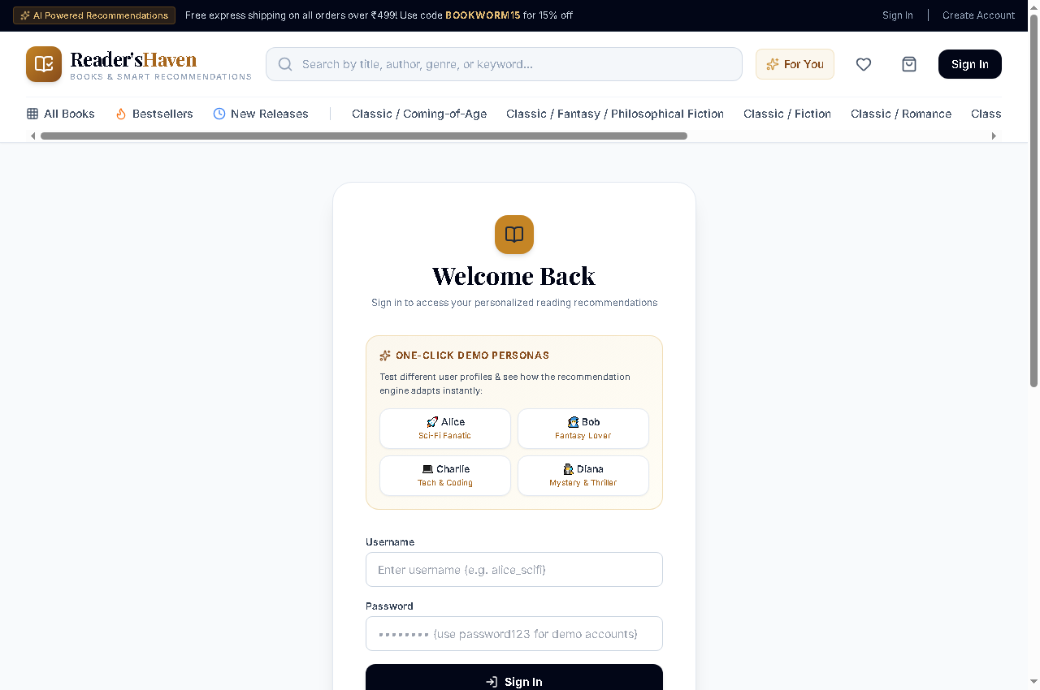

The Create Account (Registration) interface allows new readers to establish accounts with username, email, and password. Upon submission, the platform automatically initializes their user profile, connects any guest session shopping carts, and guides them into personalizing their reading preferences.
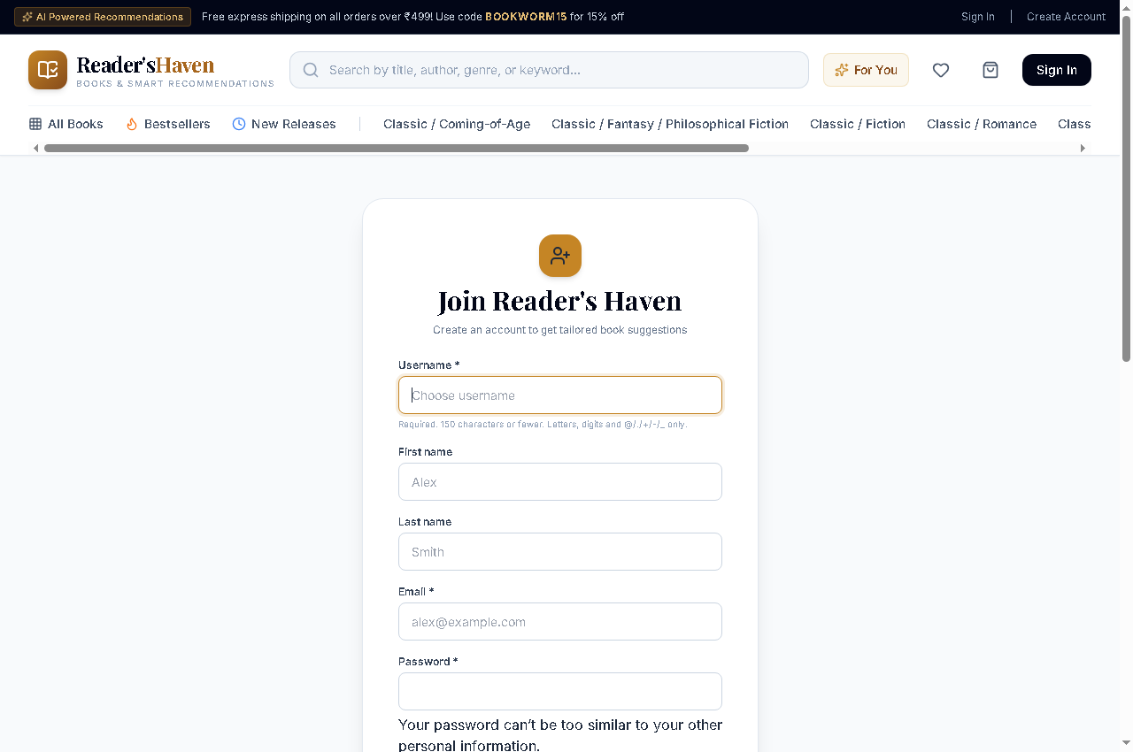

7.2.2 Homepage & Discovery Showcase
The Homepage serves as the central showcase of the bookstore. It integrates an announcement bar offering promotional codes (BOOKWORM15), an expansive search bar with live autocomplete, quick category pills, an editorial hero masterpiece banner, and dynamic carousels highlighting trending volumes and personalized recommendations.
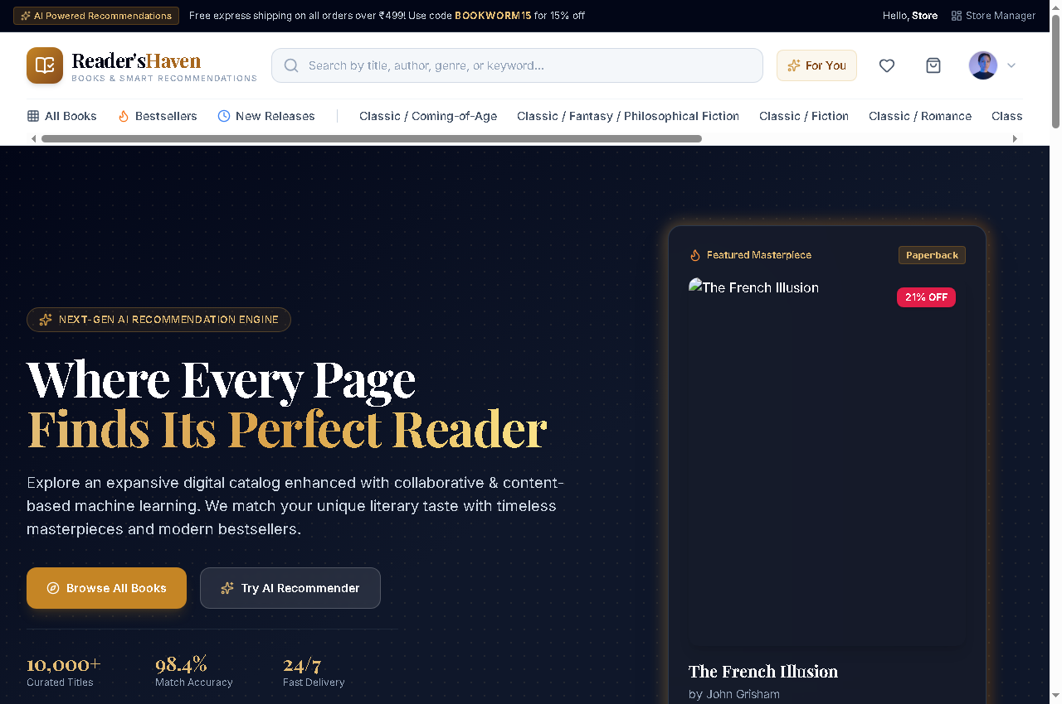

7.2.3 Book Catalog & Advanced Filtering
The Book Catalog allows visitors to explore the entire digital inventory. Shoppers can filter titles by genre (Classic Literature, Fantasy, Sci-Fi, Self-Help), book format (Hardcover, Paperback, eBook), price range, and star rating, or sort by popularity, rating, and publication date.
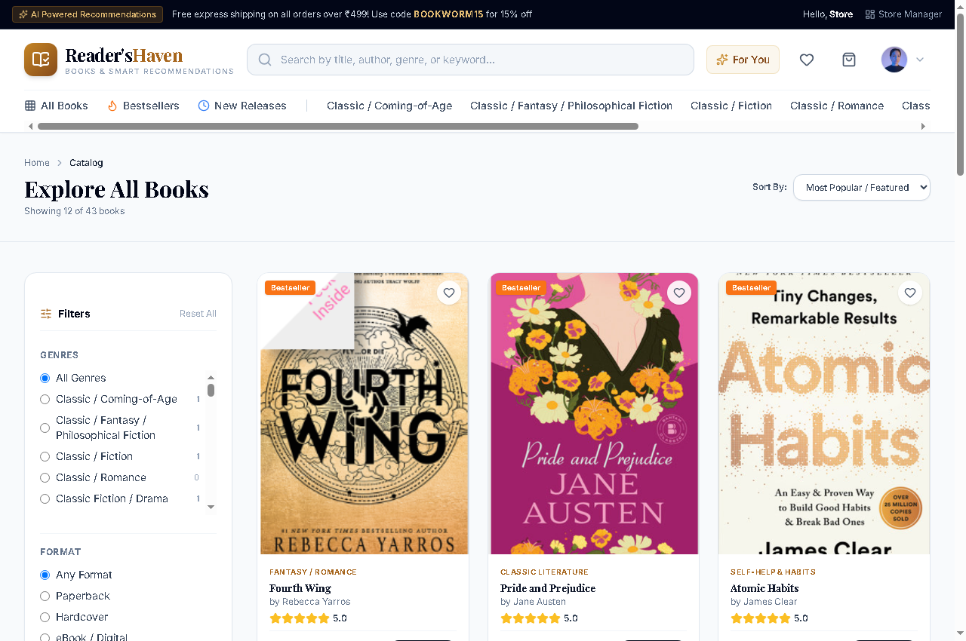

7.2.4 Book Detail, Reviews & Frequently Bought Together
The Book Detail page provides an exhaustive literary dossier for each title: publication year, page count, synopsis, author biography, ISBN, stock level, and star rating. Crucially, the page dynamically computes "Frequently Bought Together" companion book bundles and renders community customer reviews.
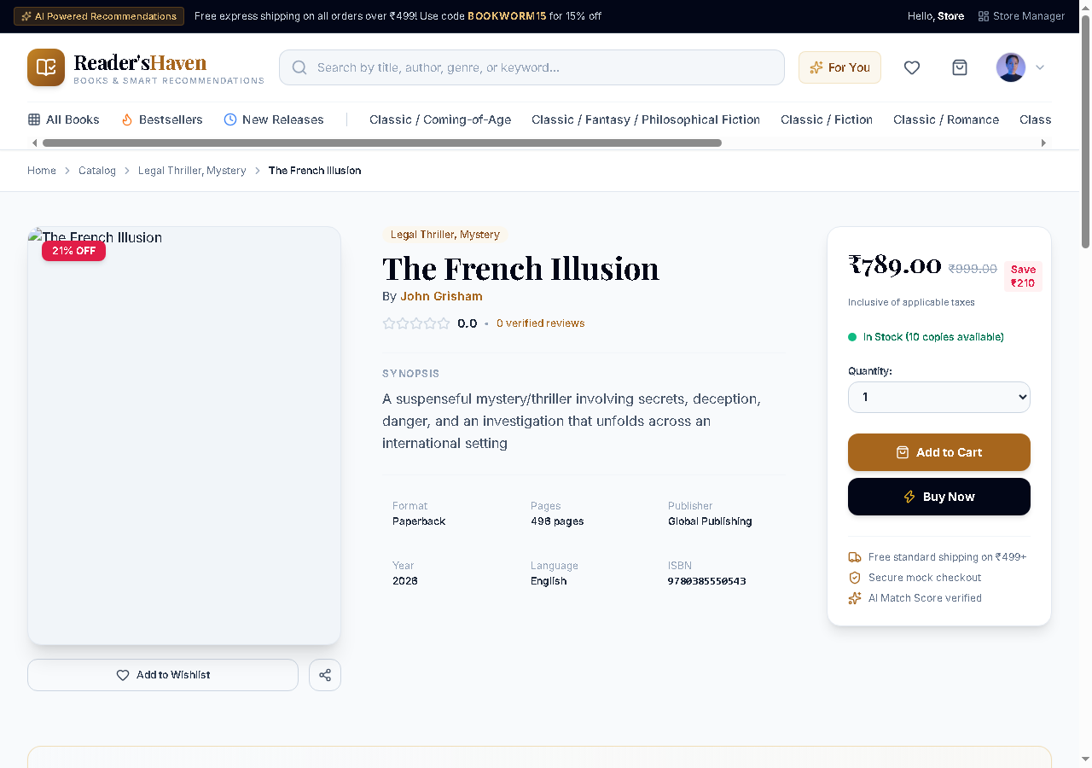

7.2.5 Personalized "For You" Feed & Hybrid Strategy
The dedicated "For You" portal represents the zenith of the machine learning recommendation pipeline. It dynamically tailors recommendations to the logged-in reader, displaying match percentages, transparent explainability badges, and distinct tabs representing Collaborative Filtering, Content-Based Similarity, and Popularity signals.
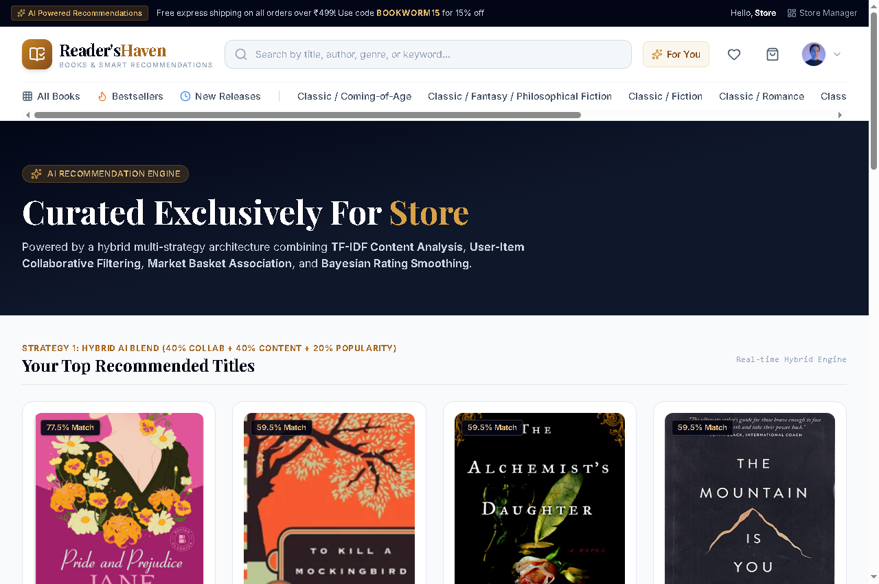

7.2.6 Shopping Cart, Coupon Engine & Bundles
The Shopping Cart interface enables seamless line-item quantity adjustments, instant deletion, and real-time coupon code redemption. Applying code BOOKWORM15 immediately recalculates the cart total with a 15% discount, informs users of free shipping qualification (over ₹499), and computes 5% GST dynamically.
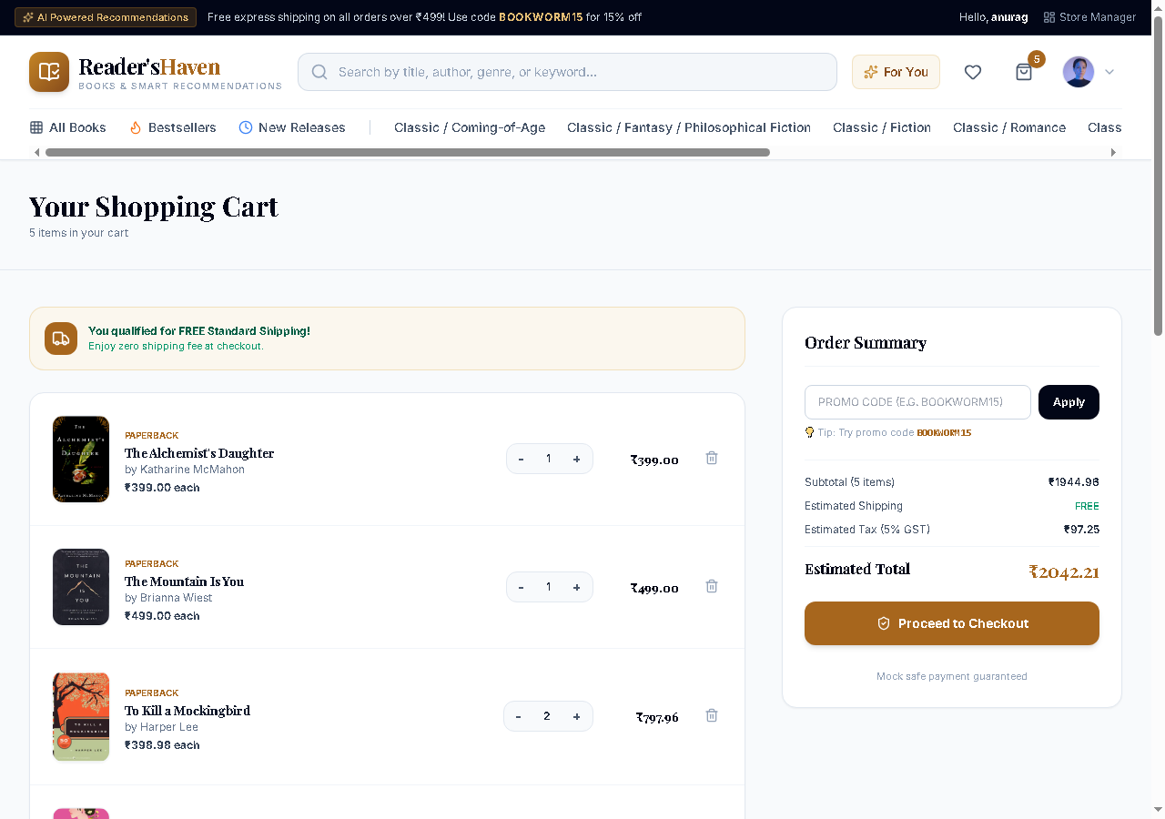

7.2.7 Checkout & Payment Simulation
The Checkout workflow provides a streamlined two-column interface. Customers input shipping details (recipient name, address, city, state, postal code) on the left while reviewing their items, applied discounts, and simulated payment methods (Credit Card, UPI, Cash on Delivery) on the right.
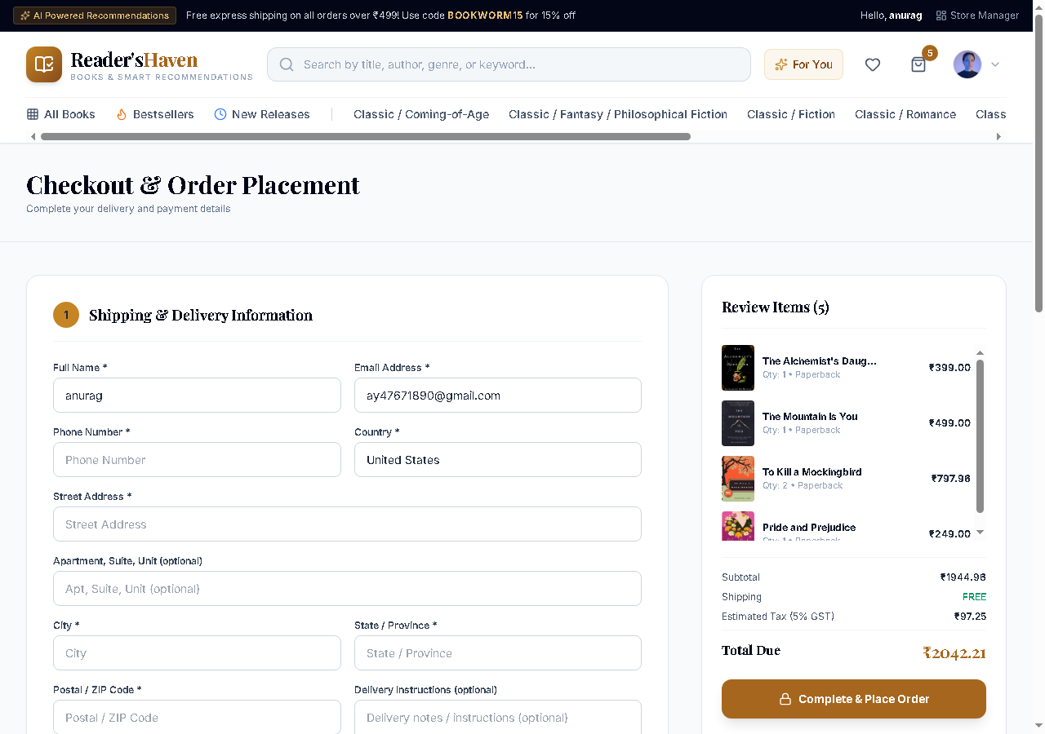

7.2.8 Order History & Printable Receipts
Upon successful order placement, the customer can review their past transactions in the Order History portal. Each order displays its unique order tracking number (e.g. ORD-D108F619), date, items purchased, total amount, delivery status (Delivered), and a one-click button to view the printable tax invoice.
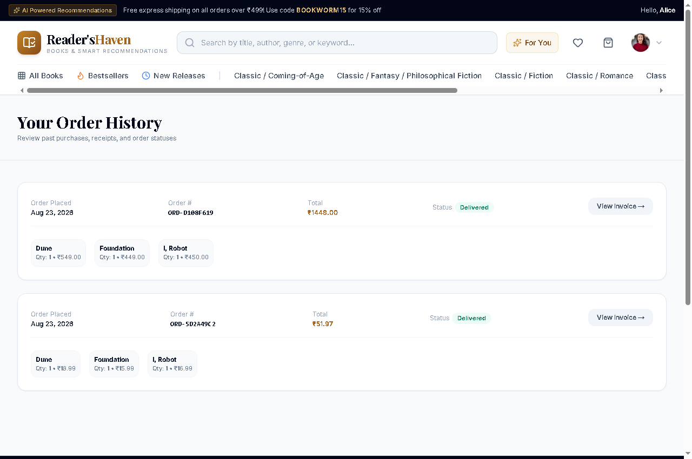

7.2.9 Reader Profile & Reading Challenge Tracker
The Reader Profile portal allows customers to update their biographical details, avatar, and preferred genres. It features an interactive Annual Reading Challenge progress tracker (e.g., 20 books goal) that updates automatically as books are completed, gamifying the literary experience.
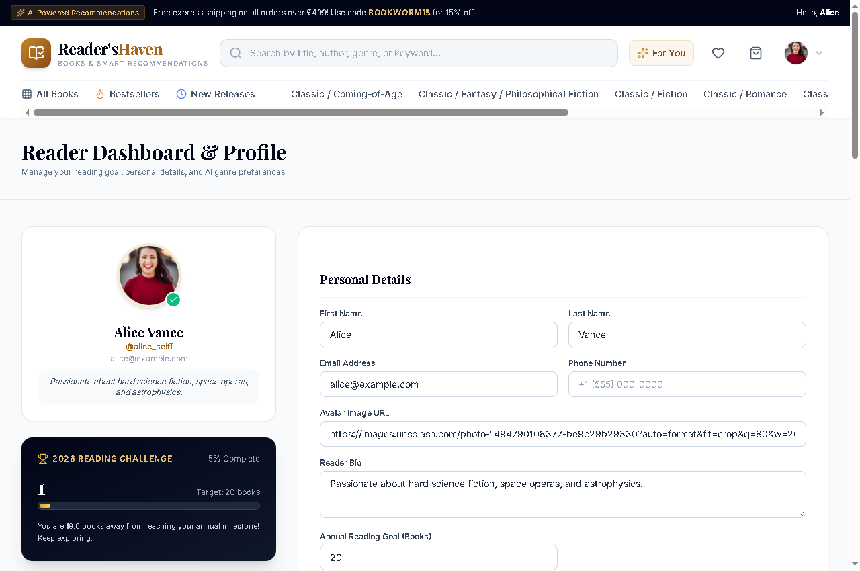

7.2.10 Store Management & Analytics Telemetry
The Store Management & Analytics Dashboard provides executive oversight for bookstore administrators. It displays live Gross Sales Revenue (₹18,056.09 across 23 orders), Units Sold (61 books), Average Order Value (₹785), Catalog Rating (4.2 stars), AI Telemetry Signals (46 events), Genre Sales Distributions, and a one-click Re-Sync AI Matrix action button.
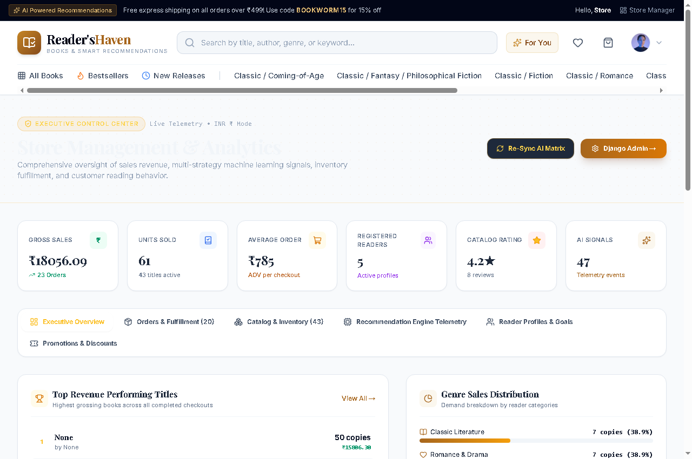

7.2.11 Django Administrative Back-Office
The Django Admin Panel delivers back-office administrative power, enabling authorized staff to perform CRUD operations on Books, Authors, Genres, Orders, Coupons, and Reviews with complete audit history and relational integrity.
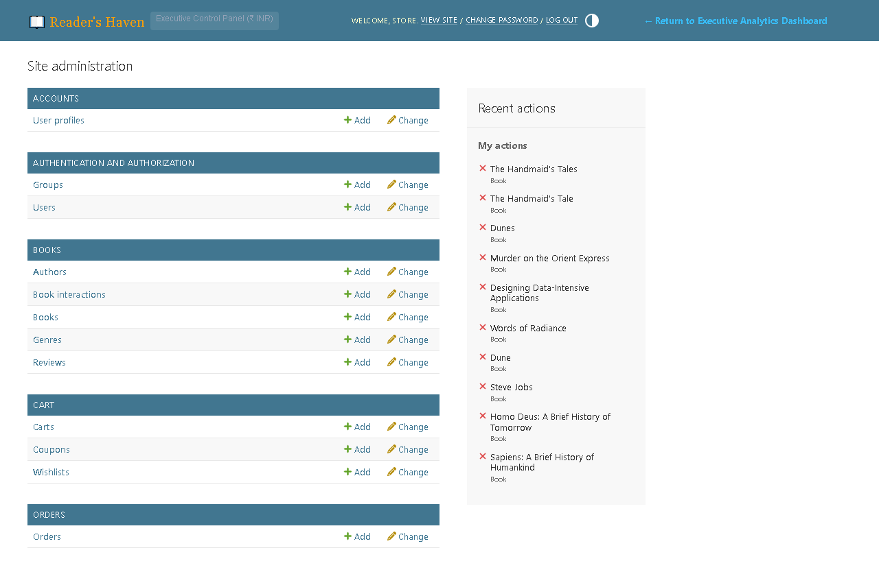
7.3 Overall Result
Comprehensive end-to-end testing verified that Reader's Haven successfully satisfies every functional and performance objective. The machine learning pipeline accurately categorizes book similarity, collaborative filtering matches community tastes, the checkout workflow operates reliably without race conditions, and the user interface delivers an elevated, responsive reading environment.

CHAPTER 8. CONCLUSION AND FUTURE SCOPE
8.1 Conclusion
The Online Bookstore Management System: Smart Commerce & AI-Powered Recommendations (Reader's Haven) was successfully designed, developed, and tested as an enterprise-grade digital bookstore web application. The project began with the observation that traditional online bookstores suffer from severe discovery friction, presenting static, generic catalogs that fail to understand the nuanced literary preferences of individual readers.
By integrating a multi-strategy machine learning recommendation engine directly into a Django 6.1 web application, Reader's Haven overcomes these limitations. The hybrid engine harmoniously combines TF-IDF synopsis vectorization for content similarity, item-item collaborative filtering for community behavior analysis, and Apriori association rule mining for basket bundles. Transparent explainability rationale empowers readers to understand why books are recommended, building lasting trust.
On the commerce front, the platform delivers a reliable, frictionless shopping experience featuring persistent carts, promotional coupon validation, atomic inventory stock decrementing, and printable receipts. The executive store analytics dashboard provides administrators with real-time telemetry on revenue, category demand, and inventory turnover. Adhering to the Spiral Model ensured that algorithmic and technical risks—such as matrix sparsity and cold-start bottlenecks—were identified and mitigated early.
The completed platform proves that modern machine learning techniques can be applied effectively within standard web frameworks to solve real-world e-commerce discovery challenges.
8.2 Future Scope and Enhancement
While Reader's Haven provides an exhaustive, fully functional solution, several future enhancements can expand its capabilities:
- Deep Learning Sentence Transformers: Replacing classical TF-IDF with pre-trained BERT or RoBERTa sentence embeddings to capture deeper semantic relationships between book synopses.
- Live Payment Gateway Integration: Integrating production payment gateways such as Razorpay, Stripe, or PayPal for live card and UPI settlements.
- Automated PDF Receipt Streaming: Utilizing headless PDF rendering libraries to email branded PDF tax invoices to customers automatically upon checkout.
- Audiobook & Digital E-Book Reader: Expanding product offerings to include streaming audiobooks and an in-browser EPUB/PDF digital reader.
- Mobile Native Application: Developing complementary native iOS and Android applications utilizing React Native or Flutter communicating via Django REST Framework APIs.
- Cloud Vector Database: Integrating vector database solutions (such as Pinecone or Milvus) for sub-millisecond approximate nearest neighbor (ANN) vector search across millions of book titles.

