

**Computer Science Department**

**COMP133 ( Spring 2024)**

**Project Phase Three *Due Date: Mon (3/6/2024) by 10:00 pm ( on itc )***

**Notes:**

1. This project phase should be submitted by the due date and time ***( Late project phases will not be accepted for any reason ) on itc.***

In this phase, you need to add the book names (strings) to the functions you created in phase two as follows:

***void displayMainMenu();*** // displays the main menu shown above

This function will remain similar to that in phase two.

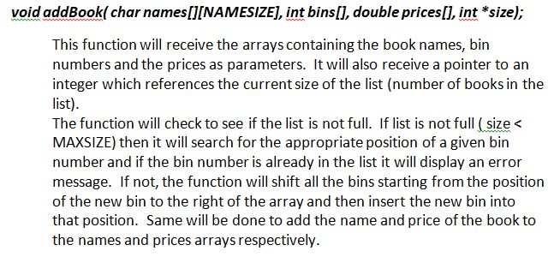

***void removeBook(char names[][NAMESIZE], int bins[], double prices[], int *size);***

This function will receive the arrays containing the book names, bin numbers and the prices as parameters. It will also receive a pointer to an integer which references the current size of the list (number of books in the list).

The function will check if the list is not empty. If it is not empty (size > 0) then it will search for the bin number to be removed and if not found will display an error message. If the bin number exists, the function will remove it and shift all the elements that follow it to the left of the array. Same will be done to remove the name and the price of the book from the names and prices arrays respectively.

***void searchForBook(char names[][NAMESIZE], int bins[], double prices[], int size);***

This function will receive the arrays containing the book names, bin numbers and the prices as parameters. It will also receive an integer which has the value of the current size of the list (number of books in the list).

The function will check if the list is not empty. If it is not empty (size > 0) then it will ask the user to enter a bin number and will search for that bin number. If the bin number is not found it will display an error message.

If the bin number is found then it will be displayed along with the book name and price in a suitable format on the screen.

***void uploadDataFile (char names[][NAMESIZE], int bins[], double prices[], int *size );***

This function will receive the arrays containing the book names, bin numbers and the prices as parameters. It will also receive a pointer to an integer which references the current size of the list (number of books in the list).

The function will open a file called ***books.txt*** for reading and will read all the book names, bin numbers and prices and store them in the arrays.

***void updateDataFile(char names[][NAMESIZE], int bins[], double prices[], int size);***

This function will receive the arrays containing the book names, bin numbers and the prices as parameters. It will also receive an integer which has the value of the current size of the list (number of books in the list).

The function will open the file called ***books.txt*** for writing and will write all the book names, bin numbers and prices in the arrays to that file.

***void printBooks (char names[][NAMESIZE], int bins[], double prices[], int size);***

This function will receive the arrays containing the book names, bin numbers and the prices as parameters. It will also receive an integer which has the value of the current size of the list (number of books in the list).

This function will print the information (names, bins and prices) currently stored in the arrays in a suitable format.

**IMPORTANT: The book info stored in the arrays should always be stored in ascending order based on the books’ bin numbers that exist in the bins array. You should NOT use any sorting functions to do this but should depend completely on the shifting procedure described above in the *addBook* and *removeBook* functions to keep the data in the correct order.**

***Note: You need to define a constant called MAXSIZE ( max number of books stored) equal to 100 as well as a constant NAMESIZE (max size of a book name) equal to 50.***

***A book name may contain only letters, numbers, and underscore and must start with a letter (e.g. Introdcution_To_Computers, Computer_Programming_Fun, Geography_1 and so forth). You DO NOT have to check. You may assume that book names will NOT have any space characters in them (Do Not check).***

**VERY IMPORTANT:**

1. ***YOU MUST IMPLEMENT THE PROJECT USING PARALLEL ARRAYS EXACTLY AS SPECIFIED IN THE DESCRIPTION ABOVE. YOU MUST NOT USE ANY STRUCTURES. USING ANY STRUCTURES ANYWHERE IN YOUR PROJECT WILL RESULT IN YOU GETTING A GRADE OF ZERO FOR THE WHOLE PROJECT PHASE.***
2. Turn in your project phase by ***attaching your main.c code file under the meta lab section on itc*** .
3. You must include your full name, student id number, and lecture + lab section numbers in a comment at the beginning of your ***main.c*** code file.

***SAMPLE RUN:***

Make sure your program works **very similar** to the following sample run:

***Assuming that at the beginning of the run file books.txt has the following information stored:***

***Introduction_To_Geography*** 1234 72.45

***Computer_Fun*** 2345 25.20

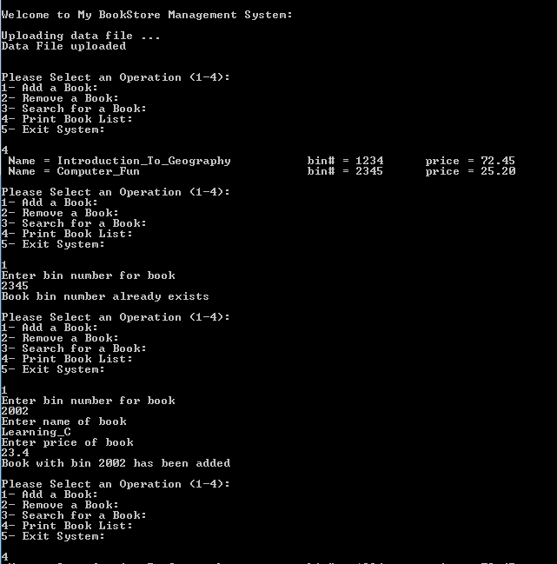

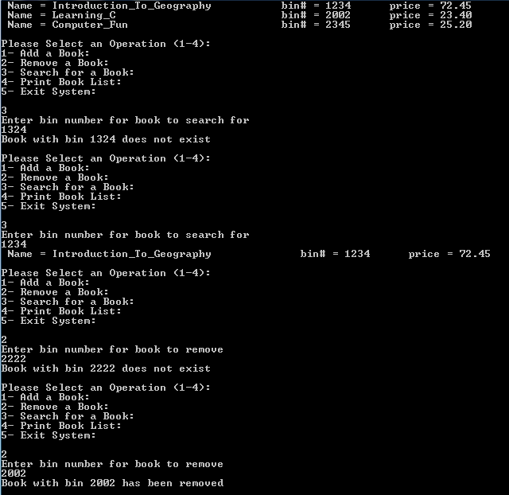

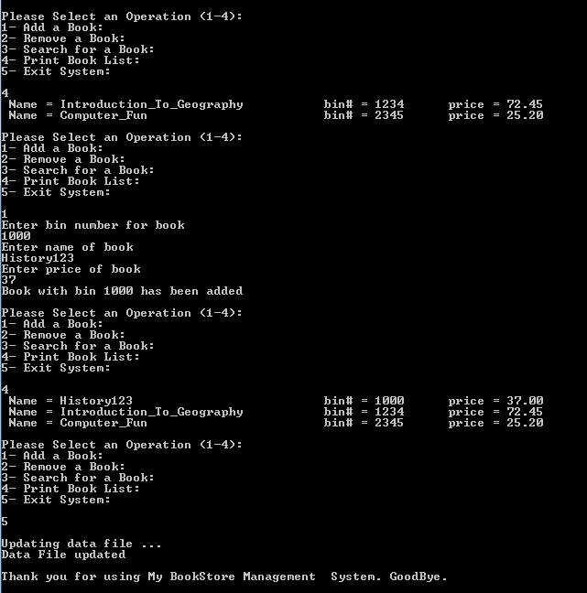

***Late project phases or those not turned in on itc as specified will not be accepted for any reason***. ***It is your responsibility to make sure that your code file has been uploaded correctly to itc.***