AI-Based Intrusion Detection System (IDS) Using Python
Date: 12/12/2025
Name: Mohammad Haneef

Table of Contents:

S NO. | Topics | Page NO.
1 | Introduction | 3
2 | Exploratory Data Analysis (EDA) | 4-8
3 | Machine Learning Model Implementation | 9
4 | Neural Network Model | 10
5 | Model Comparison and Analysis | 11
6 | Real-Time IDS Prototype | 12
7 | Conclusion | 13

Introduction:

As cyber threats continue to grow in complexity and scope, intrusion detection systems (IDS) continue to be one of the most important components of contemporary network security. Businesses are using intrusion detection systems (IDS) to identify malicious activity early and take action before an attack can do significant harm. Using the well-known KDD Cup 1999 dataset, which is frequently used for benchmarking intrusion detection research, this project focuses on creating a workable, end-to-end IDS solution. The project's goals are to fully understand the dataset, analyze its structure, develop many machine-learning-based detection models, and then put into practice a basic real-time intrusion detection prototype that can instantly classify incoming network samples.

Exploratory Data Analysis (EDA), Machine Learning model building, Neural Network implementation, model comparison, and a real-time IDS demonstration are the five different stages of the project that are used to achieve this. Specific Python modules are used to carry out each step, and they all work together effectively through the main controller script final.py. The entire workflow, including loading the dataset, producing visual analysis outputs, creating training features, training the ML models, training the neural network, storing the models, and starting the real-time detection server, is coordinated by this one script. It guarantees that each stage of the pipeline runs automatically in the correct order when it is conducted, allowing a seamless and reliable testing technique.

The dataset used for this coursework includes both typical traffic and various kinds of attack types, each with unique traits and behaviors. Before developing models, EDA was used to investigate patterns in class balance, attack frequency, and correlations between attributes. After the investigation was finished, two traditional machine learning models were trained and assessed: a Random Forest classifier and a Linear Support Vector Machine. To find out their advantages and disadvantages, each model's performance was then compared.

A real-time IDS prototype is put in place as the project comes to an end. Network feature vectors are sent to a server over a TCP socket, and the prediction engine provides an instant classification. This shows how the trained models can be used in a useful, real-world security situation, particularly those controlled by final.py. Overall, the coursework shows how machine learning can be used to improve cybersecurity monitoring by providing a whole pipeline from dataset analysis to real-time intrusion detection.

Exploratory Data Analysis (EDA):

The basis of this part is exploratory data analysis (EDA), which allows for a thorough understanding of the KDD Cup 1999 dataset before performing any modeling. Each record in the dataset has a label describing whether it represents an attack or regular traffic, along with 41 features. The EDA stage automatically imports the dataset, creates graphs, saves summary statistics, and helps in finding interesting behavioral patterns when it runs inside final.py. Creating summary statistics for each number column is the very first step in this analysis. These statistics, which allows immediate detection of abnormal distributions and extreme values, includes count, mean, standard deviation, minimums, and maximums. These findings are important for directing preprocessing decisions in the next stages since network traffic data often has irregular patterns and anomalies.

The division of the dataset into normal and attack traffic is part of the analysis's following part. To show the proportion of each class, bar charts were made for both the training and testing sets. These images show a noticeable difference with far more attack reports in the training data. Because machine learning models often choose the dominant class unless particular methods are used to correct it, this unequal distribution is important.

Techniques like careful data segmentation and the use of class-weight changes were used to overcome this problem later in the modeling phase. By insuring that both classes receive equal treatment during training, these methods help keep the model from only learning about the class that is dominant. Understanding the structure of the data and potential problems for the models depends heavily on the class distribution visualization (class_counts.png). This stage is important for developing an accurate intrusion detection system because it makes it easier to prepare for how different algorithms could react during training and validation by examining the percentage of normal and attack traffic early on.

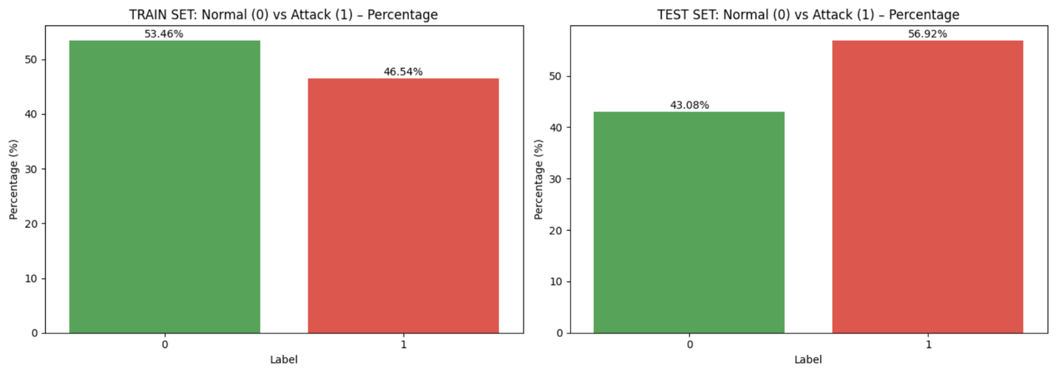
(class_counts.png)

The distribution of various attack types within the training dataset is examined in the following section of the analysis. The attack_type data was used to create a bar chart that shows this by displaying the frequency of each attack category. A significant imbalance between the different attack families is shown in the following graph (attack_type_distribution.png). While many other attack types only happen a few times or in small numbers, some attacks like ipsweep, smurf, and neptune appear often and dominate the dataset.
The behavior of machine learning models is greatly affected by this unequal distribution. The model naturally gets better at identifying particular attack types when they are highly common, which often results in high recall for these dominant categories. However, the model finds it far more challenging to learn attack kinds which happen rarely. Even if the model does well overall, this may result in decreased precision or missing detections for those categories. Understanding the success of multiple models across different assessments therefore needs an understanding of this imbalance. The (attack_type_distribution.png) helps explain why some attacks are simpler or more difficult for the system to detect during training and testing, and it gives a clear image of how broad the dataset actually is. As you can see in here normal is showing at 53% and Neptune being at 32%.
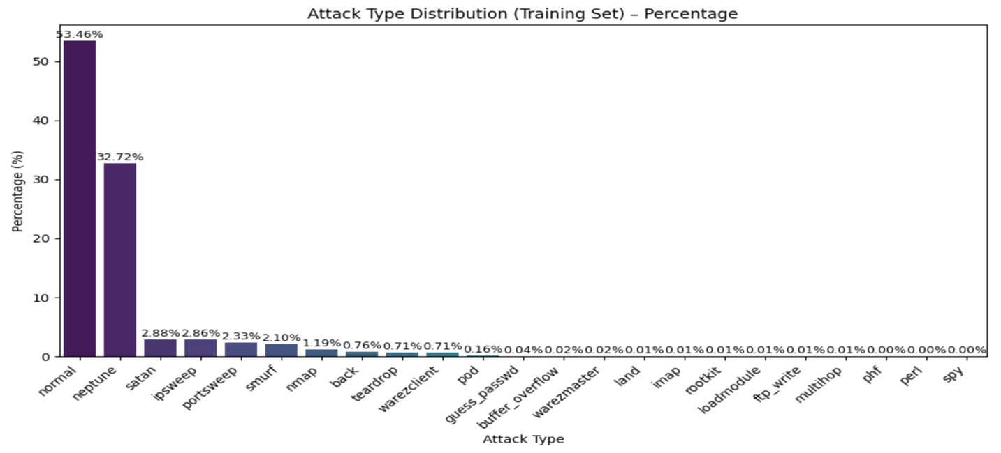
(attack_type_distribution.png)

At last, a correlation heatmap is created to look into the connections between the top 25 numerical features. Strong and weak correlations are highlighted in the heatmap, making it easier to see which features include information that overlaps. For example, there is significant clustering in features related to connection rates and server faults. For the purpose of directing model architecture and identifying which inputs have a major impact on predictions, it is important to know these groupings.

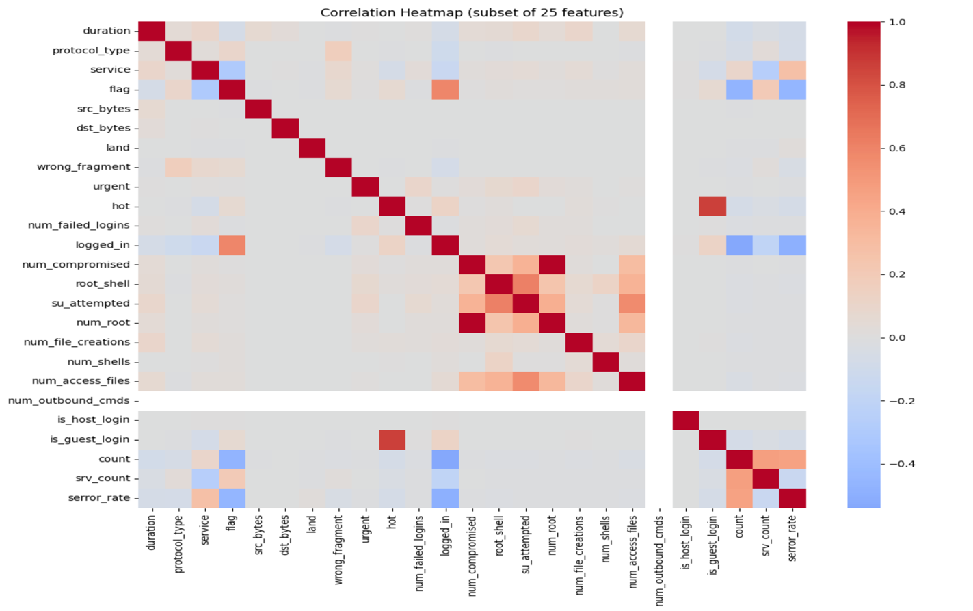
(correlation_heatmap.png)

When combined, these EDA results provide a comprehensive summary of the dataset and provide a strong analytical foundation for the modeling stages. Every time the project runs out, consistency and repeatability are guaranteed by its integration of EDA into final.py. If you open it from zip file u can see it in csv format.

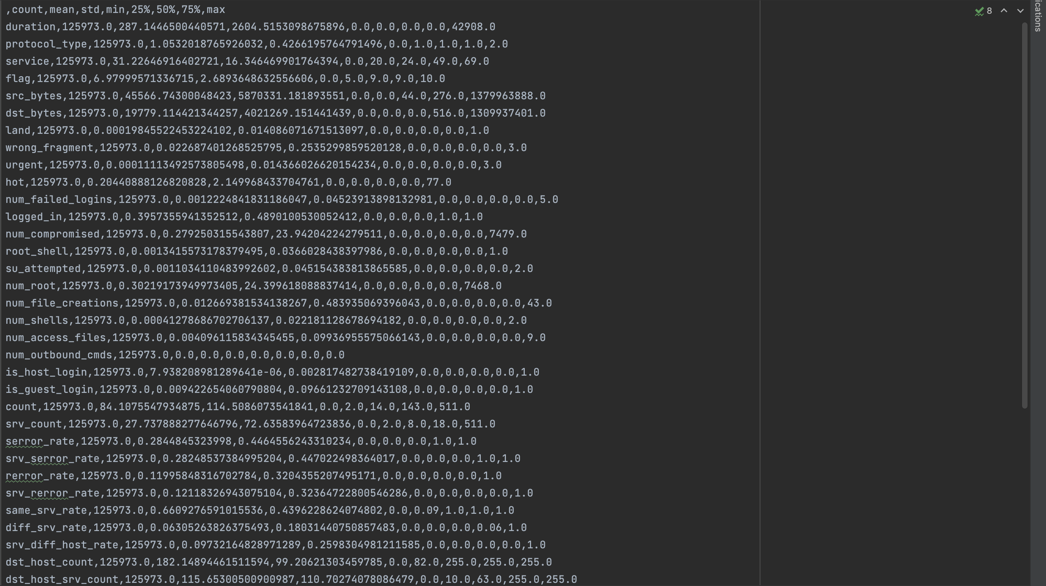
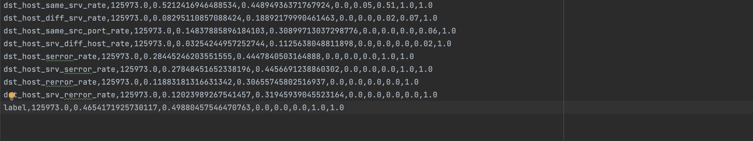
(train_summary_stats.csv)

There is also train summary statistics readable table format for easy understanding of it in the /outputs/eda/train_summary_stats.md, if you want to view it from application.

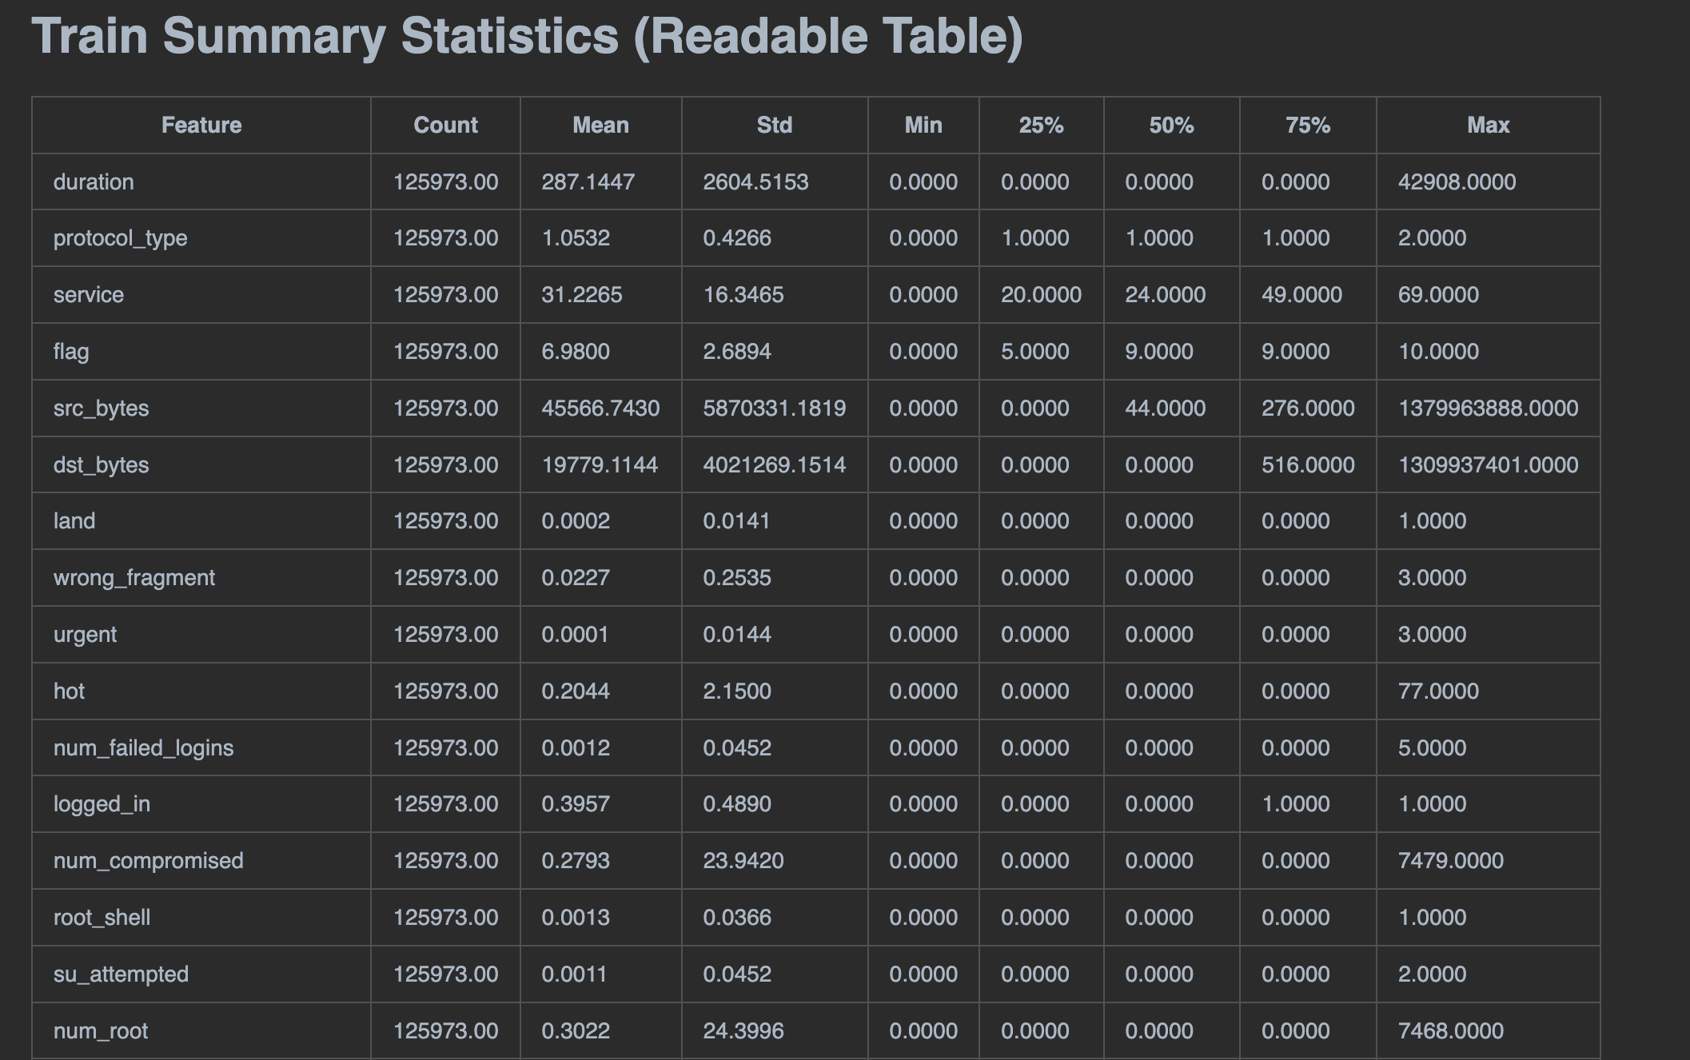
(train_summary_stats.md)

Machine Learning Model Implementation:

The project's second part includes creating, refining, and assessing traditional machine learning models for intrusion detection. This step provides a completely integrated workflow by using the functions provided in ml_models.py and being automatically launched by final.py. This section's goal is to analyze and contrast the behavior of conventional algorithms before going into deep learning. Random Forest (RF) and Linear Support Vector Classifier (LinearSVC) were the two models used.

With an accuracy of 0.7947 and an F1 score of 0.7679, the Random Forest performed decently when trained and assessed on the validation data. These findings show that RF identifies significant connections in the dataset even at low levels of complexity.

With an accuracy of 0.8518 and an F1 score of 0.8341, the LinearSVC outperformed the RF model in terms of generalization.

The accuracy, precision, recall, and F1 score of both models were examined using compute_metrics(), print_metrics_table() was used to print these metrics in tabular form. While LinearSVC is particularly good at class separation in high-dimensional environments, Random Forest is better at capturing non-linear interactions.
In order to make sure that both trained models can be reloaded for real-time inference, the last step in Part 2 involves saving them using joblib. Adding them into the final.py pipeline provides a seamless transition from EDA to modeling to preparation, allowing for automatic retraining each time the script is run.

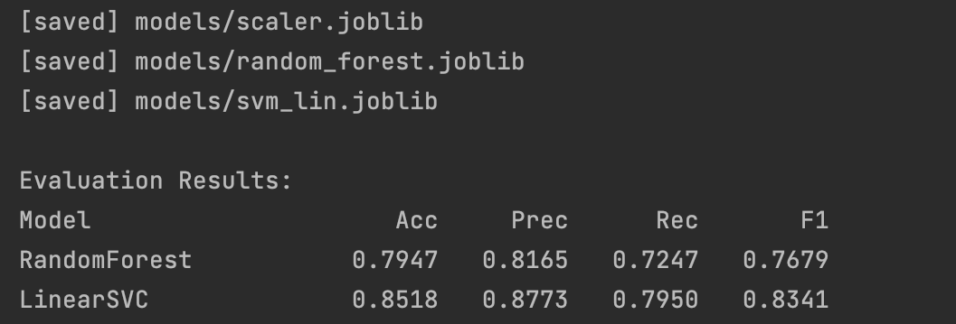

Neural Network Model:

In Part 3, the project moves from normal machine learning to the use of deep learning using a neural network specified in nn_model.py. This entire process is also put together by final.py, which runs the train_nn() method, trains the model, assesses it using validation data, and saves the final version.
ReLU activations, dropout layers to keep the model from becoming too confident, and two dense layers with tiny neuron counts make up the neural network that is called MediumNN. Six neurons make up the first layer, while three neurons make up the second layer. A probability score that shows whether the input represents normal or attack traffic is produced by a final logistic output layer.
The neural network's validation F1 score increased over the course of eight training epochs to a final value of 0.8785. Further validation scores were 0.8743 for accuracy, 0.8830 for precision, and 0.9695 for recall. These results show a balanced model with strong recall, able to detect fraudulent traffic effectively. For real-time inference, the model is loaded again after being stored as nn_model.pt.
The neural network shows improved recall performance and smoother learning behavior as compared to conventional machine learning models. Every time final.py is run, it automatically trains thanks to its inclusion into the entire pipeline.
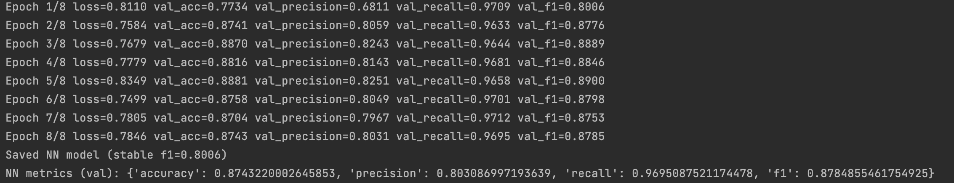

Model Comparison and Analysis:

The performance of all machine learning and neural network models is assessed and compared in the project's fourth part. A fair and consistent comparison is made possible because all models share the same feature preprocessing processes because they are all automatically trained within final.py. Accuracy, precision, recall, and F1 score are used for comparing each model, and when combined, they provide a comprehensive picture of its advantages and disadvantages.

The Random Forest model got an F1 score of 0.7679 and an accuracy of 0.7947. The Random Forest shows that it can identify non-linear relationships in the data. Its lower recall shows that it has trouble detecting all attack traffic, particularly that which falls into less common categories.

With an accuracy of 0.8518 and an F1 score of 0.8341, the LinearSVC model produced better results. Its ability to create effective linear decision boundaries in the high-dimensional feature space explains the improvement over Random Forest. However, unexpected changes in recall can be explained by the model's sensitivity to noise and feature scaling.
With a validation F1 score of 0.8785, the neural network outperformed both classical models. It shows more flexibility in learning complex connections within the dataset. An IDS system must be able to identify attacks, and this can be seen by its strong recall.

The models differ significantly when compared:

- Although Random Forest is stable, its complexity is limited.
- LinearSVC is more effective and has better generalization.
- The ideal ratio of recall to precision is provided by neural networks.

These results show how model selection affects IDS performance, with the neural network being best suited to a range of attack types.
This section additionally points out the benefit of having a single pipeline using final.py, which ensures repeatability, uniform preprocessing, and automated re-evaluation each time models are re trained.

Real-Time IDS Prototype:

The project's last part creates a basic real-time intrusion detection prototype to show how the trained models might be used in a real-world security scenario. Because realtime_server.py and realtime_client.py are fully integrated into final.py, the entire real-time infrastructure may be started automatically after training is finished. This closely mimics the processing of incoming network data by actual IDS tools.

A client-server architecture is used by the real-time system. The trained Random Forest model and the scaler, which were both saved earlier in the pipeline, are first loaded by the server. After being started, the server waits for incoming feature vectors by listening on TCP port 9999. After being parsed and, if necessary, scaled, each incoming sample is run through the prediction model. After that, the client receives the output in JSON format. This configuration is similar to how IDS systems frequently receive and quickly classify network traffic.

The system is similarly simple on the client side. JSON is used to send a feature vector to the server over the socket connection. If something goes wrong, the server replies with an error message or a prediction label (0 = normal, 1 = attack). A sample data point is saved as sample_for_realtime.npy during the pipeline to show this feature. This sample is sent through the client to the server by final.py when it reaches the real-time stage, and the output is printed. The sample was identified as an attack in the given run, showing that the real-time pipeline works as expected.

This prototype shows that using the trained IDS models in real-world settings is possible. Although being simplified, it shows how, based on setup, incoming network records could be immediately assessed using machine learning or neural network models. If you want, the server script's USE_NN toggle makes it simple to convert from classical models to neural networks.

All things considered, the real-time IDS component is a helpful example of how analytical models created earlier in the project may be used beyond static evaluation, acting as the foundation for a more complete network monitoring solution.

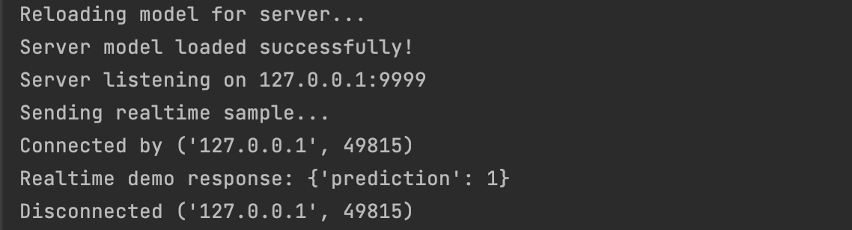

Conclusion:

Using the KDD Cup 1999 dataset, this coursework successfully shows a full end-to-end implementation of an intrusion detection system. The project provides an organized and useful method for understanding IDS creation by combining exploratory data analysis, classical machine learning models, a neural network model, performance evaluation, and a real-time detection prototype. final.py controls the entire system, ensuring that every part from real-time prediction to dataset loading runs successfully and in the right sequence. Workflow automation, reproducibility, and simplicity are all supported by this integration.

Important elements of the dataset, such as class imbalance, the frequency of particular attack types, and relationships between features, were found through the exploratory analysis. By bringing out possible problems like uneven distributions and features that are duplicates, these understandings helped the modeling procedure. We learn how feature selection, label noise, and class weights influence performance by being exposed to classic algorithms like Random Forest and LinearSVC.

The network's balanced performance, especially in recall, makes it perfect for intrusion detection applications where it is important to detect malicious traffic. A brief explanation of each model's advantages and disadvantages was given by the comparison, which also showed how different algorithms react to the same dataset.

The project was connected to a real-world application by the last real-time intrusion detection feature. The system showed how trained models can quickly identify incoming data using a client-server architecture. This practical demonstration shows the importance of developing academic modelling into operational tools that allow network security monitoring.

Putting it all together, this project provides a thorough understanding in IDS development. It increases practical skills in data processing, model training, evaluation, and deployment in addition to strengthening theoretical understanding. Easy testing, scalability, and clarity are guaranteed by the system's modular design and final.py execution. The effort provides a strong basis for future developments in intrusion detection and network security research while showing how machine learning and neural networks may improve cybersecurity systems.

