**Activity – For Online Class**

**Date – 13th October 2025**

**4.1.** In each case below, say what language (a subset of {*a, b*}*) is generated

by the context-free grammar with the indicated productions.

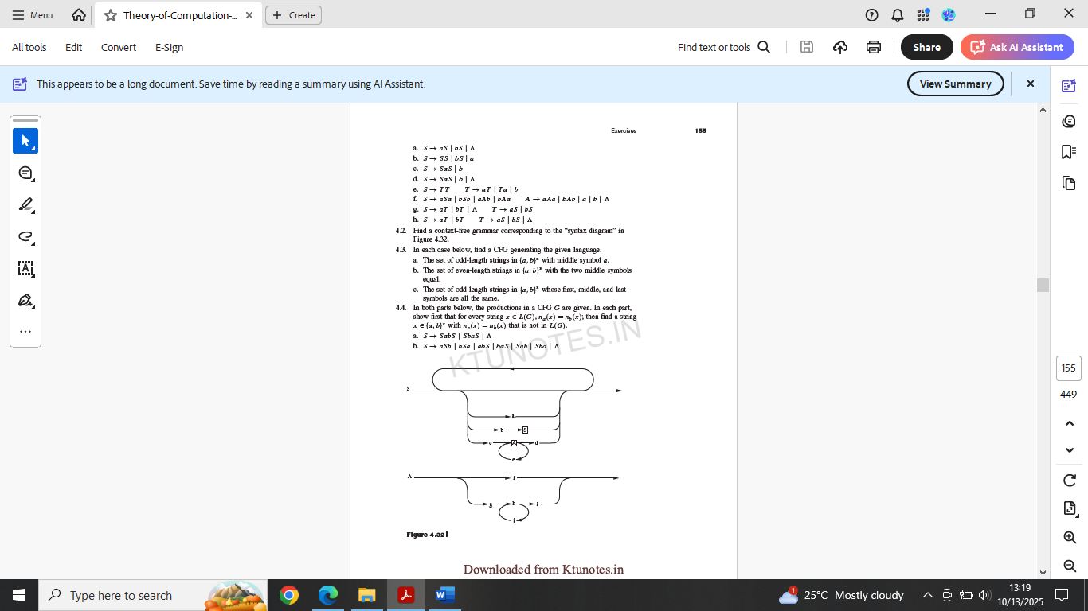

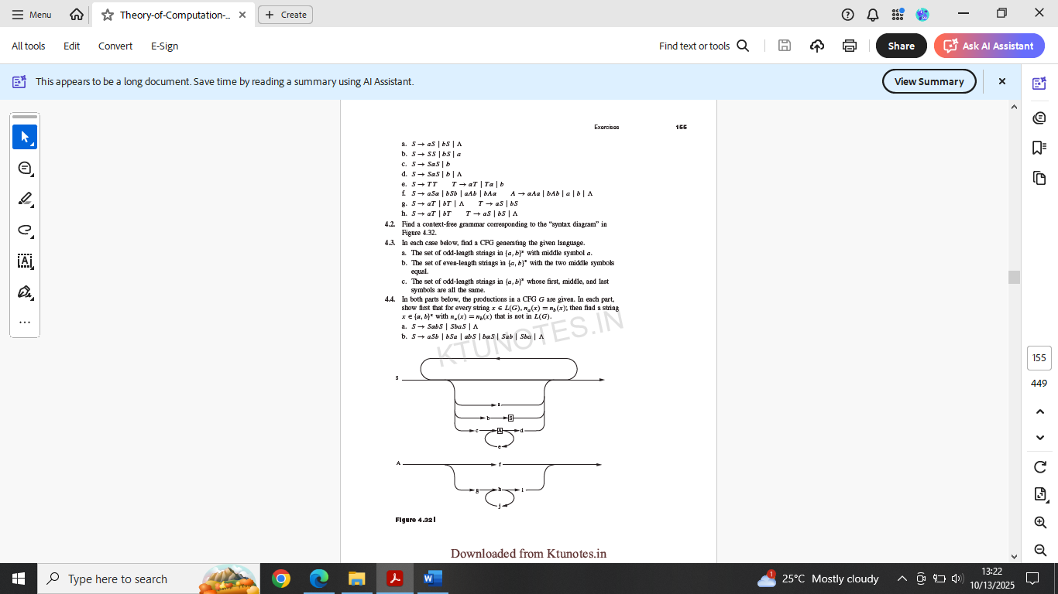

Can we obtain ‘aaabbb’ string with this language grammar?

In either case, give working and/or reason.