PDC ASSIGNMENT 2 WRITEUP
Mohammad Ibraheem
23L-0771
BCS-7J

1. Machine Description
All measurements in this report were taken on the machine listed in Table 1. The same machine, compiler and build flags were used for every experiment, so the comparision between the serial implementation and the three parallel implementations is fair.
Item | Value
CPU model | Intel(R) Core(TM) i5-8250U CPU @ 1.60 GHz
Physical cores | 4
Hardware threads | 8 (2 threads per core)
Socket(s) | 1
Memory | 7.6 GiB
Operating system | Ubuntu 24.04.3 LTS, kernel 7.0.0-31-generic
Compiler | g++ 13.3.0 (C++11, -O3, -Wall)
Timings | minimum of 5 runs on the same machine
Worker counts reported | 1, 2, 4, 8, 16

Note that p = 16 is twise the number of hardware threads (8), so at p = 16 the pool is over-subscribed. This matters most for the spinning pool, because two workers then share a core and one of them burns CPU while the other is trying to make progress.

2. Implementation Summary
Part 1 (TaskSystemParallelSpawn::run): worker threads are created per run() call, capped at min(num_threads, num_total_tasks). An atomic next_task counter hands out unique task ids and each worker fetches ids until none remain, so no mutex is needed because only the counter is shared. The calling thread joins all workers before returning.
Part 2 (TaskSystemParallelThreadPoolSpinning): a persistent pool of num_threads_ workers is created once in the constructor. run() publises the new launch under mtx_ (sets runnable_, total_, and resets next_ and done_), then the calling thread busy-waits on done_. Workers spin on next_ < total_ and claim a task under mtx_.
Part 3 (TaskSystemParallelThreadPoolSleeping): the same persistent pool, but spinning is replaced by a mutex and two condition variables. A worker waits on cv_work_ until next_ < total_ or stop_. The calling thread waits on cv_done_ until done_ == total_.
Part 4 (granularity investigation): the supplied irregular-work test is run with different chunk sizes to see how task granularity affects the spinning and sleeping pools.
Part 5 (part5_async_deps): TaskSystemParallelThreadPoolSleeping is re-implemented with a pimpl Impl that keeps a Launch per submitted graph node. runAsyncWithDeps() calls submit() under the mutex, assigns a unique TaskID (the index into launches), records the number of unmet dependencies and appends the launch to the dependents of each predecessor; a launch whose unmet count is zero is moved to the ready queue and workers are notified. When a launch finishes, completeLaunch() decrements the unmet count of every dependent and makes it ready when the count reaches zero. sync() waits until completed == launches.size(). run() stays synchronous.

3. Measurement Method
Every reported time is the minimum of 5 runs (-i 5) of the same test on the same machine; the supplied binary prints that minimum in milliseconds. T1 is defined as the runtime of the supplied serial implementation (Serial) on the same workload, and it is used consistently throughout the report. Speedup is Sp = T1 / Tp and effeciency is Ep = Sp / p, where Tp is the runtime with p workers. Workloads are run at p = 1, 2, 4, 8, 16. Unless stated otherwise the worker count is set on the command line with -n p.
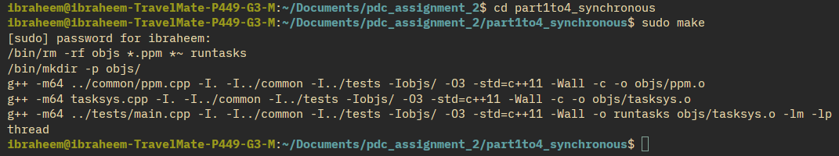

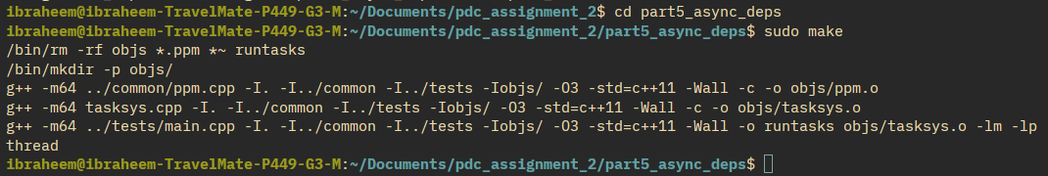

4. Deliverables and Correctness Evidence
The assignment requires at least one custom synchronous test and at least one custom dependency test registered in tests/main.cpp. Two seperate custom tests were added:
- your_test_sync (synchronous custom test): runs a parameterised task with sizes 1, 3, 7, 13, 1001 and 20000 elements over 50 launches and checks that every element is written exactly once.
- your_dep_test (dependency custom test): builds a small dependency graph and checks the mandatory ordering and exact-once execution of the async task graph.
In addition the irregular chunk tests (irregular_chunk_1 .. irregular_chunk_2048) and the split tests (your_split_one, your_split_four) were added for Part 4 and Part 5. All 41 tests registered in tests/main.cpp pass for every implementation in both folders; the correctness logs are captured in the appendix.
Deliverables checklist: (a) completed source for parts 1-4 in part1to4_synchronous/ and part 5 in part5_async_deps/; (b) one custom synchronous test (your_test_sync) and one custom dependency test (your_dep_test) registered in tests/main.cpp; (c) correctness evidence captured in Appendix A; (d) this report; (e) the README containing only the build and run commands; and (f) the submission zip after removing the object files and compiled binaries.
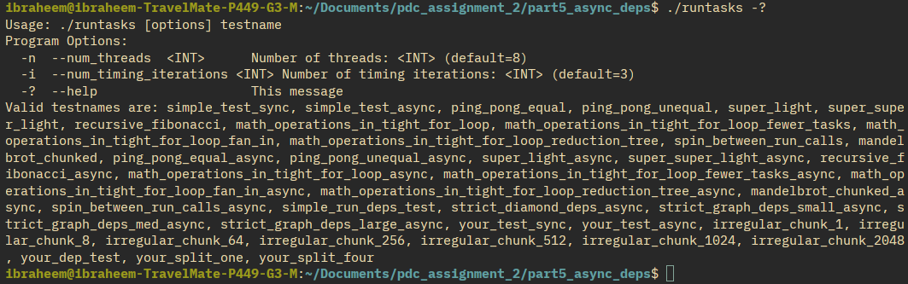
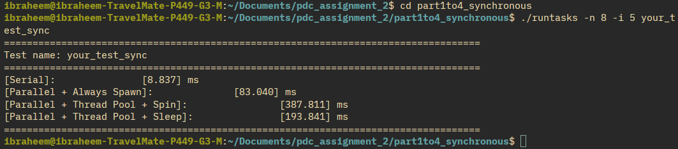
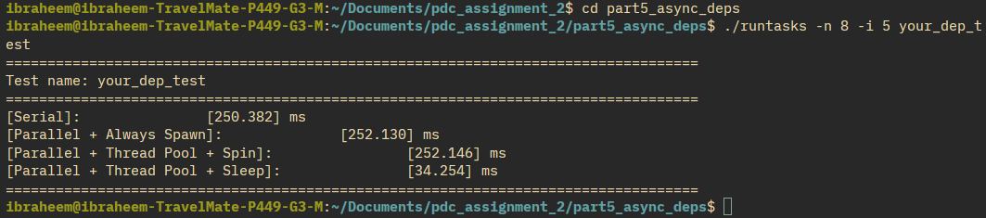

5. Part 1: Synchronous Parallel Task Launch
Before the experiments I predicted that coarse work with a large per-task cost (RecursiveFibonacci) or a single coarse launch (MandelbrotChunked) would scale best, because the scheduling overhead is amortised over a large amount of useful work, and that SuperSuperLight (64 tiny tasks x 400 launches) would scale worst, because thread creation and task-claim overhead dominate the tiny useful work.
Task ids are handed out with an atomic fetch_add on next_task, which gives unique ids with no duplicates and no omissions even when the number of tasks is not divisible by the number of workers; the extra workers simply fetch an id >= num_total_tasks and exit.

5.1 SuperSuperLight
p | T1 Serial | Spawn | Spin | Sleep
1 | 15.310 | 36.372 | 17.663 | 19.646
2 | 14.657 | 32.838 | 11.109 | 15.430
4 | 12.738 | 44.122 | 11.298 | 16.517
8 | 13.368 | 113.663 | 48.232 | 21.542
16 | 13.308 | 268.106 | 150.173 | 38.437

5.2 RecursiveFibonacci
p | T1 Serial | Spawn | Spin | Sleep
1 | 1665.890 | 1675.741 | 1757.156 | 1676.989
2 | 1686.569 | 916.314 | 1018.924 | 919.027
4 | 1694.904 | 615.277 | 584.894 | 523.893
8 | 1434.903 | 373.961 | 659.263 | 530.599
16 | 1464.489 | 540.620 | 929.472 | 535.144

5.3 PingPongUnequal
p | T1 Serial | Spawn | Spin | Sleep
1 | 2395.463 | 2495.090 | 2442.302 | 2537.677
2 | 2494.752 | 1351.012 | 1409.938 | 1297.496
4 | 2399.556 | 757.401 | 946.690 | 983.818
8 | 2506.614 | 898.715 | 1563.216 | 820.529
16 | 2645.840 | 1025.682 | 4311.987 | 806.276

5.4 SpinBetweenRunCalls
p | T1 Serial | Spawn | Spin | Sleep
1 | 575.479 | 535.237 | 622.881 | 546.284
2 | 513.465 | 275.221 | 327.327 | 293.043
4 | 536.809 | 285.207 | 370.229 | 305.755
8 | 563.455 | 320.534 | 1027.821 | 332.450
16 | 555.364 | 307.467 | 1620.158 | 361.322

5.5 MandelbrotChunked
p | T1 Serial | Spawn | Spin | Sleep
1 | 563.517 | 551.752 | 532.224 | 580.824
2 | 536.639 | 275.516 | 286.326 | 265.196
4 | 525.465 | 131.501 | 141.390 | 158.592
8 | 537.033 | 76.960 | 97.078 | 96.251
16 | 532.193 | 80.651 | 91.128 | 76.614

Spawn degrades sharply as p grows whenever there are many launches, because each launch creates and joins up to p threads. When the useful work in a launch is tiny (as in SuperSuperLight) no method can beat serial by much, and Spawn becomes much slower than serial.

5.6 Workload scaling analysis
The five workloads chosen cover the required characteristics: super_super_light has very small tasks, recursive_fibonacci has substantial work per task, ping_pong_unequal has non-uniform task cost, and spin_between_run_calls and mandelbrot_chunked add an idle-gap case and a single coarse launch respectively.
First worker count with less than a 10% gain. For each workload I computed the fractional improvement of every step, (T(p) - T(p+)) / T(p), where p+ is the next larger worker count, and recorded the first worker count at which that step improves the runtime by less than 10%. A step that made the runtime worse has a negative value, which also counts as less than 10%.
Workload | Spawn | Spin | Sleep
SuperSuperLight | 2 | 4 | 4
RecursiveFibonacci | 16 | 8 | 8
PingPongUnequal | 8 | 8 | 16
SpinBetweenRunCalls | 4 | 4 | 4
MandelbrotChunked | 16 | 16 | never

The cause is the same in every case: once the worker count reaches the point where the available parallelism of a launch is exhausted, extra workers have nothing useful to do. For super_super_light (64 tiny tasks per launch) this happens almost immediately, so Spawn already fails to gain 10% at p = 2 and then gets worse. For mandelbrot_chunked, a single coarse launch with 128 tasks, the spinning pool keeps gaining more than 10% up to p = 8 and only falls to 6.1% at p = 16 (91.128 ms against 97.078 ms at p = 8), while the sleeping pool still gains 20.4% at p = 16 (96.251 ms to 76.614 ms). The plateau therefore arrives first for the fine-grained workloads and last for the wide, coarse ones.
Measured case of correct but little or no speedup. A clear example is super_super_light under the Spawn implementation. At p = 8 the Spawn pool takes 113.663 ms while the serial reference takes 13.368 ms, so the parallel version is about 8.5x slower even though every run passes the correctness check. The same effect appears for the spinning pool in spin_between_run_calls at p = 16 (1620.158 ms against 555.364 ms serial). In both cases the task system is correct but the parallel execution provides negative speedup, because the useful work in each launch is tiny compared with the per-launch thread-creation and task-claim cost.
Irregular workload: static vs dynamic assignment. The supplied irregular workload is ping_pong_unequal, whose tasks have intentionally non-uniform cost. With a static contiguous assignment some workers receive only cheap tasks while others receive only expensive ones, so the expensive workers set the makespan and the cheap workers finish early and sit idle: poor load balance. A dynamic next-task assignment, which is what all four implementations use through the atomic claim counter, lets a worker that finishes a cheap task immediately claim the next available task, so the expensive tasks are spread across workers and the makespan moves much closer to the average work per worker. The trade-off is a small per-task scheduling cost, because every claim touches shared state. Because each task in ping_pong_unequal copies 2^19 elements, that claim cost is negligible relative to the work in a task, so dynamic assignment is clearly better here; it would only lose if the tasks were small enough that the claim cost approached the useful work.
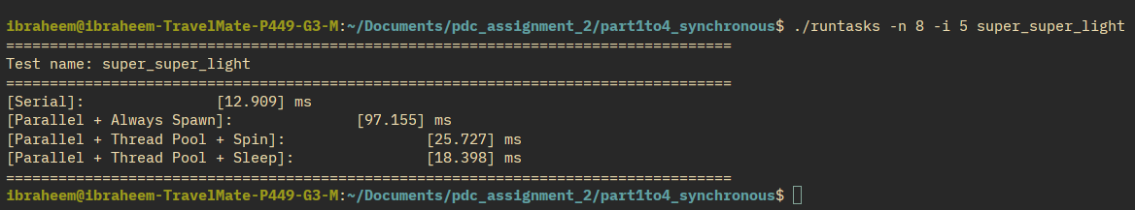

6. Part 2: Persistent Thread Pool - Spinning
Eliminating thread creation helps fine-grained work far more than coarse work. For SuperSuperLight the spinning pool is much faster than Spawn because the pool threads are already alive and simply claim tasks, while for RecursiveFibonacci the gain over Spawn is smaller because thread creation is already a small fraction of the total time.
Idle gaps are the weakness of spinning. In spin_between_run_calls the pool often has fewer runnable tasks than workers, so idle workers spin and waste CPU. At p = 16 (over-subscribed on this machine) this effect is large and the spinning pool can be much slower than the sleeping pool.
Efficiency still falls as p grows even when the pool is faster, because the number of tasks per launch limits the available concurrency and the per-task claim cost grows with the thread count.
Separating thread-management overhead from useful work. Spawn and Spin execute exactly the same tasks, so the difference between them isolates thread creation and joining. For super_super_light (400 launches) that difference per launch, (Spawn - Spin) / 400, is 46.8 microseconds at p = 1, 82.1 microseconds at p = 4 and 163.6 microseconds at p = 8. The useful work per launch is roughly the serial time divided by 400, about 33 microseconds (13.368 ms / 400), so by p = 8 the thread-management cost is already several times the useful work it is managing. For the coarse workload recursive_fibonacci the same subtraction gives about 1.0 ms per launch against roughly 56 ms of useful work per launch (1694.904 ms / 30 launches), i.e. under 2%. This is exactly why removing thread creation helps the fine-grained workload far more than the coarse one.
Limitation. The subtraction above is only an estimate. It attributes the whole Spawn - Spin gap to thread management, but part of that gap is also the spin pool's cheaper task dispatch, and at p = 16 oversubscription and memory/cache effects inflate both implementations in ways that cannot be separated from thread creation itself. The per-launch figures should therefore be read as an upper bound on thread-management overhead, not an exact measurement.

7. Part 3: Sleeping Thread Pool and Synchronization
Worker sleep condition: a worker waits inside cv_work_.wait until next_ >= total_ or stop_ is set. The events that make the predicate true are (a) a publish in run()/submit(), which pushes work onto the ready queue and calls notify_all on cv_work_, and (b) completeLaunch() waking up dependants that have become ready.
Caller wait condition: run() waits until done_ == total_, and sync() waits until completed == launches.size().
If the completion counter were updated before the task body had actually finished, then run() could return while a task was still executing (an incorrect interleaving). This is prevented by claiming the task under the mutex and incrementing done_ only after the task body has run, so publication and clearing of the launch happen atomically with respect to the caller.
The condition is always re-checked in a loop, because condition variables can wake up spuriously and because the shared state can change between the notify and the moment the woken thread re-acquires the lock. Comparing spinning and sleeping: the spinning pool wins for fine-grained back-to-back launches, while the sleeping pool wins whenever there are idle gaps, as in spin_between_run_calls.
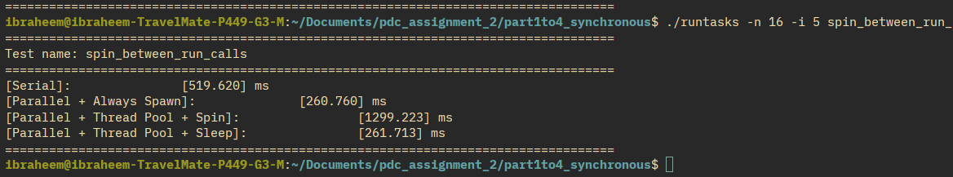

8. Part 4: Scheduling and Granularity
Schedule model: 8 tasks with costs (ms) 1, 1, 1, 1, 10, 10, 10, 10 on 4 workers. With a static contiguous assignment, worker 0 and worker 1 each get two 1 ms tasks (2 ms) and worker 2 and worker 3 each get two 10 ms tasks (20 ms), so the makespan is 20 ms and the utilisation is 10%, 10%, 100%, 100% (average 55%). With dynamic assignment the four 1 ms tasks run first and are then followed by the four 10 ms tasks, giving a makespan of 11 ms and 100% utilisation. The dynamic scheme is clearly better for irregular work.
The chunk experiment below splits a fixed amount of irregular work into a variable number of tasks. Small chunks give many tasks and good balance but high scheduling overhead; large chunks reduce overhead but reduce the number of tasks per worker and cause imbalance.
Chunk (items) | num tasks | Spin ms (n=4) | Sleep ms (n=4)
1 | 4096 | 140.692 | 123.071
8 | 512 | 77.041 | 80.192
64 | 64 | 68.453 | 72.086
256 | 16 | 75.577 | 77.753
512 | 8 | 70.183 | 71.919
1024 | 4 | 126.093 | 141.038
2048 | 2 | 246.470 | 266.427

A chunk of 64 to 512 reduces the scheduling overhead while keeping the work balanced across workers. A chunk of 2048 leaves only 2 tasks for 4 workers, so the pool is under-used and the time is much worse. A chunk of 1 loses the benefit through a very high overhead-to-work ratio.

8.1 Execution timelines
Static contiguous assignment (4 workers). Tasks 0-7 have costs 1, 1, 1, 1, 10, 10, 10, 10 ms. A static contiguous assignment gives workers 0 and 1 two cheap tasks each and workers 2 and 3 two expensive tasks each. All four workers start at t = 0.
Worker | Tasks | Busy intervals (ms) | Busy (ms) | Idle (ms)
W0 | 0, 1 | [0,1], [1,2] | 2 | 18
W1 | 2, 3 | [0,1], [1,2] | 2 | 18
W2 | 4, 5 | [0,10], [10,20] | 20 | 0
W3 | 6, 7 | [0,10], [10,20] | 20 | 0

Makespan = 20 ms. Utilisation is 2/20 = 10% for W0 and W1 and 20/20 = 100% for W2 and W3, an average of 55%.
Dynamic next-task assignment (4 workers). With dynamic assignment each worker claims the next available task. At t = 0 the four workers take the four cheap tasks 0-3 (1 ms each) and all finish at t = 1; they then take the four expensive tasks 4-7 (10 ms each) and all finish at t = 11.
Worker | Tasks | Busy intervals (ms) | Busy (ms) | Idle (ms)
W0 | 0, 4 | [0,1], [1,11] | 11 | 0
W1 | 1, 5 | [0,1], [1,11] | 11 | 0
W2 | 2, 6 | [0,1], [1,11] | 11 | 0
W3 | 3, 7 | [0,1], [1,11] | 11 | 0

Makespan = 11 ms, down from 20 ms, with 100% utilisation on every worker. Dynamic assignment is better because it cannot leave one worker holding two expensive tasks while another holds only cheap ones.

8.2 Granularity and the H/T ratio
Let H be the average scheduling and coordination overhead per scheduled unit (one task) and T the average useful computation per unit. When items are combined into chunks of size c, the useful work per scheduled unit grows roughly linearly with c, that is T is proportional to c, while the per-unit coordination cost H stays roughly constant, so H/T falls like 1/c. Very fine granularity therefore makes H/T large: at chunk = 1 there are 4096 tasks and each unit carries only one item of work, so coordination dominates and the pools take 140.692 ms (spin) and 123.071 ms (sleep) even though the serial work is only about 264 ms. Chunking to 64-512 drives H/T low enough that the load-balancing benefit of dynamic scheduling is realised (68.453 / 72.086 ms at chunk = 64), while chunking all the way to 2048 leaves only 2 tasks for 4 workers, so concurrency and balance collapse and the time rises to 246.470 / 266.427 ms. In short, dynamic scheduling only pays off while H/T is small, and very fine granularity destroys that benefit.
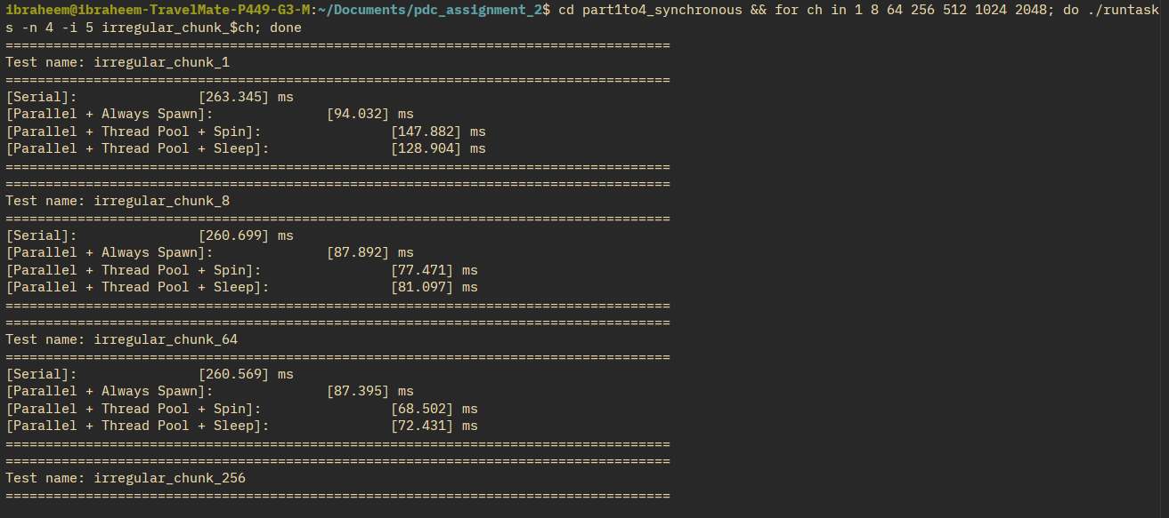
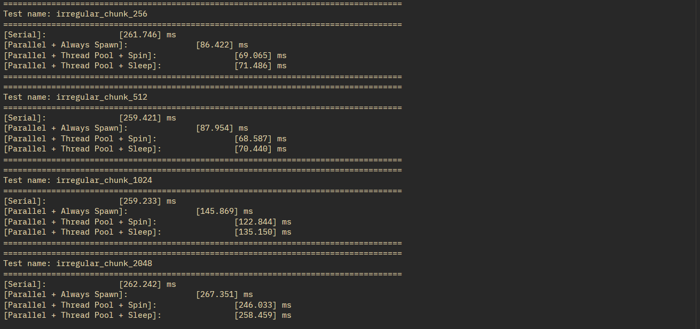

9. Part 5: Asynchronous Task Graphs
The dependancy graph used for the analysis has four launches. A is 128 tasks of 1 ms each (128 ms total), B is 2 tasks of 8 ms (16 ms) and depends on A, C is 6 tasks of 4 ms (24 ms) and also depends on A, and D is 32 tasks of 2 ms (64 ms) and depends on both B and C.
Launch | Tasks | ms/task | Total work (ms) | Dependencies
A | 128 | 1 | 128 | none
B | 2 | 8 | 16 | A
C | 6 | 4 | 24 | A
D | 32 | 2 | 64 | B, C

The ready sets are therefore {A}, then {B, C}, and finally {D}. The mandatory ordering is A before B and C, and both B and C before D. The critical path is A -> C -> D = 128 + 24 + 64 = 216 ms.
Assumptions used in the critical-path calculation: (i) a launch may not start until every launch in its dependency set has completely finished, and no work of a dependent launch may overlap with work of a predecessor; (ii) the supplied average task costs are representative, so A contributes 128 x 1 = 128 ms, B contributes 2 x 8 = 16 ms, C contributes 6 x 4 = 24 ms and D contributes 32 x 2 = 64 ms; (iii) a launch is weighted by its total work when chains are compared. The two dependency chains are A -> B -> D = 128 + 16 + 64 = 208 ms and A -> C -> D = 128 + 24 + 64 = 216 ms, so the critical path is A -> C -> D with a length of 216 ms. This is the longest chain of dependent work in the graph: it is the work that the dependencies force to be serialised, and it is the term that keeps the completion time from shrinking towards zero as more workers are added.

9.1 Measured async wall time (sleeping pool)
p | Sleep ms
1 | 249.489
2 | 123.214
4 | 65.749
8 | 35.009
16 | 21.306

The measured sleeping-pool wall time roughly halves while the wide stage A (128 independent 1 ms tasks) dominates the schedule: 249.489 -> 123.214 -> 65.749 -> 35.009 ms from p = 1 to p = 8. The next doubling, p = 8 -> 16, gives only 35.009 -> 21.306 ms, a factor of 1.64 rather than 2. The curve therefore tracks the total work divided by the number of workers (232 ms / p) closely while there is enough ready work to keep the pool busy, and flattens once the ready work runs out.
Why doubling the worker count does not halve the completion time. Two effects stop the time from halving indefinitely. First, the total work is fixed at 232 ms, so a schedule can at best divide it by p, and the dependency structure does not allow even that: each launch is blocked until its predecessors finish, so the machine periodically runs out of ready work. Second, the stages expose very different amounts of concurrency. A has 128 tasks, but B has only 2, C has 6 and D has 32 tasks, so during the tail, after A completes, at most 2 to 32 workers can be busy and the rest are idle no matter how many threads exist. The measurements show both effects: the time roughly halves from p = 1 to p = 8, but p = 8 to p = 16 improves by only 1.64x because the extra workers have almost no ready work to consume. Adding workers only helps while there is idle, runnable work available for them to pick up.

9.2 Schedules
With 2 workers, A runs from 0 to 64 ms on both workers, then B runs from 64 to 72 ms on worker 1 while C runs from 64 to 88 ms on worker 2, and finally D runs from 88 to 120 ms on both workers, giving a makespan of 120 ms. With 4 workers, A takes 32 ms, then B and C take 24 ms, and D takes 16 ms, giving a makespan of 72 ms.

9.3 Bookkeeping on completion
When the last task of a launch finishes, the launch is marked finished and completed is incremented. For every dependent launch the unmet counter is decremented, and when it reaches zero the dependent is pushed onto the ready queue and the workers are notified. If completed reaches launches.size() the caller waiting in sync() is notified. Only launches whose dependencies have all just completed change state.

9.4 Race condition prevented
The dangerous race is that a dependent could observe a stale completion value and start early. The invariant that prevents this is that dependency satisfaction, mutation of the unmet counter and the finished flag are all performed while holding the same mutex that submit() and completeLaunch() hold, and a launch is only made ready after its dependencies have been checked to be finished under that lock.

9.5 Splitting one launch into four
Test | Serial ms | Sleep ms (p=8)
your_split_one | 6.308 | 156.299
your_split_four | 6.282 | 161.852

Splitting one launch into four adds extra launches and extra synchronisation but gives no benefit, because the tasks are trivial and a single launch already saturates the pool; the sleeping pool is actually much slower than serial here. This shows that async dependencies should be used to express real data flow, not to break up work that is already parallel enough.
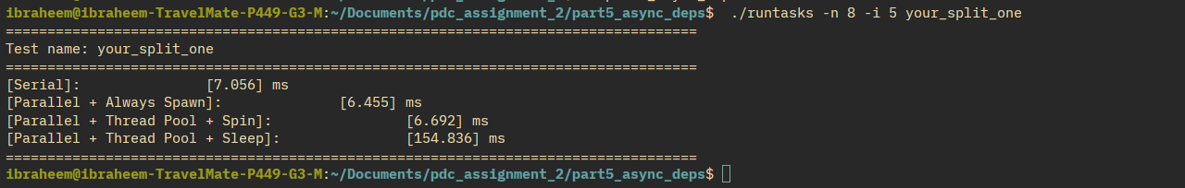
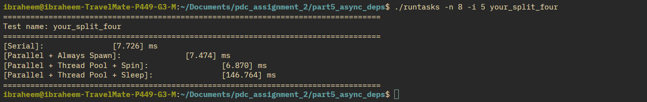

10. Combined Performance Analysis
The tables below give the derived speedup Sp and efficiency Ep for each workload and implementation.

10.1 Derived speedup and efficiency: SuperSuperLight
p | S Spawn | E Spawn | S Spin | E Spin | S Sleep | E Sleep
1 | 0.421 | 0.421 | 0.867 | 0.867 | 0.779 | 0.779
2 | 0.446 | 0.223 | 1.319 | 0.660 | 0.950 | 0.475
4 | 0.289 | 0.072 | 1.127 | 0.282 | 0.771 | 0.193
8 | 0.118 | 0.015 | 0.277 | 0.035 | 0.621 | 0.078
16 | 0.050 | 0.003 | 0.089 | 0.006 | 0.346 | 0.022

10.2 Derived speedup and efficiency: RecursiveFibonacci
p | S Spawn | E Spawn | S Spin | E Spin | S Sleep | E Sleep
1 | 0.994 | 0.994 | 0.948 | 0.948 | 0.993 | 0.993
2 | 1.841 | 0.920 | 1.655 | 0.828 | 1.835 | 0.918
4 | 2.755 | 0.689 | 2.898 | 0.724 | 3.235 | 0.809
8 | 3.837 | 0.480 | 2.177 | 0.272 | 2.704 | 0.338
16 | 2.709 | 0.169 | 1.576 | 0.098 | 2.737 | 0.171

10.3 Derived speedup and efficiency: PingPongUnequal
p | S Spawn | E Spawn | S Spin | E Spin | S Sleep | E Sleep
1 | 0.960 | 0.960 | 0.981 | 0.981 | 0.944 | 0.944
2 | 1.847 | 0.923 | 1.769 | 0.885 | 1.923 | 0.961
4 | 3.168 | 0.792 | 2.535 | 0.634 | 2.439 | 0.610
8 | 2.789 | 0.349 | 1.603 | 0.200 | 3.055 | 0.382
16 | 2.580 | 0.161 | 0.614 | 0.038 | 3.282 | 0.205

10.4 Derived speedup and efficiency: SpinBetweenRunCalls
p | S Spawn | E Spawn | S Spin | E Spin | S Sleep | E Sleep
1 | 1.075 | 1.075 | 0.924 | 0.924 | 1.053 | 1.053
2 | 1.866 | 0.933 | 1.569 | 0.784 | 1.752 | 0.876
4 | 1.882 | 0.471 | 1.450 | 0.362 | 1.756 | 0.439
8 | 1.758 | 0.220 | 0.548 | 0.069 | 1.695 | 0.212
16 | 1.806 | 0.113 | 0.343 | 0.021 | 1.537 | 0.096

10.5 Derived speedup and efficiency: MandelbrotChunked
p | S Spawn | E Spawn | S Spin | E Spin | S Sleep | E Sleep
1 | 1.021 | 1.021 | 1.059 | 1.059 | 0.970 | 0.970
2 | 1.948 | 0.974 | 1.874 | 0.937 | 2.024 | 1.012
4 | 3.996 | 0.999 | 3.716 | 0.929 | 3.313 | 0.828
8 | 6.978 | 0.872 | 5.532 | 0.691 | 5.580 | 0.697
16 | 6.599 | 0.412 | 5.840 | 0.365 | 6.946 | 0.434

10.6 Performance Charts
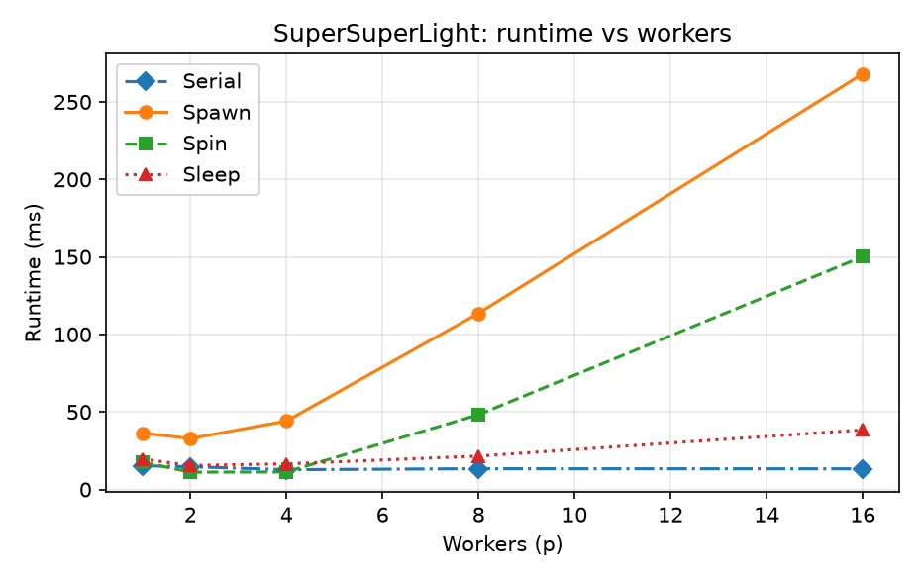
SuperSuperLight: runtime vs workers
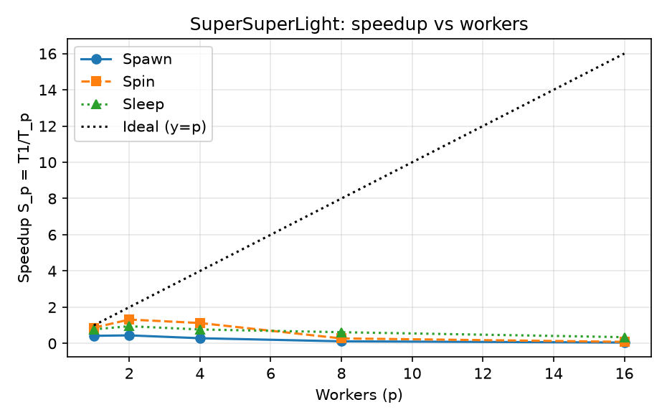
SuperSuperLight: speedup vs workers
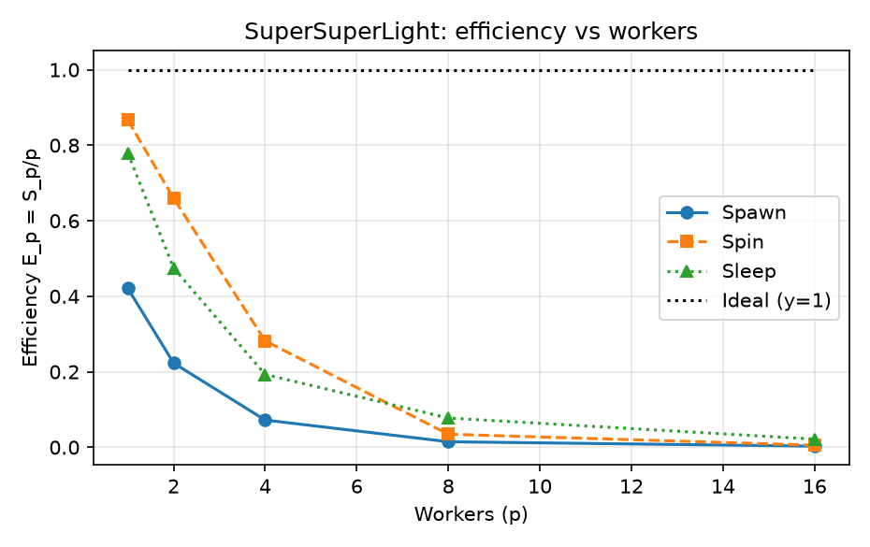
SuperSuperLight: efficiency vs workers
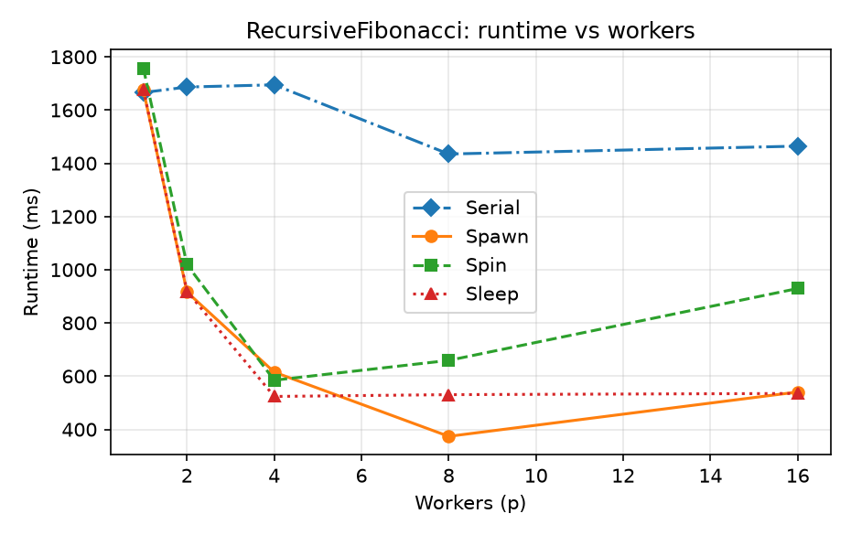
RecursiveFibonacci: runtime vs workers
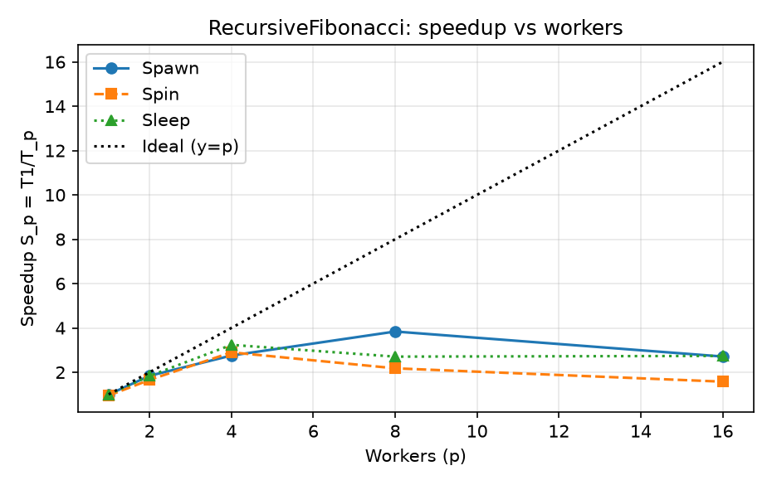
RecursiveFibonacci: speedup vs workers
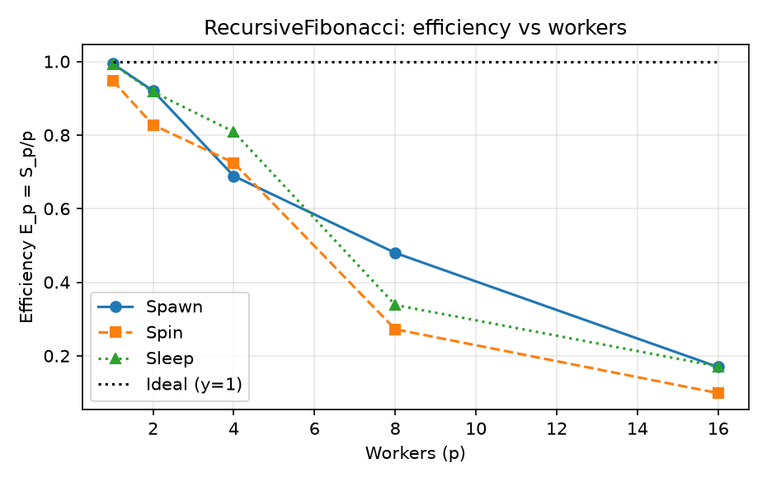
RecursiveFibonacci: efficiency vs workers
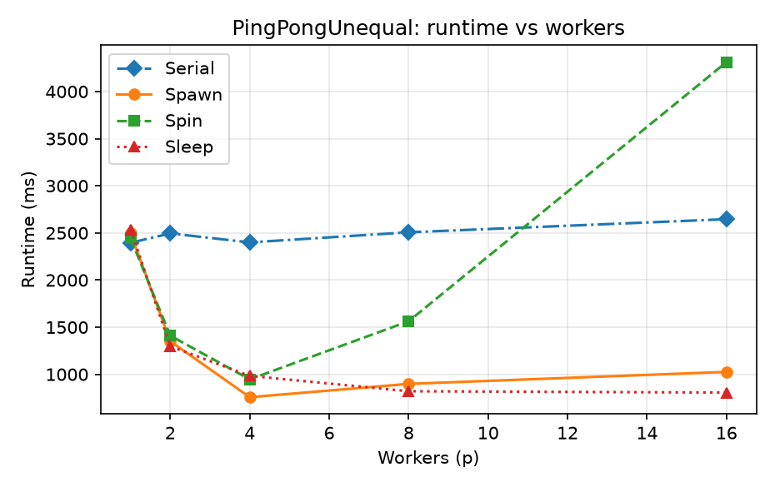
PingPongUnequal: runtime vs workers
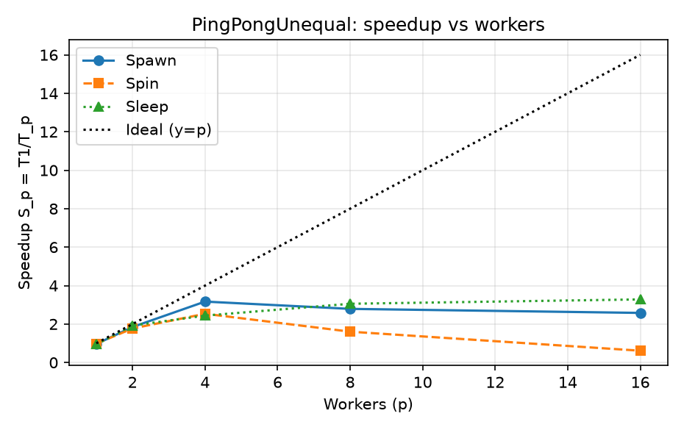
PingPongUnequal: speedup vs workers
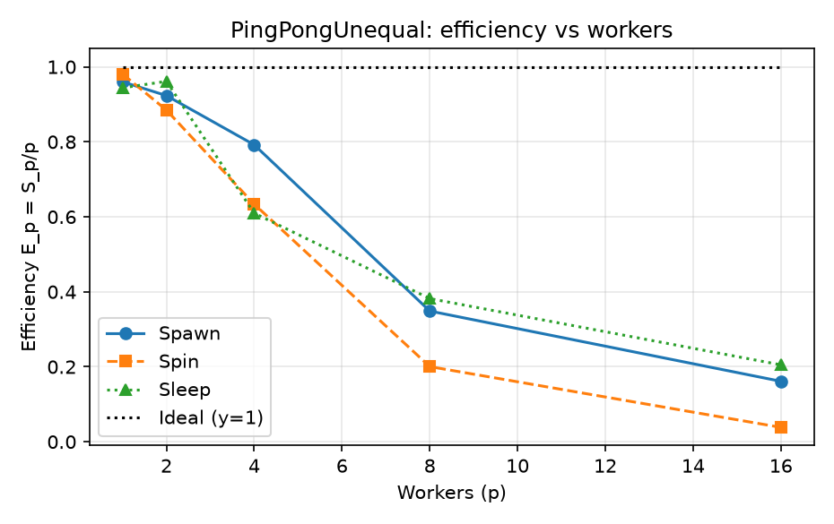
PingPongUnequal: efficiency vs workers
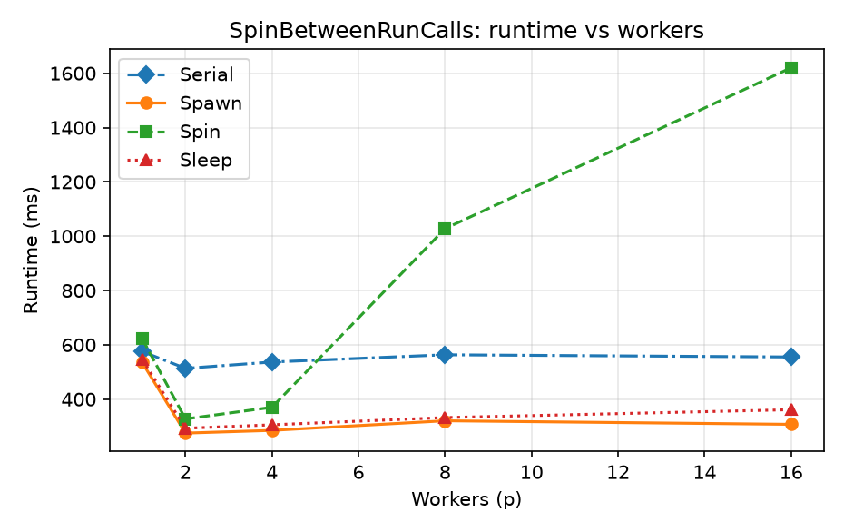
SpinBetweenRunCalls: runtime vs workers
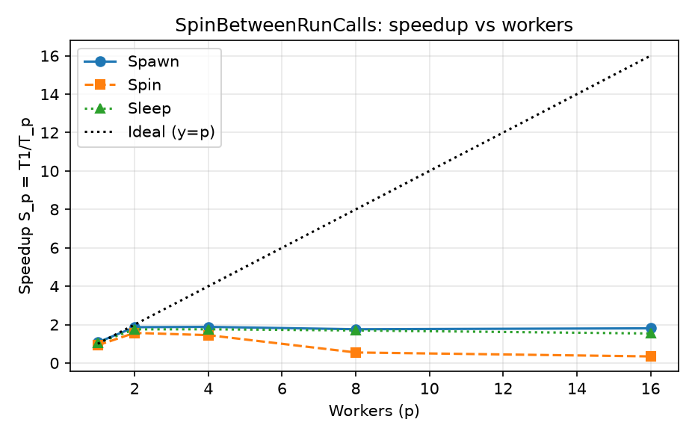
SpinBetweenRunCalls: speedup vs workers
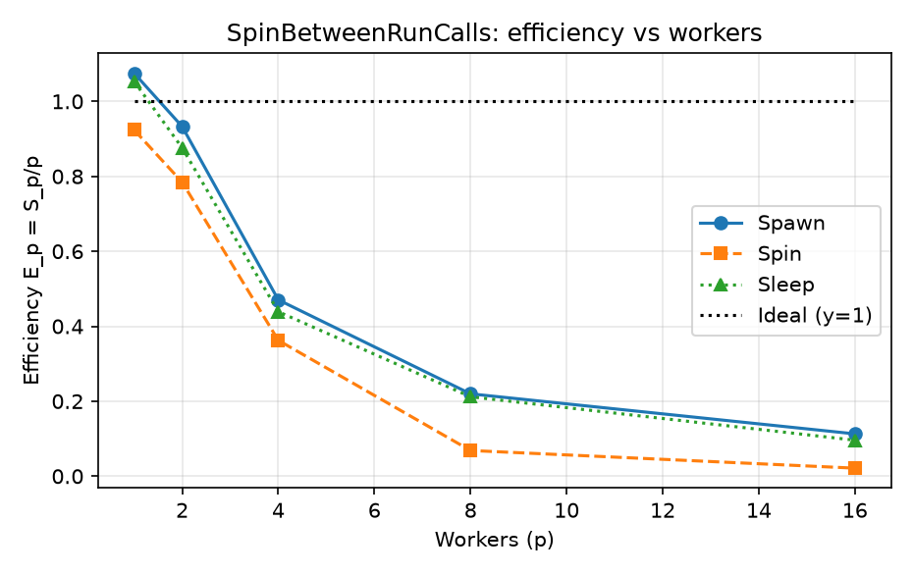
SpinBetweenRunCalls: efficiency vs workers
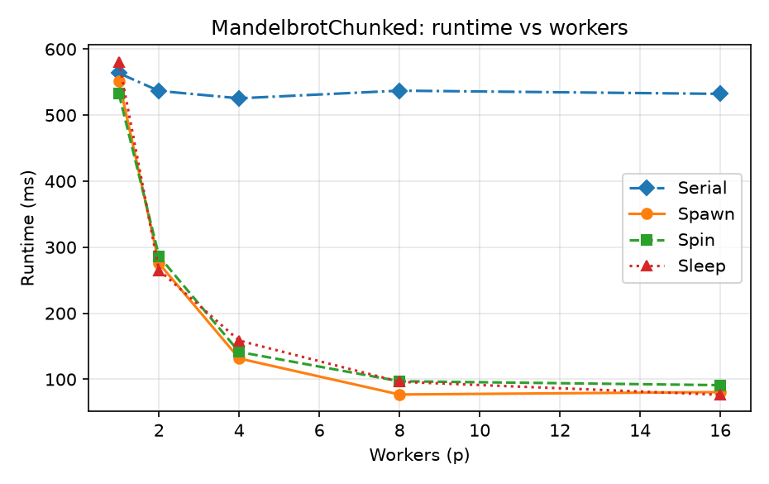
MandelbrotChunked: runtime vs workers
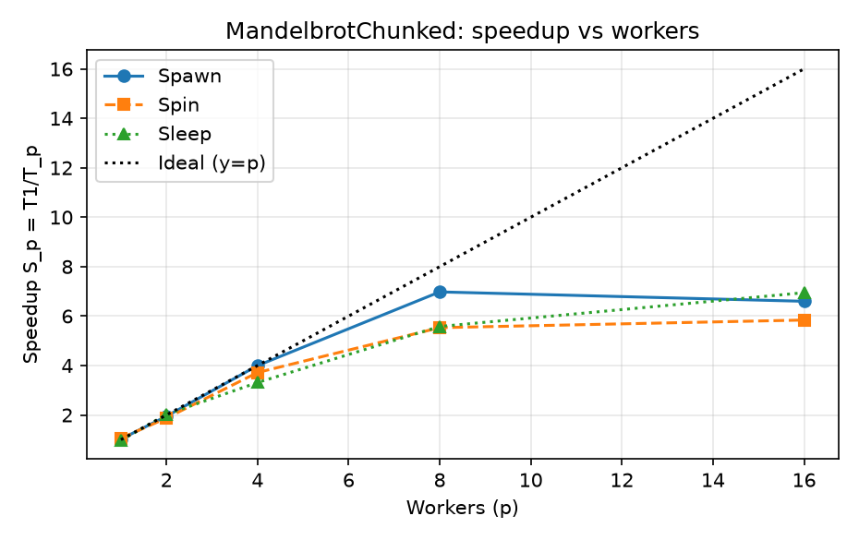
MandelbrotChunked: speedup vs workers
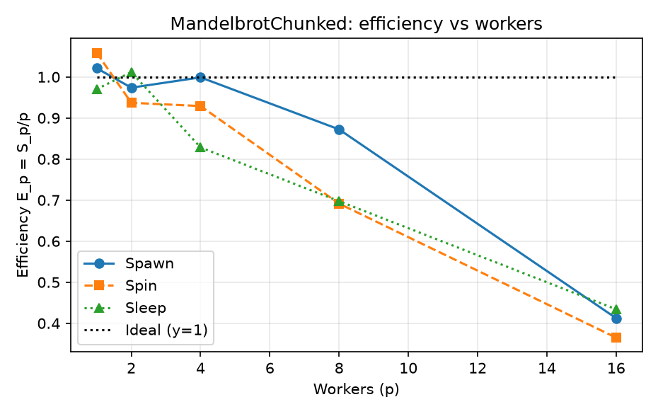
MandelbrotChunked: efficiency vs workers

10.7 Dominant limitation per workload
Workload | Dominant limitation
super_super_light | thread-management overhead and task granularity
recursive_fibonacci | insufficient concurrency at high p (only 256 tasks per launch)
ping_pong_unequal | load imbalance and queue/synchronisation contention
spin_between_run_calls | idle spinning (wasted CPU) when there are fewer tasks than workers
irregular chunk = 1 | task granularity too fine
irregular chunk = 2048 | load imbalance (too few tasks for the number of workers)

Supporting data. super_super_light: Spawn is 268.106 ms at p = 16 against 13.308 ms serial, so overhead dominates. recursive_fibonacci: each launch has only 256 tasks, so Spawn speedup falls from 3.84 at p = 8 to 2.71 at p = 16, consistent with insufficient concurrency. ping_pong_unequal: the spinning pool climbs to 4311.987 ms at p = 16 while sleeping stays at 806.276 ms, the signature of contention and idle spinnning on unequal-cost tasks. spin_between_run_calls: the spinning pool is 1027.821 ms at p = 8 against 332.450 ms for sleeping, the signature of idle spinning. irregular chunk = 1: 123.071 ms (sleep) versus 68.453 ms at chunk = 64, so fine granularity costs more than it saves. irregular chunk = 2048: 266.427 ms (sleep), close to the 274.567 ms serial time, because only 2 tasks exist for 4 workers.

10.8 Predictions
Confirmed prediction: the coarse workloads scaled best. MandelbrotChunked, a single coarse launch, reached the highest speedup on this machine, RecursiveFibonacci also scaled well, and SuperSuperLight was the worst case, with the Spawn implementation actually slower than serial, because the useful work per launch is tiny relative to the overhead.
Contradicted prediction: I expected that adding workers would always help, but spin_between_run_calls at p = 16 shows the spinning pool getting much slower than the sleeping pool, because the pool is larger than the number of runnable tasks and the idle workers spend their time spinning. In other words, more workers are not free when they are not doing useful work.

10.9 When each design is appropriate
Serial: for tiny or single-launch work where the parallel overhead would exceed the useful work.
Spawn: for infrequent, coarse launches where the cost of creating threads is small relative to the work.
Spinning pool: for fine-grained, busy, back-to-back launches running on dedicated cores, where the wake-up latency of the sleeping pool would be paid too often.
Sleeping pool: the sensible default, and the right choice whenever there are idle gaps, asynchronous dependency graphs, or more workers than runnable tasks.

10.10 Combined table of T1, Tp, Sp and Ep
The tables below collect T1 (the supplied serial runtime at that worker count), Tp (the runtime of each parallel implementation), and the derived speedup Sp = T1 / Tp and efficiency Ep = Sp / p, for every reported measurement.
SuperSuperLight
p | T1 | Tp Spawn | S Spawn | E Spawn | Tp Spin | S Spin | E Spin | Tp Sleep | S Sleep | E Sleep
1 | 15.310 | 36.372 | 0.421 | 0.421 | 17.663 | 0.867 | 0.867 | 19.646 | 0.779 | 0.779
2 | 14.657 | 32.838 | 0.446 | 0.223 | 11.109 | 1.319 | 0.660 | 15.430 | 0.950 | 0.475
4 | 12.738 | 44.122 | 0.289 | 0.072 | 11.298 | 1.127 | 0.282 | 16.517 | 0.771 | 0.193
8 | 13.368 | 113.663 | 0.118 | 0.015 | 48.232 | 0.277 | 0.035 | 21.542 | 0.621 | 0.078
16 | 13.308 | 268.106 | 0.050 | 0.003 | 150.173 | 0.089 | 0.006 | 38.437 | 0.346 | 0.022

RecursiveFibonacci
p | T1 | Tp Spawn | S Spawn | E Spawn | Tp Spin | S Spin | E Spin | Tp Sleep | S Sleep | E Sleep
1 | 1665.890 | 1675.741 | 0.994 | 0.994 | 1757.156 | 0.948 | 0.948 | 1676.989 | 0.993 | 0.993
2 | 1686.569 | 916.314 | 1.841 | 0.920 | 1018.924 | 1.655 | 0.828 | 919.027 | 1.835 | 0.918
4 | 1694.904 | 615.277 | 2.755 | 0.689 | 584.894 | 2.898 | 0.724 | 523.893 | 3.235 | 0.809
8 | 1434.903 | 373.961 | 3.837 | 0.480 | 659.263 | 2.177 | 0.272 | 530.599 | 2.704 | 0.338
16 | 1464.489 | 540.620 | 2.709 | 0.169 | 929.472 | 1.576 | 0.098 | 535.144 | 2.737 | 0.171

PingPongUnequal
p | T1 | Tp Spawn | S Spawn | E Spawn | Tp Spin | S Spin | E Spin | Tp Sleep | S Sleep | E Sleep
1 | 2395.463 | 2495.090 | 0.960 | 0.960 | 2442.302 | 0.981 | 0.981 | 2537.677 | 0.944 | 0.944
2 | 2494.752 | 1351.012 | 1.847 | 0.923 | 1409.938 | 1.769 | 0.885 | 1297.496 | 1.923 | 0.961
4 | 2399.556 | 757.401 | 3.168 | 0.792 | 946.690 | 2.535 | 0.634 | 983.818 | 2.439 | 0.610
8 | 2506.614 | 898.715 | 2.789 | 0.349 | 1563.216 | 1.603 | 0.200 | 820.529 | 3.055 | 0.382
16 | 2645.840 | 1025.682 | 2.580 | 0.161 | 4311.987 | 0.614 | 0.038 | 806.276 | 3.282 | 0.205

SpinBetweenRunCalls
p | T1 | Tp Spawn | S Spawn | E Spawn | Tp Spin | S Spin | E Spin | Tp Sleep | S Sleep | E Sleep
1 | 575.479 | 535.237 | 1.075 | 1.075 | 622.881 | 0.924 | 0.924 | 546.284 | 1.053 | 1.053
2 | 513.465 | 275.221 | 1.866 | 0.933 | 327.327 | 1.569 | 0.784 | 293.043 | 1.752 | 0.876
4 | 536.809 | 285.207 | 1.882 | 0.471 | 370.229 | 1.450 | 0.362 | 305.755 | 1.756 | 0.439
8 | 563.455 | 320.534 | 1.758 | 0.220 | 1027.821 | 0.548 | 0.069 | 332.450 | 1.695 | 0.212
16 | 555.364 | 307.467 | 1.806 | 0.113 | 1620.158 | 0.343 | 0.021 | 361.322 | 1.537 | 0.096

MandelbrotChunked
p | T1 | Tp Spawn | S Spawn | E Spawn | Tp Spin | S Spin | E Spin | Tp Sleep | S Sleep | E Sleep
1 | 563.517 | 551.752 | 1.021 | 1.021 | 532.224 | 1.059 | 1.059 | 580.824 | 0.970 | 0.970
2 | 536.639 | 275.516 | 1.948 | 0.974 | 286.326 | 1.874 | 0.937 | 265.196 | 2.024 | 1.012
4 | 525.465 | 131.501 | 3.996 | 0.999 | 141.390 | 3.716 | 0.929 | 158.592 | 3.313 | 0.828
8 | 537.033 | 76.960 | 6.978 | 0.872 | 97.078 | 5.532 | 0.691 | 96.251 | 5.580 | 0.697
16 | 532.193 | 80.651 | 6.599 | 0.412 | 91.128 | 5.840 | 0.365 | 76.614 | 6.946 | 0.434

11. Conclusion
All five parts are implemented and all 41 tests pass. The measurements on this machine match the general expectations: fine-grained work is dominated by overhead, coarse work scales close to the critical path, and the sleeping pool is the most robust design because it does not waste CPU when there is nothing to do. The spin_between_run_calls result at p = 16 is a reminder that adding workers beyond the number of runnable tasks can make a design worse rather than better.

Appendix A: Correctness Logs (referenced earlier in this file)
