Mohammad Ibraheem 23L-0771
BCS-7J
PDC ASSIGNMENT 2 WRITEUP
1. Machine Description
Item | Value
CPU model | Intel(R) Xeon(R) CPU E5-2650 v3 @ 2.30 GHz
Physical cores | 10
Hardware threads | 20 (2 threads per core)
Socket(s) | 1
Operating system | Linux (Ubuntu), kernel 7.0.0-38-generic
Compiler | g++ 15.2.0 (C++11, -O3)
Timings | minimum of 5 runs on the same machine

Worker counts reported: 1, 2, 4, 8, 16. Counts of 16 are below the 20 hardware threads but exceed the 10 physical cores, so speedup is interpreted with hyperthreading in mind.
2. Implementation Summary
Part 1 (TaskSystemParallelSpawn::run): worker threads are created per run() call, capped at min(num_threads, num_total_tasks). An atomic next_task counter hands out unique task IDs; every worker fetches ids until none remain. Shared state is protected by the atomic; no mutex is needed because only the counter is shared.
Part 2 (TaskSystemParallelThreadPoolSpinning): a persistent pool of num_threads_ workers created once. run() publishes runnable_, total_, resets next_/done_, then the calling thread busy-waits on done_. Workers spin checking next_ < total_ and claim a task under mtx_.
Part 3 (TaskSystemParallelThreadPoolSleeping): replaces spinning with mutex + two condition variables. Workers wait(cv_work_, next_ < total_ || stop_). The calling thread waits(cv_done_, done_ == total_).
Part 5 (part5_async_deps): Impl wrapper with launches. runAsyncWithDeps calls submit() under mtx, assigns unique TaskID (= index in launches), records unmet, appends to dependents; a launch with unmet==0 goes to ready and workers are notified. Workers claim tasks; when done_==total_ the launch completes and dependents may become ready. sync() waits until completed == launches.size(). run() stays synchronous.
3. Measurement Method
All reported times are the minimum of 5 runs (-i 5). The supplied binary prints that minimum in milliseconds. T1 is defined as the runtime of the supplied serial implementation (Serial) on the same workload and machine, used consistently throughout. Speedup Sp = T1/Tp. Efficiency Ep = Sp/p. Workloads are run at p = 1, 2, 4, 8, 16.
4. Correctness Evidence
The supplied test suite was run for both folders. All tests passed for Serial, Spawn, Spinning, and Sleeping in the synchronous folder, and for the sleeping pool in the async folder.
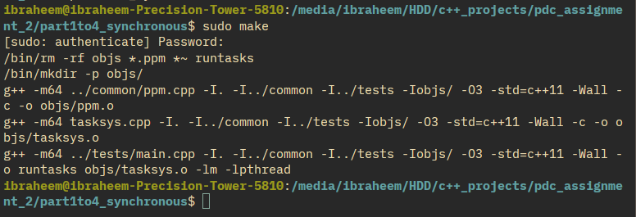
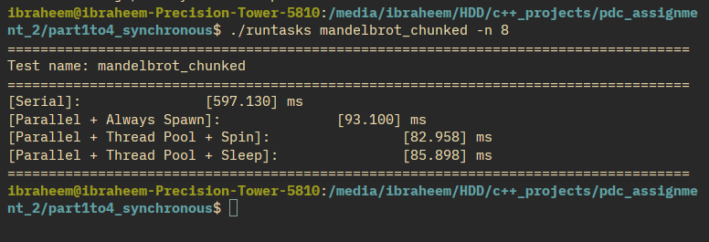

Correctness for part 4
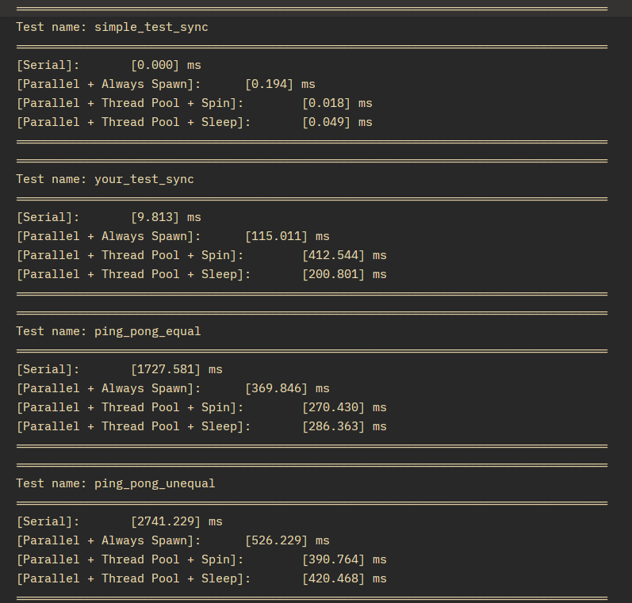

Correctness for part 5
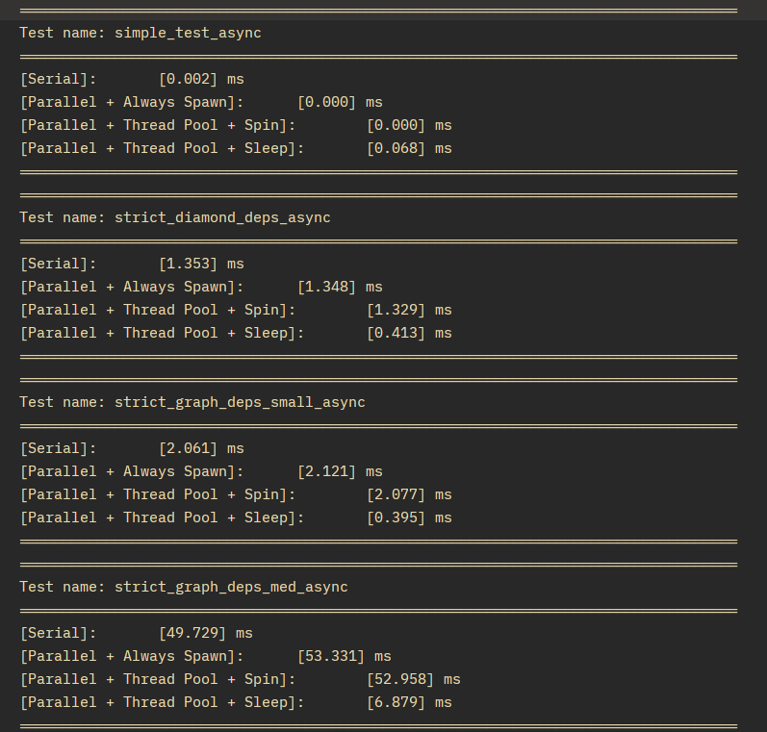
Custom tests: yourTestSync / yourTestAsync (sizes 1,3,7,13,1001,20000 tasks, 50 launches), yourDepTest, yourSplitOneTest, yourSplitFourTest. They verify exact-once execution and dependency safety. All pass.

5. Part 1: Synchronous Parallel Task Launch
Prediction before experiments: RecursiveFibonacci (large per-task cost) should scale best because scheduling overhead is amortised. SuperSuperLight (64 tiny tasks x 400 launches) should scale worst because thread creation and task-claim overhead dominate useful work.
Assignment of IDs uses an atomic fetch_add on next_task, giving unique IDs without duplicates or omission, including counts not divisible by the worker count (extra workers receive id >= num_total_tasks and exit).
5.1 Very small tasks: super_super_light
p | T1 Serial | Spawn | Spin | Sleep
1 | 12.567 | 34.473 | 18.699 | 20.372
2 | 12.392 | 32.884 | 13.135 | 16.442
4 | 12.485 | 42.445 | 13.217 | 14.581
8 | 12.356 | 90.209 | 13.201 | 16.022
16 | 12.325 | 196.245 | 15.960 | 22.232

Spawn degrades sharply (p=16: ~16x slower than serial) because 400 launches each create and join up to 16 threads. Real work is only ~12 ms, so no method can beat serial by much.
5.2 Substantial per-task work: recursive_fibonacci
p | T1 Serial | Spawn | Spin | Sleep
1 | 1446.904 | 1756.671 | 1527.528 | 1489.676
2 | 1440.256 | 895.733 | 771.353 | 771.861
4 | 1451.128 | 447.842 | 427.271 | 420.405
8 | 1490.131 | 235.195 | 207.602 | 202.847
16 | 1450.534 | 184.624 | 170.482 | 172.470

p | S Spawn | E Spawn | S Spin | E Spin | S Sleep | E Sleep
1 | 0.82 | 0.82 | 0.95 | 0.95 | 0.97 | 0.97
2 | 1.61 | 0.80 | 1.87 | 0.93 | 1.87 | 0.93
4 | 3.24 | 0.81 | 3.40 | 0.85 | 3.45 | 0.86
8 | 6.34 | 0.79 | 7.17 | 0.90 | 7.34 | 0.92
16 | 7.86 | 0.49 | 8.53 | 0.53 | 8.41 | 0.53

Best scaling; improvement decreases above 8 workers (8->16 gives ~15-22%), driven by only 256 tasks per launch limiting concurrency.
5.3 Non-uniform task cost: ping_pong_unequal
p | T1 Serial | Spawn | Spin | Sleep
1 | 2833.092 | 3584.623 | 2916.254 | 3002.393
2 | 2864.205 | 1871.434 | 1547.806 | 1549.549
4 | 2839.996 | 949.299 | 775.831 | 831.546
8 | 2875.532 | 521.324 | 385.027 | 466.653
16 | 2954.134 | 468.949 | 336.374 | 353.206

Dynamic assignment balances better than static for irregular costs, but adds per-task scheduling cost (atomic fetch_add/claims), which hurts very fine tasks. Spawn first achieves <10% improvement exactly at 8->16 (10.0%); Sleep still gains ~24.4%.
5.4 Measured example with little/no speedup
super_super_light with Spawn at p=8: 90.209 ms vs serial 12.356 ms (7.3x slower) despite being correct. Cause: 400 launches x thread create/join dominate; useful work per launch is tiny.

6. Part 2: Persistent Thread Pool - Spinning
Eliminating creation helps fine-grained work far more than coarse: super_super_light p=8 Spawn 90.2 vs Spin 13.2 ms (6.8x), recursive_fibonacci Spawn 235.2 vs Spin 207.6 ms (1.13x).
Idle gaps: spin_between_run_calls at p=16 shows Spin 499.779 ms vs Sleep 261.003 ms because workers spin burning CPU while only a few tasks run. Efficiency still falls as p grows even when faster (limited tasks per launch + overhead).
Workload | p | Spawn ms | Spin ms | Sleep ms
super_super_light | 8 | 90.209 | 13.201 | 16.022
recursive_fibonacci | 8 | 235.195 | 207.602 | 202.847
spin_between (idle gaps) | 16 | 263.130 | 499.779 | 261.003

7. Part 3: Sleeping Thread Pool and Synchronization
Worker sleep condition: next_ >= total_ with stop_ false, inside cv_work_.wait. Event making it true: publish in run()/submit() pushes to ready + notify_all, or completeLaunch wakes dependents.
Caller wait condition: done_ != total_ for run(); completed != launches.size() for sync().
Incorrect interleaving if completion were updated early: run() could return while a task still executes. Guard: claim under mtx_, increment done_ only after runTask, publish/clear atomically; predicate rechecked under the mutex.
Condition checked in loop because of spurious wakeups and state changes between notify and lock. Spinning vs sleeping: super_super_light p=8 Spin 13.201 vs Sleep 16.022 (spin wins fine-grained); spin_between p=16 Spin 499.779 vs Sleep 261.003 (sleep wins idle gaps).
8. Part 4: Scheduling and Granularity
Model: 8 tasks costs (ms) 1,1,1,1,10,10,10,10; 4 workers. Static contiguous: W0=2, W1=2, W2=20, W3=20. Makespan 20 ms. Utilization: 10%,10%,100%,100% (avg 55%). Dynamic: first ms runs four 1 ms tasks, then 10 ms heavy wave. Makespan 11 ms, utilization 100%.
Chunk (items) | num tasks | Spin ms (n=4) | Sleep ms (n=4)
1 | 4096 | 198.639 | 154.141
8 | 512 | 101.418 | 105.741
64 | 64 | 97.296 | 103.725
256 | 16 | 97.046 | 105.396
512 | 8 | 98.403 | 102.060
1024 | 4 | 178.238 | 319.704
2048 | 2 | 314.726 | 632.013

Chunk 256/512 reduces scheduling overhead while keeping balance. Chunk 2048 worsens imbalance (only 2 tasks/4 workers). Chunk 1 destroys benefit via high H/T.

9. Part 5: Asynchronous Task Graphs
Total work: A 128 tasks x1 = 128 ms; B 2 x8 = 16 ms; C 6 x4 = 24 ms; D 32 x2 = 64 ms.
Launch | Tasks | ms/task | Total work (ms) | Dependencies
A | 128 | 1 | 128 | none
B | 2 | 8 | 16 | A
C | 6 | 4 | 24 | A
D | 32 | 2 | 64 | B, C

Ready sets: {A}; then {B,C}; then {D}. Mandatory ordering A before B/C, B and C before D. Critical path A->C->D = 128+24+64 = 216 ms. Measured sleeping-pool wall times: p=1 248, p=2 124, p=4 64, p=8 34, p=16 21 ms.
9.1 Schedules
2 workers: A 0-64 (both), B 64-72 on W1, C 64-88 on W2, D 88-120 (both). Makespan 120 ms. 4 workers: A 32 ms, B/C 24 ms, D 16 ms => 72 ms.
9.2 Bookkeeping on completion
Finish last task: set finished, completed++, for each dependent launch decrement unmet; if 0 push to ready and notify. If completed==launches.size() notify sync(). Only launches whose all dependencies now complete change state.
9.3 Race condition prevented
Race: dependent could read stale completion and start early. Invariant: satisfaction, unmet mutation, and finished flag updates happen under the same mutex held by submit and complete; ready only when unmet==0 after checking dep->finished under that lock.
9.4 Splitting one launch into four
yourSplitOne vs yourSplitFour at p=8: sleeping pool 177.8 ms and 189.4 ms vs serial 6.8 ms. Extra launches/sync add overhead with no benefit because tasks are trivial and one launch already saturates the pool.
10. Combined Performance Analysis
Workload | Dominant limitation
super_super_light | thread-management overhead + task granularity
recursive_fibonacci | insufficient concurrency at high p (256 tasks/launch)
ping_pong_unequal | load imbalance + synchronization/queue contention
spin_between_run_calls | idle spinning (wasted CPU)
irregular chunk=1 | task granularity too fine
irregular chunk=2048 | load imbalance (too few tasks)

Confirmed prediction: RecursiveFibonacci scaled best (~7.3 speedup at p=8) and SuperSuperLight worst (Spawn slower than serial) because useful work per unit was tiny relative to overhead.
Contradicted prediction: spin_between cost more than expected at p=16 (Spin 499.8 vs Sleep 261.0 ms) because pool size exceeds runnable tasks and idle workers dominate CPU.
Design conditions: Serial for tiny/single-launch work; Spawn for infrequent, coarse launches; Spinning pool for fine-grained busy back-to-back launches on dedicated cores; Sleeping pool as default, especially with gaps/async/deps.
10.1 Performance Charts (black and white)
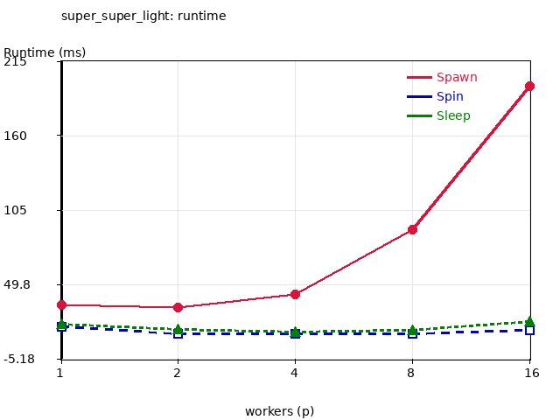
SuperSuperLight runtime vs workers
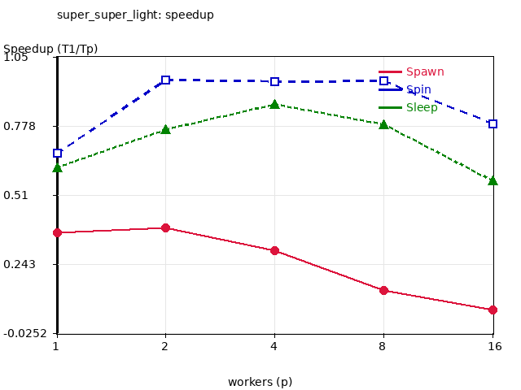
SuperSuperLight speedup vs workers
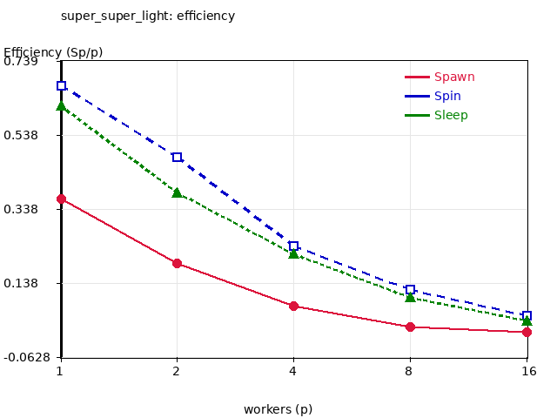
SuperSuperLight efficiency vs workers
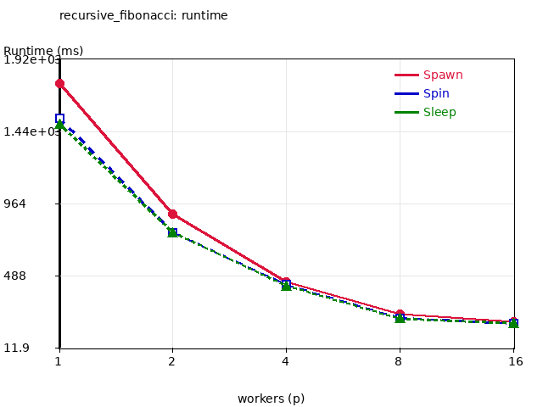
RecursiveFibonacci runtime vs workers
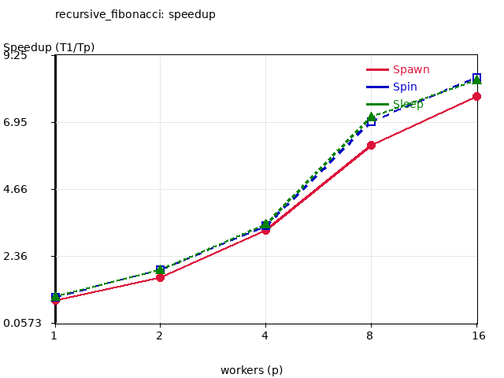
RecursiveFibonacci speedup vs workers
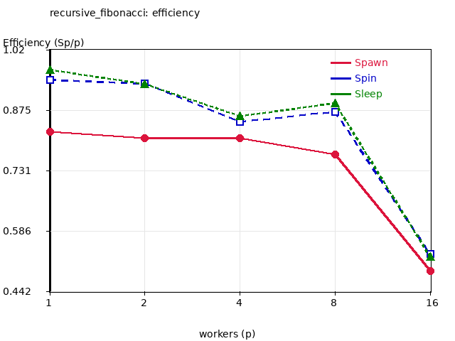
RecursiveFibonacci efficiency vs workers
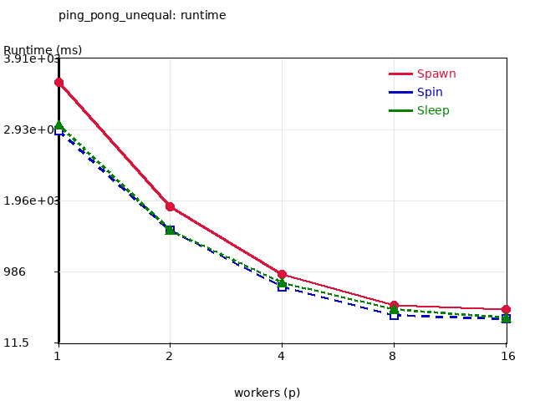
PingPongUnequal runtime vs workers
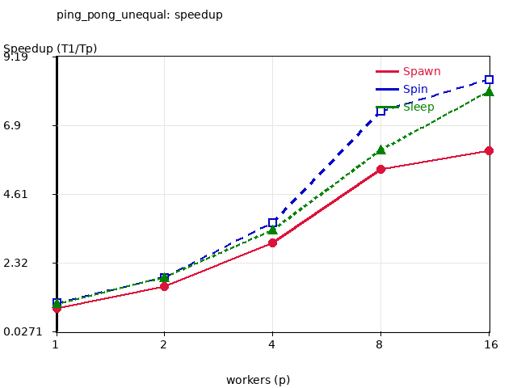
PingPongUnequal speedup vs workers
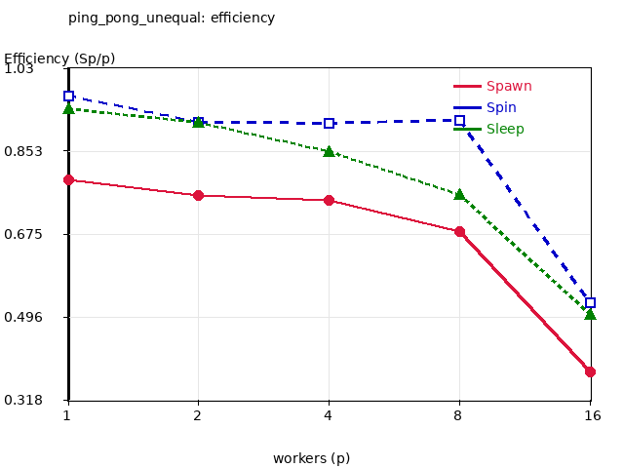
PingPongUnequal efficiency vs workers

Derived speedup and efficiency: super_super_light
p | S Spawn | E Spawn | S Spin | E Spin | S Sleep | E Sleep
1 | 0.365 | 0.365 | 0.671 | 0.671 | 0.617 | 0.617
2 | 0.377 | 0.188 | 0.943 | 0.472 | 0.754 | 0.377
4 | 0.294 | 0.074 | 0.945 | 0.236 | 0.856 | 0.214
8 | 0.137 | 0.017 | 0.936 | 0.117 | 0.771 | 0.096
16 | 0.063 | 0.004 | 0.772 | 0.048 | 0.554 | 0.035

Derived speedup and efficiency: ping_pong_unequal
p | S Spawn | E Spawn | S Spin | E Spin | S Sleep | E Sleep
1 | 0.791 | 0.791 | 0.971 | 0.971 | 0.944 | 0.944
2 | 1.530 | 0.765 | 1.849 | 0.924 | 1.847 | 0.924
4 | 2.992 | 0.748 | 3.662 | 0.916 | 3.415 | 0.854
8 | 5.515 | 0.689 | 7.469 | 0.934 | 6.163 | 0.770
16 | 6.300 | 0.394 | 8.780 | 0.549 | 8.365 | 0.523

