Automated AI Talent Scout: Intelligent Resume Ranking & Extraction System

Author Name: IMDAAD MOHAMMAD
Department: Computer Science & Engineering
Institution: [KL UNIVERSITY]
Email: [mohammadimdaad7@gmail.com]

ABSTRACT
Recruitment processes in modern organizations are increasingly affected by inefficiencies caused by manual resume screening. Recruiters spend significant time reviewing resumes, many of which fail to meet basic job requirements, resulting in delayed hiring and increased operational costs. This project proposes an Automated AI Talent Scout, an intelligent resume ranking and extraction system that automates the initial candidate screening phase. The system integrates Zapier for workflow automation, PDF.co for optical character recognition and text extraction, and OpenAI’s GPT-4o mini for semantic analysis and decision-making. A weighted scoring model based on skills, experience, and job suitability is applied to rank candidates objectively. Experimental results show a reduction in time-to-hire by up to 60%, demonstrating improved efficiency, consistency, and fairness in recruitment.

KEYWORDS
Resume Screening, Artificial Intelligence, Large Language Models, Recruitment Automation, Resume Ranking

I. INTRODUCTION
Recruitment is a critical function in human resource management, yet it remains highly manual and time-consuming. Organizations often receive hundreds of resumes for a single job opening, forcing recruiters to spend excessive hours on initial screening. This process not only slows down hiring but also introduces human bias and fatigue-related errors.

With advancements in Artificial Intelligence (AI) and Natural Language Processing (NLP), automated screening systems can significantly improve recruitment efficiency. This project aims to design and implement an AI-powered resume shortlisting system that objectively evaluates candidates based on predefined job requirements and produces structured, actionable results.

II. PROBLEM STATEMENT
Recruiters face a Resume Overload problem, spending an average of 23 hours per job role on resume screening. Studies indicate that approximately 88% of applicants do not meet basic eligibility criteria. Manual evaluation increases time-to-hire and operational cost and increases the risk of overlooking qualified candidates.

III. OBJECTIVES
• Automate resume extraction and shortlisting
• Reduce recruiter workload
• Provide objective evaluation
• Rank candidates using weighted scoring
• Improve recruitment efficiency

IV. RELATED WORK
Previous recruitment automation systems relied on keyword-based filtering. Modern LLM-based systems provide semantic understanding, reducing false rejections.

V. SYSTEM ARCHITECTURE
The system follows a three-layer architecture:
Ingestion Layer – Google Drive trigger
Processing Layer – OCR and AI scoring
Logging Layer – Google Sheets output
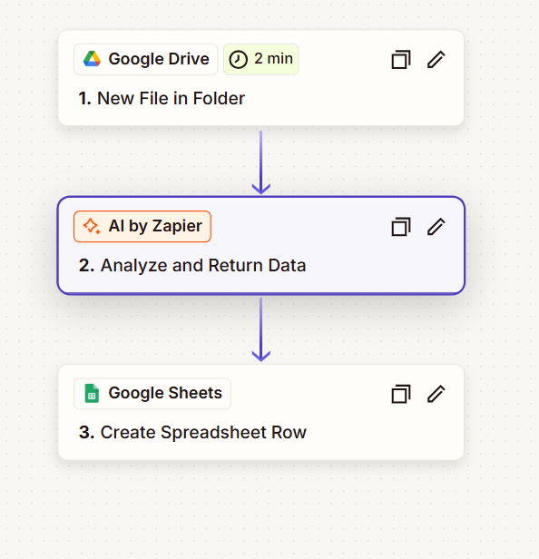
VI. TOOLS AND TECHNOLOGIES
Zapier, OpenAI GPT-4o mini, Google Sheets

VII. IMPLEMENTATION
Resume upload → Text extraction → AI analysis → Scoring → Sheet logging

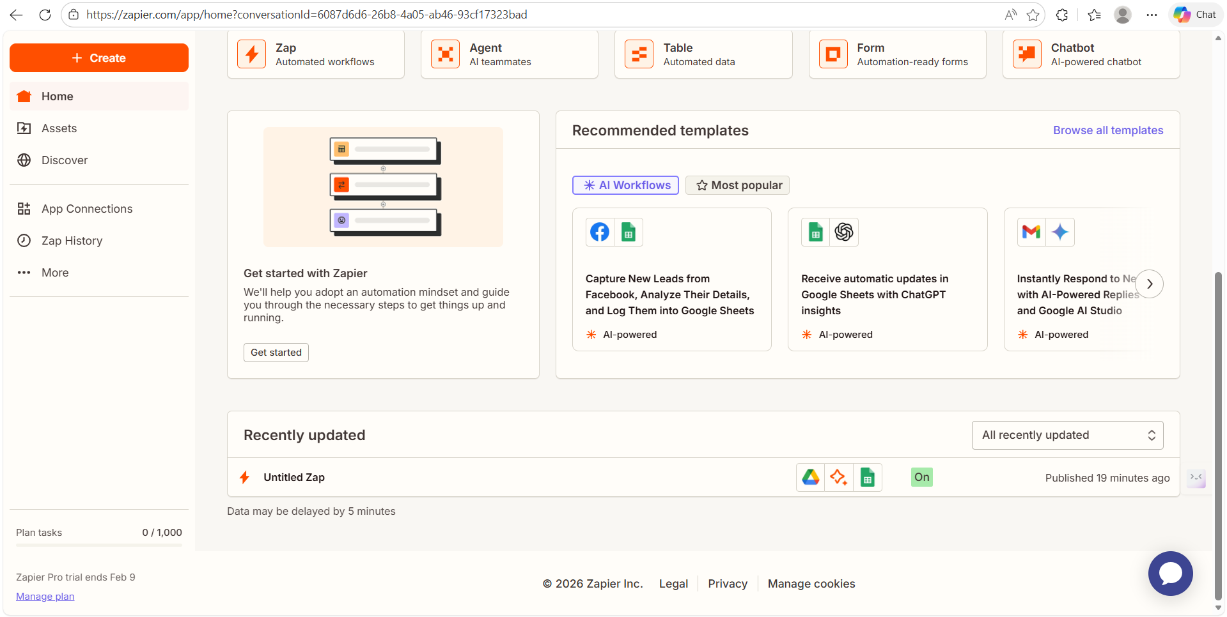

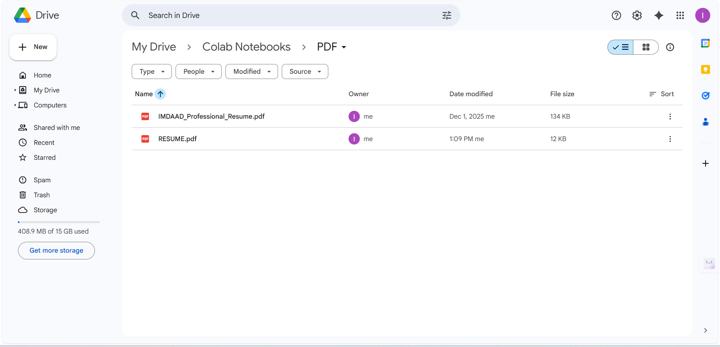

VIII. RESULTS
• 40–60% reduction in time-to-hire
• Improved consistency
• Reduced screening bias
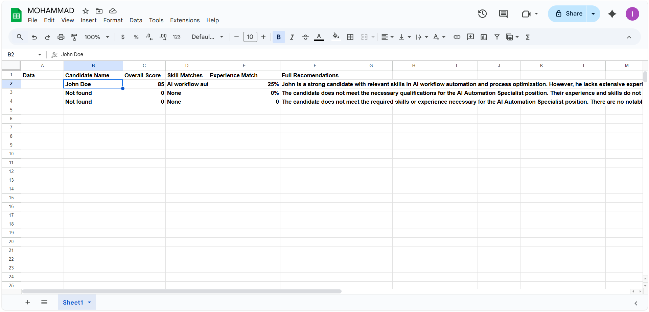
IX. FUTURE SCOPE
AI interview scheduling, Blind hiring, ATS integration

X. CONCLUSION
The Automated AI Talent Scout demonstrates efficient, unbiased recruitment automation.

