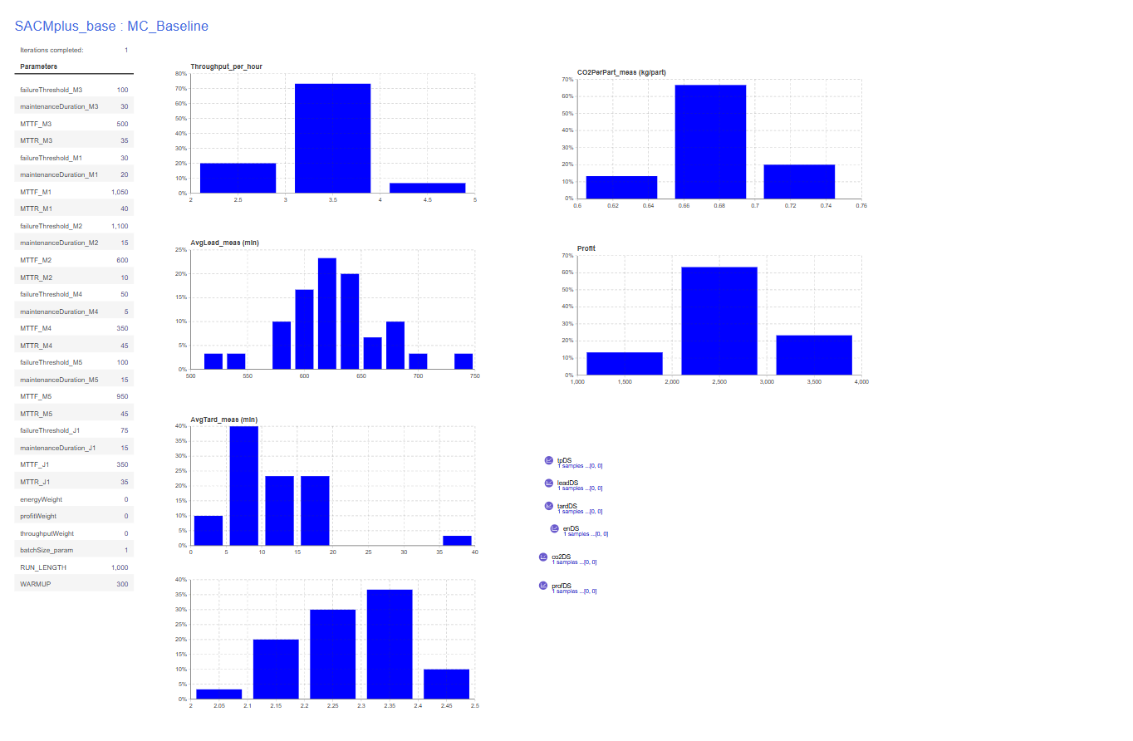
Console:
Warm-up reached. measuring=true
measuring=true leadSamples=46 tardSamples=46
Warm-up reached. measuring=true
measuring=true leadSamples=43 tardSamples=43
Warm-up reached. measuring=true
measuring=true leadSamples=44 tardSamples=44
Warm-up reached. measuring=true
measuring=true leadSamples=41 tardSamples=41
Warm-up reached. measuring=true
measuring=true leadSamples=40 tardSamples=40
Warm-up reached. measuring=true
measuring=true leadSamples=34 tardSamples=34
Warm-up reached. measuring=true
measuring=true leadSamples=31 tardSamples=31
Warm-up reached. measuring=true
measuring=true leadSamples=42 tardSamples=42
Warm-up reached. measuring=true
measuring=true leadSamples=43 tardSamples=43
Warm-up reached. measuring=true
measuring=true leadSamples=43 tardSamples=43
Warm-up reached. measuring=true
measuring=true leadSamples=46 tardSamples=46
Warm-up reached. measuring=true
measuring=true leadSamples=42 tardSamples=42
Warm-up reached. measuring=true
measuring=true leadSamples=26 tardSamples=26
Warm-up reached. measuring=true
measuring=true leadSamples=51 tardSamples=51
Warm-up reached. measuring=true
measuring=true leadSamples=52 tardSamples=52
Warm-up reached. measuring=true
measuring=true leadSamples=39 tardSamples=39
Warm-up reached. measuring=true
measuring=true leadSamples=37 tardSamples=37
Warm-up reached. measuring=true
measuring=true leadSamples=39 tardSamples=39
Warm-up reached. measuring=true
measuring=true leadSamples=43 tardSamples=43
Warm-up reached. measuring=true
measuring=true leadSamples=27 tardSamples=27
Warm-up reached. measuring=true
measuring=true leadSamples=36 tardSamples=36
Warm-up reached. measuring=true
measuring=true leadSamples=39 tardSamples=39
Warm-up reached. measuring=true
measuring=true leadSamples=43 tardSamples=43
Warm-up reached. measuring=true
measuring=true leadSamples=25 tardSamples=25
Warm-up reached. measuring=true
measuring=true leadSamples=37 tardSamples=37
Warm-up reached. measuring=true
measuring=true leadSamples=27 tardSamples=27
Warm-up reached. measuring=true
measuring=true leadSamples=44 tardSamples=44
Warm-up reached. measuring=true
measuring=true leadSamples=45 tardSamples=45
Warm-up reached. measuring=true
measuring=true leadSamples=42 tardSamples=42
Warm-up reached. measuring=true
measuring=true leadSamples=38 tardSamples=38

==== KPI NUMERIC SUMMARY (all collected replications) ====
Throughput/h | n=30 mean=3.3857 sd=0.5873 min=2.1429 max=4.4571
AvgLead | n=30 mean=626.4667 sd=45.1237 min=519.9244 max=738.6729
AvgTard | n=30 mean=11.1839 sd=6.8944 min=0.2589 max=38.6826
Energy/part | n=30 mean=2.2711 sd=0.0911 min=2.0723 max=2.4168
CO2/part | n=30 mean=0.6813 sd=0.0273 min=0.6217 max=0.7250
Profit | n=30 mean=2720.8841 sd=473.2231 min=1686.5866 max=3583.0925
==== END SUMMARY ====

