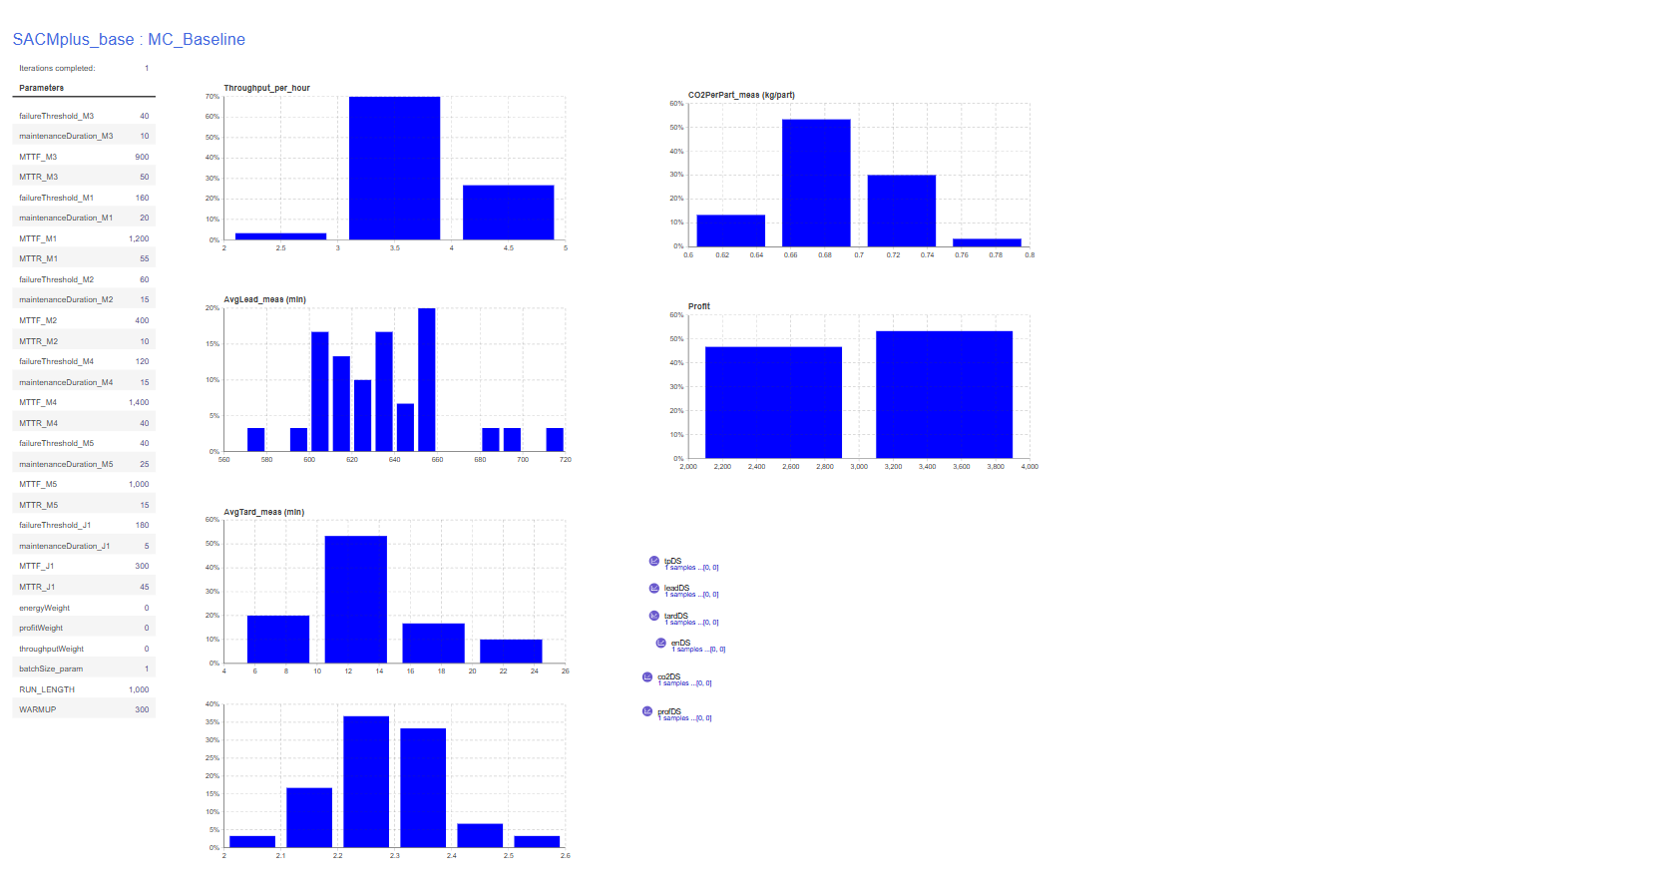
Console:
Warm-up reached. measuring=true
measuring=true leadSamples=40 tardSamples=40
Warm-up reached. measuring=true
measuring=true leadSamples=38 tardSamples=38
Warm-up reached. measuring=true
measuring=true leadSamples=40 tardSamples=40
Warm-up reached. measuring=true
measuring=true leadSamples=37 tardSamples=37
Warm-up reached. measuring=true
measuring=true leadSamples=44 tardSamples=44
Warm-up reached. measuring=true
measuring=true leadSamples=35 tardSamples=35
Warm-up reached. measuring=true
measuring=true leadSamples=45 tardSamples=45
Warm-up reached. measuring=true
measuring=true leadSamples=44 tardSamples=44
Warm-up reached. measuring=true
measuring=true leadSamples=42 tardSamples=42
Warm-up reached. measuring=true
measuring=true leadSamples=46 tardSamples=46
Warm-up reached. measuring=true
measuring=true leadSamples=43 tardSamples=43
Warm-up reached. measuring=true
measuring=true leadSamples=50 tardSamples=50
Warm-up reached. measuring=true
measuring=true leadSamples=37 tardSamples=37
Warm-up reached. measuring=true
measuring=true leadSamples=49 tardSamples=49
Warm-up reached. measuring=true
measuring=true leadSamples=36 tardSamples=36
Warm-up reached. measuring=true
measuring=true leadSamples=33 tardSamples=33
Warm-up reached. measuring=true
measuring=true leadSamples=52 tardSamples=52
Warm-up reached. measuring=true
measuring=true leadSamples=42 tardSamples=42
Warm-up reached. measuring=true
measuring=true leadSamples=54 tardSamples=54
Warm-up reached. measuring=true
measuring=true leadSamples=50 tardSamples=50
Warm-up reached. measuring=true
measuring=true leadSamples=50 tardSamples=50
Warm-up reached. measuring=true
measuring=true leadSamples=45 tardSamples=45
Warm-up reached. measuring=true
measuring=true leadSamples=46 tardSamples=46
Warm-up reached. measuring=true
measuring=true leadSamples=46 tardSamples=46
Warm-up reached. measuring=true
measuring=true leadSamples=55 tardSamples=55
Warm-up reached. measuring=true
measuring=true leadSamples=43 tardSamples=43
Warm-up reached. measuring=true
measuring=true leadSamples=49 tardSamples=49
Warm-up reached. measuring=true
measuring=true leadSamples=46 tardSamples=46
Warm-up reached. measuring=true
measuring=true leadSamples=39 tardSamples=39
Warm-up reached. measuring=true
measuring=true leadSamples=42 tardSamples=42

==== KPI NUMERIC SUMMARY (all collected replications) ====
Throughput/h | n=30 mean=3.7657 sd=0.4859 min=2.8286 max=4.7143
AvgLead | n=30 mean=634.5283 sd=30.0718 min=579.8906 max=715.5313
AvgTard | n=30 mean=12.5969 sd=3.9948 min=5.3326 max=21.8492
Energy/part | n=30 mean=2.2815 sd=0.1007 min=2.0823 max=2.5374
CO2/part | n=30 mean=0.6845 sd=0.0302 min=0.6247 max=0.7612
Profit | n=30 mean=3023.4335 sd=396.2099 min=2256.9896 max=3789.0046
==== END SUMMARY ====

