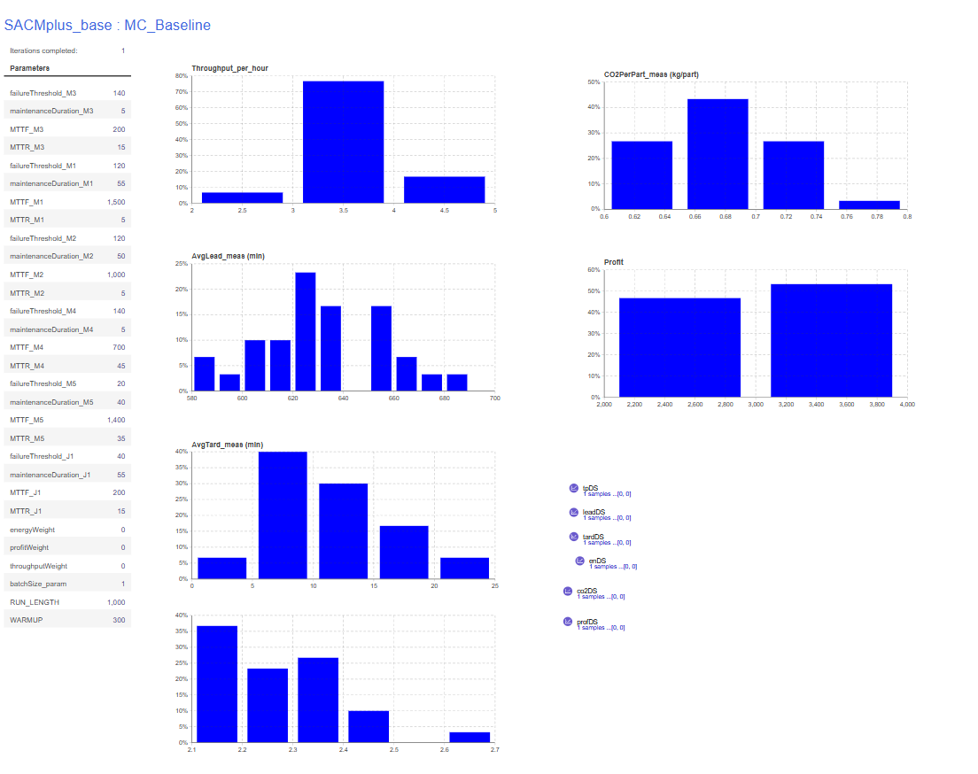
CONSOLE:
Warm-up reached. measuring=true
measuring=true leadSamples=46 tardSamples=46
Warm-up reached. measuring=true
measuring=true leadSamples=44 tardSamples=44
Warm-up reached. measuring=true
measuring=true leadSamples=43 tardSamples=43
Warm-up reached. measuring=true
measuring=true leadSamples=45 tardSamples=45
Warm-up reached. measuring=true
measuring=true leadSamples=40 tardSamples=40
Warm-up reached. measuring=true
measuring=true leadSamples=39 tardSamples=39
Warm-up reached. measuring=true
measuring=true leadSamples=46 tardSamples=46
Warm-up reached. measuring=true
measuring=true leadSamples=33 tardSamples=33
Warm-up reached. measuring=true
measuring=true leadSamples=44 tardSamples=44
Warm-up reached. measuring=true
measuring=true leadSamples=44 tardSamples=44
Warm-up reached. measuring=true
measuring=true leadSamples=42 tardSamples=42
Warm-up reached. measuring=true
measuring=true leadSamples=41 tardSamples=41
Warm-up reached. measuring=true
measuring=true leadSamples=43 tardSamples=43
Warm-up reached. measuring=true
measuring=true leadSamples=34 tardSamples=34
Warm-up reached. measuring=true
measuring=true leadSamples=45 tardSamples=45
Warm-up reached. measuring=true
measuring=true leadSamples=36 tardSamples=36
Warm-up reached. measuring=true
measuring=true leadSamples=38 tardSamples=38
Warm-up reached. measuring=true
measuring=true leadSamples=47 tardSamples=47
Warm-up reached. measuring=true
measuring=true leadSamples=44 tardSamples=44
Warm-up reached. measuring=true
measuring=true leadSamples=40 tardSamples=40
Warm-up reached. measuring=true
measuring=true leadSamples=41 tardSamples=41
Warm-up reached. measuring=true
measuring=true leadSamples=49 tardSamples=49
Warm-up reached. measuring=true
measuring=true leadSamples=44 tardSamples=44
Warm-up reached. measuring=true
measuring=true leadSamples=52 tardSamples=52
Warm-up reached. measuring=true
measuring=true leadSamples=44 tardSamples=44
Warm-up reached. measuring=true
measuring=true leadSamples=43 tardSamples=43
Warm-up reached. measuring=true
measuring=true leadSamples=48 tardSamples=48
Warm-up reached. measuring=true
measuring=true leadSamples=45 tardSamples=45
Warm-up reached. measuring=true
measuring=true leadSamples=53 tardSamples=53
Warm-up reached. measuring=true
measuring=true leadSamples=41 tardSamples=41

==== KPI NUMERIC SUMMARY (all collected replications) ====
Throughput/h | n=30 mean=3.6971 sd=0.3884 min=2.8286 max=4.5429
AvgLead | n=30 mean=632.2838 sd=24.9646 min=589.0628 max=685.6931
AvgTard | n=30 mean=11.4806 sd=4.4279 min=4.0399 max=22.3707
Energy/part | n=30 mean=2.2732 sd=0.1278 min=2.1023 max=2.6432
CO2/part | n=30 mean=0.6820 sd=0.0383 min=0.6307 max=0.7930
Profit | n=30 mean=2970.4506 sd=315.5721 min=2262.6069 max=3655.7858
==== END SUMMARY ====

