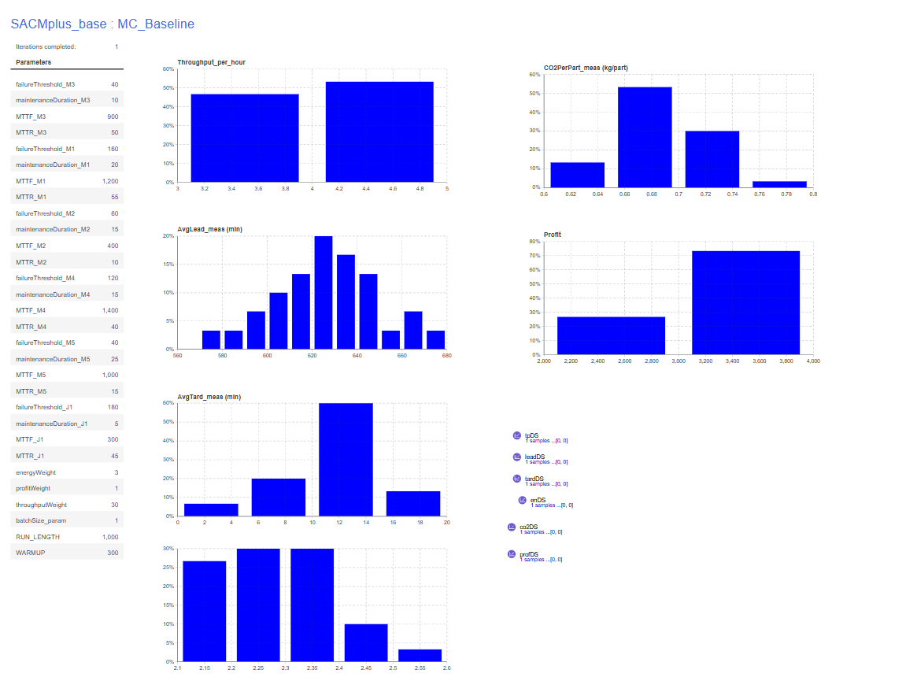
CONSOLE:
Warm-up reached. measuring=true
measuring=true leadSamples=42 tardSamples=42
Warm-up reached. measuring=true
measuring=true leadSamples=38 tardSamples=38
Warm-up reached. measuring=true
measuring=true leadSamples=50 tardSamples=50
Warm-up reached. measuring=true
measuring=true leadSamples=41 tardSamples=41
Warm-up reached. measuring=true
measuring=true leadSamples=45 tardSamples=45
Warm-up reached. measuring=true
measuring=true leadSamples=56 tardSamples=56
Warm-up reached. measuring=true
measuring=true leadSamples=51 tardSamples=51
Warm-up reached. measuring=true
measuring=true leadSamples=45 tardSamples=45
Warm-up reached. measuring=true
measuring=true leadSamples=51 tardSamples=51
Warm-up reached. measuring=true
measuring=true leadSamples=49 tardSamples=49
Warm-up reached. measuring=true
measuring=true leadSamples=45 tardSamples=45
Warm-up reached. measuring=true
measuring=true leadSamples=40 tardSamples=40
Warm-up reached. measuring=true
measuring=true leadSamples=43 tardSamples=43
Warm-up reached. measuring=true
measuring=true leadSamples=35 tardSamples=35
Warm-up reached. measuring=true
measuring=true leadSamples=44 tardSamples=44
Warm-up reached. measuring=true
measuring=true leadSamples=49 tardSamples=49
Warm-up reached. measuring=true
measuring=true leadSamples=48 tardSamples=48
Warm-up reached. measuring=true
measuring=true leadSamples=51 tardSamples=51
Warm-up reached. measuring=true
measuring=true leadSamples=55 tardSamples=55
Warm-up reached. measuring=true
measuring=true leadSamples=49 tardSamples=49
Warm-up reached. measuring=true
measuring=true leadSamples=41 tardSamples=41
Warm-up reached. measuring=true
measuring=true leadSamples=51 tardSamples=51
Warm-up reached. measuring=true
measuring=true leadSamples=44 tardSamples=44
Warm-up reached. measuring=true
measuring=true leadSamples=50 tardSamples=50
Warm-up reached. measuring=true
measuring=true leadSamples=47 tardSamples=47
Warm-up reached. measuring=true
measuring=true leadSamples=51 tardSamples=51
Warm-up reached. measuring=true
measuring=true leadSamples=47 tardSamples=47
Warm-up reached. measuring=true
measuring=true leadSamples=44 tardSamples=44
Warm-up reached. measuring=true
measuring=true leadSamples=50 tardSamples=50
Warm-up reached. measuring=true
measuring=true leadSamples=42 tardSamples=42

==== KPI NUMERIC SUMMARY (all collected replications) ====
Throughput/h | n=30 mean=3.9829 sd=0.4234 min=3.0000 max=4.8000
AvgLead | n=30 mean=626.4604 sd=23.4436 min=572.4436 max=678.1022
AvgTard | n=30 mean=11.2941 sd=3.5829 min=2.1562 max=19.1387
Energy/part | n=30 mean=2.2895 sd=0.1145 min=2.1264 max=2.5630
CO2/part | n=30 mean=0.6869 sd=0.0344 min=0.6379 max=0.7689
Profit | n=30 mean=3199.8720 sd=340.5221 min=2408.4484 max=3858.9253
==== END SUMMARY ====

