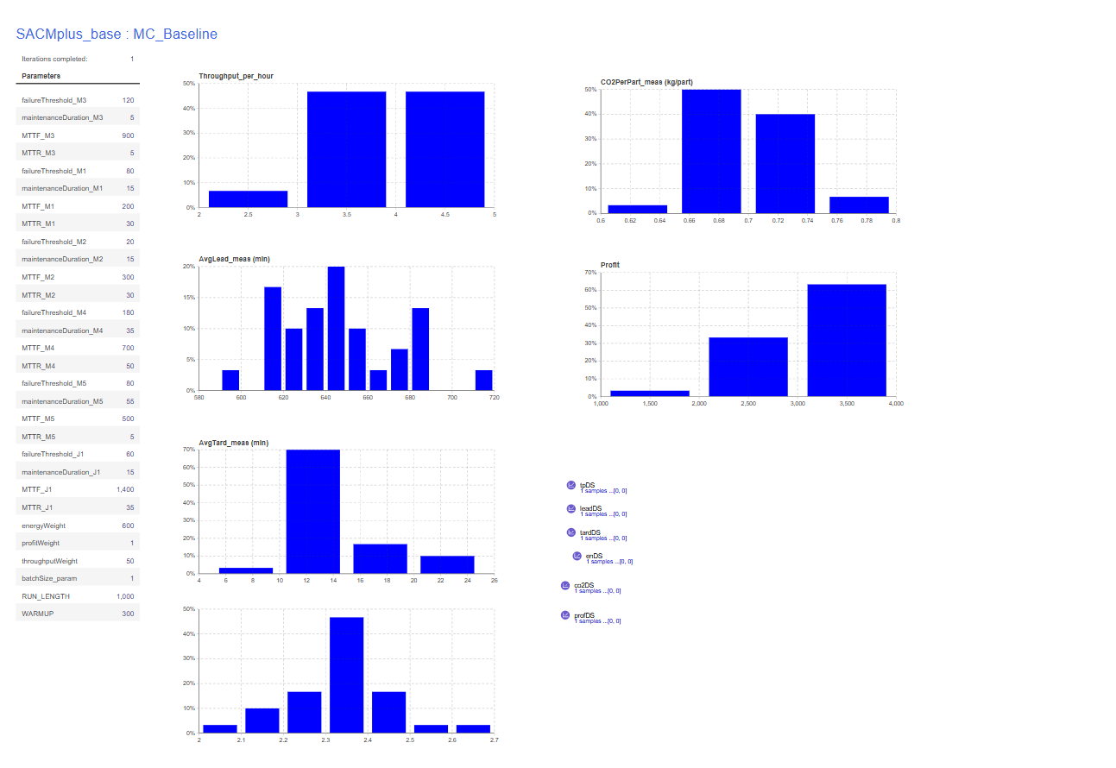
CONSOLE:
Warm-up reached. measuring=true
measuring=true leadSamples=42 tardSamples=42
Warm-up reached. measuring=true
measuring=true leadSamples=53 tardSamples=53
Warm-up reached. measuring=true
measuring=true leadSamples=36 tardSamples=36
Warm-up reached. measuring=true
measuring=true leadSamples=50 tardSamples=50
Warm-up reached. measuring=true
measuring=true leadSamples=40 tardSamples=40
Warm-up reached. measuring=true
measuring=true leadSamples=52 tardSamples=52
Warm-up reached. measuring=true
measuring=true leadSamples=52 tardSamples=52
Warm-up reached. measuring=true
measuring=true leadSamples=44 tardSamples=44
Warm-up reached. measuring=true
measuring=true leadSamples=52 tardSamples=52
Warm-up reached. measuring=true
measuring=true leadSamples=48 tardSamples=48
Warm-up reached. measuring=true
measuring=true leadSamples=42 tardSamples=42
Warm-up reached. measuring=true
measuring=true leadSamples=34 tardSamples=34
Warm-up reached. measuring=true
measuring=true leadSamples=52 tardSamples=52
Warm-up reached. measuring=true
measuring=true leadSamples=27 tardSamples=27
Warm-up reached. measuring=true
measuring=true leadSamples=35 tardSamples=35
Warm-up reached. measuring=true
measuring=true leadSamples=40 tardSamples=40
Warm-up reached. measuring=true
measuring=true leadSamples=47 tardSamples=47
Warm-up reached. measuring=true
measuring=true leadSamples=43 tardSamples=43
Warm-up reached. measuring=true
measuring=true leadSamples=51 tardSamples=51
Warm-up reached. measuring=true
measuring=true leadSamples=42 tardSamples=42
Warm-up reached. measuring=true
measuring=true leadSamples=35 tardSamples=35
Warm-up reached. measuring=true
measuring=true leadSamples=45 tardSamples=45
Warm-up reached. measuring=true
measuring=true leadSamples=54 tardSamples=54
Warm-up reached. measuring=true
measuring=true leadSamples=44 tardSamples=44
Warm-up reached. measuring=true
measuring=true leadSamples=47 tardSamples=47
Warm-up reached. measuring=true
measuring=true leadSamples=56 tardSamples=56
Warm-up reached. measuring=true
measuring=true leadSamples=53 tardSamples=53
Warm-up reached. measuring=true
measuring=true leadSamples=47 tardSamples=47
Warm-up reached. measuring=true
measuring=true leadSamples=44 tardSamples=44
Warm-up reached. measuring=true
measuring=true leadSamples=46 tardSamples=46

==== KPI NUMERIC SUMMARY (all collected replications) ====
Throughput/h | n=30 mean=3.8657 sd=0.5995 min=2.3143 max=4.8000
AvgLead | n=30 mean=646.1770 sd=27.5275 min=592.1171 max=712.4849
AvgTard | n=30 mean=13.7469 sd=3.0383 min=9.9568 max=21.5724
Energy/part | n=30 mean=2.3388 sd=0.1145 min=2.0927 max=2.6612
CO2/part | n=30 mean=0.7016 sd=0.0344 min=0.6278 max=0.7983
Profit | n=30 mean=3099.9352 sd=482.8721 min=1856.2267 max=3854.7328
==== END SUMMARY ====

