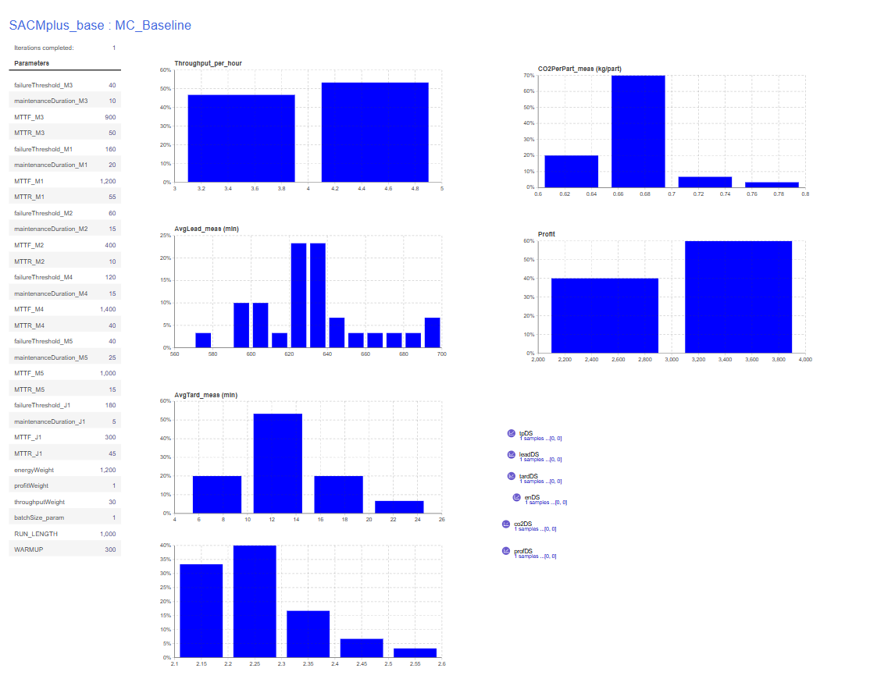
CONSOLE:
Warm-up reached. measuring=true
measuring=true leadSamples=43 tardSamples=43
Warm-up reached. measuring=true
measuring=true leadSamples=48 tardSamples=48
Warm-up reached. measuring=true
measuring=true leadSamples=36 tardSamples=36
Warm-up reached. measuring=true
measuring=true leadSamples=38 tardSamples=38
Warm-up reached. measuring=true
measuring=true leadSamples=47 tardSamples=47
Warm-up reached. measuring=true
measuring=true leadSamples=48 tardSamples=48
Warm-up reached. measuring=true
measuring=true leadSamples=50 tardSamples=50
Warm-up reached. measuring=true
measuring=true leadSamples=51 tardSamples=51
Warm-up reached. measuring=true
measuring=true leadSamples=41 tardSamples=41
Warm-up reached. measuring=true
measuring=true leadSamples=37 tardSamples=37
Warm-up reached. measuring=true
measuring=true leadSamples=46 tardSamples=46
Warm-up reached. measuring=true
measuring=true leadSamples=44 tardSamples=44
Warm-up reached. measuring=true
measuring=true leadSamples=37 tardSamples=37
Warm-up reached. measuring=true
measuring=true leadSamples=41 tardSamples=41
Warm-up reached. measuring=true
measuring=true leadSamples=38 tardSamples=38
Warm-up reached. measuring=true
measuring=true leadSamples=49 tardSamples=49
Warm-up reached. measuring=true
measuring=true leadSamples=50 tardSamples=50
Warm-up reached. measuring=true
measuring=true leadSamples=47 tardSamples=47
Warm-up reached. measuring=true
measuring=true leadSamples=40 tardSamples=40
Warm-up reached. measuring=true
measuring=true leadSamples=52 tardSamples=52
Warm-up reached. measuring=true
measuring=true leadSamples=50 tardSamples=50
Warm-up reached. measuring=true
measuring=true leadSamples=47 tardSamples=47
Warm-up reached. measuring=true
measuring=true leadSamples=37 tardSamples=37
Warm-up reached. measuring=true
measuring=true leadSamples=50 tardSamples=50
Warm-up reached. measuring=true
measuring=true leadSamples=37 tardSamples=37
Warm-up reached. measuring=true
measuring=true leadSamples=48 tardSamples=48
Warm-up reached. measuring=true
measuring=true leadSamples=38 tardSamples=38
Warm-up reached. measuring=true
measuring=true leadSamples=51 tardSamples=51
Warm-up reached. measuring=true
measuring=true leadSamples=49 tardSamples=49
Warm-up reached. measuring=true
measuring=true leadSamples=57 tardSamples=57

==== KPI NUMERIC SUMMARY (all collected replications) ====
Throughput/h | n=30 mean=3.8486 sd=0.4990 min=3.0857 max=4.8857
AvgLead | n=30 mean=632.1922 sd=29.9940 min=572.3809 max=696.6669
AvgTard | n=30 mean=13.1015 sd=4.1297 min=8.1166 max=23.8551
Energy/part | n=30 mean=2.2586 sd=0.0930 min=2.1086 max=2.5163
CO2/part | n=30 mean=0.6776 sd=0.0279 min=0.6326 max=0.7549
Profit | n=30 mean=3088.8674 sd=405.2533 min=2466.7878 max=3927.4642
==== END SUMMARY ====

