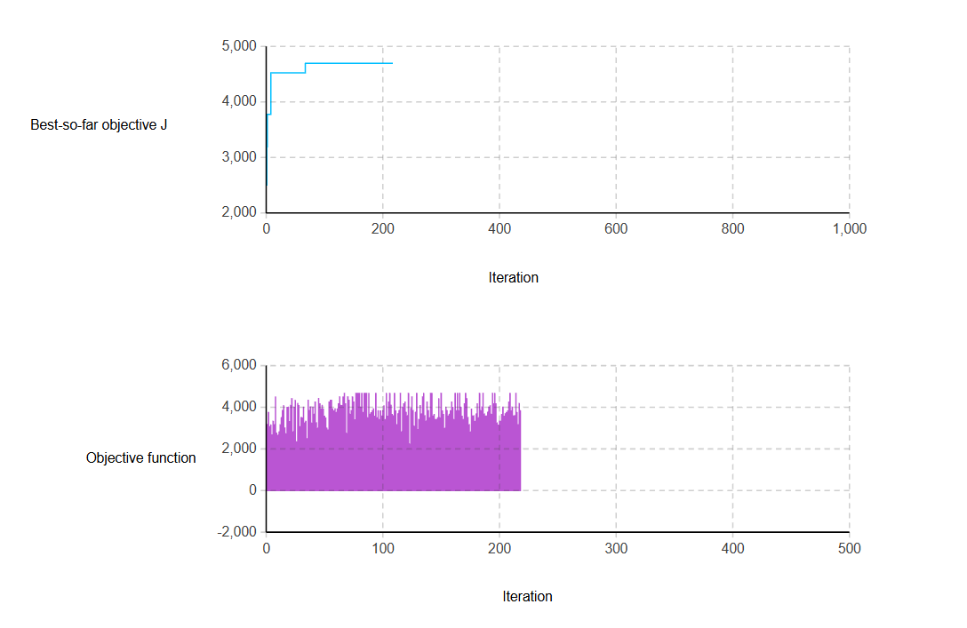

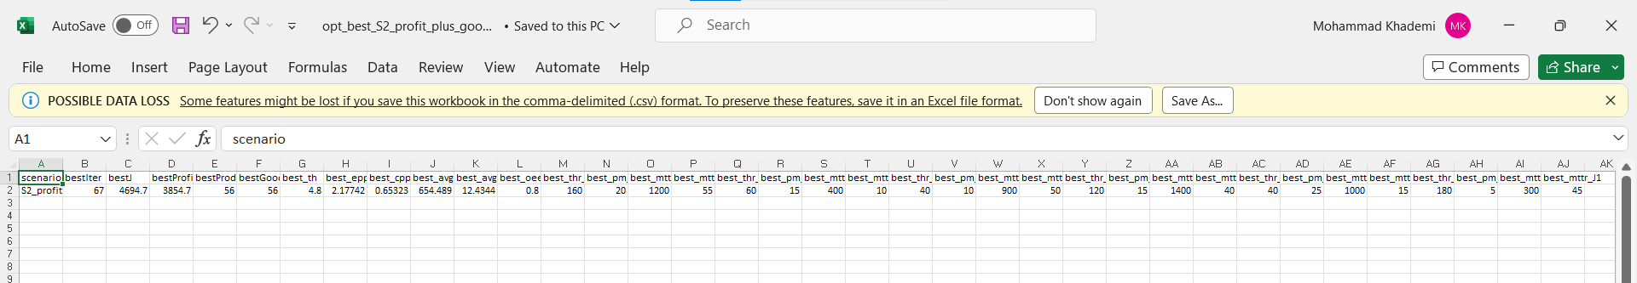

Console:
=== Optimization started === SC=S2_profit_plus_good alpha=15.0
iter=0 profit=2053.15 good=30 J=2503.15 | bestJ=2503.15
iter=1 profit=2626.44 good=38 J=3196.44 | bestJ=3196.44
iter=2 profit=3101.63 good=45 J=3776.63 | bestJ=3776.63
iter=3 profit=2537.97 good=37 J=3092.97 | bestJ=3776.63
iter=4 profit=2611.30 good=38 J=3181.30 | bestJ=3776.63
iter=5 profit=2215.06 good=32 J=2695.06 | bestJ=3776.63
iter=6 profit=2753.42 good=40 J=3353.42 | bestJ=3776.63
iter=7 profit=2623.38 good=38 J=3193.38 | bestJ=3776.63
iter=8 profit=3713.79 good=54 J=4523.79 | bestJ=4523.79
iter=9 profit=2283.63 good=33 J=2778.63 | bestJ=4523.79
iter=10 profit=2194.99 good=32 J=2674.99 | bestJ=4523.79
iter=11 profit=2335.63 good=34 J=2845.63 | bestJ=4523.79
iter=12 profit=2608.58 good=38 J=3178.58 | bestJ=4523.79
iter=13 profit=2899.46 good=42 J=3529.46 | bestJ=4523.79
iter=14 profit=3176.57 good=46 J=3866.57 | bestJ=4523.79
iter=15 profit=3360.56 good=49 J=4095.56 | bestJ=4523.79
iter=16 profit=2483.94 good=36 J=3023.94 | bestJ=4523.79
iter=17 profit=2257.60 good=33 J=2752.60 | bestJ=4523.79
iter=18 profit=3296.06 good=48 J=4016.06 | bestJ=4523.79
iter=19 profit=3310.41 good=48 J=4030.41 | bestJ=4523.79
iter=20 profit=2740.20 good=40 J=3340.20 | bestJ=4523.79
iter=21 profit=3378.45 good=49 J=4113.45 | bestJ=4523.79
iter=22 profit=3640.15 good=53 J=4435.15 | bestJ=4523.79
iter=23 profit=2333.61 good=34 J=2843.61 | bestJ=4523.79
iter=24 profit=3308.40 good=48 J=4028.40 | bestJ=4523.79
iter=25 profit=3571.79 good=52 J=4351.79 | bestJ=4523.79
iter=26 profit=1944.70 good=28 J=2364.70 | bestJ=4523.79
iter=27 profit=3449.76 good=50 J=4199.76 | bestJ=4523.79
iter=28 profit=3372.65 good=49 J=4107.65 | bestJ=4523.79
iter=29 profit=2538.54 good=37 J=3093.54 | bestJ=4523.79
iter=30 profit=2903.88 good=42 J=3533.88 | bestJ=4523.79
iter=31 profit=2881.99 good=42 J=3511.99 | bestJ=4523.79
iter=32 profit=3312.90 good=48 J=4032.90 | bestJ=4523.79
iter=33 profit=2691.80 good=39 J=3276.80 | bestJ=4523.79
iter=34 profit=2751.84 good=40 J=3351.84 | bestJ=4523.79
iter=35 profit=2064.44 good=30 J=2514.44 | bestJ=4523.79
iter=36 profit=3577.57 good=52 J=4357.57 | bestJ=4523.79
iter=37 profit=3182.66 good=46 J=3872.66 | bestJ=4523.79
iter=38 profit=3324.36 good=48 J=4044.36 | bestJ=4523.79
iter=39 profit=2674.26 good=39 J=3259.26 | bestJ=4523.79
iter=40 profit=3310.63 good=48 J=4030.63 | bestJ=4523.79
iter=41 profit=3030.87 good=44 J=3690.87 | bestJ=4523.79
iter=42 profit=3512.27 good=51 J=4277.27 | bestJ=4523.79
iter=43 profit=2684.65 good=39 J=3269.65 | bestJ=4523.79
iter=44 profit=2476.44 good=36 J=3016.44 | bestJ=4523.79
iter=45 profit=3654.17 good=53 J=4449.17 | bestJ=4523.79
iter=46 profit=3436.68 good=50 J=4186.68 | bestJ=4523.79
iter=47 profit=3230.05 good=47 J=3935.05 | bestJ=4523.79
iter=48 profit=3380.97 good=49 J=4115.97 | bestJ=4523.79
iter=49 profit=3234.56 good=47 J=3939.56 | bestJ=4523.79
iter=50 profit=2949.72 good=43 J=3594.72 | bestJ=4523.79
iter=51 profit=2880.02 good=42 J=3510.02 | bestJ=4523.79
iter=52 profit=2485.81 good=36 J=3025.81 | bestJ=4523.79
iter=53 profit=2409.35 good=35 J=2934.35 | bestJ=4523.79
iter=54 profit=3508.82 good=51 J=4273.82 | bestJ=4523.79
iter=55 profit=3582.35 good=52 J=4362.35 | bestJ=4523.79
iter=56 profit=3577.57 good=52 J=4357.57 | bestJ=4523.79
iter=57 profit=3236.42 good=47 J=3941.42 | bestJ=4523.79
iter=58 profit=3165.58 good=46 J=3855.58 | bestJ=4523.79
iter=59 profit=3238.55 good=47 J=3943.55 | bestJ=4523.79
iter=60 profit=3102.24 good=45 J=3777.24 | bestJ=4523.79
iter=61 profit=3236.42 good=47 J=3941.42 | bestJ=4523.79
iter=62 profit=3442.99 good=50 J=4192.99 | bestJ=4523.79
iter=63 profit=3713.79 good=54 J=4523.79 | bestJ=4523.79
iter=64 profit=3380.08 good=49 J=4115.08 | bestJ=4523.79
iter=65 profit=3375.26 good=49 J=4110.26 | bestJ=4523.79
iter=66 profit=3713.79 good=54 J=4523.79 | bestJ=4523.79
iter=67 profit=3854.70 good=56 J=4694.70 | bestJ=4694.70
iter=68 profit=3441.34 good=50 J=4191.34 | bestJ=4694.70
iter=69 profit=2277.88 good=33 J=2772.88 | bestJ=4694.70
iter=70 profit=3713.79 good=54 J=4523.79 | bestJ=4694.70
iter=71 profit=3586.91 good=52 J=4366.91 | bestJ=4694.70
iter=72 profit=3032.31 good=44 J=3692.31 | bestJ=4694.70
iter=73 profit=3172.30 good=46 J=3862.30 | bestJ=4694.70
iter=74 profit=3713.79 good=54 J=4523.79 | bestJ=4694.70
iter=75 profit=3514.22 good=51 J=4279.22 | bestJ=4694.70
iter=76 profit=2811.39 good=41 J=3426.39 | bestJ=4694.70
iter=77 profit=3854.70 good=56 J=4694.70 | bestJ=4694.70
iter=78 profit=3854.70 good=56 J=4694.70 | bestJ=4694.70
iter=79 profit=3854.70 good=56 J=4694.70 | bestJ=4694.70
iter=80 profit=3854.70 good=56 J=4694.70 | bestJ=4694.70
iter=81 profit=3309.25 good=48 J=4029.25 | bestJ=4694.70
iter=82 profit=3854.70 good=56 J=4694.70 | bestJ=4694.70
iter=83 profit=3096.17 good=45 J=3771.17 | bestJ=4694.70
iter=84 profit=3854.70 good=56 J=4694.70 | bestJ=4694.70
iter=85 profit=3854.70 good=56 J=4694.70 | bestJ=4694.70
iter=86 profit=3854.70 good=56 J=4694.70 | bestJ=4694.70
iter=87 profit=2885.07 good=42 J=3515.07 | bestJ=4694.70
iter=88 profit=3854.70 good=56 J=4694.70 | bestJ=4694.70
iter=89 profit=3030.03 good=44 J=3690.03 | bestJ=4694.70
iter=90 profit=3089.58 good=45 J=3764.58 | bestJ=4694.70
iter=91 profit=3172.57 good=46 J=3862.57 | bestJ=4694.70
iter=92 profit=3239.95 good=47 J=3944.95 | bestJ=4694.70
iter=93 profit=2950.68 good=43 J=3595.68 | bestJ=4694.70
iter=94 profit=3854.70 good=56 J=4694.70 | bestJ=4694.70
iter=95 profit=2885.07 good=42 J=3515.07 | bestJ=4694.70
iter=96 profit=3170.27 good=46 J=3860.27 | bestJ=4694.70
iter=97 profit=2818.01 good=41 J=3433.01 | bestJ=4694.70
iter=98 profit=3159.30 good=46 J=3849.30 | bestJ=4694.70
iter=99 profit=2964.80 good=43 J=3609.80 | bestJ=4694.70
iter=100 profit=3170.27 good=46 J=3860.27 | bestJ=4694.70
iter=101 profit=3364.97 good=49 J=4099.97 | bestJ=4694.70
iter=102 profit=2816.66 good=41 J=3431.66 | bestJ=4694.70
iter=103 profit=3854.70 good=56 J=4694.70 | bestJ=4694.70
iter=104 profit=2953.53 good=43 J=3598.53 | bestJ=4694.70
iter=105 profit=3513.83 good=51 J=4278.83 | bestJ=4694.70
iter=106 profit=3854.70 good=56 J=4694.70 | bestJ=4694.70
iter=107 profit=3378.06 good=49 J=4113.06 | bestJ=4694.70
iter=108 profit=3019.15 good=44 J=3679.15 | bestJ=4694.70
iter=109 profit=2967.44 good=43 J=3612.44 | bestJ=4694.70
iter=110 profit=3854.70 good=56 J=4694.70 | bestJ=4694.70
iter=111 profit=3161.10 good=46 J=3851.10 | bestJ=4694.70
iter=112 profit=2614.14 good=38 J=3184.14 | bestJ=4694.70
iter=113 profit=3048.38 good=44 J=3708.38 | bestJ=4694.70
iter=114 profit=3176.80 good=46 J=3866.80 | bestJ=4694.70
iter=115 profit=3854.70 good=56 J=4694.70 | bestJ=4694.70
iter=116 profit=2337.46 good=34 J=2847.46 | bestJ=4694.70
iter=117 profit=3310.39 good=48 J=4030.39 | bestJ=4694.70
iter=118 profit=3440.63 good=50 J=4190.63 | bestJ=4694.70
iter=119 profit=3513.63 good=51 J=4278.63 | bestJ=4694.70
iter=120 profit=3098.94 good=45 J=3773.94 | bestJ=4694.70
iter=121 profit=2974.16 good=43 J=3619.16 | bestJ=4694.70
iter=122 profit=3854.70 good=56 J=4694.70 | bestJ=4694.70
iter=123 profit=1858.78 good=27 J=2263.78 | bestJ=4694.70
iter=124 profit=3252.46 good=47 J=3957.46 | bestJ=4694.70
iter=125 profit=3713.00 good=54 J=4523.00 | bestJ=4694.70
iter=126 profit=3176.80 good=46 J=3866.80 | bestJ=4694.70
iter=127 profit=2563.33 good=37 J=3118.33 | bestJ=4694.70
iter=128 profit=3109.31 good=45 J=3784.31 | bestJ=4694.70
iter=129 profit=3854.70 good=56 J=4694.70 | bestJ=4694.70
iter=130 profit=2428.83 good=35 J=2953.83 | bestJ=4694.70
iter=131 profit=2816.66 good=41 J=3431.66 | bestJ=4694.70
iter=132 profit=3369.09 good=49 J=4104.09 | bestJ=4694.70
iter=133 profit=3039.08 good=44 J=3699.08 | bestJ=4694.70
iter=134 profit=3713.00 good=54 J=4523.00 | bestJ=4694.70
iter=135 profit=3854.70 good=56 J=4694.70 | bestJ=4694.70
iter=136 profit=2967.44 good=43 J=3612.44 | bestJ=4694.70
iter=137 profit=2755.44 good=40 J=3355.44 | bestJ=4694.70
iter=138 profit=3508.82 good=51 J=4273.82 | bestJ=4694.70
iter=139 profit=3167.04 good=46 J=3857.04 | bestJ=4694.70
iter=140 profit=2892.27 good=42 J=3522.27 | bestJ=4694.70
iter=141 profit=3854.70 good=56 J=4694.70 | bestJ=4694.70
iter=142 profit=3854.70 good=56 J=4694.70 | bestJ=4694.70
iter=143 profit=2960.92 good=43 J=3605.92 | bestJ=4694.70
iter=144 profit=3017.18 good=44 J=3677.18 | bestJ=4694.70
iter=145 profit=2819.65 good=41 J=3434.65 | bestJ=4694.70
iter=146 profit=2818.01 good=41 J=3433.01 | bestJ=4694.70
iter=147 profit=2885.07 good=42 J=3515.07 | bestJ=4694.70
iter=148 profit=3636.88 good=53 J=4431.88 | bestJ=4694.70
iter=149 profit=2885.75 good=42 J=3515.75 | bestJ=4694.70
iter=150 profit=3854.70 good=56 J=4694.70 | bestJ=4694.70
iter=151 profit=3164.66 good=46 J=3854.66 | bestJ=4694.70
iter=152 profit=3023.45 good=44 J=3683.45 | bestJ=4694.70
iter=153 profit=2480.70 good=36 J=3020.70 | bestJ=4694.70
iter=154 profit=3306.78 good=48 J=4026.78 | bestJ=4694.70
iter=155 profit=3170.09 good=46 J=3860.09 | bestJ=4694.70
iter=156 profit=2956.78 good=43 J=3601.78 | bestJ=4694.70
iter=157 profit=3030.03 good=44 J=3690.03 | bestJ=4694.70
iter=158 profit=3168.72 good=46 J=3858.72 | bestJ=4694.70
iter=159 profit=3513.63 good=51 J=4278.63 | bestJ=4694.70
iter=160 profit=3305.20 good=48 J=4025.20 | bestJ=4694.70
iter=161 profit=2818.01 good=41 J=3433.01 | bestJ=4694.70
iter=162 profit=3854.70 good=56 J=4694.70 | bestJ=4694.70
iter=163 profit=3170.27 good=46 J=3860.27 | bestJ=4694.70
iter=164 profit=3854.70 good=56 J=4694.70 | bestJ=4694.70
iter=165 profit=3167.04 good=46 J=3857.04 | bestJ=4694.70
iter=166 profit=3854.70 good=56 J=4694.70 | bestJ=4694.70
iter=167 profit=3309.47 good=48 J=4029.47 | bestJ=4694.70
iter=168 profit=2953.53 good=43 J=3598.53 | bestJ=4694.70
iter=169 profit=2819.65 good=41 J=3434.65 | bestJ=4694.70
iter=170 profit=3444.73 good=50 J=4194.73 | bestJ=4694.70
iter=171 profit=3854.70 good=56 J=4694.70 | bestJ=4694.70
iter=172 profit=3642.66 good=53 J=4437.66 | bestJ=4694.70
iter=173 profit=2896.44 good=42 J=3526.44 | bestJ=4694.70
iter=174 profit=2614.14 good=38 J=3184.14 | bestJ=4694.70
iter=175 profit=2322.95 good=34 J=2832.95 | bestJ=4694.70
iter=176 profit=3230.85 good=47 J=3935.85 | bestJ=4694.70
iter=177 profit=2958.55 good=43 J=3603.55 | bestJ=4694.70
iter=178 profit=2967.44 good=43 J=3612.44 | bestJ=4694.70
iter=179 profit=2746.89 good=40 J=3346.89 | bestJ=4694.70
iter=180 profit=3039.08 good=44 J=3699.08 | bestJ=4694.70
iter=181 profit=3444.73 good=50 J=4194.73 | bestJ=4694.70
iter=182 profit=2885.07 good=42 J=3515.07 | bestJ=4694.70
iter=183 profit=3854.70 good=56 J=4694.70 | bestJ=4694.70
iter=184 profit=3168.72 good=46 J=3858.72 | bestJ=4694.70
iter=185 profit=3309.25 good=48 J=4029.25 | bestJ=4694.70
iter=186 profit=3854.70 good=56 J=4694.70 | bestJ=4694.70
iter=187 profit=3037.75 good=44 J=3697.75 | bestJ=4694.70
iter=188 profit=2956.33 good=43 J=3601.33 | bestJ=4694.70
iter=189 profit=2956.33 good=43 J=3601.33 | bestJ=4694.70
iter=190 profit=3112.97 good=45 J=3787.97 | bestJ=4694.70
iter=191 profit=3309.47 good=48 J=4029.47 | bestJ=4694.70
iter=192 profit=3363.25 good=49 J=4098.25 | bestJ=4694.70
iter=193 profit=3028.21 good=44 J=3688.21 | bestJ=4694.70
iter=194 profit=3854.70 good=56 J=4694.70 | bestJ=4694.70
iter=195 profit=3439.40 good=50 J=4189.40 | bestJ=4694.70
iter=196 profit=3854.70 good=56 J=4694.70 | bestJ=4694.70
iter=197 profit=3439.40 good=50 J=4189.40 | bestJ=4694.70
iter=198 profit=2689.87 good=39 J=3274.87 | bestJ=4694.70
iter=199 profit=2600.55 good=38 J=3170.55 | bestJ=4694.70
iter=200 profit=2751.23 good=40 J=3351.23 | bestJ=4694.70
iter=201 profit=2751.23 good=40 J=3351.23 | bestJ=4694.70
iter=202 profit=3021.65 good=44 J=3681.65 | bestJ=4694.70
iter=203 profit=3312.55 good=48 J=4032.55 | bestJ=4694.70
iter=204 profit=2953.53 good=43 J=3598.53 | bestJ=4694.70
iter=205 profit=3048.38 good=44 J=3708.38 | bestJ=4694.70
iter=206 profit=3096.17 good=45 J=3771.17 | bestJ=4694.70
iter=207 profit=3159.30 good=46 J=3849.30 | bestJ=4694.70
iter=208 profit=3512.09 good=51 J=4277.09 | bestJ=4694.70
iter=209 profit=3854.70 good=56 J=4694.70 | bestJ=4694.70
iter=210 profit=3159.30 good=46 J=3849.30 | bestJ=4694.70
iter=211 profit=3312.55 good=48 J=4032.55 | bestJ=4694.70
iter=212 profit=2974.16 good=43 J=3619.16 | bestJ=4694.70
iter=213 profit=2969.52 good=43 J=3614.52 | bestJ=4694.70
iter=214 profit=3854.70 good=56 J=4694.70 | bestJ=4694.70
iter=215 profit=3098.94 good=45 J=3773.94 | bestJ=4694.70
iter=216 profit=2614.14 good=38 J=3184.14 | bestJ=4694.70
iter=217 profit=3452.56 good=50 J=4202.56 | bestJ=4694.70
iter=218 profit=3175.23 good=46 J=3865.23 | bestJ=4694.70
WARNING SACMplus_base : Opt_model_Profit_and_Penalty: The optimization experiment has ended: an autostop was triggerred.

===== OPTIMIZATION FINISHED =====
Scenario = S2_profit_plus_good
alpha = 15.0
Best iteration= 67
Best J = 4694.70
Best profit = 3854.70
Best produced = 56
Best good = 56
Best th/hr = 4.8000
Best epp = 2.1774
Best cpp = 0.6532
Best avgLead = 654.4894
Best avgTard = 12.4344
Best OEE(M3) = 0.8000

