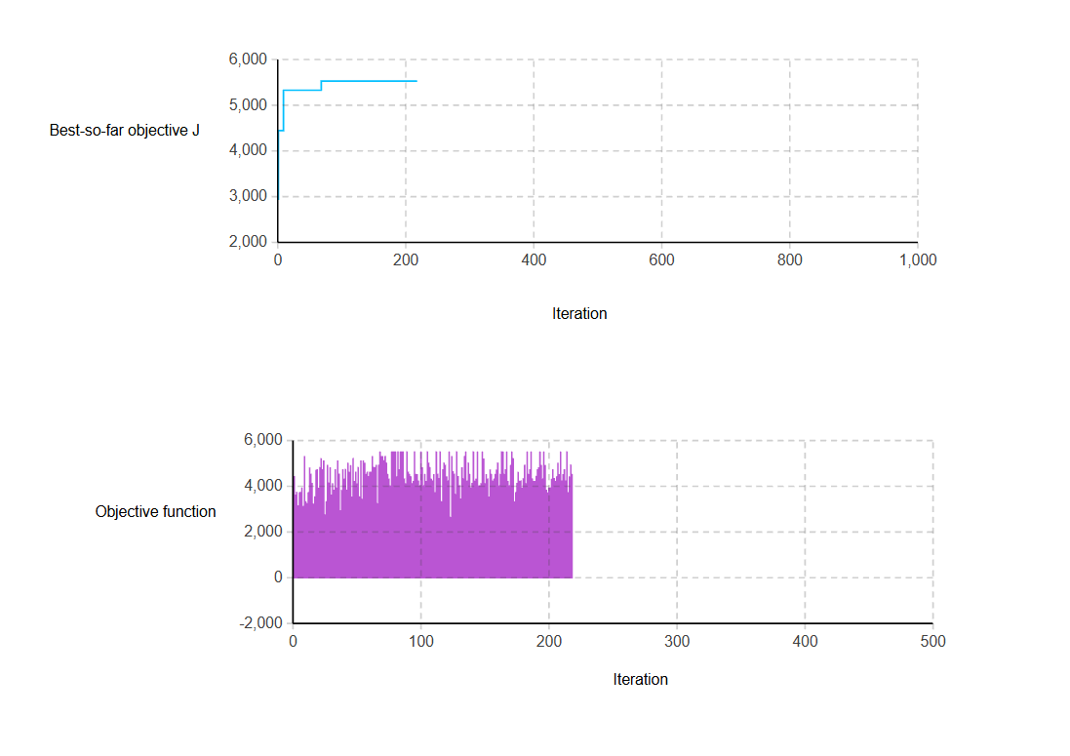
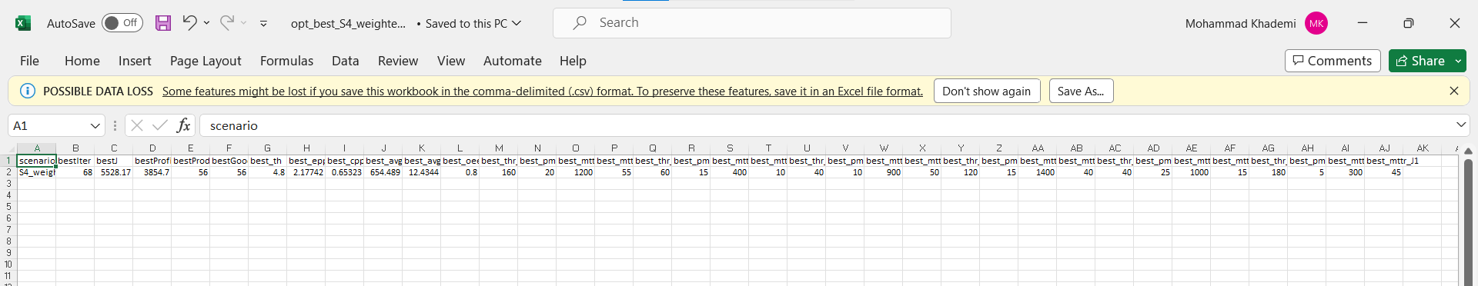

Console:
=== Optimization started === SC=S4_weighted w1=1.0 w2=30.0 w3=3.0
iter=0 J=2946.28 | profit=2053.15 | good=30 | epp=2.293 | bestJ=2946.28
iter=1 J=4445.25 | profit=3101.63 | good=45 | epp=2.128 | bestJ=4445.25
iter=2 J=3640.64 | profit=2537.97 | good=37 | epp=2.443 | bestJ=4445.25
iter=3 J=3759.48 | profit=2626.44 | good=38 | epp=2.317 | bestJ=4445.25
iter=4 J=3167.94 | profit=2215.06 | good=32 | epp=2.373 | bestJ=4445.25
iter=5 J=3744.25 | profit=2611.30 | good=38 | epp=2.351 | bestJ=4445.25
iter=6 J=3756.61 | profit=2623.38 | good=38 | epp=2.256 | bestJ=4445.25
iter=7 J=3946.78 | profit=2753.42 | good=40 | epp=2.214 | bestJ=4445.25
iter=8 J=3147.71 | profit=2194.99 | good=32 | epp=2.429 | bestJ=4445.25
iter=9 J=5327.30 | profit=3713.79 | good=54 | epp=2.166 | bestJ=5327.30
iter=10 J=3349.10 | profit=2335.63 | good=34 | epp=2.176 | bestJ=5327.30
iter=11 J=3266.94 | profit=2283.63 | good=33 | epp=2.230 | bestJ=5327.30
iter=12 J=3741.35 | profit=2608.58 | good=38 | epp=2.412 | bestJ=5327.30
iter=13 J=4823.55 | profit=3360.56 | good=49 | epp=2.337 | bestJ=5327.30
iter=14 J=4549.80 | profit=3176.57 | good=46 | epp=2.256 | bestJ=5327.30
iter=15 J=4152.62 | profit=2899.46 | good=42 | epp=2.281 | bestJ=5327.30
iter=16 J=3240.74 | profit=2257.60 | good=33 | epp=2.285 | bestJ=5327.30
iter=17 J=3557.52 | profit=2483.94 | good=36 | epp=2.142 | bestJ=5327.30
iter=18 J=4728.51 | profit=3296.06 | good=48 | epp=2.514 | bestJ=5327.30
iter=19 J=4743.64 | profit=3310.41 | good=48 | epp=2.258 | bestJ=5327.30
iter=20 J=3934.10 | profit=2740.20 | good=40 | epp=2.031 | bestJ=5327.30
iter=21 J=4841.96 | profit=3378.45 | good=49 | epp=2.162 | bestJ=5327.30
iter=22 J=5223.63 | profit=3640.15 | good=53 | epp=2.173 | bestJ=5327.30
iter=23 J=4741.54 | profit=3308.40 | good=48 | epp=2.289 | bestJ=5327.30
iter=24 J=5125.33 | profit=3571.79 | good=52 | epp=2.152 | bestJ=5327.30
iter=25 J=2778.15 | profit=1944.70 | good=28 | epp=2.185 | bestJ=5327.30
iter=26 J=3346.92 | profit=2333.61 | good=34 | epp=2.231 | bestJ=5327.30
iter=27 J=4942.99 | profit=3449.76 | good=50 | epp=2.255 | bestJ=5327.30
iter=28 J=4157.21 | profit=2903.88 | good=42 | epp=2.222 | bestJ=5327.30
iter=29 J=4835.83 | profit=3372.65 | good=49 | epp=2.274 | bestJ=5327.30
iter=30 J=3641.90 | profit=2538.54 | good=37 | epp=2.213 | bestJ=5327.30
iter=31 J=4134.76 | profit=2881.99 | good=42 | epp=2.409 | bestJ=5327.30
iter=32 J=3854.97 | profit=2691.80 | good=39 | epp=2.275 | bestJ=5327.30
iter=33 J=4746.42 | profit=3312.90 | good=48 | epp=2.160 | bestJ=5327.30
iter=34 J=3944.74 | profit=2751.84 | good=40 | epp=2.366 | bestJ=5327.30
iter=35 J=5130.95 | profit=3577.57 | good=52 | epp=2.205 | bestJ=5327.30
iter=36 J=4555.80 | profit=3182.66 | good=46 | epp=2.287 | bestJ=5327.30
iter=37 J=2957.86 | profit=2064.44 | good=30 | epp=2.193 | bestJ=5327.30
iter=38 J=3837.58 | profit=2674.26 | good=39 | epp=2.226 | bestJ=5327.30
iter=39 J=4743.54 | profit=3310.63 | good=48 | epp=2.362 | bestJ=5327.30
iter=40 J=4344.15 | profit=3030.87 | good=44 | epp=2.242 | bestJ=5327.30
iter=41 J=4758.09 | profit=3324.36 | good=48 | epp=2.091 | bestJ=5327.30
iter=42 J=3847.75 | profit=2684.65 | good=39 | epp=2.299 | bestJ=5327.30
iter=43 J=5035.37 | profit=3512.27 | good=51 | epp=2.298 | bestJ=5327.30
iter=44 J=4632.79 | profit=3230.05 | good=47 | epp=2.422 | bestJ=5327.30
iter=45 J=4929.97 | profit=3436.68 | good=50 | epp=2.237 | bestJ=5327.30
iter=46 J=3549.99 | profit=2476.44 | good=36 | epp=2.150 | bestJ=5327.30
iter=47 J=5237.75 | profit=3654.17 | good=53 | epp=2.142 | bestJ=5327.30
iter=48 J=4232.43 | profit=2949.72 | good=43 | epp=2.427 | bestJ=5327.30
iter=49 J=4637.89 | profit=3234.56 | good=47 | epp=2.222 | bestJ=5327.30
iter=50 J=4132.62 | profit=2880.02 | good=42 | epp=2.469 | bestJ=5327.30
iter=51 J=4844.40 | profit=3380.97 | good=49 | epp=2.191 | bestJ=5327.30
iter=52 J=3558.70 | profit=2485.81 | good=36 | epp=2.372 | bestJ=5327.30
iter=53 J=5135.62 | profit=3582.35 | good=52 | epp=2.243 | bestJ=5327.30
iter=54 J=3452.64 | profit=2409.35 | good=35 | epp=2.237 | bestJ=5327.30
iter=55 J=5130.95 | profit=3577.57 | good=52 | epp=2.205 | bestJ=5327.30
iter=56 J=5032.18 | profit=3508.82 | good=51 | epp=2.211 | bestJ=5327.30
iter=57 J=4539.13 | profit=3165.58 | good=46 | epp=2.149 | bestJ=5327.30
iter=58 J=4639.80 | profit=3236.42 | good=47 | epp=2.205 | bestJ=5327.30
iter=59 J=4445.64 | profit=3102.24 | good=45 | epp=2.201 | bestJ=5327.30
iter=60 J=4641.83 | profit=3238.55 | good=47 | epp=2.240 | bestJ=5327.30
iter=61 J=4639.80 | profit=3236.42 | good=47 | epp=2.205 | bestJ=5327.30
iter=62 J=5327.30 | profit=3713.79 | good=54 | epp=2.166 | bestJ=5327.30
iter=63 J=4838.68 | profit=3375.26 | good=49 | epp=2.194 | bestJ=5327.30
iter=64 J=4843.19 | profit=3380.08 | good=49 | epp=2.297 | bestJ=5327.30
iter=65 J=4936.48 | profit=3442.99 | good=50 | epp=2.170 | bestJ=5327.30
iter=66 J=3261.18 | profit=2277.88 | good=33 | epp=2.231 | bestJ=5327.30
iter=67 J=4934.84 | profit=3441.34 | good=50 | epp=2.169 | bestJ=5327.30
iter=68 J=5528.17 | profit=3854.70 | good=56 | epp=2.177 | bestJ=5528.17
iter=69 J=5327.30 | profit=3713.79 | good=54 | epp=2.166 | bestJ=5528.17
iter=70 J=5327.30 | profit=3713.79 | good=54 | epp=2.166 | bestJ=5528.17
iter=71 J=5140.52 | profit=3586.91 | good=52 | epp=2.130 | bestJ=5528.17
iter=72 J=5327.30 | profit=3713.79 | good=54 | epp=2.166 | bestJ=5528.17
iter=73 J=5037.71 | profit=3514.22 | good=51 | epp=2.172 | bestJ=5528.17
iter=74 J=4545.60 | profit=3172.30 | good=46 | epp=2.233 | bestJ=5528.17
iter=75 J=4345.88 | profit=3032.31 | good=44 | epp=2.143 | bestJ=5528.17
iter=76 J=4034.68 | profit=2811.39 | good=41 | epp=2.237 | bestJ=5528.17
iter=77 J=5528.17 | profit=3854.70 | good=56 | epp=2.177 | bestJ=5528.17
iter=78 J=5528.17 | profit=3854.70 | good=56 | epp=2.177 | bestJ=5528.17
iter=79 J=5528.17 | profit=3854.70 | good=56 | epp=2.177 | bestJ=5528.17
iter=80 J=5528.17 | profit=3854.70 | good=56 | epp=2.177 | bestJ=5528.17
iter=81 J=4439.40 | profit=3096.17 | good=45 | epp=2.259 | bestJ=5528.17
iter=82 J=5528.17 | profit=3854.70 | good=56 | epp=2.177 | bestJ=5528.17
iter=83 J=4742.60 | profit=3309.25 | good=48 | epp=2.217 | bestJ=5528.17
iter=84 J=5528.17 | profit=3854.70 | good=56 | epp=2.177 | bestJ=5528.17
iter=85 J=5528.17 | profit=3854.70 | good=56 | epp=2.177 | bestJ=5528.17
iter=86 J=5528.17 | profit=3854.70 | good=56 | epp=2.177 | bestJ=5528.17
iter=87 J=4343.29 | profit=3030.03 | good=44 | epp=2.246 | bestJ=5528.17
iter=88 J=4138.25 | profit=2885.07 | good=42 | epp=2.273 | bestJ=5528.17
iter=89 J=5528.17 | profit=3854.70 | good=56 | epp=2.177 | bestJ=5528.17
iter=90 J=4643.11 | profit=3239.95 | good=47 | epp=2.282 | bestJ=5528.17
iter=91 J=4545.82 | profit=3172.57 | good=46 | epp=2.252 | bestJ=5528.17
iter=92 J=4433.23 | profit=3089.58 | good=45 | epp=2.119 | bestJ=5528.17
iter=93 J=4138.25 | profit=2885.07 | good=42 | epp=2.273 | bestJ=5528.17
iter=94 J=4233.51 | profit=2950.68 | good=43 | epp=2.392 | bestJ=5528.17
iter=95 J=5528.17 | profit=3854.70 | good=56 | epp=2.177 | bestJ=5528.17
iter=96 J=4543.30 | profit=3170.27 | good=46 | epp=2.324 | bestJ=5528.17
iter=97 J=4532.73 | profit=3159.30 | good=46 | epp=2.193 | bestJ=5528.17
iter=98 J=4247.73 | profit=2964.80 | good=43 | epp=2.357 | bestJ=5528.17
iter=99 J=4041.30 | profit=2818.01 | good=41 | epp=2.235 | bestJ=5528.17
iter=100 J=5528.17 | profit=3854.70 | good=56 | epp=2.177 | bestJ=5528.17
iter=101 J=4828.12 | profit=3364.97 | good=49 | epp=2.285 | bestJ=5528.17
iter=102 J=4039.40 | profit=2816.66 | good=41 | epp=2.419 | bestJ=5528.17
iter=103 J=4543.30 | profit=3170.27 | good=46 | epp=2.324 | bestJ=5528.17
iter=104 J=4236.26 | profit=2953.53 | good=43 | epp=2.422 | bestJ=5528.17
iter=105 J=5528.17 | profit=3854.70 | good=56 | epp=2.177 | bestJ=5528.17
iter=106 J=5037.34 | profit=3513.83 | good=51 | epp=2.164 | bestJ=5528.17
iter=107 J=4841.20 | profit=3378.06 | good=49 | epp=2.285 | bestJ=5528.17
iter=108 J=4332.38 | profit=3019.15 | good=44 | epp=2.257 | bestJ=5528.17
iter=109 J=4250.51 | profit=2967.44 | good=43 | epp=2.311 | bestJ=5528.17
iter=110 J=4534.39 | profit=3161.10 | good=46 | epp=2.239 | bestJ=5528.17
iter=111 J=3747.15 | profit=2614.14 | good=38 | epp=2.331 | bestJ=5528.17
iter=112 J=5528.17 | profit=3854.70 | good=56 | epp=2.177 | bestJ=5528.17
iter=113 J=4550.11 | profit=3176.80 | good=46 | epp=2.230 | bestJ=5528.17
iter=114 J=4361.89 | profit=3048.38 | good=44 | epp=2.163 | bestJ=5528.17
iter=115 J=5528.17 | profit=3854.70 | good=56 | epp=2.177 | bestJ=5528.17
iter=116 J=3350.68 | profit=2337.46 | good=34 | epp=2.258 | bestJ=5528.17
iter=117 J=4744.10 | profit=3310.39 | good=48 | epp=2.094 | bestJ=5528.17
iter=118 J=5036.96 | profit=3513.63 | good=51 | epp=2.224 | bestJ=5528.17
iter=119 J=4933.60 | profit=3440.63 | good=50 | epp=2.343 | bestJ=5528.17
iter=120 J=4441.92 | profit=3098.94 | good=45 | epp=2.338 | bestJ=5528.17
iter=121 J=4257.46 | profit=2974.16 | good=43 | epp=2.233 | bestJ=5528.17
iter=122 J=5528.17 | profit=3854.70 | good=56 | epp=2.177 | bestJ=5528.17
iter=123 J=2661.69 | profit=1858.78 | good=27 | epp=2.364 | bestJ=5528.17
iter=124 J=5326.38 | profit=3713.00 | good=54 | epp=2.207 | bestJ=5528.17
iter=125 J=4655.85 | profit=3252.46 | good=47 | epp=2.206 | bestJ=5528.17
iter=126 J=4550.11 | profit=3176.80 | good=46 | epp=2.230 | bestJ=5528.17
iter=127 J=3666.33 | profit=2563.33 | good=37 | epp=2.331 | bestJ=5528.17
iter=128 J=5528.17 | profit=3854.70 | good=56 | epp=2.177 | bestJ=5528.17
iter=129 J=4452.57 | profit=3109.31 | good=45 | epp=2.244 | bestJ=5528.17
iter=130 J=4039.40 | profit=2816.66 | good=41 | epp=2.419 | bestJ=5528.17
iter=131 J=3471.57 | profit=2428.83 | good=35 | epp=2.420 | bestJ=5528.17
iter=132 J=4832.40 | profit=3369.09 | good=49 | epp=2.228 | bestJ=5528.17
iter=133 J=4352.40 | profit=3039.08 | good=44 | epp=2.226 | bestJ=5528.17
iter=134 J=5326.38 | profit=3713.00 | good=54 | epp=2.207 | bestJ=5528.17
iter=135 J=5528.17 | profit=3854.70 | good=56 | epp=2.177 | bestJ=5528.17
iter=136 J=4250.51 | profit=2967.44 | good=43 | epp=2.311 | bestJ=5528.17
iter=137 J=5032.04 | profit=3508.82 | good=51 | epp=2.260 | bestJ=5528.17
iter=138 J=4540.37 | profit=3167.04 | good=46 | epp=2.222 | bestJ=5528.17
iter=139 J=3948.22 | profit=2755.44 | good=40 | epp=2.406 | bestJ=5528.17
iter=140 J=4145.64 | profit=2892.27 | good=42 | epp=2.209 | bestJ=5528.17
iter=141 J=5528.17 | profit=3854.70 | good=56 | epp=2.177 | bestJ=5528.17
iter=142 J=4244.56 | profit=2960.92 | good=43 | epp=2.119 | bestJ=5528.17
iter=143 J=4330.29 | profit=3017.18 | good=44 | epp=2.297 | bestJ=5528.17
iter=144 J=5528.17 | profit=3854.70 | good=56 | epp=2.177 | bestJ=5528.17
iter=145 J=4042.96 | profit=2819.65 | good=41 | epp=2.231 | bestJ=5528.17
iter=146 J=4041.30 | profit=2818.01 | good=41 | epp=2.235 | bestJ=5528.17
iter=147 J=4138.25 | profit=2885.07 | good=42 | epp=2.273 | bestJ=5528.17
iter=148 J=5528.17 | profit=3854.70 | good=56 | epp=2.177 | bestJ=5528.17
iter=149 J=5220.11 | profit=3636.88 | good=53 | epp=2.257 | bestJ=5528.17
iter=150 J=4138.73 | profit=2885.75 | good=42 | epp=2.337 | bestJ=5528.17
iter=151 J=4537.97 | profit=3164.66 | good=46 | epp=2.232 | bestJ=5528.17
iter=152 J=4336.52 | profit=3023.45 | good=44 | epp=2.313 | bestJ=5528.17
iter=153 J=3554.02 | profit=2480.70 | good=36 | epp=2.225 | bestJ=5528.17
iter=154 J=4740.31 | profit=3306.78 | good=48 | epp=2.158 | bestJ=5528.17
iter=155 J=4543.62 | profit=3170.09 | good=46 | epp=2.156 | bestJ=5528.17
iter=156 J=4239.94 | profit=2956.78 | good=43 | epp=2.278 | bestJ=5528.17
iter=157 J=4343.29 | profit=3030.03 | good=44 | epp=2.246 | bestJ=5528.17
iter=158 J=4541.40 | profit=3168.72 | good=46 | epp=2.438 | bestJ=5528.17
iter=159 J=4738.49 | profit=3305.20 | good=48 | epp=2.236 | bestJ=5528.17
iter=160 J=5036.96 | profit=3513.63 | good=51 | epp=2.224 | bestJ=5528.17
iter=161 J=4041.30 | profit=2818.01 | good=41 | epp=2.235 | bestJ=5528.17
iter=162 J=4543.30 | profit=3170.27 | good=46 | epp=2.324 | bestJ=5528.17
iter=163 J=5528.17 | profit=3854.70 | good=56 | epp=2.177 | bestJ=5528.17
iter=164 J=5528.17 | profit=3854.70 | good=56 | epp=2.177 | bestJ=5528.17
iter=165 J=4540.37 | profit=3167.04 | good=46 | epp=2.222 | bestJ=5528.17
iter=166 J=4742.60 | profit=3309.47 | good=48 | epp=2.293 | bestJ=5528.17
iter=167 J=5528.17 | profit=3854.70 | good=56 | epp=2.177 | bestJ=5528.17
iter=168 J=4236.26 | profit=2953.53 | good=43 | epp=2.422 | bestJ=5528.17
iter=169 J=4042.96 | profit=2819.65 | good=41 | epp=2.231 | bestJ=5528.17
iter=170 J=4938.34 | profit=3444.73 | good=50 | epp=2.130 | bestJ=5528.17
iter=171 J=5528.17 | profit=3854.70 | good=56 | epp=2.177 | bestJ=5528.17
iter=172 J=5225.79 | profit=3642.66 | good=53 | epp=2.289 | bestJ=5528.17
iter=173 J=3336.37 | profit=2322.95 | good=34 | epp=2.192 | bestJ=5528.17
iter=174 J=3747.15 | profit=2614.14 | good=38 | epp=2.331 | bestJ=5528.17
iter=175 J=4149.75 | profit=2896.44 | good=42 | epp=2.232 | bestJ=5528.17
iter=176 J=4634.12 | profit=3230.85 | good=47 | epp=2.243 | bestJ=5528.17
iter=177 J=4241.63 | profit=2958.55 | good=43 | epp=2.307 | bestJ=5528.17
iter=178 J=4250.51 | profit=2967.44 | good=43 | epp=2.311 | bestJ=5528.17
iter=179 J=3939.25 | profit=2746.89 | good=40 | epp=2.548 | bestJ=5528.17
iter=180 J=4352.40 | profit=3039.08 | good=44 | epp=2.226 | bestJ=5528.17
iter=181 J=4938.34 | profit=3444.73 | good=50 | epp=2.130 | bestJ=5528.17
iter=182 J=4138.25 | profit=2885.07 | good=42 | epp=2.273 | bestJ=5528.17
iter=183 J=5528.17 | profit=3854.70 | good=56 | epp=2.177 | bestJ=5528.17
iter=184 J=4541.40 | profit=3168.72 | good=46 | epp=2.438 | bestJ=5528.17
iter=185 J=4742.60 | profit=3309.25 | good=48 | epp=2.217 | bestJ=5528.17
iter=186 J=5528.17 | profit=3854.70 | good=56 | epp=2.177 | bestJ=5528.17
iter=187 J=4351.08 | profit=3037.75 | good=44 | epp=2.224 | bestJ=5528.17
iter=188 J=4239.46 | profit=2956.33 | good=43 | epp=2.293 | bestJ=5528.17
iter=189 J=4239.46 | profit=2956.33 | good=43 | epp=2.293 | bestJ=5528.17
iter=190 J=4456.25 | profit=3112.97 | good=45 | epp=2.238 | bestJ=5528.17
iter=191 J=4742.60 | profit=3309.47 | good=48 | epp=2.293 | bestJ=5528.17
iter=192 J=4826.53 | profit=3363.25 | good=49 | epp=2.240 | bestJ=5528.17
iter=193 J=5528.17 | profit=3854.70 | good=56 | epp=2.177 | bestJ=5528.17
iter=194 J=4932.85 | profit=3439.40 | good=50 | epp=2.182 | bestJ=5528.17
iter=195 J=4341.05 | profit=3028.21 | good=44 | epp=2.389 | bestJ=5528.17
iter=196 J=5528.17 | profit=3854.70 | good=56 | epp=2.177 | bestJ=5528.17
iter=197 J=4932.85 | profit=3439.40 | good=50 | epp=2.182 | bestJ=5528.17
iter=198 J=3852.65 | profit=2689.87 | good=39 | epp=2.405 | bestJ=5528.17
iter=199 J=3733.82 | profit=2600.55 | good=38 | epp=2.242 | bestJ=5528.17
iter=200 J=3944.23 | profit=2751.23 | good=40 | epp=2.334 | bestJ=5528.17
iter=201 J=3944.23 | profit=2751.23 | good=40 | epp=2.334 | bestJ=5528.17
iter=202 J=4334.97 | profit=3021.65 | good=44 | epp=2.228 | bestJ=5528.17
iter=203 J=4745.88 | profit=3312.55 | good=48 | epp=2.222 | bestJ=5528.17
iter=204 J=4361.89 | profit=3048.38 | good=44 | epp=2.163 | bestJ=5528.17
iter=205 J=4236.26 | profit=2953.53 | good=43 | epp=2.422 | bestJ=5528.17
iter=206 J=4439.40 | profit=3096.17 | good=45 | epp=2.259 | bestJ=5528.17
iter=207 J=5035.41 | profit=3512.09 | good=51 | epp=2.225 | bestJ=5528.17
iter=208 J=4532.73 | profit=3159.30 | good=46 | epp=2.193 | bestJ=5528.17
iter=209 J=5528.17 | profit=3854.70 | good=56 | epp=2.177 | bestJ=5528.17
iter=210 J=4257.46 | profit=2974.16 | good=43 | epp=2.233 | bestJ=5528.17
iter=211 J=4532.73 | profit=3159.30 | good=46 | epp=2.193 | bestJ=5528.17
iter=212 J=4745.88 | profit=3312.55 | good=48 | epp=2.222 | bestJ=5528.17
iter=213 J=4252.78 | profit=2969.52 | good=43 | epp=2.249 | bestJ=5528.17
iter=214 J=5528.17 | profit=3854.70 | good=56 | epp=2.177 | bestJ=5528.17
iter=215 J=3747.15 | profit=2614.14 | good=38 | epp=2.331 | bestJ=5528.17
iter=216 J=4441.92 | profit=3098.94 | good=45 | epp=2.338 | bestJ=5528.17
iter=217 J=4946.01 | profit=3452.56 | good=50 | epp=2.184 | bestJ=5528.17
iter=218 J=4548.31 | profit=3175.23 | good=46 | epp=2.307 | bestJ=5528.17
WARNING SACMplus_base : Opt_model_MultiObjective: The optimization experiment has ended: an autostop was triggerred.

===== OPTIMIZATION FINISHED =====
Scenario = S4_weighted
Best iteration= 68
Best J = 5528.1677
Best profit = 3854.70
Best produced = 56
Best good = 56
Best th/hr = 4.8000
Best epp = 2.1774
Best cpp = 0.6532
Best avgLead = 654.4894
Best avgTard = 12.4344
Best OEE(M3) = 0.8000

