Question Topic (Module 1 Concept) | Exact Question Formulation(s) | Marks (per occurrence) | Number of Times Asked
Issues in Machine Learning | What are the issues in Machine learning? | 5 marks* | 3 times (2022 Dec Q1.a, 2025 May Q1.a)
 | Write a short note on issues in Machine Learning. | 10 marks
Steps in developing ML Applications | Explain the steps of developing Machine Learning applications. | 10 marks | 2 times (2022 Dec Q2.a, 2025 May Q2.a)
Applications of Machine Learning | Explain any five applications of Machine Learning. | 10 marks | 1 time (2023 May Q2 A)
Training Error / Generalization Error | Explain Training error and Generalization error. | 5 marks* | 1 time (2024 Dec Q1.A)
Overfitting, Underfitting, Bias-Variance Trade-off | Explain the terms overfitting, underfitting, bias-variance trade-off in Machine Learning. | 10 marks | 2 times
 | What is over fitting, under fitting and Bias variance trade-off with reference to Machine learning? | 10 marks

Exam Session | Module 1 Questions Asked | Marks Allocation | Total Marks from Chapter 1
2022 December | Q1. a. Issues in Machine learning (5 marks) + Q2. a. Steps of developing Machine Learning applications (10 marks). | 5 + 10 | 15 marks
2023 May | Q2 A. Explain any five applications of Machine Learning (10 marks). | 10 | 10 marks
2023 December | Q2 A. Explain the terms overfitting, underfitting, bias-variance trade-off (10 marks). | 10 | 10 marks
2024 May | Q2 A. Write a short note on issues in Machine Learning (10 marks). | 10 | 10 marks
2024 December | Q1 A. Explain Training error and Generalization error (5 marks) + Q3 B. What is over fitting, under fitting and Bias variance trade-off (10 marks). | 5 + 10 | 15 marks
2025 May | Q1. a. What are the issues in Machine learning? (5 marks) + Q2. a. Explain the steps of developing Machine Learning applications (10 marks). | 5 + 10 | 15 marks

Summary of Chapter 1 Weightage
The analysis of the question papers shows that Module 1 typically contributes 10 to 15 marks to the total theory paper marks (Maximum Marks: 80).
The primary concepts consistently targeted from this introductory module are:
- Issues in Machine Learning (Asked in 2022 Dec, 2024 May, 2025 May).
- Steps in developing ML applications (Asked in 2022 Dec, 2025 May).
- Overfitting, Underfitting, and Bias-Variance Trade-off (Asked in 2023 Dec, 2024 Dec).

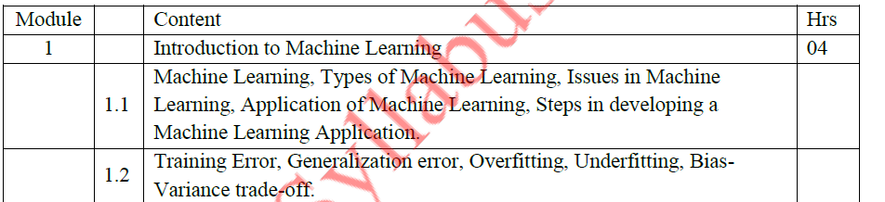
🔹 What is Machine Learning?
Machine Learning (ML) is a subset of Artificial Intelligence (AI) that focuses on building systems that can learn from data and improve their performance on a task without being explicitly programmed for every scenario.
Instead of a developer writing specific, fixed rules for every possible input, an ML model is "trained" on a large dataset. During training, the algorithm identifies patterns and relationships within the data, creating a mathematical model that can then make predictions, classifications, or decisions when presented with new, unseen data.
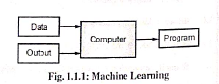

Example:
A spam filter learns from past emails which are spam and which are not. Based on that, it decides if a new email is spam.

🔹 Types of Machine Learning
- Supervised Learning
Supervised learning is the most common type of machine learning. Here, the algorithm is trained using a labeled dataset, which means each input data point has a corresponding correct output (target). The model learns a function that maps inputs to outputs. Once trained, it can predict outputs for new, unseen inputs.

  - The model learns using labelled data (input and correct output).
- Types of Problems:
  - Classification: Predicts categories. Example: Email spam detection (spam / not spam).
  - Regression: Predicts continuous values. Example: Predicting house prices or stock market values.
- Common Algorithms:
  - Linear Regression
  - Logistic Regression
  - Decision Trees
  - Random Forest
  - Support Vector Machines (SVM)

  - Neural Networks

  - Example: Predicting house prices using past data of houses (size, location, price).
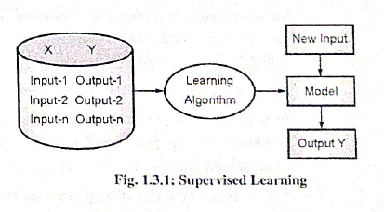

- Unsupervised Learning
Unsupervised learning deals with unlabeled data, where the system does not have predefined outputs. The goal is to discover hidden patterns, relationships, or groupings within the data. Unlike supervised learning, it is exploratory in nature.

  - The model learns from data without any labels.
- Types of Problems:
  - Clustering: Grouping similar data points together. Example: Customer segmentation in marketing.
  - Dimensionality Reduction: Simplifying large datasets by reducing features while keeping essential information. Example: Principal Component Analysis (PCA).
- Common Algorithms:
  - K-Means Clustering
  - Hierarchical Clustering
  - DBSCAN
  - PCA (Principal Component Analysis)
  - Autoencoders

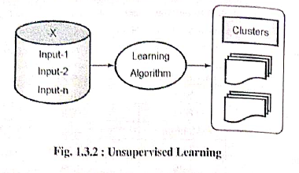
  - Example: Grouping customers based on shopping habits (clustering).
Feature | Supervised Learning | Unsupervised Learning
Data includes answers? | ✅ Yes (Labeled data) | ❌ No (Unlabeled data)
Goal | Predict or classify | Find patterns or groups
Example | Predict price of house | Group customers by buying habits
Common Algorithms | Decision Trees, SVM, Linear Regression | K-Means, Hierarchical Clustering

- Reinforcement Learning
Reinforcement learning is different from both supervised and unsupervised learning. Here, an agent learns by interacting with an environment. It performs actions and receives feedback in the form of rewards or penalties. Over time, it learns the best strategy (policy) that maximizes long-term rewards.
- Key Features:
  - No labeled data; relies on trial-and-error learning.
  - Learns by maximizing cumulative rewards.
  - Focuses on sequential decision-making.
- Important Components:
  - Agent: The learner/decision maker.
  - Environment: The world in which the agent operates.
  - Action: Choices made by the agent.
  - Reward: Feedback (positive or negative) for each action.
  - Policy: The strategy followed to take actions.
- Common Algorithms:
  - Q-Learning
  - Deep Q-Networks (DQN)
  - Policy Gradient Methods
- Real-World Examples:
  - Self-driving cars learning to navigate roads safely.
  - Game-playing AI like AlphaGo or chess engines.
Robots learning to walk or optimize tasks
  - The model learns by interacting with the environment and getting rewards or penalties.
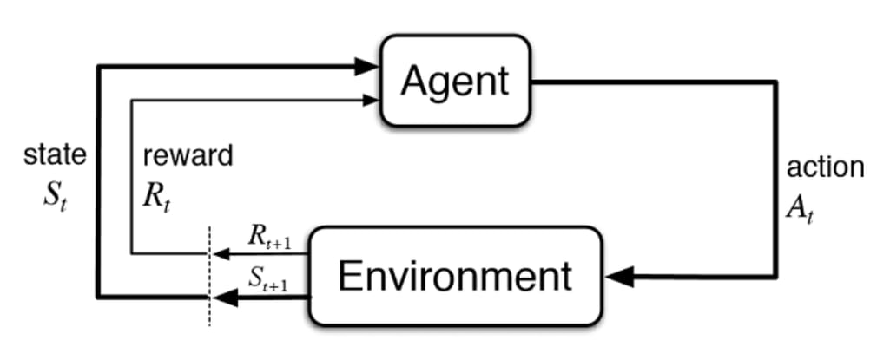
OR
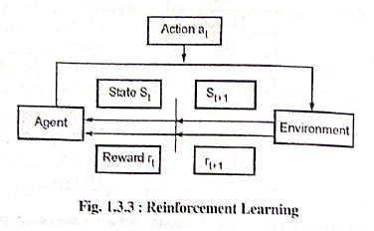
  - Example: A robot learning to walk by trying different steps and getting rewards when it walks correctly.

Issues in Machine Learning
(Imp 5 or 10 Marks)
Machine learning sounds amazing, but it has many challenges that developers must solve:

Data Quality Problems
The Problem: The data quality problem refers to issues arising from inaccurate, incomplete, inconsistent, or outdated data that negatively impact the performance, reliability, and validity of analytical models and decision-making processes.

Common Issues:
Incomplete data: Missing important information
Wrong data: Incorrect measurements or entries
Biased data: Data that favors one group over another
Too little data: Not enough examples to learn properly
Real Example: If you train a hiring model with data from a company that mostly hired men, the model will be biased against women candidates.
Solution: Always check your data quality, remove errors, and ensure you have enough diverse, accurate data.

Data Privacy and Security
The Problem: Machine learning often needs personal information, which raises serious privacy concerns.

Examples:
Healthcare: Patient medical records
Banking: Financial transactions and credit scores
Social media: Personal photos, messages, location data

Risks:
Data theft by hackers
Misuse of personal information

Selling data to third parties without permission
Solution: Use data encryption, get user consent, and follow privacy laws like GDPR.

Bias and Fairness
The Problem: Models can be unfair to certain groups of people.

How it happens:
- Training data contains historical discrimination
- Certain groups are under-represented in data
- Features indirectly discriminate (zip code might indicate race)

Real Examples:
- Facial recognition works better on light skin than dark skin
- Credit scoring systems discriminating against minorities
- Job recommendation systems favoring men for technical roles
Solution: Use diverse data, test for bias regularly, and ensure fair representation.

Interpretability (Black Box Problem)
The Problem: Some models are like black boxes - you can't understand how they make decisions.

Why it matters:
Medical diagnosis: Doctors need to know why the model suggests a treatment
Legal decisions: Courts need explanations for AI recommendations
Trust: People don't trust systems they can't understand
Example: A deep learning model says "This person will default on a loan" but can't explain why. The bank can't use this without understanding the reasoning.
Solution: Use simpler, more interpretable models when possible, or develop explanation tools.

5.Overfitting and Underfitting
Overfitting occurs when a machine learning model learns the training data too well, including noise and random fluctuations, which makes it perform well on the training data but poorly on unseen/test data.
Underfitting occurs when a machine learning model is too simple to capture the underlying patterns of the data, resulting in poor performance on both training and unseen/test data.
Causes:
- Overfitting: Caused by models with too many parameters or when there is insufficient regularization.
- Underfitting: Occurs when the model is too simple or lacks the capacity to capture complex patterns.

Strategies to Address Overfitting and Underfitting: Cross-Validation: Regularly test models on unseen data during training to prevent overfitting. To fix underfitting, make the model more capable and give it enough data/features to learn the underlying trends.

6. Scalability Issues
The Problem: Training complex models needs lots of computer power and time.

Challenges:
Big data: Millions of records take forever to process
Complex models: Deep learning needs powerful GPUs
Real-time predictions: Some applications need instant results
Cost: High-performance computers are expensive
Example: Training a language model like ChatGPT costs millions of dollars in computing resources.
Solution: Use cloud computing, optimize algorithms, or use simpler models when appropriate.

7.Ethical Concerns
The Problem: AI can be used for harmful purposes or make society worse.

Serious Issues:
Autonomous weapons: AI-powered military weapons
Mass surveillance: Governments tracking citizens
Job displacement: AI replacing human workers
Manipulation: Using AI to spread fake news or influence elections
Example: Deepfake technology can create fake videos of politicians saying things they never said.
Solution: Develop ethical guidelines, government regulations, and responsible AI practices.

8.Concept Drift
The Problem: The world changes, but your model stays the same.

What happens:

- Data patterns change over time: Trends evolve with new information and technologies.
- User behaviour evolves: Preferences shift with digital experiences and innovation.
- Market conditions shift: Economic and technological factors drive constant change.
- Social trends change: Cultural values and lifestyles evolve over time.

Example: A model trained to predict shopping behavior before COVID-19 became useless during the pandemic because people's shopping habits completely changed.
Solution: Continuously monitor model performance and retrain with new data regularly.

Applications of Machine Learning
(Imp 5 or 10 marks)
Machine learning has become an integral part of modern life, powering many technologies and services we use every day. Below are some of the most important real-world applications with detailed explanations.

1. Image Recognition (Computer Vision)
What it does: Enables computers to interpret and understand visual data such as images and videos.
How it works:
- Camera captures an image.
- AI breaks the image into pixels.
- The model compares pixel patterns with millions of stored examples.
- Identifies objects, people, or scenes accurately.
Real-Life Examples:
- Facebook Auto-Tagging: Automatically recognizes faces and suggests tags.
- Google Photos: Categorizes photos (e.g., beaches, pets, food).
- Security Cameras: Detect suspicious activities or known individuals.
- Medical Imaging: Assists doctors in identifying diseases like cancer.
- Self-Driving Cars: Recognize traffic signs, pedestrians, and other vehicles.
Impact: Improves accuracy, saves time, and enables innovations like autonomous vehicles.

2. Speech Recognition (Voice-to-Text)
What it does: Converts human speech into text that computers can interpret.
How it works:
- Microphone captures sound waves.
- AI converts sound into digital signals.
- Matches sound patterns with known words.
- Generates corresponding text output.
Popular Examples:
- Siri (Apple): “Hey Siri, what’s the weather?”
- Alexa (Amazon): “Alexa, play my favorite song.”
- Google Assistant: “OK Google, set a timer for 10 minutes.”
- Voice Typing & Dictation Software: Used by professionals for efficiency.
Benefits: Enables hands-free operation, accessibility, and faster communication.

3. Traffic Prediction and Navigation
What it does: Uses data to predict traffic conditions and find the most efficient routes.
How it works:
- Collects data from smartphones and GPS devices.
- Analyzes current road speeds and conditions.
- Compares with historical traffic data.
- Predicts congestion and suggests optimal routes.
Examples:
- Google Maps: Real-time traffic color indicators.
- Waze: Crowdsourced traffic updates.
- Uber/Lyft: ETA and surge pricing predictions.
- City Planning: Traffic light optimization and congestion control.
Impact: Reduces commute time, fuel consumption, and urban congestion.

4. Product Recommendations (Personalization)
What it does: Suggests products, movies, or content tailored to user preferences.
How it works:
- Analyzes user behavior (purchases, views, likes).
- Identifies patterns and similarities among users.
- Suggests new items based on predictive modeling.
Major Examples:
- E-Commerce: Amazon, eBay – personalized product recommendations.
- Entertainment: Netflix, Spotify, YouTube, TikTok – customized content feeds.
Business Impact: Increases engagement, customer satisfaction, and sales.

5. Email Spam and Security Filtering
What it does: Automatically classifies emails and protects against spam or phishing.
How it works:
- Analyzes email content and sender reputation.
- Detects suspicious patterns.
- Continuously improves from user feedback.
Types of Filtering:
- Spam detection
- Malware prevention
- Phishing protection
- Priority classification (e.g., Gmail’s “Primary,” “Promotions”)
Examples:
- Gmail & Outlook: Auto-sorting and junk filtering.
- Enterprise Mail: Advanced threat protection for organizations.
Benefits: Saves time, enhances cybersecurity, and organizes communication.

6. Online Fraud Detection
What it does: Detects and prevents fraudulent financial transactions.
How it works:
- Monitors transactions in real time.
- Compares activities against normal spending behavior.
- Flags or blocks anomalies automatically.
Detection Patterns:
- Unusual location or transaction amount.
- Multiple purchases in short time.
- Suspicious merchant categories.
Examples:
- Banks & Credit Cards: Visa, MasterCard real-time fraud detection.
- PayPal: Account security verification.
- E-commerce: Identifies fake or stolen accounts.
Impact: Prevents financial loss, protects consumers, and ensures transaction safety.

7. Stock Market Trading (Algorithmic Trading)
What it does: Uses AI algorithms to analyze data and make trading decisions autonomously.
How it works:
- Processes real-time market data and news.
- Identifies profitable trends and patterns.
- Executes trades automatically within milliseconds.
Types:
- High-frequency trading
- Trend analysis
- Risk management
- Portfolio optimization
Applications:
- Investment Firms: Automated AI-based traders.
- Robo-Advisors: Platforms like Betterment, Wealthfront.
- Crypto Trading Bots: Automated crypto trading and portfolio rebalancing.
Benefits: Eliminates emotional bias, speeds up decision-making, and improves investment performance.

8. Language Translation
What it does: Translates text or speech between different languages automatically.
How it works:
- Analyzes sentence structure and meaning.
- Understands linguistic and cultural context.
- Generates accurate, natural-sounding translations.
Major Examples:
- Google Translate: Text and speech translation in 100+ languages.
- Microsoft Translator: Real-time multilingual conversation.
- DeepL: High-quality document translation.
- Social Media: Auto-translation on Facebook and Twitter.
Advanced Features:
- Camera-based translation.
- Real-time voice conversation translation.
- Document translation while preserving formatting.
Impact: Removes language barriers, enhances global communication, and supports international collaboration.

business application of Machine Learning
(5 Marks)
- Enhanced Personalization and Recommendations: ML models analyze customer data (browsing history, purchase patterns) to provide highly relevant product or content suggestions, significantly increasing customer engagement and revenue (e.g., Netflix, Amazon).
- Real-Time Fraud and Risk Detection: Algorithms monitor vast streams of financial transactions and user behavior in real-time to identify and flag anomalies or patterns indicative of fraudulent activity, thereby protecting assets and maintaining financial security.
- Predictive Maintenance and Analytics: ML is used to forecast potential equipment failures and maintenance needs in industrial and manufacturing settings, enabling proactive repairs and dramatically reducing unscheduled downtime and operational costs.
- Customer Service Automation (Chatbots): Natural Language Processing (NLP) models power intelligent chatbots and virtual assistants, automating the handling of routine customer inquiries, resolving issues faster, and allowing human staff to concentrate on more complex tasks.
- Optimized Supply Chain and Demand Forecasting: Machine learning analyzes historical sales data, market trends, and external factors to accurately predict future product demand. This optimization leads to better inventory management, reduced waste, and more efficient logistics.

Steps of Developing Machine Learning Applications
(10 Marks)
Building a machine learning application involves a systematic process, much like following a recipe. There are seven key steps that guide the development from problem identification to prediction.

Step 1: Define the Problem
This is the foundation of any machine learning project. Clearly identify what you want to achieve.
Ask questions such as:
- What do I want to predict?
- What type of answer is expected (Yes/No, a number, a category)?
- What data will help solve this problem?
Example: Predicting whether it will rain tomorrow (a Yes/No classification problem) using weather data such as temperature, humidity, and wind speed.

Step 2: Collect Data
Gather relevant data that will help in solving the defined problem. Data can come from multiple sources such as:
- Manual collection: Surveys, forms, or interviews.
- Web scraping: Automated data collection from websites.
- Sensors: Devices like weather stations or cameras.
- Databases: Public or private datasets from organizations.
Example: Collect weather data for the past five years, including temperature, humidity, wind speed, and rainfall.

Step 3: Prepare Data (Data Cleaning)
Raw data often contains errors or inconsistencies. Data cleaning ensures quality and uniformity.
Key tasks include:
- Removing duplicate entries.
- Handling missing values (by filling or removing).
- Correcting errors and inconsistencies.
- Ensuring uniform formats (e.g., consistent units for temperature).
Example: Convert all temperature values to Celsius to maintain consistency.

Step 4: Explore Data (EDA – Exploratory Data Analysis)
EDA helps in understanding data patterns and relationships.
Typical steps include:
- Visualizing data using charts and graphs.
- Identifying patterns or correlations.
- Detecting outliers or anomalies.
Example: Discover that when humidity > 80% and temperature < 25°C, rainfall occurs 90% of the time.

Step 5: Build the Model
Select and train a machine learning algorithm suitable for the problem.
- Split data: Training set (70–80%) and testing set (20–30%).
- Choose algorithm: Select the most appropriate model (e.g., Decision Tree, SVM).
- Train the model: Allow the algorithm to learn from training data.
Example: Train a Decision Tree using 4 years of weather data to predict rainfall.

Step 6: Evaluate and Optimize the Model
Measure model performance and refine it for better results.
- Evaluate accuracy: Test with unseen data.
- Identify weaknesses: Check where predictions fail.
- Optimize: Adjust parameters, use cross-validation, or test alternative algorithms.
Example: Improve accuracy from 70% to 85% by tuning parameters or switching algorithms.

Step 7: Make Predictions
Use the finalized model to make predictions on new data.
- Input new data: Provide unseen examples.
- Get predictions: Model outputs results as categories or probabilities.
Example: Input tomorrow’s weather (temperature, humidity, wind speed) → Output: “Yes, 85% chance of rain.”

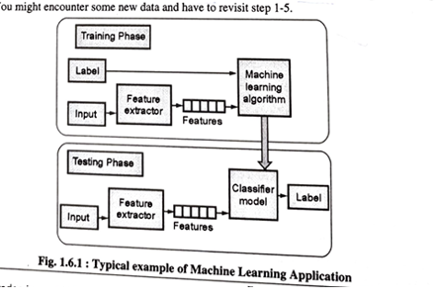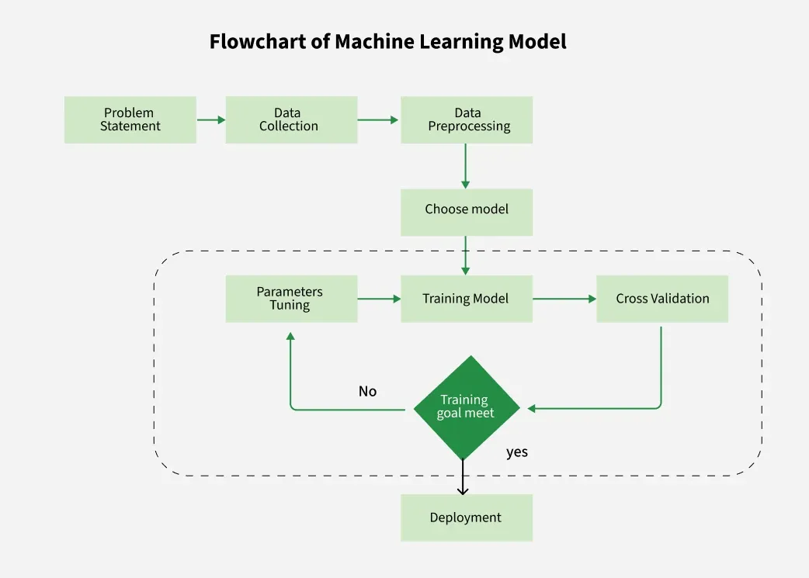
1. Training Error
Definition:
In machine learning, training error refers to how much the model’s predictions differ from the actual outputs on the training data — the data that the model has already seen and learned from.
Formula:
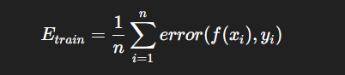
Explanation of Formula:
- ( n ) → Total number of training examples.
- ( f(x_i) ) → Model’s predicted value for the ( i^{th} ) input.
- ( y_i ) → True or actual value for the ( i^{th} ) input.
- ( error(f(x_i), y_i) ) → Measures the difference between predicted and actual values.
In simple terms, the training error is the average of all prediction errors over the training set.
It tells how well the model has learned the data it was trained on.
A low training error means the model fits the training data well.

2. Generalization Error
Definition:
Generalization error measures how well a trained model performs on unseen data — i.e., data that was not part of the training process. It represents the model’s ability to generalize beyond what it has already seen.
Formula:
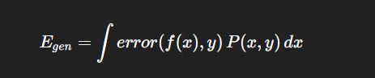
Explanation of Formula:
- ( f(x) ) → Model’s prediction for input ( x ).
- ( y ) → True (actual) value.
- ( P(x, y) ) → Probability distribution of all possible input-output pairs in the real world.
- ( error(f(x), y) ) → Represents how much the model’s prediction differs from the actual value.
This formula computes the expected (average) error over all possible data points — not just the ones seen during training.
A model with a low generalization error is one that can make accurate predictions on new, unseen data.

3. Difference Between Training Error and Generalization Error
Aspect | Training Error | Generalization Error
Definition | Error calculated on the data used to train the model. | Error calculated on unseen/test data not used during training.
Formula | ( E_{train} = \frac{1}{n} \sum_{i=1}^{n} error(f(x_i), y_i) ) | ( E_{gen} = \int error(f(x), y) P(x, y) dx )
Purpose | Measures how well the model fits the training data. | Measures how well the model generalizes to new data.
Error Source | Comes from how well the model memorizes or fits the training data. | Comes from the model’s ability to handle unseen patterns.
Ideal Condition | Should be low but not zero. | Should be close to the training error (small gap).
If Too Low | May indicate overfitting (memorizing data). | Low generalization error means good generalization.
Affected By | Model complexity and training data size. | Data distribution, noise, and overfitting/underfitting.

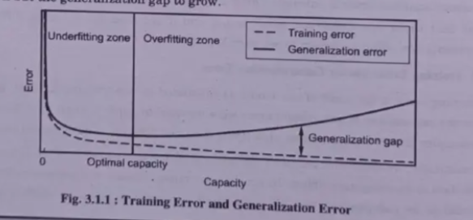
✅ Summary:
- Training Error → How well the model fits known data.
- Generalization Error → How well the model performs on new, unseen data.
- The goal in machine learning is to minimize both, keeping the gap between them as small as possible for better generalization.

1. Overfitting in Machine Learning
Overfitting occurs when a model learns not only the underlying patterns in the training data but also the noise, outliers, or irrelevant details. This makes the model perform very well on training data but poorly on new, unseen data.
Analogy: Overfitting models are like students who memorize answers for a practice test but cannot handle variations in real exam questions.
Example: Suppose you have a set of points forming a smooth curve. If you fit a highly complex curve that passes through every single point, it will perfectly match the training data but fail to predict new points correctly.
Reasons for Overfitting:
- The model has high variance and low bias.
- The model is too complex relative to the data.
- The size of the training dataset is too small.
Techniques to Reduce Overfitting:
- Improve the quality of training data (remove noise).
- Increase the amount of training data.
- Reduce model complexity.
- Early stopping during training when loss starts increasing.
- Apply regularization (Ridge, Lasso).
- Use dropout in neural networks.

2. Underfitting in Machine Learning
Underfitting is the opposite of overfitting: the model is too simple to capture the underlying patterns in the data.
Analogy: Underfitting models are like students who don’t study enough and fail in both practice tests and real exams.
Example: If the dataset follows a curved pattern, fitting a straight line would miss the curve entirely, resulting in poor performance on both training and test data.
Reasons for Underfitting:
- The model is too simple.
- Features used do not adequately represent the target.
- Training dataset is too small.
- Excessive regularization constrains the model.
- Features are not scaled properly.
Techniques to Reduce Underfitting:
- Increase the number of features or perform feature engineering.
- Remove noise from data.
- Increase training duration (more epochs).

3. Bias and Variance
Bias and variance are two key sources of error in machine learning models.
Bias:
- Error due to oversimplification of the model.
- High bias leads to underfitting.
- Analogy: Assuming all birds are small and can fly, failing to recognize exceptions like penguins or ostriches.
- Example: A linear model trying to fit non-linear data.
Variance:
- Error due to the model learning too much from training data, including noise.
- High variance leads to overfitting.
- Example: A complex model fits every training point but fails to generalize to new points.

4. Visualizing Underfitting vs Overfitting
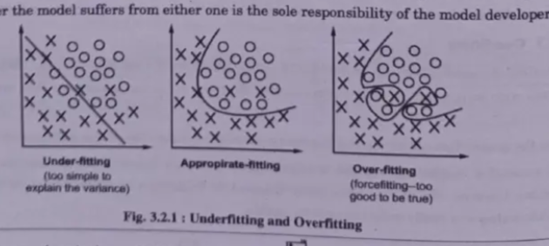
- Underfitting: Straight line through curved data → poor performance on training & test sets.
- Overfitting: Squiggly curve passes through all training points → performs well on training but poorly on test sets.
- Appropriate Fitting: Smooth curve captures the underlying trend without being too complex → generalizes well.

5. Bias-Variance Trade-offs
Balancing bias and variance is crucial for good model performance:
- Increasing model complexity → reduces bias but increases variance (risk of overfitting).
- Simplifying the model → reduces variance but increases bias (risk of underfitting).
Goal: Find the optimal model complexity where both bias and variance are minimized for best generalization.

