# Methods

## Data source and recording details

### International Brain Laboratory (IBL)

We used the open-access dataset from the International Brain Laboratory (IBL). IBL provides a comprehensive set of recordings collected from more than 100 mice across 11 laboratories doing a standardized perceptual decision-making task. 547 Neuropixel probes were inserted in the left forebrain, midbrain, right hindbrain, and cerebellum to collect data on 267 brain regions (Benson et al. 2023).

### Task detail

At the start of each trial, the mouse was required to refrain from moving the wheel for a quiescence period lasting between 400 and 700 milliseconds. After this period, a visual stimulus (Gabor patch) appeared on either the left or right side of the screen, accompanied by a 100-millisecond tone (5 kHz sine wave). The contrast of the stimulus was randomly chosen from five levels (100%, 25%, 12.5%, 6%, and 0%). If the mouse correctly moved the stimulus to the center (±35° azimuth), it received a 3 µL water reward. Incorrect responses or failing to respond within 60 seconds resulted in a 500-millisecond burst of white noise and a timeout. The experiment began with 90 unbiased trials where the stimulus appeared equally on both sides. The contrast levels were presented in a ratio of [2:2:2:2:1] for contrasts [100%, 25%, 12.5%, 6%, 0%]. After this initial block, trials were organized into biased blocks, where the likelihood of the stimulus appearing on one side was fixed at 20% for the left and 80% for the right in “right blocks,” or vice versa in “left blocks.” These blocks consisted of 20 to 100 trials, determined by a truncated geometric distribution, with stimulus contrast levels similar to those in the unbiased block. In 0% contrast trials, where no stimulus was visible, the side assignment followed the bias of the block (e.g. right side for right blocks)(Benson et al. 2023).

### Electrophysiological recording

The neural recordings were conducted using Neuropixels 1.0 (3A or 3B) probes, with 384 recording channels and 960 low-impedance sites on a single shank (Benson et al. 2023). Neuropixels probes are advanced silicon-based neural recording devices designed for high-density recording of neural activity across large populations of neurons with precise spatial and temporal resolution (Jun et al. 2017). After the recordings, electrode tracks were reconstructed by performing serial-section 2-photon microscopy. A region was then assigned to each recording site and neuron within the Allen Common Coordinate Framework (Benson et al. 2023).

## Preprocessing

we first apply destriping and then downsampling to 500 Hz **destriping** -> **decimating**-> **annotation** -> **epoching** define noisy channels and trials remove sessions with more than 40 % noisy channel or trials

## compute current source density and bipolar montage

## tf itc

## pac

## stats

**Time_frequency**

permutation test

TF decoding

## behavior analysis

**task engagment**

# Results

A total of 63 probes were identified in the IBL datasets, with at least one channel assigned to the primary visual cortex (V1). There were seven insertions excluded due to more than 40% noisy channels, and 15 insertions excluded because of more than 40% noisy trials. In the end, 41 insertions were retained, consisting of 2,262 total channels and 25,075 trials. On average, each probe was associated with 53 channels in V1 (range: 2 to 118), with an average of 532 trials per session (range: 276 to 1,098). Among the total number of channels, 212 (9.37%) were located in layer 1, 456 (20.16%) in layer 2/3, 338 (14.94%) in layer 4, 650 (28.74%) in layer 5, and 606 (26.79%) in layer 6.

To have sanity check and better understanding of selected sessions, we replicated the behavioral results of IBL paper (Benson et al. 2023). In line with previous results on whole sessions, mice performed correctly on 80.7% ± 5.8% (mean ± s.d.) of the trials, responding better and faster to trials with higher stimulus contrast. In 0% contrast trials, where mice had to rely only on their expectation and prior experience, they made correct choices in 57% ± 8% (mean ± s.d.) of the trials.

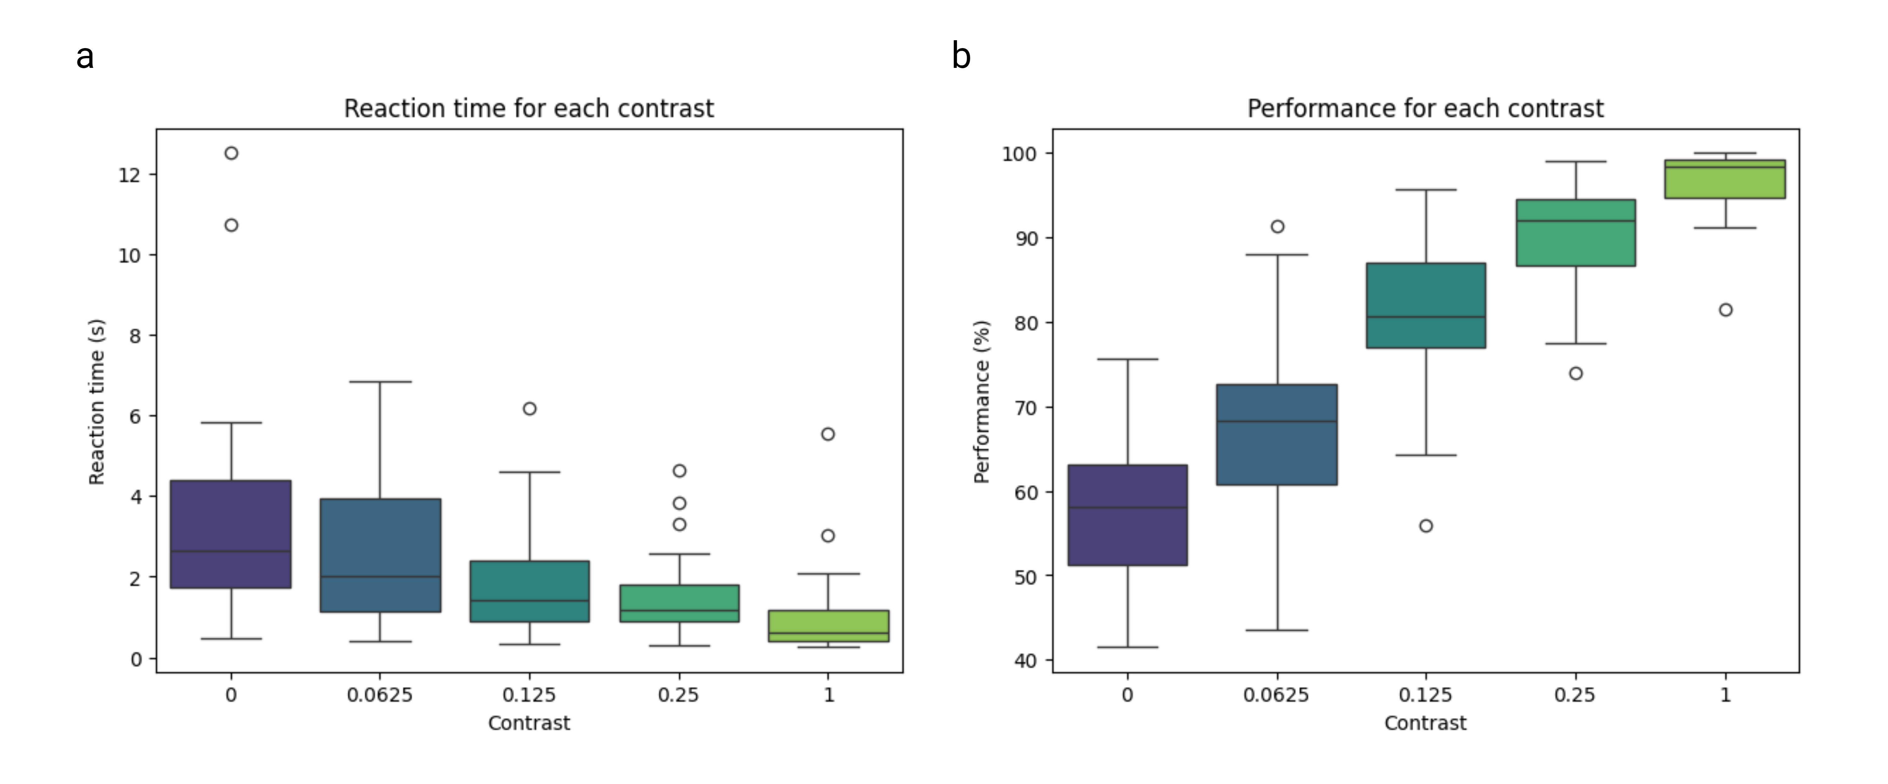

**Behavior results**: **a**) Reaction time for different contrast. **b**) performance as a percent of correct trials over total number of trials for each contrast levels

Benson, Brandon, Julius Benson, Daniel Birman, Niccolò Bonacchi, Matteo Carandini, Joana A Catarino, Gaelle A Chapuis, et al. 2023. “A Brain-Wide Map of Neural Activity During Complex Behaviour.” *bioRxiv*, January, 2023.07.04.547681. <https://doi.org/10.1101/2023.07.04.547681>.

Jun, James J., Nicholas A. Steinmetz, Joshua H. Siegle, Daniel J. Denman, Marius Bauza, Brian Barbarits, Albert K. Lee, et al. 2017. “Fully Integrated Silicon Probes for High-Density Recording of Neural Activity.” *Nature* 551 (7679): 232–36. <https://doi.org/10.1038/nature24636>.