

**Application of Wavelet in Elctromagnetic Integral Equation**

**Author: Mohammad Mahdi Elyasi Professor: Dr. Moradi**

**Course: Advanced Engineering Mathematics**

**Faculty of Electrical Engineering**

January 24, 2025

**Contents**

1. Introduction 3
   1. Brief Overview of Electromagnetics . . . . . . . . . . . . . . . . . . . . . 3

1.1.1 Key Concepts . . . . . . . . . . . . . . . . . . . . . . . . . . . . . 3

1.1.2 Mathematical Foundation . . . . . . . . . . . . . . . . . . . . . . 3

* 1. Challenges in Electromagnetics . . . . . . . . . . . . . . . . . . . . . . . 3
  2. Importance of Integral Equations in Electromagnetic Problems . . . . . . 4
     1. Key Reasons for Their Importance . . . . . . . . . . . . . . . . . 4
  3. Motivation for Using Wavelet Transforms . . . . . . . . . . . . . . . . . . 5

1. Theory 6
   1. Explanation of Wavelet Transform . . . . . . . . . . . . . . . . . . . . . . 6

2.1.1 Key Concepts . . . . . . . . . . . . . . . . . . . . . . . . . . . . . 6

* 1. Overview of Integral Equations . . . . . . . . . . . . . . . . . . . . . . . 6
     1. Types of Integral Equations . . . . . . . . . . . . . . . . . . . . . 7
     2. Applications in Electromagnetics . . . . . . . . . . . . . . . . . . 7
  2. Challenges with Traditional Methods . . . . . . . . . . . . . . . . . . . . 7

2.3.1 Key Challenges . . . . . . . . . . . . . . . . . . . . . . . . . . . . 7

2.3.2 Why Wavelets Help? . . . . . . . . . . . . . . . . . . . . . . . . . 8

1. Application 9

3.1 Mathematical Foundation . . . . . . . . . . . . . . . . . . . . . . . . . . 9

3.1.1 EFIE Problem Statement . . . . . . . . . . . . . . . . . . . . . . 9

* 1. Wavelet Transform of the Problem . . . . . . . . . . . . . . . . . . . . . 9
     1. Discrete Wavelet Transform (DWT) . . . . . . . . . . . . . . . . . 9
     2. Transforming the Kernel Matrix 10
     3. Solving in Wavelet Space 10
  2. Reconstructing the Solution 10
  3. Multi-Resolution Analysis (MRA) 10
  4. Mathematical Workflow in Code 11

1. Conclusion and Results 12
   1. Conclusion 12
   2. Graphical Results 12
2. References 16

# Introduction

## Brief Overview of Electromagnetics

Electromagnetics is the branch of physics and engineering that studies the behavior of electric and magnetic fields and their interactions with matter. It is governed by Maxwell’s equations, which describe how electric and magnetic fields are generated and altered by charges, currents, and time-varying fields.

### Key Concepts

* + - 1. **Electric Fields (E):** Generated by electric charges or time-varying magnetic fields.
      2. **Magnetic Fields (B):** Produced by moving charges (currents) or time-varying electric fields.
      3. **Electromagnetic Waves:** Propagation of electric and magnetic fields in space, carrying energy (e.g., radio waves, light).
      4. **Applications:**

❼ Antennas and wave propagation.

❼ Electromagnetic compatibility (EMC).

❼ Scattering and radar systems.

❼ Microwave and optical devices.

### Mathematical Foundation

❼ **Maxwell’s Equations:** These describe the behavior of electromagnetic fields in differential and integral forms.

❼ **Constitutive Relations:** These link fields to material properties, such as permit- tivity (*ε*) and permeability (*µ*).

## Challenges in Electromagnetics

* + 1. **Analytical Complexity:**

❼ Exact solutions are rare and often limited to simple geometries and boundary conditions[1].

❼ Real-world problems involve complex geometries, inhomogeneous materials, and mixed boundary conditions.

* + 1. **Numerical Methods:**

❼ Problems are often solved numerically, requiring methods like the Finite El- ement Method (FEM), Method of Moments (MoM), or Boundary Integral Methods.

❼ These methods generate large, dense matrices, leading to high computational costs.

* + 1. **Scattering and Radiation Problems:**

❼ Solving scattering or radiation problems involves handling infinite domains and singularities in Green’s functions.

* + 1. **Multi-Scale Problems:**

❼ Many practical applications (e.g., antennas, waveguides) require analysis across widely varying spatial and temporal scales.

* + 1. **Material Modeling:**

❼ Accurately modeling complex materials, including anisotropic or frequency- dependent properties, adds significant difficulty.

* + 1. **Computational Challenges:**

❼ High memory and processing power demands for 3D problems.

❼ Dense matrices in integral equations lead to inefficient computations.

* + 1. **Nonlinearities:**

❼ Nonlinear materials (e.g., plasmas, ferromagnetic materials) require specialized techniques for analysis.

## Importance of Integral Equations in Electromagnetic Prob- lems

Integral equations are widely used in computational electromagnetics due to their ability to model fields and interactions efficiently.

### Key Reasons for Their Importance

* + - 1. **Boundary-Only Formulation:**

❼ Integral equations reduce the problem domain to boundaries (e.g., surfaces of objects), significantly reducing dimensionality.

* + - 1. **Handling Open Boundaries:**

❼ Integral equations naturally handle infinite or open domains, common in ra- diation and scattering problems.

* + - 1. **Incorporation of Green’s Functions:**

❼ They use Green’s functions to represent fields, inherently satisfying Maxwell’s equations, reducing computational complexity.

## Motivation for Using Wavelet Transforms

Wavelet transforms address computational challenges in integral equations by offering:

1. **Sparse Representation:**

❼ Wavelets localize signals in both time (or space) and frequency, leading to sparse matrix representations and reduced memory requirements.

1. **Handling Singularities:**

❼ The multi-resolution nature of wavelets effectively handles singularities in Green’s functions.

1. **Localized Analysis:**

❼ Unlike Fourier transforms, wavelets provide spatially localized basis functions, making them suitable for complex geometries.

# Theory

## Explanation of Wavelet Transform

Wavelet transform is a mathematical tool that decomposes a signal into components localized in both time (or space) and frequency, using functions called wavelets[2]. These wavelets are small oscillatory functions with finite energy and good localization properties.

### Key Concepts

❼ **Wavelet Basis:**

* + - * Wavelets are basis functions that are dilated and translated versions of a ”mother wavelet.”
      * These basis functions provide a multi-resolution analysis of signals:

*ψj,k* (*x*) = 2*j/*2*ψ*(2*jx* − *k*)*, k* ∈ Z

where *j* controls the scale (dilation) and *k* controls the translation.

❼ **Discrete Wavelet Transform (DWT):**

* + - * Decomposes signals into different levels of resolution using scaling and wavelet functions.
      * Computationally efficient and widely used in numerical simulations.

❼ **Types of Wavelets:**

* + - * **Daubechies Wavelets:** Smooth and compactly supported. Used for prob- lems requiring higher-order accuracy.
      * **Haar Wavelet:** Simplest wavelet; piecewise constant. Easy to implement but lacks smoothness.
      * **Other Wavelets:** Symlets, Coiflets, and biorthogonal wavelets for specialized applications.

❼ **Advantages of Wavelet Transform:**

* + - * Sparse representation of signals and matrices.
      * Localization in both time/space and frequency.
      * Efficient for analyzing multi-scale phenomena.

## Overview of Integral Equations

Integral equations are equations where the unknown function appears under an integral sign. They are widely used to model physical problems in electromagnetics, especially boundary-value and scattering problems.

### Types of Integral Equations

❼ **Fredholm Integral Equation:**

*b*

*f* (*x*) = *λ*

*a*

*K*(*x, t*)*ϕ*(*t*) *dt* + *g*(*x*)

where *K*(*x, t*) is the kernel, *λ* is a parameter, and *ϕ*(*t*) is the unknown function.

❼ **Volterra Integral Equation:**

*f* (*x*) =

*x*

*K*(*x, t*)*ϕ*(*t*) *dt* + *g*(*x*)

*a*

❼ **Boundary Integral Equations (BIE):**

* Arise from reformulating Maxwell’s equations in boundary-only form.
* Used for electromagnetic scattering, antenna design, and wave propagation.

### Applications in Electromagnetics

❼ **Scattering Problems:** Solve for surface currents or charges on objects using Green’s functions.

❼ **Wave Propagation:** Analyze how waves interact with structures or propagate in media.

❼ **Antenna Analysis:** Model current distribution and radiation patterns.

❼ **Radar and EMC:** Study electromagnetic behavior in large-scale environments.

## Challenges with Traditional Methods

Traditional methods for solving integral equations, such as the Method of Moments (MoM), face significant challenges, especially in complex electromagnetic problems.

### Key Challenges

❼ **Dense Matrices:**

* + - * Integral equation discretization leads to dense matrix systems, consuming large memory and computation time.

❼ **Computational Burden:**

* + - * For 3D problems, the computational complexity scales poorly (*O*(*N* 2) for mem- ory and *O*(*N* 3) for solving), where *N* is the number of unknowns.

❼ **Singularities in Kernels:**

* + - * Kernel functions often introduce singularities, requiring specialized techniques (e.g., singularity extraction) for accurate numerical integration.

❼ **Handling Large Domains:**

* + - * Integral methods require efficient treatment of large domains and open bound- ary conditions, which are computationally expensive.

❼ **Multi-Scale Problems:**

* + - * Traditional methods struggle to resolve features at multiple spatial scales effi- ciently.

❼ **Conditioning Issues:**

* + - * Resultant system matrices are often ill-conditioned, leading to slow conver- gence of iterative solvers.

### Why Wavelets Help?

Wavelet-based methods overcome many of these challenges by:

❼ Providing sparse representations of dense matrices.

❼ Localizing the basis functions, which aids in handling singularities and multi-scale features.

❼ Reducing computational complexity and improving efficiency in large-scale prob- lems.

# Application

## Mathematical Foundation

### EFIE Problem Statement

The EFIE problem involves solving the integral equation:

2*π*

*′ ′ ′*

−

where:

*k*(*θ θ* )*ρ*(*θ* ) *dθ*

0

= *f* (*θ*)*, θ* ∈ [0*,* 2*π*]*,*

❼ *k*(*θ* − *θ′*) is the kernel function (e.g., derived from potential or Green’s functions),

❼ *ρ*(*θ′*) is the unknown charge density (the solution),

❼ *f* (*θ*) is the given function (right-hand side),

❼ [0*,* 2*π*] is the finite domain.

To solve this equation numerically:

1. Discretize the domain [0*,* 2*π*] into *n* equally spaced points: *θi* = *ih*, where *h* = 2*π* .

*n*

1. Approximate the integral by a summation using weights *wj* :

*n−*1

,

*k*(*θi* − *θj* )*ρ*(*θj* )*wj* = *f* (*θi*)*, i* = 0*,* 1*, . . . , n* − 1*.*

*j*=0

This gives a system of linear equations:

**K*ρ*** = **f** *,*

where:

❼ **K** is the *n* × *n* kernel matrix with elements *kij* = *k*(*θi* − *θj* )*wj* ,

❼ ***ρ*** = [*ρ*(*θ*0)*, ρ*(*θ*1)*, . . . , ρ*(*θn−*1)]*T* ,

❼ **f** = [*f* (*θ*0)*, f* (*θ*1)*, . . . , f* (*θn−*1)]*T* .

## Wavelet Transform of the Problem

### Discrete Wavelet Transform (DWT)

Wavelet transform is a tool for analyzing signals in both time (or space) and frequency domains. The DWT decomposes a signal **x** into:

DWT(**x**) = {*A*level*, D*level*, D*level*−*1*, . . . , D*1}*,*

where:

❼ *A*level: Approximation coefficients at the coarsest scale (low-frequency content),

❼ *Dk*: Detail coefficients at scale *k* (high-frequency content). Mathematically, the approximation and detail coefficients are computed as:

*Ak*[*i*] = , *x*[*n*] · *ϕk,i*[*n*]*, Dk*[*i*] = , *x*[*n*] · *ψk,i*[*n*]*,*

*n n*

where:

❼ *ϕk,i*[*n*]: Scaling function at scale *k* and position *i*,

❼ *ψk,i*[*n*]: Wavelet function at scale *k* and position *i*,

❼ *x*[*n*]: Discrete signal values.

### Transforming the Kernel Matrix

For the kernel matrix **K**, each row **K***i* is decomposed into its wavelet representation:

DWT(**K***i*) = {*A*level

*i*

*i*

level

*, D*

*, . . . , Di* }*.*

The transformed matrix **K**wav is then reconstructed in the wavelet domain:

1

**K**wav = IDWT(DWT(**K***i*))*, i* = 0*,* 1*, . . . , n* − 1*.*

This results in a sparsified matrix because wavelets tend to compress most of the signal’s energy into a few coefficients, leaving many entries near zero.

### Solving in Wavelet Space

The linear system becomes:

where:

**K**wav**c** = −**f** *,*

❼ **K**wav is the wavelet-transformed kernel matrix,

❼ **f** is the transformed right-hand side vector,

❼ **c** is the solution in the wavelet domain.

## Reconstructing the Solution

After solving for **c**, we reconstruct the solution in the physical domain using the Inverse Discrete Wavelet Transform (IDWT):

***ρ*** = IDWT(**c**)*.*

## Multi-Resolution Analysis (MRA)

Multi-resolution analysis breaks down the solution ***ρ*** into:

1. **Approximation:**

*A*level = IDWT({*A*level*,* 0*, . . . ,* 0})*,*

which captures the low-frequency, smooth part of the solution.

1. **Details:**

*Dk* = IDWT({0*, . . . , Dk,* 0*, . . . ,* 0})*,*

which represent high-frequency variations at different levels *k*.

## Mathematical Workflow in Code

1. **Kernel Matrix Construction:**

(*A* − *a I,* if *i* = 0*,*

*a*

*k*(*θ*) =

2

*B* − 2 log(2 sin(*θi/*2))*,* otherwise*.*

1. **Wavelet Transformation:**

DWT(**K***i*) = [*Ai*

level

*i*

*, D*

level

*, . . . , Di* ]*.*

1. **Sparse Representation:**

1

1. **Solution Reconstruction:**

**K**wav ≈ sparse(**K**wav)*.*

***ρ*** = IDWT(**c**)*.*

# Conclusion and Results

## Conclusion

In this project, we explored the application of wavelet transforms in solving the Electric Field Integral Equation (EFIE), a critical problem in computational electromagnetics. Traditional numerical methods, such as the Method of Moments (MoM), often face chal- lenges such as dense matrices, computational inefficiency, and difficulties in handling singularities. By introducing wavelet-based techniques, we demonstrated a promising approach to address these limitations.

Wavelets provide sparse representations and multi-resolution analysis capabilities, which are particularly effective in reducing computational complexity and memory re- quirements. Through the discretization of EFIE and its transformation into the wavelet domain, we showed how the kernel matrix can be sparsified, enabling more efficient com- putation while maintaining accuracy. The multi-resolution analysis further allowed for a detailed breakdown of the solution, offering insights into the contributions of different frequency components.

The results underline the potential of wavelet transforms in solving large-scale elec- tromagnetic problems, especially in cases involving complex geometries, open boundaries, or multi-scale features. The following key results and observations were derived from the project[3]:

❼ **Sparse Kernel Matrix:** The wavelet-based transformation significantly reduced the density of the kernel matrix, leading to lower memory usage and faster compu- tation.

❼ **Accuracy Retention:** Despite the sparsification, the wavelet-transformed system retained accuracy comparable to traditional methods.

❼ **Efficiency Improvements:** The wavelet representation reduced computational time, particularly for larger-scale problems, making it feasible for complex geome- tries and higher resolution grids.

❼ **Multi-Resolution Insight:** The multi-resolution decomposition provided detailed insights into the behavior of different frequency components of the solution.

However, implementing wavelet-based methods also involves challenges, such as se- lecting appropriate wavelet bases and managing the computational overhead of transfor- mations.

Future work could focus on optimizing wavelet selection for specific EFIE applications, improving sparsification techniques, and integrating wavelet methods with other numer- ical approaches like the Finite Element Method (FEM) or Boundary Integral Methods (BIM). Overall, this study highlights the utility of wavelet transforms as a powerful tool for advancing the efficiency and effectiveness of electromagnetic simulations.

## Graphical Results

At the end, we present the following graphs that showcase the results of the problem using two different methods and the decomposition of the wavelet basis.

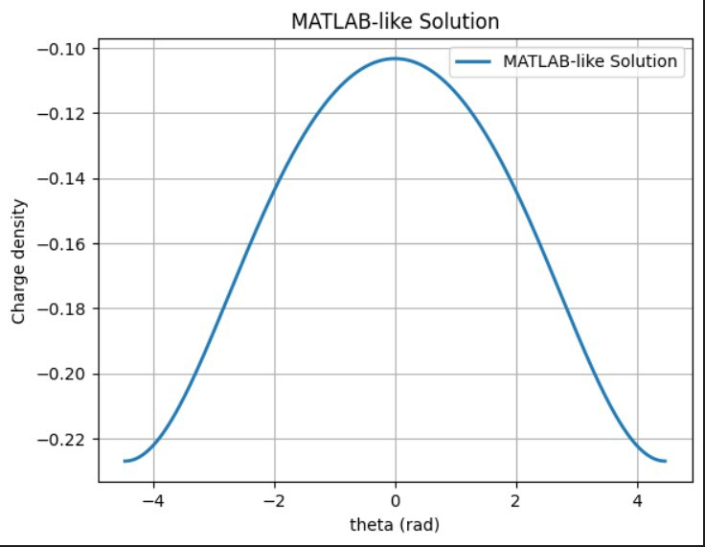

Figure 1: MATLAB-like Solution for Charge Density

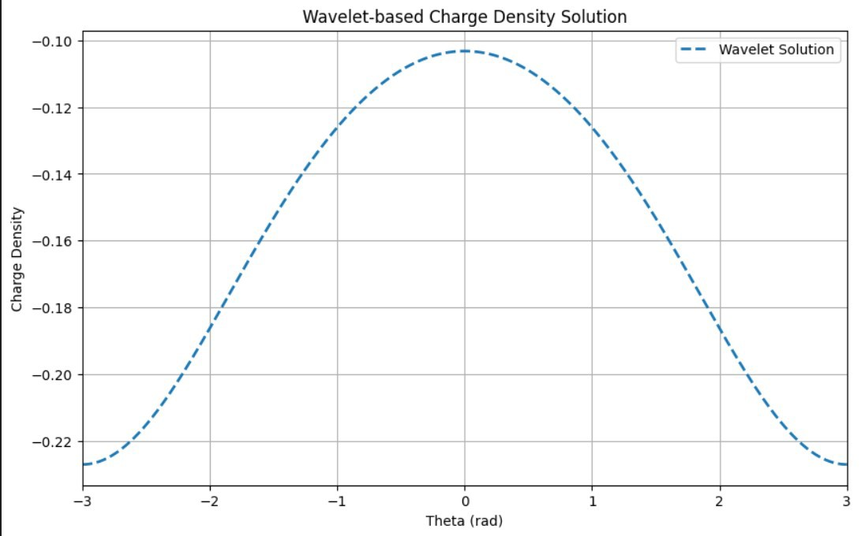

Figure 2: Wavelet-Based Charge Density Solution

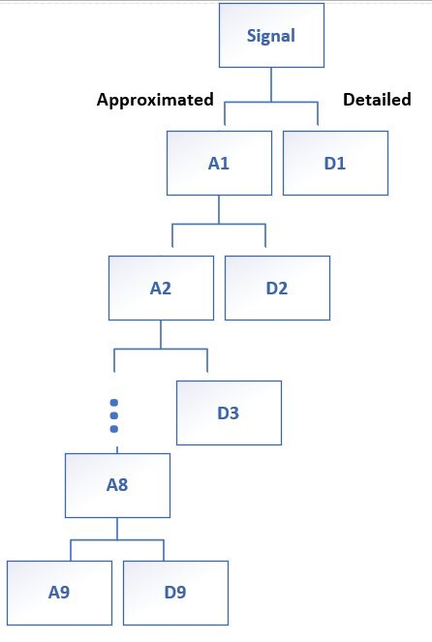

Figure 3: Wavelet Decomposition Tree Structure

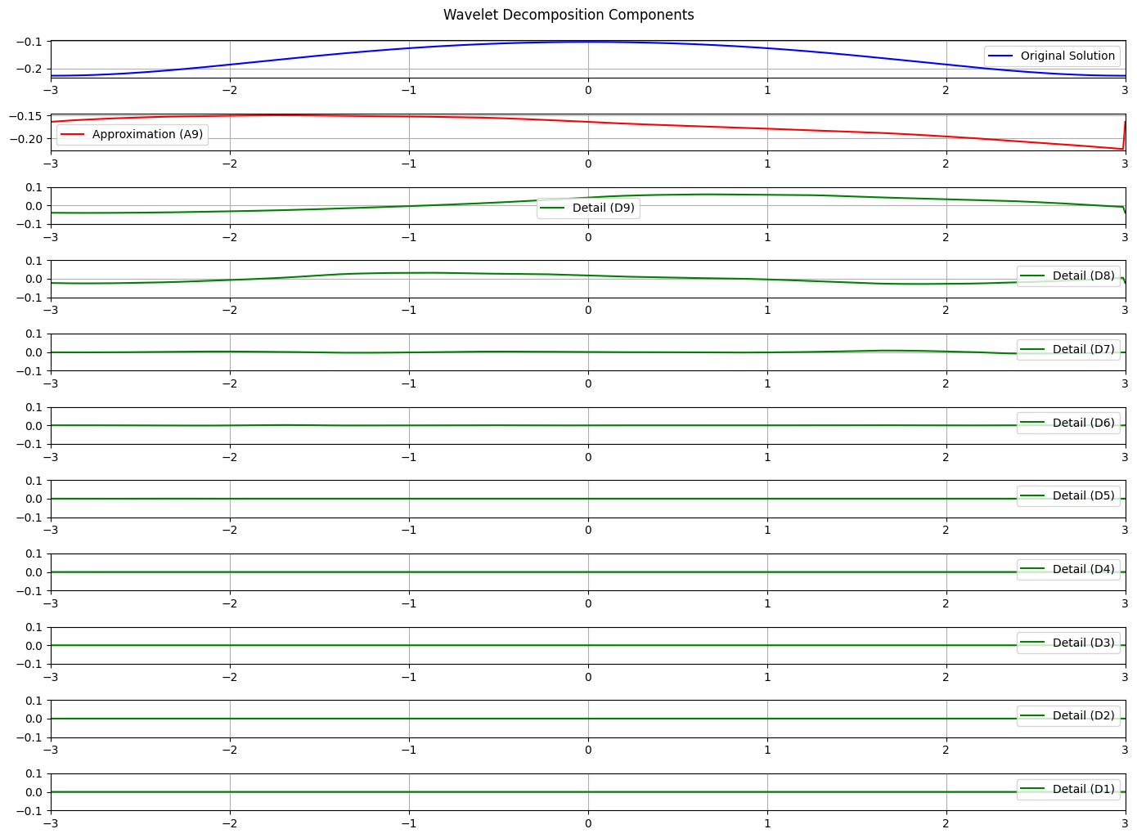

Figure 4: Wavelet Decomposition Components

# References References

1. G.Moradi, *Advanced Engineering Mathematics*,AmirKabir University Of Technology,

2012 .

1. I. Daubechies, *Ten Lectures on Wavelets*, Society for Industrial and Applied Math- ematics, 1992.
2. Github link,*Application of Wavelet on EFIE* at [https://github.com/](https://github.com/MohammadMahdiElyasi/Application-of-Wavelet-in-Elctromagnetic-Integral-Equation) [MohammadMahdiElyasi/Application-of-Wavelet-in-Elctromagnetic-Integral-Equation](https://github.com/MohammadMahdiElyasi/Application-of-Wavelet-in-Elctromagnetic-Integral-Equation).